

Module Name: Digital Skills for Personal Development and Business Growth

Module Code: BMSW4008

Student Name: Cristian Batranu
Student Number: 2410787

I confirm that I have not presented any AI generated materials as my own work.
I confirm that I have copies of my drafts, notes, and other resources I used, which I may be asked to provide in evidence.

Contents
MOV Films 3
Introduction 3
Market Research 4
Conclusion 8
The Importance of Excel in the Digital Era and Its Relevance to Small Business Management 9
Reference List 12
Fig. 1: MOV Films Homepage 15
Fig. 2: MOV Films Services Page 16
Fig. 3: MOV Films SEO Site description 17
Fig. 4: Instagram Promotion 18
Fig. 5: Cashflow Forecast 19
Fig. 6: Chart 20
Fig. 7: 21st Century Skills 21

MOV Films

Introduction
MOV Films is a wedding videography business specialising in cinematic storytelling. This report demonstrates how primary research can powerfully inform business development in the digital era. Research plays a crucial role in shaping business strategy. According to Forbes Councils Member, Kelly (2023), market research helps companies understand customer demographics, refine segmentation, and evaluate competitors—critical for long-term viability. Kantar (2023) adds that research delivers insights on consumer behaviour and market trends, enabling businesses to make informed, data-driven decisions
To adapt our strategies, a digital questionnaire was conducted to gain insights into the preferences, expectations, and behaviours of our target audience. The questionnaire was designed in Google Forms and distributed to a relevant sample of respondents, focusing on individuals likely to engage in using our wedding videography services. This report analyses five key questions that generated the most valuable insights. These findings were used to shape our website design and digital marketing materials.

Market Research

The first survey question asked respondents to indicate their age bracket. An overwhelming 83.3 % identified as 24–35 and the remaining 16.7 % were 35–44, placing virtually the entire sample within the millennial cohort.
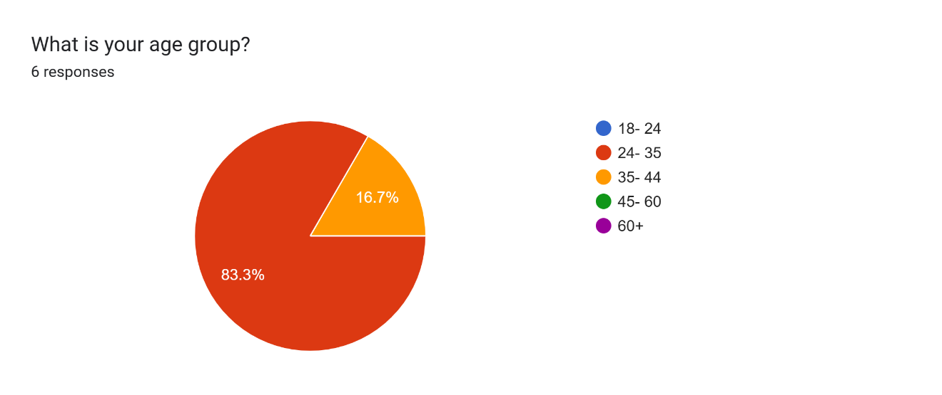
Millennials are widely recognised as digital natives who move fluently between mobile, web and social channels and favour visually rich storytelling (Barrios, 2015; Byrd, 2021). Social platforms are their preferred customer-service channel—82 % of millennials report interacting with brands on social media (USC, 2023) making transparency and responsiveness non-negotiable. This demographic insight directly informed the tone, the style, and user experience of the MOV Films services.
Cropink (2025), highlights that traditional platforms are losing ground to short-form video and influencer-driven content. As a generation accustomed to rapid, impactful media experiences, millennials respond better to concise, emotionally charged storytelling. Reflecting this, our wedding films are intentionally crafted in a cinematic highlight format—designed to deliver maximum emotional resonance in a condensed form, rather than presenting hours of unedited footage. This approach not only respects the viewing preferences of our core audience but also enhances shareability across social media platforms where brief, high-quality content thrives.
Factors that influence hiring decisions were addressed in Question 2 where respondents were asked to select their top three priorities when choosing a videographer. Portfolio/style was selected by all the respondents, followed by price with 83.3% and recommendations/reviews with 50%.
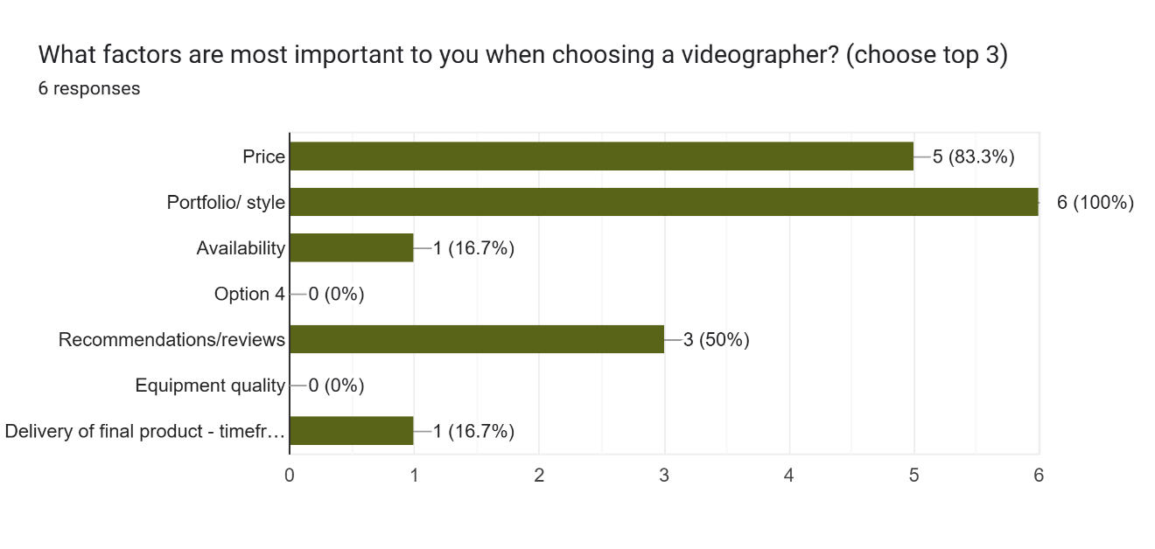
These insights highlight the need for a value-driven offer, particularly for millennial audiences who prioritise authenticity, emotional resonance, and brand purpose. As Byrd (2021) notes, storytelling in digital media is a powerful pedagogical and emotional tool, capable of shaping perception and engagement when crafted with intention and relevance. Visual content succeeds not merely through aesthetic appeal but through its ability to create emotional connection and co-participation. Reflecting this, MOV Films’ website prominently features its cinematic portfolio on the homepage to immediately showcase artistic quality and storytelling impact, building trust and engagement from the first interaction (see Fig. 1).
When it comes to budget, a strong 66.7% of respondents indicated willingness to pay over £1,000, while 22.2% selected £500–£1,000, and 11.1% were open to £1,500+. This contrasts with UK industry averages of £1,300–£1,500 for videography, suggesting that many couples are actively seeking high-quality services below typical market rates—likely influenced by wider economic pressures (Hitched, 2024).
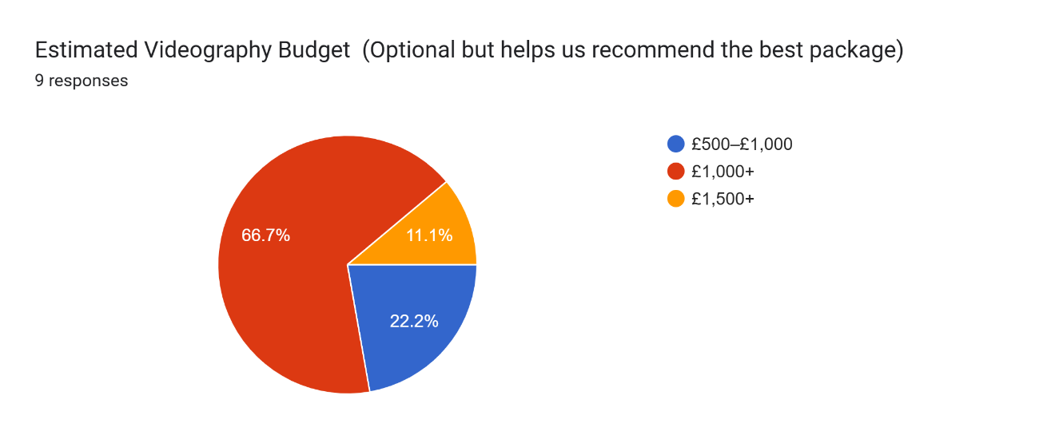
MOV Films responds to this demand by offering a three-tier pricing structure presented through three different packages: ‘Dancing into Forever’, ‘How it all started’ and ‘Love Fiesta’ (see Fig. 2) that will offer our customers the same value but under different timeframes. We structured our packages so we could give our customers the same service while they decide if they wish these for a shorter or a longer period of time.
Our prices depend mainly on the amount of time our services are booked for, not reducing the amount of services or quality. For example, all packages have 2 videographers for the entire event and also drone footage included (see Fig. 2).
Digital marketing has become a fundamental aspect of modern business strategy, enabling companies to reach and engage audiences effectively in the digital era (Zhang and Cabage, 2017). Marketing efforts were further refined based on insights from Question 5 that focused to find out how customers find us.
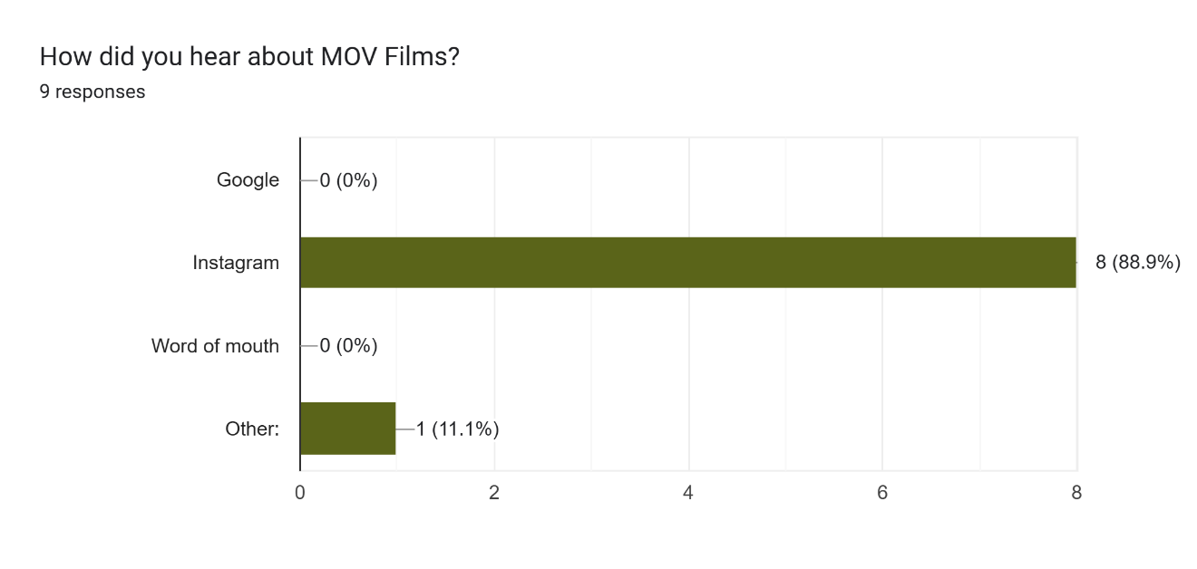
A striking 88.9% of respondents said Instagram, while 0% came from Google or word of mouth. This finding established Instagram as MOV Films’ most effective marketing tool and directed our focus towards the platform. We have started to build a community and in the last 90 days, our page has improved reaching 324.4% more users than we previously did (see Fig. 4). This was purely organic reach that refers to the number of unique users who see content without paid promotion, often through their own feeds or shared content (Hootsuite, 2024).
MOV Films uses visually compelling, short-form videos to maximise organic reach and ensure our content resonates with users without relying heavily on paid advertising. Our Canva marketing materials reflect this platform as being our way of being reached by customers as an alternative to the classic way - the official website.
However, the absence of Google-driven discovery highlights the need to improve SEO. A meta-analysis by Usmany et al. (2024) explains that in digital marketing, SEO plays a crucial role as the core driver in increasing the online visibility of a business. For MOV Films, we used a short and clear SEO: “WEDDING VIDEOGRAPHY – cinematic, documentary-style wedding films” (see Fig. 3).

Conclusion
The four questions analysed provided important insights into audience demographics, values and behaviours, which shaped every aspect of MOV Films’ launch—from website structure to pricing and marketing. By applying academic and professional knowledge to real-world data, MOV Films has built a brand that is audience-focused, competitively positioned, and digitally visible. This research-led approach has not only enhanced business decisions but also improved the chances of success in a highly competitive, emotionally driven industry.

The Importance of Excel in the Digital Era and Its Relevance to Small Business Management

In the digital age, the ability to handle and analyse data efficiently has become an essential skill for businesses of all sizes. Despite its age, Microsoft Excel remains one of the most widely used tools in business operations. Excel is widely recognized as the primary tool for financial modelling, valued for its flexibility, accessibility, and ability to manage complex data and calculations efficiently (Fairhurst, 2019).
Excel’s core strength lies in its versatility. As highlighted in the Week 4 slides on Data Analysis, Excel is regularly used for tasks such as budgeting, scheduling, project management, and business reporting. Built-in functions like =SUM, =AVERAGE, and =IF allow even non-technical users to perform complex calculations. In a small business context, this means owners can project monthly income, expenses, and profit/loss over time, helping them to plan with confidence and clarity.
The digital transformation of business has created an environment where data-driven decision-making is paramount. Digital literacy is now indispensable, especially for small business owners managing digital tools without dedicated IT support (Bandura & Méndez Leal, 2022). According to the World Economic Forum, while numeracy and basic literacy are still essential to fundamental learning, digital literacy has emerged as another critical life skill and is now part of the twenty-first-century toolkit (see Fig. 3). Spreadsheet skills are key to understanding and navigating today’s economy. The skills to create financial projections, track performance, and visualise results through Excel not only enhance operational oversight but also enable agile responses to market changes. For small business owners, this competency enables day-to-day control over finances, inventory, and operations—without the need for costly external consultants.

For instance, in my business plan for MOV Films, Excel plays a vital role in managing projected income, tracking expenses, and forecasting profit. The spreadsheet includes three main packages, each with a set price, and forecasts how many of each will be sold each month. Excel then calculates total monthly revenue and subtracts key expenses—such as wages, travel, and marketing—to estimate the net cash flow and closing balance (see Fig. 5). As shown in Fig.6, Excel was used to visualise 12 months of income, expenses, and net cash flow, allowing for clearer analysis of seasonal trends and profitability. This level of financial oversight is essential for small businesses, where even modest miscalculations can significantly impact sustainability and growth.
Research by Lee, Kerler, and Ivancevich (2018), as cited in Sandhu (2020), indicates that Excel is the most frequently used and recommended software in university accounting education. While Excel excels at numerical computations, it’s also widely used for non‑numerical tasks—such as database management, text manipulation, and graphical dashboard creation—thanks to its rich array of functions and data‑visualisation tools (Alexander, Kusleika & Walkenbach, 2018). This highlights Excel’s importance as a foundational digital tool, particularly for developing data analysis and data visualisation skills—both of which are increasingly critical for modern business and accounting professionals.
Moreover, spreadsheet tools such as Microsoft Excel strengthen transparency and accuracy in reporting, thereby underpinning good governance. Practitioners rank Excel as the most frequently used and most critical application for new accounting hires because its cell-based structure makes every calculation visible and auditable (Lee, et. al 2018). Survey evidence from 148 Belgian glass-house SMEs further shows that Excel spreadsheets are the dominant digital accounting tool for day-to-day record-keeping, offering an accessible electronic trail that owners, investors and accountants can readily verify (Taragola, et. al, 2001). In small firms—where managers often juggle multiple roles—this built-in traceability can spell the difference between sustainable growth and costly mis-statements.
As Rogerson (2024) argues, the rise of digital technology risks creating a divide between digital natives and outcasts. Tools like Excel are essential—not just for productivity, but also for inclusion and digital ethics.
Excel has evolved from a simple calculation tool into a powerful business intelligence platform. As noted by Wired (Thompson, 2019), spreadsheet skills are now considered essential for employability, with the Brookings Institution reporting that nearly two-thirds of new jobs since 2010 require mid-to-high level digital skills. This makes Excel not only a vital productivity tool but also a critical component of digital transformation strategies in modern organisations.
In summary, Microsoft Excel remains a foundational tool in the digital business landscape. The program was installed on over 750 million desktops worldwide in 2012 (Nash et. Al, 2012) According to recent data, Microsoft Excel now reaches an estimated 1.1 to 1.5 billion users worldwide as of 2023–2025—far surpassing the 750 million desktop figure mentioned in Don’t Fear the Spreadsheet. (Scottmax, 2025). Its utility spans financial management, data analysis, marketing optimisation, and even ethical data practices. For small businesses like mine, Excel serves not just as a number-crunching tool, but as a digital assistant—offering structure, insight, and strategic control. As we continue to embrace digital tools, mastering Excel is not optional—it is essential. In a world where digital capability often determines existence, small business owners who master Excel gain a competitive edge.

Reference List

- Alexander, M., Kusleika, R. & Walkenbach, J., 2018. Excel 2019 Bible. 1st ed. Hoboken, NJ: Wiley.
- Bandura, R. and Méndez Leal, E. I. (2022) ‘The digital literacy imperative’, Center for Strategic and International Studies (CSIS), 18 July. Available at: https://www.csis.org/analysis/digital-literacy-imperative (Accessed: 7 June 2025).
- Barrios, I. (2015). Nuevas miras hacia los millenials del lujo. Forbes. Available at: https://www.forbes.com.mx/forbes-life/nuevas-miras-hacia-los-millennials-del-lujo (Accessed: 15 June 2025)
- Byrd, L. S. (2018). Advocate, educate and transform: How community media labs are pioneering cutting edge innovation, digital media literacy education and HBCU sustainability. In J. Cubbage (Ed.), Media literacy in higher education environments. IGI Global
- Cropink (2025) 40+ Millennials on Social Media Statistics That Will Shape 2025. Available at: https://cropink.com/millennials-social-media-statistics-2025 (Accessed: 15 June 2025)
- Fairhurst, D.S., 2019. Using Excel for Business and Financial Modelling: A Practical Guide. 3rd ed. Chichester: John Wiley & Sons Ltd.
- Hitched (2022) Wedding Videography Prices: We Asked the Experts. Available at: https://www.hitched.co.uk/wedding-planning/photography/wedding-videography-prices/ (Accessed: 15 June 2025).
- Hootsuite (2024) What Is Organic Reach, and How Can You Improve Yours? Available at: https://blog.hootsuite.com/organic-reach (Accessed: 15 June 2025)
- Kantar (2023) 5 Reasons Why Marketing Research is Important to Your Business. Available at: https://www.kantar.com/inspiration/research-services/why-marketing-research-is-important-pf (Accessed: 15 June 2025).
- Kelly, R. (2023) Market Research: An Important Investment for Long‑Term Viability. Available at: https://www.forbes.com/councils/forbestechcouncil/2023/06/01/market-research-an-important-investment-for-long-term-viability/ (Accessed: 15 June 2025).
- Lee, L., Kerler, W. and Ivancevich, D. (2018) ‘Beyond Excel: Software Tools and the Accounting Curriculum’, AIS Educator Journal, 13(1), pp. 44–61. Available at: https://aiseducators.org/journal/ (Accessed: 10 June 2025).
- Nash, T., Jelen, B., Jones, K. & Urtis, T., 2012. Don’t Fear the Spreadsheet: A Beginner’s Guide to Overcoming Excel’s Frustrations. Chicago, IL: Holy Macro! Books.
- Rogerson, S. (2024) ‘Practical digital ethics’, ITNOW, Winter (65/4), pp. 54–55. Available at: https://www.bcs.org/articles-opinion-and-research/practical-digital-ethics/ (Accessed: 15 June 2025).
- Sandhu, K. (ed.) (2020) Digital transformation and innovative services for business and learning. Hershey, PA: IGI Global. doi: 10.4018/978-1-7998-5175-2.
- Scottmax.com (2025). 17 Excel statistics to know [June 2025 update]. [online] Available at: https://scottmax.com/excel-statistics/ [Accessed 18 Jun. 2025].
- Taragola, N., Van Lierde, D. and Van Huylenbroeck, G. (2001) ‘Adoption of computers, internet and accounting software at the glasshouse holdings of the Belgian farm accountancy data network’, in Proceedings of the 3rd EFITA Conference, Montpellier, 18–20 June, pp. 669–674. Available at: https://www.researchgate.net/publication/237667604 (Accessed: 10 June 2025).
- Thompson, C. (2019) ‘Worried about robots taking your job? Learn spreadsheets’, Wired, 4 March. Available at: https://www.wired.com/story/worried-about-robots-taking-your-job-learn-spreadsheets/ (Accessed: 15 June 2025).
- University of Southern California (2023) Psychology of Successfully Marketing to Millennials. USC MAPP Online, 17 November. Available at: https://appliedpsychologydegree.usc.edu/blog/psychology-of-successfully-marketing-to-millennials (Accessed: 15 June 2025).
- Usmany, P., Rachmawati, R., Rembe, E. and Sopacua, F. (2024) ‘The effectiveness of search engine optimization (SEO) in marketing: a meta‑analysis study’, Journal of Economic, Business and Accounting, 7(5), pp. 807–811. Available at: https://www.researchgate.net/publication/382953524_The_Effectiveness_Of_Search_Engine_Optimization_SEO_In_Marketing_A_Meta-Anlysis_Study (Accessed: 15 June 2025)
- World Economic Forum (2015) New vision for education: Unlocking the potential of technology. Geneva: World Economic Forum. Available at: https://www3.weforum.org/docs/WEFUSA_NewVisionforEducation_Report2015.pdf (Accessed: 7 June
- Zhang, S., & Cabage, N. (2017). Search Engine Optimization: Comparison of Link Building and Social Sharing. Journal of Computer Information Systems, 57(2), 148–159. https://doi.org/10.1080/08874417.2016.1183447 (Accessed: 15 June 2025)

Fig. 1: MOV Films Homepage

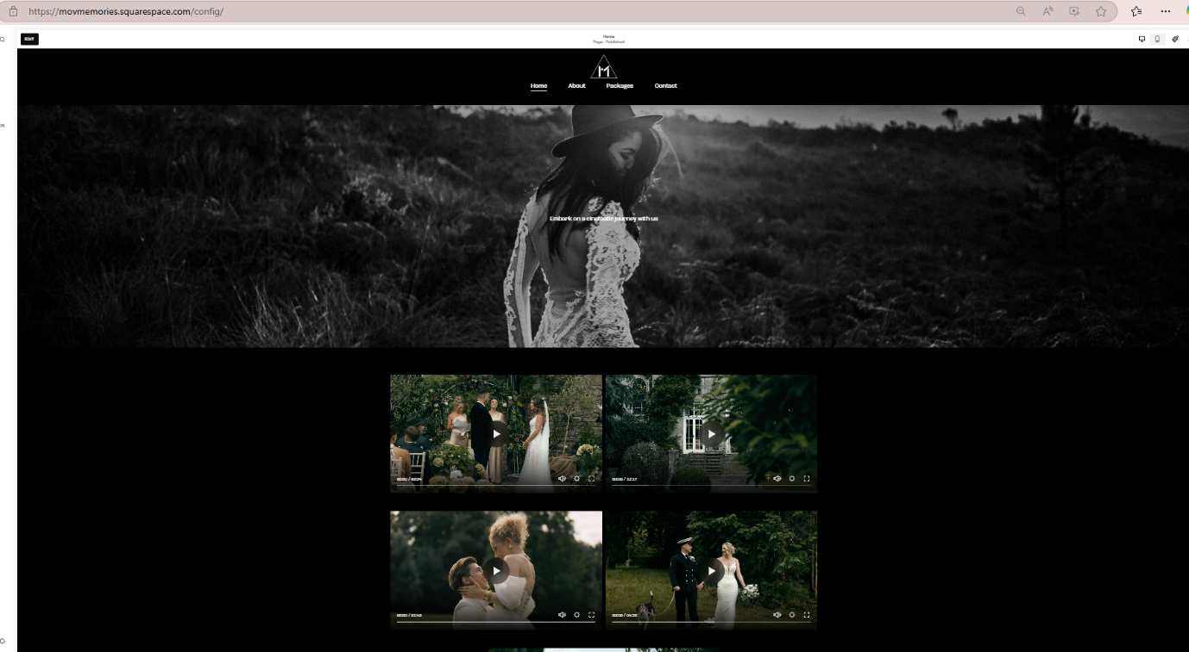

Fig. 2: MOV Films Services Page

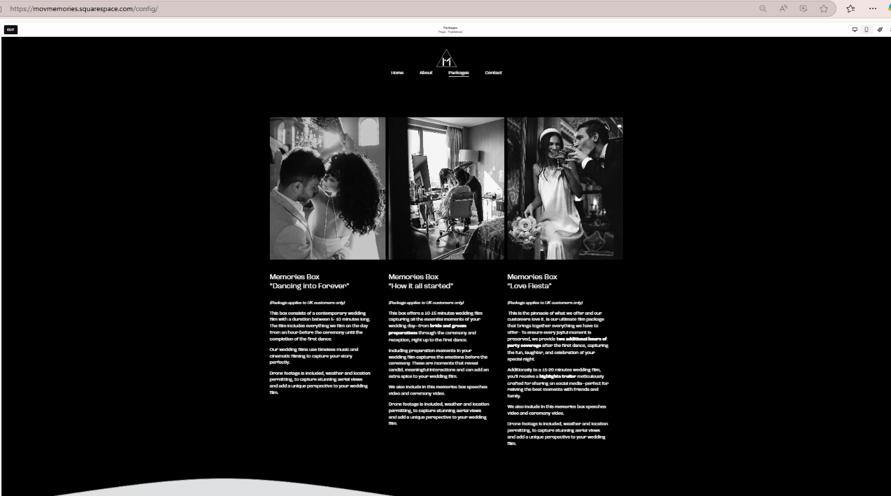

Fig. 3: MOV Films SEO Site description

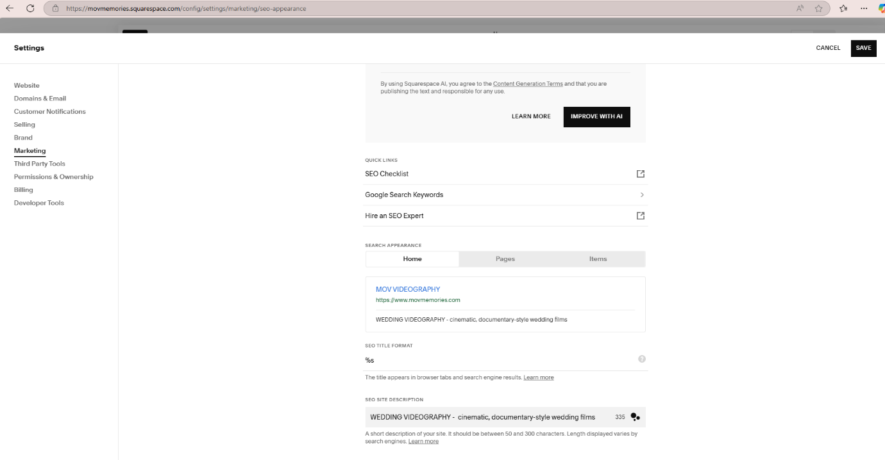

Fig. 4: Instagram Promotion

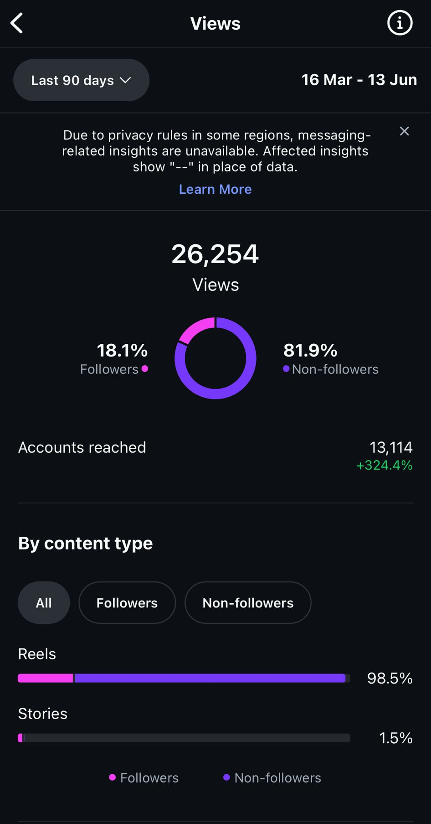

Fig. 5: Cashflow Forecast

Fig. 6: Chart

Fig. 7: 21st Century Skills


