Provide a critical case study on the dynamics of Muslim interfaith OR intra-faith activity in an area of your choice

Case Study on the Dynamics of Muslim Interfaith and Intercultural Exchanges and Development in Taiwan during the Latest Sixty to Seventy Years

Abstract
Taiwanese Muslims consist of two major migratory systems. The first system is the Muslim groups that migrated from the mainland China to Taiwan and their descendants. They came to Taiwan during different periods. The first period of migration was in mid-seventeen century, the second period of migration in 1949 and the 1950s, and the third period of migration in the 1980s. These Muslims have a cultural dynamic that mixes Islamic tradition with the Chinese traditions of Confucianism, Buddhism and Taoism. They are the Sinicized Chinese Muslims or are called Hui Muslims.

The second system comprise the Muslims from the Middle East, South Asia, Southeast Asia, and Africa. They came for short-term stays or long-term settlement or permanent residence and have settled down through marriage, work or business since the 1990s. These two systems form the multicultural and multi-ethnic Islamic community in Taiwan.

So far, Taiwan’s permanent Muslim residents, including some local Taiwanese who convert to Islam, have reached more than 60,000 people (Bao 2014, Islam and Muslims in Taiwan). This accounts for around 0.2 percent of the Taiwan's total population of 23.5 million. Most of them are Sunni Muslims and only few from Iran are Shiite Muslims. But there are also more than 200,000 foreign Muslim workers with temporary residence status. They come to Taiwan in waves, one after another, and they have also become part of the Muslim community in Taiwan.

Hence, the structure of the Muslim community in Taiwan has gradually changed from majority of Hui Muslim to a multi-symbiosis Muslim group with various backgrounds. The Islamic belief has united various Muslims from different ethnic groups and established a common identity. The essay plans to discuss the change, development and intercultural and interfaith exchange of the Islamic community in Taiwan during the latest 60-70 years in historical and anthropological perspectives.

Introduction
There are twenty two major religious categories in Taiwan according to statistics of the Ministry of the Interior (MOI) of the Republic of China (ROC Taiwan) in 2017, including Buddhism, Taoism, Judaism, Islam and Christianity (comprising Catholic, Orthodox and other Christian denominations).

According to the ‘List of Important Statistics of the Republic of China’ in 2019, the ROC government estimates that Taiwan's total population is about 23.58 million with a land area of 36,000 square kilometers. A comprehensive survey conducted by the Religious Affairs Section of the Ministry of the Interior (MOI) in 2005 showed that about 35% of the population in Taiwan recognized themselves as Buddhists, around 33 percent considered themselves Daoists (Taoists), 2.6 percent claimed themselves as Protestants, 1.3 percent Roman Catholics and 0.2 percent Sunni Muslims (AIT 2006, Section I. Religious Demography). Approximate 70 percent of indigenous population (co. 500,000 people) in Taiwan is Christian (AIT 2006). Although the Ministry of the Interior has not followed up on the religious population since then, the MOI has indicated that for the most part, this statistic data has remained unchanged. The majority of people in Taiwan are either Buddhists or Taoists or adherents of folk belief system. Most Taiwanese residents hold diffusive beliefs, a complex belief landscape that combines the ideas on the universe of yin and yang, the worship of ancestry and the philosophy of Confucianism, Buddhism, and Daoism. Muslims in Taiwan are a minority of total population.

A brief introduction of the origin of the first system starts from here. Those who believe in Islam are called Muslims, and in China they are called Hui Muslims. ‘Hui’ refers to the Hui ethnic group who are descendants of Huihe or Huihu people of the Tang Dynasty (618-907 CE) (Chao and Chang 2019, p. 7). Most of them are Islamic adherents. According to the 2010 statistics of the People’s Republic of China (PRC), China has over 20 million Muslims. Hui Muslims account for nearly 50 percent of total Muslim population becoming the largest Muslim group in China. Islam has a history of about 1,400 years in China, and it was transmitted to China in the 7th century (618 CE in Tang Dynasty). The earliest Muslims who came to China were mainly Arab and Persian traders who engaged in business and trade. During the Tang, Song (960-1279 CE) and Yuan (1271-1368 CE) Dynasties, the Muslims still retained their original culture and living habits, and the influence of localization was not deep. Until the Ming Dynasty (1368-1644 CE), under the compulsory policy of Emperor Taizu, Zhu Yuanzhang (1328-1398 CE), Muslims started to have Chinese surnames, speak Chinese, wear Chinese costumes (Hanfu) and marry Han Chinese. They then integrated into Han Chinese society and were given the names of Hui Jiaotu in Chinese—Hui Muslims—Chinese Muslims.

The development of Islam in Taiwan dates back to the late Ming and early Qing (1636-1911 CE) dynasties. In 1661, Zheng Cheng-kung’s (1624-1662 CE) army crossed the sea to Taiwan and drove away the Dutch forces. He took Taiwan as the base for the aspiration of returning to the Mainland of China to restore the Ming Dynasty. At that time, some Muslim soldiers from Fujian Province of China followed the army of Zheng Cheng-kung (also known as Koxinga in Dutch) moved to Taiwan. These soldiers brought with their families settled in Taiwan becoming the earliest Muslims in Taiwan. In 1683, Shi Lang (1621-1696 CE) of Qing Dynasty seized Taiwan, and some Muslims came with the army to settle in the western areas of Taiwan. These are the first wave of Muslim migration to Taiwan.

Most of these Muslim descendants were scattered in the towns on the western coast of Taiwan, such as Lukang and Changhua in the midwest coastal area of Taiwan, and Keelung, Suao, and Tamsui in the northwest coastal area of Taiwan. They mainly made their lliving from fishing and were the earliest Muslims in Taiwan. They even built a mosque in Lukang that copied the likeness of the Quanzhou Mosque in Fujian Province of China. However, because of the distance barrier, the Muslims who came to Taiwan gradually failed to keep in touch with the Muslims in China and the Islamic world. There was also a lack of talented people who could promote Islam. Being a minority in Taiwan, they gradually assimilated with the Chinese traditions of the ethnic Hans in Qing dynasty. The mosque in Lukang is now no longer in existence.

In addition, the Japanese colonial occupation of Taiwan from 1895 to 1945 cut off religious and cultural exchanges between Taiwan and Mainland China, and the Iman who presided over religious rituals had difficulty in entering Taiwan. This eventually led to the localization of these local Muslims. They integrated with traditional Chinese culture and religions. The outcome was that their spoken language and living habits were not much different from most Han Chinese’s. Though their descendants still retain some Islamic-style culture such as no worshipping idols, no raising of pigs or consuming of pork on specific days, nor cremation during funeral rites and even placing the Quran in Arabic wrapped in yellow cloth on the ancestral shrines, they are unable to read the Quran or understand the meanings of these traditions.

The revival and development of Islam in Taiwan during the period of the Republic of China

The tradition of having the Imam from the Mainland China to Taiwan ended around in 1922 but was resumed in 1948. Around 1950s, many Muslims came to Taiwan.

The second wave of Muslim migration started in 1949. More than 20,000 Muslims with their families followed the Nationalist Government of ROC led by Chiang Kai-shek 蔣介石(1887-1975 CE) to move to Taiwan. Their head leaders were distinguished Muslims, General Bai Chongxi白崇禧(1893-1966 CE) and Ma Bufang馬步芳 (1903-1975 CE). Most of them were soldiers, civil servants and teachers. They were from Islamic populated provinces in the northwestern and southern areas of China, such as Gansu, Ningxia, Xinjiang and Yunnan. Most of the migrants settled around Taipei and Kaohsiung of Taiwan. They built the Taipei Grand Mosque in 1947 and other mosques such as Kaohsiung Mosque in 1949, Taipei Cultural Mosque in 1950, and Taichung Mosque in 1951.

From 1953 to1960, Yunnan-based Chinese Muslims accompanying with two withdrawals of troops including soldiers and their families and refugees about 11,000 people migrated from Myanmar and Thailand to Taiwan (Yu 2019, p. 12). They mainly settled in Zhongli (Chungli) District of Taoyuan where they established the Long Gang Mosque in 1964 (Yu 2019, p. 411), and other towns.

There was another wave of movement in the 1980s. A group of Yunnan-originated overseas Chinese Muslims who lived in Myanmar and Thailand migrated to Taiwan because of the blossoming of Taiwan’s economy and the poor living conditions of Chinese diaspora in Myanmar and Thailand. They came to Taiwan for further studies or to be near their relatives or to search for better opportunities (Yu 2019, p. 410). They settled mainly in Myanmar Street at the Zhonghe District of New Taipei City, the Chungli District of Taoyuan and other towns. Meanwhile, in 1983, Kaohsiung Muslims planned to build Tainan Mosque to serve Muslims in Tainan area. After ten years of fundraising, the construction of the Tainan Mosque began in 1993 (Hsu 2019, pp. 226-227).

Before 1990, the majority of Muslims in Taiwan were Chinese Muslims that belonged to the first migratory system. These Muslim residents settled mainly in Taipei, Taoyuan, Taichung and Kaohsiung. According to statistics of MOI in 1991, there were about 52,000 Chinese Muslims in Taiwan (Lin 2014, p.18). After 1990, the Taiwan Muslim community embraced the second migratory system, which brought the fourth wave of Islamic migration.

The fourth wave of migration comprised the foreign Muslims who came to Taiwan mainly from five areas including the Central Asia, South Asia (Pakistan, India, Bangladesh, Sri Lanka and Myanmar), Southeast Asia (Indonesia, Malaysia, Philippines and Brunei), the Middle East (Arab countries, Turkey, and Iran), and Africa. After the ROC Government lifted restrictions in 1987, Taiwan has been becoming a multicultural and multi-faith welcoming country that attracts people from different corners of the world to come to Taiwan for study, work, run business, or to get married. It also attracts more migrant workers to answer the shortage of manpower.

According to statistic data of the MOI of the ROC in 2017-2018, the population of foreign Muslims in Taiwan is approximately between 280,000 and 330,000 (Bao 2019, p. 469). Muslims from the Southeast Asian region comprise of over 99 percent of the population of foreign Muslims in Taiwan. Among them, Indonesian Muslims are the large majority. There are about 270,000 migrant workers from Indonesia who engage in construction, fishery, housekeeping, and caregiving for the elderly and other patients. There are over 170,000 female Indonesian workers engaging in family caregiving (Bao 2019, p. 476). According to the statistics of the Ministry of Education of the ROC, there are over 6,000 Indonesia students who study in Taiwan for postgraduate degrees (Bao 2019, p. 470). Most of these students are Muslims and have received scholarships from the ROC Government and the local corporates. There are approximately 250 Turkish Muslims (Bao 2019, p. 471) and 300 Pakistan Muslims (Bao 2019, p. 474). The following is the table for the composition for the population of the foreign Muslims in Taiwan. This table does not include the migration from China:

Table 1: Composition and Statistical Estimation of Foreign Muslims’ Population in Taiwan在台灣的外國穆斯林人口組成與統計估算 (Bao 2019, p. 469)
Areas | Population (at least) | Percentage
Southeast Asia | 280,000 | 99.61%
The Middle East | 550 | 0.20%
South Asia | 300 | 0.11%
Africa | 200 | 0.07%
Central Asia | 50 | 0.02%
Total | 281,100 | 100%

More foreign Muslims to come, the six established mosques are not able to afford the need. Two more mosques were built. They are the At-Taqwa Mosque in Dayuan District of Taoyuan City and the An-Nur Tongkang Mosque in Pingtung. These two newly built mosques provide services mainly for Indonesian Muslims. Both have Indonesian names, namely Masjid At-Taqwa and Masjid An-Nur Tongkang, and these are displayed prominently at the entrances.

Figure 1 Photos taken from https://en.wikipedia.org/wiki/List_of_mosques_in_Taiwan

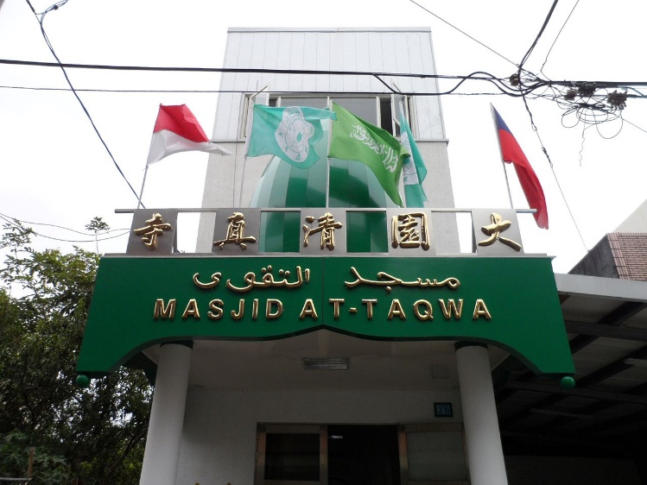 | 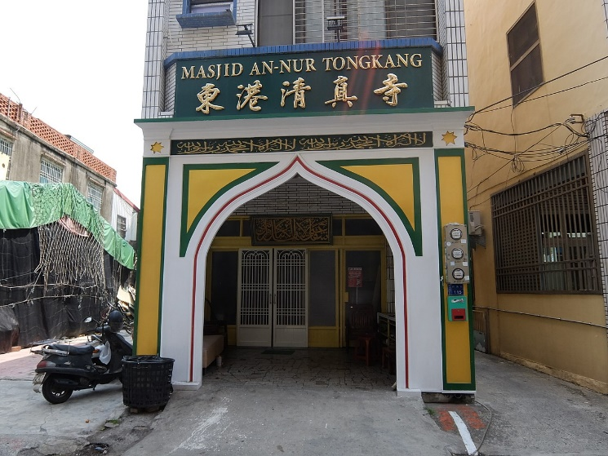
At-Taqwa Mosque | An-Nur Tongkang Mosque
Figure 2

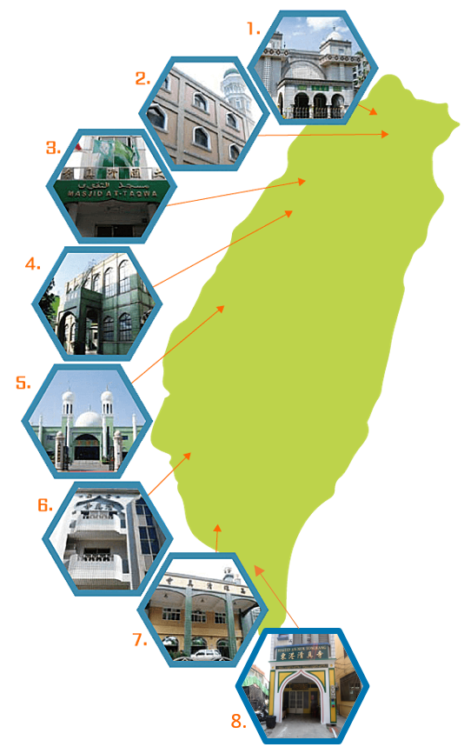
‘Mosques in Taiwan’ in the Taiwan Halal Center at
https://thpc.taiwantrade.com/Taiwan_mosque

An-Nur Tongkang Mosque
Kaohsiung Mosque
Tainan Mosque
Taichung Mosque
Taipei Grand Mosque
At-Taqwa Mosque
Long Gang Mosque
Taipei Cultural Mosque

The other six mosques display their names mainly in Chinese. This change in signage shows a historical watershed that Taiwan Muslim community has transmitted from a Chinese Muslim community to a multi-ethnic Muslim community.

Take the Taipei Grand Mosque, for example. In 1987, the religious gathering were mostly Chinese Muslims with only few foreign Muslims. But after 20 years, local Muslims are less than 10 percent of the congregation and most attendees are foreign Muslims (Su 2002, p. 131). Chinese Muslims inherit the Islamic tradition and combine them with the elements of Chinese culture. They apply the teachings of Confucianism, Buddhism and Daoism to explain ‘The Five Pillars of Islam’. Foreign Muslims practice the ‘Five Pillars’ according to the traditions of their native countries.

There are several Islamic organizations in Taiwan that provide different functions for the pluralistic Muslim community in Taiwan. They are Chinese Muslim Association中國回教協會(CMA,1938), Chinese Muslim Youth League中國回教青年會(1949), Chinese Islamic Cultural and Educational Foundation中國回教文化教育基金會(CICEF, 1976), Keluarga Muslim Indonesia di Taiwan台灣印尼穆斯林之家 (KMIT, 2007), Taiwan Halal Integrity Development Association台灣清真產業品質保證推廣協會 (THIDA, 2011), Islamic Association of Taiwan, IAT (台灣伊斯蘭協會 2016), Taiwan Muslim Association臺灣輔導穆斯林協會(TMA, 2016) and other Islamic organizations (Bao 2019, pp. 488-489).

Interfaith exchange by Intermarriage

Most Pakistani Muslims engage in trade and food catering in Taiwan. They speak the local language and marry local women. Many of them have acquired Taiwan citizenships by marrying Taiwanese women. They are becoming an increasing minority in Taiwan.

Marriage is a quick way to assimilate two different traditions. According to the Statistics of the National Immigration Agency of the MOI of the ROC, from January 1987 to December 2018, the total number of new immigrants through marriage in Taiwan reached 543,807. In the past 30 years, the number of new residents from China (Mainland China, Hong Kong and Macao) constitute the largest percentage (66.1%), followed by Vietnam (19.34%) and Indonesia (5.52%) (EY 2019a).

However, the spouses from Indonesia are not all Muslims. Many of them are Chinese Indonesians. According to Retno Widyastuti’s thesis, there are Indonesian Muslims, mainly female workers, married to Taiwanese residents. Through marriage, they become new residents in Taiwan and most of their Taiwanese spouses convert to Muslims. For example, a Taiwanese Taoist married a female Indonesian Muslim, and later he became a sincere Muslim. There are some Indonesian Muslim workers married to local Iman or local Muslims to become a good Muslim couple. But some female Muslim workers after marrying to local Taiwanese residents convert to Chinese traditional religions and follow their husband’s family traditions. The interfaith and intercultural exchange in Muslim-Chinese intermarriages is a pull between Islamization and Sinicization. Hence, the number of Muslim couples between Indonesians and Taiwanese is not as many as the intermarriage between Pakistanis and Taiwanese (Retno 2015, pp.61-62). There are also intermarriages between Moroccan Muslims and Taiwanese, Turkishs and Taiwanese, and Indians and Taiwanese. Such intermarriages number only a few.

Interfaith activities

The Chinese Muslim Association (CMA), located at the Taipei Grand Mosque, plays an important role in participating the interfaith activities. The CMA assisted the ROC
Government in receiving very important guests at the Taipei Grand Mosque over the years. They have included such people as Mohammad Reza Shah Pahlavi (1919-1980 CE), the last Shah of Iran, Adnan Menderes(1899-1961 CE),Turkish Prime Minister, King Hussein of Jordan(1935–1999 CE) and King Faisal of Saudi Arabia (1906 - 1975 CE). They contributed greatly to the ROC Government in facilitating diplomatic connections and cultural exchanges with Islamic countries. Many young Muslims were encouraged to study at World’s famous Islamic Universities such as Al-Azhar University, Islamic University in Madinah and Muhammad Ali Sanousi Islamic University to learn Arabic and Islamic laws and teachings during 1960s to 1970s. The main goal was to carry on Islamic education and to train the Islamic religious teachers.

The CMA issued the journal Islam in China, which is the main publication by the Hui Muslims in Taiwan, to introduce Islam. It was first published in 1952. It is now a bi-monthly magazine. The CMA is also one of the major members of the Taiwan Conference on Religion and Peace (TCPR) to participate in interfaith activities. In 2001, the CMA hosted the "Religious Interview" at the Taipei Grand Mosque. More than 50 religious groups, including Catholicism, Protestantism, Buddhism, Taoism, Tien Ti Chiao, I-Kuan Tao, Tien Te Chiao have participated in the promotion of religious exchanges and cooperation.
Iman Ma Hsiao-chi of the mosque introduced basic Islamic teachings to people of other faiths through the activities organized by the TCPR. In the same year the CMA co-organized with the World Assembly of Muslim Youth to hold the Summer Muslim Youth Camp for young Muslims to interact with one another and to learn more about Islam.

The CMA hold lectures on Islamic culture, symposiums, etc., so that Muslims can more correctly understand Islamic teachings; open mosques to let more people understand Islamic culture; run classes to let a new generation of Muslims believe in Islam through learning and comprehension; hold various festivals, such as the Taipei Grand Mosque to celebrate Eid al-Fitr festival for marking the end of the fast of Ramadan in 2001 that attracting thousands of Muslims; and actively participate in international Muslim conferences.

In 2014 National Taiwan Museum organized an exhibition to display Islamic culture. There are also the Islam Culture Week held in 2013 and the Islamic Cultural Fair in 2017. In recent years the ROC government has promoted the New Southbound Policy that wish to develop a Muslim-friendly tour environment. There are over 300 certified Halal Muslim restaurants all over the Formosa Island (Taiwan).

The Muslim community in Taiwan has been gradually moving from an implicitly of community to a community presenting itself in front of the public.
Taiwan has almost no interreligious conflicts. This is probably because the traditional Chinese faiths emphasize humanistic morals and ethics, and the philosophy of middle way and universal harmony, instead of exclusive theology. People of different religions live in harmony, embrace each other and flourish. However, sometimes a lack of the knowledge of religions may cause unexpected misunderstanding.
Conclusion

In the past 60-70 years, the Muslim community in Taiwan has gradually developed from a one ethnic community to a pluralistic community. The interfaith and intercultural exchanges are still on going. There are eight mosques in Taiwan already and there will be more to be built. The Islamic community in Taiwan continues its development and vitality though they are the minority.

The Muslim community in Taiwan faces the challenges on how to maintain the Islamic teachings, understanding and practice. How to preserve the Islamic traditions and keeping interaction with communities of other faiths so as to maintain a harmonious relationship with people of different faiths will be a task for the Muslim community.

The combination of Islamic tradition and philosophy of traditional Chinese culture of Confucianism, Buddhism and Daoism has brought the rich spirituality to Hui Muslims.

The next combination with a context of a multi-ethnic Muslim community in Taiwan will be even rich and colorful.

The more I study, I see more aspects of Islam in Taiwan. What I presented here only brief introduction. There are far more areas to explore.

Bibliography

‘A Documentary Voice from a Student of Tamkang University: I Am a Muslim But Not a Terrorist淡大生紀錄片發聲：我是穆斯林但不恐怖’ in the China Times News中時電子報 (2016-05-20 11:33), at www.chinatimes.com [accessed on 17 July 2019].

AIT (American Institute in Taiwan), ‘International Religious Freedom Report for 2006: Taiwan Part’,
(Taipei: AIT Taipei Main Office, 2006), at https://www.ait.org.tw/39112-2/ [accessed on 12 July 2019]

AIT (American Institute in Taiwan), ‘Taiwan 2018 International Religious Freedom Report’ (Taipei: AIT Taipei Main Office, 2019), at https://www.ait.org.tw/taiwan-2018-international-religious-freedom-report/ [accessed on 15 July 2019]

Bao Hsiu-ping (Ibrahim)包修平, ‘Chapter 13: New Trends and Influences of Foreign Muslims in Taiwan外國穆斯林在台灣開展的新趨勢及其影響’ in the Inheritance and Continuation of the Main Life: The Development and Outlook of Islam in Taiwan, ed. by Chao Ibrahim and Chang Chung-fu (Taipei: Chengchi University Press, 2019), pp. 467-497.

Bao Hsiu-ping (Ibrahim)包修平, ‘Islam and Muslims in Taiwan’ of the Interfaith Dialogue in the New Age Islam (14 April 2014) at NewAgeIslam.Com.

Bao Hsiu-ping (Ibrahim)包修平, ‘Hidden Muslims: A history of the development and transition of Muslim communities in Taiwan, 1948-2015 隱身的穆斯林：穆斯林在臺灣的發展與變遷簡史 (1949-2015)’ in the Journal of Hui Muslim Minority Studies回族研究, no. 3 (2016), pp. 61-65, at
https://www.academia.edu/29285267/穆斯林在台灣的變遷史_1949-_.pdf [accessed on 6 July 2019].

Chao, Ibrahim趙錫麟, Oral History Series No. 74: The Reminiscences of Dr. Ibrahim Chao天方學涯: 趙錫麟先生訪談錄, interviewed by Chang Chung-fu, taken down by Yu Jia-ming于嘉明 (Taipei: Academia Historica國史館, 2014)

Chao Ibrahim趙錫麟 edit, Inheritance and Continuation of the Main Life: the Development and Outlook of Islam in Taiwan主命的傳承與延續︰回教在台灣的發揚與展望, ed. by Chao Ibrahim趙錫麟and Chang Chung-fu張中復 (Taipei: Chengchi University Press, 2019), pp.1-597.

Chao Ibrahim趙錫麟 and Chang Chung-fu張中復, ‘Introduction: The Basic Connotation of Islam and Its Historical Background and Trajectory for Its Being Brought into China回教的基本內涵及其傳入中國的歷史背景與軌跡’ in the Inheritance and Continuation of the Main Life: The Development and Outlook of Islam in Taiwan, ed. by Chao Ibrahim and Chang Chung-fu (Taipei: Chengchi University Press, 2019), pp. 1-18.

‘Chinese Muslim Demographics中国穆斯林人口统计表’ in the Online Muslim (2017), at http://www.muslimwww.com/html/2017/rumen_0810/32973.html [accessed on 7 July 2019]

EY, ‘List of Important Statistics of the Republic of China中華民國重要統計數據一覽’ in the Important Statistics of the Country Profile of the Country Profile國情簡介, Executive Yuan (EY), Republic of China (Taiwan) (Taipei: Executive Yuan, 2019b) at https://www.ey.gov.tw/state/ [accessed on 17 July 2019]

EY, ‘Ethnic Group族群’ in the Country Profile國情簡介, Executive Yuan (EY), Republic of China (Taiwan) (Taipei: Executive Yuan, 2019a), at https://www.ey.gov.tw/state/99B2E89521FC31E1/2820610c-e97f-4d33-aa1e-e7b15222e45a
[accessed on 16 July 2019]

EY, ‘Religions in Taiwan宗教信仰在台灣’ in the Country Profile國情簡介, Executive Yuan (EY), Republic of China (Taiwan) (Taipei: Executive Yuan, 2019c), at https://www.ey.gov.tw/state/D00B53C98CD4F08F/0fe638e7-c0bf-401e-b9f2-3db11eecd508
[accessed on 16 July 2019]

Gowing, Peter G., ‘Islam in Taiwan’ in the Saudi Aramco World, Volume 21, Number 4, 1970, pp. 22-27.

Guo Teng-yi郭廷以, Interview Records of Mr Bai Chongxi白崇禧先生訪問紀錄 (Taipei: Academia Sinica on Modern History Research中央研究院近代史研究, 1989)

Hsu Li-chen徐立真, ‘Chapter 5: The Construction, Evolution and Contemporary Adaptation of the Mosque清真寺的修建、沿革與當代適應’ in the Inheritance and Continuation of the Main Life: The Development and Outlook of Islam in Taiwan, ed. by Chao Ibrahim and Chang Chung-fu (Taipei: Chengchi University Press, 2019), pp. 191-240
[accessed on 18 July 2019]

Kuo, Wen-ban. ‘An Explorative Study on the Taiwanese Muslim (2012-2013) for Asian Muslim Studies of Waseda University’, Department of Sociology, National Taipei University, 2013. at https://www.waseda.jp/inst/ias/assets/uploads/2016/07/An_Explorative_Study_on_the_Taiwanese_Muslim.pdf [accessed on 6 July 2019]

Lien Ya-tang連雅堂, History of Taiwan臺灣通史 (Taiwan: Taiwan Tongshi Society台灣通史社, 1920)

Lin Chang-kuan林長寬, ‘Taiwan Islamic Studies Review 1949-2005 (台灣伊斯蘭研究綜述1949-2005)’ in the Taiwan Religious Research Yearbook 2004台灣宗教研究年鑑2004 (Taipei: Museum of World Religions Press世界宗教博物館出版社, 2006), pp. 269-301.

Lin Chang-kuan林長寬, ‘A General Survey of the Development of Islam in Taiwan 臺灣伊斯蘭教發展綜述’ in Encyclopedia of Taiwan (Taipei: Ministry of Culture, 2012) at https://web.archive.org/web/20140423135957/http://taiwanpedia.culture.tw/en/content?ID=370&Keyword=islam [accessed on 6 July 2019]

Lin Chang-kuan林長寬, ‘Islam in the Republic of China: A Critical Survey of the History of Han-speaking Muslim Community中華民國伊斯蘭: 當代漢語穆斯林社群發展解析’
in the Across Culture文化越界, ed. by Lee Peiling李珮玲, vol. 1, no. 11 (Taipei: Center For Translation & Cross Culture Studies of the Chengchi University政治大學翻譯與跨文化中心, (03/2014), pp. 113-150.

MOI, ‘2016 Foreign Spouses from Southeast Asian Comprise the Largest Amount of the Naturalized Nationals of the ROC’, Department of Statistics of the Ministry of the Interior, Republic of China (Taiwan) (Taipei: MOI, 2017) at https://www.moi.gov.tw/stat/news_detail.aspx?sn=11929 [accessed on 17 July 2019]

MOI, ‘Statistical Description of Religious Categories in Taiwan臺灣地區宗教類別統計說明’ from the Department of Civil Affairs of the Ministry of the Interior, Republic of China (Taiwan)內政部民政司 (Taipei: MOI, 2018) at https://www.moi.gov.tw/dca/02faith_001.aspx [accessed on 16 July 2019]

MOI, ‘New Residents Create a Multicultural Society新住民打造多元文化社會’, National Immigration Agency, Ministry of the Interior, Republic of China (Taiwan) (Taipei: MOI, 2019a), at https://www.immigration.gov.tw/5385/7344/70395/143257/ [accessed on 18 July 2019]

MOI, ‘The number of foreign spouses and of spouses from Mainland China (including Hong Kong and Macao)_1987-2018外籍配偶與大陸(含港澳)配偶人數’, National Immigration Agency, Ministry of the Interior, Republic of China (Taiwan) (Taipei: MOI, 2019b), at https://www.gender.ey.gov.tw/gecdb/Stat_Statistics_DetailData.aspx?sn=lJvq%2BGDSYHCFfHU73DDedA%3D%3D [accessed on 18 July 2019]

Pelletier, Robert. ‘Becoming Taiwanese Muslims: Ethnic, National, and Religious Identity Transformations’ In a Muslim Minority, Sociology and Anthropology, Faculty of Social Sciences, University of Ottawa, 2014.

Retno Widyastuti孫莉瑋, ‘Social Adaptation of Muslim Ethnic Minorities in Taiwan: Case Study of Indonesian Muslim and Chinese Muslim台灣穆斯林少數民族的社會適應：以印尼穆斯林與中國穆斯林為例’, Master’s thesis, International Master’s Program in Asia-Pacific Studies, Chengchi University (Taipei: Chengchi University Press, 2015), pp. 1-79

Records of Events of the Taiwan Conference on Religion and Peace—TCRP, http://www.tcrp.org.tw/中華民國宗教與和平協進會大事紀.html

Su Yi-wen蘇怡文, ‘The Development and Changes of Islam in Taiwan伊斯蘭教在台灣的發展與變遷’, Master's thesis in the Department of Ethnology, Chengchi University (Taipei, 2002), p. 131.

Tainan Mosque台南清真寺(2011) at http://www.zhishi5.com/shrw/2011/1203/article_6409.html

Ting, Haj Dawood C.H., ‘Islamic Traditions Continue in Taiwan’ in the Taiwan Today (01 January, 1988), at https://taiwantoday.tw/news.php?post=25307&unit=20,29,35,45 [accessed on 6 July 2019]

Tung Fang-yuan董芳苑, The Religions in Taiwan 台灣宗教大觀 (Taipei: Avanguard Publishing House, 2008), pp. 435-441.

‘Visiting the footprint of Islam in Taiwan Day2: Muslims in Long Gangof Taoyuan探訪伊斯蘭在台灣的足跡：桃園龍崗滇緬回民聚落’ ( 28 Aug 2008) https://eressea.pixnet.net/blog/post/21634105-探訪伊斯蘭在台灣的足跡day2：桃園龍崗滇緬
[accessed on 17 July 2019]

YouTube, ‘Opportunities for Learning as Muslim Population of Taiwan Grows’ in the Formosa TV English News (4 June 2018), at https://www.youtube.com/watch?v=vJwadKbvHmk&t=241s [accessed on 7 July 2019]

YouTube, ‘Uncovering the Mystery of Muslims in Taiwan揭開穆斯林在台灣神秘面紗’ in the Sanli News TV (19 August 2018) at https://www.youtube.com/watch?v=KY2H43VXMXs&t=86s

YouTube, Standing in Taiwan: Ali (Pakistan) in the Tzu Chi Da Ai Video (23 January 2016), at https://www.youtube.com/watch?v=F3g35f9m3bE

Yu Chia-ming于嘉明, ‘Ethnic identity of Muslims in Yunnan, Taiwan, and Thailand在台泰緬雲南籍穆斯林的族群認同’, Master's thesis in the Department of Ethnology, Chengchi University (Taipei: Chengchi University, 2008), pp. 1-156.
Yu Chia-ming 于嘉明, ‘Chapter 11: The Characteristics of Development for Thai-Myanmar Muslims who Settle in Taiwan泰緬雲南裔穆斯林來台定居發展的特色’ in the Inheritance and Continuation of the Main Life: The Development and Outlook of Islam in Taiwan, ed. by Chao Ibrahim and Chang Chung-fu (Taipei: Chengchi University Press, 2019), pp. 403-433.

Figure 3
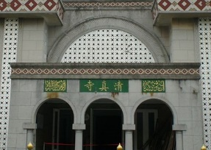 | 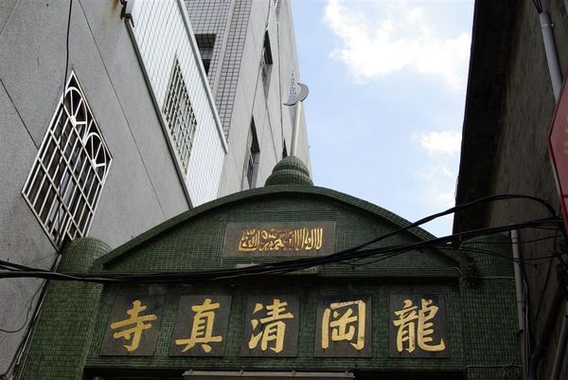
Taipei Grand Mosque | Long Gang Mosque
 | https://eressea.pixnet.net/blog/post/21634105-探訪伊斯蘭在台灣的足跡day2：桃園龍崗滇緬
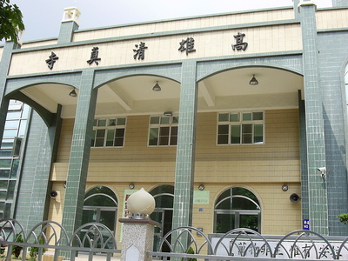 | 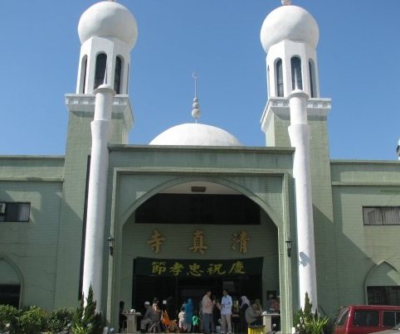
Kaohsiung Mosque | Taichung Mosque
https://en.wikipedia.org/wiki/Islam_in_Taiwan | https://ica-chu.blogspot.com/p/masjid-in-taiwan.html

Figure 4
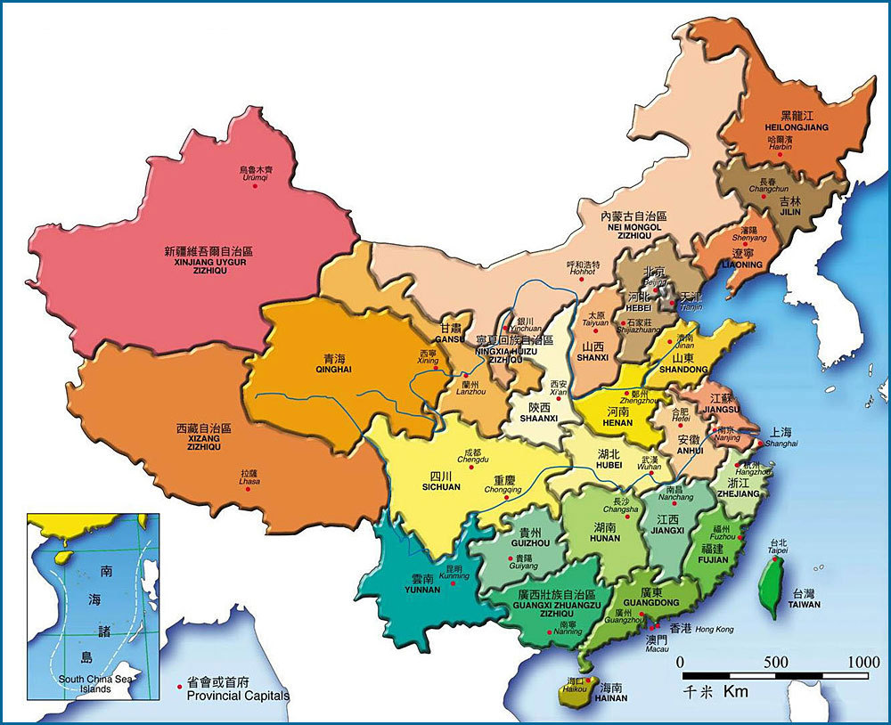
https://zhuanlan.zhihu.com/p/22186929
Mainland China and Taiwan

Name: Hsueh-Ying Hsu
Student No.: 1707645
Module: HPPD 7008

