Introduction
The Cruise Industry is one of the fastest growing sectors in tourism. According to the Cruise Lines International Association (CLIA),17.8 million passengers cruised in 2009 compared to a projected forecast of 30 million passengers expected to travel in 2019 which equates to an annual growth rate of 5.4% (CLIA, 2019).
The growth of this sector can be attributed to destination choice, improved ship designs and the diverse range of amenities, facilities and services now available onboard. Additionally, cruise lines are offering guests cruise themes and voyage lengths to meet the changing needs and holiday patterns of today’s travellers (FCCA, 2018).
The popularity of this holiday type has consequently led to an increase in competition between the cruise line companies and host destinations where traditional business models have been adapted to meet the changing needs of their customers (Aggett, 2011; Perucic, 2007). Each year, new trends emerge in the cruise industry.
Recently, cruise line companies have expanded into destinations such as Antarctica where itineraries have been designed to meet the growing customer demand for bucket list holidays. This essay will analyse whether this expansion into the Antarctic region is environmentally sustainable and identify what safeguard measures are in place to protect this very unique and fragile environment.

An overview of Antarctica
Antarctica is the fifth largest continent and is earths most southernmost point. It is is divided into three major areas: the East, West and the Antarctic Peninsula. (Fig1). The Transantarctic Mountains separates the east from the west and the Peninsula is the main base for most scientific research stations (Hale, 2020). The region is mostly made up of ice in the form of glaciers, ice shelves and icebergs (nasa.gov, 2010). The environment is extremely fragile where the land, waters and marine life are increasingly being impacted by the effects of climate change; the biggest environmental threat to our planet (Christian, 2020).
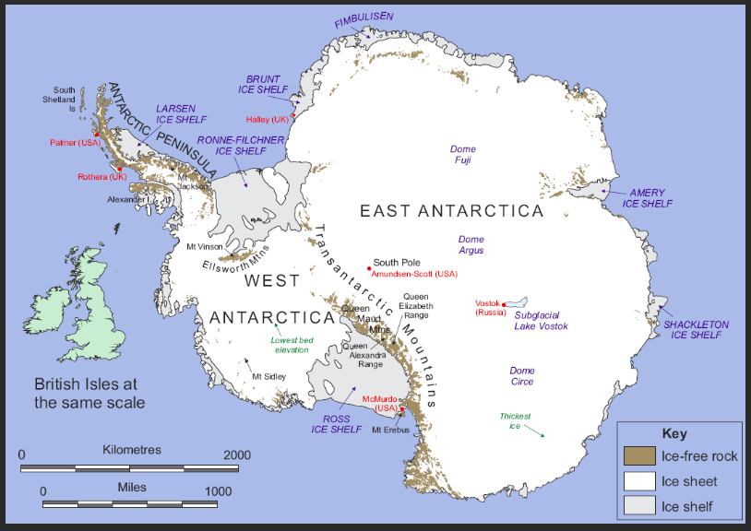
Fig1: Map of the Antarctic Region.
In recent years, tourism in the Antarctic region has skyrocketed as Travellers set their sights on destinations that were previously out of reach. According to the Cruise Line International Association (CLIA), an emerging trend are tourists seeking unique experiences and are looking for offbeat travel destinations. As a result, the number of tourists travelling to the Antarctic region has increased significantly. In the early 1990’s, visitor numbers were relatively small at 6,700 compared to recent years where visitor numbers went from 36,702 during 2014-2015 to 55,489 between 2018-2019. These numbers are expected to rise to more than 78,500 in the current year (IAATO, 2019). These figures are relatively low in comparison to the global tourism industry as a whole. Nevertheless, the visitor numbers are on the increase and have inadvertently brought potential threats and challenges to the Antarctic environment and its wildlife.
Cruise Tourism in Antarctica
In the 1960’s, expedition cruising was the dominant form of tourism and involved smaller ships of less than 200 passengers. However, since the early 2000’s, cruises to the Antarctic region have started to cater to the mainstream market where larger vessels carrying 500 customers have commenced sailing into the region, although in 2007, the Golden Princess became the largest ship to enter Antarctic waters carrying 3700 passengers. It can be seen in (Fig2) that the number of tourists visiting the Antarctic region has grown steadily since 2002 e 55,489 visitors travelled to the region between 2018-2019; 41,996 arrived by cruise ship (IAATO, 2019).
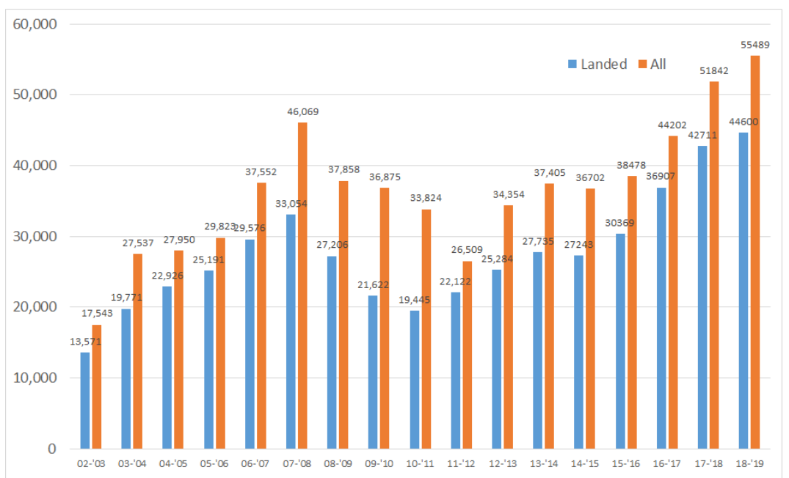
Fig2: Tourist Numbers in Antarctica since 2002 (Source: IAATO, 2019)
These statistics indicate that tourism to the Antarctic region is on the rise and that the majority of tourists are arriving by cruise ship. According to CLIA, these numbers are being driven by demand where recent cruise trends indicate that customers are seeking new experiences to remote places. One of the top 10 cruise trends for 2019 was “Access is the new Luxury” whereby travellers are wanting to be the first amongst their peers to experience destinations that were previously out of reach; some now only accessible by cruise ship. Antarctica was one of these destinations. In order to meet this demand, at least 19 new ships are expected to join the fleet by 2020 (CLIA, 2019). With the increased demand in visitors, especially by cruise ship, it has become necessary to put rules and regulations in place to help safeguard the environment and to protect Antarctica’s fragile ecosystem. The International Association of Antarctic Tour Operators (IAATO) is an organisation that is promoting safe and sustainable tourism practices in the Antarctic region (IAATO, 2019).
The Impacts of Cruise Tourism in Antarctica
Cruise ships have often been criticized for being major emitters of air pollutants such as sulphur dioxide (SO2 ) and nitrogen oxides (NOx). Previous studies estimated that ships contributed 15% of NOx and 4-9% of SO2 towards global emissions (Eyring et al., 2010). Additionally, although accidents are rare they have happened. One such incident was in November 2007, when the MS Explorer carrying approximately 100 passengers and 50 crew, hit submerged ice cracking its hull. Everyone was rescued. But the damage to the environment from 55,000 gallons of spilt oil, lubricant and petrol was detrimental and spread over two square miles. It was also reported that the oil sheen was still visible more than a year later.
Furthermore, cruise ships also generate a number of waste streams such as sewage, grey water, hazardous wastes, oil bilge water, ballast waters and solid waste (CRS report, 2018). Although the International Maritime Organizations polar code has new measures in place to control pollution, ships are still allowed to dump raw sewage into the ocean if they are more than 12 nautical miles (approx. 13 miles) away from the nearest ice shelf.
In response, the cruise industry has accelerated their efforts in being leaders in “responsible tourism” where environmental sustainability is central to their business. The cruise industry has committed over $22 billion in new, energy-efficient ships and technology to minimize their environmental impact and to progress towards their goal of reducing the rate of carbon emissions by 40% by 2030 (CLIA, 2020).
Environmental Concern
Climate change is the biggest environmental threat to our planet and it is well established that human activity contributes to global climate change. The effects that climate change is having on our oceans and marine life can be seen across the globe. In fact, Antarctica has some of the fastest warming areas on the planet and iconic species such as penguins are already experiencing the negative effects. Furthermore, the collapse of the Larsen C ice-shelf -a giant sized iceberg that broke away - is a reminder of the effects of climate change. As a consequence, these changes will affect global sea level rise as well as impact on Antarctic ecosystems and species.
Therefore, it could be argued that cruise tourism to a region that is so fragile is not necessary considering its detrimental impacts on the environment. On the other hand, tourism can help educate and bring awareness to a global problem that affects us all – Climate change. However, the risks and potential negative effects of tourism must be managed accordingly to help safeguard and protect the Antarctic region.
Managing the Impacts of Cruise Tourism in Antarctica
Due to the surge in tourism activity to the Antarctic, it has been necessary to put strict rules and regulations in place to minimise any potential impacts. The economic and environmental sustainability of cruise travel is of high importance to international policymakers, national governments and industry officials and is being closely monitored.
The International Association of Antarctic Operators (IAATO) was primarily set up to promote environmentally safe and responsible travel, improve collaboration among its members and create a “corps of ambassadors” who could advocate conservation of the Antarctic region after they returned home from their trip. The members are made up of tour operators and associates such as travel agents, marketers and other industry workers that don’t run their own tours (IAATO, 2019).
The Antarctic Treaty system (ATS) governs all human activity to Antarctica such as passenger numbers allowed ashore, staff to visitor ratios and the experience level required by crew. Rules that stipulate vessels carrying more than 500 people are not allowed to make landings whereas smaller vessels are allowed to disembark were also developed through the treaty (ATS, 2019)
The International Maritime Organisation (IMO) is a specialised agency responsible for regulating shipping and includes things such as safety, environmental concerns and maritime security. Since the MS Explorer incident, the new “polar code” was introduced and imposed tighter restrictions to avoid a similar situation. The IMO also sets the standard for ship design specifications, for example, fuel tanks must be situated away from the hull especially to the Antarctic (IMO, 2019).
The International Convention for Prevention of Pollution from Ships (MARPOL) controls pollution, in particular fuel pollution from carbon emissions and in 2011, banned the use of heavy fuel oil (MARPOL, 2019). With cruise vessels being one of the major emitters of air pollution, cruise companies are constantly under scrutiny.
The presence of these organisations indicate that tourism is currently well managed. However, further safeguarding regulations and policies may need to be implemented to ensure visits to Antarctica remain environmentally sustainable. The Antarctic Treaty, acknowledge that a new approach will be needed to handle future growth if the numbers continue to grow as they have done in recent years. Stronger regulations such as prohibiting disruptive activities such as heli-skiing and jet skiing, prosecuting visitors for misbehaving, enforcing compulsory membership to IAATO or capping the number of visitors have been under discussion.
Conclusion
With the expansion of cruise tourism into the Antarctic region, the cruise industry already acknowledges the importance of protecting an environment that is unique yet very fragile. The industry is already demonstrating responsible tourism practice by investing in new energy-efficient ships and technologies in an effort to reducing carbon emissions by 40% by 2030. The introduction of these new ships into the fleet indicates that cruise companies understand the seriousness of minimising their impact if cruise tourism is the remain environmentally sustainable; especially in the Antarctic region.
Furthermore, the Antarctic Treaty parties are aware that tourism growth is inevitable and will require careful management and possibly stronger regulations as visitor numbers increase. The majority of these organisations fully support the presence of tourist visitors to the Antarctic because it increases awareness where tourists go home with more knowledge and understanding and will fight for stronger protection laws. At the same time, they recognise the importance of ensuring that all stakeholders such as tour operators, travel guides, staff and travellers all comply with the rules and regulations in an effort to protect and preserve the environment.
Therefore, with strict codes of conduct being enforced by the IAATO in collaboration with the ATS, and the cruise industry prioritising responsible tourism by producing more energy efficient ships, then the expansion of cruise tourism into the Antarctic region could be considered environmentally sustainable. This will ultimately ensure that the region is protected for future generations.

References

