Akram Ahmad Fakhredin (2511138)
Lecturer: Amit NAik

Networks and Cyber Security Essentials
ACCA4024

Abstract
As Automation 4.0, Internet of Things (IoT) devices and cloud-based systems have become more prevalent in manufacturing, it has improved the business so much but created new cybersecurity issues. The report outlines a comprehensive cybersecurity and data governance strategy for SteelForm Manufacturing Ltd to identify cyber risks facing the company from external (malware, phishing attacks, ransomware, unauthorised or unbalanced access), and internal sources (insider threats); and create a strategy for managing the risks and threats from these sources while monitoring any changes. It suggests practical policies for security, technical and administrative mitigations, ongoing network monitoring and a plan for incidents. In addition, it suggests a program to educate employees on security to enhance the practices of compliance and lessen cyber risk. Taken together these recommendations make an organization more resilient, better protect those critical assets and help to ensure secure business operations.
Table of Contents
Abstract 1
1. Introduction 4
2. Company Background 4
3. Threats Identification 4
3.1 Internal Threats 4
3.2 External Threats 5
4. Security Policies 7
4.1 Access Control Policy 7
4.2 Network Security Policy 7
4.3 Data Protection Policy 7
4.4 Acceptable Use Policy 7
4.5 Patch and Vulnerability Management Policy 8
4.6 Security Governance 8
5. Mitigation Measures 9
5.1 Technical Controls 9
5.2 Administrative Controls 9
5.3 Physical Security Controls 9
6. Monitoring and Incident Response 11
6.1 Continuous Network Monitoring 11
6.2 Incident Response Plan 12
7. Staff Training and Awareness 13
7.1 Employee Security Awareness Programme 13
7.2 Compliance and Continuous Improvement 13
8. Conclusion 14
9. References 15

1. Introduction
Industry 4.0 technologies have disrupted the manufacturing industry by combining automation with the Internet of Things (IoT) sensors, cloud computing and smart production systems. It's an age of innovations that helps in stronger operational efficiency, productivity and decision making, but that also brings in many cyber security challenges. Ransomware, phishing scams, malware, insider fraud and industrial espionage are on the rise among manufacturing companies, serving as a tool to potentially halt production, expose sensitive business data and damage the reputation and bottom line. As such, in today's manufacturing environment, cyber security is a strategic consideration (Javaid et al., 2022). This report was prepared with the goal of creating an extensive cybersecurity as well as data governance policy for SteelForm Manufacturing Ltd. It recommends practical cybers Protection Policies, Mitigation, Monitoring, Staff Awareness and Training Programs to enhance protection in the presence of internal and external cyber threats.

2. Company Background
The SteelForm Manufacturing Ltd (SFM) is a medium-sized manufacturing company, which has a specialisation in manufacturing custom-engineered components for the automotive and aerospace industry. The company implements Industry 4.0 technologies into processes to gain operational efficiency and to ensure the quality of the products such as sensors, automated production equipment and cloud-based production management system for the internet of things. These technologies enable the monitoring of processes, prediction of failures or necessary processing time and better production planning in real time. The connectivity of operational technology (OT) and information technology (IT) systems has, however, also placed the organisation at a low risk of being compromised by a cybersecurity attack. Malware attacks, phishing attacks targeting the procurement staff and a breach attempt on the production network are just a few examples of recent incidents that have occurred. The events underscore the importance of introducing a practical cyber security and data governance policy to provide better security for critical business assets, strengthen the security posture and ensure business continuity.

3. Threats Identification

3.1 Internal Threats
The internal threats are threats that are introduced by individuals, processes within individuals or within SteelForm Manufacturing Ltd and can easily impact on the confidentiality, integrity and availability of the systems of SteelForm Manufacturing Ltd. Using weak passwords on a network, even if there are policies to prevent this, makes it easier to access, especially when employees use the same password and are not using a strong authentication (such as long passwords with a mix of numbers, capitals, and symbols). Whether intentional or accidental, inside threats can lead to the stealing of sensitive production data, intellectual property or customer information. Human error is one of the most common sources of security incidents such as clicking on links in malicious emails, handling sensitive information improperly, or not adhering to security protocols. Unauthorised USB devices could add malware to the production network, which might interfere with the automatic machinery and other connected IoT devices. Also, poorly configured systems and overly permissive user permissions can make a system vulnerable to attack yielding potential high level security access. To mitigate these internal threats to cybersecurity, it is crucial to establish robust access restrictions, conduct regular audits of systems, and provide staff training on establishing internal security protocols. Ensuring effective access control measures, periodic security system updates and training staff on cyber security strategies are key to minimising these internal security threats (Gokkaya, Aniello and Halak, 2025).

3.2 External Threats
External threats come from outside the organisation and can also be considered high risks to operational technology (OT) and information technology (IT) of SteelForm Manufacturing Ltd. The end result of a ransomware attack is a lost day at production and financial loss, as production data is held for ransom for as long as it takes before a payment is made. Automated machinery, Internet of Things (IoT) devices and business systems can be adversely affected by a malware attack, decreasing operational efficiency. Phishing attacks are directed at employees via an email designed to attract employees in its attempt to acquire their login details or to peddle malicious software. Supply Chain Attacks exploit vulnerabilities within third party vendors or software providers that can give attackers an unauthorised access to the organisation's systems. One appealing thing is that a lot of IoT devices have been left with insecure configurations, or outdated firmware which can be exploited to get into the production networks. Likewise, without proper access controls and encryption can compromise the security of cloud-based production management systems exposure to data breaches. Business critical operations are the ones that can be affected by Distributed Denial-of-Service (DDoS) attacks, and industrial espionage attacks run the risk of stealing Intellectual Property Rights, engineering designs, and confidential manufacturing processes (Li and Liu, 2021). To reduce the risk of the organisation, there needs to be a proactive security measure, as well as ongoing surveillance, for these threats.
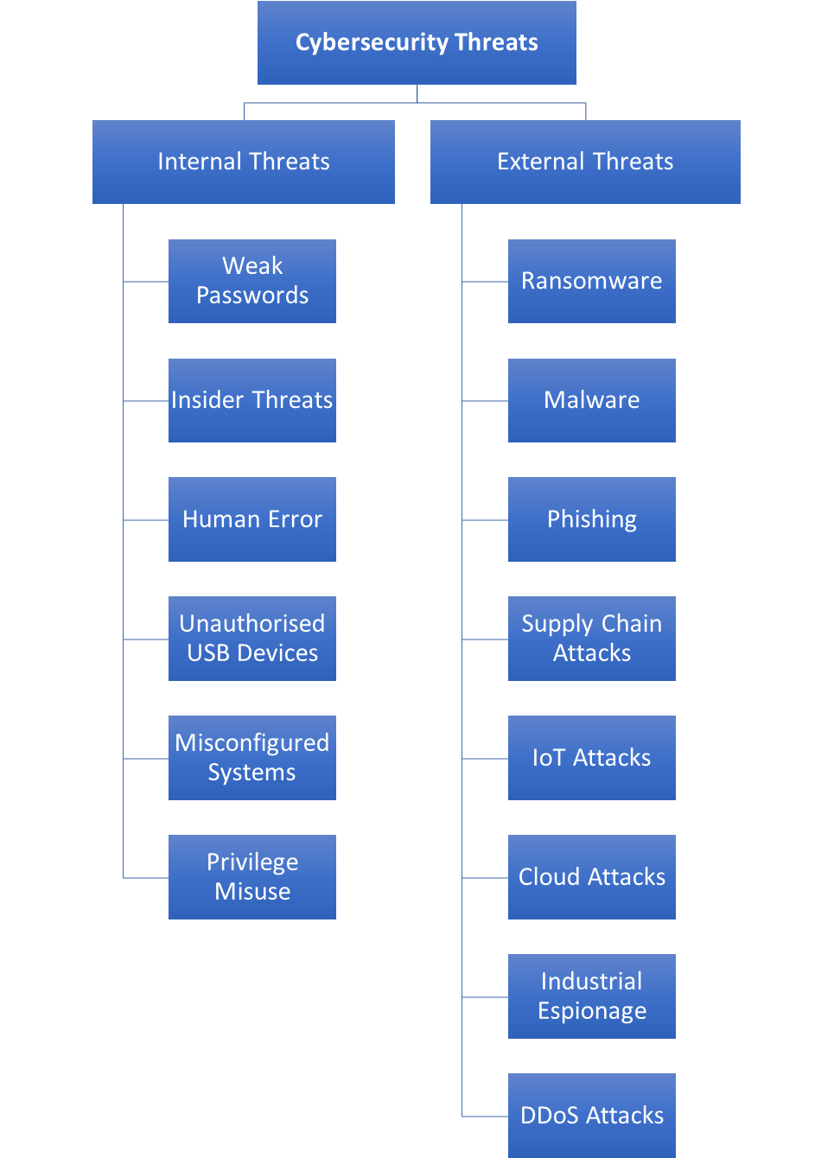
Fig 1: Internal vs External Threats for SteelForm Manufacturing Ltd
Source: Created by Learner

4. Security Policies

4.1 Access Control Policy
It is recommended that SteelForm Manufacturing Ltd have a strong access control policy in place, a policy that conforms to Role Based Access Control (RBAC) allowing only systems and information which are necessary for them to do their jobs, to be accessed by employees (Male, 2025). Implementing Multi-Factor Authentication (MFA) for all user accounts would be a good additional layer of security. In addition, it is recommended that a robust password policy be enacted for the password system which manages well-kept passwords, frequent change of password and limiting the use of identical passwords for multiple logins so as to prevent people from breaking the password (Al-Mutairi and Al-Sahli, 2024).

4.2 Network Security Policy
SteelForm Manufacturing Ltd must reinforce its network security with the installation of firewalls which enable it to block unauthorised traffic and prevent others from being able to penetrate the network. Use Virtual Private Networks (VPNs) to provide for remote access of creditable employees under an encrypted link (Hussain, 2022). Network security is vital and must be monitored and protected at all times with Intrusion Detection and Prevention Systems (IDS/IPS) to prevent and detect suspicious activity on the network (Abbas, Khuder and Abbas, 2023). Also, it is important to ensure that office, production and IoT networks are also kept segregated to reduce the reach of any cyber attacks.

4.3 Data Protection Policy
SteelForm Manufacturing Ltd must have an extensive data protection policy to help cover all aspects of business and production information. To ensure that data cannot be accessed by someone who is not authorised to get in, it's important that data is encrypted both in transit and at rest. Automated backups of data should be kept and securely backed up to provide for recovery in a disaster. Information should be managed by its sensitivity and all data practices being followed must adhere to General Data Protection Regulation (GDPR) ensuring legal and regulatory compliance (Labadie and Legner, 2022).

4.4 Acceptable Use Policy
SteelForm Manufacturing Ltd should create an Acceptable Use Policy to define how its IT resources are used. Any employee's use of the internet or company e-mail should be for authorised business use. A ban on unauthorised USB devices should be implemented and before personal devices are allowed to be attached to company system/ networks they should meet the organisation's security requirements to ensure there are no breaches in security and privacy.

4.5 Patch and Vulnerability Management Policy
SteelForm Manufacturing Ltd should adopt a patch & vulnerability management policy to reduce the security risks. Operating systems, applications, IoT devices, and production systems should be updated and patched regularly to ensure security. As soon as vulnerabilities are discovered they should be averted. Further, it is important to have an inventory of assets up-to-date so that all hardware and software assets are adequately tracked and secured.

4.6 Security Governance
SteelForm Manufacturing Ltd should adhere to the known cybersecurity practices and frameworks and regulations. The ISO 27001 is a structured information security management system and the NIST Cybersecurity Framework includes all elements of the information security lifecycle; identification, protection, detection, response and recovery (Alshar’e, 2023). Confidentiality, integrity and availability are the three fundamental principles of information security, collectively, the CIA Triad. By respecting GDPR, one's personal data is legitimate, protected and processed for purposes of law (Chitadze, 2023).
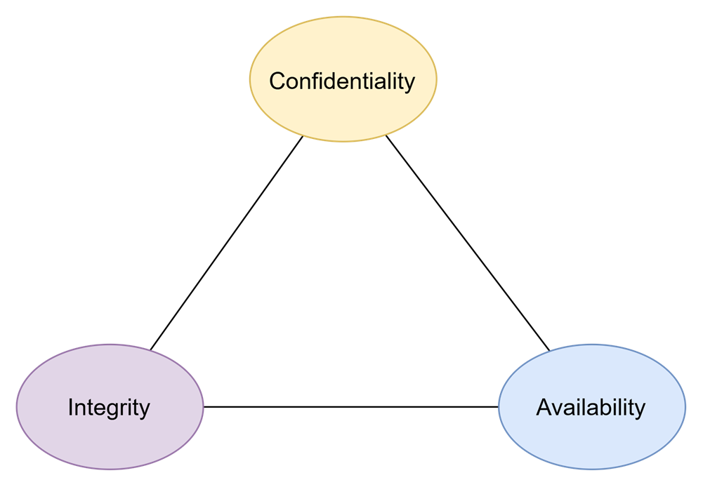
Fig 2: CIA Triad for SteelForm Manufacturing Ltd
Source: Created by Learner
Confidentiality: Ensures that sensitive information is not accessed by unauthorised parties. Integrity: Makes sure that the data is accurate, complete and not changed. Accessibility: Delivers authorised users the access needed to systems and data when necessary.

5. Mitigation Measures

5.1 Technical Controls
SteelForm Manufacturing Ltd needs a number of implements of technical controls to minimize the possible risks of cyber security. The next-generation firewalls, anti-virus and Endpoint Detection & Response (EDR) will need to keep the organisational devices safe from malware, ransomware, attacks and more (Amrez, 2025). Highly sensitive data should be protected by Multi-Factor Authentication (MFA), Data Encryption and Secure Virtual Private Networks (VPNs). The system should be put in place to detect and prevent network activities on a constant basis, called an Intrusion Detection and Prevention Systems (IDS/IPS) (Nwakeze , 2024). A range of software upgrades, updates on security patches and vulnerability analyses is designed to help mitigate possible weaknesses that can be exploited within IT systems, cloud platforms, and IoT production machinery, thus improving the company's cyber security stance in total.

5.2 Administrative Controls
Administrative controls should put in place clear guidelines and stakeholders liability regarding cyber security issues. Security policies should be implemented, staff awareness sessions should be run regularly and methods should be set up to undertake regular risk assessments at SteelForm Manufacturing Ltd. User permissions must have the ‘need to know' principle and need to be updated frequently. Security assessments of third-party supplies should be conducted before access of their systems to systems and resources belonging to organisations. Also, it is necessary to keep record, test and update incident response procedures and business continuity plans to ensure effective responses to a cyber incident.

5.3 Physical Security Controls
Critical infrastructure needs to be protected from unauthorised access, environmental threats etc. by physical security measures. Should be restricted to use access cards, biometric access control devices and cameras to control access to server rooms, production facilities and network equipment. Participants should be properly accepted and supervised when at the facility. Backup systems and critical hardware must be housed in secure areas with temperature and fire control to ensure seamless operations and the prevention of damage to critical equipment or hardware being stolen.
Threat | Mitigation Measure | Expected Benefit
Malware | Antivirus software, EDR, regular patching | Prevents Malware attacks and endpoints protection
Ransomware | Consider offline backups, Multi-Factor Authentication (MFA) and endpoint protection | Reduce the amount of data loss and allows for quicker recovery
Phishing | Filter e-mail and to train employees' awareness | Prevents being scammed by tamperproofing credentials and phishing
Insider Threats | Role Based Access Control (RBAC) and least privilege | Resists the unauthorized access to sensitive information
IoT Attacks | Firmware updates, along with network segmentation | Ensures connected devices are secured and restricts attack spread
Cloud Attacks | Secure data encrypt, MFA and secure cloud configuration | Ensures configuration of data and apps
Table 1: Threats, Mitigation Measures and Expected Benefits for SteelForm Manufacturing Ltd
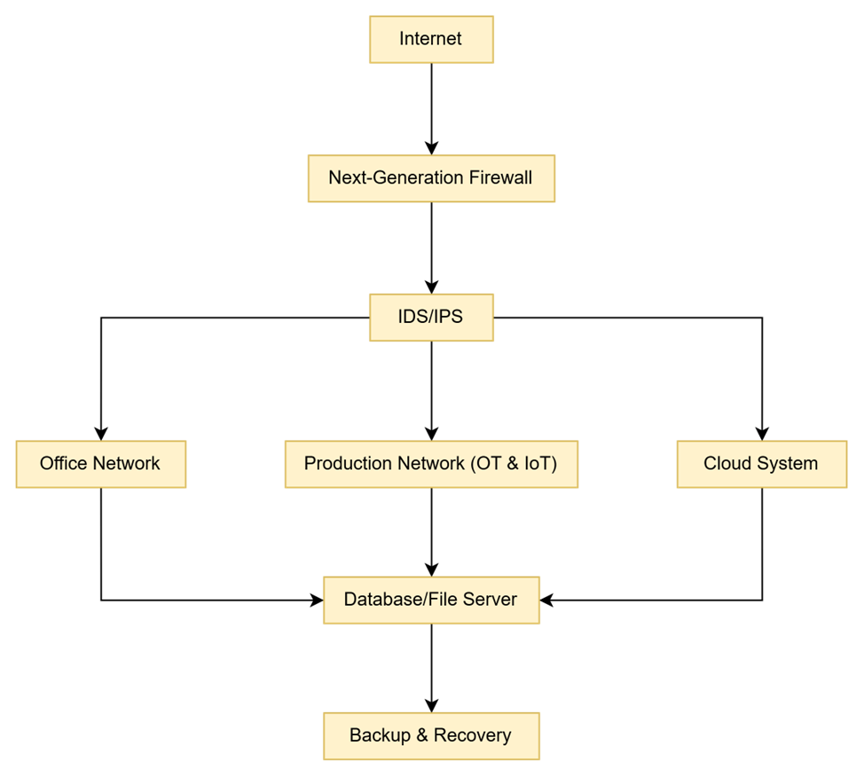
Fig 3: Network Security Architecture for SteelForm Manufacturing Ltd
Source: Created by Learner

6. Monitoring and Incident Response

6.1 Continuous Network Monitoring
It will be necessary for SteelForm Manufacturing Ltd to monitor constantly on their network so that they can prevent and act in advance when facing cyber threats. The security information and event management (SIEM) systems need to collect and log security events on-premise servers, on premises endpoints, IoT devices and cloud platforms (Jhaveri and Parmar, 2023). It is suggested that network activity should be monitored to see if there is any suspicious activity in the network and nonintrusives measures should be implemented like Intrusion Detection and Intrusion Prevention Systems (IDS/IPS), periodic security audit and vulnerability assessment so that they can identify and address new threats before they impact the business.

6.2 Incident Response Plan
If a cybersecurity incident(such as a data breach) occurs there needs to be a plan in place to handle the incident in as systematic a way as possible in order to reduce its impact on the company. It should begin with some of the preparation e.g. roles, responsibilities, security procedures etc. Additionally, any potential threats that could occur should identify and analyse on-going through a mechanical system of monitoring. If Malicious Software (or unauthorised access)has been detected this should be isolated to prevent any further damage, and the Malicious Software or access should be eradicated. From then on it would be important to recover system & data in a secure way with the backups of hard drives and replication, and make sure that they are backed up and verified before they're placed in regular operations. Last but definitely not least, a lesson learned review should first examine and evaluate the incident, weaknesses or gaps identified, and recommend further measures to improve security, which were not implemented then, but are needed in the future.
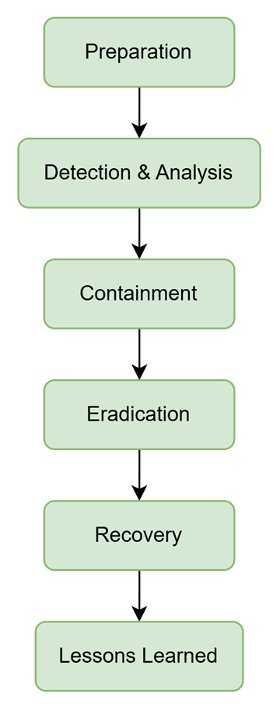
Fig 4: Incident Response Flowchart for SteelForm Manufacturing Ltd
Source: Created by Learner

7. Staff Training and Awareness

7.1 Employee Security Awareness Programme
A detailed security awareness program needs to be carried out to inform employees of the (new) threats SteelForm Manufacturing Ltd face in the cyber world and the security policies of the organisation. Educational training should be delivered on the knowledge of phishing, password management, safe use of the internet and e-mail, IoT responsible handling of data and safe use of IoT enabled systems. Induction training should be provided for new workers and periodic refresher exercises should be carried out for the existing ones, regarding cyber security. Phishing scenarios to practice and practical sessions should be held to enhance employees' abilities to identify and act on cyber threats. There will be regular security awareness campaigns which will help to build a positive security culture within the organisation.

7.2 Compliance and Continuous Improvement
It's prudent for SteelForm Manufacturing Ltd to periodically audit their cybersecurity policies and training to meet compliance requirements, based on the ISO 27001, NIST Cybersecurity Framework and GDPR guidelines and frameworks (Alshar’e, 2023). Give a security awareness quiz, phishing simulation and compliance audit to check the performance of employees. Any of the foregoing information gathered from the security incidents should be used to optimise the training content, organisation security processes (remonstrances and countermeasures) continuous improvement, and a long-term cyber resilient organisation.
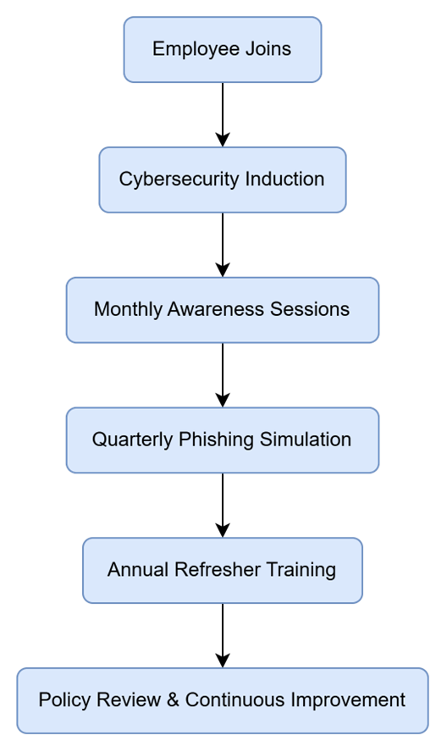
Fig 5: Security awareness Training Timeline for SteelForm Manufacturing Ltd
Source: Created by Learner

8. Conclusion
From internal to external, including malware attacks, phishing, ransomware, attacks against IOT systems and cloud systems, to insider threats, SteelForm Manufacturing Ltd face numerous threats and vulnerabilities. These risks will be mitigated with extensive security policies, using a comprehensive suite of technical, administrative and physical security controls, continually monitoring network infrastructure as well as a heads-up incident response plan. Furthermore, its ability to continually reinforce security skills and to follow known security frameworks will improve the organisation's cyber security approach, strengthen the resilience to their operations, and help facilitate the safe use of the most up-to-date manufacturing technologies.

9. References
Abbas, S., Khuder, A. and Abbas, A. (2023). Subject review: Intrusion detection system (IDS) and intrusion prevention system (IPS). [online] ResearchGate. unknown. Available at: https://www.researchgate.net/publication/368928254_Subject_review_Intrusion_Detection_System_IDS_and_Intrusion_Prevention_System_IPS.
Al-Mutairi, A. and Al-Sahli, R. (2024). Secure authentication system based on multi-factor authentication. ResearchGate. [online] doi:10.13140/RG.2.2.24880.74247.
Alshar’e, M. (2023). Cyber security framework selection: Comparision of NIST and ISO27001. Applied computing Journal, [online] 3(1), pp.245–255. doi:10.52098/acj.202364.
Amrez, Z. (2025). Endpoint security: Threats, defences and best practices. Defences and Best Practices. [online] doi:10.2139/ssrn.5272843.
Chitadze, N. (2023). Basic principles of information and cyber security. [online] www.igi-global.com, IGI Global, pp.193–223. Available at: https://www.igi-global.com/chapter/basic-principles-of-information-and-cyber-security/328110.
Gokkaya, B., Aniello, L. and Halak, B. (2025). Software supply chain: A taxonomy of attacks, mitigations and risk assessment strategies. Journal of Information Security and Applications, [online] 97, p.104324. doi:10.1016/j.jisa.2025.104324.
Hussain, J. (2022). Virtual private networks: Fundamentals, security issues and solutions. [online] Social Science Research Network. Rochester, NY. doi:10.2139/ssrn.4478285.
Javaid, M., Haleem, A., Singh, R.P., Suman, R. and Gonzalez, E.S. (2022). Understanding the adoption of industry 4.0 technologies in improving environmental sustainability. Sustainable Operations and Computers, [online] 3(1), pp.203–217. doi:https://doi.org/10.1016/j.susoc.2022.01.008.
Jhaveri, M. and Parmar, V. (2023). CLOUD security information and event management. GIS-Zeitschrift fü Geoinformatik, [online] 10(3), p.13. Available at: https://www.researchgate.net/publication/369302413_CLOUD_Security_Information_and_Event_Management.
Labadie, C. and Legner, C. (2022). Building data management capabilities to address data protection regulations: Learning from EU-GDPR. Journal of Information Technology, [online] 38(1), pp.16–44. Available at: https://journals.sagepub.com/doi/pdf/10.1177/02683962221141456.
Li, Y. and Liu, Q. (2021). A comprehensive review study of cyber-attacks and cyber security; emerging trends and recent developments. Energy Reports, [online] 7(7), pp.8176–8186. doi:https://doi.org/10.1016/j.egyr.2021.08.126.
Male, V.R. (2025). Decoding role-based access control (RBAC). International Journal of Scientific Research in Computer Science Engineering and Information Technology, [online] 11(1), pp.2082–2090. doi:10.32628/CSEIT251112211.
Nwakeze , O.M. (2024). The Importance of Network Security in Protecting Sensitive Data and Information. International Journal of Research and Innovation in Applied Science, IX(VI), pp.259–270. doi:10.51584/ijrias.2024.906024.

Slide 1

Slide 2

1. Introduction
Industry 4.0 technologies have disrupted the manufacturing industry by combining automation with the Internet of Things (IoT) sensors, cloud computing and smart production systems. It's an age of innovations that helps in stronger operational efficiency, productivity and decision making, but that also brings in many cyber security challenges. Ransomware, phishing scams, malware, insider fraud and industrial espionage are on the rise among manufacturing companies, serving as a tool to potentially halt production, expose sensitive business data and damage the reputation and bottom line. As such, in today's manufacturing environment, cyber security is a strategic consideration (Javaid et al., 2022). This report was prepared with the goal of creating an extensive cybersecurity as well as data governance policy for SteelForm Manufacturing Ltd. It recommends practical cybers Protection Policies, Mitigation, Monitoring, Staff Awareness and Training Programs to enhance protection in the presence of internal and external cyber threats.

Slide 3

2. Company Background
The SteelForm Manufacturing Ltd (SFM) is a medium-sized manufacturing company, which has a specialisation in manufacturing custom-engineered components for the automotive and aerospace industry. The company implements Industry 4.0 technologies into processes to gain operational efficiency and to ensure the quality of the products such as sensors, automated production equipment and cloud-based production management system for the internet of things. These technologies enable the monitoring of processes, prediction of failures or necessary processing time and better production planning in real time. The connectivity of operational technology (OT) and information technology (IT) systems has, however, also placed the organisation at a low risk of being compromised by a cybersecurity attack. Malware attacks, phishing attacks targeting the procurement staff and a breach attempt on the production network are just a few examples of recent incidents that have occurred. The events underscore the importance of introducing a practical cyber security and data governance policy to provide better security for critical business assets, strengthen the security posture and ensure business continuity.

Slide 4

3. Threats Identification
3.1 Internal Threats
The internal threats are threats that are introduced by individuals, processes within individuals or within SteelForm Manufacturing Ltd and can easily impact on the confidentiality, integrity and availability of the systems of SteelForm Manufacturing Ltd. Using weak passwords on a network, even if there are policies to prevent this, makes it easier to access, especially when employees use the same password and are not using a strong authentication (such as long passwords with a mix of numbers, capitals, and symbols). Whether intentional or accidental, inside threats can lead to the stealing of sensitive production data, intellectual property or customer information. Human error is one of the most common sources of security incidents such as clicking on links in malicious emails, handling sensitive information improperly, or not adhering to security protocols. Unauthorised USB devices could add malware to the production network, which might interfere with the automatic machinery and other connected IoT devices. Also, poorly configured systems and overly permissive user permissions can make a system vulnerable to attack yielding potential high level security access. To mitigate these internal threats to cybersecurity, it is crucial to establish robust access restrictions, conduct regular audits of systems, and provide staff training on establishing internal security protocols. Ensuring effective access control measures, periodic security system updates and training staff on cyber security strategies are key to minimising these internal security threats (Gokkaya, Aniello and Halak, 2025).
3.2 External Threats
External threats come from outside the organisation and can also be considered high risks to operational technology (OT) and information technology (IT) of SteelForm Manufacturing Ltd. The end result of a ransomware attack is a lost day at production and financial loss, as production data is held for ransom for as long as it takes before a payment is made. Automated machinery, Internet of Things (IoT) devices and business systems can be adversely affected by a malware attack, decreasing operational efficiency. Phishing attacks are directed at employees via an email designed to attract employees in its attempt to acquire their login details or to peddle malicious software. Supply Chain Attacks exploit vulnerabilities within third party vendors or software providers that can give attackers an unauthorised access to the organisation's systems. One appealing thing is that a lot of IoT devices have been left with insecure configurations, or outdated firmware which can be exploited to get into the production networks. Likewise, without proper access controls and encryption can compromise the security of cloud-based production management systems exposure to data breaches. Business critical operations are the ones that can be affected by Distributed Denial-of-Service (DDoS) attacks, and industrial espionage attacks run the risk of stealing Intellectual Property Rights, engineering designs, and confidential manufacturing processes (Li and Liu, 2021). To reduce the risk of the organisation, there needs to be a proactive security measure, as well as ongoing surveillance, for these threats.

Slide 5

4. Security Policies
4.1 Access Control Policy
It is recommended that SteelForm Manufacturing Ltd have a strong access control policy in place, a policy that conforms to Role Based Access Control (RBAC) allowing only systems and information which are necessary for them to do their jobs, to be accessed by employees (Male, 2025). Implementing Multi-Factor Authentication (MFA) for all user accounts would be a good additional layer of security. In addition, it is recommended that a robust password policy be enacted for the password system which manages well-kept passwords, frequent change of password and limiting the use of identical passwords for multiple logins so as to prevent people from breaking the password (Al-Mutairi and Al-Sahli, 2024).
4.2 Network Security Policy
SteelForm Manufacturing Ltd must reinforce its network security with the installation of firewalls which enable it to block unauthorised traffic and prevent others from being able to penetrate the network. Use Virtual Private Networks (VPNs) to provide for remote access of creditable employees under an encrypted link (Hussain, 2022). Network security is vital and must be monitored and protected at all times with Intrusion Detection and Prevention Systems (IDS/IPS) to prevent and detect suspicious activity on the network (Abbas, Khuder and Abbas, 2023). Also, it is important to ensure that office, production and IoT networks are also kept segregated to reduce the reach of any cyber attacks.
4.3 Data Protection Policy
SteelForm Manufacturing Ltd must have an extensive data protection policy to help cover all aspects of business and production information. To ensure that data cannot be accessed by someone who is not authorised to get in, it's important that data is encrypted both in transit and at rest. Automated backups of data should be kept and securely backed up to provide for recovery in a disaster. Information should be managed by its sensitivity and all data practices being followed must adhere to General Data Protection Regulation (GDPR) ensuring legal and regulatory compliance (Labadie and Legner, 2022).
4.4 Acceptable Use Policy
SteelForm Manufacturing Ltd should create an Acceptable Use Policy to define how its IT resources are used. Any employee's use of the internet or company e-mail should be for authorised business use. A ban on unauthorised USB devices should be implemented and before personal devices are allowed to be attached to company system/ networks they should meet the organisation's security requirements to ensure there are no breaches in security and privacy.
4.5 Patch and Vulnerability Management Policy
SteelForm Manufacturing Ltd should adopt a patch & vulnerability management policy to reduce the security risks. Operating systems, applications, IoT devices, and production systems should be updated and patched regularly to ensure security. As soon as vulnerabilities are discovered they should be averted. Further, it is important to have an inventory of assets up-to-date so that all hardware and software assets are adequately tracked and secured.
4.6 Security Governance
SteelForm Manufacturing Ltd should adhere to the known cybersecurity practices and frameworks and regulations. The ISO 27001 is a structured information security management system and the NIST Cybersecurity Framework includes all elements of the information security lifecycle; identification, protection, detection, response and recovery (Alshar’e, 2023). Confidentiality, integrity and availability are the three fundamental principles of information security, collectively, the CIA Triad. By respecting GDPR, one's personal data is legitimate, protected and processed for purposes of law (Chitadze, 2023).

Slide 6

5. Mitigation Measures
5.1 Technical Controls
SteelForm Manufacturing Ltd needs a number of implements of technical controls to minimize the possible risks of cyber security. The next-generation firewalls, anti-virus and Endpoint Detection & Response (EDR) will need to keep the organisational devices safe from malware, ransomware, attacks and more (Amrez, 2025). Highly sensitive data should be protected by Multi-Factor Authentication (MFA), Data Encryption and Secure Virtual Private Networks (VPNs). The system should be put in place to detect and prevent network activities on a constant basis, called an Intrusion Detection and Prevention Systems (IDS/IPS) (Nwakeze , 2024). A range of software upgrades, updates on security patches and vulnerability analyses is designed to help mitigate possible weaknesses that can be exploited within IT systems, cloud platforms, and IoT production machinery, thus improving the company's cyber security stance in total.
5.2 Administrative Controls
Administrative controls should put in place clear guidelines and stakeholders liability regarding cyber security issues. Security policies should be implemented, staff awareness sessions should be run regularly and methods should be set up to undertake regular risk assessments at SteelForm Manufacturing Ltd. User permissions must have the ‘need to know' principle and need to be updated frequently. Security assessments of third-party supplies should be conducted before access of their systems to systems and resources belonging to organisations. Also, it is necessary to keep record, test and update incident response procedures and business continuity plans to ensure effective responses to a cyber incident.
5.3 Physical Security Controls
Critical infrastructure needs to be protected from unauthorised access, environmental threats etc. by physical security measures. Should be restricted to use access cards, biometric access control devices and cameras to control access to server rooms, production facilities and network equipment. Participants should be properly accepted and supervised when at the facility. Backup systems and critical hardware must be housed in secure areas with temperature and fire control to ensure seamless operations and the prevention of damage to critical equipment or hardware being stolen.

Slide 7

Fig 3: Network Security Architecture for SteelForm Manufacturing Ltd

Slide 8

6. Monitoring and Incident Response
6.1 Continuous Network Monitoring
It will be necessary for SteelForm Manufacturing Ltd to monitor constantly on their network so that they can prevent and act in advance when facing cyber threats. The security information and event management (SIEM) systems need to collect and log security events on-premise servers, on premises endpoints, IoT devices and cloud platforms (Jhaveri and Parmar, 2023). It is suggested that network activity should be monitored to see if there is any suspicious activity in the network and nonintrusives measures should be implemented like Intrusion Detection and Intrusion Prevention Systems (IDS/IPS), periodic security audit and vulnerability assessment so that they can identify and address new threats before they impact the business.
6.2 Incident Response Plan
If a cybersecurity incident(such as a data breach) occurs there needs to be a plan in place to handle the incident in as systematic a way as possible in order to reduce its impact on the company. It should begin with some of the preparation e.g. roles, responsibilities, security procedures etc. Additionally, any potential threats that could occur should identify and analyse on-going through a mechanical system of monitoring. If Malicious Software (or unauthorised access)has been detected this should be isolated to prevent any further damage, and the Malicious Software or access should be eradicated. From then on it would be important to recover system & data in a secure way with the backups of hard drives and replication, and make sure that they are backed up and verified before they're placed in regular operations. Last but definitely not least, a lesson learned review should first examine and evaluate the incident, weaknesses or gaps identified, and recommend further measures to improve security, which were not implemented then, but are needed in the future.

Slide 9

7. Staff Training and Awareness
7.1 Employee Security Awareness Programme
A detailed security awareness program needs to be carried out to inform employees of the (new) threats SteelForm Manufacturing Ltd face in the cyber world and the security policies of the organisation. Educational training should be delivered on the knowledge of phishing, password management, safe use of the internet and e-mail, IoT responsible handling of data and safe use of IoT enabled systems. Induction training should be provided for new workers and periodic refresher exercises should be carried out for the existing ones, regarding cyber security. Phishing scenarios to practice and practical sessions should be held to enhance employees' abilities to identify and act on cyber threats. There will be regular security awareness campaigns which will help to build a positive security culture within the organisation.
7.2 Compliance and Continuous Improvement
It's prudent for SteelForm Manufacturing Ltd to periodically audit their cybersecurity policies and training to meet compliance requirements, based on the ISO 27001, NIST Cybersecurity Framework and GDPR guidelines and frameworks (Alshar’e, 2023). Give a security awareness quiz, phishing simulation and compliance audit to check the performance of employees. Any of the foregoing information gathered from the security incidents should be used to optimise the training content, organisation security processes (remonstrances and countermeasures) continuous improvement, and a long-term cyber resilient organisation.

Slide 10

8. Conclusion
From internal to external, including malware attacks, phishing, ransomware, attacks against IOT systems and cloud systems, to insider threats, SteelForm Manufacturing Ltd face numerous threats and vulnerabilities. These risks will be mitigated with extensive security policies, using a comprehensive suite of technical, administrative and physical security controls, continually monitoring network infrastructure as well as a heads-up incident response plan. Furthermore, its ability to continually reinforce security skills and to follow known security frameworks will improve the organisation's cyber security approach, strengthen the resilience to their operations, and help facilitate the safe use of the most up-to-date manufacturing technologies.

Slide 11

9. References
Abbas, S., Khuder, A. and Abbas, A. (2023). Subject review: Intrusion detection system (IDS) and intrusion prevention system (IPS). [online] ResearchGate. unknown. Available at: https://www.researchgate.net/publication/368928254_Subject_review_Intrusion_Detection_System_IDS_and_Intrusion_Prevention_System_IPS.
Al-Mutairi, A. and Al-Sahli, R. (2024). Secure authentication system based on multi-factor authentication. ResearchGate. [online] doi:10.13140/RG.2.2.24880.74247.
Alshar’e, M. (2023). Cyber security framework selection: Comparision of NIST and ISO27001. Applied computing Journal, [online] 3(1), pp.245–255. doi:10.52098/acj.202364.
Amrez, Z. (2025). Endpoint security: Threats, defences and best practices. Defences and Best Practices. [online] doi:10.2139/ssrn.5272843.
Chitadze, N. (2023). Basic principles of information and cyber security. [online] www.igi-global.com, IGI Global, pp.193–223. Available at: https://www.igi-global.com/chapter/basic-principles-of-information-and-cyber-security/328110.
Gokkaya, B., Aniello, L. and Halak, B. (2025). Software supply chain: A taxonomy of attacks, mitigations and risk assessment strategies. Journal of Information Security and Applications, [online] 97, p.104324. doi:10.1016/j.jisa.2025.104324.
Hussain, J. (2022). Virtual private networks: Fundamentals, security issues and solutions. [online] Social Science Research Network. Rochester, NY. doi:10.2139/ssrn.4478285.
Javaid, M., Haleem, A., Singh, R.P., Suman, R. and Gonzalez, E.S. (2022). Understanding the adoption of industry 4.0 technologies in improving environmental sustainability. Sustainable Operations and Computers, [online] 3(1), pp.203–217. doi:https://doi.org/10.1016/j.susoc.2022.01.008.
Jhaveri, M. and Parmar, V. (2023). CLOUD security information and event management. GIS-Zeitschrift fü Geoinformatik, [online] 10(3), p.13. Available at: https://www.researchgate.net/publication/369302413_CLOUD_Security_Information_and_Event_Management.
Labadie, C. and Legner, C. (2022). Building data management capabilities to address data protection regulations: Learning from EU-GDPR. Journal of Information Technology, [online] 38(1), pp.16–44. Available at: https://journals.sagepub.com/doi/pdf/10.1177/02683962221141456.
Li, Y. and Liu, Q. (2021). A comprehensive review study of cyber-attacks and cyber security; emerging trends and recent developments. Energy Reports, [online] 7(7), pp.8176–8186. doi:https://doi.org/10.1016/j.egyr.2021.08.126.
Male, V.R. (2025). Decoding role-based access control (RBAC). International Journal of Scientific Research in Computer Science Engineering and Information Technology, [online] 11(1), pp.2082–2090. doi:10.32628/CSEIT251112211.
Nwakeze , O.M. (2024). The Importance of Network Security in Protecting Sensitive Data and Information. International Journal of Research and Innovation in Applied Science, IX(VI), pp.259–270. doi:10.51584/ijrias.2024.906024.

Slide 12

