PROFESSOR: PHIL ORGAN
deep blue
Xinyu Shi (2121915)
DOCUMENT OF INTENT
2025
Document of Intent
I. Project Overview
Project Name: Deep Blue
Project Background and Uniqueness
As an animation student, my major has provided me with a source of inspiration. Additionally, my love for nature has become the primary inspiration for creating this 3D animation. It is not merely an animated work; it is a profound environmental protection initiative. It aims to capture the audience's attention through the medium of 3D animation and raise public awareness of marine pollution and ecological conservation. The uniqueness of this project lies in its seamless integration of personal emotions with global issues. Through its delicate emotional expression and visual effects, it allows viewers to appreciate the beauty of art while also deeply reflecting on the impact of human activities on the natural environment. At the same time, it has promoted the popularity and deepening of environmental protection actions.

Project objectives and expected outcomes
Objective: To attract audience attention through 3D animation and raise public awareness of marine pollution and ecological conservation. At the same time, this project aims to create 3D animation in the style of Studio Ghibli. The preliminary visual effects will be presented at the mid-term briefing on 31 July 2025.

Expected outcomes:
Complete a high-quality 3D animated short film, approximately 1 minute in length, showcasing the beauty and fragility of the marine ecosystem.
Raise public awareness and participation in marine conservation.

Project Promotion Strategy
Social media marketing: Use social media platforms such as Instagram, Xiaohongshu, and TikTok to post animated trailers, behind-the-scenes footage, and other content to attract fans' attention and encourage them to share.

For my master's project, I chose to work independently. Below is my statement of intent for the master's project. The project focuses on marine conservation and uses 3D animation technology to present a unique visual narrative. The production process is divided into four stages: preliminary time planning, preliminary design, 3D animation production, and post-production integration.

II. Preliminary Time Planning and Formulation
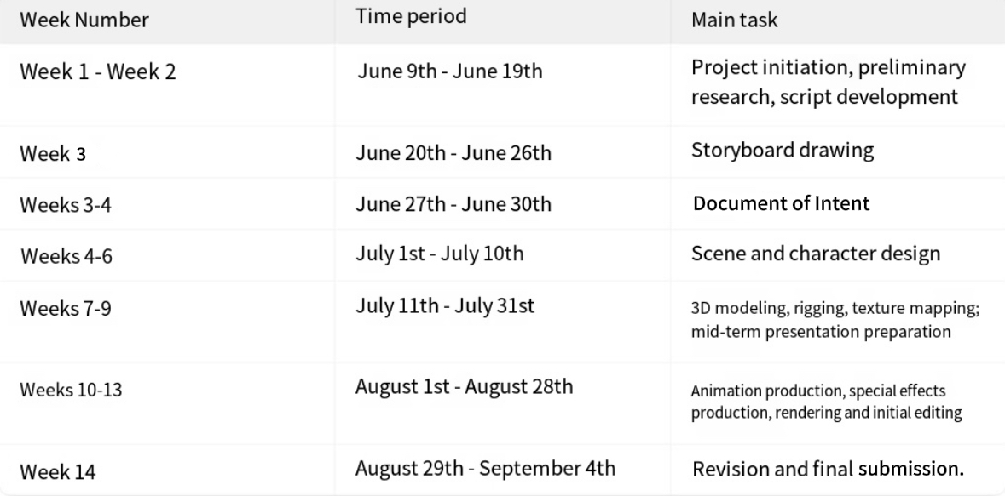
The total project duration is 14 weeks. The specific time allocation is as follows:

III. Preliminary Design
1. Preliminary research
The theme of this project is marine conservation, with healing as the main tone of the creation. References include Hayao Miyazaki's animated films Castle in the Sky and My Neighbour Totoro, Makoto Shinkai's animated film Your Name, and Gints Zilbalodis' 3D animated film Flow. These works will be used as references to assist in the narrative rhythm, cinematography, character design, and other aspects to make this project more mature and complete.

2. Script and Storyboard Production
Break down the 1-minute script into 12-15 key shots, noting the shot type, duration, and transition method.
Completed using Procreate.

3. Scene Design
Draw concept sketches to determine the color tone and spatial layout of the main scene.
Use Procreate to complete 2D concept drawings, marking the direction of light and shadow and material references.

4. Character Design
Design the main characters, including their appearance, clothing, and expression library, ensuring that they match the characters' personalities in the script.
Create three views of the character (front, side, and back) for reference during modelling.
Since this project includes animal characters, the design must also be consistent with the project's style.

IV. 3D Animation Production
1. Modelling and Binding
Modelling
Use Blender and MAYA for model building.
Follow polygon optimism principles to ensure that the number of model faces is kept within the rendering performance range.

Binding
Complete character rigging in Blender. Test weight distribution to avoid clipping or deformation issues.

2. Textures and Materials
Design UV maps for scenes and characters to ensure seamless texture mapping.

3. Animation Production
Keyframe animation.
Use Blender to create K-frames and animations.

4. Special Effects and Rendering
Special Effects
Create special effects using After Effects and Blender.

Rendering
Many scenes in this project take place in the ocean, which may increase the difficulty of rendering. Therefore, there will be two rendering solutions. The first is to use Blender's Cycles rendering engine for rendering. If the hardware is not high-end and time is limited, the backup solution will be enabled. Use Blender's EEVEE engine for rendering.

5. Export and Post Production
Export
Export sequence frames (PNG format) with a resolution setting of 1080×720.

Editing
Use CapCut to edit, adjust the rhythm and transitions.

Sound Effects
Find appropriate sound effects for the animation and create your own sound effects. Place background music, ambient sounds, and character dialogue on the corresponding video tracks.

V. Risk Management and Quality Control
1. Technical risks
Test rendering settings in advance to avoid hardware damage.
Data backup: Regularly back up project data to prevent data loss or damage.

2. Creative deviation
Submit weekly progress reports and maintain close communication with the supervisor.

VI. Stimulating Audience Targets and Implementation Methods
1. Target audience
Audiences of all ages, especially teenagers and environmental enthusiasts.

2. Implementation method
Through delicate emotional expression and stunning visual effects, it evokes emotional resonance in the audience.

VII. Future Vision
To expand the animation's influence, a cross-platform communication strategy will be adopted to promote it to major video websites and social media platforms. At the same time, animation-related products such as toys, stationery, and clothing will be developed to bring the characters and stories in the animation into the daily lives of the audience.

