

Module Code: LCMB7024
Module Title: Marketing Management

Lecturer: Dian Mayasari (Birmingham)

Marketing Environment Analysis of the Electric vehicles Industry

Student Name: Manikandan Gopalakrishnan
Student ID: 2507423
Date of Submission: 24th October 2025

Table of Contents
1.0 Introduction 4
2.0 Overview of the Electric Vehicles Industry 4
3.0 Critical Assessment of Macro Marketing Actor (Technological) 5
3.1 Overview of Technological Environment 5
3.2 Opportunities for Pioneers 6
3.3 Threats for Pioneers 7
3.4 Opportunities for Followers 8
3.5 Threats for Followers 8
4.0 Critical Assessment of Macro Marketing Actor (Political) 9
4.1 Overview of Political Environment 9
4.2 Opportunities for Pioneers 10
4.3 Threats for Pioneers 10
4.4 Opportunities for Followers 11
4.5 Threats for Followers 11
5.0 Evaluation of Strategic Response to the External Factors 1000 11
5.1 Identification of Response to the Technological Aspects 11
5.2 Identification of Response to the Political Aspects 13
6.0 Conclusion 14
References 15

List of Figures
Figure 1: Electric Vehicle Market forecast 5
Figure 2: UK Electric vehicle charging infrastructure 6
Figure 3: Robotaxi by Tesla 7
Figure 4: Tesla sales decline in the European EV market 8
Figure 5: Enactment of the ZEV mandate 9
Figure 6: Threats faced by General Motors 10
Figure 7: Vehicle-to-Grid technology of Nissan 12

1.0 Introduction
The macro-marketing environment can be defined as the external parameters that govern the marketing decisions of an organisation. Concerning strategic marketing management, critical evaluation of the macro-environment facilitates an organisation to forecast challenges, recognise opportunities, and eradicate threats (Priporas et al., 2020). The core aspects encompassed within the macro marketing are “Economic”, “Demographic”, “Technological”, “Natural”, Political”, and “Cultural”. Assessment of these parameters authorises the marketers to correspond their tactics to the environmental forces, which validates the accomplishment of a competitive edge in the long term.
The marketing actors are perceived in a different manner by the pioneers and the follower companies in the market. As per Giachetti and Pira (2022), pioneers refer to the organisations that instigate an innovation, service, or product into the market, and therefore accomplish a competitive edge by means of customer loyalty and brand recognition. Consequently, followers enter the market in the later phase by acquiring experiences from the pioneers. Although they acquire benefits like reduced cost and risk, product differentiation remains a major obstacle, which hampers the competitive advantage in the long term.
The main aim of the report will be to assess the threats and opportunities generated by the actors on the pioneer and follower companies within the Electric Vehicle industry. The two actors that are selected for assessment are “Technological factor” and “Political factor”. The latter part of the report will emphasise the response of the companies operating within the Electric Vehicle industry to the macro-marketing actors, and it governs their competitive advantage.

2.0 Overview of the Electric Vehicles Industry
​The Electric Vehicles industry confines electric cars, buses, trucks, and two-wheelers with electric power instead of fossil fuels, which is a promising sustainable technology in the transport industry (Sanguesa et al., 2021). ​​This industry is incredibly adaptable to the macro-environmental analysis, as the growth of this industry is very high, and the factors discussed, including political, economic, social, technological, environmental, and legal factors, have a major impact on this industry. ​To illustrate, the total EV sales in the world will reach up to “21.3 million” units by the end of 2025, which will be equivalent to 24% market share, as compared to the scheduled 2024 sales at “17.8 million units” (EV Volumes, 2025).
In the year 2024, the size of the market of EVs was estimated to at USD 1,328.08 billion, and it is estimated that by the year 2025, the market size of EVs will hit USD 993.0 billion (Grand View Research, 2025). ​This is due to the rising levels of environmental concerns, government stimulus, and battery technology (Sanguesa et al., 2021). Hence, different actors encapsulated within the aspect of macro-marketing govern the growth of this industry, and thus it will be beneficial to assess the threats and opportunities generated by the actors in the industry, along with their strategic reactions.
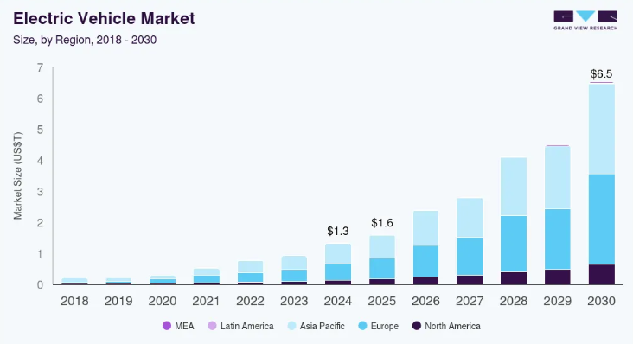
Figure 1: Electric Vehicle Market forecast
(Source: Grand View Research, 2025)

3.0 Critical Assessment of Macro Marketing Actor (Technological)

3.1 Overview of Technological Environment
The technological aspects have been a critical driver of success for the Electric Vehicle industry in the UK, assisting in accomplishing significant market growth (YEUNG, 2025). In 2024, the electric vehicle sales in the UK rose to 381,970 units, characterising a market share of approximately 19.6% across all the new vehicles registered (S&P Global, 2025). As per reports, the revenue of the EV market in the UK is forecasted to accomplish USD 40.9 billion by the end of 2025 (Statista, 2025). The charging infrastructure is also expanding in the UK, making adopting an electric vehicle feasible among users. It has been reported that in the future, widespread changes are expected within the EV industry in the UK, through technological advancements (Eocharging, 2025).
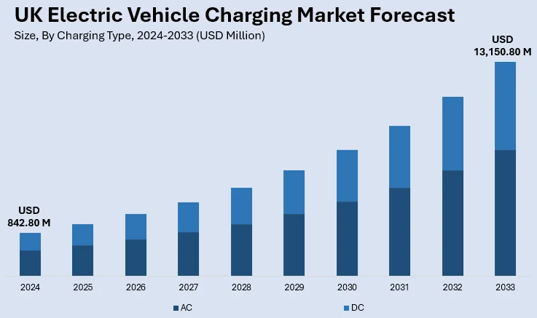
Figure 2: UK Electric vehicle charging infrastructure
(Source: IMARC, 2025)

3.2 Opportunities for Pioneers
The technological actors present significant opportunities for pioneers within the EV industry, like Tesla, and they have enacted modern technologies to sustain their competitive advantage. Different opportunities are gained by Tesla through the enactment of “ecosystem-scale investments” and innovation leadership. Recently, Tesla inaugurated a next-generation AI voice assistant by forming partnerships with DeepSeek Technologies and ByteDance Ltd in China, characterising deeper engagement within the smart-vehicle software (Bloomberg, 2025). Moreover, Tesla also made a progression towards autonomous mobility through the robotaxi test rides recently carried out in Austin. This will present a modern service-based business model for Tesla besides car sales (CNBC, 2025). These progressions assist in generating opportunities concerning new revenue streams, differentiation, and cementing the “first-mover advantage”.
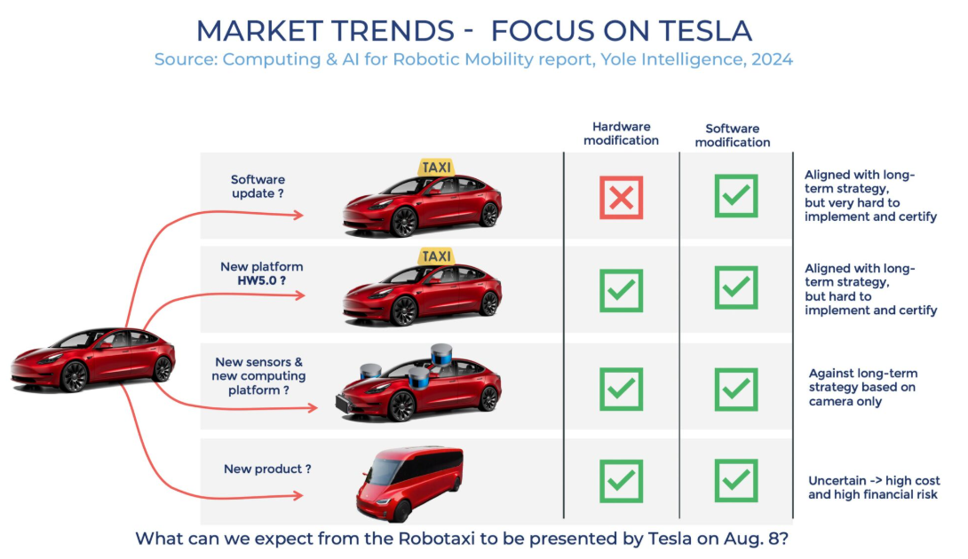
Figure 3: Robotaxi by Tesla
(Source: Dipert, 2024)

3.3 Threats for Pioneers
Besides gaining an advantage, Tesla has also encountered threats from technological factors. The emergence of new forms like BYD is causing issues for Tesla, as they are offering advanced driver-assisted systems at an affordable price with the enactment of Lidar sensors (The Times of India, 2025). The inauguration of advanced batteries that get charged within a few minutes is also gaining attention from the market. This is causing their market share to decline in regions like China and Europe, as Tesla observed a 38% decline in market share in Europe (Reuters, 2025).
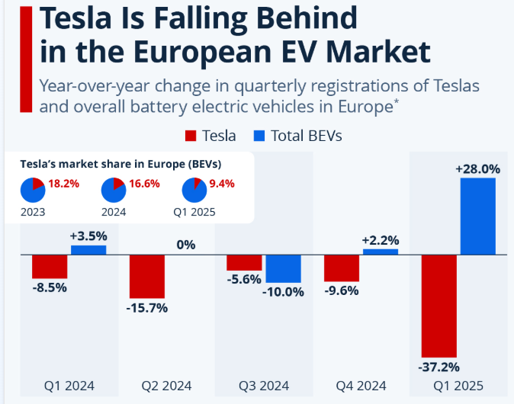
Figure 4: Tesla sales decline in the European EV market
(Source: Richter, 2025)

3.4 Opportunities for Followers
Technological factors and advancements also provide opportunities for the follower companies within the electric vehicle industry. As an example, advancement in battery technology, like reduction of cost, augmented energy density, and speeding up the charging procedures, allows the follower companies to take advantage of these without making an investment in Research on new technologies (Dickinson, Ooi and Stringwell, 2025). Moreover, the emergence of other technologies like “over-the-air software updates” and the deployment of smart-grid technologies facilitates the follower companies to avoid the traditional ICE technologies and incorporate modern technologies to gain a competitive edge (Dickinson, Ooi and Stringwell, 2025).

3.5 Threats for Followers
Changes in technological aspects pose a huge threat to the follower companies within the EV industry. With the progression of advanced battery chemistries, software-driven vehicles, and autonomous driving, the follower companies face obstacles concerning being locked with traditional architecture, and failure to adapt to the pace of innovation enacted by the pioneer firms (Hossain et al., 2022). For example, one such firm is Rivian Automotive Inc, which faces a significant threat from rapid technological advancement, and thus they are facing the issue of product differentiation and loss of market share and profitability (Investing, 2025).

4.0 Critical Assessment of Macro Marketing Actor (Political)

4.1 Overview of Political Environment
The Electric Vehicle market is largely affected by the political environment, whose effect differs in different countries. ​The 2024 presidential election may drastically alter the policies of clean energy and manufacturing cars in the US (Nolan, 2024). ​An example of this is that the Trump administration could attempt to discontinue regulations and subsidies that render EVs cheap because it will counteract the goal of decarbonising transport (Nuccitelli, 2025). ​The cancellation of federal EV tax credits, including the $7,500 incentive, can significantly decrease EV demand and sales, and one of the studies estimates the decline in demand and sales by 20% by 2035 (Electric Vehicle Association, 2025).
On the contrary, the EV sales in the UK are doubling with the progression of time. By May 2025, the number of electric cars on the UK roads was recorded as 1.5 million, accounting a 4.5% of the total cars in the UK (Evision, 2025). This growth can be attributed to the enactment of the mandate concerning the “Zero Emission Vehicle”, and the incorporation of a new subsidy for the lower-priced vehicles has also caused the sales of electric vehicles to be augmented (Walker, 2025).
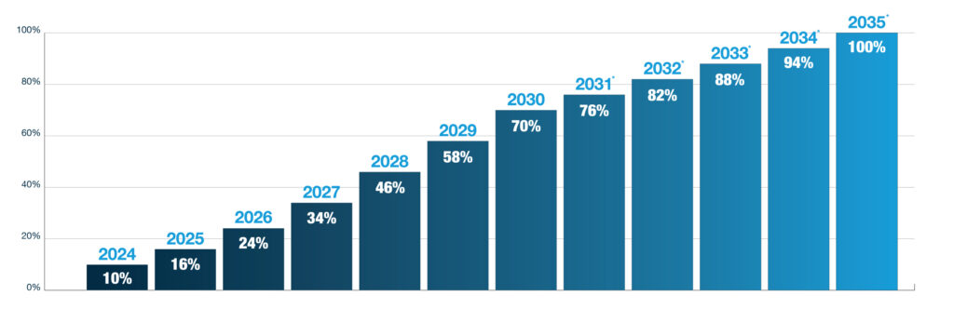
Figure 5: Enactment of the ZEV mandate
(Source: Patrick, 2024)

4.2 Opportunities for Pioneers
Modifications in the political landscape open different opportunities for pioneering companies within the EV industry. As an example, the aspect of Stellantis in Spain can be identified, which received a grant of £133 million from the government to develop a gigafactory for making its electric vehicle leadership more sustainable by forming a partnership with CATL (Rajagopal, 2024). Moreover, the incentives in Europe concerning EV purchase allow the companies to capitalise on supply chain advantages and other advancements.

4.3 Threats for Pioneers
Changes in the political factors pose different threats for the pioneering companies within the Electric vehicles industry. As an example, the situation of General Motors can be considered, and the organisation encountered a financial issue of $1.6 billion in response to the termination of the electric vehicle tax credits by the US government (Chapman, 2025). Moreover, the emission rules have been eased by the Environmental Protection Agency during the administration of Trump, characterising a broader shift in policies. The shift also encompasses opposition to the EV charging infrastructure and the ban on gas vehicle sales (Wile, 2025). This has raised complications for General Motors, and sales decline has been observed compared to different rivals within the sector.
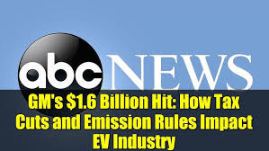
Figure 6: Threats faced by General Motors
(Source: Wile, 2025)

4.4 Opportunities for Followers
Changes in political aspects can generate a significant opportunity for the follower companies within the Electric Vehicle industry. As an example, the aspect of Ford can be identified, which is returning market entry to India because of the favourable political landscape in the country (Economic Times, 2024). The Government of India’s inclination towards electric mobility, encompassing infrastructure development, is corroborated for with the plan of Ford to resume their business successfully (Economic Times, 2024).

4.5 Threats for Followers
Modifications in the political factors can develop threats for the follower companies within the EV industry. As an example, changes in the policies of the government on subsidies, import tariffs and emission regulations may have a disproportionate impact on followers of cheaper production or later entry into the market (Auto Pacific, 2024). An abrupt decline or discontinuation of EV incentives in major markets, including the United States or Europe, may create high costs of production and lower demand by consumers, which may not allow follower companies such as Lucid Motors or Fisker Inc. to compete successfully (Auto Pacific, 2024). Moreover, there will be protectionist measures which give preference to the domestic pioneers and restrict the market accessibility and expansion of the followers.

5.0 Evaluation of Strategic Response to the External Factors 1000

5.1 Identification of Response to the Technological Aspects
Electric vehicle industry pioneer and follower organisations are strategic in responding to technological aspects to stay competitive. Pioneers such as Nissan use innovation to create a note of difference, and followers are using the new technologies to improve their products.
Nissan, as an early developer of EVs, has been leading the way in incorporating the use of advanced technology in its vehicles. In 2025, Nissan released the second-generation Leaf, which has a greater range and allows quicker charging (Nissan, 2025b). The car has high driver-assistance technology, including Level 3 technology of autonomous driving, which makes Nissan an EV technology leader. Moreover, the e-Power hybrid technology that is utilised by Nissan to stay pertinent, in which the electric motor is powered by a gasoline engine to produce electricity, helps to deliver a modern and advanced driving experience and has the side effect of increasing the range of the vehicle (Kageyama, 2025).
However, Nissan has issues with the developing market of EVs. Nissan has announced its plan to stop selling the Ariya electric SUV in the U.S. market since the year 2026, based on the dropping sales trend and trade tariffs (Fitzgerald, 2025). Such a strategic change will permit Nissan to redistribute resources, prioritise cheaper EV cars, and emphasise “vehicle-to-Grid technology” for a sustained competitive edge from 2026 (Nissan, 2025a).
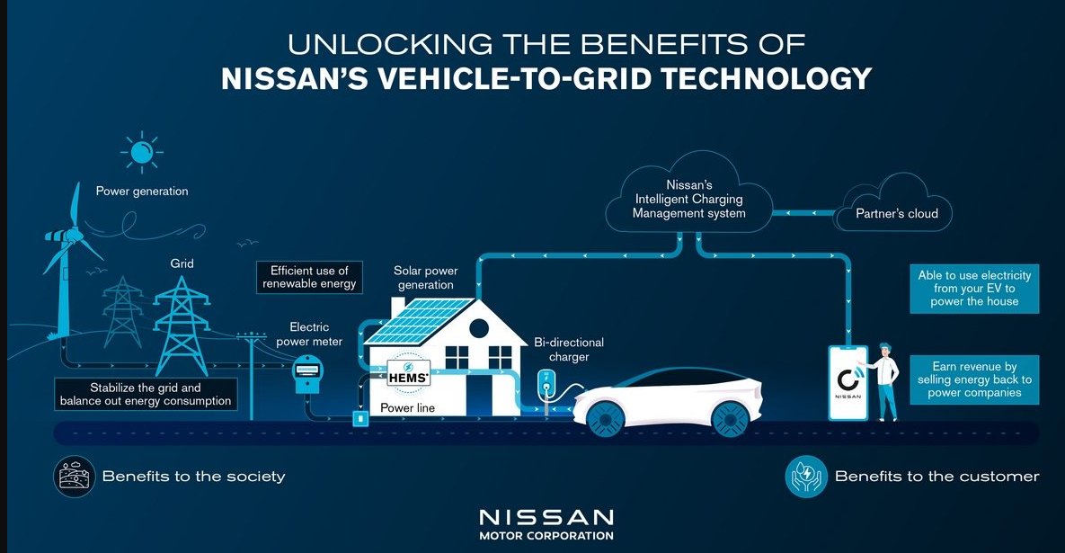
Figure 7: Vehicle-to-Grid technology of Nissan
(Source: Nissan, 2025a)
Li Auto is a low-tech company in the EV industry that has become a follower of innovative technologies to improve its products. Li Auto has launched two fully electric SUVs, the i6 and i8, in 2025 in a bid to increase its electric vehicles and serve a wider audience (Global China EV, 2025). Another way in which the company is concentrating is on focusing on Level 3 autonomous driving tech-enabled vehicles, which would further improve the safety and convenience of its vehicles (Gasgoo, 2024).
The strategic position of Li Auto is to explore the available technologies to enhance its vehicles without necessarily spending a lot of money on research and development, as it would cost them in-house (Business Wire, 2025). Li Auto has a chance to compete in the trend of the EV market by successfully entering and adopting established technologies, focusing on user comfort, and satisfying the rising demand of EVs.
Therefore, pioneering and follower organisations within the EV industry respond to technological factors in a strategic manner to be competitive. The innovators, like Nissan, invest in new productive technologies to make their products take a different shape, whereas the followers, such as Li Auto, implement the innovative solutions to develop their products and compete successfully in the market.

5.2 Identification of Response to the Political Aspects
The political factors play a great role in the strategic decision-making of both the pioneer and the follower companies in the Electric Vehicle industry since government policies directly affect the production costs, the provision of markets and consumer incentives.
Pioneering organisations like Toyota position themselves in strategic manner to their operations in relation to favourable political environments to ensure that they are competitive. An example is the case of Toyota, which has made an active investment in EV and hybrid technology, expecting policy decarbonisation on the global level (Ochoa, 2024). Government grants and subsidies, including those for zero-emission vehicles, have also been used by the company to increase the number of its EV production facilities in Europe, and it has been using strategic partnerships with its battery suppliers to gain advantages in the supply chain. Moreover, Toyota also participates in lobbying and advocating for policies that would facilitate enabling regulatory environments so that there is always be availability of incentives, charging stations, and emission credits (Robinson, 2024). Distributing its manufacturing capacity to politically sound countries with leading EV policies would also help Toyota to reduce the risk of policy changes, including the extension of tax credits in the U.S., which would help achieve stability in demand and dominate the market even in the face of political undoing.
In contrast to that, the follower companies, such as Wuling, which in most cases are late entrants to the market and create cheaper passenger vehicles, have a different collection of strategic issues. Their entry to the market and survival in the market are greatly influenced by political factors, including subsidies, tariffs on imports, and EV requirements (Vietnam News, 2025). Wuling has reacted effectively by exploring the potential of new markets that have favourable EV policies, like China and Southeast Asia, where the government offers incentives to purchase electric cars in large numbers (Feng, 2025). With the local policy structures, Wuling can minimise the cost of production and quicken the process of entering the market. Besides, the company also enters into joint ventures with local manufacturers and suppliers as a way of adhering to local regulations, circumventing protectionist obstacles, and tapping into other incentives supported by the government (Rochim, Ilman and Ismail, 2025). This would offer Wuling the chance to strategically align with positive political trends and live up to the competition with global pioneers regardless of the available resources.
However, innovators and followers have the weakness of being subject to sudden policy changes. The regulatory easing that faces Toyota in some areas may lead to reduced financial payoffs of its investments, but the response of Wuling may be limited by an abrupt cut in subsidies or addition of protectionist policies in favour of domestic innovators.

6.0 Conclusion
Finally, the electric vehicle sector has pioneer companies and followers in the market responding strategically to both political and technological influences to remain competitive. Innovators or Pioneers take advantage of government subsidies, lobbying activities and strategic alliances to increase production, gain supply chains and retain first-mover advantage even in situations of political uncertainty. On the other hand, the followers exploit favourable policy conditions in upcoming markets, enter into joint ventures and embrace existing technologies to venture into the market at low costs and compete with the world leaders. However, they are both susceptible to changes or shifts in policy without prior notice or regulatory changes that may affect profitability and position. Hence, being aligned to macro-environmental actors is still a major parameter of long-term resilience and competitive power in the swiftly changing EV industry.

References
Auto Pacific (2024). Political Influence on Electric Vehicle Interest is Waning According to Auto Pacific Study. Available at: https://www.autopacific.com/autopacific-insights/2024/10/31/political-influence-on-electric-vehicle-interest-is-waning-according-to-autopacific-study. (Accessed: 13th October 2025)
Bloomberg (2025). Tesla to integrate Deepseek, Doubao AI voice controls in China. Available at: https://economictimes.indiatimes.com/tech/technology/tesla-to-integrate-deepseek-doubao-ai-voice-controls-in-china/articleshow/123450034.cms?from=mdr (Accessed: 12th October 2025)
Business Wire (2025). Global and China L3/L4 Autonomous Driving and Startups Research Report, 2025: Robotaxi Steps Towards Scaling During 2026-2030, L3 Personal Vehicles Open New Commercial Opportunities. Available at: https://www.businesswire.com/news/home/20250415369610/en/Global-and-China-L3L4-Autonomous-Driving-and-Startups-Research-Report-2025-Robotaxi-Steps-Towards-Scaling-During-2026-2030-L3-Personal-Vehicles-Open-New-Commercial-Opportunities---ResearchAndMarkets.com. (Accessed: 14th October 2025)
Chapman, M. (2025). GM to take a $1.6 billion hit as tax incentives for EVs are slashed and emission rules ease. Available at: https://apnews.com/article/general-motors-gm-ev-emission-tax-2d2e43fd9dc0e12864e590a018be280f. (Accessed: 13th October 2025)
CNBC (2025). Tesla shares jump 10% as robotaxi pilot hits the streets of Austin. Available at: https://www.cnbctv18.com/market/tesla-stock-surges-robotaxi-service-launch-elon-musk-19625583.htm (Accessed: 12th October 2025)
Dickinson, J., Ooi, B. and Stringwell, J. (2025). How Technology Is Impacting the EV Industry. Available at: https://www.mackinnon-bruce.com/insights-hub/blog/how-technology-is-impacting-the-ev-industry/ (Accessed: 12th October 2025)
Dipert, B. (2024). Tesla’s Robotaxi Surprise: What You Need to Know - Edge AI and Vision Alliance. Available at: https://www.edge-ai-vision.com/2024/04/teslas-robotaxi-surprise-what-you-need-to-know/. (Accessed: 12th October 2025)
Economic Times (2024). Ford plans to re-enter India with focus on EVs: Report. The Economic Times. Available at: https://economictimes.indiatimes.com/industry/renewables/ford-plans-to-re-enter-india-with-focus-on-evs-report/articleshow/108032852.cms?from=mdr. (Accessed: 13th October 2025)
Electric Vehicle Association (2025). Understanding the Impact of Trump’s EV Policy Reversals. Available at: https://www.myeva.org/blog/understanding-the-impact-of-trumps-ev-policy-reversals (Accessed: 13th October 2025)
Eocharging (2025). Driving the Future: Innovation and Growth in the UK EV Market in 2025. Available at: https://www.eocharging.com/stories/driving-the-future-innovation-and-growth-in-the-uk-ev-market-in-2025 (Accessed: 12th October 2025)
EV Volumes (2025). EV-Volumes - The Electric Vehicle World Sales Database. Available at: https://ev-volumes.com/. (Accessed: 12th October 2025)
Evision (2025). EV Market Stats in 2025: Will You Swap to an EV? | EVision. Available at: https://www.evisionevs.co.uk/2025/07/17/ev-market-stats-in-2025-will-you-swap-to-an-ev/ (Accessed: 13th October 2025)
Feng, Z. (2025). How Chinese automakers are reshaping the EV landscape in Southeast Asia. Available at: https://globalvoices.org/2025/10/09/how-chinese-automakers-are-reshaping-the-ev-landscape-in-southeast-asia/. (Accessed: 14th October 2025)
Fitzgerald, J. (2025). Nissan Cancels Ariya Electric SUV from 2026 Model Year Onward. Available at: https://www.caranddriver.com/news/a67948305/nissan-ariya-canceled/. (Accessed: 13th October 2025)
Gasgoo (2024). Gasgoo Daily: Li Auto likely to realize L3 autonomous driving capabilities in 2025. Available at: https://autonews.gasgoo.com/china_news/70035547.html (Accessed: 13th October 2025)
Giachetti, C. and Pira, S.L. (2022) ‘Catching up with the market leader: Does it pay to rapidly imitate its innovations?’, Research Policy, 51(5), p.104505. http://doi.org/10.1016/j.respol.2022.104505
Global China EV (2025). Li Auto plans to release the i6 and i8 in 2025, two fully electric SUVs. Available at: https://globalchinaev.com/post/li-auto-plans-to-release-the-i6-and-i8-in-2025-two-fully-electric-suvs (Accessed: 13th October 2025)
Grand View Research (2025). EV Market Size & Share | Global Electric Vehicles Industry Report, 2020. Available at: https://www.grandviewresearch.com/industry-analysis/electric-vehicles-ev-market. (Accessed: 12th October 2025)
Hossain, M.S., Kumar, L., El Haj Assad, M. and Alayi, R. (2022) ‘Advancements and future prospects of electric vehicle technologies: a comprehensive review’, Complexity, 2022(1), p.3304796. https://doi.org/10.1155/2022/3304796
IMARC (2025). UK Electric Vehicle Charging Market Size & Forecast 2033. Available at: https://www.imarcgroup.com/uk-electric-vehicle-charging-market. (Accessed: 12th October 2025)
Investing (2025). Rivian’s SWOT analysis: electric vehicle maker faces growth hurdles amid fierce competition. Available at: https://in.investing.com/news/swot-analysis/rivians-swot-analysis-electric-vehicle-maker-faces-growth-hurdles-amid-fierce-competition-93CH-5036036 (Accessed: 12th October 2025)
Kageyama, Y. (2025). Japan’s troubled automaker Nissan banks on hybrid EV technology. Available at: https://apnews.com/article/nissan-japan-automakers-losses-ev-hybrids-eb87779c2b251254768327aa713ce0a2. (Accessed: 13th October 2025)
Nissan (2025a). Nissan to launch affordable Vehicle to Grid technology from 2026. Available at: https://www.nissan-me.com/experience-nissan/news-and-events/latestnews/nissan-v-to-g-launch.html (Accessed: 14th October 2025)
Nissan (2025b). Jim Bass Nissan. Available at: https://www.jimbassnissan.com/blog/2025-nissan-technology-and-safety-updates-revealed/ (Accessed: 13th October 2025)
Nolan, S. (2024). US Election 2024: The Future of EVs at Stake. Available at: https://evmagazine.com/articles/us-election-2024-the-future-of-evs-at-stake. (Accessed: 13th October 2025)
Nuccitelli, D. (2025). Electric vehicle adoption is stumbling, but still growing amid geopolitical clashes. Available at: https://yaleclimateconnections.org/2025/02/electric-vehicle-adoption-is-stumbling-but-still-growing-amid-geopolitical-clashes/. (Accessed: 13th October 2025)
Ochoa, J. (2024). Toyota exec slams ‘impossible’ EV mandate amidst political chaos. Available at: https://www.thestreet.com/automotive/toyota-exec-slams-impossible-ev-mandate-amidst-political-chaos (Accessed: 14th October 2025)
Patrick (2024). The Zero Emissions Vehicle Mandate – What Impact Could This Have For Fleets? Available at: https://www.dawsongroupvans.co.uk/the-zero-emissions-vehicle-mandate-what-impact-could-this-have-for-fleets/. (Accessed: 13th October 2025)
Priporas, C.V., Kamenidou, I., Nguyen, N. and Shams, R. (2020) ‘The impact of the macro-environment on consumer scepticism towards cause-related marketing: Insights from an economic crisis setting’, International Marketing Review, 37(5), pp.841-861. https://doi.org/10.1108/IMR-04-2019-0124
Rajagopal, U. (2024). Spain grants $146 million subsidy to Stellantis for potential EV battery plant. Available at: https://www.globalbankingandfinance.com/spain-grants-146-million-subsidy-to-stellantis-for-potential-ev-battery-plant (Accessed: 13th October 2025)
Reuters (2025). Why China’s auto, tech giants threaten Tesla’s self-driving future. Available at: https://economictimes.indiatimes.com/industry/auto/china-byd-auto-tech-threaten-elon-musk-tesla-self-driving-future/articleshow/121751578.cms?from=mdr. (Accessed: 12th October 2025)
Richter, F. (2025). Infographic: Tesla Is Falling Behind in the European EV Market. Available at: https://www.statista.com/chart/34036/tesla-in-europe/?srsltid=AfmBOopTkJtUAlDSaqbxt_xd3BTkgk7r1hm6MxK2YBVB_WefuY0h9_LP (Accessed: 12th October 2025)
Robinson, A.D., Ella Nilsen, Lou (2024). Toyota hits the gas on hybrids as EV sales cool. But what does that mean for the planet? Available at: https://edition.cnn.com/2024/03/10/climate/hybrids-evs-toyota-climate-impact-int. (Accessed: 14th October 2025)
Rochim, A.I., Ilman, G.M. and Ismail, H. (2025) ‘Political Economy Implications of Electric Vehicle Policies: A Bibliometric Analysis’, Society, 13(1), pp.417-438. https://www.societyfisipubb.id/index.php/society/article/download/772/627
S&P Global (2025). UK DATA: EV sales reach record high of 381,970 units in 2024. Available at: https://www.spglobal.com/commodity-insights/en/news-research/latest-news/metals/010625-uk-data-ev-sales-reach-record-high-of-381970-units-in-2024. (Accessed: 12th October 2025)
Sanguesa, J.A., Torres-Sanz, V., Garrido, P., Martinez, F.J. and Marquez-Barja, J.M. (2021) ‘A review on electric vehicles: Technologies and challenges’, Smart Cities, 4(1), pp.372-404. https://doi.org/10.3390/smartcities4010022
Statista (2025). Electric Vehicles - United Kingdom | Market Forecast. Available at: https://www.statista.com/outlook/mmo/electric-vehicles/united-kingdom?srsltid=AfmBOoosg_rQlvHoiHVOJDoV3ffLLVCFst195a181Vmt993GLiEeYJeJ (Accessed: 12th October 2025)
The Times of India (2025). New challenge for Musk’s Tesla? China’s EV giant reveals next-gen battery with lightning-fast charging. Available at: https://timesofindia.indiatimes.com/business/international-business/new-challenge-for-musks-tesla-chinas-ev-giant-reveals-next-gen-battery-with-lightning-fast-charging/articleshow/120574583.cms (Accessed: 12th October 2025)
Vietnam News (2025). Distributor of Wuling electric cars continues to face deep losses. Available at: https://vietnamnews.vn/economy/1692003/distributor-of-wuling-electric-cars-continues-to-face-deep-losses.html (Accessed: 14th October 2025)
Walker, C. (2025). Government EV policy change could cost over £1000 a year for millions. Available at: https://eciu.net/media/press-releases/2025/government-ev-policy-change-could-cost-over-1000-a-year-for-millions-of-families. (Accessed: 13th October 2025)
Wile, R. (2025). GM takes $1.6 billion hit on electric vehicle rollout as U.S. automakers rethink future. Available at: https://www.nbcnews.com/business/autos/electric-vehicle-ev-slowdown-rcna237652. (Accessed: 13th October 2025)
YEUNG, K. (2025) ‘Understanding value creation and appropriation in a disruptive narrative: the UK EV sector’. https://www.ijbms.net/assets/files/1737336271.pdf

