


Cover Page

Dale Monks
Module: Modern & Traditional Construction CW 1
Module code: ACBA 5000
Student ID : 2114358

1.0 - Table of Contents
Contents
1.0 - Table of Contents 1
2.0 - Index of Tables 2
3.0 - Index of Figures 2
4.0 - Introduction 3
5.0 - History 3
4
6.0 - Foundations 4
7.0 - Materials 7
7.1 - Structure 7
7.2 - Design & Finishes 8
7.3 - Interior and Technology 9
8 - Conclusion 10
9 - References 11

2.0 - Index of Tables

3.0 - Index of Figures
Figure 1 - Raleigh Building 2003 3
Figure 2 - Deconstruction late 2003 3
Figure 3 - Site before construction 2009 - (Google Maps, 2009) 4
Figure 4 - Vibro stone installation method - (Keller, 2022) 4
Figure 5 - Displacement and vibration of stone columns - (Keller, 2022) 5
Figure 6 - Borehole Map - (DigiMaps, 2022) 5
Figure 7 - Borehole Report - (DigiMaps, 2022) 6
Figure 8 - GSK Lab South view (Henkel, 2023) 7
Figure 9 - GSK Lab North View (Henkel, 2023) Figure 10 - GSK Lab East View - (Henkel, 2023) 7
Figure 11 - Showing the steel dowels and Oak plugs - (Henkel, 2023) 8
Figure 12 - Natural Ventilation Towers - (Henkel, 2023) 8
Figure 13 - Winter Garden - (Henkel, 2023) Figure 14 - Building overview - (Henkel, 2023) 9

4.0 - Introduction
This paper will review and discuss the foundation choice and method of installation, in relation to its location for the GlaxoSmithKline (GSK) Carbon Neutral Laboratory for Sustainable Chemistry at the University of Nottingham.
I will also review the materials used for the superstructure evaluating their suitability for various aspects that were deemed important to meet its goal of being carbon neutral throughout the next 25 years of use.

5.0 - History
The Laboratory is based on University of Nottingham’s Jubilee Campus, which was previously an industrial site in the 1960’s home to several factories; Triumph Cycle, Raleigh and Sturmey Archer to new a few. These companies were all subsidiaries of the Raleigh cycle dynasty producing bicycle parts and assembly.
In 1901 a school was based partly on the site but was removed many years before the factories were built.
Before the school the site was home to the Radford Colliery in 1883 and the Nottingham Canal passed through until abandoned 1954, and in 1996 the canal was culverted.
The University of Nottingham took ownership of the development site in 1995 and started a large-scale redevelopment plan to deliver innovative buildings for its students and staff.
However, the site in question wasn’t acquired until much later in 2002 when Raleigh Group decided to reduce manufacturing in the UK and was sold to the University who combined the original purchase with this new acquisition into a 4-phase development. Deconstruction of the various sites within the estate took place within a year.
(Nanrah, 2021)
(Figure 1 - Raleigh Building 2003 & Figure 2 - Deconstruction late 2003).
(The Magazine of Lenton Local History Society, 2010)
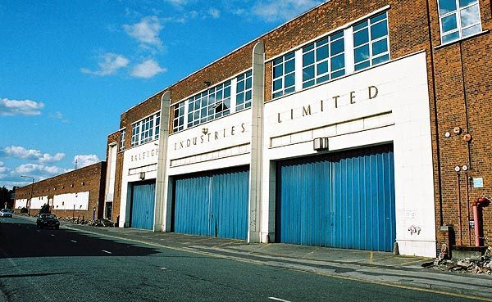
Most of the rubble was removed from site however some was crushed and buried where the buildings once stood. The university built other structures before the GSK lab in 2017, and for approximately 10 years the site was reclaimed by nature as seen in Figure 3 - Site before construction 2009.

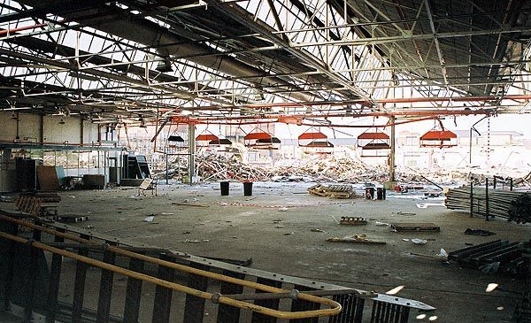
Figure 1 - Raleigh Building 2003

Figure 2 - Deconstruction late 2003

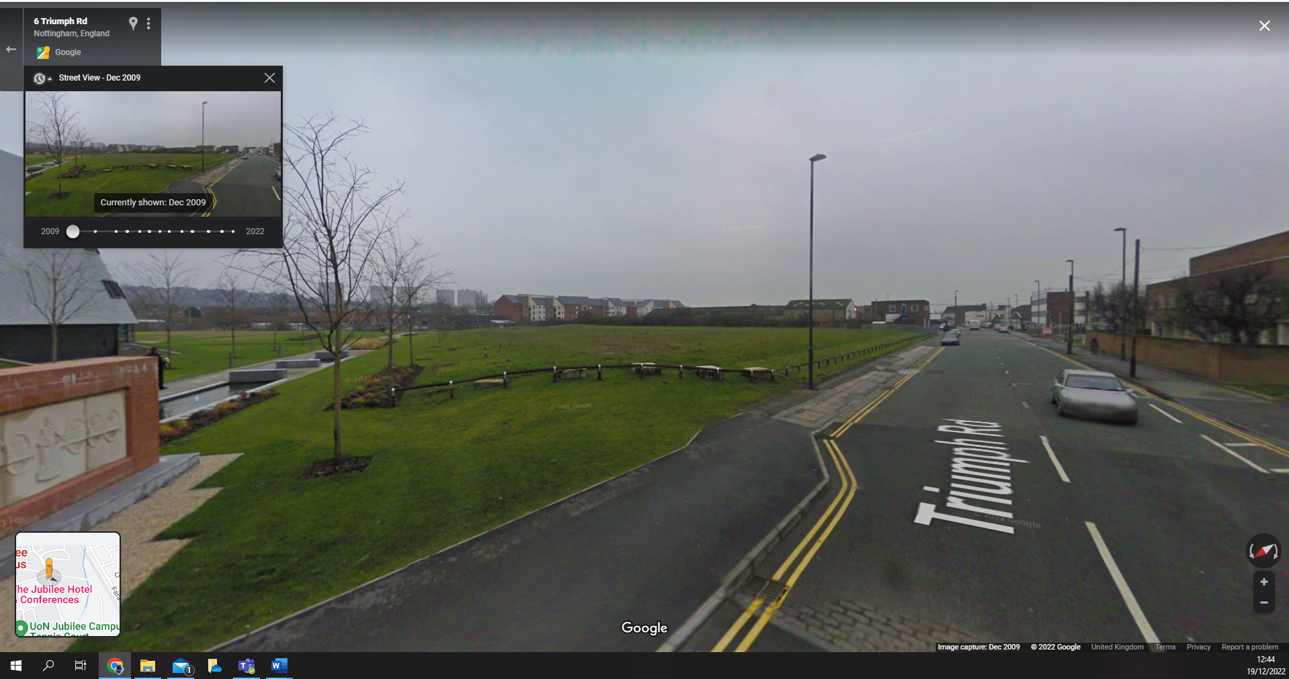
Figure 3 - Site before construction 2009 - (Google Maps, 2009)

6.0 - Foundations
The GSK lab is built on a brownfield site where the previous structure was demolished by the university in 2003. However, work would not commence on the laboratory for nearly 10 years later, so the site was part landscaped and reclaimed by nature.
Not knowing exactly how much of the previous building had been buried and what lay beneath that, and to encourage biodiversity which would be lost through construction, a geotechnical survey was completed with various options for foundations. The survey uncovered large elements of concrete likely from the previous structure, an absence of any large-scale parent soil, therefore resulting in a mix of subsoils and crushed rubble and clay with neutral acidic levels. (Arnott, 2016). The university estimates that 26,0000 cubic metres of material was brought back onto the site for landscaping. (Whitehouse, 2017)
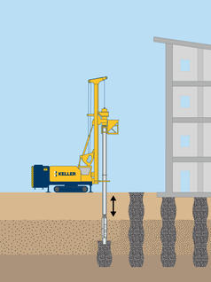
The foundation method chosen was vibro stone columns delivered by Keller group. This was only possible as geotechnical surveys showed that the ground make-up contained no collapsible soils and was largely clay and rubble.
This process looks to enhance any fragile soils or loose material by compacting columns derived from gravel or comparable materials with a powerful vibrator. Using a displacement process it strengthens the soil around the column and densifies the nearby granular soils. In a similar vein it can be compared to the construction of dry-stone walls. (Keller, 2022)
It has many advantages reducing foundation movement, maximised bearing capacity, increased shear strength and stiffness. It also has time saving advantages allowing for shallow footings. However, this can be offset against the number of columns needing to be installed, particularly as this development occupies 4,500 square meters over two floors.
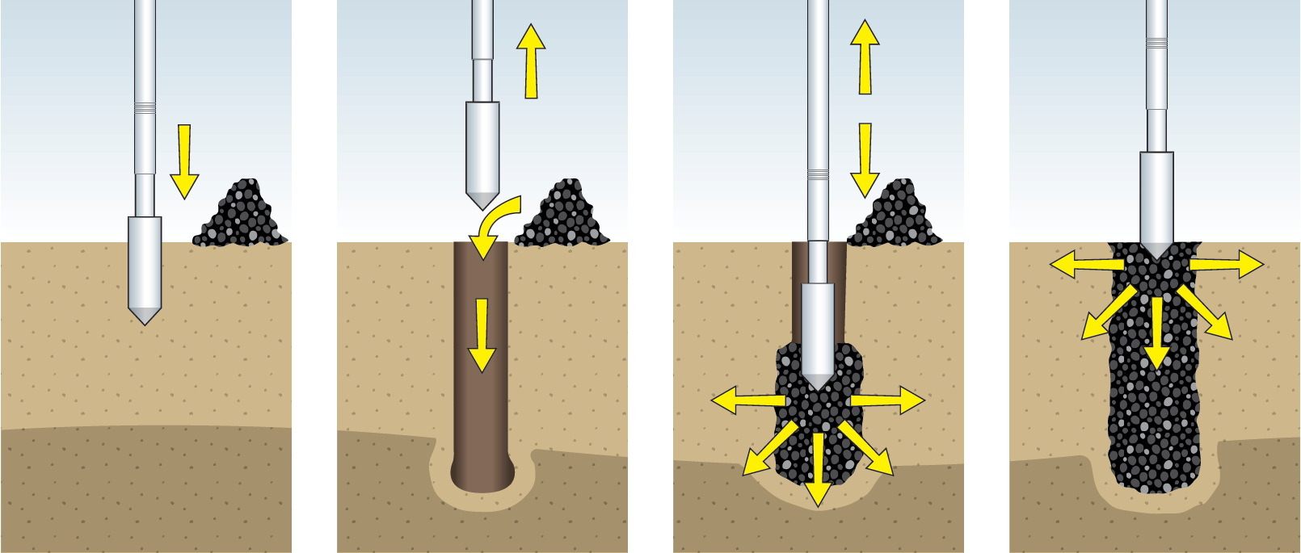
Not using concrete or reinforced steel bars reduces the amount of materials/cost on site and the storage requirements, but also in keeps with the vision that this project needed to deliver “Carbon neutral over its 25-year lifetime”. Not using the traditional CFA piles and moving to vibro stone columns reduced embodied carbon from 90 tonnes to just 6 tonnes and ground granulated blast furnace slag (GGBS) was used as a cement substitute for the ground floor slab. (Whitehouse, 2017)
Figure 4 - Vibro stone installation method - (Keller, 2022)
Figure 5 - Displacement and vibration of stone columns - (Keller, 2022)
There are also significant savings with regards to landscaping and the CO2 that would have been used to excavate to the required depth for traditional foundations giving it is a brownfield site.
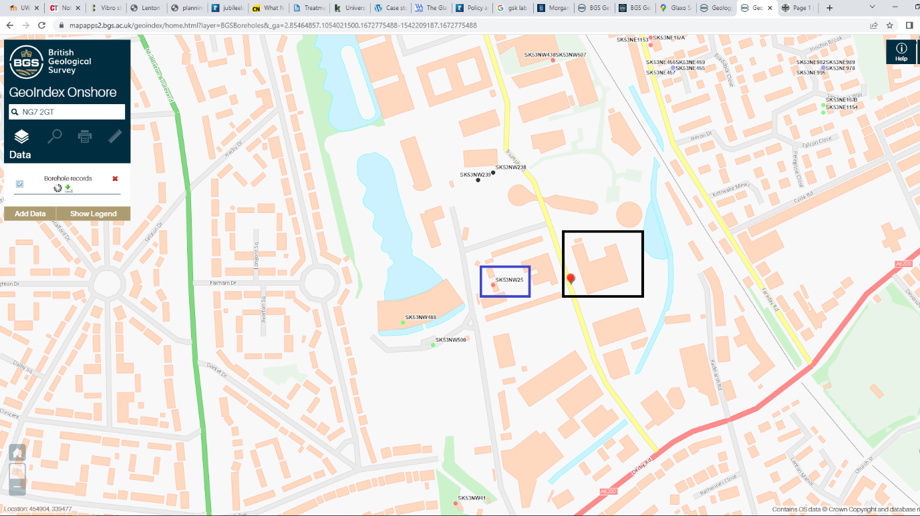

Figure 6 - Borehole Map - (DigiMaps, 2022)
Details of the borehole investigation in 1978 on what was the site of a diary company highlighted in blue on the map adjacent to the GSK Lab, makes a reference to a depth dug to 60 meters. Part of the report captured below reads rock (blue shale) was located at a depth of 29.26m. It is therefore likely that the traditional piles would have required to pile at this depth.

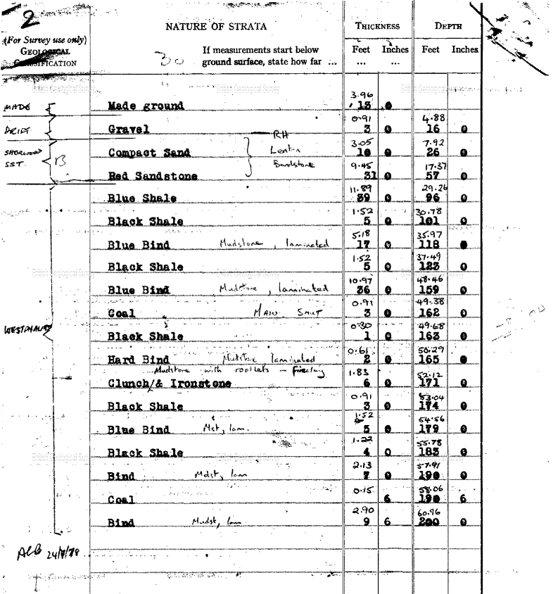
Figure 7 - Borehole Report - (DigiMaps, 2022)

7.0 - Materials
Chemistry labs have traditionally been demanding in their need for energy and natural resources, and heavy in terms of their impact on the environment. Therefore, the University was keen to show how sustainable this lab could be, and with stakeholders such as GSK investing heavily in the project, it would require new and innovative design, materials, and technology to fit the University Global Sustainability Strategy 2020. A part of which was to also achieve a BREEAM Outstanding/LEED Platinum wooden framed building award for the lab. (Whitehouse, 2017)
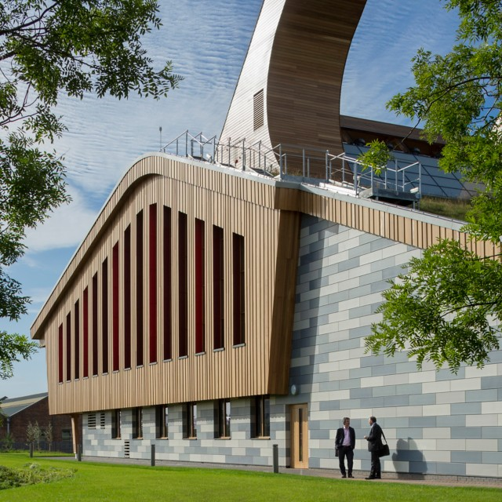
The contractors worked closely with the architects to select products with Environmental Product Declarations (EPDs), ultimately resulting in over 90% of the sub and superstructure of the building mass covered by EPDs. (Arnott, 2016)
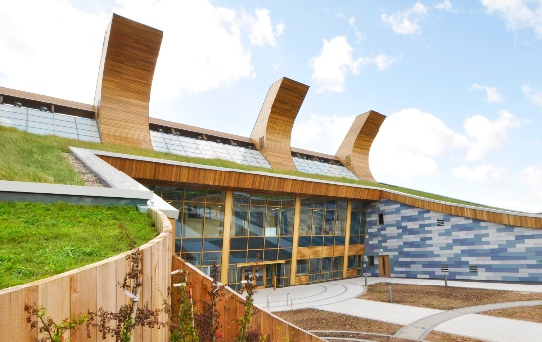
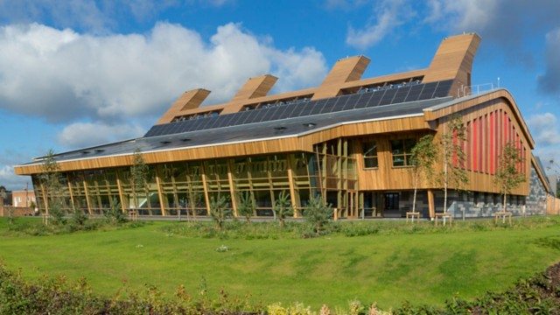
Figure 8 - GSK Lab South view (Henkel, 2023)
Figure 9 - GSK Lab North View (Henkel, 2023) Figure 10 - GSK Lab East View - (Henkel, 2023)

7.1 - Structure
Rather than just use sustainable materials the contractors gave thought as to where they would be sourced and what could be reclaimed from the site or previous construction projects on campus. A selection of local and reclaimed materials was used and coupled with offsite manufacturing for a modular design, which allows for quicker assembly on site, unhampered by weather conditions, and reducing injuries throughout the construction in a controlled environment, ensured that waste was minimised. (bmtrada, 2019)
The timber frame was created with glulam (glued laminated timber), which is a combination of timber pressed in opposing directions and glued together creating a strong, sustainable product weighing 1,396 tonnes. This is addition to the CLT (Cross Laminated Timber) used for the floors, structural walls, and roof deck. The timber used in these products is from PEFC-FSC certified, (or more commonly known as ‘managed’) alpine spruce timber sourced from Austrian spruce forests, containing extracted carbon from the atmosphere to a value of 1,600 tonnes. (Arnott, 2016)
Although a steel structure was not used, fixings of the beams were steel dowels covered by oak plugs to create a seamless timber structure whilst protecting the steel from fire, and allows for any movement or construction tolerances. (bmtrada, 2019)
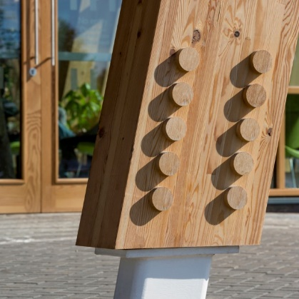
Figure 11 - Showing the steel dowels and Oak plugs - (Henkel, 2023)
This choice of material although meeting its green credentials came under re-consideration when a fire burnt the entire structure to the ground just a few weeks into the project. At this point the fire retardant had not yet been installed so the damage was total. Despite the setback the contractors salvaged what materials they could and rebuilt with haste. It is believed that without the fire, the building would have achieve its goals of being carbon neutral within 10 years rather than 25. (Northumbria University, 2014)
Using CLT as a structural product allowed the designers to offset the vibration caused by in-lab machinery, and a perfect material to create the large structural bays and internal divisions, allowing the layout to be flexible, creating smaller spaces with lightweight dividers and future adaptability. All services where pre-planned and cut, ensuring the timbers integrity by removing any notching later in the build process.
For the walls and roof, wood fibre (waste wood – sawdust, chips, off-cuts – from the sawmill industry) was used for insulation. It is a raw material/untreated softwood that is deconstructed to a fibrous condition before being formed into boards or quilts of natural insulation. Glue can be added before being pressed and if natural glue is used this can be released through the heat process involved in the pressing. It can also be treated to prevent it being consumed by animals and fire resistant so that it will char and not burn. (Home Building, 2022)

7.2 - Design & Finishes
The design best suited to meet the main needs was a horseshoe, which would allow the services and ventilation systems to be looped around the building. (bmtrada, 2019)
From a design aspect timber gives a warm affect as a final finish, delicately varying in colour rather than a large colour block. It also reduced the need to plaster and paint which will require ongoing maintenance, increasing the carbon deficits. Some other final finishes were natural rubber floors which maintain heat and low VOC (Volatile Organic Compounds) paints, which contain the minimum amount of solvents for paint to adhere and protect. (bmtrada, 2019)
Other design aspects include large double glazed curtain windows to the rear of the building which is south facing to capture daylight and heat into an area known as the winter garden. With its double height ceiling it ticks two of the architects trifector; light and height. Natural ventilation was used for the open plan laboratory and collaborative spaces. This was achieved via four tall prefabricated towers. To force air into these towers the design was curved creating pressure at the ridge. This air would be fed into heat exchangers providing heat recovery. (Arnott, 2016)
Figure 12 - Natural Ventilation Towers - (Henkel, 2023)
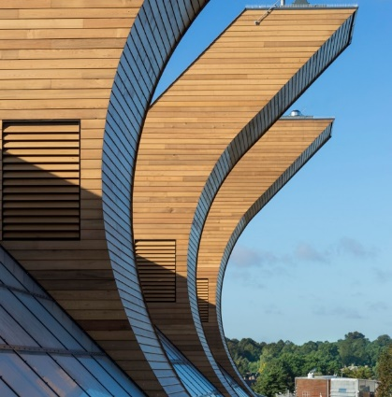
Mechanical ventilation would be required to remove any hazardous fumes when conducting tests, therefore the extraction cupboards will also benefit from the towers forced air, and only use fan assistance during emergencies. There is an onus on the students/staff to consider conducting tests that would be safe in the naturally ventilated environment. (bmtrada, 2019)
Externally, part of the finishes included a wall clad with a rainscreen of western cedar boards, which is on the most durable softwoods, due to its hard-core properties, which resists twisting, bowing and contains oils that help preserve its integrity and deter insects. This oil defines cedar by its smell and is known as “non-resinous” meaning it is accepting of many finishes. Using terracotta single fired panels as a curtain wall fenestration, provides a thermal performance through maintaining heat loss, but resistant to solar heat and water/rain. With its low cost and being a natural material, it was an ideal choice to feed into the sustainability of the build. (Whitehouse, 2017)
As part of the initial brief or encouraging biodiversity back to the site, the lab incorporates a green roof. Which is located on the North side of the building and sweeps around the main entrance, creating an inviting space, which is part sheltered by the roof to allow for outdoor seating away from winds. The green roof also slows down the process of collating rainwater by feeding the grass, and any excess is dropped into waster saving storage units. It is likely wildflowers and wildlife will return to the green roof overtime. Another feature of the green roof is that it incorporates the surrounding landscape, making it non-intrusive on the eye creating a biophilic design.

7.3 - Interior and Technology
Within the building the windows have been set into the façade, giving them natural shade when required from strong solar heat, whilst protecting the glass and fittings from the elements.
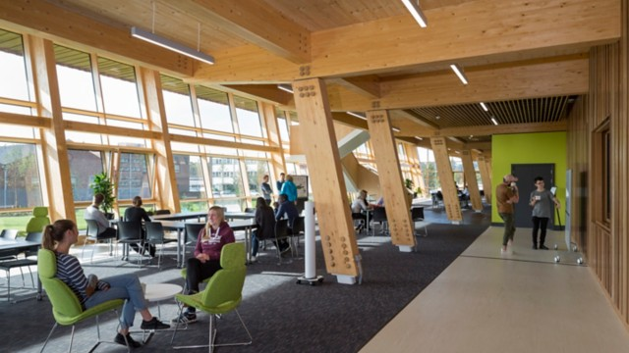
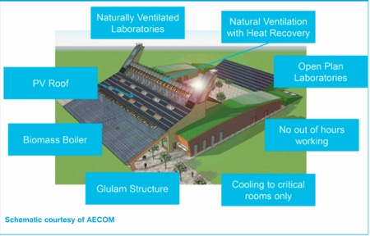
Making use of the timber beams, LED lighting has been attached and used throughout the building, with an output at an average of 5.4 watts per Sq.m. LED builds use much less energy than traditional lighting methods and therefore it is estimated the building will save 60% of the power. (bmtrada, 2019)
Figure 13 - Winter Garden - (Henkel, 2023) Figure 14 - Building overview - (Henkel, 2023)
These savings will be supported thanks to 230.9 kWp array of solar panels attached to the southside of the building set at a 45-degree angle for maximum output. Coupled with a 125kWe biofuel heat and power system (CHP), fuelled by a secret blend of organic liquid materials, which the team claim is diverting material which would otherwise become waste which can send any surplus heat to other building on the campus. Therefore, they estimate the building will use only 15% of the of heat required for a traditional build. (Arnott, 2016)
In the absence of a sprinkler system the contractor has used fire resistant materials or coatings and has installed water saving strategies including a leak detection system to reduce waste and receive early warning of a flood or leak. All water usage is metered on the same system for an overall insight into the buildings performance.
The building’s renewable energy supply offsets the (low) carbon associated with its energy efficient equipment and services, and construction, making it net-zero carbon and giving a 75% lower energy use than traditional chemistry laboratories. (Whitehouse, 2017)

8 - Conclusion
This £18m, 4,500 m2, BREEAM Outstanding/LEED Platinum wooden framed building deserves its accolades and in researching this paper the University has a well-managed and documented plan for the entire Jubilee campus covering all matters for sustainability, maintenance, security, biodiversity, and people.
It houses many bird boxes, uses a pump system to create flowing water in the onsite lake, reduces use of pesticides, has an on-site composting program, herb garden, water conservation and sustainable drainage systems.
It also has great links via pedestrian/cycle and public transport, allowing users to reduce their carbon footprint when attending site.
The university concerns itself with a long-term vision and building in a way that enhances its use for all.

9 - References

Arnott, A., 2016. The University of Nottingham’s Carbon Neutral Chemistry Lab, University of Edinburgh: Creative Commons Attribution CC BY 3.0.
bmtrada, 2019. GSK Carbon Neutral Laboratory for Sustainable Chemistry, High Wycombe: BM Trada.
DigiMaps, 2022. DigiMaps. [Online]
Available at: https://mapapps2.bgs.ac.uk/geoindex/home.html?layer=BGSBoreholes&_ga=2.85464857.1054021500.1672775488-1542209187.1672775488
[Accessed 12 11 2022].
Google Maps, 2009. Google Maps. [Online]
Available at: https://www.google.com/maps/@52.9508883,-1.1837979,3a,75y,117.79h,95.53t/data=!3m6!1e1!3m4!1s3wx8eUt_e9TX7lG1ISf20w!2e0!7i13312!8i6656
[Accessed 12 11 2022].
Henkel, 2023. University of Nottingham. [Online]
Available at: https://www.henkel-adhesives.com/uk/en/applications/all-applications/case-studies/university-of-nottingham-uk.html
[Accessed 12 11 2022].
Home Building, 2022. Home Building - Wood Fibre. [Online]
Available at: https://www.homebuilding.co.uk/advice/wood-fibre-insulation
[Accessed 12 11 2022].
Keller, 2022. Keller - Vibro stone columns. [Online]
Available at: https://www.keller.co.uk/expertise/techniques/vibro-stone-columns
[Accessed 12 11 2022].
Nanrah, G., 2021. Nottingham News. [Online]
Available at: https://www.nottinghampost.com/news/nottingham-news/what-like-work-raleigh-nottingham-4990725
[Accessed 12 11 2022].
Northumbria University, 2014. What Nottingham University fire means for timber-frame construction. [Online]
Available at: https://www.constructionnews.co.uk/agenda/what-nottingham-university-fire-means-for-timber-frame-construction-17-09-2014/
[Accessed 12 11 2022].
The Magazine of Lenton Local History Society, 2010. Lenton Times. [Online]
Available at: https://www.lentontimes.co.uk/streets/triumph_road.htm
[Accessed 12 11 2022].
Whitehouse, J., 2017. University of Nottingham - Jubliee Campus, Nottingham: University of Nottingham.

