










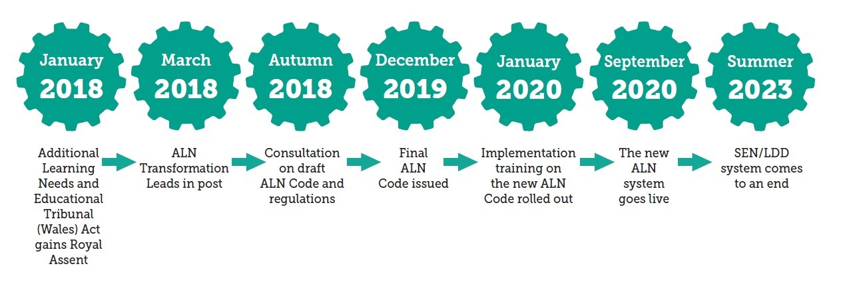


More information can be found at:
Welsh Government (2020) Additional learning needs (ALN) transformation programme. Available at: https://gov.wales/sites/default/files/publications/2018-09/additional-learning-needs-aln-transformation-programme-v2.pdf
Cerebra (2018) Special Educational Needs Reform in Wales. Available at: https://cerebra.org.uk/latest-news/special-educational-needs-reform-in-wales/

Cerabra (2018)
Introduction
Wales is about to implement a reform of the current SEN framework to a new ALN. The introduction of the Additional Learning Needs and Education Tribunal (Wales) Act 2018 will merge the current two separate systems of SEN in schools and LDD in further education into one statutory framework for all learners with additional needs for 0-25 years. (Snap Cymru 2021).
Placing the learner and their family at the heart of planning, intervention and decision making (Welsh Government 2020).

Google image (No Date)
ALN implementation timeline image Welsh Government (2018)
NEW ALN LEGISLATION IN WALES
Student Amanda Brown 1907463 Module Code EAEE6002
Person Centred Approach
Welsh Government (2018) state the aim of reforming ALN is to transform expectations, outcomes and experience learners have with ALN. The Additional Learning Need Code for Wales (Welsh Government 2021) supports practitioners to adapt a person-centred approach. Placing the rights and voice of a learners at the heart of discussion and decisions. Working together in collaboration to ensure that the best possible support is identified and delivered (Welsh Government 2021). A person-centred approach highlights a learner’s strengths and talents, empowering a learner (Mansell & Beadle-Brown 2002)

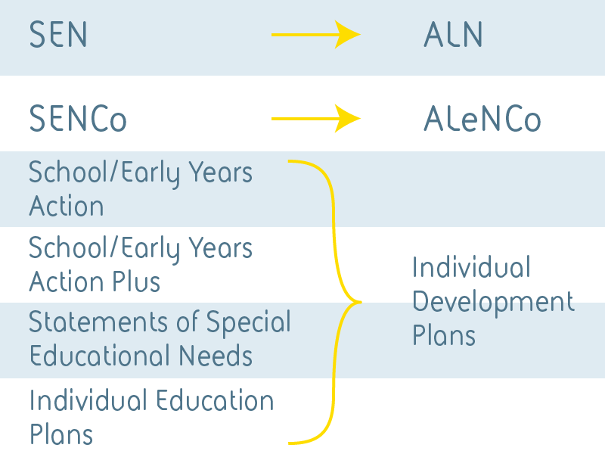
Special Educational Needs (SEN) to Additional Learning Needs (ALN)
The introduction of The Additional Learning Needs and Educational Tribunal (Wales) Act 2018 will bring a change in terminology used. Special Educational Needs will be replaced wit Additional Learning Needs or ALN (Welsh Government 2018). This will affect policies, procedures, guidance use and completion of supporting documents. The new ALN legislation and code will change the current Individual Education Plans (IEP’s) and statements of SEN into Individual Development Plans (IDP’s) (Cerebra 2018).
The welsh Government (2018) aims to implement the introduction in a phased timeframe with the new legislation and code running in parallel to the existing SEN framework.
It is not just a change in name, the role of the current SENCO will change. As will the expectation for practitioners (Welsh Government 2018).

Conclusion
The reform of the ALN system if Wales is imminent. Welsh government have taken time and consulted constantly to ensure that the reform being introduced are robust, effective and fit for purpose. Practitioners should feel confident that the changes are intended to support and enhance the provision for learners with ALN. The single legislation will provide continuedly for learners and ensure support is provided post 16. The new ALN legislation will ensure each learner is supported holistically and appropriately for their needs by everybody that is involved.

Google image (No Date)

