Certificate of Higher Education
in
Skills for the Workplace

STUDENT NAME: DIANA LAWRENCE
STUDENT NUMBER:1906445
MODULE: DIGITAL SKILLS AND RESEARCH METHODS
MODULE CODE: BMSW4003
MODULE LEADER: PAUL RANSON
ASSIGNMENT TITLE: COMPONENT 2 RESEARCH METHODS

CONTENTS PAGE No:
Contents 2
Aims 3
Objectives 3
Indicative Content 3 - 4
Introduction 4 - 5
Title Page 5
Angela Duckworth 5 - 6
DIKW Hierarchy Triangle 7 - 8
Collection of Data 8
Data to Information 9
Knowledge 10
Wisdom 11
Conclusion 12
References 13

AIMS
- To verify Angela Duckworth’s credibility by using the CRAAP test
- To conduct research by collecting and examining primary data and comparing it to secondary data conducted by UWTSD to evaluate the possible outcomes.
- Processing raw data through Ackoff’s DIKW model

OBJECTIVE
- To assess and validate without prejudice if Angela Duckworth’s claim on having ‘Grit’ increases students’ academic levels and to if this is an effective course of action for students here in the UK.


This is a complete overview of my presentation which was compiled in PowerPoint
Introduction
Title
Overview of Angela Duckworth
- CRAAP test applied
Overview of Russell Ackoff’s DIKW Hierarchy its application, and processes through the hierarchy:
- Data
- Information
- Knowledge
- Wisdom

Collection of Primary Data
- Demonstrating use of Microsoft Forms
- Designing questionnaires
Primary Data to Information
Data inputted to Excel to create information adding value making it more useful by:
- Sorting
- Averages
- Charts
- Collating
Knowledge
- Drawing comparisons between primary and secondary data
Wisdom
- Making judgement and decisions
CONCLUSION
My views.


I am a student of UWTSD who is researching materials of how using 'Grit' which was developed by Angela Duckworth, who in her TED lecture indicated having 'grit' improves students academically (TED, 2013). Duckworth's ‘Grit Scale’ survey has a series of ten statements that have multiple choice answers for individuals to answer which is then processed to produce a result on the scale between 0 – 5 with 5 being the highest which determines how gritty a person is to be successful in life. The higher the score the grittier and more successful, the lower the score indicates not being so gritty or successful. Duckworth made mention that IQ amongst other factors was not one of the significant predictors for success (TED, 2013). Does this then question the IQ test? Which was designed to measure intelligence, is well known worldwide and has been around for many years (Cherry, 2020). However, Duckworth’s studies have shown that if students who are gritty within themselves apply it to their studies, can improve on their academic levels.
I will be conducting a survey on ‘Grit’ to examine if this concept would benefit students in the UK. I have learnt to use a range of Microsoft tools that will assist me in my research. Microsoft PowerPoint, Forms, Excel, and Word. I will use Microsoft PowerPoint to create my presentation.
Information was sourced by researching, journals, TED lectures, website, and books.
The methodology used:
CRAAP is an acronym for Currency, Relevance, Authority, Accuracy and Purpose (UWS, 2021). It assists me to research the credibility of Duckworth providing answers to questions of who? What? When? Where? and why? Evaluating the information found. The CRAAP test will help me determine if Angela Duckworth is a credible source.
- Questionnaires to gather raw data
- Application of Ackoff's DIKW (Data Information Knowledge Wisdom) method turning primary data into information, knowledge, and wisdom
- Analyse primary data and compare it to secondary data finding any trends
- Draw conclusions on any outcomes that may exist


Title page

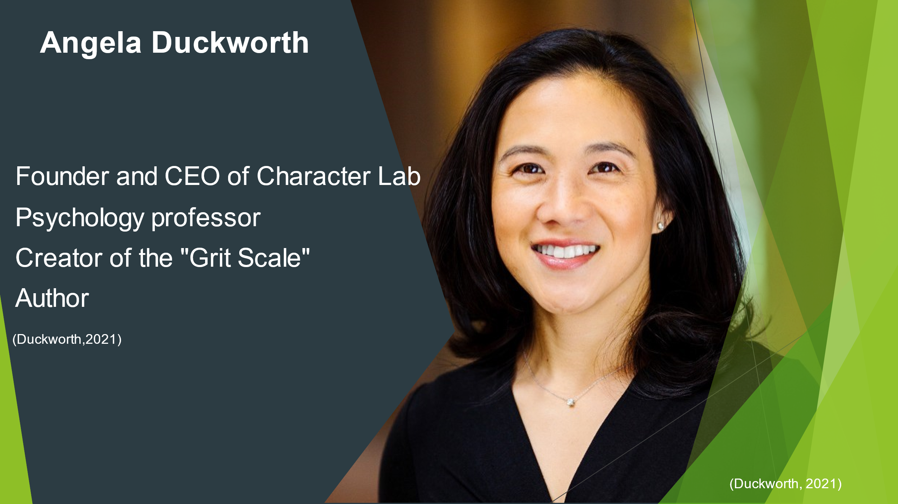
Angela Duckworth formally a maths and science teacher, now a professor of psychology, who is current in positions within higher education institutions (Duckworth, 2021b).
The construct of ‘Grit was introduced by Duckworth who appeared on a TED lecture, Grit: the power of passion and perseverance (TED, 2013).
Duckworth passes the CRAAP test, and my reasons are as follows:
Currency
- Appeared on TED (TED, 2013). Which shows a high respect for her academic credibility and ability to inform and inspire others
- Achieved peer-reviewed publications
- Received The McArthur Fellow Award 2013
- No.1 New York Times Best Seller (Duckworth, 2021c).
Relevance
- I am conducting research to show if this approach can improve student academic levels by achieving better outcomes for success in the future
Authority
- Author of GRIT: The Power of Passion and Perseverance, and twelve other books and has written chapters (Duckworth, 2021c).
- Renowned for advising top CEOs of large corporations listed within the Fortune 500 in the US, The World Bank and NFL and NBA teams (Duckworth, 2021c).
- Affiliated with academic institutions in the US (Duckworth, 2021b).
Accuracy
- Duckworth conducted research within different settings. At West Point Military Academy, it was found that cadets who were likely to complete the course of training were found to be grittier as they had self-control than other cadets. In Scripps National Spelling Bee grittier children out lasted their less gritty competitors. Different age range adults from 25 years up associated with higher education were studied to see if grit grew with age, it determined higher educated adult had more grit than those with less education (Duckworth, Kelly, Peterson, and Matthews, 2007). Duckworth also conducted studies in schools.
Purpose:
- Recognised some students were not being academically successful despite being talented and having high IQs (TED, 2013).
- Wants to implement changes towards student success in education obtaining academic resilience and long-term goals in other areas of life regardless of socioeconomic status or cultural background

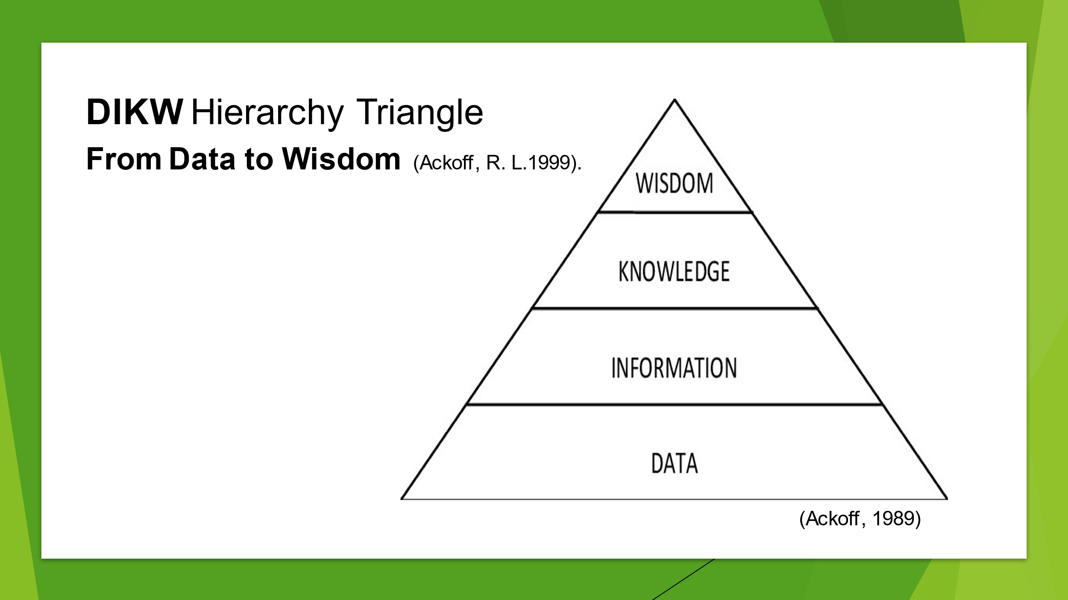
The method I will apply to check the accuracy of Angela Duckworth’s work on ‘Grit’ is Russell Ackoff’s approach to research using the DIKW model. Ackoff's paper ‘Data to Wisdom’ formulates the (DIKW) model Data, Information, Knowledge, Wisdom, and the relationship between them (Ackoff, 1999). This model is a tool that is used to gather information in a series of processes for the purpose of conducting research. It explains how data is brought through that process from beginning (data) to reach the end (wisdom). In each process questions are answered about the data which adds value to it.
The methodology used in applying Ackoff’s DIKW model.
DATA
- Collected quantitative primary data which had no structure to it because it is unprocessed, and not yet analysed
- Examine the data eliminating any errors
INFORMATION
- Input the data into excel to create a chart which will be a scatter diagram so that the data can become meaningful. Examining and measuring to extract the information whilst comparing it to the secondary source
KOWLEDGE
- Consider the comparisons between both graphs by comparing the findings from the primary data with the secondary data source looking for any trends that may emerge
WISDOM
- Consider the outcomes of my findings for example, make decisions from my judgement for future planning, or consider further research


The first process - Data.
In a class of around 25 students together we created a survey using Microsoft Forms which was distributed within the university. Personal information not collected as the survey was anonymised, we followed the guidelines of the GDPR on data protection (GOV.UK, 2018).
Primary data was collected based on two questions posed in the survey.
- What is your academic level?
I selected this question based on the UK government’s definition of ‘Academic Level,’ who in recent years have changed the qualitative distinction of named certificates and have related them to a numerical value e.g., an achievement of a Bachelor of Science (BSc)Hon, is equivalent to a level 6 (GOV.UK).
- After completing The Grit Survey on Angela Duckworth’s website what was your Grit Score?
The Grit Score completed by students who went on Duckworth’s website answering ten questions, to receive a Grit Score between 1 – 5.
Duckworth’s research is qualitative to begin with as the survey askes questions around the descriptive characteristics of a person so therefore has no numerical value until the score is produced then it becomes quantitative and can be measured. I have coupled the findings of the grit score alongside the academic levels of the UK to be measured.

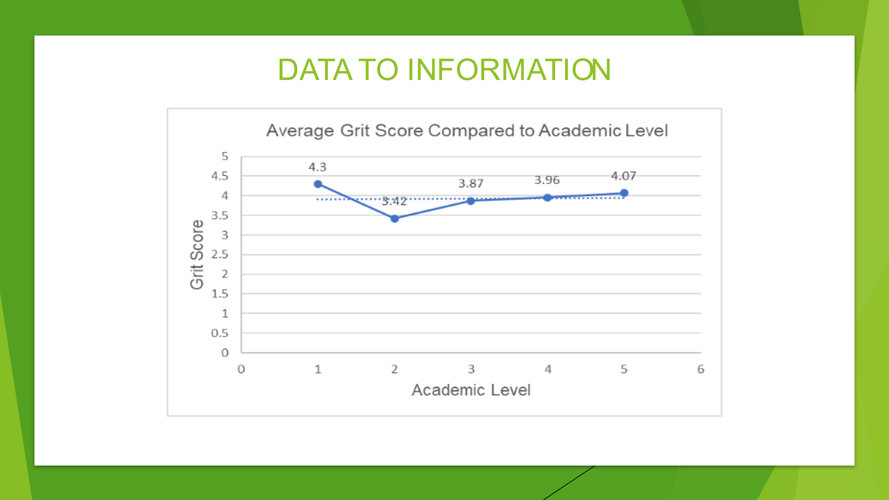
The second process - Information
Primary data was inputted into Microsoft excel, cleaned, and checked for errors, sorted into their individual groups; then averages were calculated, the two sections were highlighted, and the scatter chart was selected putting the grit score on the y-axis versus the academic level on the x-axis., and the data plotted on the graph. The y-axis numbers were changed to reflect the grit scale; numbers on the x-axis were automatically generated as was the trendline; titles were added.
I experienced from my analysis that the trendline shows a slight increase though very minimal on the trendline and it would seem not to have much baring in comparison to Duckworth’s work. However, level 1 was identified as grittier than those who were academically higher at level 5, although a steady incline was emerging above the trendline. On an overall average of 3.92 I would estimate that students were quite gritty with a likelihood of increasing in the future.
The Office for National Statistics produces statistical information collected from primary data provided by the Census questionnaire. The data is processed to supply information (secondary data) (ONS, 2011).
For example,
- Businesses rely mostly on secondary data for their own research purposes (Maud, Schriek, and Tinkler, 2017, p.158). E.g., looking at the trends of consumer spending to ascertain supply and demand as it can affect the economy if they do or do not spend
- Government bodies to set policies
- It allows them to see what resources and services are needed in communities,
- Enables decision making and future planning (ONS, 201).

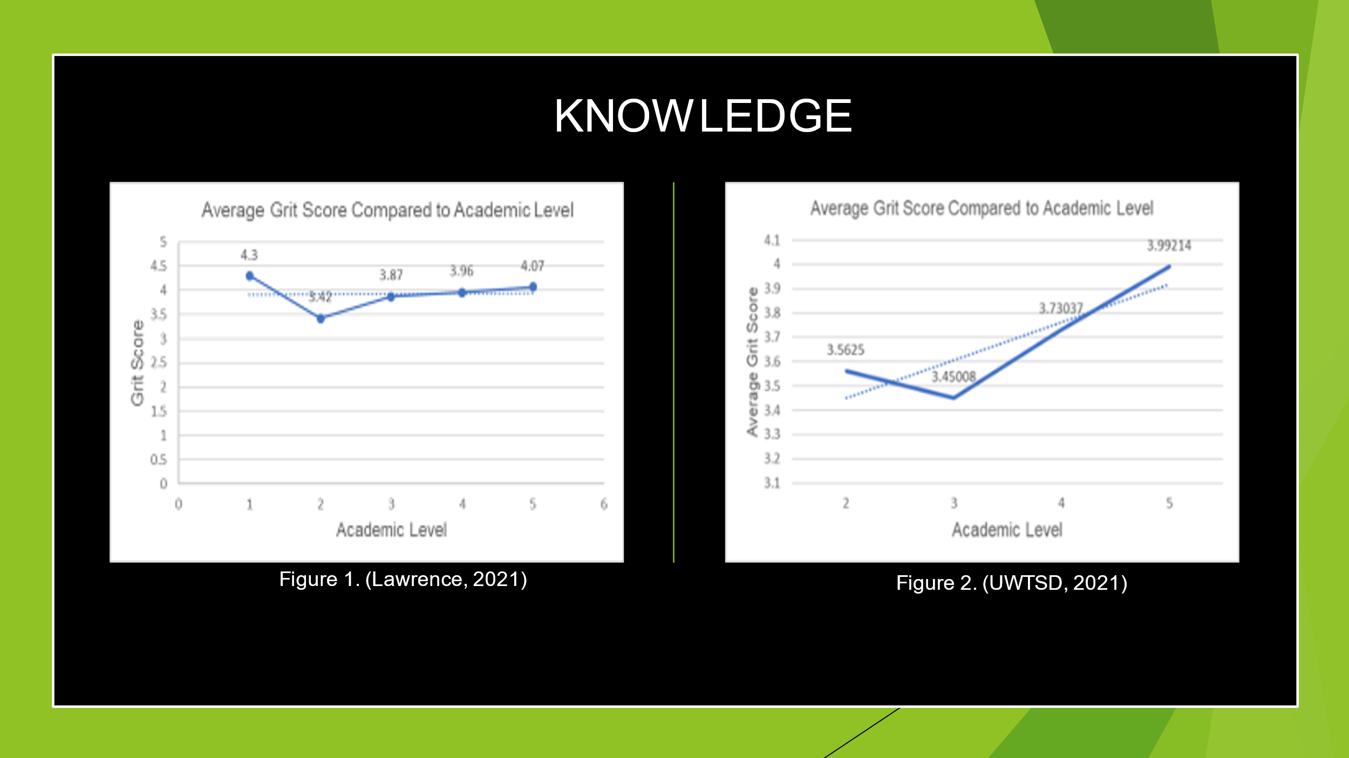
The third process - Knowledge
I compared the primary data to the secondary data researched and prepared by UWTSD in 2020 on the same subject matter of ‘Grit’ and ‘Academic Levels.’ When analysing the secondary data, it was evident the trendline across the x-axis showed a steep upward incline on the y-axis. It clearly identified the higher students achieved academically the higher the grit score, which seemed to suggest that Duckworth’s claim regarding having grit for academic success is accepted, as the trend supports research done by Duckworth, although her research was done on a significantly higher scale. Both data showed the grittiness of students with an overall average of 3.68 for the secondary data was compared to the 3.92 average of the primary data. This showed that since 2020 there has been an increase in being gritty. Though I agree with Duckworth, it does however argue the point that more research is needed to qualify the findings as the evidence is weak, my research was conducted with only a small fraction of people.

The fourth process - Wisdom

Ackoff also, considered ‘wisdom’ to be ‘permanent and that wisdom can only come if knowledge and understanding is achieved from the information supplied by the data, helping to make decisions from judgements made (Sharma 2008).
In my judgement Based on the research and the evidence produced from both primary and secondary data, was not enough to be justified to conclude an outcome. My survey was not on a great scale to make it credible therefore, further research needs to be conducted with a significant amount of primary data to make it justifiable.
When conducting further research other factors should be considered as with Carol Dweck’s ideas on ‘The Power of Yet’ and ‘Growth Mindset’ (TED, 2014).
Which are components to help in the development of functions of the brain which in turn works alongside the building of grit as was suggested Duckworth in her TED lecture (TED, 2013).

Considering the outcomes from the data being gritty to achieve academic success seem to be a way forward for the future though other should be considered such as, cognitive training to improve cognitive abilities and mind development to further strengthen and enhance academic skills. Developing grit is just another component to strengthen, assist and enhance student abilities for academic success.
To improve academic abilities for the younger generation these concepts should be adopted to improve their cognitive development. But where does it begin? Having a solid foundation in early years learning is fundamental for later life, even from inside the womb as studies have shown that babies hear from around 7 months. From that point learning can begin, so the first responsibility falls on parents as parents are the child’s first teacher.
Also, implementing these concepts as part of the framework within the UK education system in schools would have an impact on student learning in general, by helping students to become more resilient and successful in achieving more higher academic levels and their long-term goals in education, employment, business, and life in general. So, yes being gritty coupled with other characteristics can hang with other keys to success.




