5/11/2020
Maris Garuba (1910039)
UNIVERSITY OF WALES TRINITY SAINT DAVID LONDON CAMPUS

Maris Garuba (1910039)
UNIVERSITY OF WALES TRINITY SAINT DAVID LONDON CAMPUS

PROFESSIONAL CAREER DEVELOPMENT
MODULE: BMSW 4005: REPORT ON THE PERSONAL REFLECTION ON CAREER DEVELOPMENT, WITH EMPLOYMENT GOALS, PERSONAL AND PROFESSIONAL DVELOPMENT PLANS

LECTURER: JOY BOTU

PROFESSIONAL CAREER DEVELOPMENT
MODULE: BMSW 4005: REPORT ON THE PERSONAL REFLECTION ON CAREER DEVELOPMENT, WITH EMPLOYMENT GOALS, PERSONAL AND PROFESSIONAL DVELOPMENT PLANS

LECTURER: JOY BOTU

Contents
PROFESSIONAL CAREER DEVELOPMENT 0
PROFESSIONAL CAREER DEVELOPMENT 0
INTRODUCTION 2
BACKGROUND 2
THOUGHT AND FEELINGS ON THE FIRST DAY AT UNIVERSITY: 2
PERSONAL LEARNING STYLE 3
KOLBS EXPERIENTIAL LEARNING CYCLE 3
HONEY AND MUMFORD 5
ACADEMIC SKILLS ACQUIRED 7
GOAL SETTING 8
PERSONAL DEVELOPMENT PLANNING 9
PROFESSIONAL DEVELOPMENT GOALS IN PREPARATION FOR THE WORLD OF WORK 10
PROFESSIONAL DEVELOPMENT PLANNING 12
STUDY AND QUALIFICATION 12
SKILLS REQUIRED FOR NURSING CAREER 12
A good nurse must be able to find out about patients, fit information together, treat and care for them effectively. You must be able to manage any situations without letting your feelings get in the way 14
SALARY EXPECTATIONS 14
EMPLOYABILITY 14
Private health care provider nurse 15
NURSES CODE OF PRACTICE 15
EMPLOYMENT LEGISLATIONS 16
The Equality Act 2010 is the main piece of legislation in the United Kingdom overseeing discrimination. 18
CONCLUSION 18
REFERENCES 19
APPENDIX 19

INTRODUCTION
The aim of this report is to write a personal reflection on my career development, outlining the skills and knowledge contributory to working effectively. I will be using different models such as VARK, Kolb and Honey and Mumford to reflect on my learning styles. The report will also set out anticipated employment goals in preparation for the world of work and develop an action plan to meet the set goals. I will be assessing a wide range of secondary informed and relevant materials for my chosen career. These materials will include: journals, articles, books, and university libraries. I will also highlight the challenges faced, and how they were overcome.
This report is important because it will afford me the opportunity to self-evaluate myself, identify my strengths, weaknesses, threats and opportunities available to me, know the legislative laws guiding employment and over all be ready to pursue my set goals.

BACKGROUND
Journey so far:
In 2018, the loss of my sister to cancer, who was a nurse and had barely started working after graduation, prompted me to do something with myself. I had started a nursing studies course back in Ireland but due to relocation to London, and the time it took to settle into the system, my ambition to go further with my studies was put on hold. I started working part time as a care assistant, under took one or two levels two and three courses on the side but I felt unfulfilled. I finally took the bold step to research for what it takes to start a university course in the UK. That began the start of a great journey.

THOUGHT AND FEELINGS ON THE FIRST DAY AT UNIVERSITY:
Woke up about 6:30am and felt nervous about starting the day in a university. My kids gave me a little pep talk and said I would be OK. I walked down to the train station with one of them, even though we were going in opposite directions. She bid me a “good luck on your first day” as I boarded the train.
Got off at London Bridge station and an announcement came over the intercom that buses were not running via London Bridge due to the Extinction Rebellion protests. It was raining and the umbrella I had got broken while walking from London Bridge to Bank station to get the train to Chancery station. I was all wet, angry, and cursing at those protesting. I boarded the train at Bank station, got off, asked for directions to the university, met another student also going the same direction, got to the reception, presented my ID as requested by the receptionist, who looked at it, and directed me to the second floor which was room L21. Got to the classroom, sat down right in front, looking around to see if I could recognise anyone as the classroom filled up with students. With a nervous smile, and a bit of a hand-wave, looks were exchanged. The lecturer came in, introduced herself, and welcomed everyone to the university. She talked slowly, and calmly, asking each one of us to introduce ourselves. She did the register and explained the rules regarding lateness, absence, and the consequences. The first lecture lasted about two hours with a 15-minute break in between. Second lecturer came in and we had to repeat the “introduce yourself” process. I found it difficult to navigate the various log ins, but there was support from the technical department. We had a lot of information to process, and I had a feeling of anxiety as I tried to take in as much information as I possibly could. I did a tour of the building, found where the toilet, computer labs, student common room, student services, and library were situated. The day came to an end and we all filed onto the entrance of the building in groups, taking about the first day. Overall, I was happy to be back to school to pursue my dream of becoming a qualified adult nurse. Using this as an exit course at the University of Wales, Trinity Saint David.

PERSONAL LEARNING STYLE
Learning style is described as the way an individual can relate to the lesson taught (Morgan, 2017). It is well established that students have individual learning preferences and these can be best assessed using VARK questionnaire to find out a preferred style including visual, auditory, read/write and kinaesthetic. I will be using the following models to analyse my personal learning styles such as: Honey and Mumford (1986) and Kolb’s learning style,
Model one:

KOLBS EXPERIENTIAL LEARNING CYCLE
David Kolb’s (1984) Experiential model of learning is because in learning a new skill, we go through four stages, which are
Experience: For me to gain this experience and improve on my skills, I must attend a University, attend lectures, carry out research and complete all assessments as requested.
Reflection/Observation: Reflection is guided by the process of what was done, how it was done, mistakes made, what could have been done better and find areas to improve on. Looking back to what I have done so far, I have been able to reflect on some areas that I have excelled and identify other areas that needed more efforts. I could have managed my time better by planning and starting out on my assignments earlier than I had done, instead of leaving it to the last minute. I could have also been more confident in taking up the offer to start a University course instead of working part time as a Care Assistant due to family commitments. This is even made worse since I had started the process by during an Access to Nursing course in Ireland before relocating to London.
Theory: Thinking back to the decision I took before and during my studies, I would have done certain things differently. Though working afforded me the opportunity to gain valuable experience, but it cost me some years doing zero-hour contract jobs and on low pay. I could have earned more if I had the relevant professional qualifications and skills.

Experimentation/planning: To do better in my next endeavour, I would take time to reflect and think about the changes needed to bring about better result, by implementing changes needed for improvement.

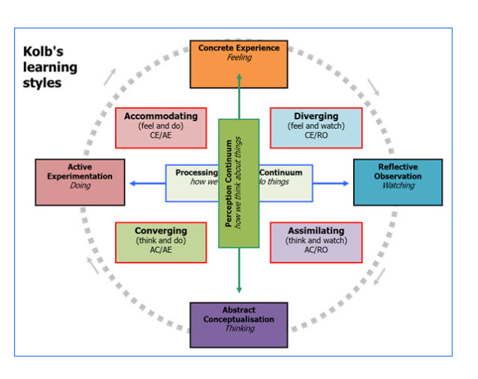

HONEY AND MUMFORD
Honey and Mumford (1986) suggested that we learn in four different ways and I will be using this model for self-evaluation. Per the definition by Cottrell (2010), self-evaluation is defined as the process of measuring personal performance and behaviour, identify strengths and weaknesses and devise ways to improve on the highlighted areas of failings.
ACTIVISTS
These individuals learn by having an active participation in tasks set. These tasks are relatively short term based.
REFLECTORS
They prefer to think, review and reflect on things before acting. They usually stand back, listen and consider the next steps to take.
THEORISTS
These sets of individuals learn by taking on new experiences.
PRAGMATISTS
They learn by linking between new information and connecting it to real life
problems

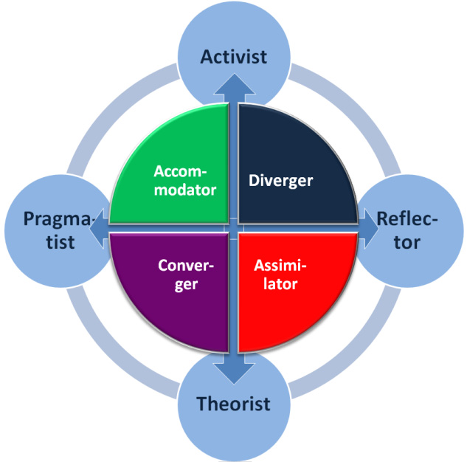

To evaluate my current learning style, I will be considering areas of strengths, weaknesses, opportunities and practical steps to address them. From the in-class exercise conducted, it is apparent that I could identify with each of the four steps and I would be approaching tasks by adopting the best style to improve my performance.

LEARNING  STYLE | STRENGTHS | POSSIBLE WEAKNESSES | WAYS TO IMPROVE
Activists | Learn by doing things. Prefer to get on with things | Doesn’t consider at what cost the job gets done. Prone to risk taking | can balance this style by taking a step back to consider risks involved.
Reflectors | Very thoughtful as learning is done by observing, listening and reviewing things. Good problem solver | Considered a day dreamer. Rely on feedback from other before acting. Seen as indecisive | Speak up in group work, presentation
Theorists | Very precise and tend to be perfectionists. Disciplined and keen to base assumptions on theories. | May be indecisive and not living in the real world | Will learn to make decisions more realistically
Pragmatists | Like new ideas, actively participate in discussions | Too much focus on techniques rather than people or policy | Avoid short cuts.

ACADEMIC SKILLS ACQUIRED
The following are some of the academic skills I have developed to enable me learn efficiently:
- Organisation
The first step to an effective study is to get organised. I have been able to acquire some organizational skills needed to effectively study. These include knowing where and when to do my study and who to contact for support.
- Time Management
It is a fact that if you manage your time badly, it will lead to less productivity, thereby leading to stress and anxiety. I have learnt to adopt the 80/20 rule by outlining the importance of a personal study plan, setting goals and prioritising my time.

- Sources of Information:
To write a good report and essay, knowing what is meant by primary and secondary documents and how to source for information using online sites and library are very important.
4 Effective Reading;
I have been able to develop my reading skills by reading lots of information, form links, able to understand opinions and put into perspective relevant research and ideas.

5 Reference :
Academic referencing is a skill which is crucial and an important skill in the life of a student. I have been able to carry out secondary researches and reference my work using Harvard style of referencing.

GOAL SETTING

In setting my career goal, it will be using the SMART acronym as a guide:

SPECIFIC:
It entails what exactly you want completed. As a future career, I want to be a qualified professional adult nurse. I will need to improve on my empathic, communication, time management, cultural awareness, professionalism and above all attention to detail skills which is essential for this field.

MEASURABLE
The ability to know whether the set goal has been completed. I will attend seminars, read extensively to acquire more words, attend workshops related to communication, participate in debates to improve on my communication skills. I order to improve on my time management skills, I will be setting priorities and planning my day’s activities using diaries, planners, notes and setting reminders. I will be doing a review at a set time.

ACHIEVABLE

I will be measuring the effectiveness of my strategies to achieve my specific tasks such as undertaking relevant training and courses. I will be making use of available resources at my disposal, managing my time, facilities, and other commitment I might have made.

TIME
To fulfil my lifelong dream of becoming a professional nurse, I would be setting my target in achieving this within the next four years. This will be followed with the development of skills and qualifications needed to achieve this goal.

PERSONAL DEVELOPMENT PLANNING
Personal development planning are plans intended to develop skills that are considered unnecessary for working life (Morgan 2017). Planning for anything in life means finding the gap between your present position and finding ways to move to the next step. I will be working to improve on the following skills and behaviours as reflected in the table;
Skill/behaviour | Action to take | Available resources | Date for action
Presentation  Skill with regular use of eye contact | Practice often, read books and watch videos on presentations.  Join debate clubs  Develop checklist | Books on presentation, online resources, | On going
Team work | Be objective  Listen to team members  Read materials on team building  Give constructive criticism | Seminars,  Books  Interactive score board  Team building exercise | On going
Communication | Be assertive  Listen actively and communicate effectively | Attend workshops on communication | On going
Time management | Prioritise  Stay overtime if possible  Stop procrastinating | Diaries  Planners  Notes  To-do lists | On going
Planning | Set appropriate to begin  Create rota of  Activities | Books on planning and organisation | On going

PROFESSIONAL DEVELOPMENT GOALS IN PREPARATION FOR THE WORLD OF WORK

The following are some Professional Development Goals to work towards in preparation for the world of work.

- Learn a new skill
To improve on my existing skills that would put me ahead of my peers and help to be more productive, I would be learning a new skill such as technical writing to improve on my writing ability. This will enable me to write better cover letter and resumes. Plans will be put in place to start this process.
2. Start networking. Networking is a vital tool for career development. Networking involves the ability to build and maintain a mutual and beneficial professional working relationships. Networking opens opportunities to work with different people from all works of life and ideas, advice and support are exchanged. It is a about developing a social and professional connections for exchange of information. Having a viable, good and strong networking abilities can help promote my profile and open more opportunities for me.

3 Read more

Reading is an underestimated and overlooked skill to acquire. It has a massive impact on one’s career as a study pointed out that the average CEO reads about 60 books in each year and 88% of successful individuals reads for 30 minutes a day. I will be taking up reading to improve on my vocabulary, improve my writing and analytical skills.

4. Improve work life balance

Creating a healthy work life balance is essential to leading a happy and productive lifestyle, it can have positive effects on your wellbeing and even your work. Build realistic boundaries between work and your personal life, whether that’s sticking to an 8-hour working day, not taking work home or by fighting the impulse to check work emails on your day off. Employing these tactics will help prevent burn out and you’ll probably find you get more done when you are at work. Work smarter, not harder.

5 Challenge myself
To prepare me for the world of work, I will be challenging myself by believing in my abilities and build my confidence. This will enable me to step out of my comfort zone and take up challenges which were daunting and inaccessible. It is acceptable to make mistakes, correct them and find ways to improve.
6 Work on my weaknesses
I will learn to work on myself as professional development is not only working on one’s strengths but the ability to identify and work on one’s weaknesses. This will help prepare me for the world of work.
7 Good organisational skills
To reduce stress and increase productivity, I will be maintaining a clear and decluttered work desks, set priorities, plan schedules and set goals using the 80/20 rule.
8 Improve communication
Having a good communication skill will help in virtually all facets of one’s life from professional to personal. This will help in the ability to relate with colleagues, superiors and open more opportunities.

PROFESSIONAL DEVELOPMENT PLANNING
I have always had the desire to be a nurse and I have chosen this path as a career. I initially started the journey of becoming a nurse by doing an access to nursing back in Ireland and did a work experience in a nursing home as the only hospital was an hour away from where I lived. I enjoyed looking after the vulnerable adults I supported and this experience encouraged me even further to pursue my dream.

STUDY AND QUALIFICATION
To carry on studying nursing in the UK there are two roots currently acceptable. These are either a level qualifications or an access to nursing course. It is better to find out what subjects you would need to be studying and the number of credits required for your UCAS.
Experience:
You can begin your training with no experience and to acquire the knowledge and required experience, it is essential to get your hands on giving care to determine if the job of a nurse is suitable for you. If you can change the patient that is incontinent and distressed and you can reassure them rather than thinking of how gross and daunting the job is, then you can be confident you are doing the right thing.
NHS and some care home providers often take on inexperienced staff and train them up to be health care assistants. This often is a good and exceptional ground to develop essential skills, reduce the shock value of future placements when proper nursing training begins.

SKILLS REQUIRED FOR NURSING CAREER

Below are some of the skills needed to pursue a career in nursing.
Excellent people skills:
You must be able to put people at ease, gain their confidence and can deal sympathetically and empathetically with their fears and worries.
Good observation and communication. The key to good nursing is communication and good observational skills. You must be a good listener as well as have good talking skills. You must be at constant alert to changes in patients’ conditions and provide quality care.
Can offer advice and answer questions. As nurses are a regular point of contact for patients, it is essential to be able to answer questions, share knowledge, skills, observations and experiences with both patients, their families, and friends.
Work as a team: you must be able to work as part of a team because nursing consists of a multi-disciplinary team including: doctor anaesthetics, physiotherapists, dietitians, pharmacists, clinical, and many more.
Emotionally capable: c=Can play a key role in helping patient and their families deal with crisis and manage their distresses.

Other useful personal soft skills are
Professionalism
Attention to details
Empathetic
Good time management
Cultural awareness
Resilience
Sense of humour
Fearlessness
Emotional intelligence

A good nurse must be able to find out about patients, fit information together, treat and care for them effectively. You must be able to manage any situations without letting your feelings get in the way

SALARY EXPECTATIONS

Per NHS Nurses website, a newly qualified nurse (Band 5) starting salary is about £24, 907. Considering the cost of living in London, extra salary weightings are given to tie in the rate of inflation.
Band 6 salary ranges between £31,890 and goes up to £44,503.

EMPLOYABILITY
CAREER PROSPECTS
As a graduate of nursing, you will be able to find work in the UK as well as can explore the prospect of working abroad. There are several career benefits such as:
- Staff nurse in a rehabilitation centre
- Community nurse working as a District nurse
- Nursing homes
- Practice nurse in GP surgery
- Prison nurse
- Nurse researcher
- Private health care provider nurse

NURSES CODE OF PRACTICE
The Code of practice contains the professional standards that registered nurses, midwives and nursing associates¹ must uphold. Health professionals must act in line with the Code, whether they are providing direct care to individuals, groups or communities. These codes are non-negotiable but they can be applied in a range of different practices with the values and principles upheld. Failure to uphold the Code can result in removal from the register.

Below are some of the codes guiding health professionals:
1 Treat people as individuals and uphold their dignity

This can be achieved by treating people with respect, kindness and compassion.

Refrain from making assumptions and recognise individual preferences and diversity.
Ensure treatment, care and assistance of patients are given without unnecessary delay.
Respect and uphold people’s human rights

2 Listen to people and respond to their preferences and concerns
To achieve this, health professionals must:
Work together to deliver care effectively
Respect the contributions of patients in respect of their health and good being

3 Make sure that people’s physical, social and psychological needs are assessed and responded to by acting in their best interests

4 Respect people’s right to privacy and confidentiality
As a health professional, you owe a duty of confidentiality to all those who are receiving care.

5. Communicate clearly and effectively
Use simple and clear terms that people in your care, colleagues and the public can understand. Use a range of verbal and non-verbal communication methods, and consider different cultural sensitivities, can communicate clearly and effectively in English

6.Work as a team by respecting the skills, expertise and contributions of your fellow colleagues, referring matters to them appropriately.

7 Can share your skills, experience and knowledge with fellow colleagues so to benefit those receiving care.

8 Use variety of sources to reflect on feedback to improve performance

9 Keep all relevant and accurate records securely by taking steps to collect, treat and store all patients’ data and research findings in an appropriate manner. All entries must be clearly written, correctly dated and timed, avoiding using unnecessary jargons, slangs abbreviations or speculations.

10 Safety Preservation
You make ensure that patient and public safety is not compromised. Only endeavour to work within the limits of your competence, appropriately raise concerns where awareness and actions are required and patients or public safety is at risk

EMPLOYMENT LEGISLATIONS

Employment laws are laws that deal with employees’ rights and employers obligations. These legal standards are set by common law, which are developed by judges, courts and the different tribunals. They are also governed by primary legislation also known as statute law and they can overturn decisions of judges, amend established and existing legislations, and establish new general rights and duties. These laws come into play as seen from the following table:
Data  protection | Entitlement to pay and holiday | Redundancies and dismissal process
Recruitment | Working hour | Health and safety at work
Employment  contract | Discrimination | Discipline grievances

RECRUITMENT
The Equality Act 2010 is one of the most significant Act dealing with employment issues. Under this Act, it is unlawful for employers to discriminate based on:
- Age
- Gender
- Sexual orientation
- Race
- Disability
- Marital status
- Religious beliefs
- Pregnancy.

EMPLOYMENT CONTRACT
Employment Rights 1996 is the main act of legislation governing employment terms and conditions setting clear lines between employers and employers. These rights include:

- Right to maternity and paternity leave
- Termination details
- Right to a written contract of employment
- Right to pay slip
- Disclosure and barring
- Redundancy payments
- Time off, Sunday work and suspension
- Unfair dismissal.

DATA PROTECTION ACT 2018
The Data Protection Act 2018 came into force and it implements the General Data Protection Regulation(GDPR)and this piece of UK legislation regulates how personal data can be stored and handled. It is all about safeguarding individual’s information ensuring they are securely stored. The Data Protection Act 2018 replaces the previous Data Act of 1998.
HEALTH AND SAFETY AT WORK
This aspect of law is covered by the Health and Safety at Work Act 1974 and employers are obligated to meet the obligations including:
Carrying out standard risk assessments
Appoint health and safety representatives
Provide appropriate training and relevant safety information
Publication of health and safety policies

DISCRIMINATION: The Equality Act 2010 is the main piece of legislation in the United Kingdom overseeing discrimination.

CONCLUSION
In conclusion, this report has been able to identify my learning styles, outline the skills needed to prepare me for the world of work and I have been able to draw up a personal and professional career development plan and set goals using the SMART acronym. By self-evaluating, I have learnt that communication is a key skill to possess as it is vital in all aspects of life. I have also been able to identify my strengths, weaknesses, threats and opportunities and map out areas for improvements.

REFERENCES
Kolb, D.A. (1984). Experiential learning: Experience as the source of learning and development. Englewood CLIFFS, NJ: Printice Hall.
Morgan, P.(2017). The business students guide to study and employability. Sage publications.
Cottrell, S.(2010). Skills for success: personal development and employability. 2nd ed. Palgrave Macmillian.
Honey, P., Mumford, A.(1986). Manual of learning styles. London

APPENDIX



