
Introduction to Web and Database Concepts
Assessment 1


Student Name: Sadaf Yusufzai

Student ID: 2513631

Module Code: ACCA4023

Lecturer: Suresh Shanmugasundaram

Date: 21.07.2026

Table of Contents
Introduction 2
Scenario Analysis 3
Entity-Relationship Diagram (ERD) 4
Data Structure Development 6
Normalisation Compliance (Up to 3NF) 7
Sample Data Population 8
Queries 12
Forms and Reports 20
Validation and Testing 23
Reflection 24
Conclusion 25
References 26

Introduction
In this report, I will develop a database system for the AutoPark Management System, which manages parking operations across multiple locations in a city. The current system relies on manual recording of vehicle entries, customer information, parking availability, and payments. This approach has caused issues such as errors in data entry, missing records, and inefficient use of parking spaces.
To address these problems, a database will be designed and implemented using Microsoft Access. The purpose of this system is to improve how information is stored, organised, and accessed, allowing parking activities to be monitored more accurately and efficiently. The system will include key components such as customers, vehicles, parking slots, bookings, and payments.
This report covers the design process, including the scenario analysis, the creation of an Entity Relationship Diagram (ERD), the development of the database structure, normalisation to Third Normal Form (3NF), sample data, queries, testing and evaluation. [1], [2]
Overall, this database aims to support better organisation, reduce errors, and improve the management of parking services.

Scenario Analysis
The AutoPark Management System was developed to improve the way parking information is managed. The existing manual system increases the risk of errors, misplaced records and inefficient use of available parking spaces. By creating a database in Microsoft Access, information can be stored in one location and accessed more efficiently.
The system records customer details, registered vehicles, parking sites, parking slots, bookings and payments. This allows staff to monitor parking availability, manage customer bookings and keep track of payment information. The database also generates reports that help management monitor parking activity and overall performance.

Entity-Relationship Diagram (ERD)

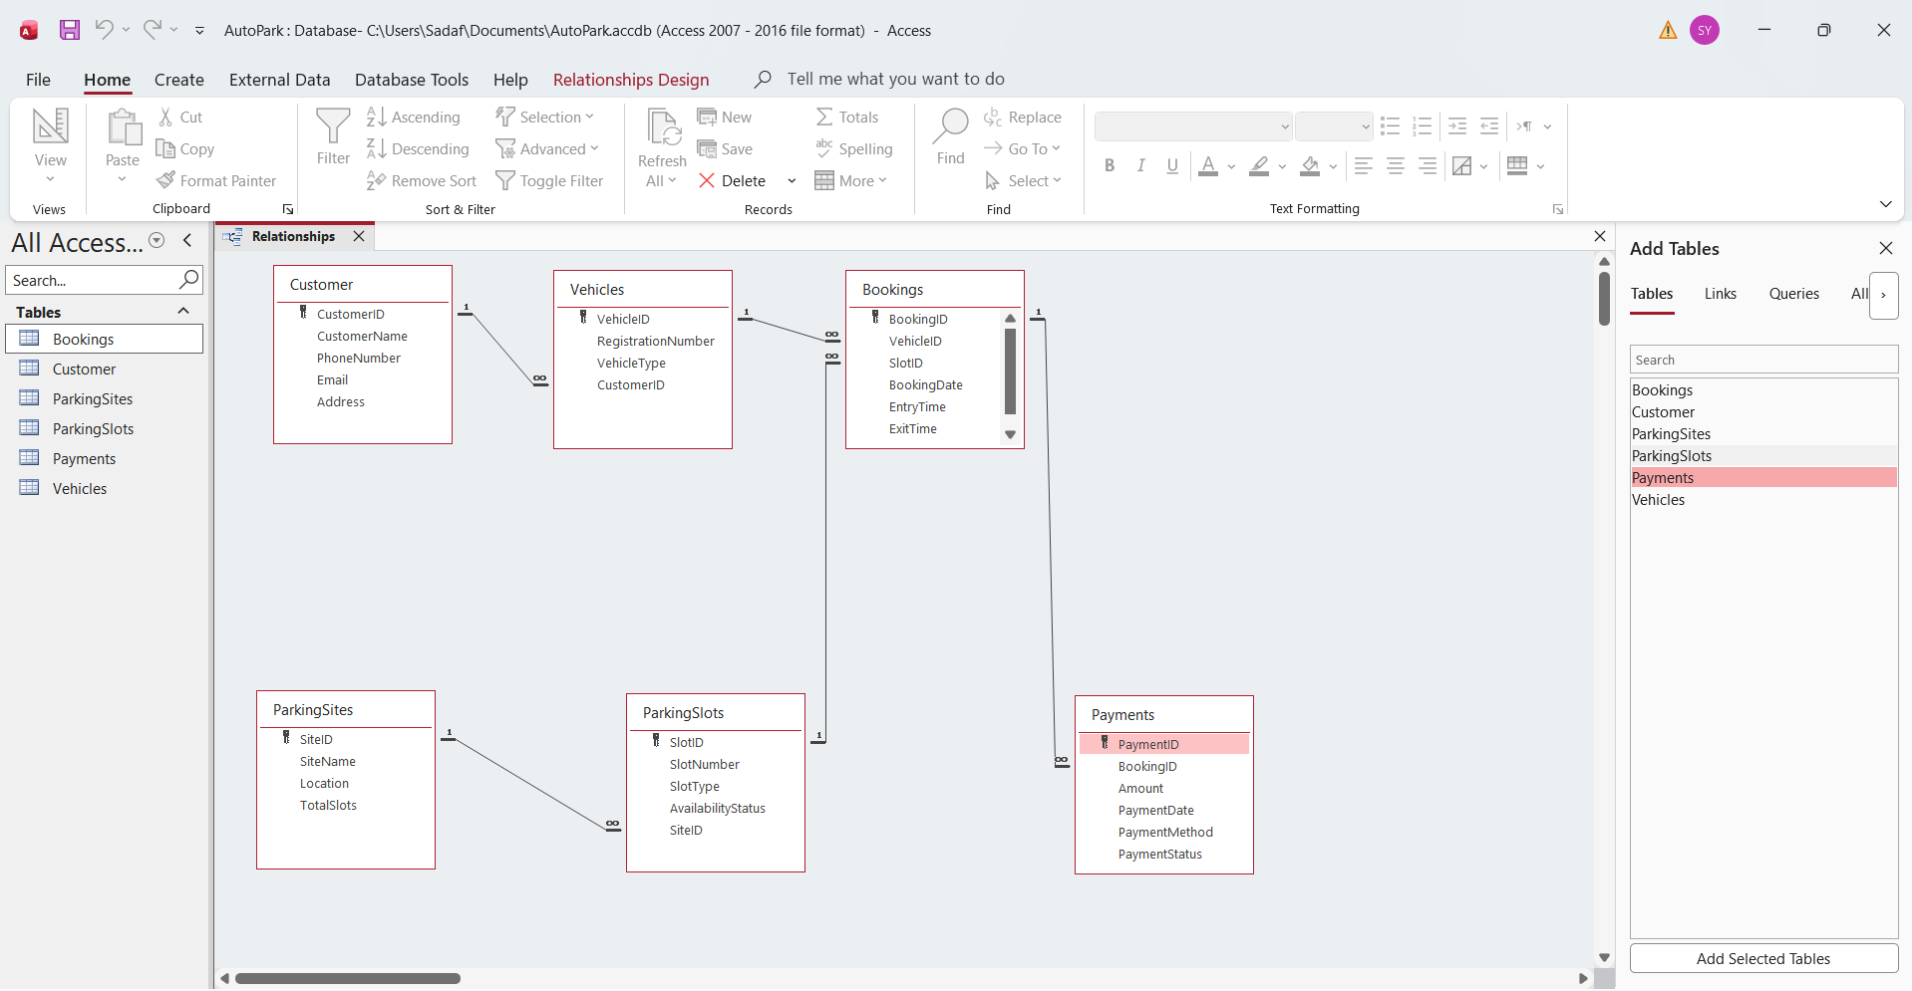
Figure 1: Entity Relationship Diagram (ERD) for the AutoPark Management System database.
The Entity Relationship Diagram (ERD) shows how the tables in the AutoPark Management System database are linked together. Each table has a primary key, which is used to identify every record. Foreign keys are used to connect the tables, making sure the information is linked correctly and remains consistent throughout the database.
The relationships within the database are:
Customer Vehicles (One-to-Many)
One customer can register more than one vehicle, while each vehicle belongs to one customer.
Parking Sites Parking Slots (One-to-Many)
Each parking site contains several parking slots, and every parking slot is assigned to a single parking site.
Vehicles Bookings (One-to-Many)
A vehicle can have multiple bookings over time, but each booking relates to one vehicle.
Parking Slots Bookings (One-to-Many)
A parking slot can be used for many bookings at different times, although each booking is linked to only one parking slot.
Bookings Payments (One-to-Many)
Each booking is linked to its payment record, allowing payment information to be stored separately while remaining connected to the booking.
Overall, these relationships help keep the database organised by reducing duplicate information and making related records easier to access. Using primary and foreign keys also helps keep the data accurate and ensures that all the tables remain connected correctly [1].

Data Structure Development
The Entity Relationship Diagram was used to create the AutoPark Management System database in Microsoft Access. Six related tables were created to store different types of information, including customers, vehicles, parking sites, parking slots, bookings and payments. Each table was created with a unique primary key to identify each record and support the design of the database.
Separating the information into different tables makes it easier to organise customer records, vehicle details, parking availability, bookings and payments. This reduces duplicate information and makes the database easier to manage. It also supports the queries, forms and reports created later in the project.
Table | Primary Key | Purpose
Customer | CustomerID | Stores customer information, including contact details.
Vehicles | VehicleID | Stores vehicle details linked to customers.
ParkingSites | SiteID | Stores information about parking locations.
ParkingSlots | SlotID | Stores parking slot details and availability.
Bookings | BookingID
  Stores booking details, including dates, times and booking status.
Payments | PaymentID | Stores payment information linked to bookings.

Figure 2: A summary of the tables created for the AutoPark Management System database.

Normalisation Compliance (Up to 3NF)
Normal Form | Rule | Example from this Database | Benefit
1NF | Each field contains only one value and there are no repeating groups. | Customer details, vehicle details, bookings and payments are stored in separate records, with each field containing a single value. | Makes the data easier to organise and reduces duplicate information.
2NF | All non-key fields depend on the whole primary key. | Customer information depends on CustomerID, vehicle information depends on VehicleID, parking site information depends on SiteID, and booking information depends on BookingID. | Prevents unnecessary duplication and keeps related information together.
3NF | Non-key fields must not depend on other non-key fields. | Payment information is stored in the Payments table rather than the Bookings table, while customer and vehicle information are stored in their own tables. This helps reduce duplication and keeps the data organised. | Improves consistency, reduces redundancy and makes the database easier to maintain.

The AutoPark Management System database was normalised to Third Normal Form (3NF) to improve the organisation of the data and reduce unnecessary duplication. Each table stores a specific type of information, helping to keep the database organised and easy to manage. Following the rules of 1NF, 2NF and 3NF has improved consistency and helped ensure that information is stored efficiently [2]
Figure 3: Normalisation of AutoPark Management System Database up to Third Normal Form (3NF)

Sample Data Population
To test the AutoPark Management System, sample data was entered into each table within Microsoft Access. A minimum of five records were added to ensure the database could demonstrate realistic parking activities and allow the forms, queries and reports to function correctly.
The sample data included customer details, registered vehicles, parking sites, parking slots, bookings and payment records. The information was created to reflect realistic situations, such as customers owning different types of vehicles, bookings being made at different parking sites and payments being completed using different payment methods.
Entering sample data allowed the database to be tested before creating queries, forms and reports. It also confirmed that information could be entered, stored and retrieved accurately throughout the database.

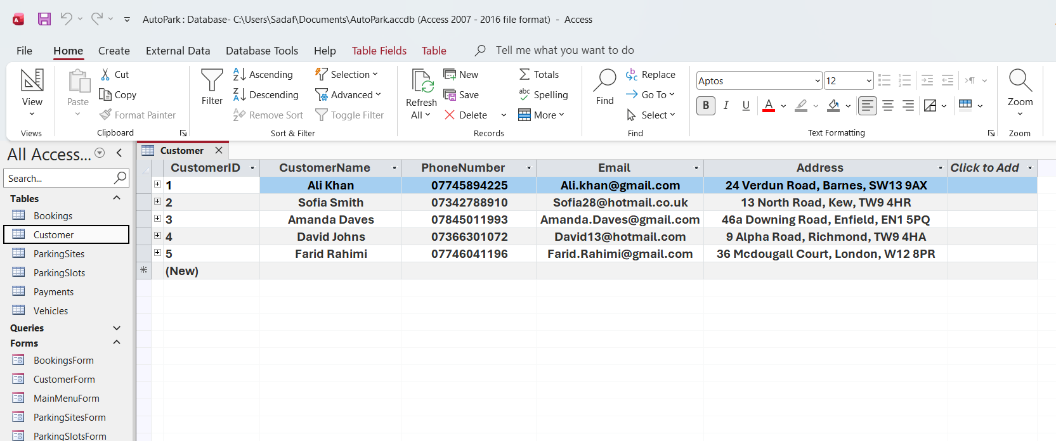
Figure 4: Customer table populated with sample data.

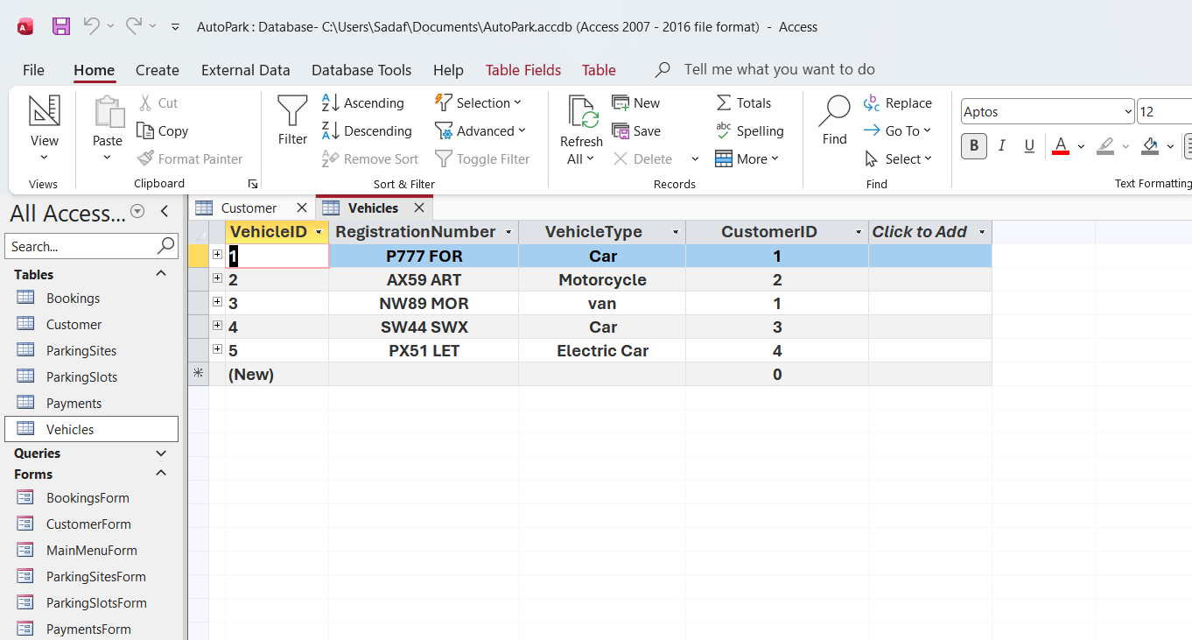
Figure 5: Vehicles table populated with sample data.

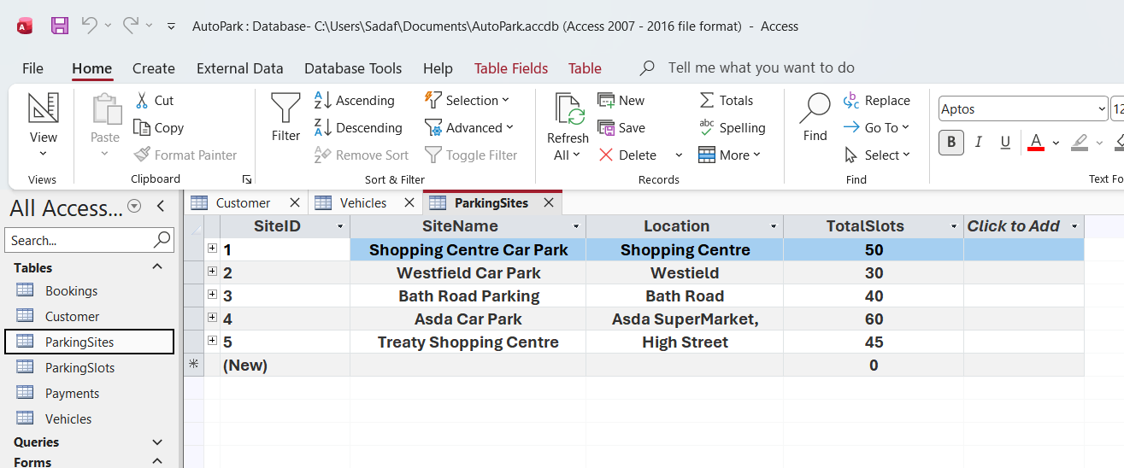
Figure 6: ParkingSites table populated with sample data.

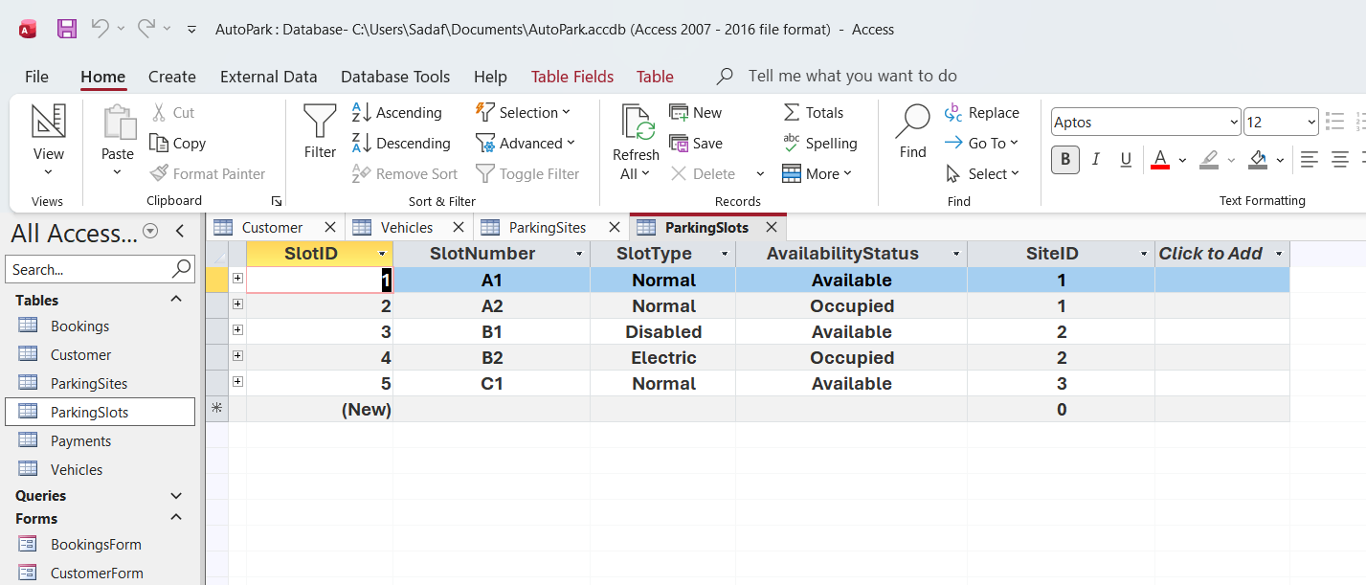
Figure 7: ParkingSlots table populated with sample data.

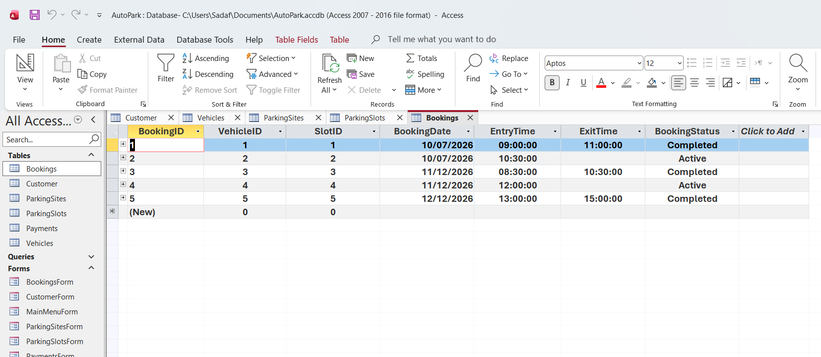
Figure 8: Bookings table populated with sample data.

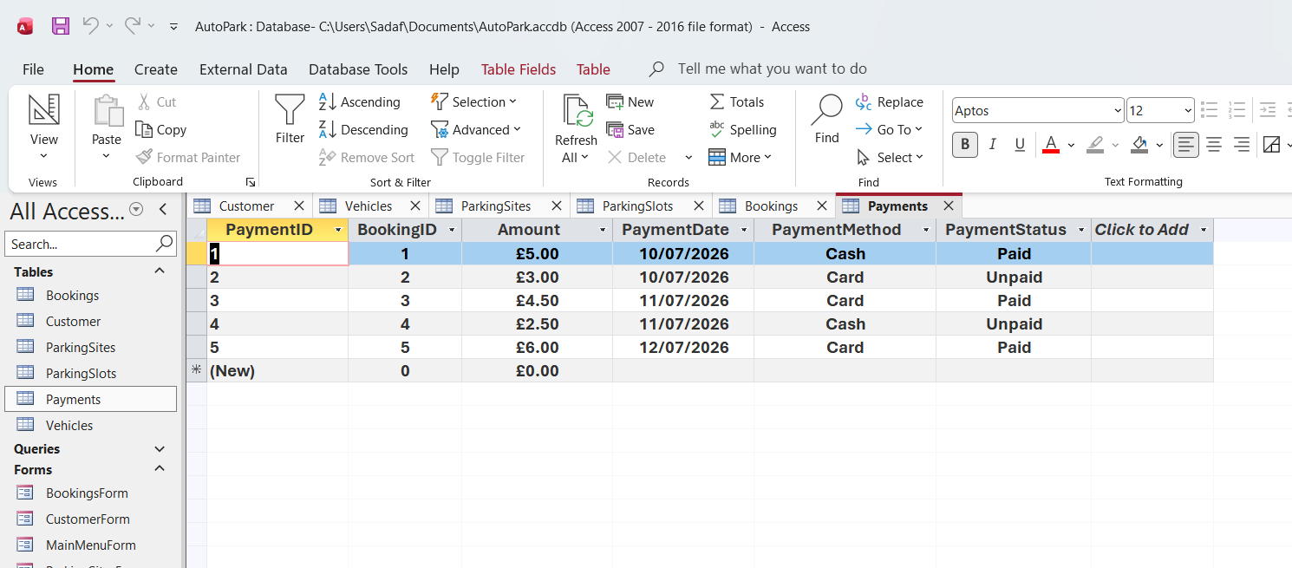
Figure 9: Payments table populated with sample data.

Queries
Queries were created in Microsoft Access to retrieve specific information from the AutoPark Management System database. They allow users to search, filter and display records based on different requirements. The queries were designed to support everyday parking management tasks by providing quick access to useful information.
AvailableSlotsQuery
The AvailableSlotsQuery was created to display parking slots that are currently available. This allows staff to identify vacant spaces before creating new bookings.

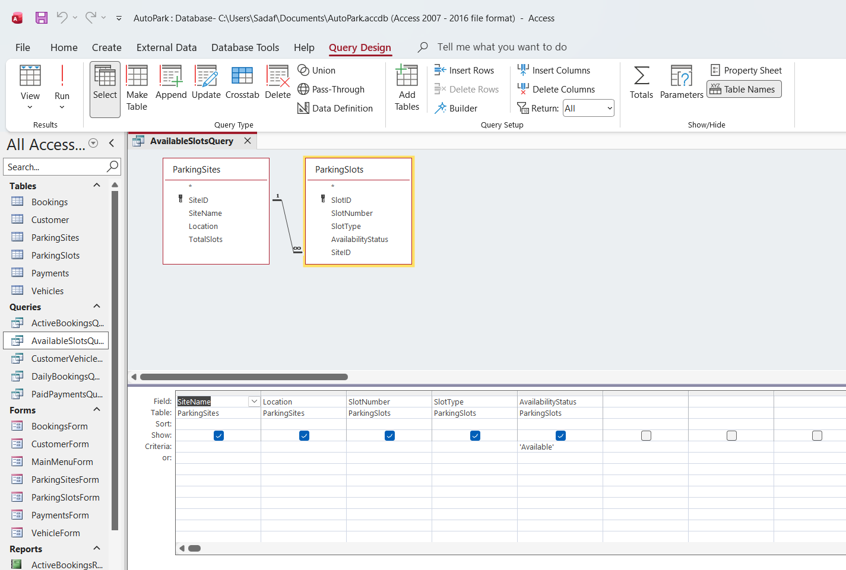
Figure 10: Design view of the AvailableSlotsQuery.

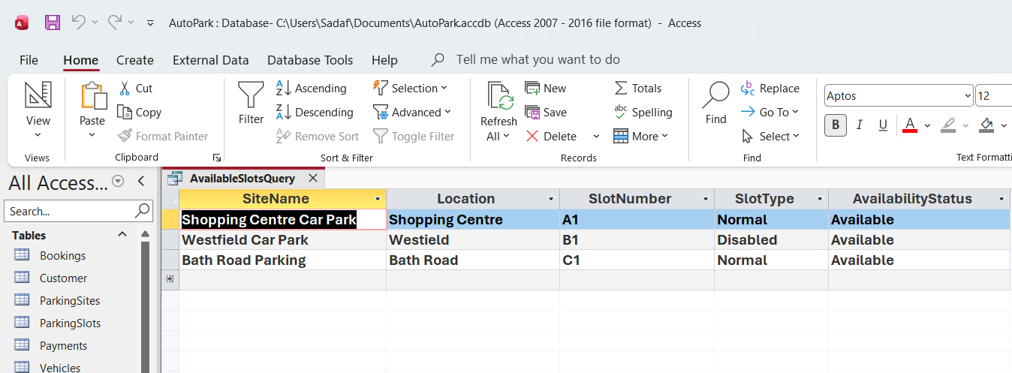
Figure 11: Results of the AvailableSlotsQuery.

ActiveBookingsQuery
The ActiveBookingsQuery was created to display bookings that are currently active. This helps staff monitor vehicles that are using parking spaces and manage ongoing bookings.

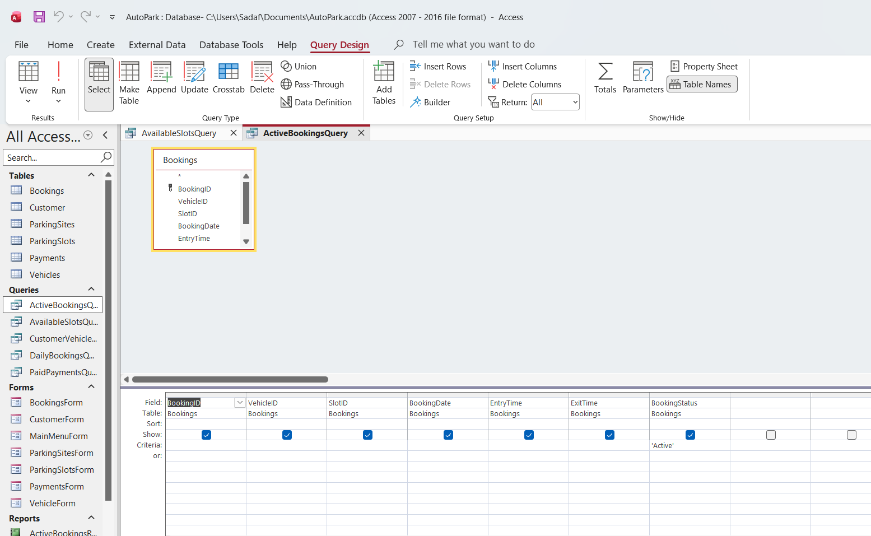
Figure 12: Design view of the ActiveBookingsQuery.

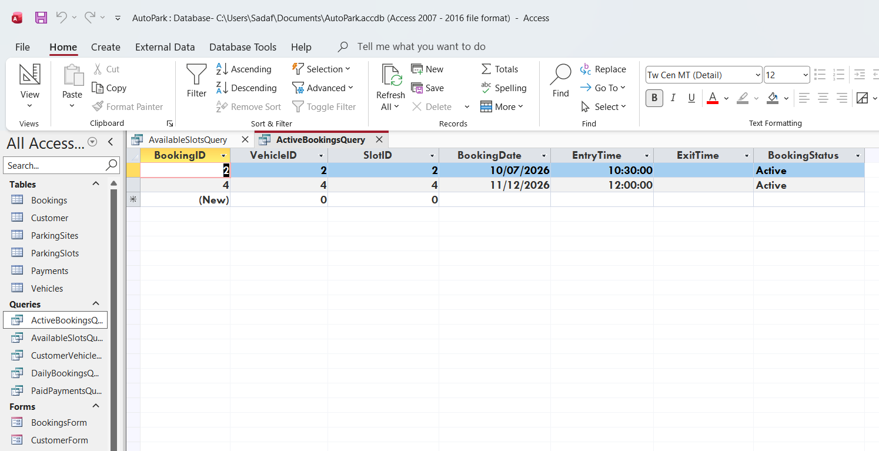
Figure 13: Results of the ActiveBookingsQuery.
PaidPaymentsQuery
The PaidPaymentsQuery was created to display payment records that have been completed. This helps staff keep track of successful payments and review completed transactions.
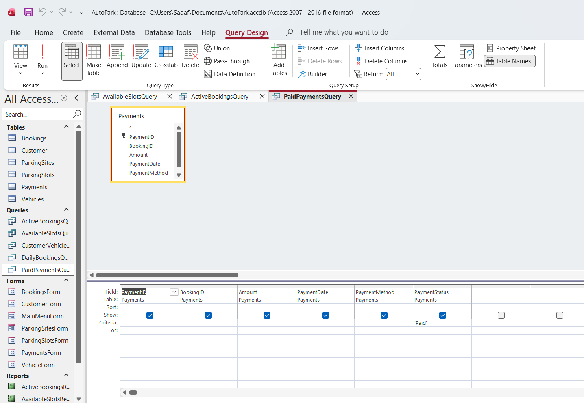
Figure 14: Design view of the PaidPaymentsQuery.

`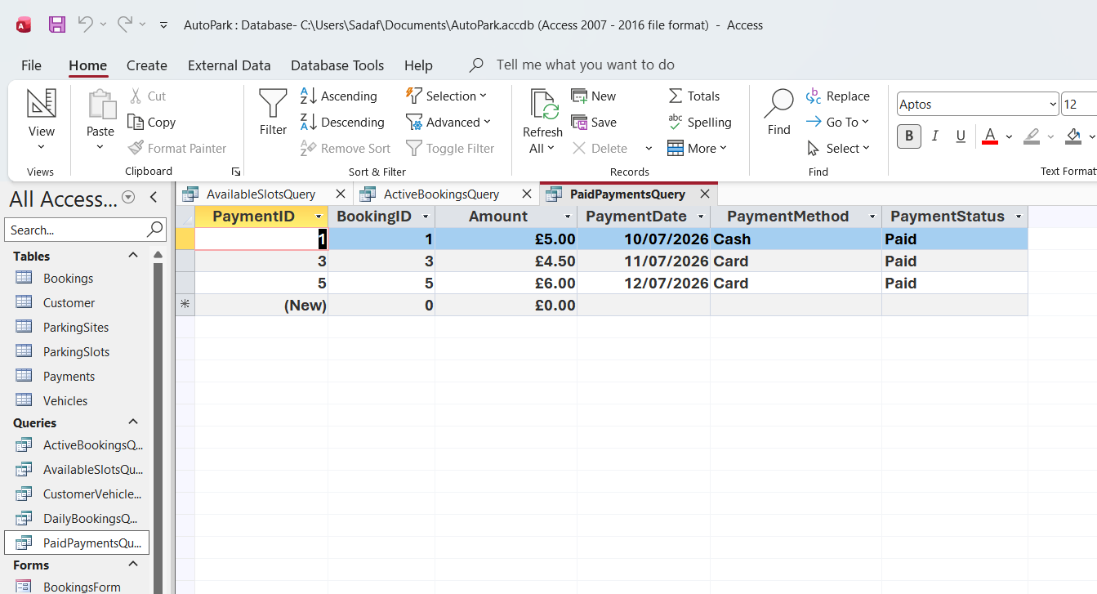
Figure 15: Results of the PaidPaymentsQuery.

CustomerVehicleQuery
The CustomerVehicleQuery was created to display customers together with their registered vehicles. This allows staff to quickly view which vehicles belong to each customer.

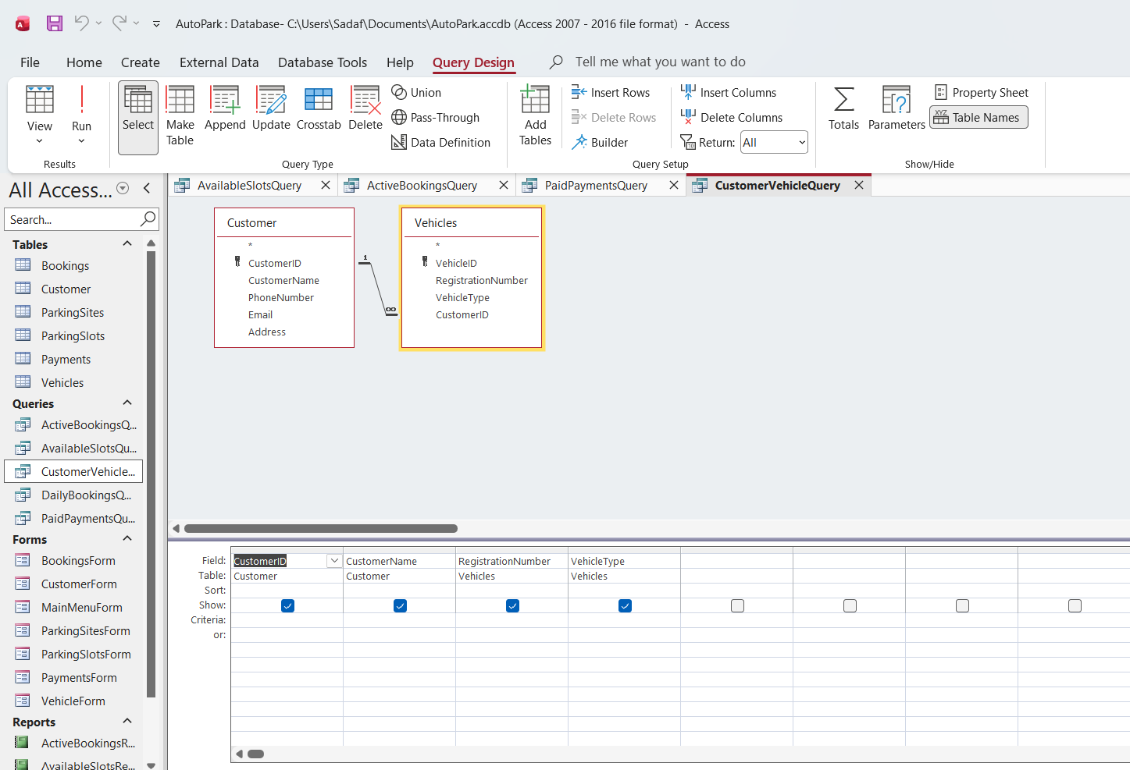
Figure 16: Design view of the CustomerVehicleQuery.

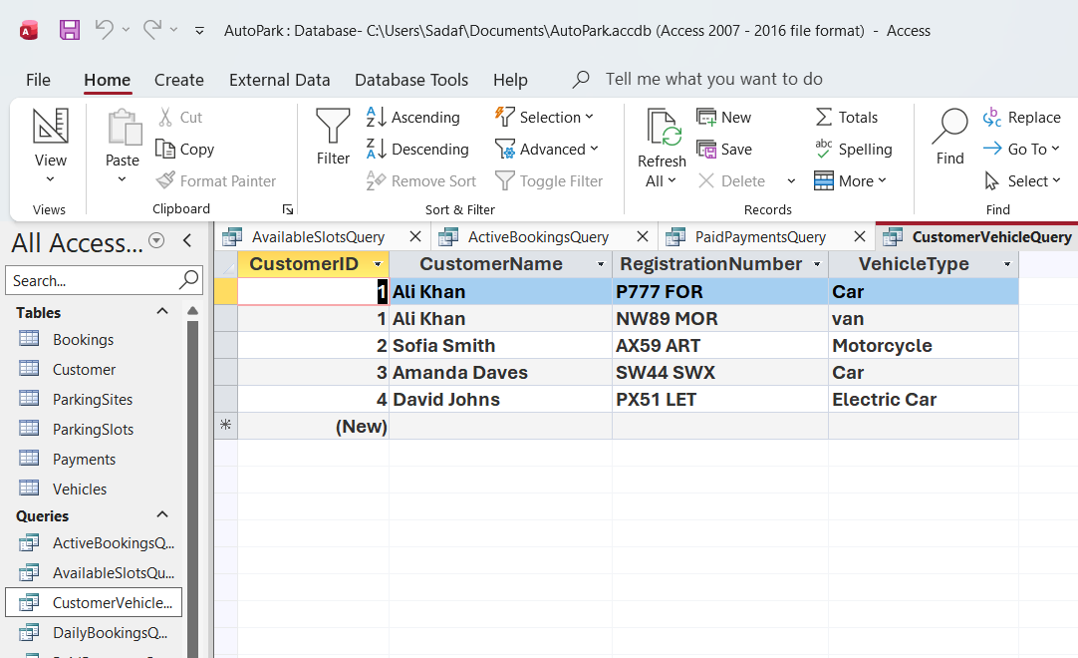
Figure 17: Results of the CustomerVehicleQuery.

DailyBookingsQuery
The DailyBookingsQuery was created to display bookings made for a selected day. This helps staff review daily parking activity and manage bookings more effectively.

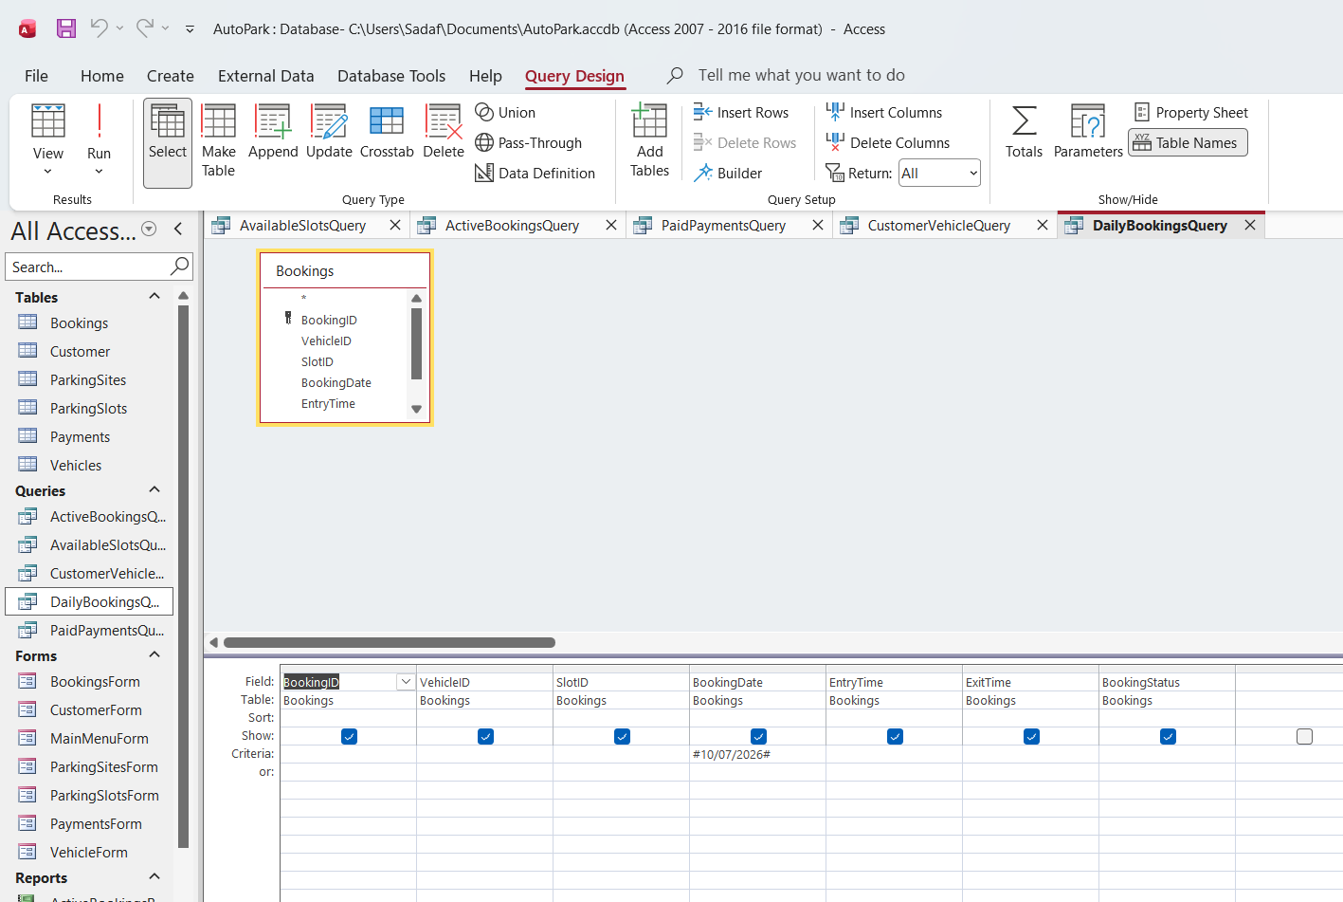
Figure 18: Design view of the DailyBookingsQuery.

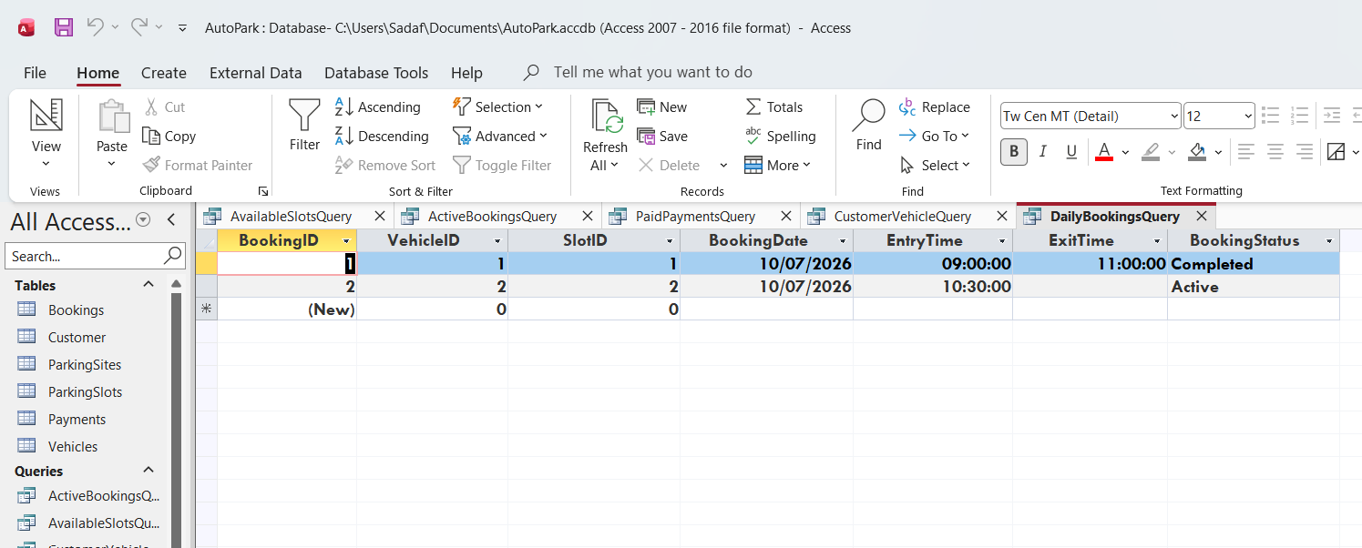
Figure 19: Results of the DailyBookingsQuery.

Forms and Reports
Forms were created in Microsoft Access to make it easier to enter, view and update information within the AutoPark Management System. A CustomerForm was developed for managing customer information, while a MainMenuForm provides easy navigation between the different forms and reports.
Reports were created to present information from the database in a clear and organised format. The reports are based on the queries created earlier and help users review parking information more efficiently.

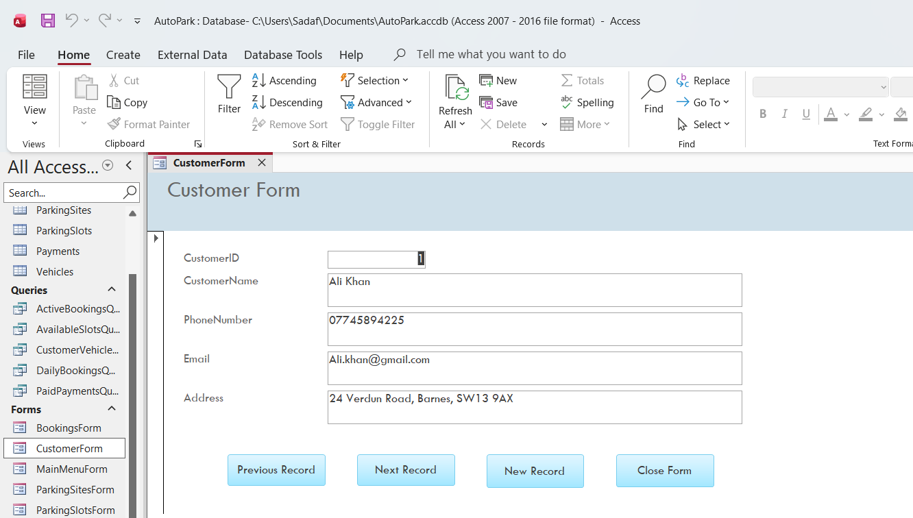
Figure 20: CustomerForm.

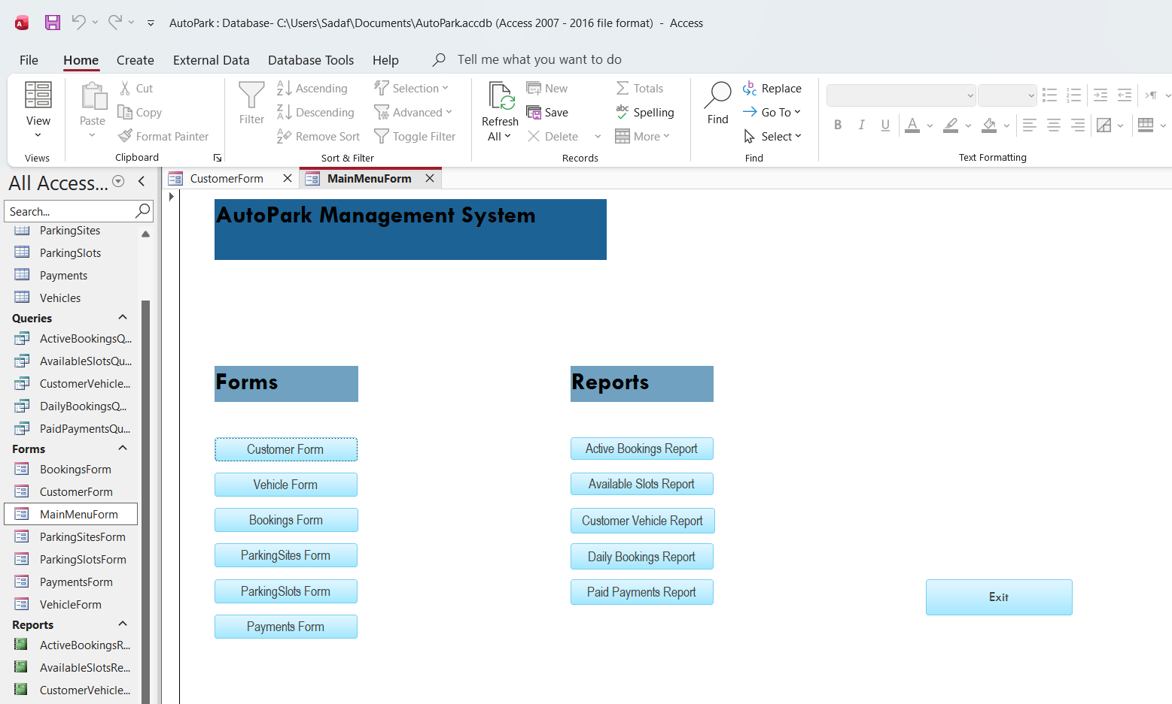
Figure 21: MainMenuForm.

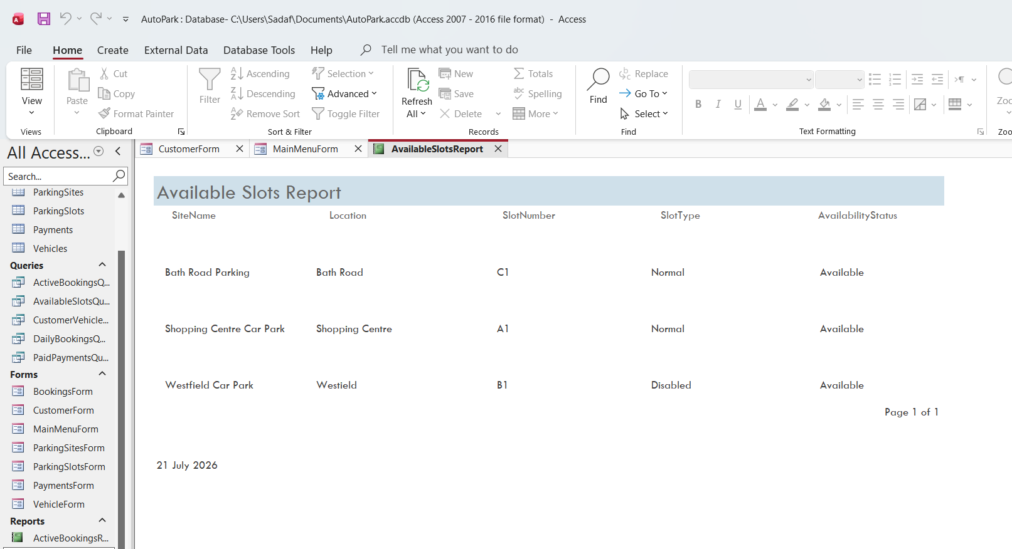
Figure 22: AvailableSlotsReport.

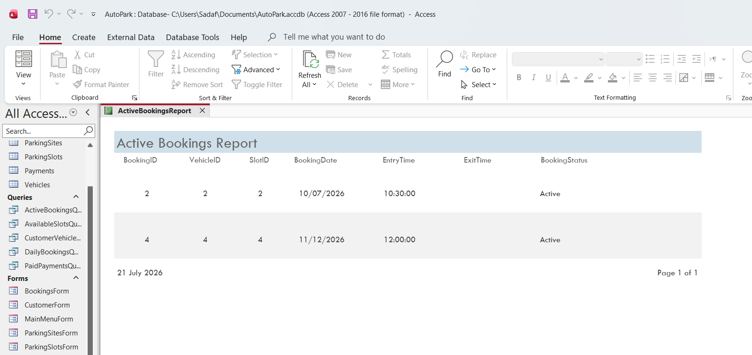
Figure 23: ActiveBookingsReport.

Validation and Testing
The AutoPark Management System was tested to ensure that all parts of the database were working correctly. Testing was carried out after the tables, queries, forms and reports had been completed to confirm that information could be entered, stored and retrieved without any problems.
The tables were tested by adding new records and checking that the information was saved correctly. Existing records were also updated to confirm that changes could be made successfully. This demonstrated that the database was able to store and manage information accurately.
The queries were tested by running each one and checking that the correct records were returned. The results matched the expected information, allowing users to view available parking slots, active bookings, completed payments, customer vehicle details and daily bookings.
The forms were tested by entering and editing records through the user interface. The navigation buttons were also checked to ensure users could move between records, add new records and close the forms without any issues. The Main Menu was tested to confirm that all buttons opened the correct forms and reports.
Finally, the reports were reviewed to ensure they displayed accurate information based on the queries. Each report generated successfully and presented the required information in a clear and organised format.
Overall, the testing confirmed that the AutoPark Management System functions as expected. All features operated correctly, and no significant errors were identified during testing [3]

Reflection
Developing the AutoPark Management System provided practical experience in designing and implementing a database using Microsoft Access. One of the main challenges was ensuring that the tables, queries, forms and reports worked together correctly and produced accurate results during testing. Creating and testing the queries also required careful checking to ensure that the correct information was returned.
If the database were developed further, additional features such as user login security, automated booking confirmations and more detailed reports could be added to improve the functionality of the system [3]. These improvements would make the database more suitable for real-world use and provide users with additional features.

Conclusion
This report has demonstrated the design and development of the AutoPark Management System using Microsoft Access. The database was created to improve the management of customer information, vehicles, parking sites, parking slots, bookings and payments. The design process included the creation of an Entity Relationship Diagram (ERD), database tables, normalisation to Third Normal Form (3NF), sample data, queries, forms and reports.
Testing and validation confirmed that the database functions correctly and meets the requirements of the system. Information can be entered, stored, updated and retrieved efficiently, while the queries, forms and reports provide users with quick access to the information they need.
Overall, the completed database provides a more organised and reliable solution than the previous manual system. It reduces the risk of errors, improves the management of parking records and supports the day-to-day operation of the AutoPark Management System.

References

[1] | T. Connolly and C. Begg, Database Systems: A Practical Approach to Design, Implementation, and Management, Harlow: Pearson Education, 2015.
[2] | R. Elmasri and S. B. Navathe, Fundamentals of Database Systems, Boston: Pearson, 2016.
[3] | I. Sommerville, Software Engineering, Harlow: Pearson, 2016.

