Schizophrenia: ICD-11 Classification, Treatment and Rehabilitation

Student name: Alexandra Elena Galiceanu
Student ID: 2330542

Table of Contents
1. Introduction 3
2. ICD-11 Classification and Diagnosis 3
3. Treatment and Rehabilitation 4
4. Current Debates and Emerging Issues 6
5. Recommendations 8
6. Conclusion 9
References 10

List of figures
Figure 1: Evidence for psychosocial and behavioural interventions for negative symptoms of schizophrenia. Source: Cella et al. (2023). 6
Figure 2:Main areas of impact of long-term community psychiatric care for people with schizophrenia. Source: Černe Kolarič et al. (2024) 7

1. Introduction
Schizophrenia is a severe form of a mental disorder which belongs to Chapter 6 of the International Classification of Diseases, Eleventh Revision (ICD-11). Schizophrenia can influence the way a person perceives things, thinks, behaves, feels emotions and interacts with other people. So, such a mental condition can significantly influence education, employment, personal relationships and independent life of the patient. The World Health Organisation (WHO) developed ICD-11 Clinical Descriptions and Diagnostic Requirements (CDDR) for the diagnosis of the disease and its proper classification to provide the appropriate clinical diagnosis and treatment in different health care systems (World Health Organisation, 2024). But classification is not only a way to put a label on a person.
This report will critically analyse the classification and diagnosis of schizophrenia under ICD-11. Also, the treatment and rehabilitation of schizophrenia will be examined. Finally, the validity of schizophrenia as a single category will be discussed along with its connection to neurodivergence. In addition, some recommendations on the diagnosis, treatment, rehabilitation and further research will be provided.

2. ICD-11 Classification and Diagnosis
2.1 Classification of schizophrenia
The category of schizophrenia or other primary psychotic disorders includes schizophrenia in ICD-11. In contrast to the DSM-5, ICD-11 defines the condition based on disturbances in cognition, perception, behaviour, and experience, rather than as a disease entity that has one cause only. The CDDR describes important characteristics, other clinical data, boundaries with normality, course features and differential diagnostic information (World Health Organisation, 2024).
One of the changes made to ICD-11 is the abandonment of the schizophrenia subtype focus that had been a characteristic feature of previous classification. Previously, such schizophrenia subtypes like paranoid, hebephrenic and catatonic schizophrenia were used. But, according to scientific data, they proved to be unstable and so not particularly useful in practice. Thus, ICD-11 introduced schizophrenia with a wider description, including information about symptoms or the course of the disorder (Valle, 2022).
Language itself is also of importance. ICD-11 usually uses the term "disorder" instead of implying the presence of one illness due to some pathological condition caused by schizophrenia. This is essential since the present-day research shows that schizophrenia is characterised by heterogeneity. A review from an international team of scientists found out that there was no single cause, pathology, clinical manifestation or treatment that defined schizophrenia entirely. Thus, the authors noted that the definition of such a construct was ambiguous, and it could be defined using a more dimensional or spectral approach (McCutcheon, Reis Marques and Howes, 2020).
2.2 Diagnostic process
ICD-11 diagnosis necessitates a thorough evaluation of the patient’s symptoms and other considerations that include symptom onset, symptoms' impact on function, and the patient’s history in terms of medications, psychiatric problems, substances consumed, and any other differential diagnosis. The CDDR intentionally does not impose an artificially high level of precision where evidence does not warrant it, and permits the exercise of clinical judgement.
This practice has some strengths, as individuals do not experience psychotic disorders in the same manner. Cultural views and ways of communicating may have an effect on the nature and expression of bizarre phenomena. Ceylan and Alkar (2023) have documented such cross-cultural differences in the manifestations of schizophrenia.
In addition, clinical judgment may also lead to inconsistency. Diagnosis could be affected by the professional’s understanding, information and differences in the health system. The category could thus have uniformity despite having inconsistencies because of the nature of the illness. The reason for this is that schizophrenia overlaps with mood disorders, substance-induced psychosis, trauma disorders and neurodevelopmental disorders.

3. Treatment and Rehabilitation
3.1 Pharmacological treatment
Antipsychotic medication is still a crucial element of schizophrenia treatment as it may decrease positive psychotic symptoms and prevent relapses. Nowadays, the effectiveness of D2 receptor antagonist and partial agonist medications is scientifically proven, but there is variability in response to such medications among people (McCutcheon, Reis Marques and Howes, 2020). So, medication needs to be perceived as an element of personalised therapy.
Long-acting injectable antipsychotics may serve as a way to avoid the intake of pills daily. Vita et al. (2024) provide evidence on the effectiveness of such medications in early-phase schizophrenia-spectrum disorders, but each case should be evaluated separately, taking into account the outcome and tolerability of this type of treatment. It might be suitable for patients who find it hard to follow their treatment plans, but it may raise issues related to the choice, side effects, and even coercion.
Another issue that requires attention is treatment-resistant schizophrenia. Salahuddin et al. (2024) stress the importance of psychosocial therapy as well as medication therapy in the treatment of people with such symptoms. Clozapine is a very significant medication used for the treatment-resistant form of schizophrenia, but it has particular monitoring requirements and side effects.
3.2 Psychological and psychosocial treatment
Drug-based therapies cannot treat the functional consequences of the condition alone. Psychological and psychosocial treatment may assist in coping with the condition, social functioning, relapse prevention, and recovery from the condition.
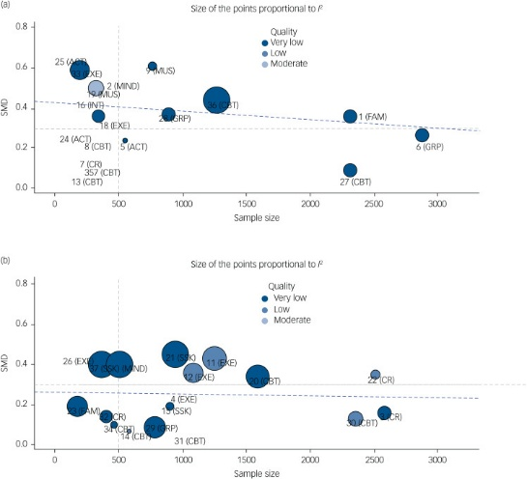
Figure 1: Evidence for psychosocial and behavioural interventions for negative symptoms of schizophrenia. Source: Cella et al. (2023).
Cella et al. (2023) have provided evidence on the efficacy of different kinds of psychosocial and behavioural treatments. But the effectiveness was not the same for all treatments and outcomes, which implies that the treatment should be personalised.
Stigma continues to be a major hindrance. According to Lamarca et al. (2024), multi-component interventions that include strategies like psychoeducation, social skills training, and cognition-based strategies have been shown to help individuals suffering from psychotic disorders overcome self-stigma, although there were major differences in results obtained across studies.
Shared decision-making has also become one of the critical developments in treating schizophrenia. A recent systematic review has shown that shared decision-making interventions in schizophrenia improve compliance with treatment in most cases, but there is still insufficient literature available on this subject (Jackson et al., 2025).
3.3 Rehabilitation
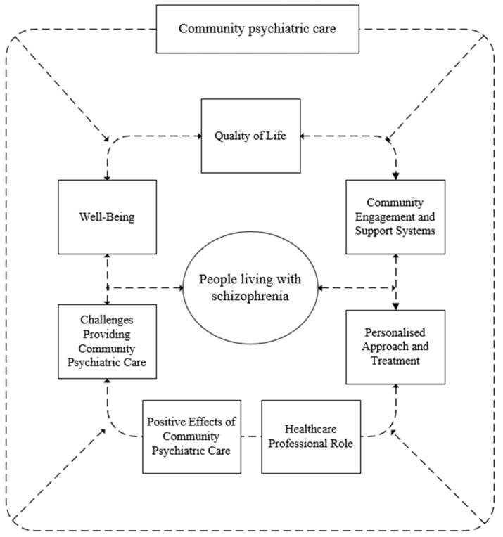
Figure 2: Main areas of impact of long-term community psychiatric care for people with schizophrenia. Source: Černe Kolarič et al. (2024)
Rehabilitation is crucial since schizophrenia impacts social relationships, work, learning, housing and independent living (Černe Kolarič et al., 2024). ICD-11 gives the classification and criteria for diagnosing schizophrenia, but it should not be viewed as a manual for rehabilitation. In turn, the process of rehabilitation is based on WHO guidelines and evidence-based interventions that increase a patient's functioning and participation. For example, the World Health Organisation (2023) Package of Interventions for Rehabilitation: Module 8: Mental Health Conditions presents evidence-based rehabilitation interventions for schizophrenia, and it aims at the integration and planning of rehabilitation services in healthcare systems.
In practice, rehabilitation interventions can include psychosocial therapy, developing social skills, support of family, supported employment, mental health services in the community and support of daily activities. All of them go beyond the sphere of alleviating symptoms since they focus on functioning and participation in the social, family and work life of a patient. According to Ye et al. (2023), community-based rehabilitation interventions contribute to an improvement of symptoms and functioning in people with schizophrenia. This means that despite the positive results, there is great heterogeneity between interventions and outcomes, and their effectiveness cannot be equal.
Historical and current provision
The link between historical and current provision is especially significant when it comes to schizophrenia rehabilitation. In the past, people suffering from schizophrenia were housed in long-stay psychiatric hospitals, where care revolved around control and surveillance.
The move towards deinstitutionalisation shifted provision towards community-based services, reflecting greater emphasis on independence and participation. But deinstitutionalisation did not automatically guarantee effective community support. Where housing, employment, family support and specialist community services were inadequate, people could experience fragmented care and social exclusion (Rivera, 2024). Contemporary rehabilitation can so be understood partly as a response to these historical limitations (George et al., 2023). Rather than focusing only on symptom control, current practice aims to support functioning, autonomy and participation through community mental health services, psychosocial interventions, supported employment and social support. The World Health Organisation (2023) rehabilitation framework further supports the integration of evidence-based rehabilitation into health systems, showing how contemporary provision has developed beyond institutional treatment towards longer-term, person-centred community support.

4. Current Debates and Emerging Issues
4.1 Schizophrenia as a single disorder
One of the most relevant debates at present pertains to whether the concept of schizophrenia continues to operate under the assumption of a categorical disorder. Schizophrenia is being increasingly viewed in terms of a heterogeneous syndrome that includes aspects like psychosis, cognition, negative features, affect/mood features and functional impairment (McCutcheon, Reis Marques and Howes, 2020).
This raises an issue within ICD-11. Having a single classification system is beneficial when it comes to communication, research, planning of services and access to services. But a singular classification system fails to address the differences between one patient and another. Two patients may be diagnosed with the same condition, but have different presentations of symptoms, causes, responses to treatments and recovery requirements.
This means that future classification systems should include more information about dimensions and individuals, as well as a longitudinal course of the illness, along with the current classification system.
4.2 Neurodivergence and diagnostic overlap
Also, the neurodivergent status poses another critical problem of classifying and diagnosing schizophrenia. Autism spectrum disorder is categorised as a neurodevelopmental disorder, but schizophrenia is categorised as a mental and behavioural disorder. But there could be an intersection of problems in communication, social withdrawal, peculiar behaviour, and even some perceptual or cognitive experiences.
The latest scientific findings demonstrate some significant correlations between autism and psychosis symptoms. The updated systematic review and meta-analysis found associations between the features of autism and several dimensions of the spectrum of psychoses, and underlined the existence of considerable heterogeneity between the studied sources (Miles, Golm and Palmer-Cooper, 2026). Guerrera et al. (2024) suggest another possibility of the neurodevelopmental continuum between autism and schizophrenia spectrum disorders, although the evidence is limited.
This intersection brings the risk of diagnostic overshadowing, when the features of neurodivergent status can be confused with psychotic features or vice versa. So, the existing evidence proves the need for differential diagnosis.
The question also brings up a larger debate about classification. In the case that some aspects of psychosis and neurodevelopment share dimensions, strict categorisation may not reflect the experience of the individual completely. But it does not imply that both conditions, schizophrenia and autism, should just be merged. Further longitudinal studies are needed first.
4.3 Stigma, inequality and social determinants
There are also social implications of classification. Being diagnosed with schizophrenia helps people access specialised treatments, but stigma could affect their chances of getting a job, being socially active, and asking for help. Fond et al. (2023) affirm that tackling internalised stigma is very pertinent today.
Social factors have an impact on outcomes too. According to Jester et al. (2023), social and environmental factors become very important in psychosis. Evidence from elsewhere suggests that factors like poverty, insecure housing, discrimination, and limited access to services could impact mental well-being (Knifton and Inglis, 2020).
So, there is no way to isolate schizophrenia management from social policy. An entirely medical approach might eliminate symptoms while failing to address social factors that lead to poor functioning.

5. Recommendations
Recommendation 1: Make diagnosis more individualised
The ICD-11 must persist in offering a universal basis for diagnosis, yet at the same time it needs to promote the application of more dimensional data, such as symptomatology, course and functional consequences.
Recommendation 2: Strengthen neurodevelopmental assessment
The mental health system needs to better assess for autism and other neurodevelopmental disorders when diagnosing schizophrenia. The clinician must not engage in diagnosis overshadowing and must take into account the person’s developmental history.
Recommendation 3: Expand integrated treatment
The services must include antipsychotics, combined with psychotherapy, family therapy and psychosocial therapy, depending on symptoms, preferences, potential side effects and functional outcomes.
Recommendation 4: Enhance community rehabilitation services
Money should go to community mental health teams, employment, housing, social rehabilitation and family services. Rehabilitation should concentrate on recovery, autonomy and social participation, not only on symptom treatment.
Recommendation 5: Promote shared decision-making
Schizophrenia patients should participate as much as possible in the decisions regarding treatment and rehabilitation (Jackson et al., 2025). Decisions should include full information regarding the benefits and disadvantages of medication, psychological therapies and alternatives.
Recommendation 6: Develop further research
Further research is needed on dimensional classification, autism-schizophrenia overlap, culturally sensitive diagnosis, and long-term rehabilitation outcomes. It is also necessary to involve participants with direct experience because then the system of classification and treatment will correspond with their outcomes.

6. Conclusion
Schizophrenia continues to be one of the prominent disorders in ICD-11 and its nosology, but current research shows that it is heterogeneous and cannot be defined using just one aetiology, symptom picture or management approach. ICD-11 offers a helpful classification system which allows flexibility and considerations of individuality and culture. But questions remain regarding diagnostic criteria and the appropriateness of a singular categorical diagnosis. Management should be broader and should encompass not only antipsychotics but also psychological approaches, family involvement, decision-making and social rehabilitation programs. Current controversies around neurodiversity and comorbidity of schizophrenia and autism illustrate the need for thorough differential diagnosis.

References
Cella, M., Roberts, S., Pillny, M., Riehle, M., O’Donoghue, B., Lyne, J., Tomlin, P., Valmaggia, L. and Preti, A. (2023). Psychosocial and behavioural interventions for the negative symptoms of schizophrenia: a systematic review of efficacy meta-analyses. The British Journal of Psychiatry, 223(3), pp.327–336. [online] Available at: https://pubmed.ncbi.nlm.nih.gov/36919340/ (Accessed: 22 September 2026).
Černe Kolarič, J., Plemenitaš Ilješ, A., Kraner, D., Gönc, V., Lorber, M., Mlinar Reljić, N., Fekonja, Z. and Kmetec, S. (2024). Long-Term Impact of Community Psychiatric Care on Quality of Life amongst People Living with Schizophrenia: A Systematic Review. Healthcare, 12(16), p.1653. [online] Available at: https://pmc.ncbi.nlm.nih.gov/articles/PMC11394810/ (Accessed: 22 September 2026).
Ceylan, A.C. and Yalçınkaya Alkar, Ö. (2023). The Cross-Cultural Differences in Symptoms of Schizophrenia: A Systematic Review. Journal of Cognitive-Behavioral Psychotherapy and Research, 12(2), pp.179–187. [online] Available at: https://jcbpr.org/article/23 (Accessed: 22 September 2026).
Fond, G., Vidal, M., Joseph, M., Etchecopar-Etchart, D., Solmi, M., Yon, D.K., Correll, C.U. and Boyer, L. (2023). Self-stigma in schizophrenia: a systematic review and meta-analysis of 37 studies from 25 high- and low-to-middle income countries. Molecular Psychiatry, 28(5), pp.1920–1931. [online] Available at: https://pubmed.ncbi.nlm.nih.gov/36890299/ (Accessed: 22 September 2026).
George, P., Jones, N., Goldman, H. and Rosenblatt, A. (2023). Cycles of reform in the history of psychosis treatment in the United States. SSM - Mental Health, 3, p.100205. [online] Available at: https://www.sciencedirect.com/science/article/pii/S2666560323000208 (Accessed: 22 September 2026).
Guerrera, S., Pontillo, M., Chieppa, F., Passarini, S., Di Vincenzo, C., Casula, L., Di Luzio, M., Valeri, G. and Vicari, S. (2024). Autism Spectrum Disorder and Early Psychosis: a narrative review from a neurodevelopmental perspective. Frontiers in Psychiatry, 15, 1362511. [online] Available at: https://pubmed.ncbi.nlm.nih.gov/38571993/ (Accessed: 22 September 2026).
Jackson, K.N., Lee, A.G., Ali, J.M., Vargas, S., Ulloa-Franco, P., Manning, T., Jimoh, Z. and Hossain, M.M. (2025). Shared Decision-Making in the Management of Schizophrenia: A Systematic Review. Cureus, 17(7), e87591. [online] Available at: https://pubmed.ncbi.nlm.nih.gov/40746817/ (Accessed: 22 September 2026).
Jester, D.J., Thomas, M.L., Sturm, E.T., Harvey, P.D., Keshavan, M., Davis, B.J., Saxena, S., Tampi, R., Leutwyler, H., Compton, M.T., Palmer, B.W. and Jeste, D.V. (2023). Review of Major Social Determinants of Health in Schizophrenia-Spectrum Psychotic Disorders: I. Clinical Outcomes. Schizophrenia Bulletin, 49(4), pp.837–850. [online] Available at: https://pubmed.ncbi.nlm.nih.gov/37022779/ (Accessed: 22 September 2026).
Knifton, L. and Inglis, G. (2020). Poverty and mental health: policy, practice and research implications. BJPsych Bulletin, 44(5), pp.201–206. [online] Available at: https://pmc.ncbi.nlm.nih.gov/articles/PMC7525587/ (Accessed: 22 September 2026).
Lamarca, M., Espinosa, V., Acuña, V., Vila-Badia, R., Balsells-Mejia, S., Moritz, S., Berna, F., König, C., Gawęda, Ł., PERMEPSY Group, Barajas, A. and Ochoa, S. (2024). Reducing self-stigma in psychosis: A systematic review and meta-analysis of psychological interventions. Psychiatry Research, 342, p.116262. [online] Available at: https://pubmed.ncbi.nlm.nih.gov/39549598/ (Accessed: 22 September 2026).
McCutcheon, R.A., Reis Marques, T. and Howes, O.D. (2020). Schizophrenia—An Overview. JAMA Psychiatry, 77(2), pp.201–210. [online] Available at: https://pubmed.ncbi.nlm.nih.gov/31664453/ (Accessed: 22 September 2026).
Miles, M.R., Golm, D. and Palmer-Cooper, E. (2026). The association between autism and psychosis and the tools used to measure it: An updated systematic review and meta-analysis. British Journal of Clinical Psychology. [online] Available at: https://pubmed.ncbi.nlm.nih.gov/41403082/ (Accessed: 22 September 2026).
Rivera, F.B. (2024). From asylums to deinstitutionalisation and after: an analytic review. International Journal of Social Psychiatry, 70(8), pp.1392–1401. [online] Available at: https://pubmed.ncbi.nlm.nih.gov/39096009/ (Accessed: 22 September 2026).
Salahuddin, N.H., Schütz, A., Pitschel-Walz, G., Mayer, S.F., Chaimani, A., Siafis, S., Priller, J., Leucht, S. and Bighelli, I. (2024). Psychological and psychosocial interventions for treatment-resistant schizophrenia: a systematic review and network meta-analysis. The Lancet Psychiatry, 11(7), pp.545–553. [online] Available at: https://pubmed.ncbi.nlm.nih.gov/388792769/ (Accessed: 22 September 2026).
Valle, R. (2022). Validity, reliability and clinical utility of mental disorders: The case of ICD-11 schizophrenia. Revista Colombiana de Psiquiatría, 51(1), pp.61–70. [online] Available at: https://pubmed.ncbi.nlm.nih.gov/33735020/ (Accessed: 22 September 2026).
Vita, G., Tavella, A., Ostuzzi, G., Tedeschi, F., De Prisco, M., Segarra, R., Solmi, M., Barbui, C. and Correll, C.U. (2024). Efficacy and safety of long-acting injectable versus oral antipsychotics in the treatment of patients with early-phase schizophrenia-spectrum disorders: a systematic review and meta-analysis. Therapeutic Advances in Psychopharmacology, 14, p.20451253241257062. [online] Available at: https://pubmed.ncbi.nlm.nih.gov/38831918/ (Accessed: 22 September 2026).
World Health Organisation (2023). Package of interventions for rehabilitation. Module 8. Mental health conditions. Geneva: World Health Organisation. [online] Available at: https://www.who.int/publications/b/67931/ (Accessed: 22 September 2026).
World Health Organisation (2024). Clinical descriptions and diagnostic requirements for ICD-11 mental, behavioural and neurodevelopmental disorders. Geneva: World Health Organisation. [online] Available at: https://www.who.int/publications/i/item/9789240077263/ (Accessed: 22 September 2026).
Ye, X., Zeng, F., Wang, Y., Ding, R., Zhao, M., Zhu, D. and He, P. (2023). Effectiveness of Community-Based Rehabilitation Interventions on Symptoms and Functioning for People with Schizophrenia: A Systematic Review and Meta-Analysis. Psychiatric Quarterly, 94(3), pp.501–529. [online] Available at: https://pubmed.ncbi.nlm.nih.gov/37249835/ (Accessed: 22 September 2026).

