Song 1

Song 1 focuses on acoustic recording techniques. It’s an original song with a lot of layered vocals and 2 different guitar tracks layered on top of eachother. I recorded the guitar using an XY microphone technique with 2 Rode NT5 microphones. These two microphones were panned left and right to create a stereo effect in the recording. I hard panned the track with the strummed chords left and right and then kept the picked track further towards the front of the stereo field to create the effect of a more fixed position. The vocals were recorded with a Shure SM7B microphone, I switched on the bass roll-off and presence boost settings. The SM7B was connected to a microphone booster to avoid oversaturating the signal with too much gain, and I triple tracked the vocals and panned them mid, left and right. I panned each harmony into its own section of the stereo field to create a fuller effect in the overall sound of the vocals. I then used a Focusrite CM25 microphone to record a small shaker that I made myself. I chose this microphone over an NT5 because it has a larger diaphragm with a cardioid polar pattern but is still a condenser, and I was moving the shaker around a lot so it made sense to me that it would pick up the sound better than the NT5s, whilst also picking up the fine details inside the shaker.

Once I had each track recorded and panned to where I wanted them to sit, I sent the vocals to a bus so that I could add compression, EQ and a basic room reverb to them all at once, and then sent the harmonies to an extra bus to add a more airy reverb to them. I added some more basic EQ, compression and reverb to the guitars, and I added EQ and compression to the shaker as well. I also used some basic volume automation to remove some breaths in between the harmonies. (See figures 1-4)

Song 2

Song 2 is also an acoustic song, but I focused more on audio manipulation and sampling techniques after the initial recording. The vocals were recorded with my SM7B again, triple tracked and panned middle, left and right, and the guitar was recorded with my CM25. I then duplicated the picking track during the first verse and inverted the phase and added a sample delay to one of them. I panned these left and right to create the effect of the part being double tracked without having to record everything twice.

Once I had the guitar recorded, I took samples of each chord and chopped them down into small clips of the chord resonating. I took these snippets and copied them, and put them back to back, alternating between the parts being played in reverse and then forward. I added fuzz-wah and phase distortion effects to distort the sound, and then added a modulation delay and used EQ to reduce the low end and boost the mid/high frequencies to make it sound more warped and airy/tinny, and then I added a stereo spreader to it to make it sound like it was coming from everywhere in the stereo field. I wanted this sound in the background to be a bit disorienting and I think I achieved that. There are two synths in this song. The first one is a clicky/ping pong ball sounding synth which I made out of a kalimba preset in Alchemy, by shortening the decay and sustain in the filter and amp envelopes of the sound, and then adding reverb and a ping-pong stereo delay to it. The other synth is a very basic shimmery/glassy sounding sine bell synth pad, also with a stereo delay added. There’s also a bassy heartbeat sounding sample running through the background of the chorus, which I took the audio sample of by accident whilst recording the sine bell keys. I accidentally recorded audio of me tapping the keys on my laptop whilst recording the midi data, so I loaded a couple of the taps into a sampler, slowed the audio down and played a root note and the fourth below it in succession to get the heartbeat sound. I also added EQ, compression and some basic reverb to the vocals and guitar the same way I did in Song 1. I also automated the panning back and forth in the guitar tracks in the chorus, so that the side by side riffs would sound more like a call/response interaction between the guitars. (See figures 5-10)

Song 3

For my final song I’ve recorded some electric guitar, bass, and drums. I recorded the electric guitar with a Shure SM57 microphone, and a Focusrite CM25 condenser, as well as running the signal from the guitar into a VOX AC30 headphone amp with built in tone and gain effects, which has then been plugged into an Orange Crush 20 amplifier. I did this because I was curious as to how it would sound, and even though I’m not very happy with the results, I had fun experimenting with it. I set up the SM57 at the edge of the amp’s cone to pick up the guitar's presence, and the CM25 further away from the amp, in the middle of the room to pick up the guitar's resonance. I’ve been recording the bass via DI by plugging it straight into my Focusrite audio interface.

I had Alef Matthews helping me with the drums as I can’t play them myself, and we mic’d up the kit using Glyn Johns technique, with 2 NT5s set up above the kit, an SM57 and an i5 on the top and bottom of the snare, D2s on the toms and a D6 in the kick. The top and bottom snare audio files ended up being out of phase, so I inverted the phase on the bottom snare file, as well as taking out some unwanted tones in the snare using EQ. I sent all the drum files to a bus and added more EQ and reverb. I also used flex time to correct any timing issues with the bass, and was going to do the same with the guitar (as it was a rushed job and I ended up playing out of time in some parts) but I ran out of time.

In the appendix below I’ve provided photo evidence of all of the steps I’ve taken to complete this assignment so far. (See figures 11-15)

Appendix
Figure 1
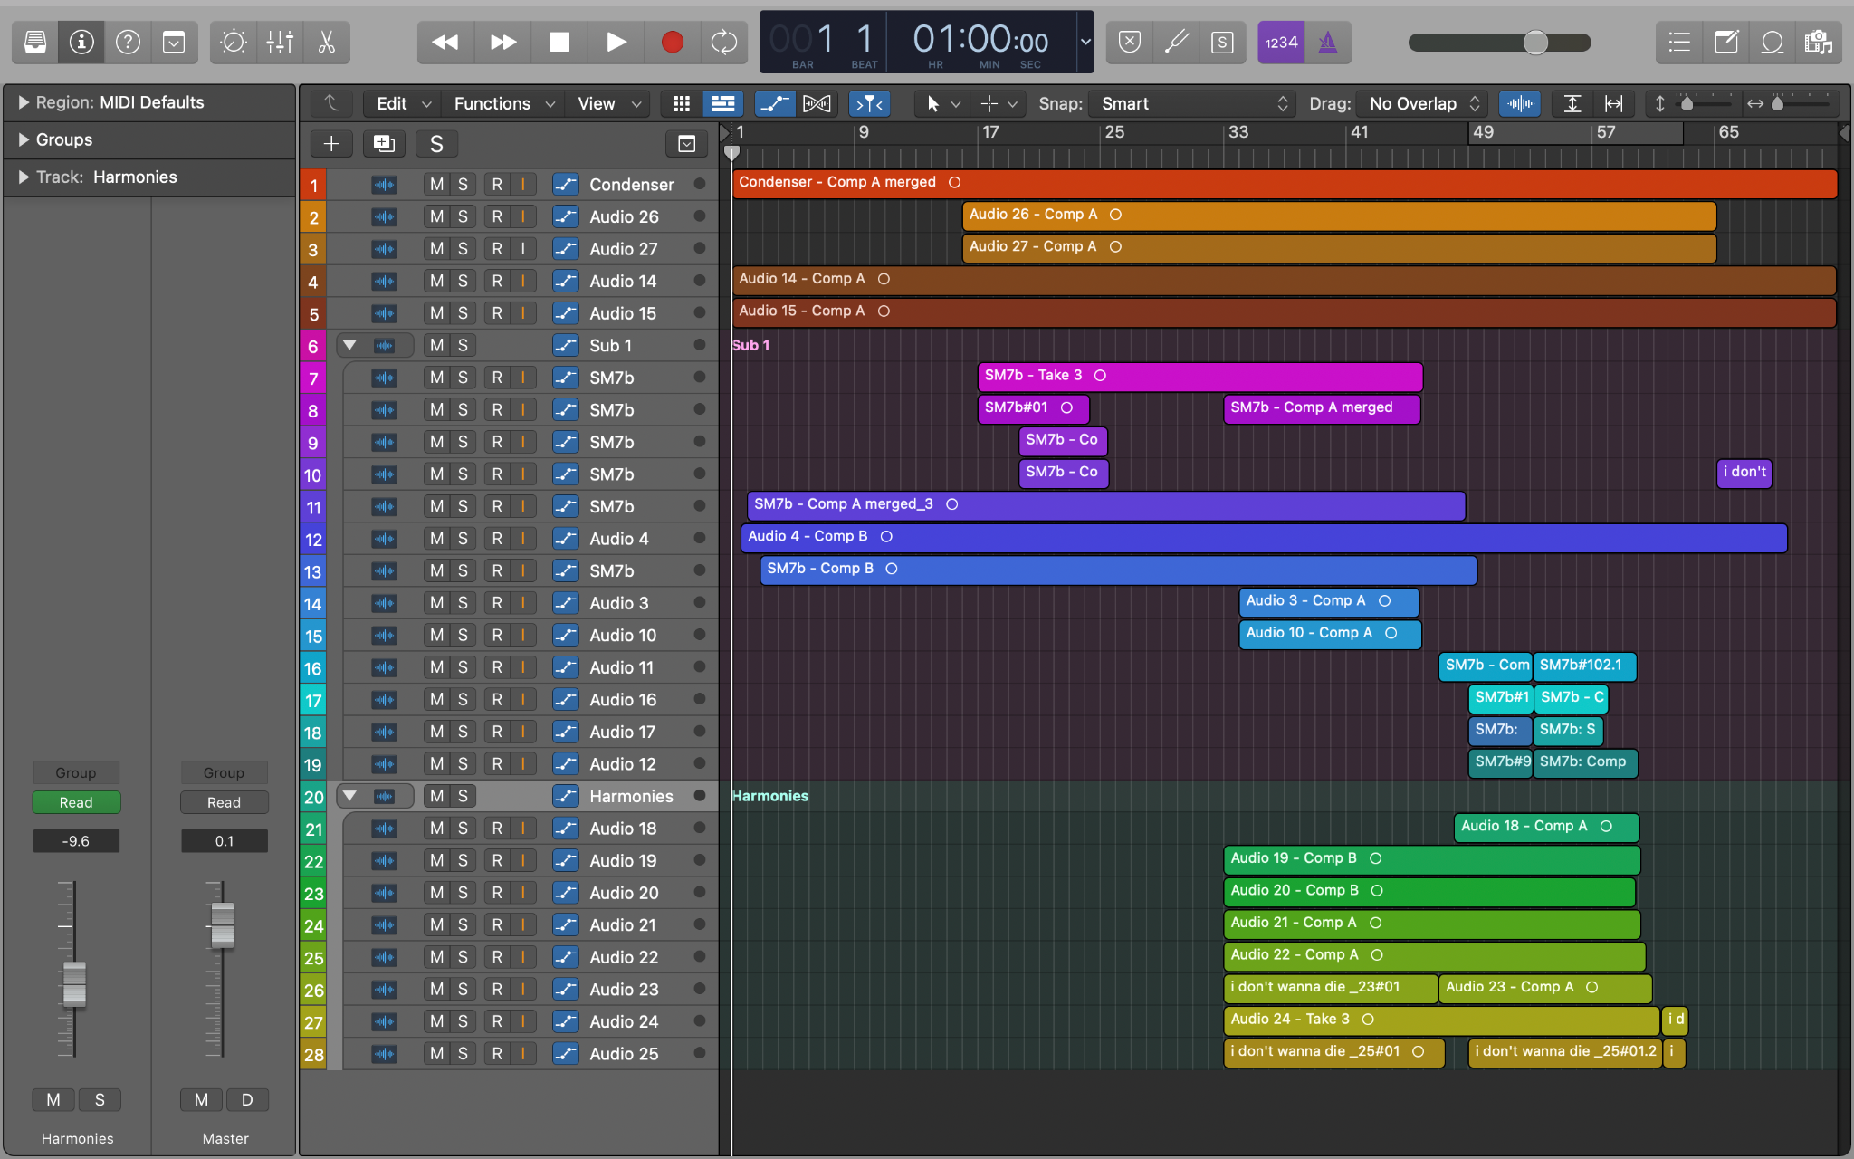
Figure 2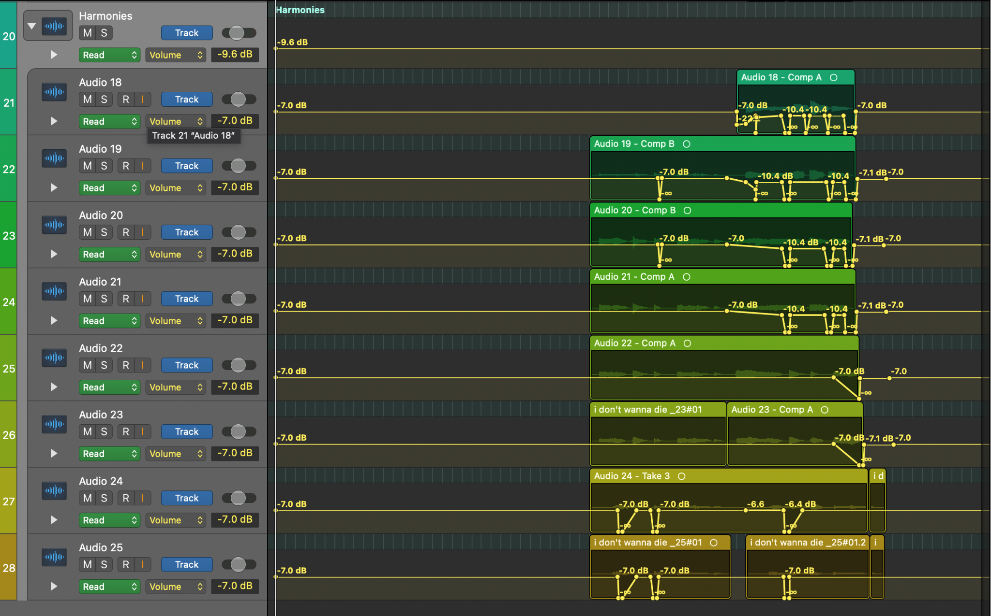

Figure 3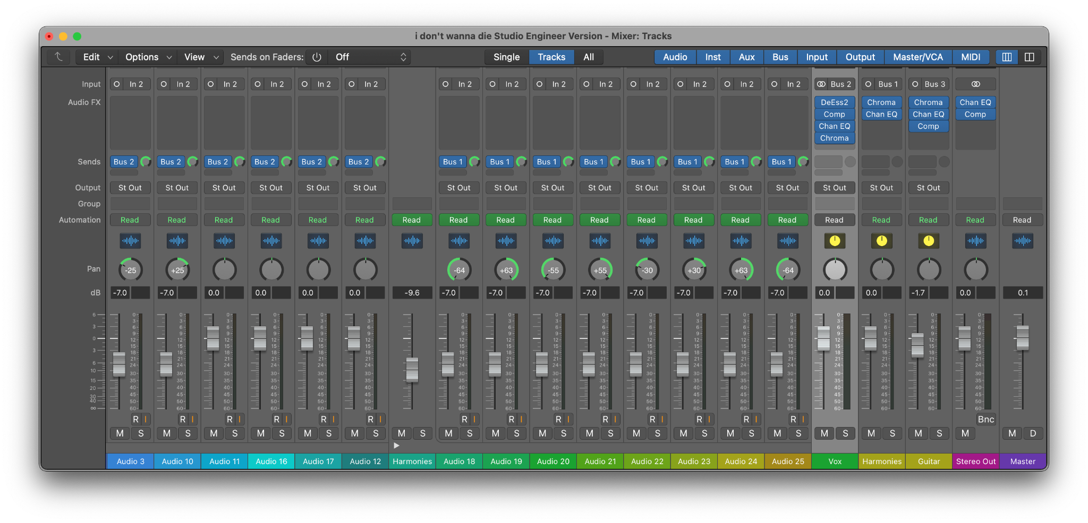
Figure 4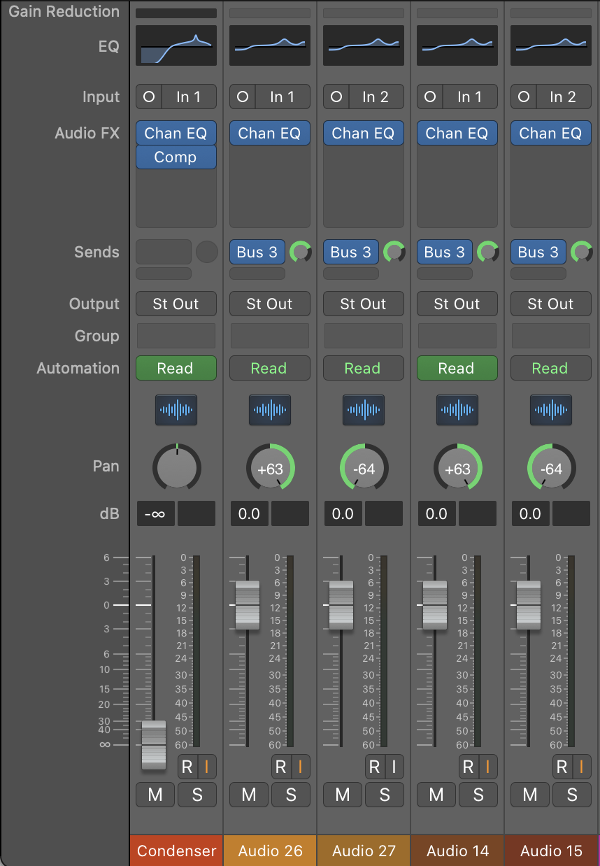

Figure 5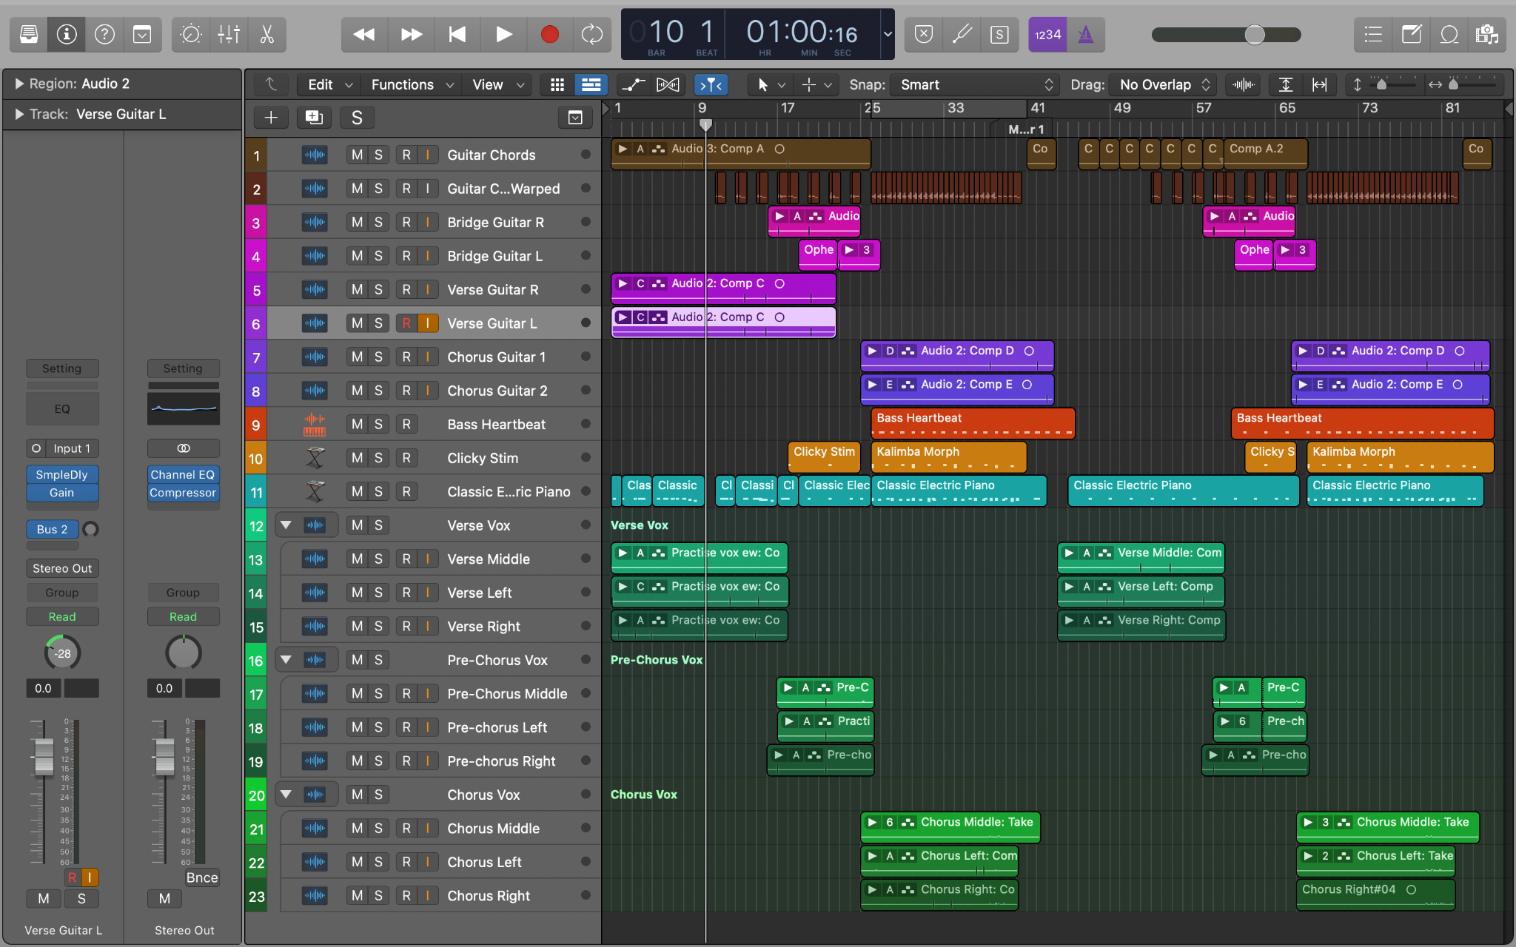

Figure 6
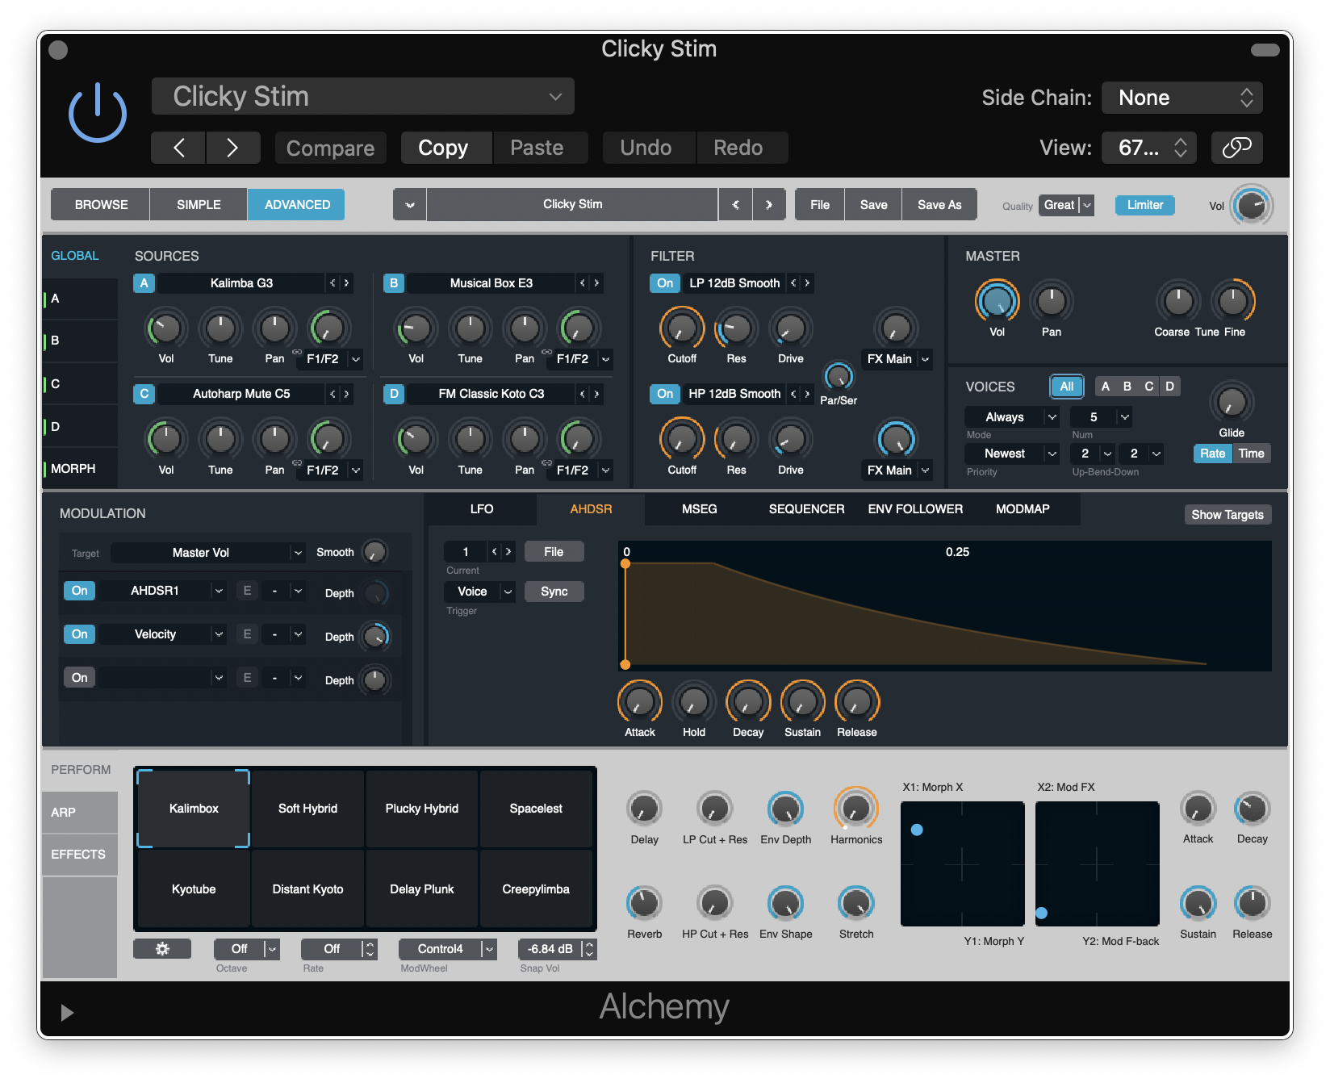

Figure 7
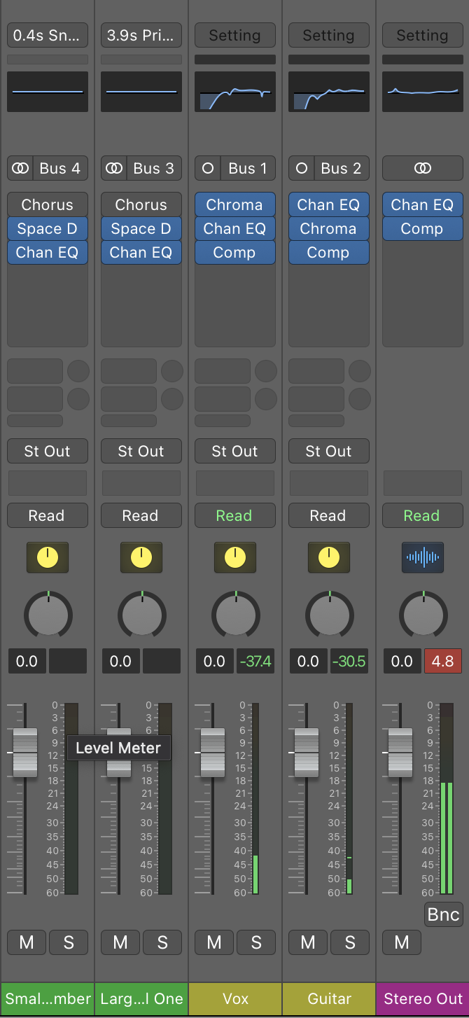
Figure 8
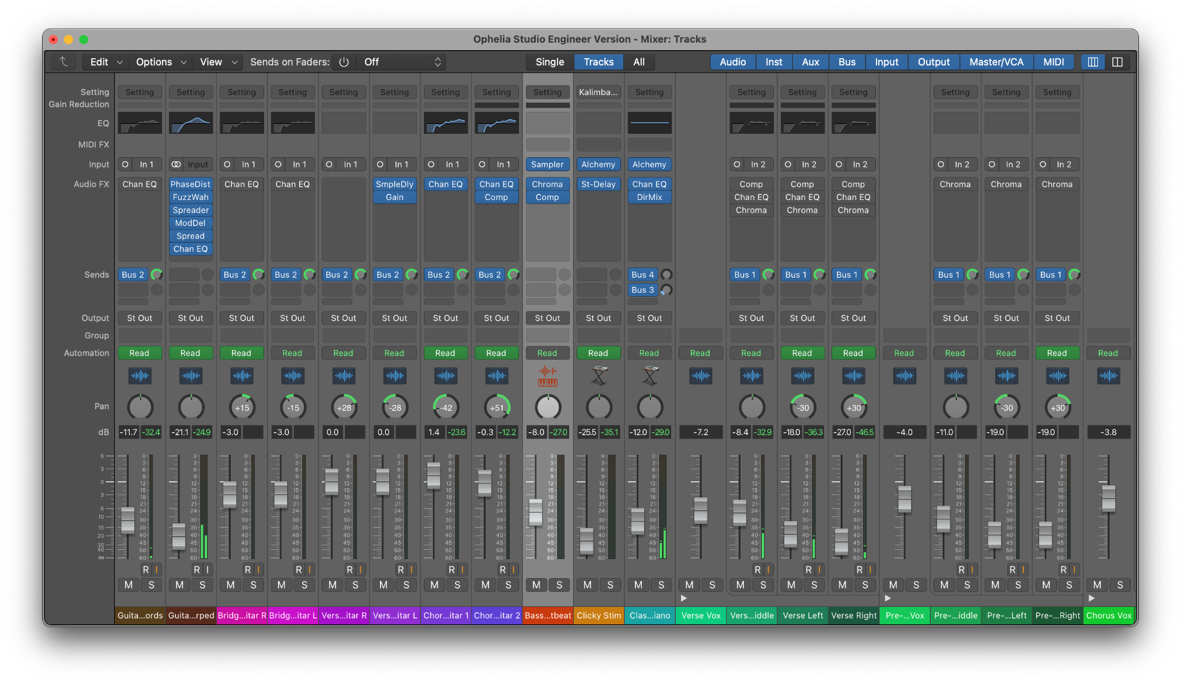
Figure 9
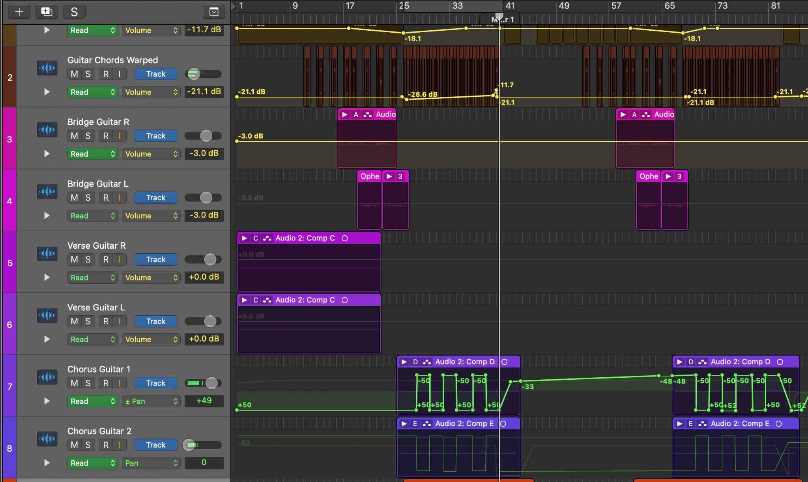

Figure 10
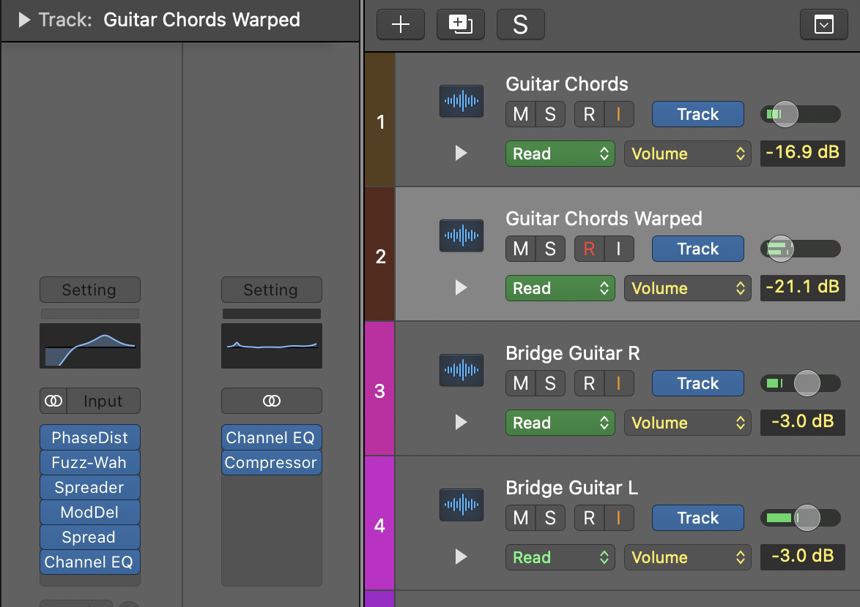

Figure 11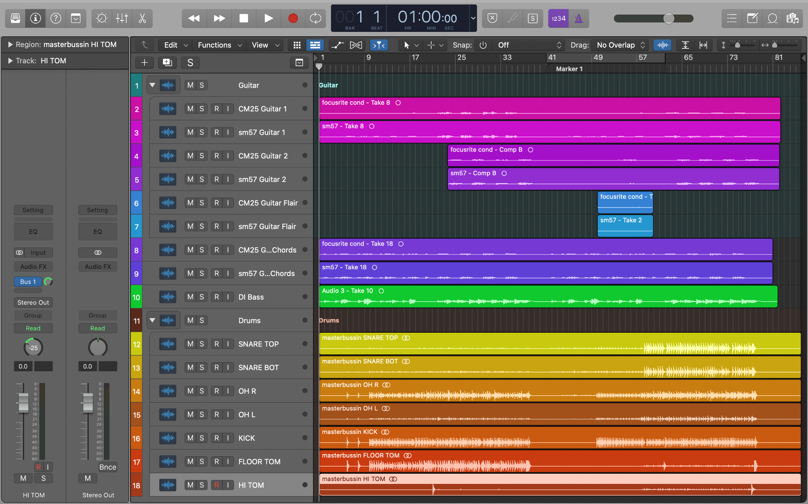

Figure 12

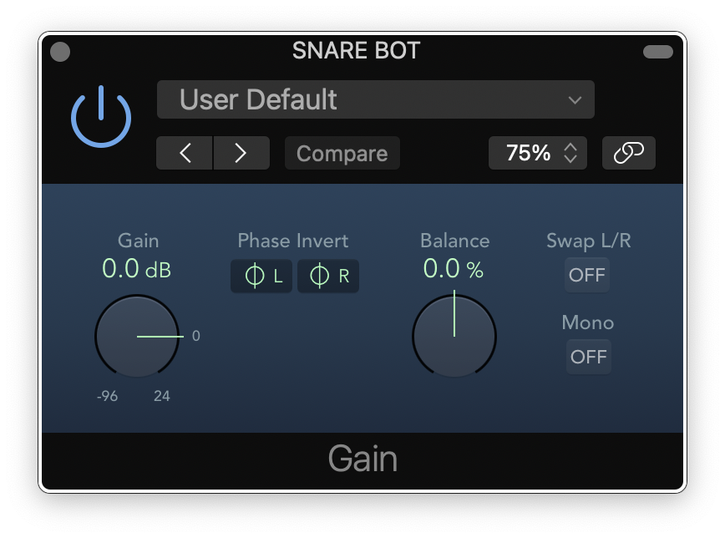

Figure 13
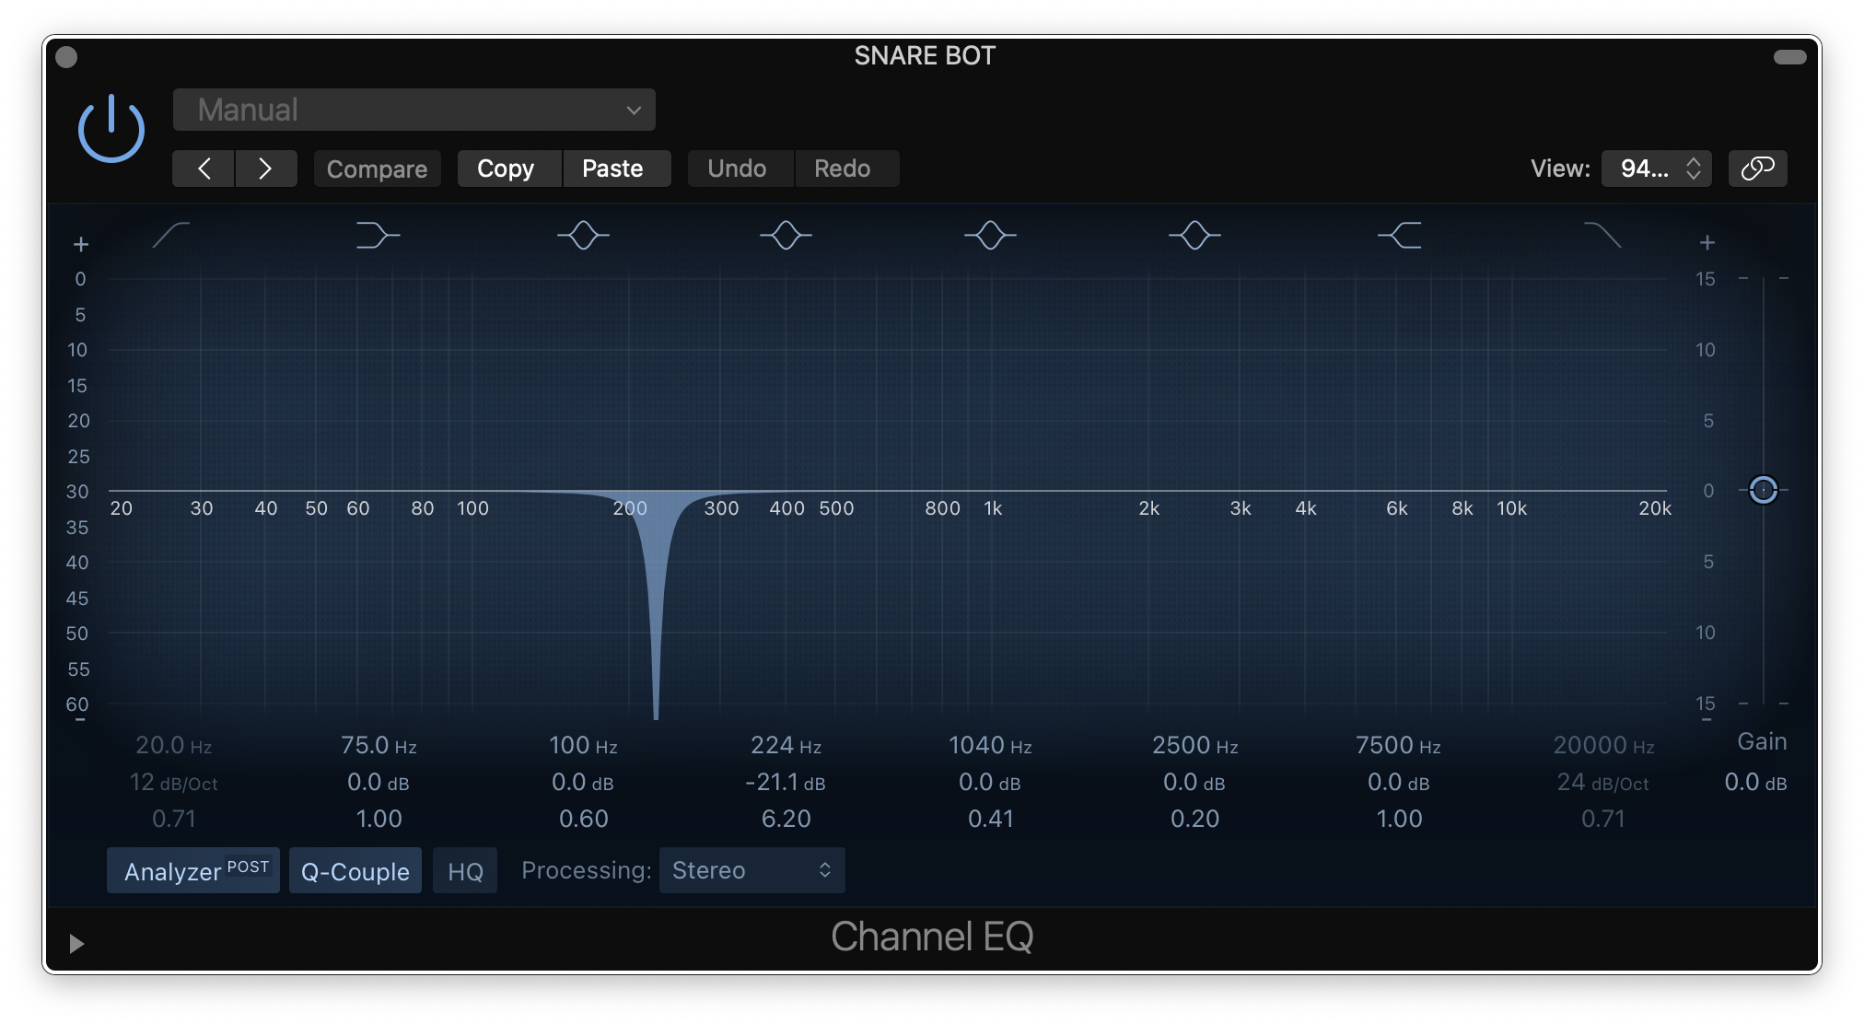
Figure 14
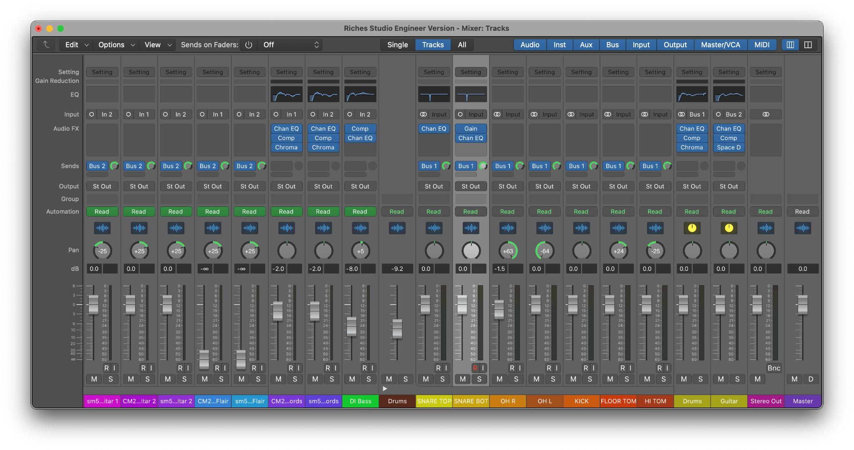
Figure 15

