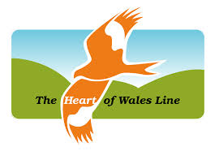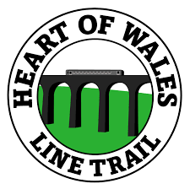
Nathan Stephens
STUDENT Number -1907774
Developing the tourism offer on the Heart of Wales line

Executive summary
This report is intended for the consideration of related politicians and transport planners into the Heart of Wales Line funding 2022. The report includes a brief introduction into the Heart of Wales Line, leading to the exploration of the main body of stakeholder consideration, similar line comparison and making use of a strategic model (SWOT analysis) before drawing to a conclusion. The report finalises with its main purposes of constructing 3 objectives while being analysed and how to put them into effect.
Contents
1.0 Introduction 3
2.0 Main Body 3
2.1 Stakeholders 3
2.2 Similar rail lines 4
2.3 Strategic Models 5
2.4 Conclusion 6
3.0 Recommendations 6
4.0 References 7

1.0 Introduction
‘The 121-mile route was built in the 1860s and has survived government cuts, bridge and tunnel collapses, and even the theft of rails – always managing, somehow, to stay open’ (The Guardian (2019)). The train service is operated by 'Transport for Wales' and runs seven days a week. Not only used for recreational purpose, but it also provides a vital transport link for many rural communities in and around Mid Wales where public transport is limited in many cases. ‘The heart of Wales Line Development Co’ promotes and develops the line as well as running the website. More can be found on the background of the line from the official website (Heart of Wales Line (2019)).
With an expansion due in 2022, doubling its transport capacity as part of its strategic transport plan, there is a real opportunity and potential need to look into ways of expanding the tourism around the line and the accompanying trail path.

2.0 Main Body

2.1 Stakeholders
It is important to consider the key stakeholders for the Heart of Wales Line, to efficiently make recommendations into further developing rail-based tourism. ‘Many authors have defended a hypothesis that the application of stakeholder management leads to a higher business performance’ (Částek, Ondřej, et al. (2017)). Stakeholders can be defined as ‘All those with interests in an organization; for example, as shareholders, employees, suppliers, customers, or members of the wider community, who could be affected by the social or environmental consequences of an organization’s activities’ (Stakeholders (2010)).
One clear key Stakeholder in particular for the line that needs to be considered is the community. For a local line that runs through a collection of small towns such as Llandeilo with a population of only 3000, a sense of a strong community where everyone knows everyone will be seen. More on Llandeilo can be found at (Carmarthenshire Council (2019)). Upon observation on a visit to Llandovery, there was a strong sense of community involvement with the Line and their strong feelings towards it. After completing a survey with local residents regarding the line most responses were positive, and all knew about the line and the walking path alongside it. Upon any development ideas and recommendations, with such strong ties, the community will be needed to be considered to sustainably manage the line.
A second key stakeholder that will need to be considered is the line's customers. ‘The relationship between customers and a firm exist because of a mutual expectation built on trust, good faith, and fair dealing’ (Ferrell, O. C (2004)). In particular, customer demographics will be needed to be understood to satisfy the customers and gain repeat purchases. ‘Satisfaction is a key variable that influences the development of long-term relationships with customers. (Jain. A et.al (2014)). Use of rail varies by age, with those aged 21-29 making an average of 41 rail trips each per year, compared to 6 for those aged over 70, More can be found at the Department of transports official website (Department for transport (2019)). However, in contrast to this, upon observation, there was a clear case to say the opposite for the heart of Wales line. With more elderly people making use of the line, this may be down to the specific usage of the line being more towards recreational as well as for transport over the standard rail line.

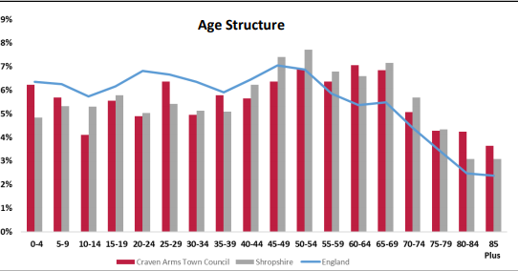
Diagram 1- Shropshire council (2018)
The above diagram illustrates the older demographics in Craven Arms, a ‘busy little town in Shropshire’ (Heart of Wales Line 2019). The demographics of this town situated on the line supports the point made on older generations making use of it.

2.2 Similar rail lines
One similar rail line organisation in the UK that can be compared and contrasted with The Heart of Wales Line is the ‘Devon and Cornwall Rail Partnership’, ‘’We are a non-profit partnership between local authorities, the railway and the University of Plymouth, where we are based’’ (Devon and Cornwall Rail Partnership (2019)). The partnership has seen much growth, for example since 2001 the ‘Tarka Line’ has seen a 241% growth. The Partnership has gained national recognition winning many times in the annual community rail awards, ‘Since the event began in 2005 we have been awarded fifteen 1st places, six 2nd places and seven 3rd places’ (Devon and Cornwall Rail Partnership (2019)).
One notable significance with the partnership is the availability of catering on the ‘Looe Valley Line’, one of many lines in the partnership. The campaign involves local restaurants serving free taster meals in November at lunchtimes to passengers. ‘Local restaurants gain great publicity and the chance to interact with potential customers face-to-face thanks to our annual Munchtime Express campaign’ (Devon and Cornwall Rail Partnership (2019)). The heart of wales line does not currently offer any catering on the trains, with a lack of even basic offerings of water or snacks. Even with some of the lengthy travel times. The ‘Looe Valley Line’ has a notable 90% growth since 2001. As well as the Heart of Wales Line, the Devon and Cornwall partnership gears towards the local community including multiple schemes and projects with schools, local businesses and universities. ‘Projects like these help us to inspire more people to take the train and create attractive station environments that provide a great first impression of our villages, towns and cities’ (Devon and Cornwall Rail Partnership (2019)).
A second similar train line organisation that can be benchmarked with The Heart of Wales Line is the ‘West Highland Line’. Developed in 1983, ‘The West Highland Lines are world-class railways making a major contribution to accessibility for residents, tourists and freight in this uniquely beautiful part of Scotland’ (West Highland Line (2019)). With 4 and a half stars on TripAdvisor and considered by some to be ‘The most scenic rail journey in the world’ (Scot Rail (2019)).
The Line also offers catering availabilities as well as the Devon and Cornwall line, ‘You can buy a selection of drinks and snacks on many of our long-distance train services’ (Scot Rail (2019)). ‘In particular, sticking with local cuisine and honouring local communities with its food selection, our menu features more Scottish produce than ever before’(Scot Rail (2019)).

2.3 Strategic Models
‘Environmental analysis is a critical part of the strategic management planning process. The SWOT (Strengths, Weaknesses, Opportunities, Threats) framework is proposed by many as an analytical tool which should be used to categorize significant environmental factors both internal and external to the organization’ (Pickton, D.W. and Wright, S., (1998)). The Heart of Wales Line will experience both internal and external factors of developing rail-based tourism and increasing footfall.
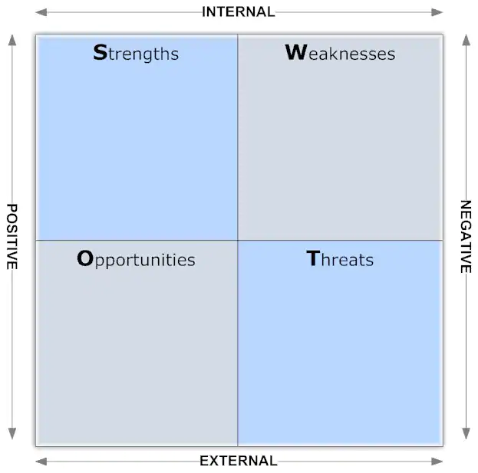

.Strong community ties .No on board catering
.Beautiful landscapes and scenic views .No clear usage of Wildlife information
. Wildlife Availability .Potentially high-ticket prices

.Consideration of wildlife on route .More government cuts
.On board catering availability . New and existing rivalling train lines
.Advertising Local community significan in the UK
-ces more on route .A potential collapsing Economy (Brexit)
.Better usage of technology

Diagram 2- SWOT Analysis
The above diagram will aid in the development of recommendations to develop the rail line and increase the demand for the line to keep up with extension development plans. The diagram is displayed simply and can be analysed effectively, and conclusions drawn with ease. The SWOT analysis has drawn on points made from the main body of the report.

2.4 Conclusion
In conclusion for the Heart of Wales Line to increase its tourism numbers, an understanding of key stakeholders will be needed to effectively apply recommendations that directly apply to the Lines individuality. As well as this, benchmarking similar lines as mentioned, will allow for the line to effectively compare and contrast factors across all aspects of the line to positively affect the organisation. The SWOT analysis has drawn on mentions through the main body and personal experience on the line, to make it easier and clearer to construct what recommendations are needed to move forward.

3.0 Recommendations
Objective 1- To provide some sort of catering service on the train line for customers
This can be achieved with making use of the free time many conductors have while on the line as previously observed. When demand increases, it may be an evident need to employ another employee who can attend to the food and drink. It may be best to start small and avoid complications with basic snacks as observed with the ‘West Highland Line’. If funding is low, there may be a need to provide catering services between stations of high footfall. In contrast, however, there are many pressure groups against the service of 'snacks' on transport following new laws like the sugar tax. 'Eating or drinking on trains and buses should be banned, in a bid to end Britain’s “mindless” snack culture’ (Telegraph (2019)). So, there may be a need for other alternative snacks like fruit etc.
Objective 2- To provide a more in-depth and interactive way to advertise the wildlife available in the areas the Rail Line runs through
‘Wales is one of Europe’s best wildlife-watching secrets [and] can rival anywhere in the world’ (BBC Earth (2019)). Although there is much information on the natural landscapes, The Heart of Wales Line lacks inadequate advertising of the wildlife available, upon observation on the official website and from experience. In fact, upon comparing with similar lines previously mentioned, there seems to be a lack of this across this niche market. ‘Globally, the market size of wildlife tourism has been estimated at 12 million trips annually with a growth rate of 10 per cent per’ (Newsome, D. and Rodger, K., (2012)). There is a clear opportunity here for the line to take advantage of and gain a competitive edge in the market and thus increase tourism. This could be achieved simply through the use of maps and signboards along the walking trail. Or in a more advanced way, to make use of technology like apps to make it more interactive for customers. However, this is largely dependent on funding.
Objective 3- To make use of ‘E-Bikes’ as an integrated transport mode
‘Electric bicycles (e-bikes) represent one of the fastest-growing segments of the transport market’ (Fishman, E. and Cherry, C., (2016)). This may be perfect for the older demographics associated with the line as previously mentioned. The elderly may be put off or even unable to use pushbikes, E-bikes can aid in the ease of recreational use. A new demographic market may be target also, with families potentially being of interest with children incapable of cycling the sometimes-hard terrains and distances as observed. ‘In 2017 there were 19.0 million families in the UK; this increased by 15% from 16.6 million in 1996’(Office of National Statistics (2017)). E-Bikes could be available for hire along with certain stops of the rail path and can be used to explore first-hand the local towns on each stop. This recommendation if applied will aid in the notable problem of lack of bike space on the trains also. With only 2 and 3 bike spaces being available with the new model trains coming in 2022. (Transport for Wales (2019)).

4.0 References

"Stakeholders." A Dictionary of Accounting (2010): A Dictionary of Accounting. Web.
BBC Earth (2019) ‘Celebrating the wonderful wildlife of Wales’. Available from:
Carmarthenshire County Council (2019) ‘Llandeilo Ward’ Available From: https://www.carmarthenshire.gov.wales/media/1212799/llandeilo-ward.pdf
Částek, Ondřej, and Martin Cenek. "A Relationship between Stakeholder Management and Business Performance in the Czech Republic." Managing Global Transitions 15.2 (2017): 187-207. Web.
Department for transport (2019) ‘Rail passengers factsheet’ Available from: https://assets.publishing.service.gov.uk/government/uploads/system/uploads/attachment_data/file/590562/rail-passengers-factsheet-2016-revised.pdf
Devon and Cornwall Rail Partnership (2019) ‘Who we are’ Available from: https://dcrp.org.uk/
Ferrell, O. C. "Business Ethics and Customer Stakeholders." The Academy of Management Executive (1993-2005) 18.2 (2004): 126-29. Web.
Fishman, E. and Cherry, C., 2016. E-bikes in the Mainstream: Reviewing a Decade of Research. Transport Reviews, 36(1), pp.72-91.
Heart of wales line (2019) Available from:
http://www.bbc.co.uk/earth/story/20160229-celebrating-the-wonderful-wildlife-of-wales
https://www.heart-of-wales.co.uk/
Jain, Arpit, Anil Kumar, and Manoj Dash. "Demographics and Customer Satisfaction: Loan Procedures Variables." SCMS Journal of Indian Management (2014): 35-49. Web.
Newsome, D. and Rodger, K., 2012. Wildlife tourism. In The Routledge handbook of tourism and the environment (pp. 367-380). Routledge.
Office of National Statistics (2017) Families and households in the UK: 2017. Available from: https://www.ons.gov.uk/peoplepopulationandcommunity/birthsdeathsandmarriages/families/bulletins/familiesandhouseholds/2017
Pickton, D.W. and Wright, S., 1998. What's swot in strategic analysis?. Strategic change, 7(2), pp.101-109.
Scot Rail (2019) ‘West Highland Line’ Available from: https://www.scotrail.co.uk/scotland-by-rail/great-scenic-rail-journeys/west-highland-line-glasgow-oban-and-fort-williammallaig
Shropshire Council (2018) ‘Craven Arms town profile’ Available from: https://shropshire.gov.uk/media/9684/craven-arms.pdf
The Guardian (2019) ‘All aboard a new walking trail across Wales’ Available from: https://www.theguardian.com/travel/2019/feb/05/walking-the-heart-of-wales-line-trail-railway-line [Online]
The Telegraph (2019) ‘Ban everyone from eating or drinking on trains and buses to end snack culture, says chief medical office’ Available From: https://www.telegraph.co.uk/news/2019/10/09/ban-everyone-eating-drinking-trains-buses-end-britains-snack/
Transport for Wales (2019) ‘Rolling stock’ Available from: https://moodle.uwtsd.ac.uk/pluginfile.php/314709/mod_resource/content/1/TfW%20and%20Heart%20of%20Wales%20Line%20presentation.pdf
West Highland line (2019) ‘Friends of the line’ Available from: https://westhighlandline.org.uk/

