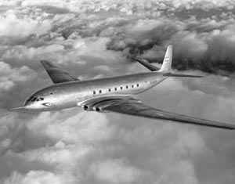

Failure Analysis of the de Havilland Comet
  - Fatigue and Material Failure
Fraser Goodwin | Materials Science ACDA 6016 | 11/01/2026

Word Count: 3022

Abstract
The de Havilland Comet was the world’s first commercial jet airliner and a landmark achievement in aerospace engineering, introducing pressurised jet travel to civilian aviation in the early 1950s. Despite its technological innovation, a series of catastrophic mid-air breakups between 1953 and 1954 led to the grounding of the fleet and revealed fundamental shortcomings in the understanding of metal fatigue and structural integrity under cyclic loading. This report presents a detailed failure analysis of the Comet, focusing on fatigue-driven fuselage failure and the material, design, and testing factors that contributed to its demise.
The investigation examines the effects of repeated cabin pressurisation cycles on the aluminium alloy fuselage, demonstrating how stresses well below the ultimate tensile strength initiated microscopic fatigue cracks that propagated over time. Particular attention is given to stress concentration effects around rectangular window cutouts and rivet holes, which significantly accelerated crack growth. Theoretical frameworks including S–N curves and Paris’ Law are applied to explain the crack initiation, propagation, and sudden catastrophic failure observed in service.
The report also reviews the experimental methods used to identify the root cause of the accidents, including wreckage recovery and reconstruction, full-scale pressurised water tank fatigue testing, and metallurgical examination of fracture surfaces. These investigations conclusively demonstrated that cyclic pressurisation-induced metal fatigue was responsible for the failures.
Finally, the report discusses the profound impact of the Comet disasters on modern aircraft design, certification, and testing standards. Lessons learned led to the adoption of damage-tolerant design philosophies, improved fatigue testing, redesigned fuselage geometries, and enhanced inspection regimes, establishing principles that continue to underpin the safety of commercial aviation.

Table of Contents
Abstract 1
Table of Contents 2
Table of Figures 2
Table of Equations 3
Introduction 3
Comet Fuselage Failure 5
Metal Fatigue Under cyclic Pressurisation 5
Design Induced Crack Propagation 6
Materials Theory 9
Wöhler curve 9
Paris Law 10
Experimental Methods 12
Initial Fatigue Testing Limitations 12
Wreckage Recovery and reconstruction 13
Pressurised Water Tank Fatigue Test 13
Metallurgical Examination and Stress Analysis 15
Conclusion and Recommendations 17
Engineering Recommendations 18
References 19

Table of Figures
Figure 1 - de Havilland Comet I 3
Figure 2 - Comet Cyclic Pressurisation 5
Figure 3 - Stress Concentrations around Windows 7
Figure 4 - Fuselage Cracks from Rivet Holes 8
Figure 5 - Typical S-N Curve 9
Figure 6 - G-ALYP Reconstruction 13
Figure 7 - G-ALYU in Testing Tank 14
Figure 8 - G-ALYU Fuselage Failure 15
Figure 9 - G-ALYP Close-up Failure 16
Figure 10 - Stress at Cutout on G-ALYU 17

Table of Equations
Equation 1 - Paris Law 11
Equation 2 - Stress Intensity Factor 11
Equation 3 - Crack Growth vs Crack Length 11

Introduction
The de Havilland Comet, seen in Figure 1, holds a unique place in aviation history as the world’s first commercial jet airliner. Introduced in 1952 by the British manufacturer de Havilland, the Comet represented a bold leap forward in technology and design. It boasted embedded turbojet engines, a pressurised fuselage and aerodynamic efficiency which promised faster, smoother, and more comfortable travel than the propeller driven aircraft of the then current era. At the time, the Comet aircraft symbolised engineering excellence and put the United Kingdom at the forefront of aviation technology. [1] [2]
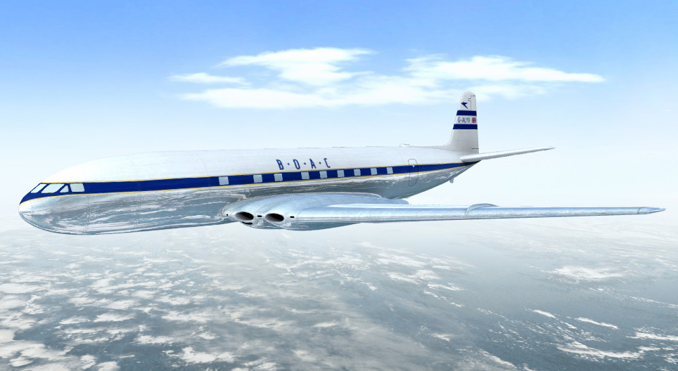
Figure 1 - de Havilland Comet I
Initially, the Comet was a resounding success, attracting global attention and setting new standards for passenger aircraft. However, this was short lived as between 1953 and 1954 a series of catastrophic accidents occurred, with several Comet aircraft suffering structural failures mid-flight. Investigations revealed that the crashes were caused by metal fatigue resulting from repeated pressurisation cycles, which was a phenomenon poorly understood at the time. The aircraft’s square shaped windows and stress concentration points accelerated crack propagation ultimately leading to failure of the aluminium fuselage. These design flaws combined with limited fatigue testing, exposed critical gaps in the industry’s understanding of jet aircraft durability. The consequences were severe as the Comet fleet was grounded in 1954 when the airlines certificate of airworthiness was revoked by the British Air Ministry which allowed American manufacturers such as Boeing to dominate the commercial jet market putting a stop to Britain’s early lead in aviation innovation. [1] [3] [4] [2]
Despite its tragic setbacks, the Comet’s legacy is profound. The failures prompted extensive changes in aircraft design, testing, and certification standards with rigorous fatigue analysis, structural principles, and comprehensive lifecycle testing becoming industry norms. The Comet’s story highlighted the importance of balancing innovation with thorough safety validation, a principle that continues to guide modern aircraft development. While the Comet aircraft innovation never recovered, its pioneering role and knowledge gained from its shortcomings laid the foundation for the global jet era, shaping the future of air travel for generations to follow. [3] [5]

Comet Fuselage Failure
The structural failures of the de Havilland Comet were primally attributed to metal fatigue in the aircraft’s fuselage. This phenomenon, poorly understood at the time, was exacerbated by design choices and operational pressure conditions unique to jet powered aircraft.

Metal Fatigue Under cyclic Pressurisation
To enable the output of the Comet to be sufficiently large for commercial viability, the weight of the aircraft and the fuel onboard had to be kept to a minimum. Additionally, to allow the engines to run as efficiently as possible, the aircraft was expected to fly at 40,000ft, which was double the cruising altitude of the then commercial aircraft. At this cruising altitude, due to the reduced air pressure, the passengers would require an artificial oxygen supply. The cabin was pressurised to the equivalent of 8000ft above sea level which was comfortable for passengers but gave a pressure differential across the aircraft skin of 56kPa at cruising altitude. This was double the number that had been previously employed, but de Havilland conducted extensive tests to ensure the integrity of the cabin. [4] [6]
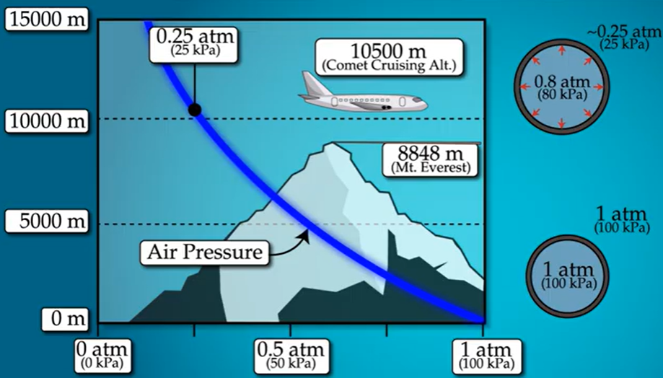
Figure 2 - Comet Cyclic Pressurisation
Figure 2 is a graph that roughly shows the pressurisation cycles that the Comet would experience on every flight when the cabin is pressurised to provide breathing air for passengers. Each cycle imposes tensile stresses on the aluminium alloy fuselage skin and supporting structure, which while lightweight and strong, was susceptible to fatigue cracking under cyclic loads. The tensile stresses experienced by the aircraft were well below the ultimate tensile strength for the material, but their repetitive nature initiated microscopic cracks that propagated over time eventually causing material catastrophic failure. This is the basis of metal fatigue. [4]

Design Induced Crack Propagation
The Comet aircraft fleet included several critical design flaws that ultimately led to its grounding. The aircraft featured rectangular window cutouts which acted as natural stress concentrators, due to the stress levels experienced at each corner of the windows being multiple times higher than the surrounding fuselage. Although high stress would be experienced at the corners of windows, this was already a known fact at the time. For this reason, the windows were not completely rectangular but had rounded edges to distribute the stress more evenly, but investigations concluded that the stress in these areas was still much higher than other areas. While the design of the window cutouts was weak, they were not the source of cracks in the fuselage. They merely provided a high stress area for cracks to propagate to and from. The stress profile of the window cutouts can be seen in Figure 3. [6] [2]
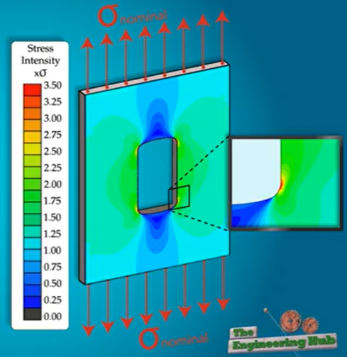
Figure 3 - Stress Concentrations around Windows
To improve aerodynamics and efficiency of the aircraft, engineers wanted the smoothest possible fuselage. At the time this was normally achieved by machining a hole into the skin of the fuselage, rather than having the rivets that connect the skin to the frames protruding from the surface, creating extra drag. However, advances in aluminium alloys meant a thinner skin could be used on the Comet with a lower weight while maintaining high strength, but this meant that the skin was too thin to drill a suitable hole in. As a solution, the ‘punch rivet’ technique was used where rivets are applied with enough force to dent into the skin creating a flat aerodynamic surface. In doing this, uneven holes and microfractures in the fuselage were created, facilitating the propagation of cracks which would grow increasingly deep with each pressurization cycle ultimately leading to the material failure of the fuselage. [4] [3]
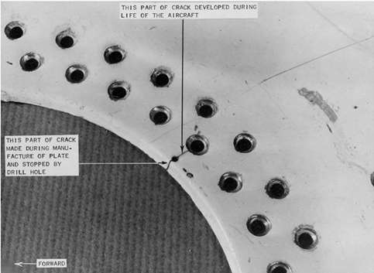
Figure 4 - Fuselage Cracks from Rivet Holes
Figure 4 shows a part of a crack that developed during the life of one of the recovered Comet aircraft. The crack propagates from the rivet hole towards the edge of the material but a 1.66mm drill was made at the end of the crack in effort to stop it propagating further which was an approved technique at the time. In most cases, the crack did not extend beyond the drilled hole, and this was assumed to be adequate security against further crack growth. But in this case, the crack continued to grow after the drilled hole, reaching the edge of the material. [4] [2]

Materials Theory

Wöhler curve
The Wöhler curve, or S-N curve, is one of the most widely used tools to represent metal fatigue data. The S-N curve describes the relationship between the cyclic stress amplitude experienced by a material and the number of cycles it takes until the material reaches failure. The curve, unique to each material, provides insights into a material’s fatigue life and is commonly used to design components that experience repeated loads over time. The S-N curve typically has two distinct regions, the low cycle fatigue region, and the high cycle fatigue region. At high stress levels, materials fail quicker after a small number of cycles whereas at lower stress levels, materials can withstand millions of cycles before failure, reaching what is called the endurance limit. A typical S-N curve for different metallic materials can be seen in Figure 5. [7] [8]
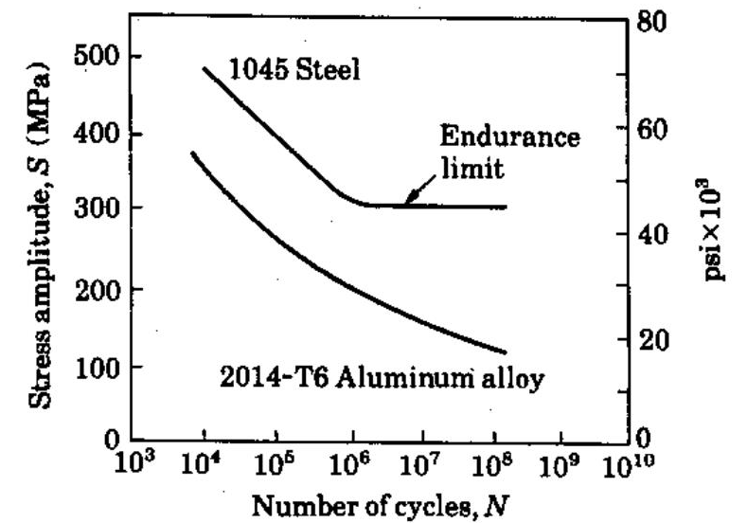
Figure 5 - Typical S-N Curve
Using the S-N approach the fuselage failure of the de Havilland Comet aircraft can be clearly understood. This is because the Comet’s fuselage was subjected to repeated pressurisation and depressurisation cycles during every flight operation, imposing a cyclic tensile stress on the fuselage skin upon every ascent and descent. Although the stress level in each cycle was well below the ultimate tensile strength of the aluminium alloy used, the S-N theory shows that failure can still occur after a significant number of cycles if the stress amplitude exceeds the materials fatigue limit. For the Comet, the fuselage experienced high cycle fatigue, where relatively low stresses led to failure after thousands of pressurisation cycles. [4] [7]
The problem of metal fatigue was accelerated more by high stress concentrations around the square window cutouts and rivet holes. According to the S-N concept, local increases in stress will shift the operating point on the S-N curve to a higher stress amplitude, thus dramatically reducing the fatigue life. The microscopic cracks initiated at these stress concentration sites grew with each pressure cycle with more high stress areas being created when cracks propagate. [2] [7]
As can be seen in Figure 5, the aluminium alloy, which is like the one used to make the fuselage skin of the Comet aircraft does not have an endurance limit, meaning that even under very low stress levels the material will eventually fail. This is unlike materials like steel which exhibit a clear endurance limit where they can theoretically endure infinite cycles under that stress level without failure.

Paris Law
The fuselage failure of the de Havilland Comet can be interpreted using Paris’ Law, which quantitively describes fatigue crack growth under cyclic loading. The constant pressurisation and depressurisation of the cabin produced cyclic hoop stresses in the fuselage skin, causing fatigue cracks to initiate at stress concentration points such as rivet holes near the corners of window cutouts.
Paris’s Law related the crack growth rate to the stress intensity factory range and is defined as:
Equation 1 - Paris Law
$$\frac{da}{dN}={C(ΔK)}^{m}$$
Where $a$ is crack length, $N$ is the number of load cycles, $C$ and $m$ are material constants, and $ΔK$ is the stress intensity factor range. [9] For a through thickness crack in a thin fuselage skin, the stress intensity factor range can be approximated as:
Equation 2 - Stress Intensity Factor
$$ΔK=YΔσ\sqrt{πa}$$
Where $Y$ is a geometrical factor. In the Comet, the corners of the rectangular window cutouts resulted in a large $Y$ value, significantly increasing $ΔK$ for a given crack length. [10] If you substitute $ΔK$ from Equation 2 into Equation 1 it can be shown that crack growth rate increases nonlinearly with crack length:
Equation 3 - Crack Growth vs Crack Length
$$\frac{da}{dN}={C(YΔσ\sqrt{πa})}^{m}$$
The relationship in Equation 3 implies that when cracks start off small, they grow slowly but as the crack length, $a$, gets larger there is a rapid acceleration in the crack growth rate. This demonstrates that a substantial period of initial fatigue for a material is spent with cracks with a length below detectable size, which could explain why the Comet aircraft failures occurred suddenly without warning. For a crack to grow large enough to induce material failure, it must reach the critical crack length. This is the point where the maximum stress intensity factor, $K_{max}$, exceeds the material fracture toughness leading to unstable fracture. [4] [10] [11]
The Comet’s structure was not evaluated against such fatigue crack progression theory as it was not available at the time. The later adoption of Paris’ Law enabled engineers to predict crack growth, establish inspection intervals, and improve fuselage design, fundamentally improving aircraft structural integrity.

Experimental Methods
Following the loss of several de Havilland Comet aircraft in the 1950s, extensive experimental investigations were undertaken to determine the root cause of the accidents. While de Havilland conducted fatigue testing of the fuselage during the original design phase, these tests proved insufficient to reveal the true failure mechanism. Several experimental procedures were used to identify the root cause of these accidents, but the three deemed critical to the identification of the root cause were: wreckage recovery and reconstruction, full scale pressurised fatigue testing, and metallurgical and stress analysis. [2] [4]

Initial Fatigue Testing Limitations
During development, fatigue tests were performed on fuselage sections to assess durability under cyclic pressurisation. These tests involved repeated loading of pressurised cabin structures, but it was found non-representative of a whole aircraft cabin. This was due to bulkheads being fitted to these sections to allow pressurisation affecting the stresses around the window cutouts.
In addition, the sections were proof tested to double the operating pressure at cruising altitude before fatigue testing began. This is thought to have caused local plastic deformation in regions of stress concentration, resulting in rounded crack initiation sites. The rounded geometry significantly reduced the local stress concentrations, allowing the structures to survive a much higher number of cycles before failure. As a result, the tests suggested an acceptable fatigue life of 18,000 cycles and did not predict catastrophic failure. [2] [4]

Wreckage Recovery and reconstruction
The first crucial step in the accident investigation was the systematic recovery and reconstruction of aircraft wreckage from the sea. The Royal Navy managed to find 70% of the Comet G-ALYP wreckage as it was in around 600ft of water, but recovery was not possible for the G-ALYY as it is thought to rest at depths of 3,500ft under water. Engineers cleaned, catalogued, and managed to reconstruct the recovered components in their relative positions on a frame as accurately as possible, as seen in Figure 6. [4]
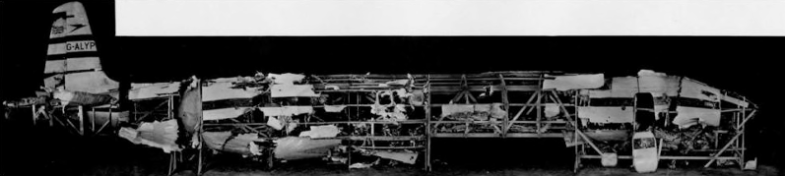
Figure 6 - G-ALYP Reconstruction
This reconstruction allowed investigators to study fracture patterns and deformation modes across the fuselage skin. The damage distribution showed that the aircraft had suffered a sudden structural failure mid-flight, rather than an explosion or impact induced breakup. It was also observed that several fractures appeared to originate near fuselage cutouts at window corners which set the basis for the rest of the investigation. This procedure was vital in narrowing the investigation down to a structural integrity problem and identifying crack initiation locations.

Pressurised Water Tank Fatigue Test
The most decisive experimental procedure was the full scale pressurised fatigue test conducted at the Royal Aircraft Establishment (RAE) in Farnborough. A full Comet fuselage (G-ALYU) was mounted inside a large water tank, with internal cabin fixtures replaced with weights, and subjected to repeated cycles of internal pressurisation and depressurisation to simulate normal flight operations. Each cycle represented one takeoff, climb to cruising altitude, and descent. An ariel view of the aircraft in the testing tank can be seen in Figure 7. [2] [4]
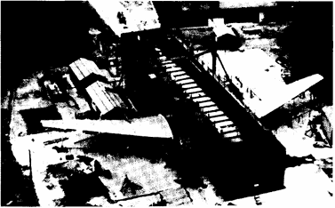
Figure 7 - G-ALYU in Testing Tank
Submerging the fuselage in water served two purposes, it absorbed the energy release during failure and allowed for visual detection of crack formation through escaping air bubbles. The test was conducted continuously, with a two hour flight able to be simulated in five minutes.
Before undergoing fatigue tests, Comet G-ALYU had already completed 1121 passenger flights, then a further 1826 simulated cycles in the test. After a total of 3057 cycles, the pressure cabin experienced fatigue failure emanating from a crack growing from a rivet hole at one of the cutouts, shown in Figure 8. This experiment conclusively demonstrated that the fuselage failed due to metal fatigue caused by cyclic pressurisation. [4]
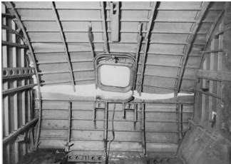
Figure 8 - G-ALYU Fuselage Failure

Metallurgical Examination and Stress Analysis
Following the identification of crack initiation sites from recovered wreckage, detailed metallurgical examinations were performed on failed fuselage components. Fracture surfaces were analysed using optical microscopy to identify fatigue characteristics such as beach marks and striations. These markings indicated progressive crack growth under repeated loading confirming fatigue as the dominant failure mechanism. The failure of Comet G-ALYP was deduced to be a fatigue crack near the rear corner of the rear ADF window emanating from a 10mm diameter bolt hole, which propagated to failure as seen in Figure 9. [2] [4]
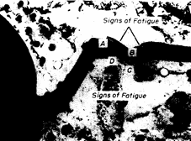
Figure 9 - G-ALYP Close-up Failure
Additionally, stress analysis conducted to understand why cracks consistently initiated near window corners. Strain gauge measurements and modelling supported by calculations revealed the high stress concentrations around the corners of window cutouts with peak stresses of 315MPa measured, which is 70% of the ultimate tensile strength of the fuselage material. The graph shown in Figure 10 shows the build up of stress at one of the window cutouts of G-ALYU, showing a rapid increase in stress as the distance to the corner of the window is decreased. [4]
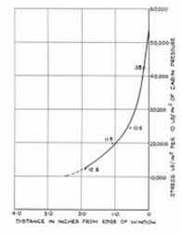
Figure 10 - Stress at Cutout on G-ALYU

Conclusion and Recommendations
The de Havilland comet represents both a landmark achievement and a pivotal lesson in the history of aerospace engineering. As the world’s first commercial jet airliner, it introduced technologies that redefined air travel, but its catastrophic failures exposed critical shortcomings in the understanding of metal fatigue and structural integrity under cyclic loading. The Comet disasters demonstrated that stress loads well below a material’s ultimate tensile strength can still lead to failure when applied repeatedly, particularly in materials like aluminium that lack a true endurance limit. Design features such as rectangular window cutouts and punch riveted joints creates areas of high stress concentration that accelerated crack initiation and propagation, ultimately resulting in explosive decompression of the pressurised fuselage. [4]
Subsequent investigations, especially the full-scale pressurised water tank fatigue tests, conclusively identified metal fatigue due to cyclic pressurisation as the root cause of the disasters. The application of fatigue theory, including S-N curves and Paris’ Law, provides a clear theoretical framework to explain the at the time seemingly unpredictable nature of the Comet failures. These theories also highlight why early fatigue testing methods were insufficient and failed to capture long term crack growth predictability.

Engineering Recommendations
- Fuselage Geometry Redesign
The Comet failures demonstrated that sharp cornered cutouts in pressurised fuselages create local stress concentrations which encourage crack growth under cyclic loading. Considerable improvement would have been achieved by adopting oval or circular windows and access hatches, significantly reducing peak tensile stresses, and removing areas of local stress concentration. Finite Element Analysis (FEA) could be applied to all fuselage sections to identify peak stress regions around joints and openings which can be used to optimise geometries by varying shapes and corner radii.
- Structural Integrity
The original design relied heavily on static strength and did not adequately account for fatigue under cyclic loading. A fatigue life and damage tolerance approach should have been adopted under the assumption that small cracks will develop during service. Structural modifications such as tear straps or frame reinforcements could have been used to limit crack growth and prevent fuselage failure.
- Mandatory Fatigue Testing
The absence of proper fatigue testing was a critical factor in the Comet failures. Engineering best practice would require full scale fuselage constructions to undergo repeated pressurisation tests simulating the complete operational life of the aircraft with a safety margin beyond design service life. This would have revealed crack initiation at stress concentration sites and validated fatigue prediction calculations. This approach was not undertaken at the time due to the lack of understanding of metal fatigue, but it is now essential for certification of all pressurised aircraft.
- Material Selection and Manufacturing Techniques
The use of aluminium alloys with limited fatigue resistance combined with manufacturing practices such as punch riveting, introduced residual stresses and microscopic cracks at joint holes. Engineering improvements should have included alloys with improved crack growth characteristics, drilled holes, a controlled riveting process, or introducing a better surface finish through polishing or deburring.
- Enhanced Inspection and Maintenance Programs
Regular non-destructive inspections of fatigue critical areas such as window cutouts and openings would have increased the likelihood of early crack detection. Inspection intervals should have been derived from crack growth analysis, governed by Paris’ Law, rather than periodic maintenance schedules. Targeted inspection protocols and fatigue liable location identification should be introduced to mitigate.

References

[1] | “DeHavilland DH 106 Comet - History,” 11 March 2019. [Online]. Available: https://www.globalsecurity.org/military/world//europe//comet-history.htm. [Accessed 11 January 2026].
[2] | “Report of the Court of Inquiry into the Accidents to Comet G-ALYP and Comet G-ALYY,” Her Majesty's Stationery Office, London, 1955.
[3] | D. Szondy, “The Comet, the 707, and the disaster that shaped the Jet Age,” 17 February 2022. [Online]. Available: https://newatlas.com/aircraft/de-havilland-comet-boeing-707-airliners-jet-age-history/. [Accessed 11 January 2026].
[4] | P. A. Withey, “FATIGUE FAILURE OF THE DE HAVILLAND COMET I,” Birmingham, 1996.
[5] | “de Havilland Comet,” 21 September 2024. [Online]. Available: https://worldofhistorycheatsheet.com/de-havilland-comet/. [Accessed 11 January 2026].
[6] | T. Van Aaken, “The De Havilland Comet: A Pioneer with a Fatal Flaw,” 26 September 2022. [Online]. Available: https://www.aeroxplorer.com/articles/the-de-havilland-comet-a-pioneer-with-a-fatal-flaw.php?utm_source=copilot.com. [Accessed 11 January 2026].
[7] | “Fatigue Testing: S-N Curves and Their Significance,” 2 January 2025. [Online]. Available: https://tactun.com/fatigue-testing-s-n-curves-and-their-significance/. [Accessed 11 January 2026].
[8] | “S-N Curve / Woehler Curve,” [Online]. Available: https://www.zwickroell.com/industries/materials-testing/fatigue-test/s-n-curve-woehler-curve/. [Accessed 11 January 2026].
[9] | S. Lee, “Paris' Law: A Comprehensive Guide,” 10 June 2025. [Online]. Available: https://www.numberanalytics.com/blog/paris-law-materials-science-guide. [Accessed 11 January 2026].
[10] | C. Wang, “Fatigue Crack Growth and Life Prediction,” in Introduction to Fracture Mechanics, DSTO Aeronautical and Maritime Research Laboratory,, 1996.
[11] | C. H. Wang, “Stress Intensity Factor,” in Introduction to Fracture Mechanics, DSTO Aeronautical and Maritime Research Laboratory, 1996.

