

Introduction to Physiology

Assessment Component 1

Poster Presentation

Student name: Mirela Bors

Student ID: 1920412

Module code: BMHP5003

Lecturer name: Noura Mohamed

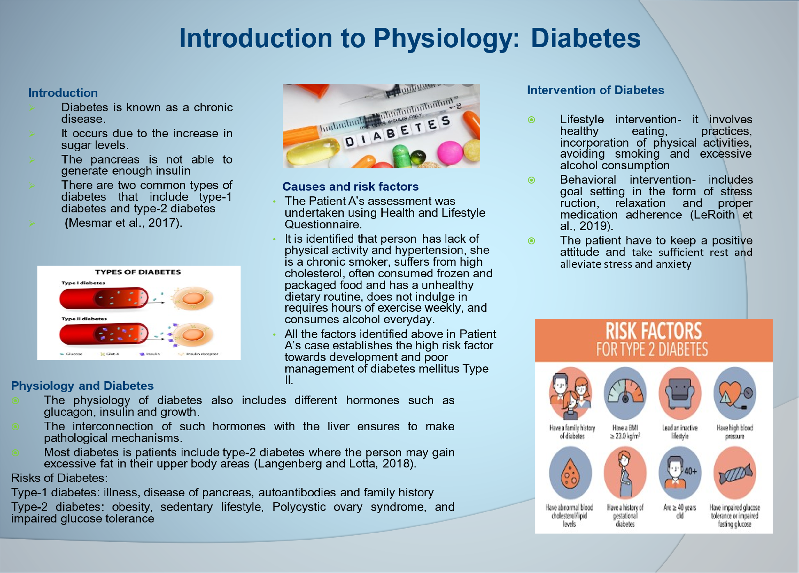

Introduction
The aim of this poster is to present a comprehensive understanding of a health issue, diabetes. The poster describes the contribution and influence of the finding of abnormal and normal physiology. Physiology is the branch of biology which deals with understanding the mechanism of living things as the basis of cell function of the nuclear and ionic level of the integrated behaviour of the overall body.

The health issue chosen in this poster includes diabetes. The poster discusses the issue of diabetes followed by its causes, types, risks and interventions. It is considered a global health concern linked with the increase in blood sugar levels. Diabetes is a life-long condition that occurs when the blood glucose becomes too high. Blood glucose is recognised as the major source of energy that is generated from food. This is a condition where the pancreas is not able to make insulin. There are two types of diabetes which are type-1 diabetes and type- 2 diabetes. In type-1 diabetes, the immune system of a person destroys the cells in the pancreases which generate insulin. In type-2 diabetes, the human body is unable to produce enough insulin and the cell of the body does not react to insulin. In the UK over 90% of adults are found of having diabetes-2(Mesmar et al., 2017).
Physiology and Diabetes
Physiology is about the internal working of the human body and its interaction with the world around them. The physiology of diabetes is all about the levels of insulin within the human body and its capability to use insulin. The pancreatic beta cells are responsible to release insulin because of the increase in the blood glucose level. The brain cells constantly require glucose to ensure the proper functioning of the cells. The physiology of diabetes includes plasma concentrations of glucose which reflect towards the body's central nervous system in order to mobilise the energy reserves. It depends upon the central blood flow along with arterial plasma glucose, tissue integrity, and speed of the glucose (Mesmar et al., 2017).
Risks of Diabetes
Type-1 diabetes- this type of diabetes is found since childhood where the pancreas stops generating insulin and it is present throughout life. The risk factors associated with it include a family history of illness which can be found in grandparents or parents and infection which damages the working of the pancreas (Olfert and Wattick, 2018).
Type-2 diabetes- this type of diabetes is generally found in adults and older ones and involves a high risk of getting obese or overweight which leads to excessive fat in the body. The other risk includes impaired glucose tolerance which is known as the condition of pre-diabetes. Insulin condition is another risk where the pancreas is required to work harder to produce sufficient insulin to meet the requirements of the body. Moreover, women with PCOS also have a high risk of diabetes.

Causes and risk factors
This section analyses the challenges faced by the patient. The patient is suffering from diabetes. The patient is a British citizen and 45 years old. The patient was diagnosed based on the cause of diabetes which involves lifestyle, behaviour and other habits.
After the assessment of exercise, it was found that the person does yoga and meditation thrice a week. Performing everyday exercise tends to enhance glucose control in type-2 diabetes and also helps in minimising the chances of cardiovascular risk factors which contributes to well-being and weight loss. This also helps in delaying type -2 diabetes. As the person performs exercise thrice a week, it will help him to ensure faster recovery from his type-2 diabetes (Langenberg and Lotta, 2018).
After analysing the eating habits of the patient, it was seen that patient is found of eating desserts and food which are rich in sugar and fats. The patient is found to consume frozen foods which are considered unhealthy. The cause of eating and consuming sugar-rich diets may be the significant cause behind type-2 diabetes in the patient.
The patient was also asked several questions related to alcohol consumption. The patient tends to drink between 3 to 6 units per day. From this analysis, it can be evaluated that the consumption of alcohol is by the patients is high. This may be the other significant cause for an increase in high blood sugar levels. The large intake of alcohol may increase the sugar level as they contain high amounts of carbohydrates. It also leads to an increase in nausea and blood pressure (Langenberg and Lotta, 2018).
When asked about the consumption of cigarettes, it was seen that the patient consumes between 1 to 9 cigarettes a day. Smoking is also considered a major cause of type-2 diabetes. It can make the insulin level more difficult for the patient thus as significant levels of nicotine can reduce the effectiveness of insulin, thus allowing them to regulate their sugar levels. On the further survey, it was found that the person is having no family history of heart attack and diabetes which ensures the changing lifestyle habits is the major reason behind the diabetes of the person (Langenberg and Lotta, 2018).
Causes of Diabetes
Lack of physical activity and obesity- this is a major reason behind type 2 where they gain excessive weight and it is directly connected t insulin resistance (Olfert and Wattick, 2018).
Genetics or family history- this is a major cause of type-1 and type -2 diabetes which occurs in either one or both parents and is found commonly in ethnic groups.
Insulin resistance- this is another significant cause behind type -2 diabetes where in which muscle, liver and fat cell is unable to consume insulin at great levels.
Intervention
Interventions are considered effective strategies and measures implemented by the patients to overcome the disease. When it comes to diabetes, the individual can effectively overcome diabetes-2 by involving come changes in their behaviour and lifestyle. Diabetes type -2 interventions integrate both physical activity and nutrition to ensure a faster recovery.
Lifestyle intervention- changes in lifestyle plays an important role in overcoming the chances of diabetes. A diabetic patient is recommended to eat healthy food with no added flavours or sugars. This will significantly help the patient to maintain their blood sugar to a normal level. The patient is advised to consume healthy foods including vegetable fruits etc. In addition to this, patients must avoid smoking and taking alcohol as it may affect the blood sugar levels and also lead to other diseases including stroke, kidney etc. On the other hand, physical activities including workouts and exercise help in lowering the blood sugar level (LeRoith et al., 2019).
Behavioural intervention- it is significant for a patient to indulge in the practice of self-care to overcome and ensure faster recovery from diabetes. The practice of self-care includes taking appropriate medicines on time as prescribed by the doctor. The patient is recommended to take sufficient rest and alleviate stress and anxiety. Moreover, the patient is also required to keep a positive attitude and build strong and positive relations with their family members and friends. This also ensures to lower the risk of having type- 2 diabetes.
Conclusion
This poster described the health issues of diabetes. It described the concepts of diabetes followed by its connection to physiology. The poster also highlighted the overall lifestyle analysis of the patient by a questionnaire. In the end, the poster described the behavioural and lifestyle interventions.

References
Langenberg, C. and Lotta, L.A. (2018). Genomic insights into the causes of type 2 diabetes. The Lancet, 391(10138), pp.2463-2474.

LeRoith, D., Biessels, G.J., Braithwaite, S.S., Casanueva, F.F., Draznin, B., Halter, J.B., Hirsch, I.B., McDonnell, M.E., Molitch, M.E., Murad, M.H. and Sinclair, A.J. (2019). Treatment of diabetes in older adults: an Endocrine Society clinical practice guideline. The Journal of Clinical Endocrinology & Metabolism, 104(5), pp.1520-1574.

Mesmar, B., Poola-Kella, S. and Malek, R. (2017). The physiology behind diabetes mellitus in patients with pheochromocytoma: a review of the literature. Endocrine Practice, 23(8), pp.999

Olfert, M.D. and Wattick, R.A. (2018). Vegetarian diets and the risk of diabetes. Current diabetes reports, 18(11), pp.1-6.

