CRISTINA TUDUREANU
Student number: 1917153
Module title: MARKETING FUNDAMENTALS
Module code: LCBB4004
Assignment title: BLOGGING TO COMMUNICATE-ASSESSMENT 1
Lecturer’s name: MALANI GUNARATNAM

Marketing Fundamentals

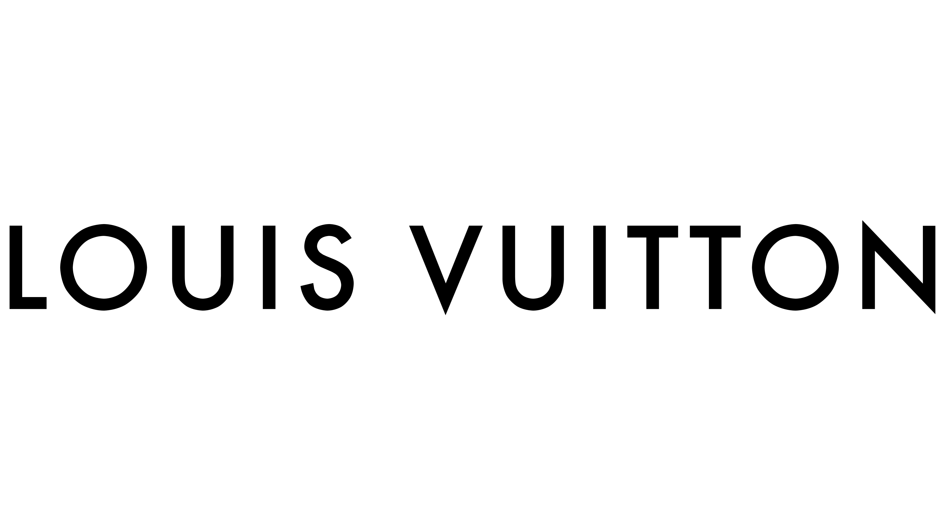
BLOG ON LOUIS VUITTON
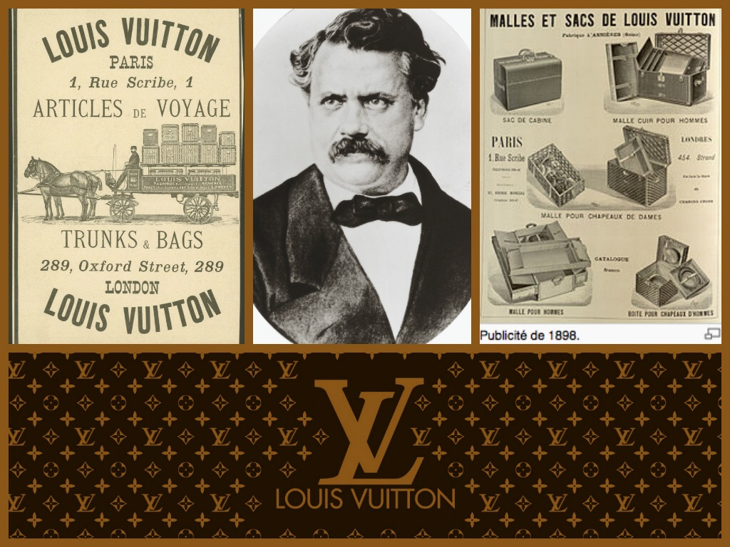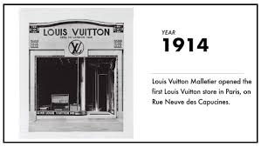
HISTORY OF LOUIS VUITTON
Louis Vuitton is also known as the Greek word Louis Vuitton Malletier. This was a fashion house of luxury branded product that was founded in 1854 by namely called Louis Vuitton. There is various type of product of luxury trunk and pure quality leather that Louis Vuitton founded. There are many products like leather shoes, leather belts, watches, jewelry, good quality accessories, sunglasses, and books.
Louis Vuitton is one of the largest world's trading as well as lending international fashion box. Louis Vuitton uses various types of techniques to sell their product as in Branded store, standard boutique, and mainly in e-commerce trading like the website.
For continuously six years (2006-2012) Louis Vuitton is commonly known as the world's largest luxury and valuable brand in the market. In 2012 the company increases the valuation to US$ 25.9 billion and in 2013 increases the valuation of the brand to US$ 28.4 billion. In the coming year, the company operates its brand in around 50 countries with more than 460 stores worldwide (Tak et al., 2015).

Marketing Mix

The Greek word marketing mix is the foundation of model business and history that tells about the product, price, place, and promotion is also called 4ps. The marketing mix also tells about the various tools of a firm that the company uses in the target market. Thus, marketing mix also has four layers or levels of the marketing mix (product, price, place, and promotion).
Louis Vuitton uses various marketing mix tools for the growth of their business. This marketing mix tells about the various frameworks of marketing decisions. These tolls tell about the development of strength and identifying various weaknesses of a business. Hence Louis Vuitton also uses these types of the various, marketing mix for the development and growth of the business (Tan et al., 2013).
Product Strategy:
Louis Vuitton was a kind of brand that always deals with sales and manufacturing of a specialized product. The main target of a company is to produce high and luxury rated goods and services. The main motive of the company is to supply the best quality of product design like in traditional design and simply exquisite. Rather than using the high quality of machines as it gives result in the increase of production to the company due to this company has taken a major step that to step backward and increase hiring of the specialized with knowledge and expert workers.
The result of increasing this kind of hiring helps to lead original and handmade merchandise that closely attracts the consumer. To face the competition with the other company this Louis Vuitton has paid a lot of his effort as they design it without a machine is not an easy task for them. These types of goods and design have been registering as counter fake goods.
As the company deals with the luxury goods that are made up of full hundred percent garneted leather and many other exclusive wear clothes are also designed with a hundred percent guaranteed originality. This makes the company famous for handbags with beautiful watches. This makes the buyer covet glittering jewelry with designer shoes.
Louis Vuitton also includes a wide range of other variables like sunglasses, scarves, briefcase, belt, and wallets. After achieving all success, the company has decided to hire many new young and talented expert designers that it will attract towards the youth generation for the purchasing of the product (Anido and Loussaïef, 2018). For looking at the product unique and attractive the company must decide the finest craftsmen for the product making. These all type of product covers a marketing mix of Louis Vuitton (Steele et al., 2017).

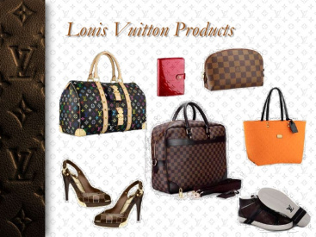
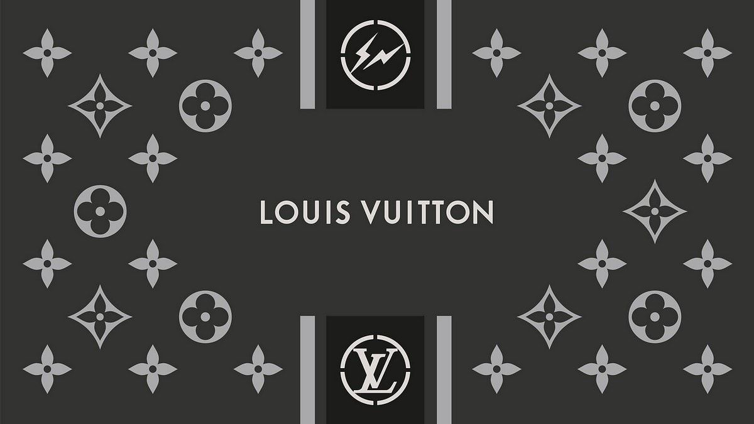

Louis Vuitton pricing strategy

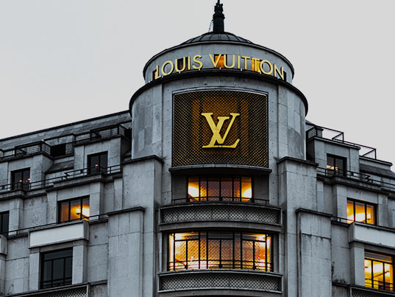
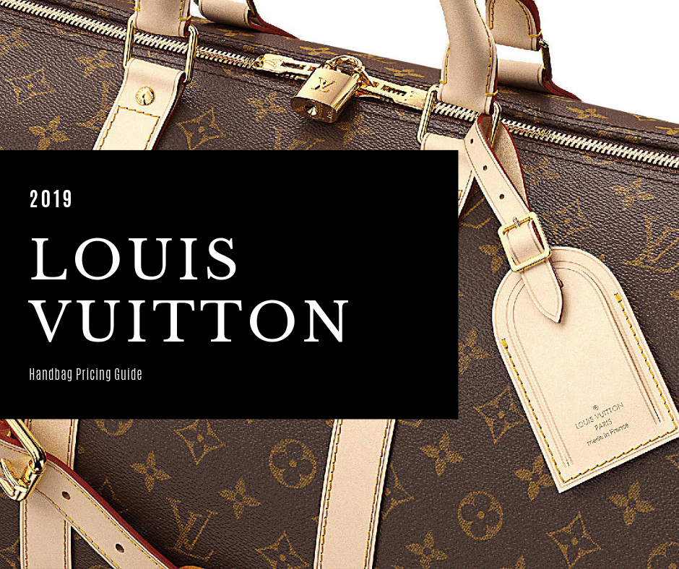
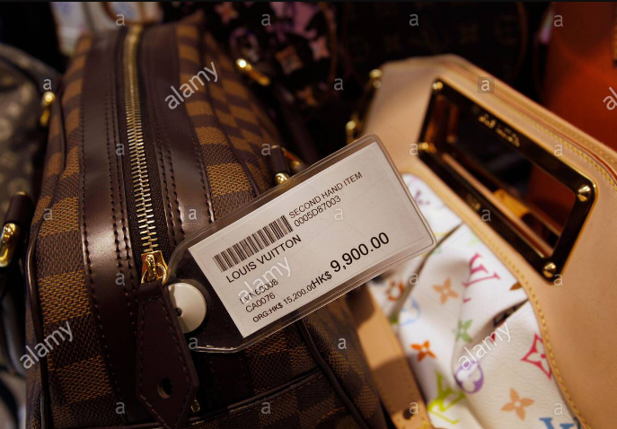

Pricing strategy
Louis Vuitton includes value-based pricing for its product. So the customers are aware of this company product as they are high values product so the customer may not look the price of the product and them willing to pay that amount even they are high because Louis Vuitton gives special attention to their customer and the good as well as the pure quality of the product. Thus, it makes the price of goods very high to keep the quality of the product in mind. So, the customers who are willing to pay a high amount of price are elite and upper-middle-class customers.
These types of brand and quality of product price are very high hence the customer is easy to pay those exorbitant prices as they know about the brand Louis Vuitton. Therefore, this company brand Louis Vuitton does not take any initiative or believe in reducing the actual price of their product and does not provide any discount or make a sale period. The company follows a policy that is the value-based pricing strategy.
As is know that the quality of the product is much high because of the good quality of the product with the uniqueness and premium quality of the material is known as premium pricing. Louis Vuitton may not affect by the price or may not fall in decrease with the product selling because as all customers know the image of Louis Vuitton in the market as they provide high and superior quality of product with no complaint in the market.
As the price of Louis Vuitton handbag was around RMB 17800 and the other company like Gucci handbag price was RMB 6800 in 2008 this shows that the Gucci is cheaper than the Louis Vuitton as the conclusion is Gucci target the middle class and Louis Vuitton target the upper-middle class (Brun et al., 2013).

Louis Vuitton Place Strategy


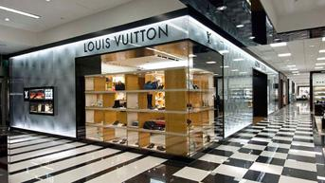
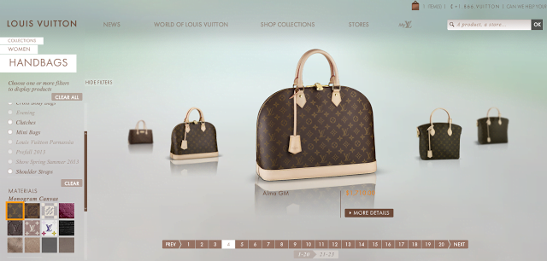

Louis Vuitton includes many types of distribution channels. These types of products are not sold in any departmental stores. This company believes that the company should have its stores.
Louis Vuitton organizes a variety of training for the salesperson so that trained salesperson should treat their customer fluently speaking and softly. Their main motive is to take care of their customer and provide them high personalized attention. There is a very limited store at a particular main area so that customers are easy to walk up to the store. Hence limited stores of Louis Vuitton may affect in reduce the cost of the company because there is a much shorter distribution channel. As they are total around 300 + Louis Vuitton stores and the main impact is that online shopping only possible in-country US.
Louis Vuitton is clear with their distribution policies. As Louis Vuitton products are very highly exclusive that can be sold in one mindset by providing exclusive offers or accessibility. For the purchase of the Louis Vuitton product company should reach their personalized stores. To the sale of this item, the company should reach very limited distribution channels.
The company has set its mindset that they use to sell their outlet for product distribution. They thought that the best way of selling their product in their store rather than selling in the departmental stores because the salespersons are highly trained, they know how to deal with the customer in their warm environment. This company does direct dealing also with the customer through effective and friendly relations as these types of stores are situated in a very high profile and a prime location (Ruanguttamanun et al., 2014).
Louis Vuitton Promotion Strategy

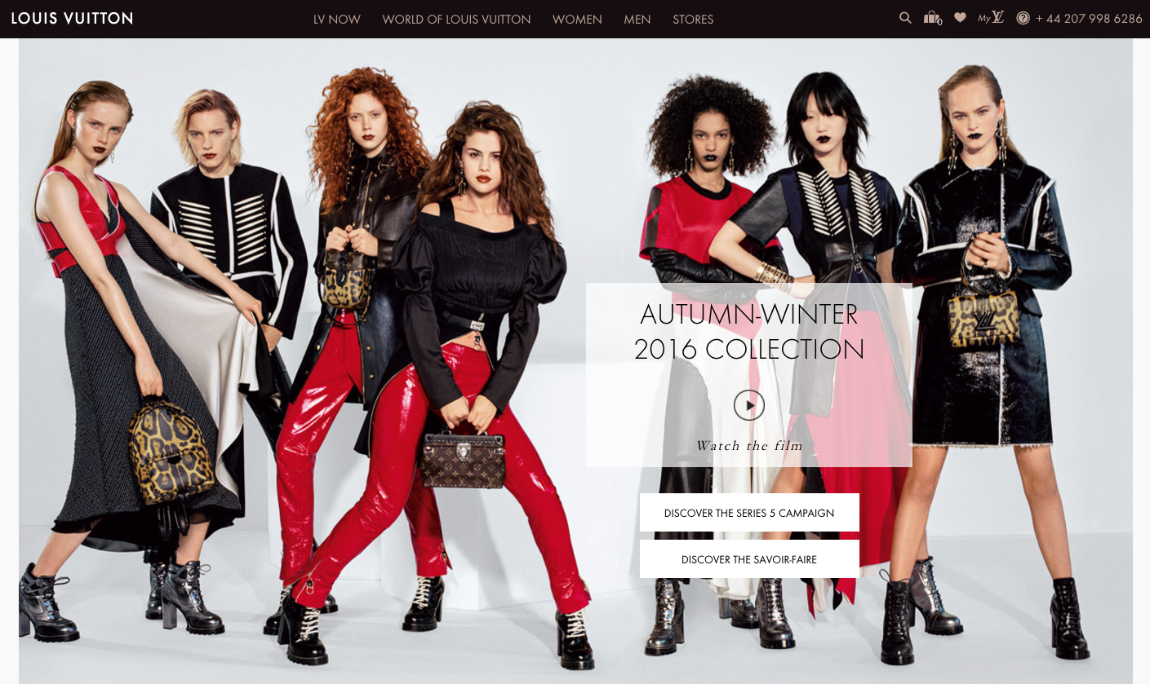
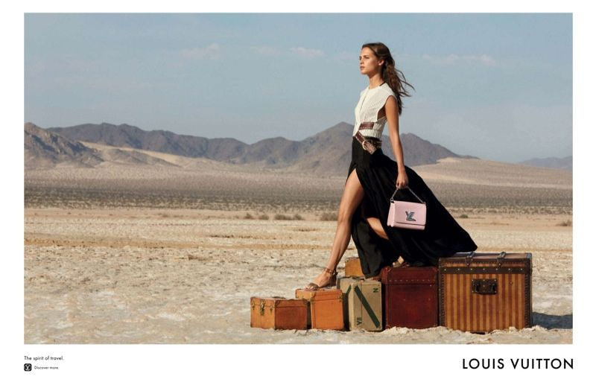
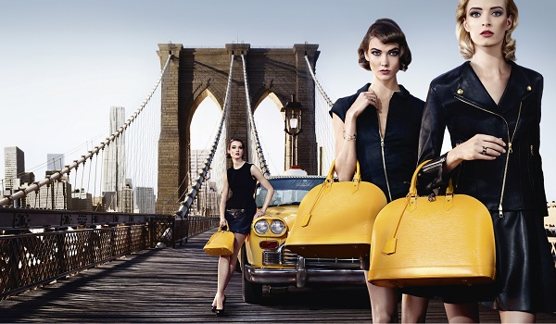
Louis Vuitton trained employees, actors; famous musicians and role models are also a part of marketing campaigns. Some specialized known personality brands like Kate Moss, Jennifer Lopez are also associated with Louis Vuitton.
As Louis Vuitton is also known as a luxury brand here celebrities also make an emotional connection with the celebrities. It also connects with celebrities employs as Steffi Graf, Andre Agassi in their marketing champing. A promotion like the primary source is also a part of print media. In luxury cities, magazines and billboards do work to make the company the best (McCutcheon et al., 2015).
Louis Vuitton does not take any reference or help with television as a promotional tool they want that luxury brands should be seen the certain valuable class of people. Thus, it makes reaching out to the target audience rather than using the multi-channel. Companies use the boosting promotional strategy of their product, so the company takes the help of celebrity endorsement.
Louis Vuitton had done sponsoring a sporting event like yachting and motorsports. These types of events are mostly attended by the higher section of society. Hence the company does not follow the advertisement on the television but goes with high rates profile advertisement like in newspaper and fashion magazine. These all show the high image of the company in the market. Here the customer believes that Louis Vuitton is a part of exclusive groups. Here the company uses various promotional tools.
To maintain an image in the market company uses premium quality professional tools for promotions. These high-quality professional tools help in maintains the image building in the market. This is an important marketing strategy for Louis Vuitton. Hence Louis Vuitton covers all marketing mix (Kim et al., 2012).

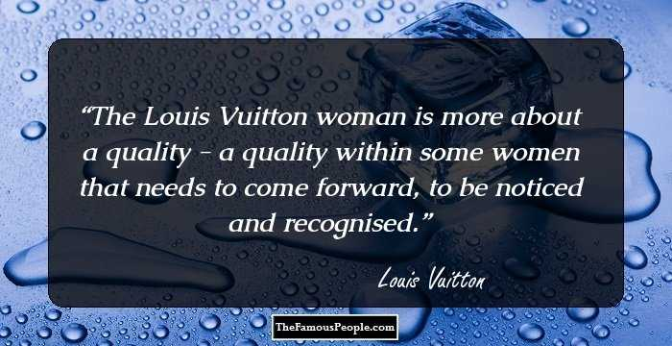

References
Anido Freire, N. and Loussaïef, L., 2018. When advertising highlights the binomial identity values of luxury and CSR principles: the examples of louis vuitton and hermès. Corporate Social Responsibility and Environmental Management, 25(4), pp.565-582.
Brun, A., Riot, E., Chamaret, C. and Rigaud, E., 2013. Murakami on the bag: Louis Vuitton's decommoditization strategy. International Journal of Retail & Distribution Management.
Kim, A.J. and Ko, E., 2012. Do social media marketing activities enhance customer equity? An empirical study of luxury fashion brand. Journal of Business research, 65(10), pp.1480-1486.
McCutcheon, J., 2015. Designs, Parody and Artistic Expression-A Comparative Prespective of Plesner v. Louis Vuitton. Monash UL Rev., 41, p.192Ruanguttamanun, C., 2014.
Neuromarketing: I put myself into a fMRI scanner and realized that I love Louis Vuitton ads. Procedia-Social and Behavioral Sciences, 148, pp.211-218
Steele, V., 2017. Louis Vuitton: art, fashion and architecture. Rizzoli Publications.
Tak, J. and Choi, J., 2015. An all-textile Louis Vuitton logo antenna. IEEE Antennas and Wireless Propagation Letters, 14, pp.1211-1214
Tan, D., 2013. The Semiotics of Alpha Brands: Encoding/Decoding/Recoding/Transcoding of Louis Vuitton and Implications for Trademark Laws. Cardozo Arts & Ent. LJ, 32, p.225

