UNIVERSITY OF WALES TRINITY SAINT DAVID
LONDON CAMPUS
Assignment 2
Learning in the Digital Era
Video Link: ‏this is my Presentation video link
Please click here
https://youtu.be/6xSI39316T8?si=S-BgF5y4TL0_9w0Q
Module Name: Learning in the Digital Era
Module Code: ACCA 4025
Student Name: Abdullah Ibrahim
Student ID: 2532063
Group:
Lecturer’s Name:

Table of Contents
Introduction 2
Main Body 2
Conclusion 9
References 9

Introduction
A general introduction for this Word document (Briefly, in a few sentences, explain what this report is going to be about)
This report discusses the importance of self-evaluation, reflective practice, and professional development. It explains how these skills help improve learning, set goals, and prepare for future career success

Main Body
Write one/two sentences.
The main body focuses on key areas such as self-evaluation, goal setting, and continuous professional development, which are important for improving skills and performance.
Video Link:
https://youtu.be/6xSI39316T8?si=S-BgF5y4TL0_9w0Q

Slide 1
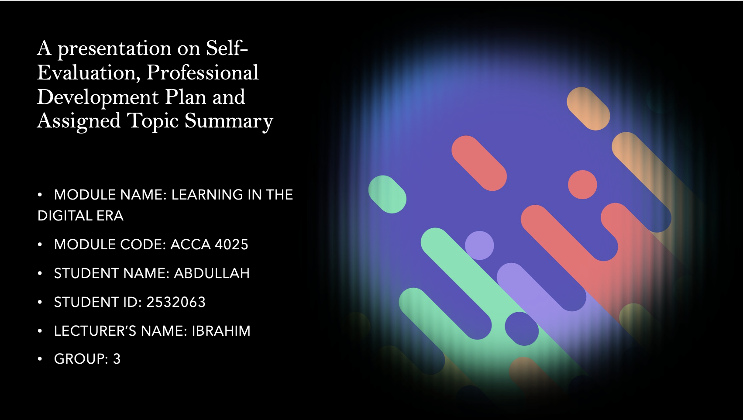

Slide 2
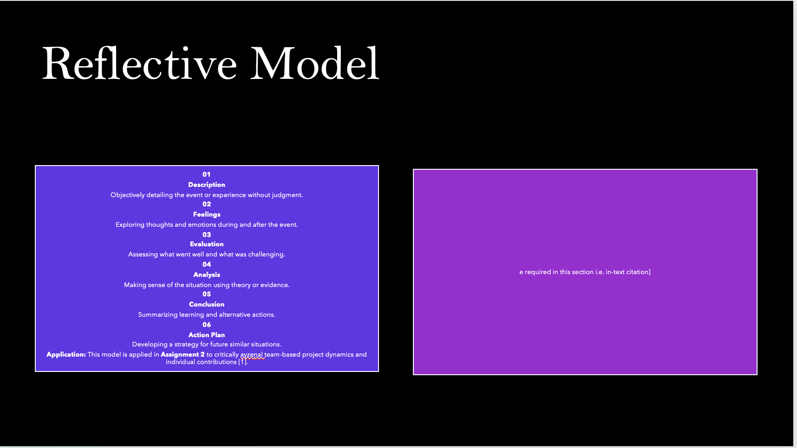
Brief explanation: Gibbs’ Model provides a structured six-stage cycle for experiential learning, allowing individuals to process experiences deeply by moving from objective description to emotional assessment and strategic planning [1]. In Assignment 2, this model will be applied to analyse team dynamics and project management during a collaborative task.

Slide 3 TASK 1: SELF EVALUATION

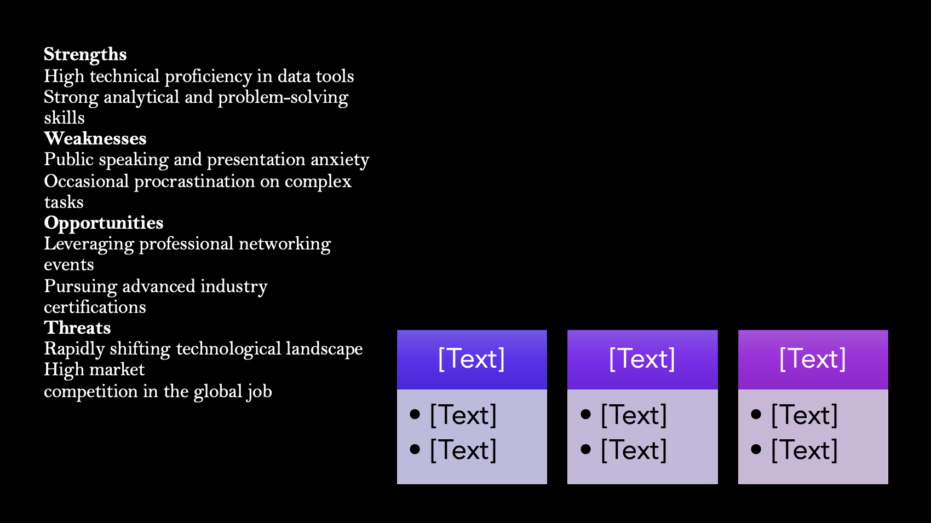

Brief explanation: Discuss your strengths and weaknesses based on your individual SWOT analysis. One Strength and one weakness are provided as examples. Please feel free to remove them if that does not apply to you
personal SWOT analysis identifies internal strengths and weaknesses while evaluating external opportunities and threats. This strategic assessment is critical for aligning individual capabilities with long-term career aspirations and professional growth [3].

Slide 4

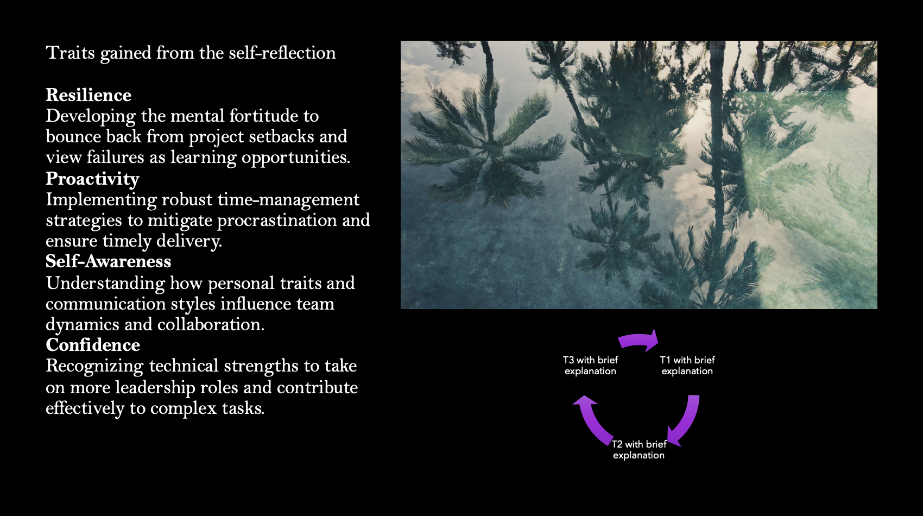

Brief explanation:
A personal SWOT analysis identifies internal strengths and weaknesses while evaluating external opportunities and threats. This strategic assessment is critical for aligning individual capabilities with long-term career aspirations and professional growth [3].

Slide 5
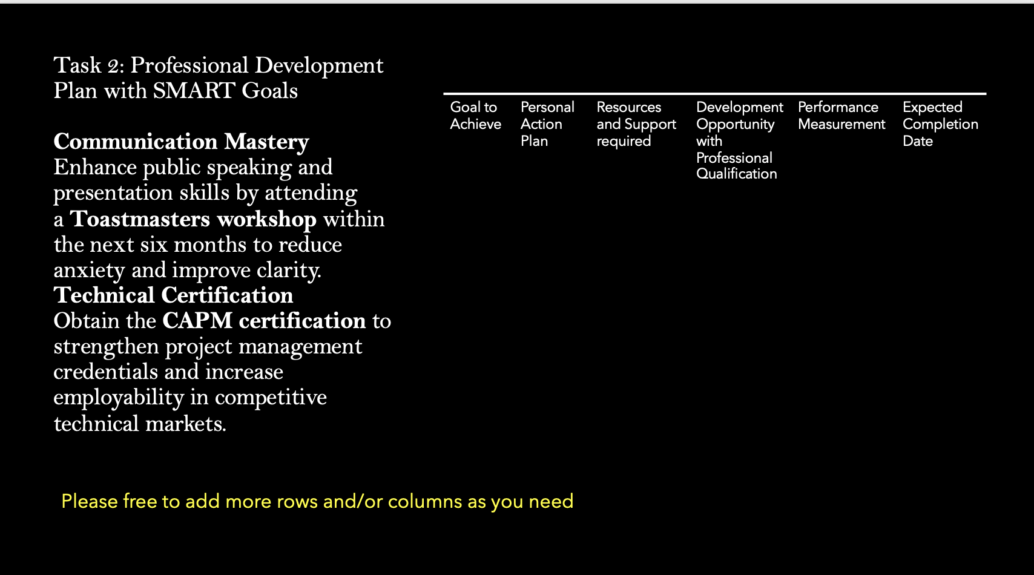

Brief explanation:
personal SWOT analysis identifies internal strengths and weaknesses while evaluating external opportunities and threats. This strategic assessment is critical for aligning individual capabilities with long-term career aspirations and professional growth [3].

Slide 6
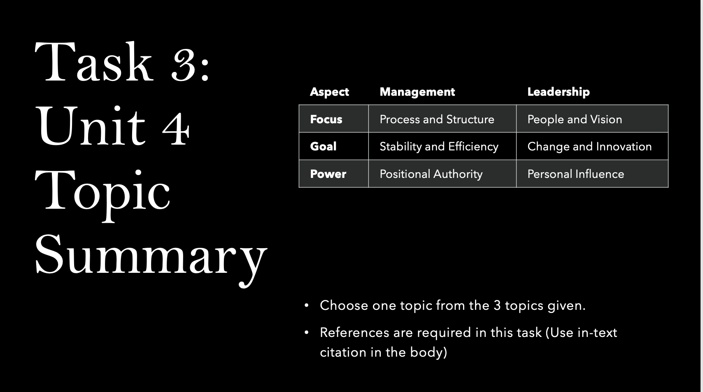
Brief explanation: Choose one topic from the 3 topics given in Unit 4 and present a short summary of that topic.
Unit 4 explores the critical distinction between leadership and management, emphasizing that while management ensures operational efficiency through structure, leadership inspires change through vision [2]. Balancing both roles is essential for managing organizational performance.

Slide 7

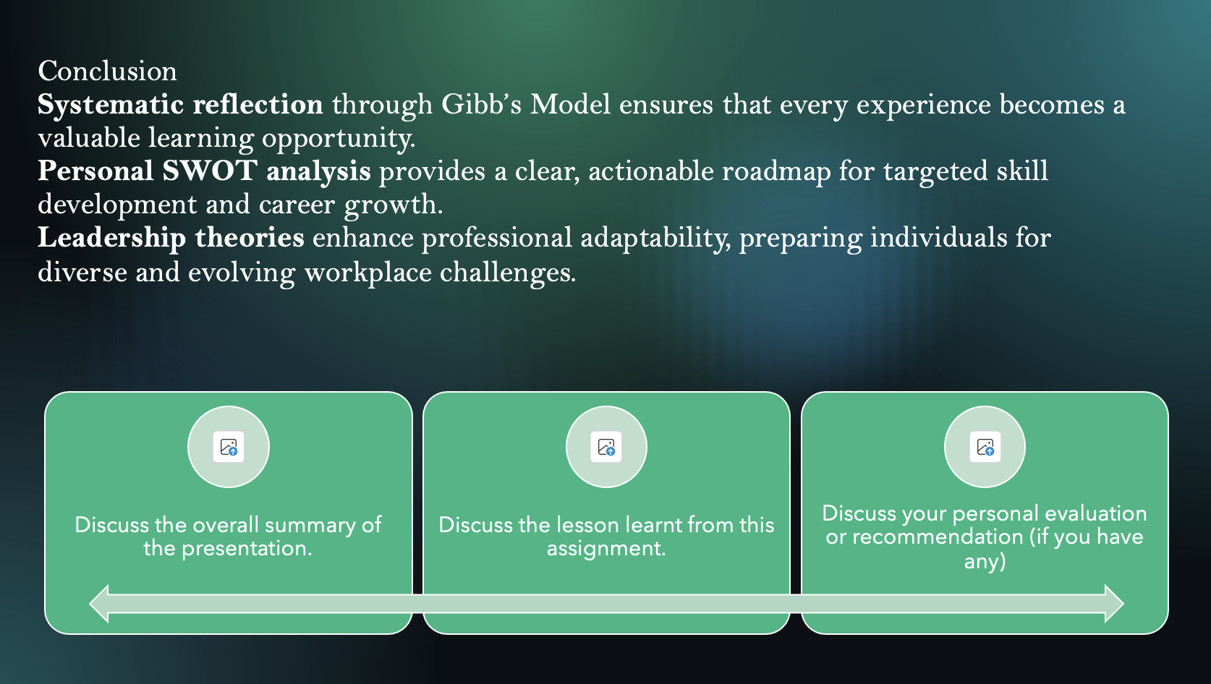

Brief explanation:
Reflective practice, combined with structured self-evaluation and strategic planning, is a powerful tool for professional growth. Integrating Gibb’s Model and leadership theories into daily practice ensures a trajectory of lifelong learning and professional excellence.

Slide 8
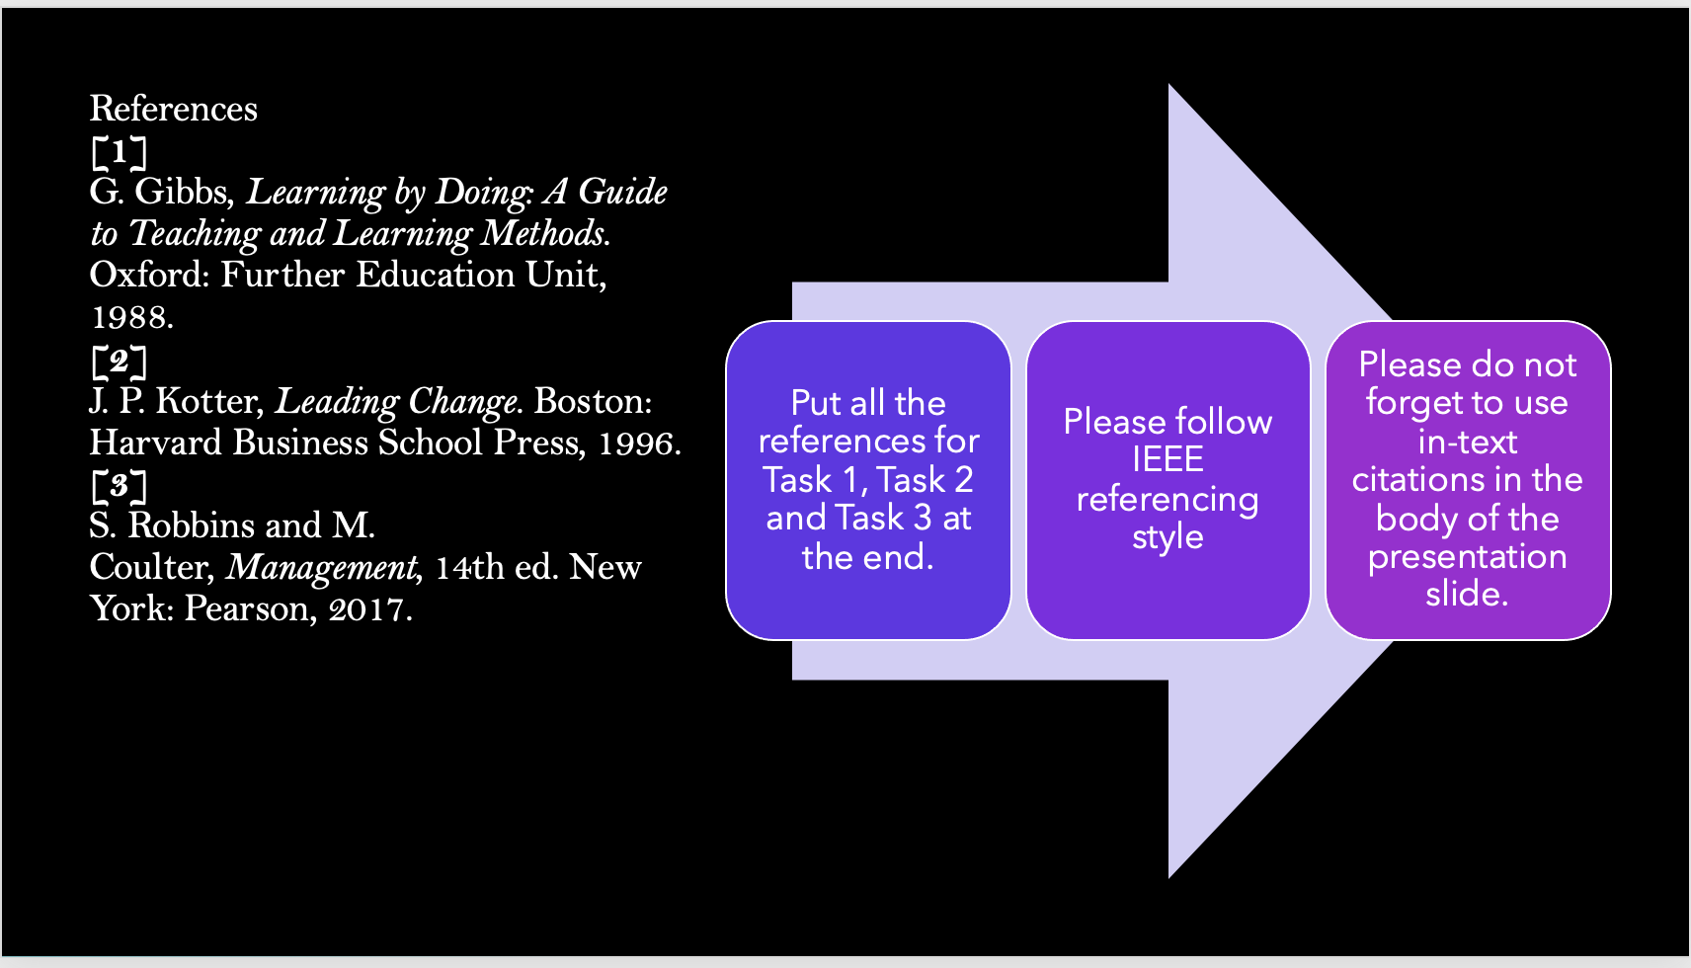

Conclusion
A general conclusion for this word document (Briefly in a few sentences)
This report has explored the importance of self-evaluation, reflective practice, and professional development in enhancing personal and career growth. By applying Gibbs’ Reflective Model, it highlighted how structured reflection can improve learning from experience and support better decision-making.
Furthermore, the development of a Professional Development Plan using SMART goals demonstrated how clear and achievable objectives can guide continuous improvement. The discussion on lifelong learning also emphasised the need to continuously develop skills in a rapidly changing professional environment.
Overall, self-reflection, goal setting, and continuous professional development are essential for long-term success and adaptability in both academic and professional contexts.

References
Copy and paste the sources from your reference slide
[1] G. Gibbs, Learning by Doing: A Guide to Teaching and Learning Methods. Oxford: Further Education Unit, 1988.
[2] J. P. Kotter, Leading Change. Boston: Harvard Business School Press, 1996.
[3] D. Schön, The Reflective Practitioner. New York: Basic Books, 1983.
[4] S. Robbins and M. Coulter, Management, 14th ed. New York: Pearson, 2017.
[5] G. T. Doran, “There’s a S.M.A.R.T. way to write management’s goals and objectives,” Management Review, 1981.
[6] World Economic Forum, The Future of Jobs Report, 2020.
.

