Developing Relationships and Workplace Achievements
Tutor: Molly Jack
Speaker Notes
Unit : BMSW5102

Slide 1: Title of the project
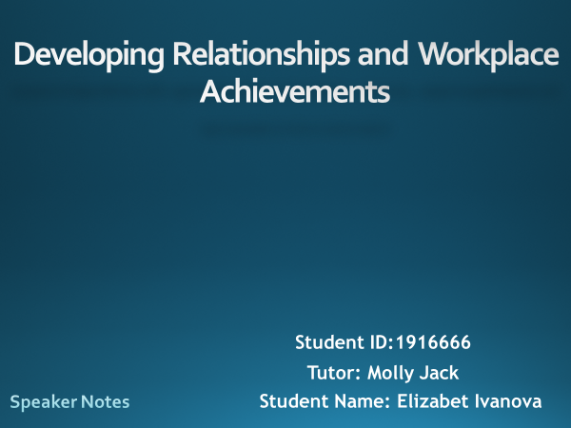

Slide 2: Introduction
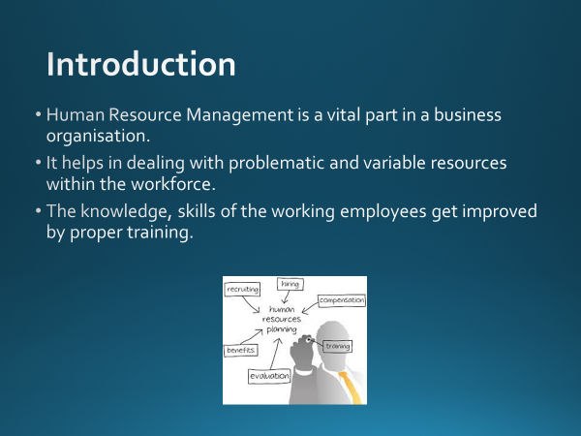
Human resource Management is an important part for executing the operations properly in a business institution as the department has to deal with a lot of variable as well as problematic resources in the workforce and employees’ form. Through effective methods of training; knowledge and skills of the employees get developed (Anand and Dalmasso, 2019). This helps in developing the overall economical performance of the company and it also improves productivity within the organisation.

Slide 3: Overview of the business establishment Sainsbury’s
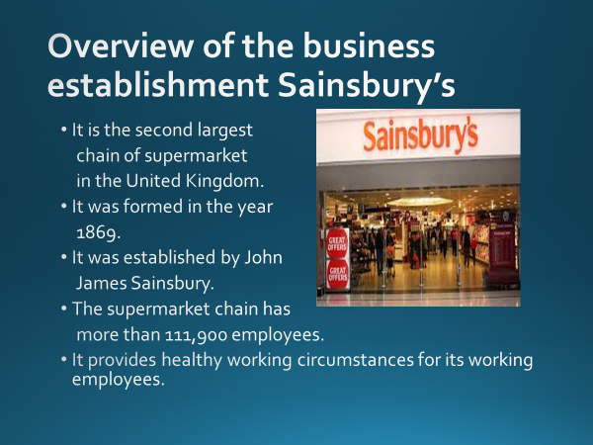
Sainsbury’s is the second largest chain of supermarket in the United Kingdom. It was formed in the year 1869 by Sir John James Sainsbury. The supermarket chain has more than 111,900 employees worldwide. It provides healthy working circumstances for its employees in order to promote all over organisational and targeted financial objectives.

Slide 4: Purpose of career Planning
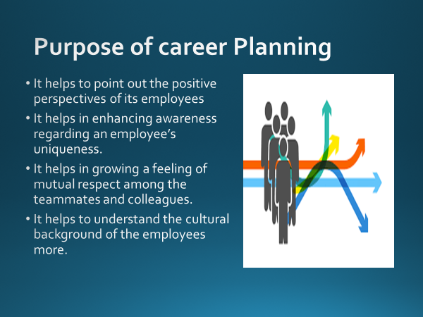
Human resource management is a vital asset of any business institution. Development of the employees is also important in order to gain more financial profit for the organisation. It helps to point out the positive perspectives of its employees. It helps in enhancing awareness regarding an employee’s uniqueness. It helps to grow a feeling of mutual respect among the teammates and colleagues. It helps to understand the cultural background of the employees more.

Slide 5: Current knowledge of the employees
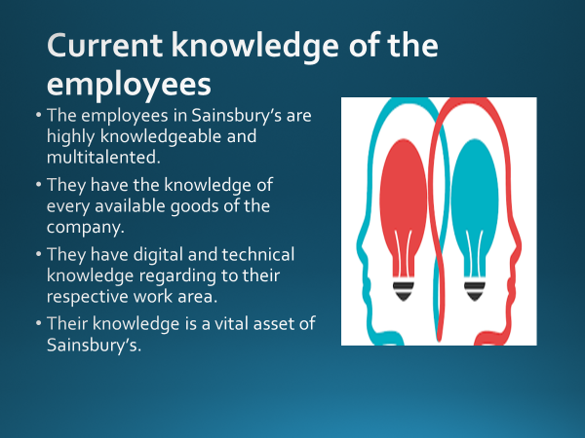
The employees in Sainsbury’s are highly knowledgeable and multitalented. They have the knowledge of every available goods of the company. They have digital and technical knowledge regarding to their respective work area. Possessing technical and digital knowledge is important for conducting the organisational operations in an appropriate manner. Their knowledge is a vital asset of Sainsbury’s.

Slide 6: Skills of the employees
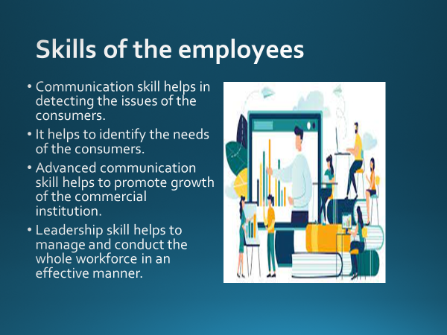
The employees mainly possess two kinds of skills in the organisation Sainsbury’s. These are – communication skill and leadership skill. Communication skill helps in detecting the issues of the consumers. It helps to identify the needs of the consumers. Advanced communication skill helps to promote growth of the commercial institution. Leadership skill helps to manage and conduct the whole workforce in an effective manner.

Slide 7: Competency of the employees
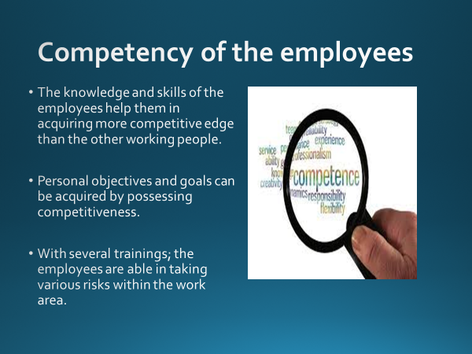
The knowledge and the skills of the employees help them in acquiring more competitive edge than the other working people. Personal objectives as well as goals can be achieved by having competitiveness among the employees of Sainsbury’s. With attending several trainings; the employees are able to undertake several risks within the work area.

Slide 8: Short term career plan of the employees
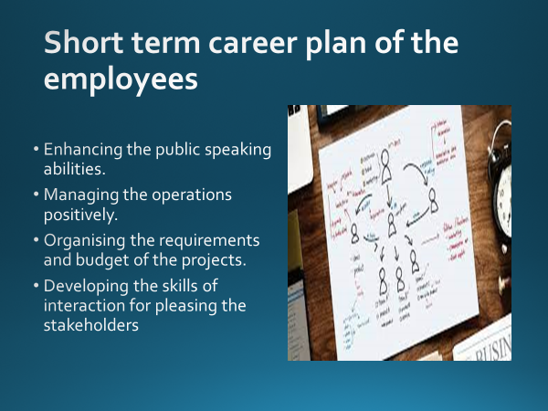
The short term career plan of the employees of Sainsbury’s include – improving the public speaking skills and abilities, managing the organisational operations in a positive way, scheduling the requirements and budgeting the projects, enhancing the skills and strategies of interaction in order to please the stakeholders of the business institution.

Slide 9: Long term career plan of the employees
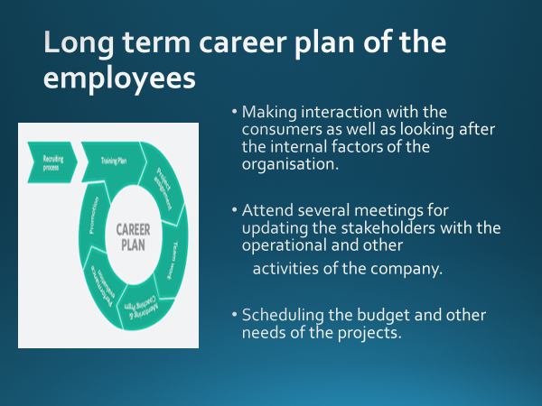
The long term career plan of the employees of Sainsbury’s include - making direct or indirect interaction with the consumers, looking after all the internal factors regarding their work area in the business organisation. It helps to detect the preferences and the questions of the stakeholders and the consumers (Yang and Wong, 2020). The employees have to attend several meetings for updating the stakeholders with operational and several other activities regarding the company for understanding the perspectives of them. They need to schedule the budget and other needs to conduct the project in an impactful way for contributing to the improvement of the organisation.

Slide 10: Annual Review
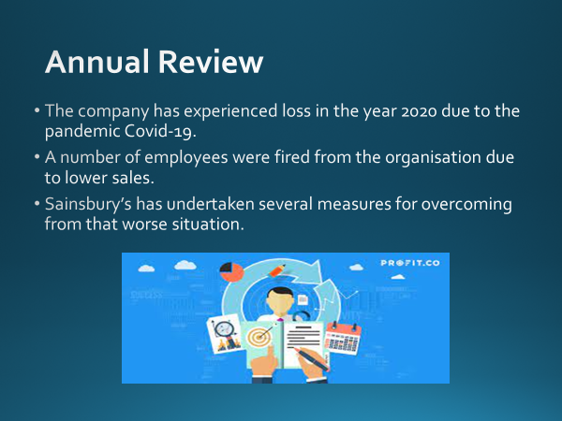
Sainsbury’s has experienced loss in the year 2020 due to the pandemic Covid-19. A large number of employees of Sainsbury’s were fired from the business establishment due to decreased sales of their goods and services (Hoffman and Tadelis, 2021). The business institution has implemented multiple measures in order to overcome the worsened situation.

Slide 11: Plan of Performance Assessment
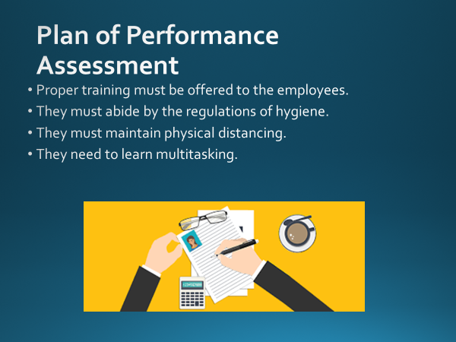
It is very important to focus on the personal development and growth of the working employees. It results in promoting growth to the business organisation. For ensuring the development of the working people within the organisation Sainsbury’s; proper training must be provided to them, the rules and regulations regarding hygiene must be abided by the employees. Maintaining physical distancing is vital for being safe throughout the time of pandemic. The employees need to learn the lessons of multitasking.

Slide 12: Knowledge of HR
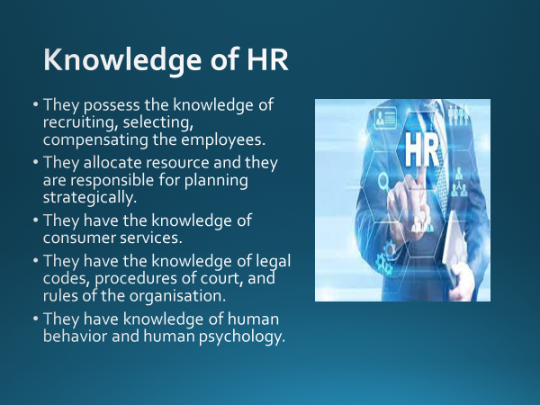
The Human Resource managers possess vast knowledge regarding various subject areas. The HR possesses the knowledge of selecting, recruiting and compensating the employees. They distribute the resources and they are responsible for strategic planning of the organisational tasks (Rantesalu et al., 2017). They have ample knowledge of consumer services and they are well aware of the rules of the business institution, codes regarding law, processes of court etc. They understand the psychology and behavior of the employees very well.

Slide 13: Skills of HR
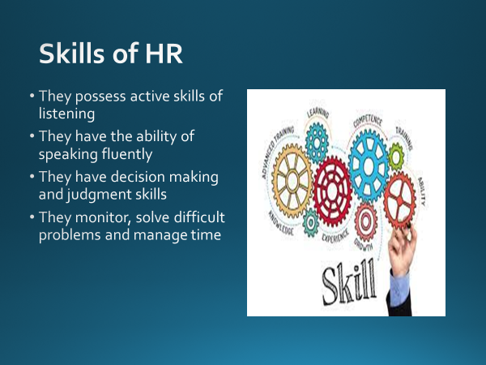
The HR of Sainsbury’s has multiple skills in their specific work areas. They have active listening skills; they can speak fluently with the stakeholders and the employees. This ability ensures that the information is conveyed in an appropriate manner (Randel and Jaussi, 2017). They also possess the skills and abilities of decision making and judgment. They can consider the relative cost and benefits of the probable actions for choosing the most suitable ones. The HR monitors the works of the employees, solve difficult issues and manage time.

Slide 14: Behavior of HR
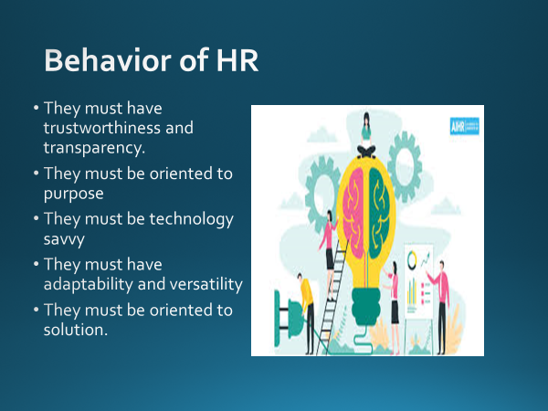
The HR of Sainsbury’s must possess several behavioral aspects which help them to perform better within the company. The HR professionals must be transparent in their way of working and dealing with the employees. They need to deal very carefully with the employees for solving their work related issues or other issues. They must have trustworthiness as they have to deal with the whole workforce and without maintaining transparency; it is next to impossible. They must be technology savvy, oriented to purpose and they possess adaptability as well as versatility (Hameed et al., 2021).

Slide 15: Personality of the HR
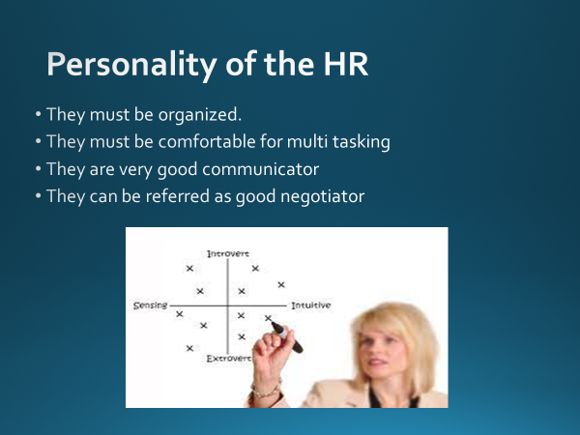
The HR of Sainsbury’s must have several personality traits which help them in performing in an efficient manner. Some of the personality traits of HR are – they must be scheduled and organized in their field of work (Nikitenko et al., 2017). They must be eligible for multi tasking, they can communicate with the consumers, stakeholders and employees very well, thus; thus the targeted message can be conveyed in an efficient way. They are good negotiator too.

Slide 16: Benefits of training and development to the organisation Sainsbury’s
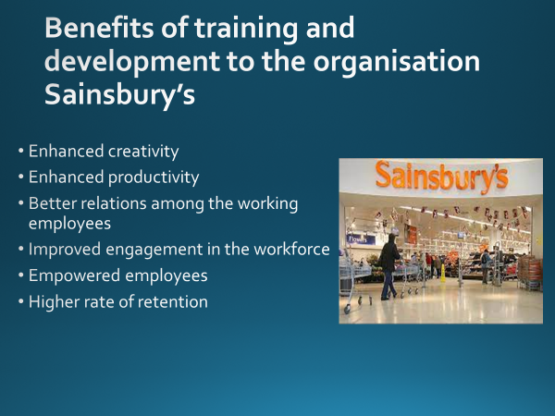
There are a lot of benefits of providing assistance in training as well as development of Sainsbury’s. It ensures more productivity and creativity of the employees as the employees feel more engaged with the workplace while they are provided with efficient training. With the help of training; the relation among the employees also gets better. Employees want to work with more dedication when they are provided with right training. The employees want to work for a longer period of time in Sainsbury’s when they feel satisfied with their job and feel more engaged.

Slide 17: Conclusion
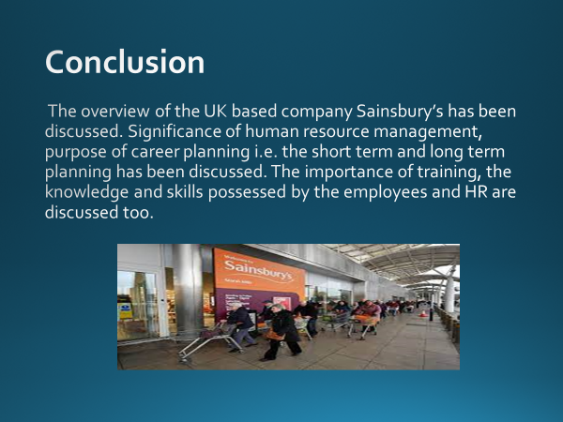
The overview of the UK based company Sainsbury’s has been discussed. Significance of human resource management, purpose of career planning i.e. the short term and long term planning has been discussed. The importance of training, the knowledge and skills possessed by the employees and HR are discussed too.
In the whole presentation; the overview of the UK based global chain market Sainsbury’s has been elaborated. The knowledge, skills and competency possessed by the employees have been showed. The short term along with long term career plan of the employees have been mentioned too. The annual review report and the final plan of performance assessment have been critically discussed. Along with that the skills, knowledge, behavior of the HR of Sainsbury’s have been discussed and it has been found that it helps in improving productivity, creativity, retention rate, satisfaction of the consumers and overall organisational benefit.
Slide 18: References
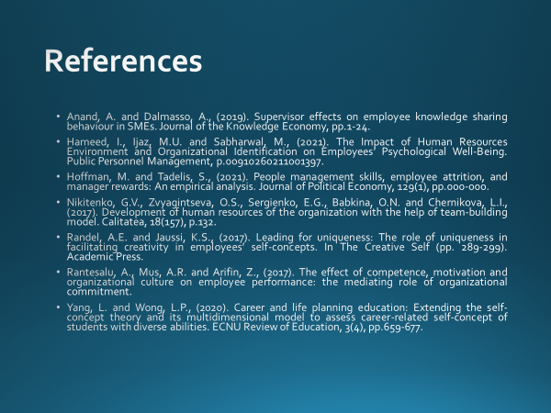

Anand, A. and Dalmasso, A., (2019). Supervisor effects on employee knowledge sharing behaviour in SMEs. Journal of the Knowledge Economy, pp.1-24.
Hameed, I., Ijaz, M.U. and Sabharwal, M., (2021). The Impact of Human Resources Environment and Organizational Identification on Employees’ Psychological Well-Being. Public Personnel Management, p.00910260211001397.
Hoffman, M. and Tadelis, S., (2021). People management skills, employee attrition, and manager rewards: An empirical analysis. Journal of Political Economy, 129(1), pp.000-000.
Nikitenko, G.V., Zvyagintseva, O.S., Sergienko, E.G., Babkina, O.N. and Chernikova, L.I., (2017). Development of human resources of the organization with the help of team-building model. Calitatea, 18(157), p.132.
Randel, A.E. and Jaussi, K.S., (2017). Leading for uniqueness: The role of uniqueness in facilitating creativity in employees’ self-concepts. In The Creative Self (pp. 289-299). Academic Press.
Rantesalu, A., Mus, A.R. and Arifin, Z., (2017). The effect of competence, motivation and organizational culture on employee performance: the mediating role of organizational commitment.
Yang, L. and Wong, L.P., (2020). Career and life planning education: Extending the self-concept theory and its multidimensional model to assess career-related self-concept of students with diverse abilities. ECNU Review of Education, 3(4), pp.659-677.

