Entrepreneurship
LCBB5001
Assignment 2
Margarita Mandulova
Student ID:2119899
Lecturer: L. Maazouz

TABLE OF CONTENT

1 Executive summary
2 Mission statement
3 Industry analysis
4 Operation plan
5 Management team plan
6 Legal structures
7 Marketing plan
8 Conclusion
9 References
10 Appendices

- Executive summary

Bright stars is a visionary child care and early education centre dedicated to providing a nurturing and stimulating environment for children aged 3 to 5 years old. Our comprehensive approach to child development integrates play, learning, and social interaction to create a foundation for future success. This business plan outlines our strategy for establishing and operating a successful nursery that meets the needs of both children and parents in Cockfosters and surrounding areas.
With a growing demand for quality childcare services and an increasing emphasis on early childhood education, Bright stars is well-positioned to tap into this expanding market. Our unique curriculum and dedication to excellence set us apart from competitors, ensuring a solid foundation for success in the childcare industry.
To launch the project, I estimate initial startup costs of £100,000, which will be allocated towards facility setup, licensing, equipment, marketing, and staff training. We are seeking funding through a combination of personal investment, small business loans, and potential investors. Our projected six-month cash budget forecast demonstrates a steady path towards financial sustainability.
Bright stars is poised to become a beacon of excellence in child care and early education. With our well-defined mission, experienced team, innovative curriculum, and strategic approach, we are confident in our ability to provide a nurturing environment where young minds can thrive. We look forward to bringing our vision to life and making a positive difference in the lives of families in Cockfosters.

.


- MISSION STATEMNT

At Bright stars, our mission is to create a nurturing and enriching environment where young minds flourish. We are dedicated to providing exceptional childcare and early education programs for children aged 3 to 5 years old. Our approach will be focused on sustainability and self-sufficiency, growing our own produce, with the help of the children, who then will be helping in the kitchen to prepare their own snacks. Through a blend of imaginative play, interactive learning, and personalized attention, we empower each child to explore, learn, and develop their full potential. Our commitment extends to fostering a strong foundation for lifelong learning, social engagement, and emotional growth. With a team of passionate educators, a carefully designed curriculum, and a focus on safety and well-being, we aspire to be a trusted partner in your child's early journey of discovery and growth.

- INDUSTRY ANALYSIS

In-depth analysis of the childcare and early education industry using both PESTLE and Porter's Five Forces frameworks reveals a comprehensive understanding of the external environment and competitive landscape that Bright stars will operate within.

3.1. PESTLE Analysis:

Political Factors: Government regulations and policies related to childcare facilities, safety standards, and licensing requirements heavily influence operations in the industry. Compliance with these regulations is essential to ensure a safe and supportive environment for children.
Economic Factors: Economic stability affects parents' ability to afford childcare services. Economic downturns may lead to reduced demand, while favourable economic conditions can drive growth in the industry.
Social Factors: Shifting societal norms and the increasing participation of both parents in the workforce have intensified the need for reliable and high-quality childcare options. Moreover, growing awareness of the benefits of early childhood education underscores the value proposition of Bright stars.
Technological Factors: Technological advancements impact operations, communication with parents, and learning methodologies. Integrating age-appropriate technology can enhance the learning experience and communication channels.
Environmental Factors: Sustainable practices and eco-friendly initiatives can contribute to a positive brand image. Parents' increasing focus on environmental consciousness can influence their choice of childcare providers.
Legal Factors: Legal frameworks for child protection, health and safety, and educational requirements are critical considerations. Adhering to these laws is paramount to maintaining the trust of parents and regulatory compliance.

Porter's Five Forces Analysis:

Five forces are represented in Michael Porter's framework as influencing an industry. Using this model, a strategic business management can have a deeper understanding of the industrial context in which their company operates, giving them a competitive advantage over other organisations. D.Pyrogov (2020).

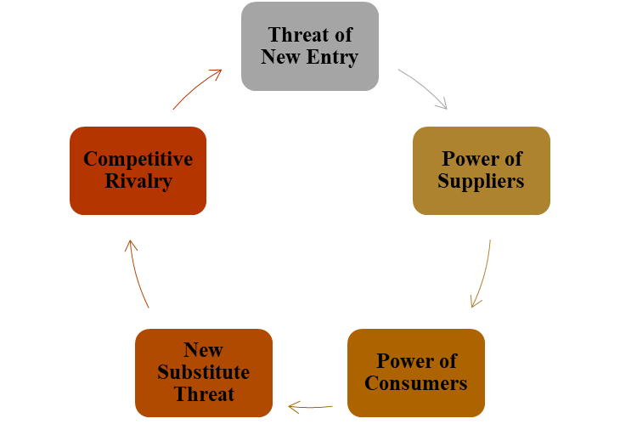

Threat of New Entrants: The childcare industry has moderate entry barriers due to stringent licensing requirements and regulations. However, a unique curriculum, experienced staff, and strategic location can create differentiation and mitigate potential new entrants.

Bargaining Power of Suppliers: Suppliers in the industry encompass educational resources, toys, equipment, and food supplies. While there may be multiple suppliers, forming strategic partnerships can help manage costs and maintain quality.

Bargaining Power of Buyers: Parents seeking childcare services have a moderate level of bargaining power due to the availability of options. Bright stars will differentiate itself through its curriculum, quality of care, and commitment to holistic child development.

Threat of Substitutes: Substitutes can include other nurseries, nannies, family members, or flexible work arrangements. To counter this threat, Bright stars will emphasize its unique educational approach and safe, stimulating environment.

Competitive Rivalry: The competitive landscape includes both established childcare centres and smaller local providers. Bright stars will focus on differentiation, innovative curriculum, and superior service quality to stand out in the market.

- Operation plan
Business Model and Revenue Stream
Our business model revolves around providing high-quality care, fostering early education, and ensuring a safe environment. Parents will be charged a monthly tuition fee based on the number of days their child is enrolled. Additional revenue streams will be generated through optional extracurricular activities and special events.

Facility and Operations
Our nursery will feature carefully designed classrooms, play areas, and outdoor spaces tailored to different developmental stages. A structured daily schedule will include a balance of educational activities, playtime, meals, and rest. Safety and security protocols will be strictly adhered to, with staff trained in first aid and emergency procedures.

Curriculum and Learning Approach
Our curriculum will be play-based, focusing on experiential learning that nurtures creativity, cognitive skills, social interactions, and emotional growth. We will provide a variety of learning materials, age-appropriate toys, and engaging activities that stimulate children's curiosity and development.

- Management Team Plan

Founder and Director:
I, Margarita Mandulova, the founder and director of Bright stars, hold a master’s degree in early childhood education and will bring my experience in child development and curriculum design. I have a proven track record of creating innovative educational programs that cater to children's unique needs. I have worked in many nurseries, and private homes as a nanny, I have a training with Montessori, which gives me a wide spectre of different educational approaches, will oversee the overall operations, curriculum development, and staff management.

Experienced Teachers and Caregivers
Our team comprises dedicated early childhood educators who are passionate about nurturing young minds. Each team member holds relevant qualifications in early childhood education and has experience working with children in various capacities. Our teachers are adept at creating a stimulating and supportive learning environment that fosters growth and development.
Overall, there will be two teachers and one caregiver to oversee a group of 20 kids.

- Legal Structure and Justification:

Bright stars will operate as a Limited Liability Company (LLC). This legal structure was chosen due to its advantages in terms of liability protection and flexibility. As an LLC, our personal assets will be shielded from business liabilities, providing us and our potential investors with peace of mind.

While other options such as sole proprietorship, partnership, and corporation were considered, an LLC aligns with our vision to combine the autonomy of a small business with the legal protections of a larger entity. This structure also simplifies administrative processes and allows for more straightforward tax reporting.

By selecting an LLC, Bright stars will be positioned to manage risks effectively while maintaining the agility needed to adapt to the evolving needs of children, parents, and the childcare industry. For our other legal and financial needs such as accounting services we will use and outside company to manage this for us.

- Marketing Plan 4P’s

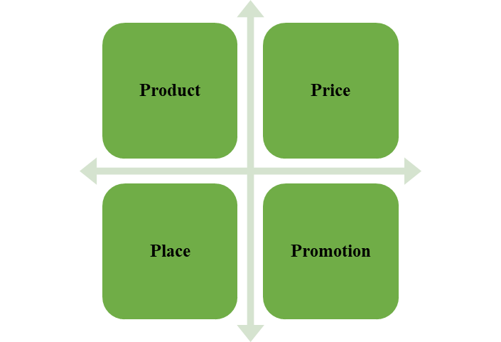

Bright Stars is committed to implementing a comprehensive marketing strategy that not only showcases our unique offerings but also establishes a strong connection with parents seeking high-quality child care and early education. Our strategy focuses on creating awareness, building trust, and delivering exceptional value to our target audience.
Extensive market research highlights the increasing demand for quality childcare and early education services in Cockfosters. Our location analysis indicates that Bright stars will serve a community that lacks accessible, high-quality childcare options. This position is to make a significant impact on the lives of both children and parents.

We will position our nursery as a premium childcare and early education centre that prioritizes holistic child development through a balanced blend of play and learning. Our nurturing environment and innovative curriculum will set us apart as a trusted partner in parents' journey to provide the best start for their children.

Our core product is childcare and early education for children aged 3 to 5 years. We offer a well-rounded curriculum, stimulating activities, nutritious meals, and a safe environment that nurtures growth and development. Optional extracurricular activities, workshops, and events will provide additional value to parents.

We will adopt a competitive pricing strategy that reflects the quality of education and care we provide. Our pricing will be structured as monthly tuition fees, offering different packages based on the number of days a child is enrolled. Our commitment to delivering value will justify the pricing to parents seeking the best for their children.

Our promotional mix will encompass a variety of channels to reach our target audience:

A user-friendly website will provide comprehensive information about our programs, curriculum, staff, and facilities. We will also engage parents through regular blog posts on child development and education.

Active presence on platforms such as Facebook, Instagram, and LinkedIn will showcase our daily activities, testimonials, and educational insights.
Open House Events: Regular open house events will allow parents to experience our environment, meet the staff, and ask questions.

Collaborations with local parent groups, schools, and community organizations will extend our reach and establish credibility.

Our services will be distributed directly through bright Star's physical location and our website. Parents will enrol their children by visiting our facility, learning about our programs, and completing the necessary paperwork.
- CONCLUSION

In conclusion bright Str's marketing plan is designed to effectively communicate our unique value proposition, build trust, and establish a strong connection with parents. By positioning ourselves as a premier childcare and early education centre with innovative curriculum and experienced staff, we are confident in attracting parents who prioritize their child's growth and development.

- Reference list

Porter, M. E.The Five Competitive Forces That Shape Strategy. Harvard Business Review, 86(1), 25-40.

Smith, J. R. (2023). Application of the 4Ps Framework in Marketing Strategy. Marketing Review, 15(2), 120-135.

Anderson, S. M. (2023). The Digital Revolution: Transforming Industries and Business M Artika, N.R., Rapini, T. and Purwaningrum, T., 2023. The relationship between service quality, trust, and consumer satisfaction on consumer loyalty. Jurnal Manajemen Strategi dan Aplikasi Bisnis, 6(1), pp.161-170.

Krüger, N.A. and Meyer, N., 2021. The development of a small and medium-sized business risk management intervention tool. Journal of Risk and Financial Management, 14(7), p.310.

NHBF 2022 NHBF industry research and statistics 2022 Available at: https://www.nhbf.co.uk/about-the-nhbf/industry-statistics/#:~:text=The%20number%20of%20hair%20%26%20beauty,%C2%A3100k%20fell%20by%203%2C500. [Accessed on 13 July 2023]
https://www.statista.com/outlook/cmo/beauty-personal-care/united-kingdom#revenue [Accessed on 10 December 2024]

Statista 2023 Value of net foreign direct investment (FDI) outward flows from the United Kingdom from 2011 to 2021 Available at: https://www.statista.com/statistics/284814/uk-net-fdi-flows-abroad/ [Accessed on: 13 July 2023Available at: https://www.statista.com/statistics/284814/uk-net-fdi-flows-abroad/ [Accessed on: 09 December2024]

- Appendixes

Appendix 1: VIRO Analysis

RESOURCES | VALUABLE | RARE | INIMTABLE | ORGANISATTION | COMPETITIVE ADVANTAGE
Sustainable | yes | yes | yes | yes | sustainable
Skilled team | yes | yes | yes | yes | sustainable
Personalised service | yes | yes | yes | yes | sustainable
Customer centred | yes | yes | yes | yes | competitive
Brand awareness | yes | no | no | yes | competitive

Appendix 2: Start-up cost
Expenses | Value (£)
Legal | 10.000
Marketing | 3.000
Rent | 40.000
Furnishing | 15.000
Catering and kitchen facilities | 40.000
Insurance | 10.000
Security | 8.000
Training | 10.000
Materials | 18.000
Sports activities materials | 5.000
Total Start-up cost | £ 159,000
Start - Up Assets
Cash required | 60.000
Personal Savings | 100,000
Total requirements | £ 60.000

Appendix 3: 6 Months budget plan

Details | January | February | March | April | May | June
Balance | 150000 | 200000 | 250000 | 280000 | 300000 | 340000
Cash from debtors | 100000 | 120000 | 100000 | 80000 | 80000 | 80000
Cash available | 250000 | 320000 | 350000 | 360000 | 380000 | 420000
Pay suppliers | 30000 | 30000 | 25000 | 25000 | 25000 | 25000
Wages | 25000 | 25000 | 30000 | 30000 | 30000 | 30000
Administrative cost | 10000 | 10000 | 10000 | 10000 | 10000 | 10000
Total | 200000 | 250000 | 280000 | 300000 | 340000 | 380000
Closing Balance | 200000 | 250000 | 280000 | 300000 | 340000 | 380000

(Source: created by author)

