

Task 1 – Reading Task Template
Upload your photo of your A3 in-class notes here:
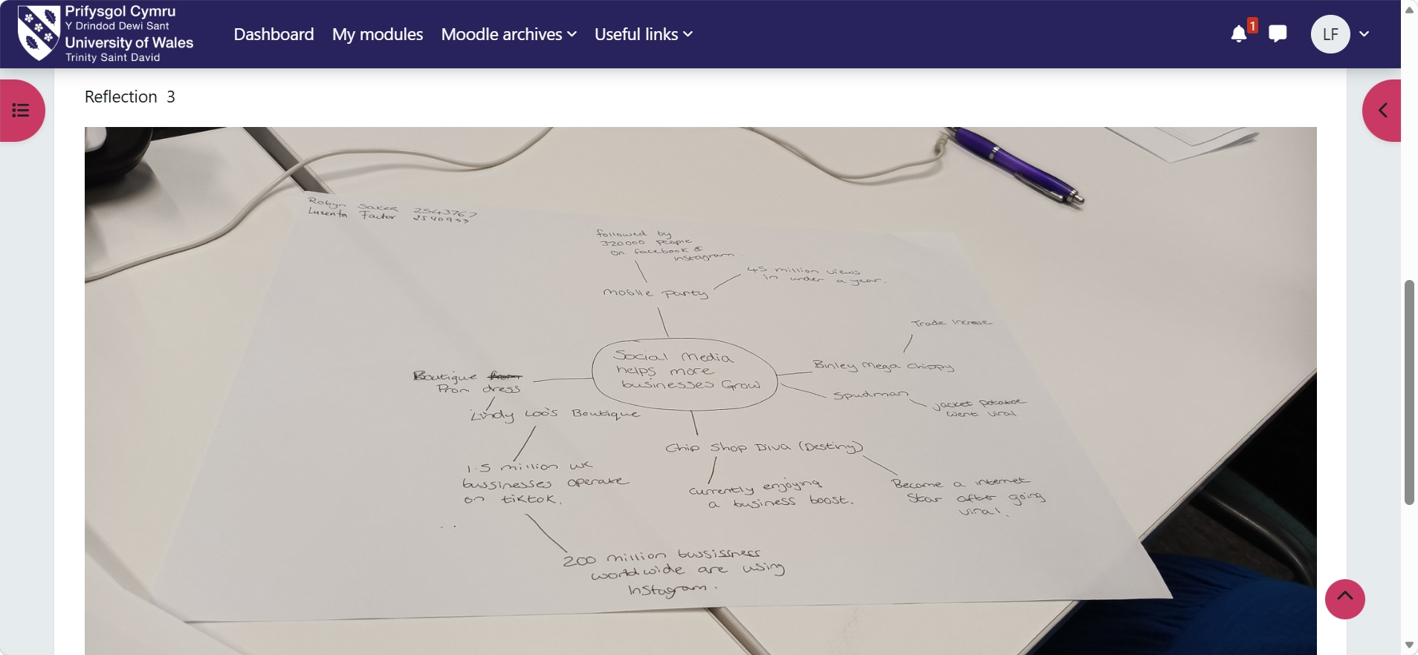

1. Answer these questions using the sentence starters below
a. What is the main idea of the text?
The main idea is that social media Helps Business Grow
b. What are two key points?
One key point is social media helps businesses grow by reaching more customers, increasing brand awareness, and boosting sales.
Another key point is social media helps businesses attract more customers and increase sales
c. What part of the text did you find most important? Why?
The most important part is that social media helps businesses reach more customers and increase sales. I think this is the most important point because it explains how businesses can grow by using social media to advertise their products, build their brand and connect with customers. Another important idea is that social media helps businesses build stronger relationships with customers. By posting updates, replying to comments, and sharing useful content, businesses can create trust and loyalty. This can lead to repeat customers, positive reviews, and more people recommending the business to others.
d. Was anything unclear or difficult to understand?
I was not sure about if my answer I right.
e. How did your group help you understand the text better?
My group helped me by discussing different ideas, asking questions, and explaining parts that were confusing. Hearing other people’s perspectives made the meaning clearer and help me notice details I might have missed on my own.
3. One sentence reflection
Question: What did you find challenging about this task?
The hardest part was making the response clear and concise while still following the instruction exactly. It also requires preserving the original meaning and tone without changing anything that should stay the same

