BSc Computing Portfolio

Smart and Connected Devices 2

ACDA6005

Internet of Things – Smart Cities Applications:

How can cities leverage the benefits of digitalization to relieve stress on overstretched services and resources?

Helen Frey

P131560

Lecturers: Dr John Rees/Dr Mabrouka Abuhmida

Table of Contents

Table of Figures 3
Abstract 4
TASK 1 4
1. Introduction: what is a smart city? 4
2. Why do we need smart cities? 5
2.2 Security 5
2.3 Smart City Standards 6
3. Smart Motorways 6
3.1 Motorway Surfaces 6
3.2 Ethical Considerations 7
3.3 Electric Cars and Charging 7
3.4 Expectation vs Reality 8
3.5 Other Transport Systems 8
3.6 UK: Smart Motorways 9
3.7 Are Smart Motorways Safe? 9
4. Internet Connections 10
5. Conclusion 12
TASK 2 12
6. Introduction to Task 2 12
7. Conclusion for Task 2 14
Bibliography 15

Table of Figures

Figure 1: Smart City Components [2] 4
Figure 2; Transducer [12] 5
Figure 3: UK - Urban and Rural Population Areas [13] 5
Figure 4: Global Urban Population 5
Figure 5: IoT connection forecast by sector 2024 [16] 5
Figure 6: Smart Pavement [27] 7
Figure 7: Real Time Data Collection [27] 7
Figure 8: Electric rails in road [32] 8
Figure 9: Lorry battery being charged [32] 8
Figure 10: Photovaltaic Cells [33] 8
Figure 11: Intelligent Highway [33] 8
Figure 12: Zhejiang electric car charging lane [35] 8
Figure 13: Smart Tunnel [37] 9
Figure 14: Smart Car Sensors [38] 9
Figure 15: Red X on Hard Shoulder [41] 9
Figure 16: Motorway with Variable Speed Limit on Hard Shoulder [44] 9
Figure 17: Current Low Power Wide Area Technology [16] 10
Figure 18: Wireless Sensor Network [50] 10
Figure 19: Centralised formation [51] 10
Figure 20: – Summary comparison of leading the standardisation of IoT connectivity technologies [16] 11
Figure 21: Packet Tracer simulation 12
Figure 22: Gantry with all light showing green 12
Figure 23: Gantry with hard shoulder red 12
Figure 24: Registration Server login 12
Figure 25: Solar panel charging car 13
Figure 26: Streetlight with no light activated 13
Figure 27: Motion sensor activated by car 13
Figure 28: AES Wireless Security 13
Figure 29: Conditions for Webcam 13
Figure 30: Motion Detector and Webcam Off 13
Figure 31: Motion Detector and Webcam On 14

Abstract
Task 1 of this report will explain what makes a city smart, why smart cities are necessary and will focus on smart mobility using smart motorways. It will set out how approaches to smart motorways are being implemented and the different aspects of sustainability via cleaner air and less congestion that having smart motorways will attempt to tackle. Security and ethical considerations will be covered together with a brief outline of networks and Internet of Things sensors and actuators. Various standards for smart cities will also be researched. Task 2 will simulate some smart motorway situations in Packet Tracer.

TASK 1

Introduction: what is a smart city?
The Internet of Things has allowed everything to become interconnected and smart cities have taken advantage of advances in technology by using sensors and actuators to make the growing urban population more sustainable through the optimisation of finite resources. According to the British Standards Institute the definition of a smart city is:
“one that makes optimal use of all the interconnected information available today to better understand and control its operations and optimize the use of limited resources” [1]
A Smart City is more of a concept that a thing [2] that uses the Internet of Things (IoT), sensor technology and big data to make cities safer, greener, faster and to improve the quality of life of its citizens through technology [3]. Urban sustainability responds to the needs of the people via sustainable solutions; the term ‘smart cities’ has no apparent definition that has been agreed on however there are some standards which have been adopted that are covered later in the report. There are many different lists of the top ten cities, each citing their own reference points to calculate how ‘smart’ they are from the use of renewable energy to education and business ecosystems, to free wi-fi [4], [5].
Figure 1 shows how smart cities use technology in agriculture, education, retail, transport, energy, pollution, homes, health and governance, eg in transport, sensors can detect that a car park is full and indicate the nearest car park that has space.
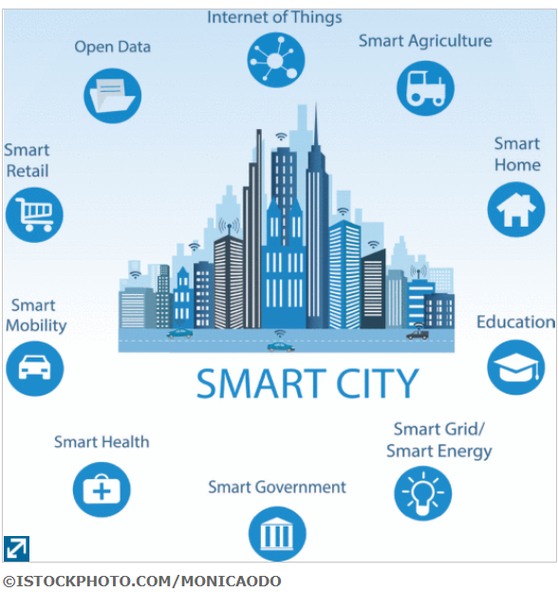
Figure 1: Smart City Components [2]
Smart cities use sensors, actuators, computers, Infra-Red (IR) Radio-frequency identification (RFID), smart phones and Global Positioning System (GPS) that form a network of interconnected ‘things’ through local area networks / the Internet / the cloud [2] to obtain data that is analysed and used to monitor trends for reactive or predictive analysis [1], [2], [6]–[11].
Figure 2 shows how a sensor converts physical phenomena into an electrical signal and actuators take an electrical signal and convert it to a physical output [12].
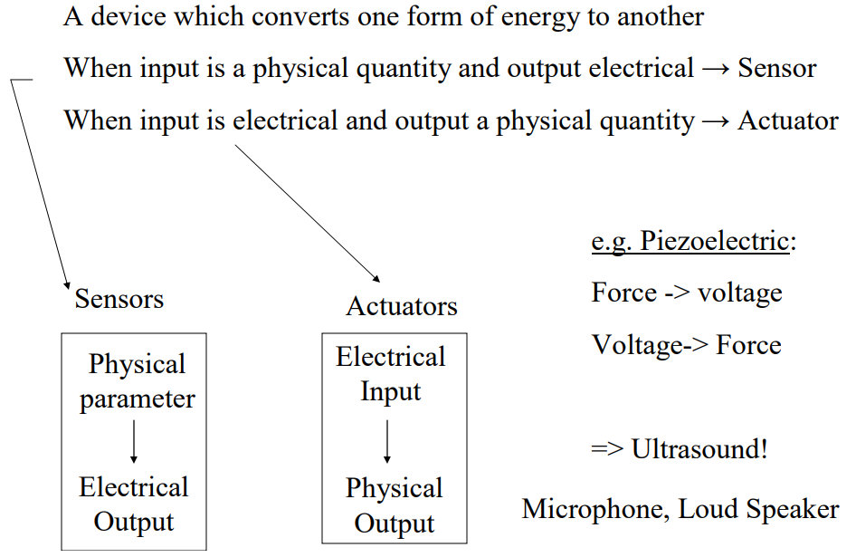
Figure 2; Transducer [12]
The use of wireless technology eliminates the need for expensive cabling and is therefore more economically sound. Information and Communications Technology (ICT) infrastructure which include software, middleware, firmware and sensors, is a fundamental aspect of smart cities.

Why do we need smart cities?
The population is increasing and according to the United Nations, 54% of people around the world live in a city. By 2050, this is estimated to reach 66% [8].
Figure 3 shows the UK with an estimated 90% of the population living in cities by 2050 [13].

Figure 3: UK - Urban and Rural Population Areas [13]
The increase in urban population is putting a lot of pressure on current infrastructures; smart cities are designed to assist with this burden.
80% of greenhouse gasses are said to come from cities and they currently consume 75% of the worlds energy and resources [2][14].
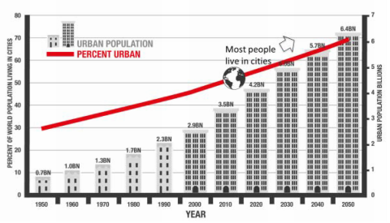
Figure 4: Global Urban Population
With so much of the population living in cities the United Nations set out Sustainable Development Goals in September 2015, ratified by 193 countries, to address the
“three dimensions of sustainable development: social, economic and environmental” [15].

2.2 Security
Figure 5 shows the IoT connection forecast for 2024.
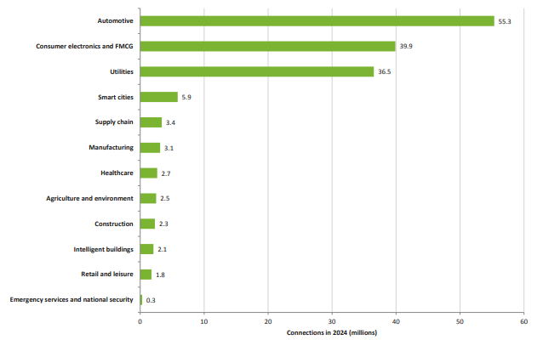
Figure 5: IoT connection forecast by sector 2024 [16]
With so many devices connected to the Internet, security is essential and is defined as:
“Security, in Information Technology (IT) is the defense of digital information and IT assets against internal and external, malicious and accidental threats.” [17]
The 4 tenets of security are: Confidentiality (can unauthorised persons see the information?), Authenticity (is the information from a reliable source as stated?), Integrity (has the data been changed?) and Availability (is the information available at the required time?).
As sensor devices are resource constrained, limited battery, speed or processing power, storage capacity and communication bandwidth, security protocols are difficult to implement [18].
New technology programming bugs are inevitable and software vulnerabilities are common. The sensor/IoT devices are connected to a backbone network and gives attackers easy access to the entire system [18].
A Distributed Denial of Service attack on Amazon’s Web Services in February 2007, left many user bereft of any type of services from security cameras to lighting [19],[20]. Smart locks are now battery powered so that during a power outage, access is still available to the homeowner [21].
The UK’s Code of Practice for Consumer Internet of Things advocates for security to be inbuilt in all internet connected devices although it appears to be voluntary for companies to sign up [18]. In May 2019 the Department for Digital, Culture, Media & Sport (UK) started a consultation assessment for ‘Mandating Security Requirements for Consumer ‘IoT’ Products that will require security labels to be added to IoT products [16].

2.3 Smart City Standards
ISO standard 37120 of The Institute of Electrical and Electronics Engineers (IEEE) has defined 46 core and 54 support performance standards to enable civic bodies to benchmark their service performances for smart cities [2].
The National Institute of Standards and Technology created an IoT-Enabled Smart City Framework to address smart city standards [22], [23].

Smart Motorways
The European Commission prepared a Strategic Transport Technology Plan for an environmentally friendly transport system by 2050 [24] and governments are looking for ways to find a low carbon energy future within transport [25]. Highways England (formerly the Highways Agency) suggest that congestion on motorways and road networks costs £2 billion with 25% of this as a direct result of incidents making smart motorways more economic and if traffic flows freely, less pollution is also emitted [26].

3.1 Motorway Surfaces
Integrated Roadways have created precast ‘Smart Pavement’ slabs (Figure 6).
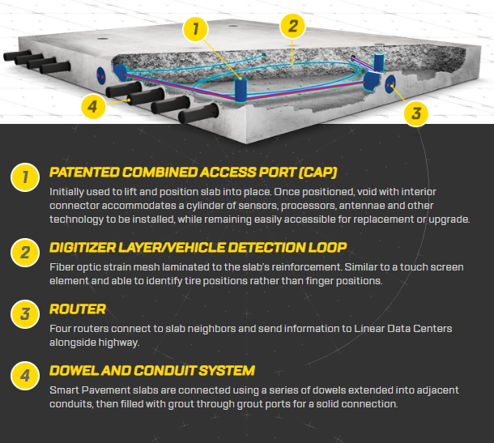
Figure 6: Smart Pavement [27]
These paving slabs are capable of sensing vehicles and could be used for accident detection allowing first responders to react quicker. They can also collect real-time data about road conditions and congestion [27].
Figure 7 show ‘Smart Pavement’ slabs on a motorway. Connection to a smart car would give updates on traffic and road conditions and signal any accidents. It would be possible to send diversion information directly to the GPS to avoid congestion.
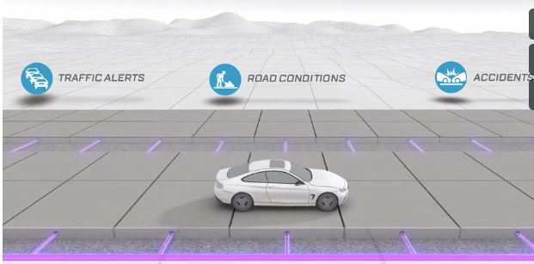
Figure 7: Real Time Data Collection [27]
The World Economic Forum suggests that these roads could be self-funding by allowing third parties access to the data for advertising purposes [28].

3.2 Ethical Considerations
To enable target advertising this suggests interactivity between a ‘smart car’ and the ‘smart pavement’ slabs. How much data would the advertisers be able to access and what about the right to privacy? Does this right have to be relinquished to be able to use the motorway? At present there are no answers to this. Another ethical consideration is Automatic Number Plate Reading technology used in ‘average speed’ camera technology that records licence, date and timestamp between two cameras to calculate average speed. In the UK there are currently approximately 263 miles of roads being covered by this technology. Is this data held and if so for what purpose [29]?
Due to the amount of data held by companies and the right to privacy the European Parliament, in 2016 (enforced in 2018), changed the Data Protection Directive to the General Data Protection Regulation (GDPR) in an attempt to regulate the way data is managed in Europe [30]. It is unknown how this would impact the smart pavement system.

3.3 Electric Cars and Charging
Electric cars are having an impact on the pollution crisis but have battery charging issues. Charging stations at motorway stops creates problems with the amount of time it takes to recharge batteries and increasing journey time. Sweden have come up with a solution by creating electrified roads that charges vehicle batteries as they drive.
Sweden has built 1.2 miles of electric road in Stockholm and their intention is to create 12,500 miles of this electric road network. Inbuilt safety features ensure no surface voltage [31].

Figure 8: Electric rails in road [32]
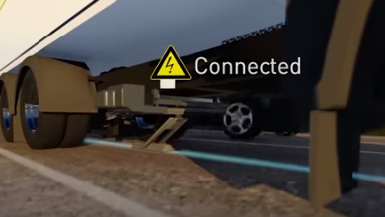
Figure 9: Lorry battery being charged [32]
In 2015 Colas launched Wattway photovoltaic road surface and have approximately 40 trial sites worldwide [33].
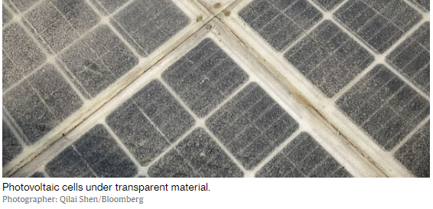
Figure 10: Photovaltaic Cells [33]
China uses Photovaltaic cells on an “Intelligent Highway” in Jinan that have solar panels, mapping sensors and electric car chargers [33].
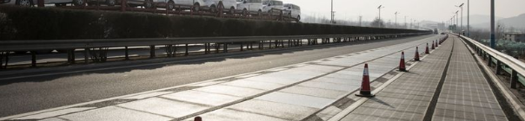
Figure 11: Intelligent Highway [33]
The cells are constructed so the top shell allows sunlight through to charge the solar panels. Solar powered heating elements allow the highway to be free from snow and ice. There is enough space to put recharging wires and sensors. With 1,080 meters of road at present, it is too short to enable wireless charging at present [33].
Zhejiang province will construct a 100 mile motorway between Hanzhjou and Ningbo that allows electric vehicles to be charged during travel [34]. It will also support autonomous vehicles that are tracked via sensors and an ‘Internet of Vehicles’ system together with solar panels [35].
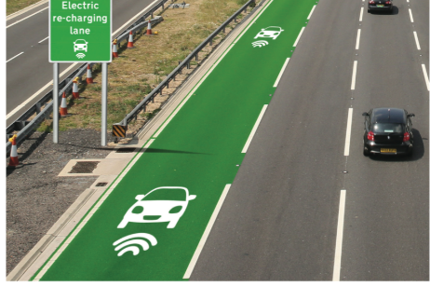
Figure 12: Zhejiang electric car charging lane [35]

3.4 Expectation vs Reality
2016 Idaho-based Solar Roadways used
“used about one-third of the electricity they generate to power their built-in LEDs,” [35],
generating just 52.9 kWh over a six-month period [35].
In December 2016 France, in partnership with Colas, opened 1 km of ‘solar road’ which generated just 409 kWh per day, substantially less than the estimated 17,936 kWh.

3.5 Other Transport Systems
Smart traffic light models have been simulated that adapt to traffic flow and suggest a reduction of congestion of up to 80% by changing when vehicles are added to the motorway [36]. There is no data to suggest how this would impact traffic conditions before the motorway.
Kuala Lumpur designed a smart tunnel that incorporates heat, lighting, CCTV, lane traffic signalisation and gas analyser sensors that automatically detect problems and react accordingly eg in case of fire a CCTV and fire alarm are triggered. Automatic detection of traffic flow speed: vehicles that are stationary or travelling in the wrong direction [37].
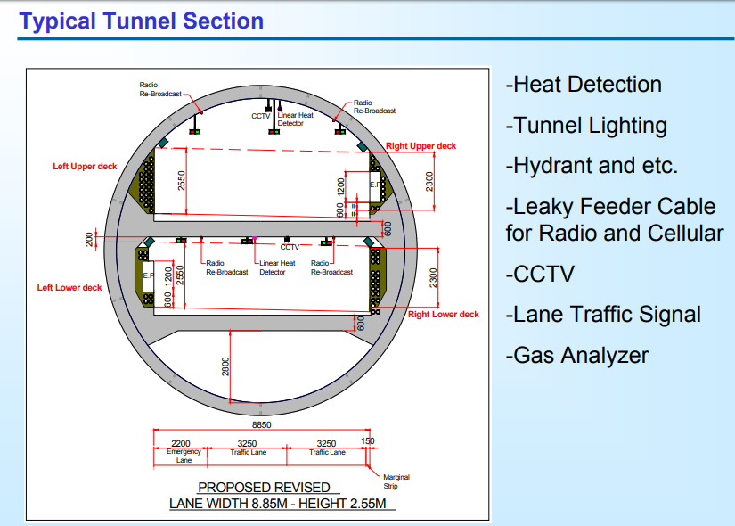
Figure 13: Smart Tunnel [37]
Future systems will include “smart cars” whereby sensors will be added to allow for autonomous driving.
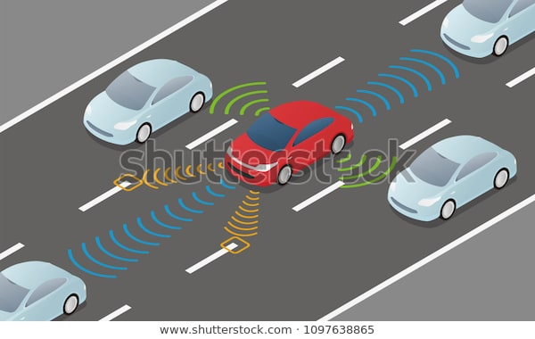
Figure 14: Smart Car Sensors [38]

3.6 UK: Smart Motorways
According to Highways England there are 3 types of smart motorways:
1. Controlled motorways: use variable speed limits and have three or more lanes with the hard shoulder being reserved for emergencies only.
2. Dynamic hard shoulder: used in conjunction with variable speed limits, the hard shoulder is used during busy times. A gantry with a red ‘X’ shows it is restricted or the current variable speed limit shows it can be used.
3. All lane running: uses variable speed limits with the hard shoulder used as a permanent lane.
Technology is used to monitor and manage traffic flow from regional control centres [29], [39], [40] .
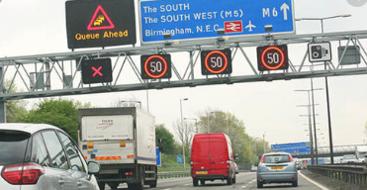
Figure 15: Red X on Hard Shoulder [41]
It is unclear whether this system works with over 23% of drivers ignoring the red ‘X’ indicating a closed lane [42] despite the Home Office legislation in effect from 10 June 2019 stating that there is an immediate £100 fine and three penalty points [43].
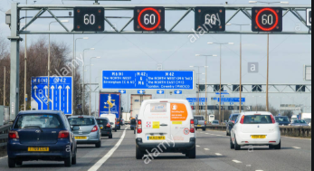
Figure 16: Motorway with Variable Speed Limit on Hard Shoulder [44]

3.7 Are Smart Motorways Safe?
Highways England’s statistics show that
“Journey reliability has improved by 22% and personal injury accidents have been reduced by more than half” [29].
Dynamic hard shoulders have been criticised following fatalities when broken-down vehicles have nowhere to stop safely. The Transport Secretary is conducting a review on smart motorways and recommendations will be forthcoming. Highways England in conjunction with the RAC have increased the amount of Emergency Refuge Areas [42], [45], [46].
Stationary Vehicle Detection technology is used to detect stationary vehicles across all lanes which triggers an alarm, that is investigated by a control centre operator. This system is said to be up to 16 minutes quicker than camera-based systems which average 17 minutes [47]. The AA suggests that stopping in a live lane of an All Lane Running Smart Motorway more than triples the danger. Only 18% of smart motorways have this technology in place [46], [47], [48].
Motorway Incident Detection and Automatic Signalling ‘MIDAS’ detects vehicles every 500 meters and calculates speed, volume and occupancy of each lane. This data is sent by the internet and fed into an algorithm at a control centre and alters speed message signs on the next gantry [47].

Internet Connections
Wireless Sensor Networks are used to connect sensors to the Internet where the data is passed via local cluster heads or sink nodes to managing servers at control centres to be analysed. With possibly hundreds of thousands of sensor nodes, data collection can be done either on a ‘polled’ (sequential) or an ‘interrupt’ basis. The polled system asks each sensor in turn to send data and the interrupt system gives data only when an event has occurred [49].
Figure 17 shows how low power wide area network technology connects directly to a wide area connection.
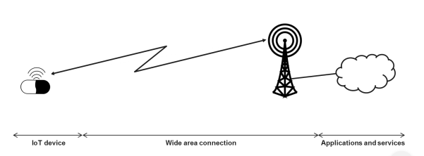
Figure 17: Current Low Power Wide Area Technology [16]
Placement of the sensors and sink nodes is critical to ensure correct coverage as can be seen in Figure 18 only the devices within the sensing range are able to send signals. If too many sensing ranges overlap, then there is too much redundant coverage, and this can interfere with signals.
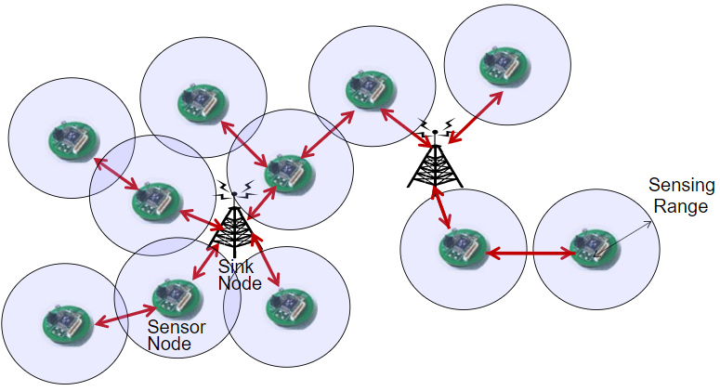
Figure 18: Wireless Sensor Network [50]
Centralised formation systems are used in networks where the processing capacity is done by a central device that forwards all collected data to the sink node.
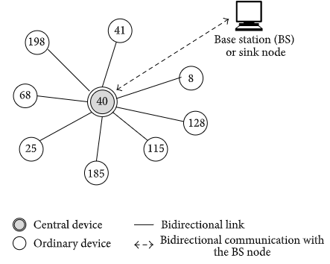
Figure 19: Centralised formation [51]
The main advantages of this system are:
- More efficient energy management.
- Roaming capabilities within the network.
- Simplified analysis of network coverage [51].
Different types of protocols are used to send the data and figure 20 is a summary comparison of the leading standardisation of IoT connectivity technologies [16].

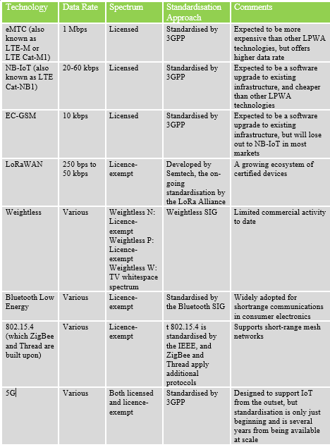
Figure 20: – Summary comparison of leading the standardisation of IoT connectivity technologies [16]

Conclusion
Smart cities are required to maintain resources in an ever-growing urban population, and they are made possible by wireless sensors and actuators that collect data. Security and ethical considerations are being investigated by various countries. IEEE have created a set of standards and a framework of standards has been made by National Institute of Standards and Technology both of which appear to need to be enforced.
Smart motorways, with or without vehicle charging systems, are needed to curb pollution and congestion and assist with the volume of traffic and more efficient real-time incident response. Data is analysed and reacted to by control centre operators. Current systems are by no means perfect, but they are being investigated to resolve the flaws.

TASK 2

Introduction to Task 2
Using a simulation tool called Packet Tracer a motorway scenario would be set out. This would include overhead gantries, web cam, street lighting and battery charging facilities.
Figure 21 shows the setup of a motorway.
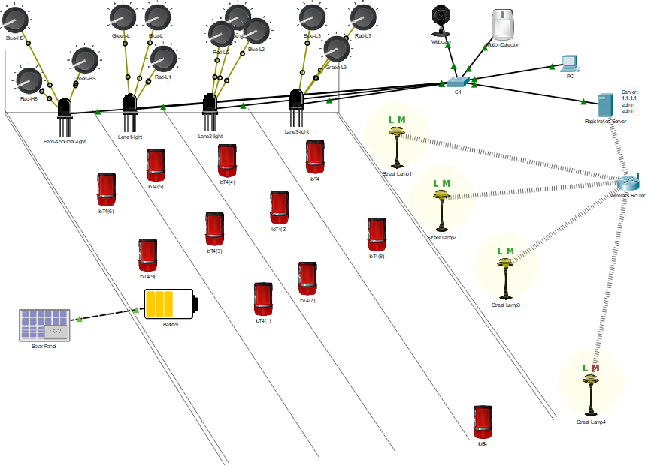
Figure 21: Packet Tracer simulation
To simulate overhead gantries, Red, Green, Blue (RGB) lights were used. To indicate stationary, when traffic would be at its highest peak, the green light would be on to simulate the hard shoulder being available to traffic. A potentiometer is used to simulate the flow of traffic and the green light changes to red when traffic conditions alter and there is no congestion.
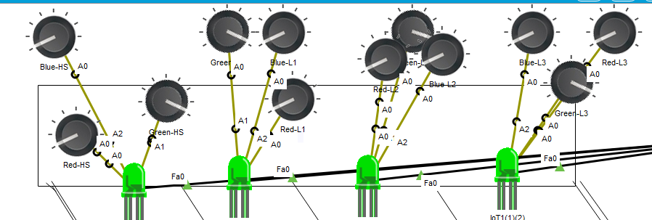
Figure 22: Gantry with all light showing green
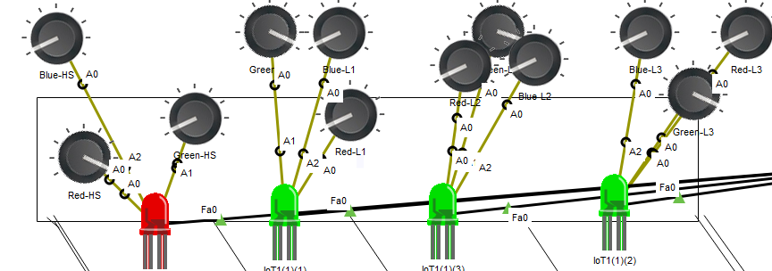
Figure 23: Gantry with hard shoulder red
The gantry was set up using a wired system to the main registry server for security reasons. This was accessed by a pc with security settings ie username and password.
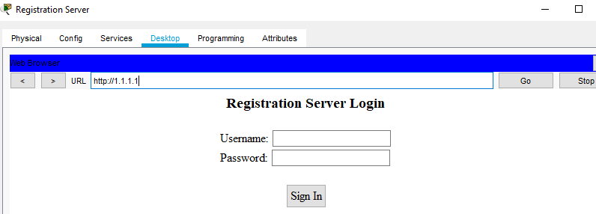
Figure 24: Registration Server login
A battery was attached to a solar panel to mimic a car being charged.
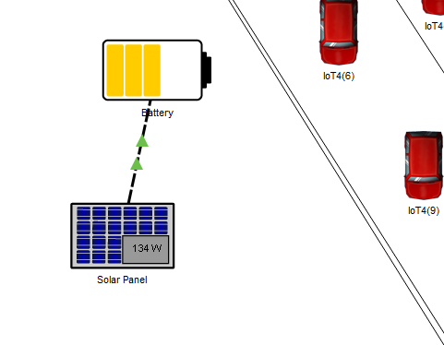
Figure 25: Solar panel charging car
Figure 26 shows the streetlights unlit as the photoresistors are showing enough light currently. They send signals to a wireless router as the information is relatively low priority.
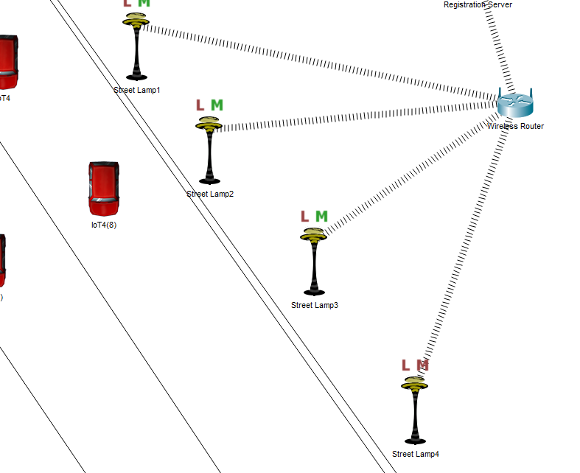
Figure 26: Streetlight with no light activated
When a car passes, it triggers the motion sensor, indicated by the red M turning green, Figure 27.
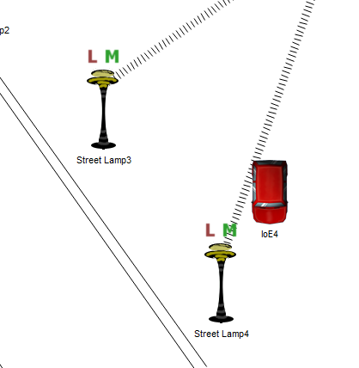
Figure 27: Motion sensor activated by car
As they are using wireless technology, the security that has been implemented is WPA2-PSK with an Advanced Encryption Standard algorithm and a password.
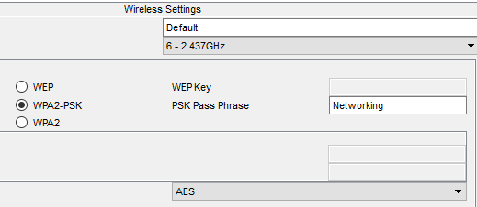
Figure 28: AES Wireless Security
A motion detector and a webcam were set up to imitate a control centre being able to see what was happening when an issue was reported to allow operators to respond more effectively.
Conditions were set up in the registry server to link the motion detector with the webcam as shown in figure 29 with figures 30 and 31 showing them working.
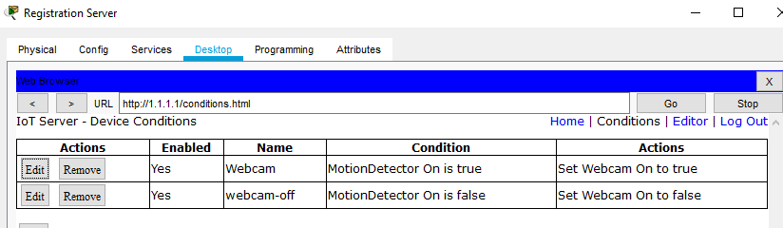
Figure 29: Conditions for Webcam
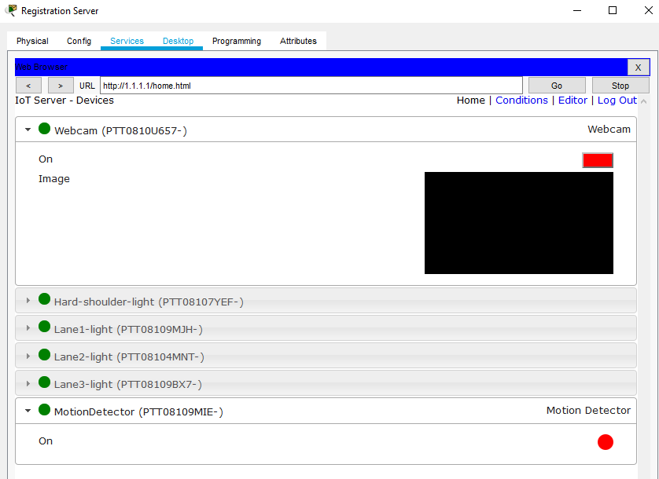
Figure 30: Motion Detector and Webcam Off

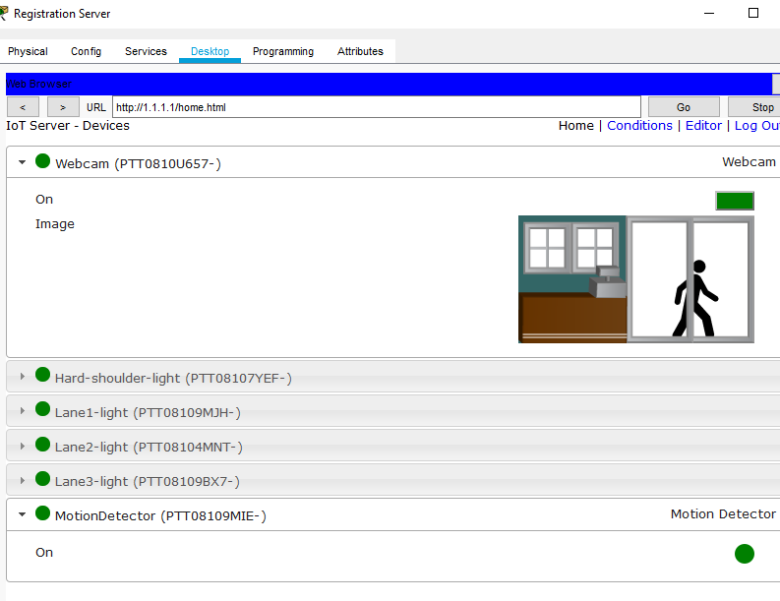
Figure 31: Motion Detector and Webcam On

Conclusion for Task 2
Packet Tracer does not lend itself to IoT smart motorways. Many different sensors were used to simulate what would be used in a real-life scenario. Localised end solutions with wireless technology were used for the streetlights as they only had to send a hello message once every day to acknowledge that they are operational. The overhead gantries were hard wired to the server. A webcam was added so that decisions could be made by an operator after visual inspection at a command centre. Data was sent to the server registry, where it could be used for predictive analysis.

Bibliography

[1] “1: Smart cities definitions | Centre for Cities.” [Online]. Available: https://www.centreforcities.org/reader/smart-cities/what-is-a-smart-city/1-smart-cities-definitions/. [Accessed: 04-Nov-2019].
[2] S. P. Mohanty, U. Choppali, and E. Kougianos, “Everything you wanted to know about smart cities,” IEEE Consum. Electron. Mag., vol. 5, no. 3, pp. 60–70, Jul. 2016.
[3] J. Arauz, “Smart Cities and the Dire Need for a Course Correction,” in 2018 IEEE International Smart Cities Conference, ISC2 2018, 2019.
[4] V. Albino, U. Berardi, and R. M. Dangelico, “Smart cities: Definitions, dimensions, performance, and initiatives,” J. Urban Technol., vol. 22, no. 1, pp. 3–21, 2015.
[5] “Top 10 Smartest Cities In The World.” [Online]. Available: https://www.designworldonline.com/top-10-smartest-cities-in-the-world/. [Accessed: 26-Nov-2019].
[6] “What is a smart city? Technology and examples.” [Online]. Available: https://www.gemalto.com/iot/inspired/smart-cities. [Accessed: 28-Oct-2019].
[7] “Smart Cities – Internet of Things (IoT) Solutions.” [Online]. Available: https://www.vodafone.com/business/industry/public-services-smart-cities. [Accessed: 29-Oct-2019].
[8] “What is a smart city? Technology and examples.” [Online]. Available: https://www.gemalto.com/iot/inspired/smart-cities. [Accessed: 04-Nov-2019].
[9] “What Is A Smart City? | Computerworld.” [Online]. Available: https://www.computerworld.com/article/3427835/what-is-a-smart-city--how-to-define-a-smart-city.html. [Accessed: 04-Nov-2019].
[10] “Definition | Brussels Smart City.” [Online]. Available: http://www.smartcity.brussels/the-project-definition. [Accessed: 04-Nov-2019].
[11] “Smart cities: 6 essential technologies - TechRepublic.” [Online]. Available: https://www.techrepublic.com/article/smart-cities-6-essential-technologies/. [Accessed: 04-Nov-2019].
[12] “Intro to Sensors.”
[13] “World Urbanization Prospects - Population Division - United Nations.” [Online]. Available: https://population.un.org/wup/Country-Profiles/. [Accessed: 04-Nov-2019].
[14] P. Wilson, “State of smart cities in UK and beyond,” IET Smart Cities, vol. 1, no. 1, pp. 19–22, Jun. 2019.
[15] “Sustainable Development Goals launch in 2016.” [Online]. Available: https://www.un.org/sustainabledevelopment/blog/2015/12/sustainable-development-goals-kick-off-with-start-of-new-year/. [Accessed: 04-Nov-2019].
[16] T. Winchcomb, S. Massey, and P. Beastall, “Review of latest developments in the Internet of Things Client: Ofcom Riverside House 2a Southwark Bridge Road London SE1 9HA,” 2017.
[17] “What is security? - Definition from WhatIs.com.” [Online]. Available: https://searchsecurity.techtarget.com/definition/security. [Accessed: 22-Nov-2019].
[18] “Secure by Design - GOV.UK.” [Online]. Available: https://www.gov.uk/government/collections/secure-by-design. [Accessed: 13-Nov-2019].
[19] “What to do when internet outages ruin your cool smart home.” [Online]. Available: https://mashable.com/2017/02/28/aws-smart-home-iot-fail/?europe=true. [Accessed: 13-Nov-2019].
[20] “How did an Amazon glitch leave people literally in the dark? | Technology | The Guardian.” [Online]. Available: https://www.theguardian.com/technology/2017/mar/01/amazon-web-services-outage-smart-homes. [Accessed: 13-Nov-2019].
[21] “What Happens to Your Smarthome When the Power Goes Out?” [Online]. Available: https://www.howtogeek.com/403888/what-happens-to-your-smarthome-when-the-power-goes-out/. [Accessed: 13-Nov-2019].
[22] “Smart City Framework.” [Online]. Available: https://pages.nist.gov/smartcitiesarchitecture/. [Accessed: 11-Nov-2019].
[23] “IES Cities Architecture | NIST.” [Online]. Available: https://www.nist.gov/el/cyber-physical-systems/ies-cities-architecture. [Accessed: 11-Nov-2019].
[24] “Strategic Transport Technology Plan (STTP) | Mobility and Transport.” [Online]. Available: https://ec.europa.eu/transport/themes/research-and-innovation/strategic-transport-technology-plan-sttp_et. [Accessed: 04-Nov-2019].
[25] B. Kolosz and S. Grant-Muller, “Comparing smart scheme effects for congested highways,” Transp. Res. Part C Emerg. Technol., vol. 60, pp. 313–323, Nov. 2015.
[26] “Smart motorways | Improvements and major road projects.” [Online]. Available: https://highwaysengland.co.uk/programmes/smart-motorways/. [Accessed: 18-Nov-2019].
[27] “Integrated Roadways | Say Hello to the Real Information Super Highway.” [Online]. Available: http://integratedroadways.com/. [Accessed: 05-Nov-2019].
[28] “This is how intelligent smart roads could become | World Economic Forum.” [Online]. Available: https://www.weforum.org/agenda/2018/05/smart-roads-could-soon-call-an-ambulance-connect-you-to-the-internet/?fbclid=IwAR1geTBLAAOakgR8w4UEs9YEBte-sTX51RMXgLlVl9yko4NimYEMqQCHdfk. [Accessed: 05-Nov-2019].
[29] “Speed cameras - our guide to staying safe and legal | RAC Drive.” [Online]. Available: https://www.rac.co.uk/drive/advice/cameras/speed-cameras/. [Accessed: 18-Nov-2019].
[30] “EU data protection rules | European Commission.” [Online]. Available: https://ec.europa.eu/commission/priorities/justice-and-fundamental-rights/data-protection/2018-reform-eu-data-protection-rules/eu-data-protection-rules_en. [Accessed: 05-Nov-2019].

[31] “World’s First Electrified Road Opens in Sweden - Yale E360.” [Online]. Available: https://e360.yale.edu/digest/worlds-first-electrified-road-opens-in-sweden. [Accessed: 05-Nov-2019].
[32] “(145) How world’s first electrified road charges moving vehicles - YouTube.” [Online]. Available: https://www.youtube.com/watch?v=VZNHZnyxCm8&feature=share&fbclid=IwAR2ixiSF9GTzkgVQwvlvHHE6pH3yJVk2MVlAmcojCsRdWAjMq7Vw-0OOlAA. [Accessed: 05-Nov-2019].
[33] “China’s Built a Road So Smart It Will Be Able to Charge Your Car - Bloomberg.” [Online]. Available: https://www.bloomberg.com/news/features/2018-04-11/the-solar-highway-that-can-recharge-electric-cars-on-the-move. [Accessed: 05-Nov-2019].
[34] “China to build a motorway that charges electric cars as they drive | Smart Highways Magazine: Industry News.” [Online]. Available: http://smarthighways.net/china-to-build-a-motorway-that-charges-electric-cars-as-they-drive/?fbclid=IwAR1Eyz-qmbqg2qoZ-tBCjGnMotEcNJh2itYbjUXFqGov5vW1g-dI1uSMWKY. [Accessed: 05-Nov-2019].
[35] “Why the world’s first smart highway will most likely be in China | TechCrunch.” [Online]. Available: https://techcrunch.com/2019/01/24/why-the-worlds-first-smart-highway-will-most-likely-be-in-china/. [Accessed: 05-Nov-2019].
[36] E. Richardson, P. Davies, and D. Newell, “Modelling a Smart Motorway,” in Advances in Intelligent Systems and Computing, 2020, vol. 993, pp. 148–158.
[37] I. Mohd and S. Santhiman, “ITS of SMART (Storm Management And Road Tunnel),” 2006.
[38] “Autonomous Car Driving On Road Sensing Stock Vector (Royalty Free) 1097638865.” [Online]. Available: https://www.shutterstock.com/image-vector/autonomous-car-driving-on-road-sensing-1097638865. [Accessed: 10-Nov-2019].
[39] “Smart motorways: What are smart motorways, where are they in the UK and why are drivers being fined for using them? | Alphr.” [Online]. Available: https://www.alphr.com/cars/1008529/smart-motorways-UK-what-where. [Accessed: 12-Nov-2019].
[40] “How to drive on a smart motorway - GOV.UK.” [Online]. Available: https://www.gov.uk/guidance/how-to-drive-on-a-smart-motorway. [Accessed: 12-Nov-2019].
[41] “Smart motorway 50mph speed limits catch out thousands of drivers on clear motorways | Express.co.uk.” [Online]. Available: https://www.express.co.uk/life-style/cars/953080/Smart-motorway-50mph-speed-limits-fine-speeding-camera. [Accessed: 12-Nov-2019].
[42] “Smart motorways - outstanding roads or seriously in need of improvement? : The insurance hub : Clyde & Co (en).” [Online]. Available: https://www.clydeco.com/blog/insurance-hub/article/smart-motorways-outstanding-roads-or-seriously-in-need-of-improvement?utm_source=Mondaq&utm_medium=syndication&utm_campaign=View-Original. [Accessed: 18-Nov-2019].
[43] “Big changes to motorway driving as red X fines come in | RAC Drive.” [Online]. Available: https://www.rac.co.uk/drive/news/motoring-news/x-marks-the-fine-for-smart-motorway-rule-breakers/. [Accessed: 09-Dec-2019].
[44] “Speed Limit Sign Uk Motorway Stock Photos & Speed Limit Sign Uk Motorway Stock Images - Alamy.” [Online]. Available: https://www.alamy.com/stock-photo/speed-limit-sign-uk-motorway.html. [Accessed: 12-Nov-2019].
[45] “Smart Motorways - Outstanding Roads Or Seriously In Need Of Improvement? - Transport - UK.” [Online]. Available: http://www.mondaq.com/uk/x/864754/cycling+rail+road/Smart+Motorways+Outstanding+Roads+Or+Seriously+In+Need+Of+Improvement. [Accessed: 19-Nov-2019].
[46] “Smart motorways - what are they and how do you use them? | RAC Drive.” [Online]. Available: https://www.rac.co.uk/drive/advice/driving-advice/smart-motorways/. [Accessed: 18-Nov-2019].
[47] “How wireless… | Clearview Intelligence - Intelligent transport systems.” [Online]. Available: https://www.clearview-intelligence.com/blog/how-wireless-vehicle-detection-could-give-you-the-midas-touch-a-cost-effective-alternative-to-inductive-loops. [Accessed: 19-Nov-2019].
[48] A. Simpson, “Stationary Vehicle Detection System (SVD) Monitoring Prepared for Highways England by IBI Group,” 2016.
[49] H. Modares, A. Moravejosharieh, R. Salleh, and J. Lloret, “Security overview of wireless sensor network,” Life Sci. J., vol. 10, no. 2, pp. 1627–1632, 2013.
[50] “Sink-Connected Barrier Coverage Optimization for Wireless Sensor Networks Jehn-Ruey Jiang National Central University Jhongli City, Taiwan. - ppt download.” [Online]. Available: https://slideplayer.com/slide/7248580/. [Accessed: 23-Nov-2019].
[51] M. Carlos-Mancilla, E. López-Mellado, and M. Siller, “Wireless sensor networks formation: Approaches and techniques,” Journal of Sensors, vol. 2016. Hindawi Limited, 2016.

Backbone network is the infrastructure that forms the core support for the network system [18].

