  Component One:  What are the key skills required when working in the housekeeping team? 750 words (+/- 10%)  Contribution to Overall Module Assessment: 25% | Student No: | Gabriela Maria  2008732
 | Module Title: | Operating Hotel Facilities
 | Module Code: | BMIH4006
 | Lecturer: | Lisa-Marie Bassler
During my work placement at Premier Inn Hotel in Brentwood, I had the opportunity to work with the housekeeping team. The housekeeping department is one of the most critical aspects of the hospitality industry, and it is responsible for maintaining the cleanliness and hygiene of the hotel. Working in this department has taught me several key skills that are essential for anyone interested in pursuing a career in the hospitality industry (Rutherford, 2021). One of the most crucial skills required when working in the housekeeping team is attention to detail. As a housekeeper, you are responsible for cleaning hotel rooms, changing bed linens, vacuuming carpets, and ensuring that every corner of the room is spotless. It is important to pay attention to the smallest details, such as the placement of pillows, the arrangement of furniture, and the condition of bathroom tiles. Even the slightest mistake can result in a negative experience for guests, which can damage the reputation of the hotel.
Another critical skill required for working in the housekeeping team is time management. Housekeepers are usually assigned a specific number of rooms to clean each day, and it is essential to complete the tasks within the allotted time. Being able to prioritize tasks, work efficiently, and manage time effectively is crucial in ensuring that guests receive a seamless experience. Communication is also a crucial skill when working in the housekeeping team. Housekeepers must communicate effectively with other members of the team, including supervisors, to ensure that tasks are completed on time and to the required standard. Communication is also essential when dealing with guests, as housekeepers may need to respond to guest requests or report any issues or complaints (Henschel et al., 2018).
Throughout my work placement, I was able to apply theoretical knowledge gained in the classroom to real-life situations. For example, I learned about the importance of using the right cleaning products and techniques for different surfaces and materials. This knowledge helped me to clean rooms effectively and efficiently, ensuring that every surface was spotless without causing any damage to the room or its contents (Batinić, 2016). The topic of housekeeping is crucial in the hospitality industry because it directly impacts the guest experience. Guests expect a clean and comfortable environment when staying in a hotel, and it is the responsibility of the housekeeping team to ensure that this expectation is met. The housekeeping department is also responsible for maintaining health and safety standards, which are essential in the current climate of the COVID-19 pandemic.
Working in the housekeeping team has also taught me the importance of teamwork. In a hotel, every department is interdependent, and the success of the hotel relies on the effective coordination between different teams. Housekeepers work closely with other departments such as reception, maintenance, and food and beverage to ensure that guests receive a seamless experience (Xu et al., 2020). During my work placement, I had the opportunity to interact with different teams, which helped me to understand the importance of teamwork in the hospitality industry.
Flexibility is another key skill required when working in the housekeeping team. As a housekeeper, you may be required to work in different areas of the hotel, such as guest rooms, public areas, and laundry. Additionally, you may be required to work different shifts, including early mornings, evenings, and weekends. Being flexible and adaptable to different situations is essential in the fast-paced environment of a hotel. The housekeeping team plays a crucial role in maintaining the hotel's reputation (Pathak et al., 2021). The cleanliness of a hotel is often the first impression that guests have, and it can impact their overall experience. A clean and well-maintained hotel can lead to positive reviews, repeat business, and referrals, while a dirty and poorly maintained hotel can lead to negative reviews and a loss of business. Therefore, the housekeeping team is essential in ensuring that guests have a positive experience and are likely to return.
My work placement at Premier Inn Hotel in Brentwood provided me with valuable insights into the world of housekeeping and the skills required to work effectively in this department. Attention to detail, time management, and communication are all crucial skills that I have developed during my time with the housekeeping team. By applying theoretical knowledge gained in the classroom to real-life situations, I was able to gain a deeper understanding of the importance of housekeeping in the hospitality industry. Overall, my work placement has been a valuable learning experience, and I look forward to applying the skills I have learned in my future career.

Word Count

Component Two:
Contribution to Overall Module Assessment: 25%
In this scenario – You have just been promoted to team leader for a floor within the hotel. A guest complains that on their arrival, their room had not been properly cleaned. Create an action plan and answer the following questions.

Problem | Why did it happen? | What are you going to do? | How will you prevent this from happening in the future? | What measures would you introduce to improve team effectiveness?
Room not properly cleaned | Lack of attention to detail during cleaning process | Apologize to the guest and immediately send a housekeeper to clean the room to the guest's satisfaction | Conduct daily quality checks to ensure that all rooms are cleaned to the highest standards | Schedule regular training sessions to improve housekeeping staff's attention to detail
Insufficient staffing | Inadequate staffing levels may lead to a rushed and incomplete cleaning job | Hire additional staff members or assign more staff members to a particular floor to ensure that rooms are cleaned to the highest standards | Regularly review staffing levels and adjust staffing levels accordingly to always ensure adequate staffing levels | Create a system for housekeeping staff to report any issues or concerns regarding staffing levels
Lack of communication | Miscommunication between staff members can result in incomplete or incorrect cleaning of rooms | Ensure that there is clear and concise communication between housekeeping staff members regarding guest requests and cleaning instructions | Establish regular team meetings to discuss any issues or concerns and to ensure that all staff members are aware of any changes or updates | Implement a system for housekeeping staff to provide feedback on the communication process
Inadequate equipment | The lack of proper equipment can lead to a poor cleaning job | Regularly inspect and maintain all cleaning equipment to ensure that it is in good working order | Provide housekeeping staff with proper equipment and supplies to ensure that all rooms are cleaned to the highest standards | Implement a system for housekeeping staff to report any equipment issues or concerns
Lack of accountability | Without accountability, staff members may not feel the need to perform at their best | Establish a clear set of expectations and standards for housekeeping staff and hold staff members accountable for meeting those standards | Conduct regular performance evaluations to ensure that all staff members are meeting the expectations and standards | Implement a system for staff members to provide feedback on their performance evaluations

Another crucial step in addressing guest complaints is to gather feedback and insights from the housekeeping staff themselves. The team leader can conduct regular meetings with the housekeeping staff to discuss any issues or concerns and to provide opportunities for feedback. This feedback can be used to improve team effectiveness by identifying areas for improvement in the cleaning process or addressing any concerns regarding staffing levels or equipment. Additionally, the team leader can implement a system for guests to provide feedback on their room's cleanliness. This feedback can be used to address specific issues and to track overall guest satisfaction with the housekeeping team's performance. Regularly reviewing and acting upon guest feedback can help prevent similar issues from arising in the future and ensure that the housekeeping team is meeting the expectations of guests. Finally, it is important to recognize and reward excellent performance from housekeeping staff members. The team leader can implement a system to acknowledge staff members who consistently meet or exceed expectations, such as providing incentives or opportunities for advancement. Recognizing and rewarding staff members for their hard work can improve morale and motivate the team to perform at their best, leading to better guest satisfaction and improved team effectiveness.
Component Three:
Contribution to Overall Module Assessment: 50%
Your task is to create and prepare a presentation following the detailed scenario provided below.

As the floor housekeeping manager and given the recent guest complaints you need to put together a basic training presentation for your colleagues within the housekeeping team to get the best out of them, ensure that brand standard is being achieved and that Health and Safety procedures are also being followed.

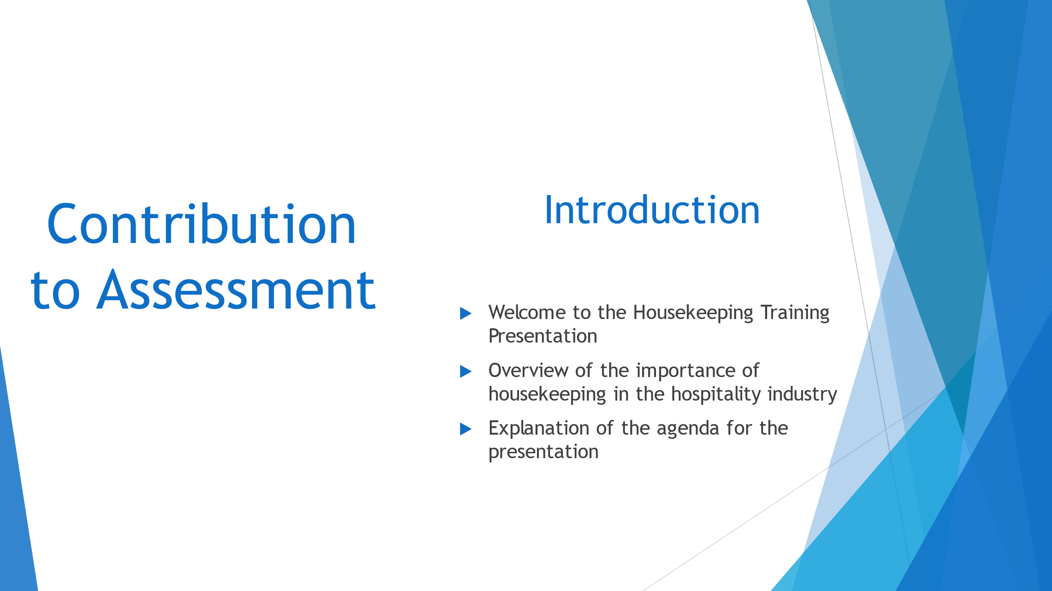

Training Notes:
Slide 1 is the introduction to the Housekeeping Training Presentation. The bullet points for this slide focus on setting the stage for the presentation, establishing learning outcomes, and providing a framework for employee engagement. The training notes should highlight the importance of housekeeping in the hospitality industry, outline the agenda for the presentation, and provide an overview of the topics that will be covered. To engage the team, an employee engagement model should be linked to a best practice industry example, providing a framework for success. Since the presentation will not be delivered by the manager for assessment, it is important to provide clear and concise notes on how the presentation should be delivered, including what should be said and how the information should be presented.

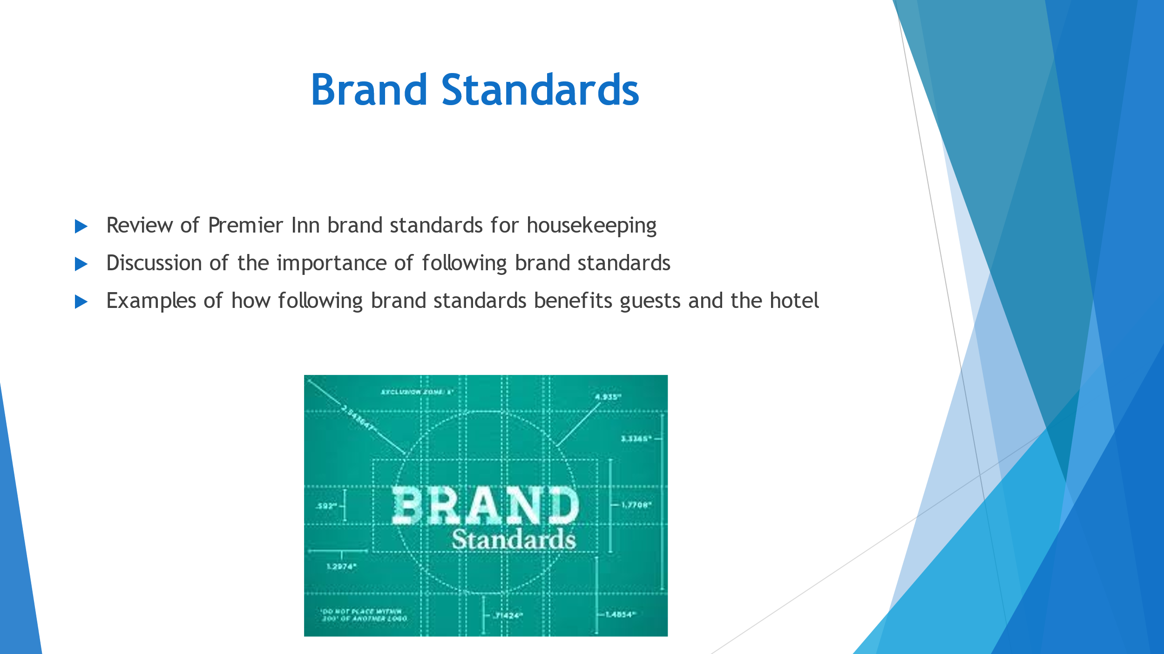

Training Notes:
Slide 2 will focus on the importance of maintaining brand standards in housekeeping. The bullet points for this slide should cover the importance of brand standards to the hotel's reputation, the impact of brand standards on customer satisfaction, and the specific brand standards that the housekeeping team is responsible for upholding. Learning outcomes for this slide should include an understanding of the role of brand standards in the hospitality industry and an appreciation for the importance of consistency in meeting these standards. An employee engagement model such as the RATER model could be linked to a best practice industry example to provide a framework for delivering quality service that meets brand standards (Davis, 2017). The training notes should provide clear and concise guidance on how to present this information to the team, including any visuals or examples that will help to reinforce the key points.

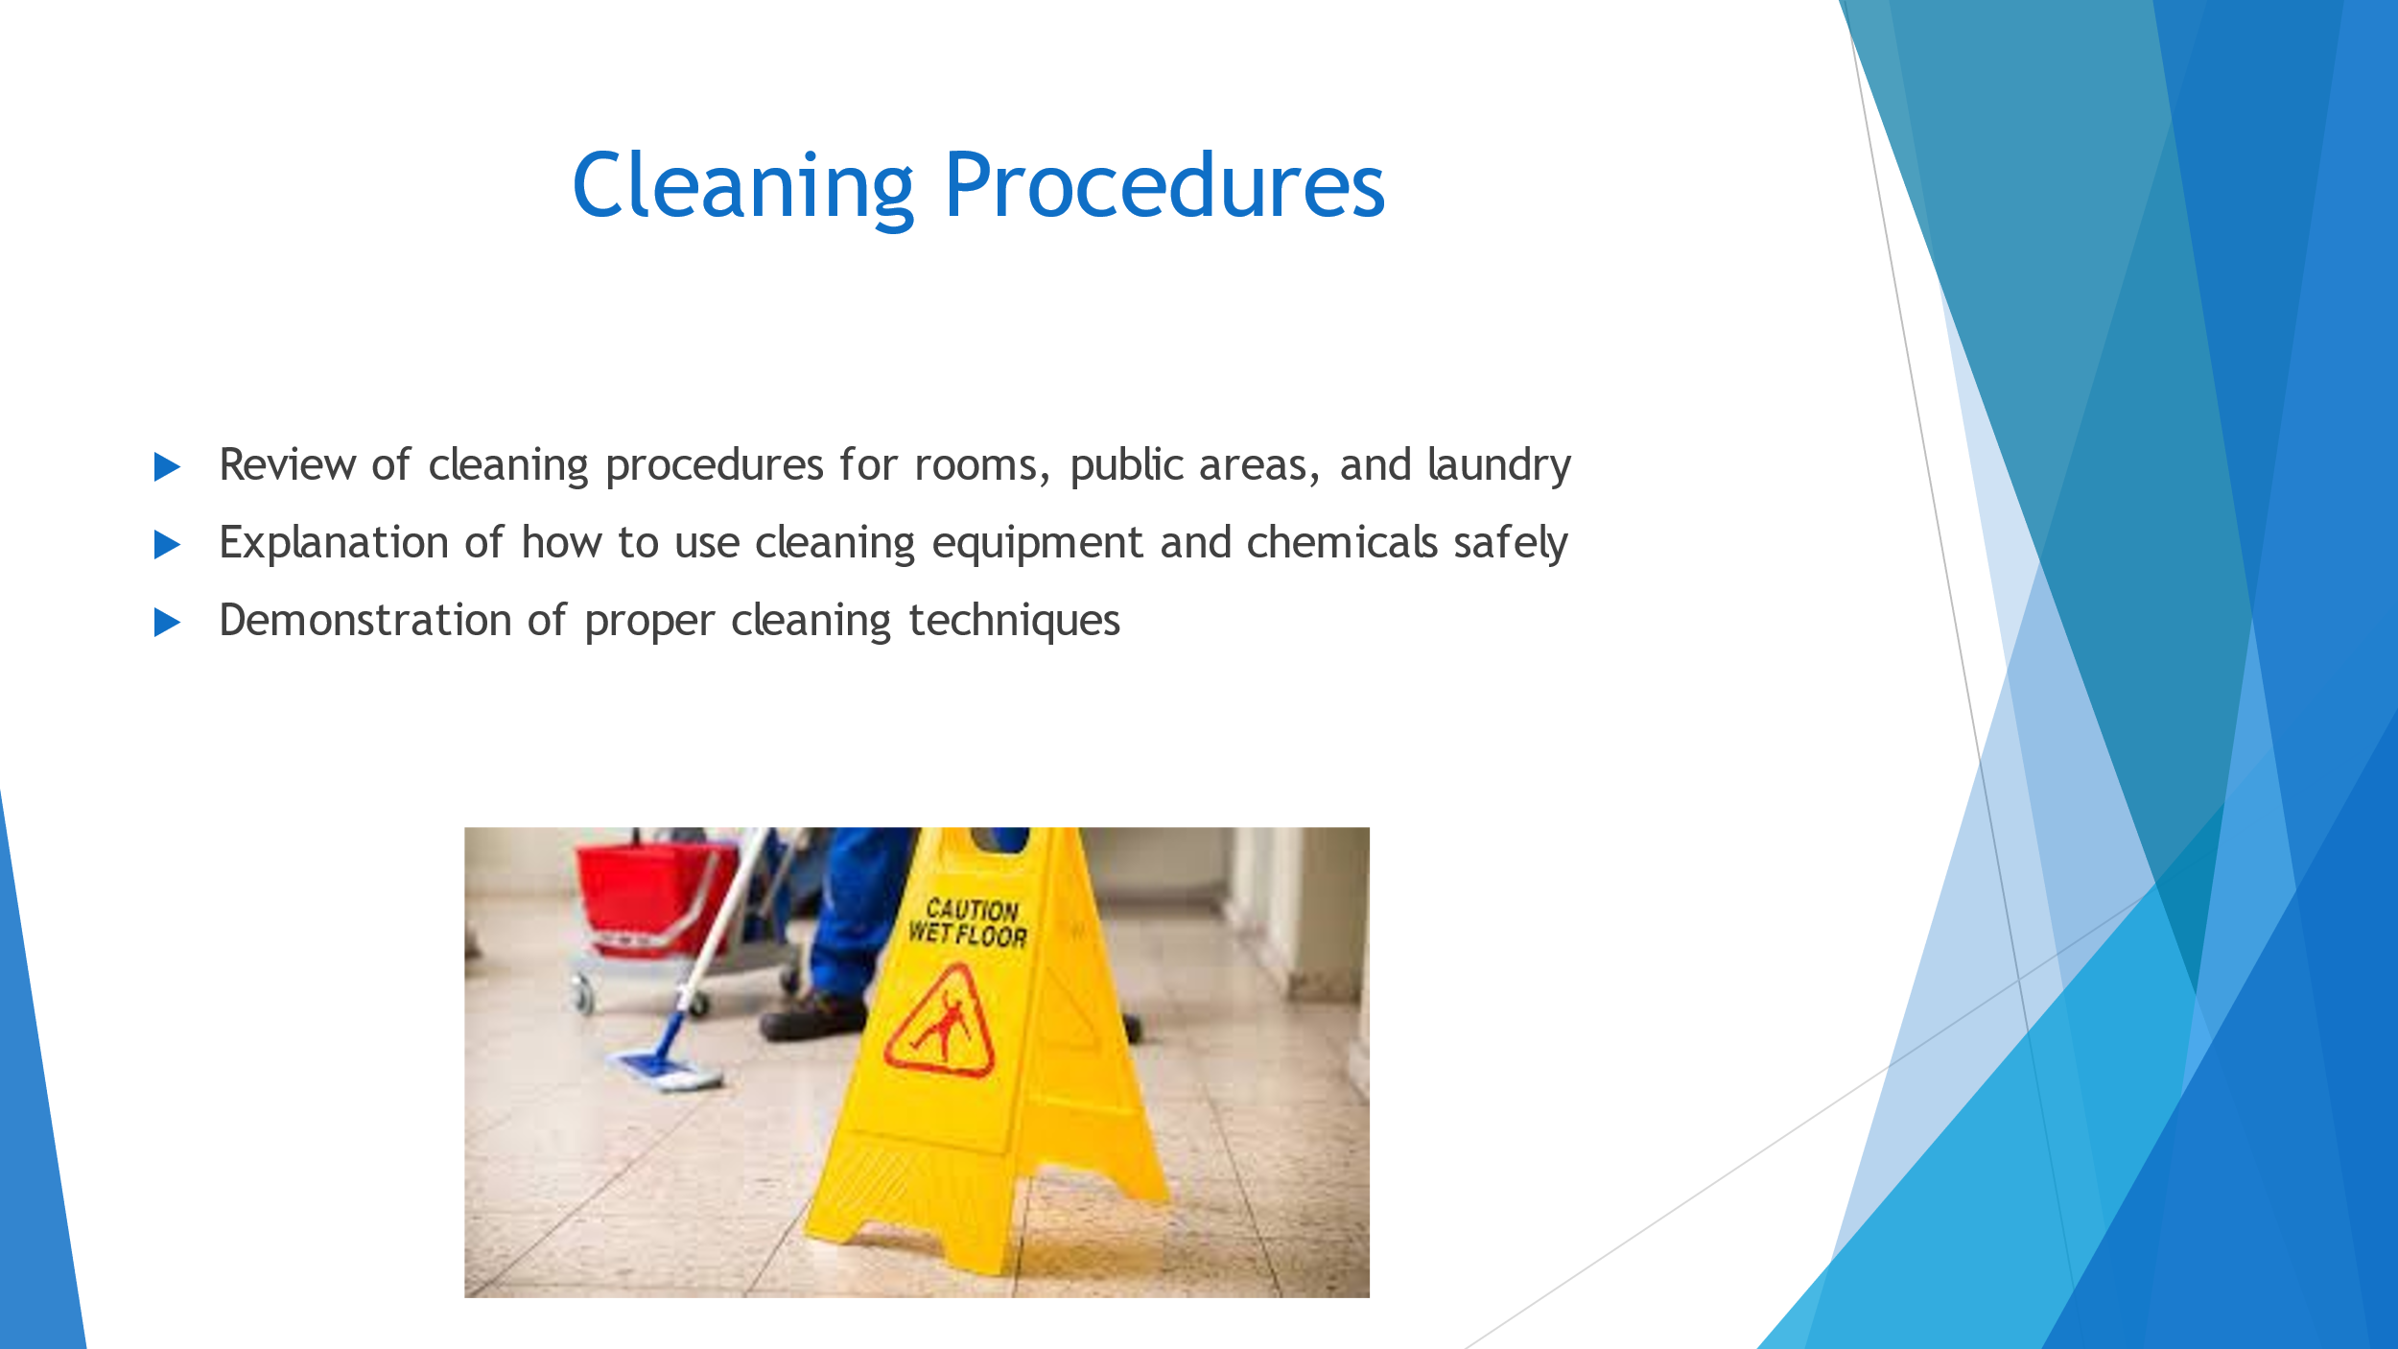

Training Notes:
Slide 3 covers the essential topic of cleaning procedures. During this slide, the presentation will review the cleaning procedures for rooms, public areas, and laundry. It is important to explain how to use cleaning equipment and chemicals safely and demonstrate proper cleaning techniques. The learning outcome for this slide is for the housekeeping team to understand the importance of following proper cleaning procedures to ensure guest satisfaction and safety. The assessment will be based on their ability to identify and follow the correct cleaning procedures. To engage employees, the team leader can link the employee engagement model to a best practice industry example. For instance, the employee engagement model known as the "Gold Standards." This model outlines the importance of delivering excellent service to guests, creating memorable experiences, and developing lasting relationships (Knezevic Cvelbar et al., 2021). By sharing this example, the team can better understand the importance of delivering high-quality service and how it impacts guest satisfaction.
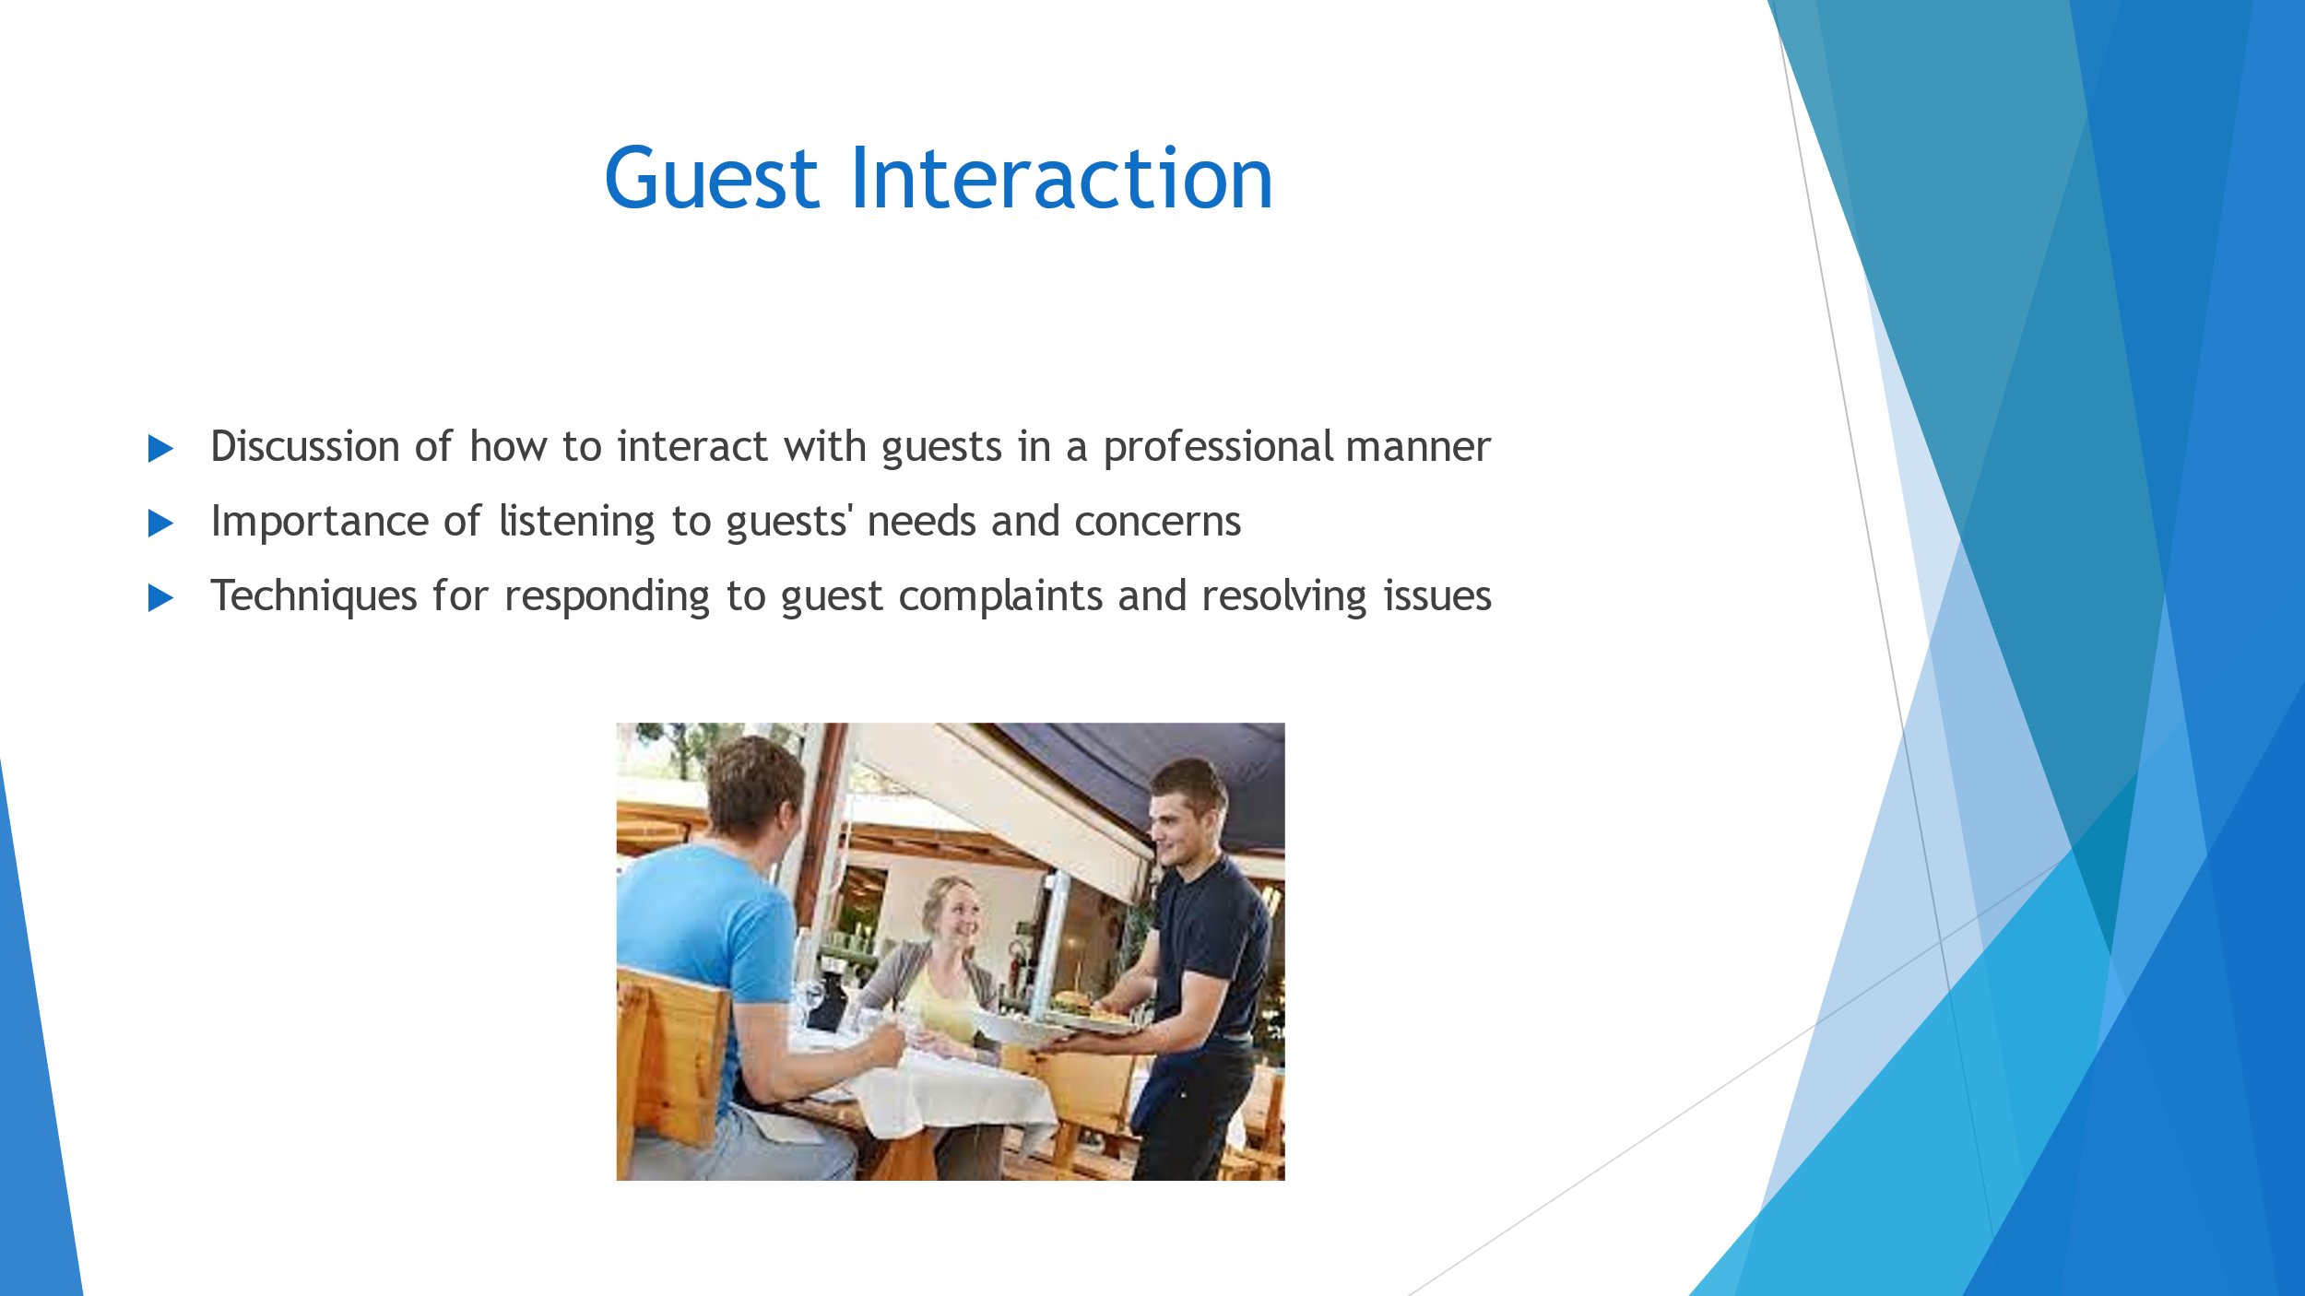

Training Notes:
Slide 4 focuses on the importance of guest interaction. As a housekeeping team member, it's crucial to interact with guests in a professional manner by listening to their needs and concerns. This slide will cover techniques for responding to guest complaints and resolving issues. By mastering these skills, we can ensure that guests are satisfied with their stay, and our brand standards are met. To assess learning outcomes, we will provide case studies and role-playing scenarios to practice responding to guest complaints. Best practice industry examples, such as the "Gold Standards," will be discussed to provide a framework for employee engagement (Bimonte and Punzo, 2016). During the presentation, we will emphasize active listening, empathy, and problem-solving skills when interacting with guests.
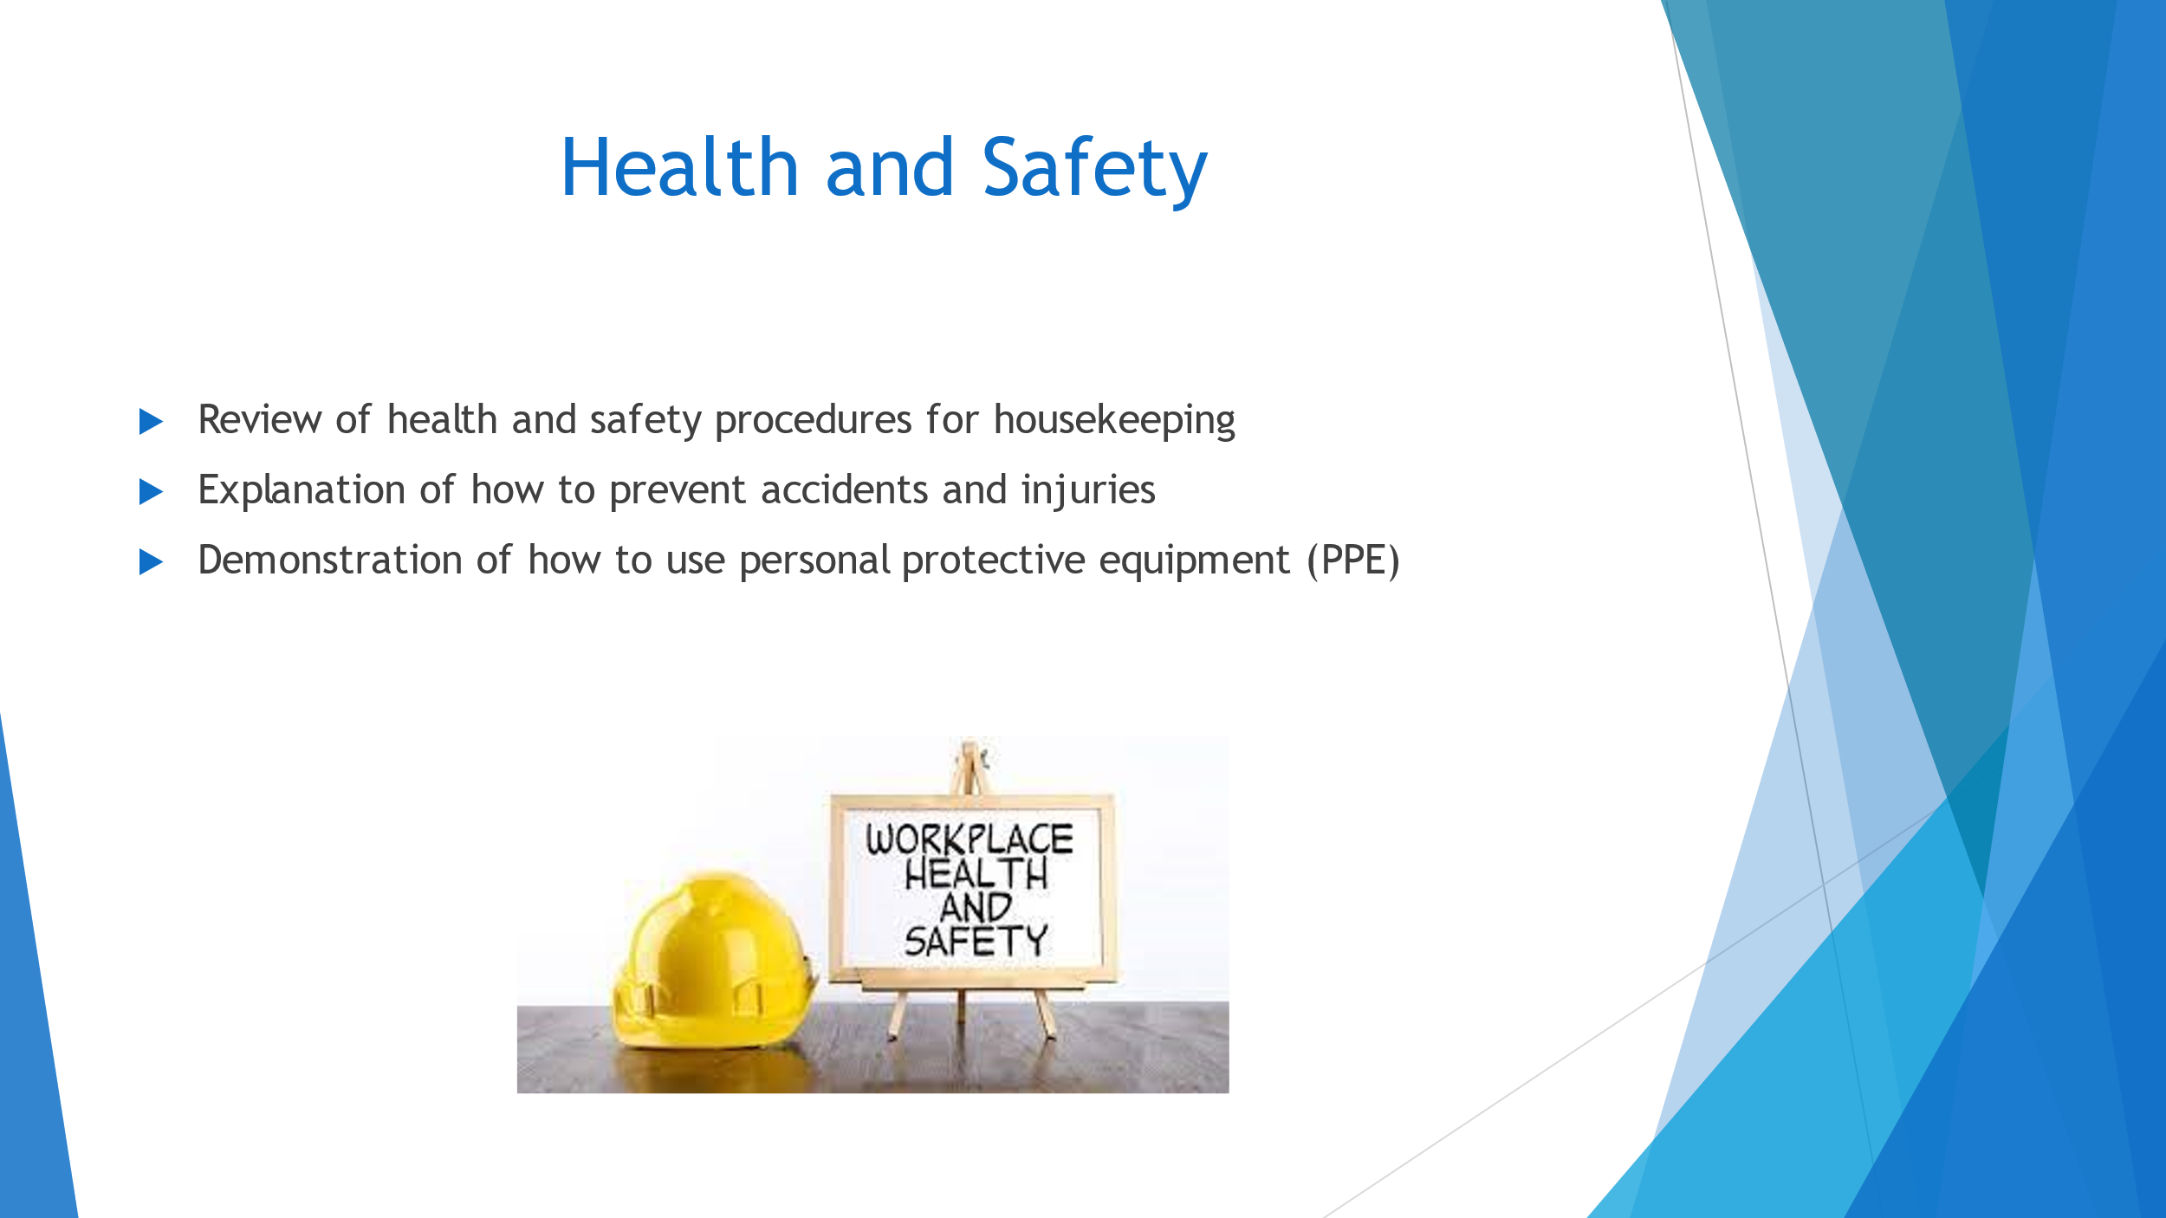

Training Notes:
Slide 5 discusses the importance of health and safety in housekeeping. As a team, we need to ensure that we follow all the necessary health and safety procedures to prevent accidents and injuries. This includes using personal protective equipment (PPE) correctly and consistently. Our goal is to create a safe and healthy environment for ourselves and our guests. To ensure that we are meeting industry standards, we will be reviewing a best practice employee engagement model and incorporating it into our daily routines (Leso et al., 2018). These notes will serve as a guide for the presentation, which will cover the proper use of PPE, accident prevention techniques, and a review of health and safety procedures.

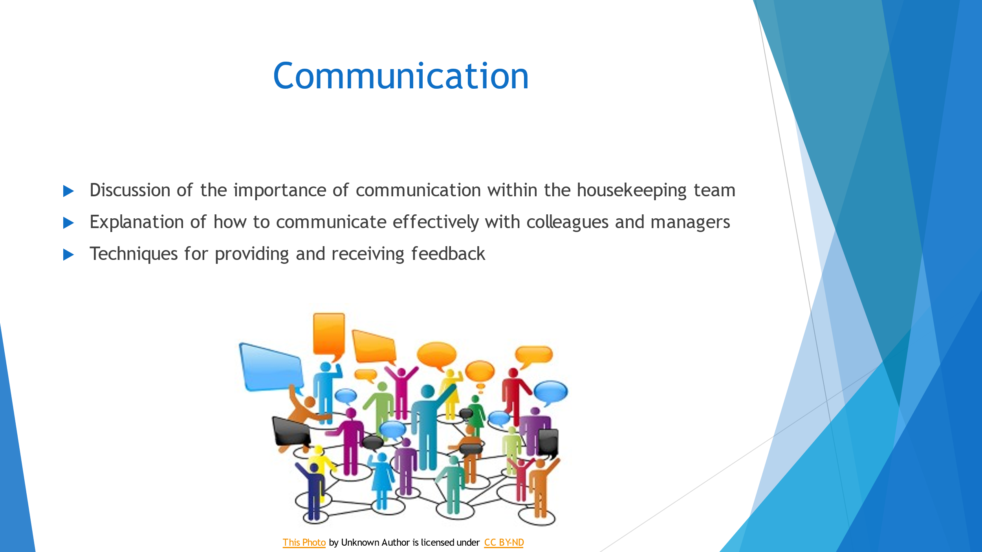

Training Notes:
Slide 6 discusses the importance of communication within the housekeeping team. Effective communication is crucial for ensuring that tasks are completed efficiently and to the required standard. This slide will cover techniques for communicating effectively with colleagues and managers, such as active listening, clear messaging, and the use of appropriate tone and body language. Providing and receiving feedback is also important in improving performance and maintaining a positive working environment. The slide will provide guidance on how to give constructive feedback and receive feedback without becoming defensive. By improving communication within the team, we can achieve our brand standards and ensure that Health and Safety procedures are being followed (Mehrabian, 2017).

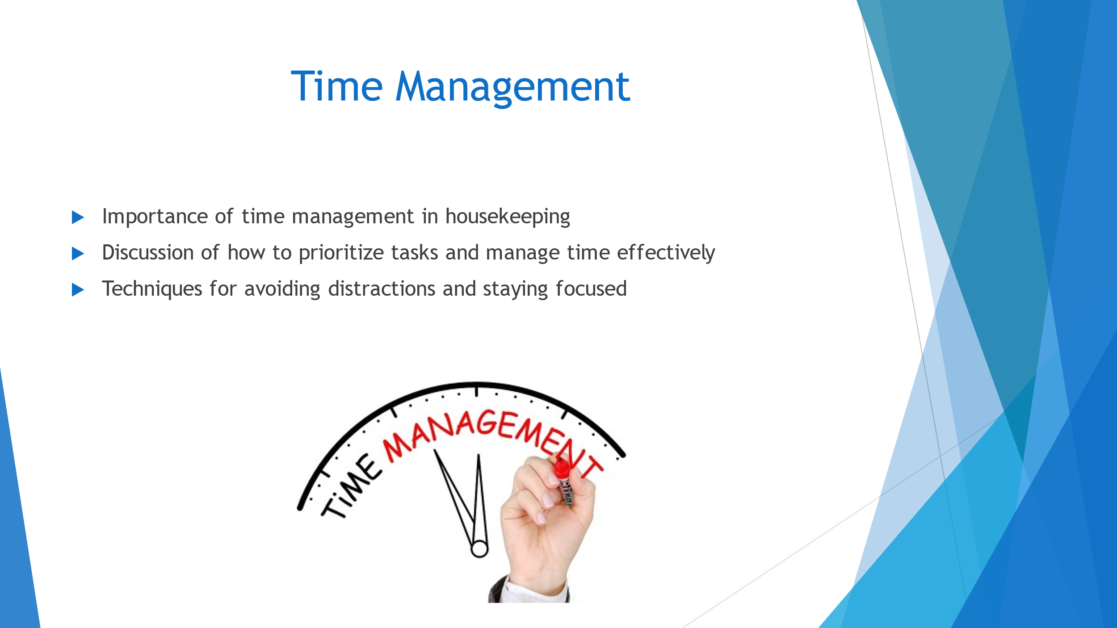

Training Notes:
Slide 7 highlights the importance of time management in housekeeping. Efficient time management is crucial in meeting brand standards and ensuring Health and Safety procedures are followed (Alvarez et al., 2019). The presentation will discuss how to prioritize tasks, manage time effectively, and avoid distractions. Techniques for staying focused will also be presented. To achieve the learning outcomes, an employee engagement model will be linked to a best practice industry example.

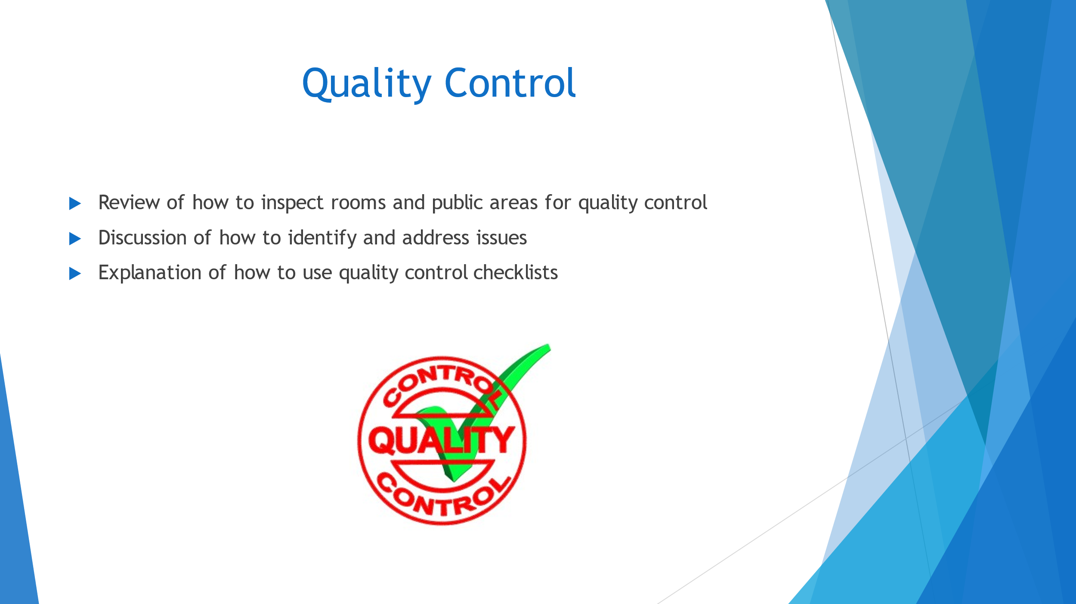

Training Notes:
Slide 8 highlights the importance of quality control in maintaining brand standards and ensuring guest satisfaction. The training will cover how to inspect rooms and public areas, identify and address issues, and use quality control checklists (Husen, 2022). The learning outcomes will include improved attention to detail and a better understanding of the importance of quality control in the housekeeping process. Best practice industry examples will be used to engage employees and provide a framework for the training (Mitra, 2016). The training notes will provide clear instructions for delivery, including what to say and how to assess employee understanding. Ultimately, this training will improve the quality of our housekeeping services and contribute to overall guest satisfaction.

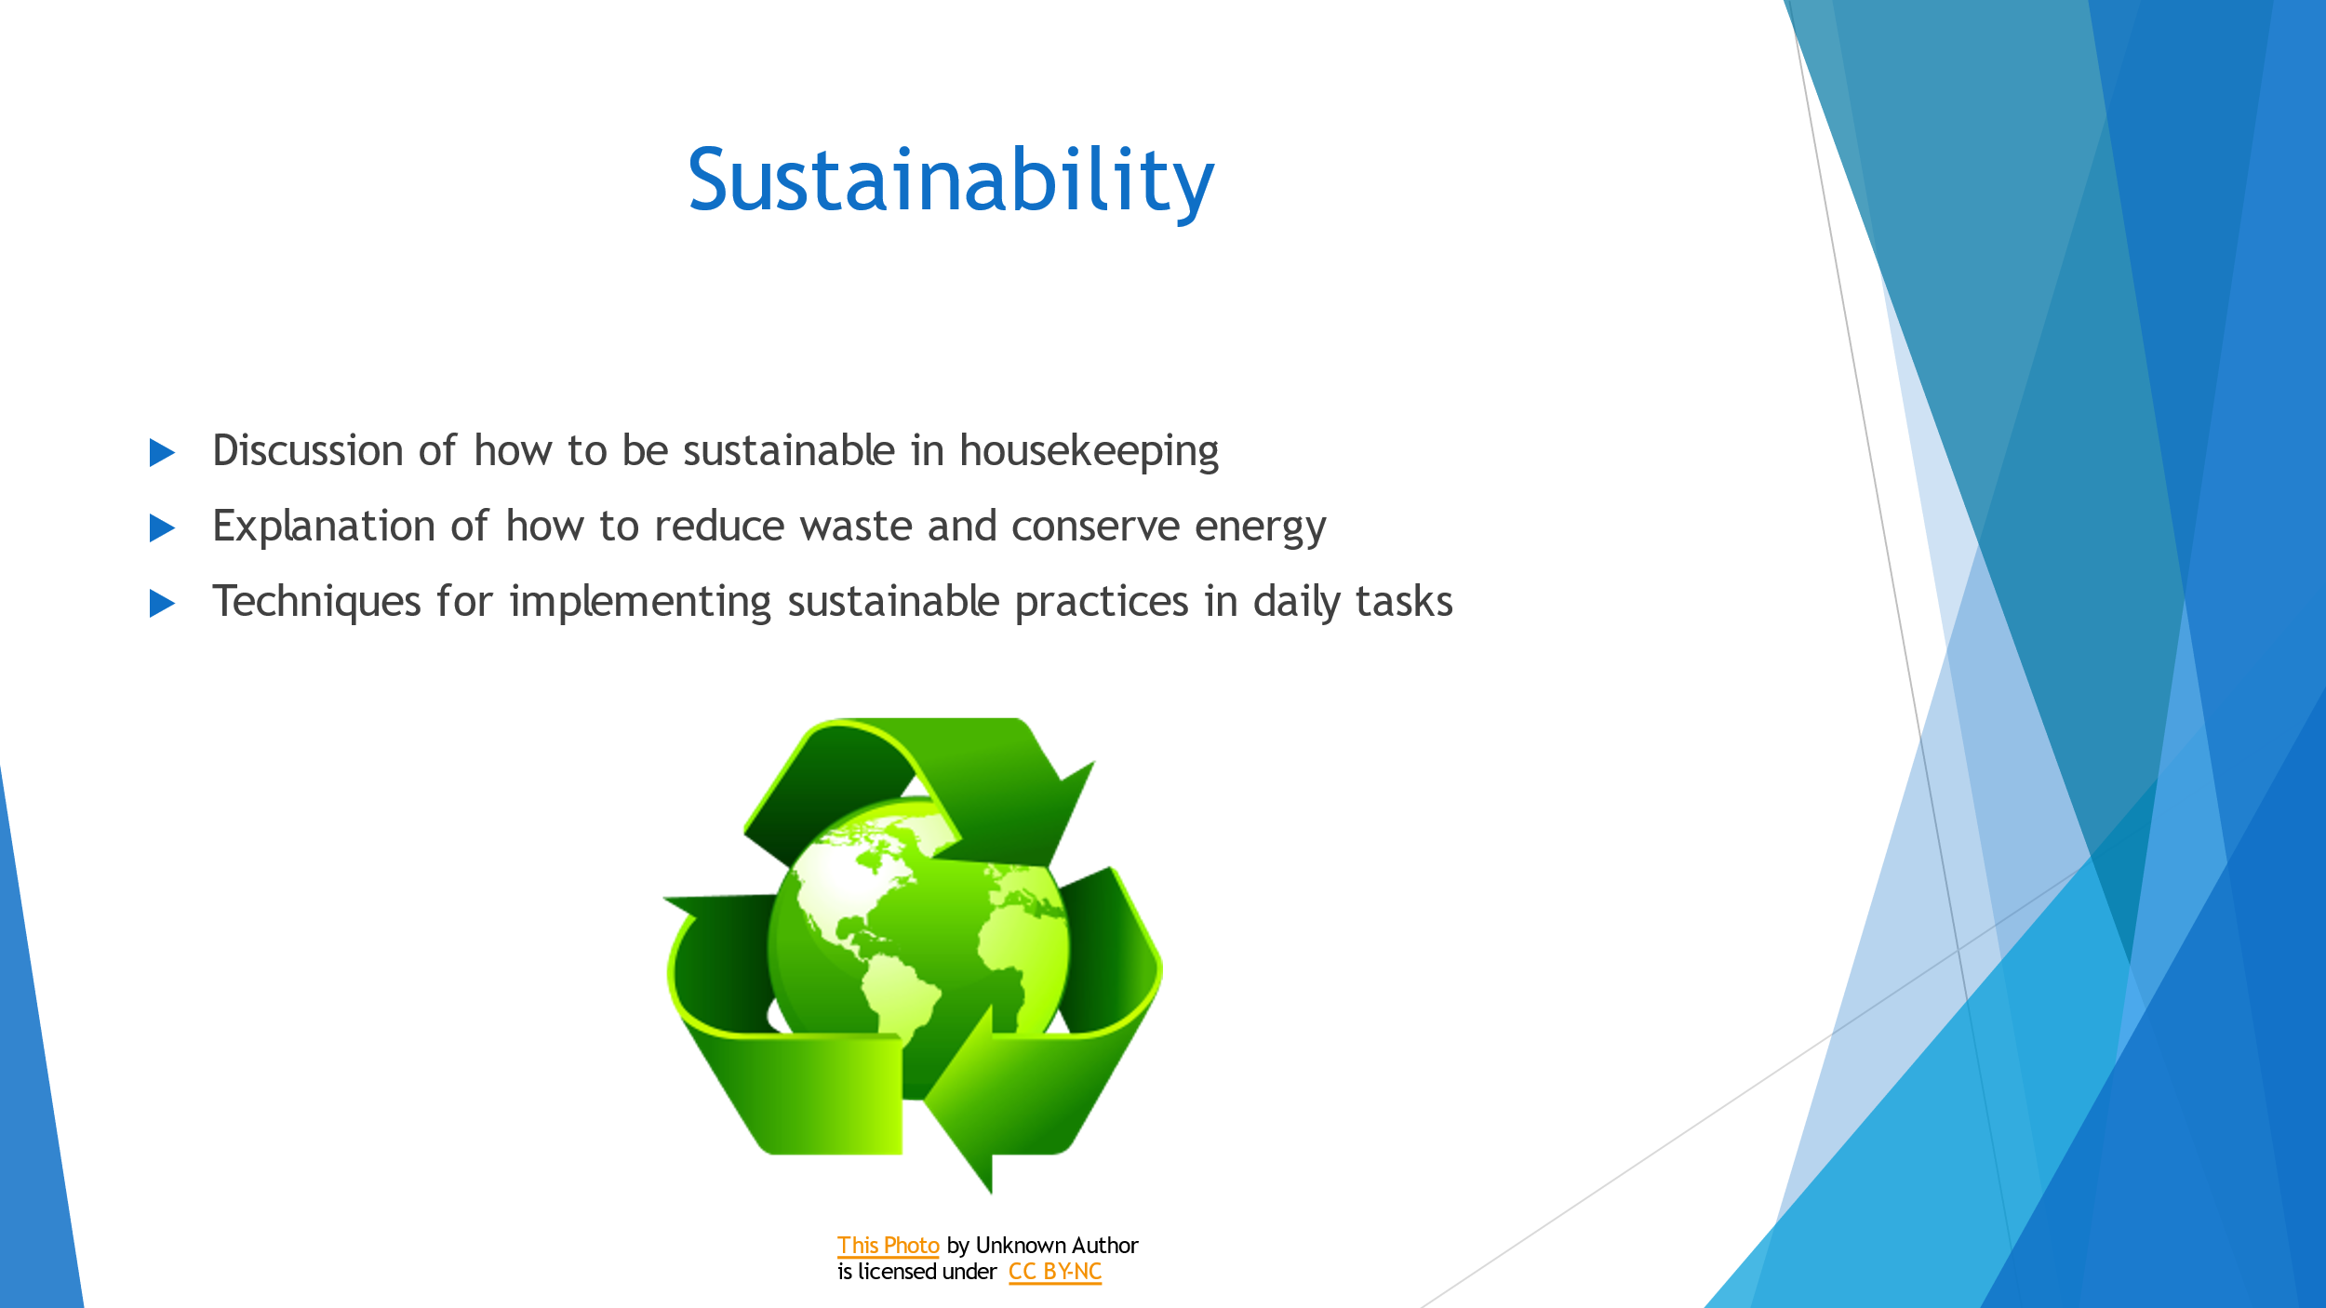

Training Notes:
Slide 9 explores the importance of sustainability in housekeeping. It is crucial to reduce waste and conserve energy to minimize the negative impact on the environment. We can implement sustainable practices in our daily tasks by reducing water usage, properly disposing of hazardous materials, and using eco-friendly cleaning products (Thiele, 2016). By doing so, we not only contribute to a greener future but also align with the brand's values and maintain a positive reputation. To ensure employee engagement, we can use the "Plan-Do-Check-Act" model, which involves planning sustainability initiatives, implementing them, checking their effectiveness, and continuously improving. Best practice examples include "Serve 360" sustainability and social impact platform. This presentation will be delivered with interactive discussions, real-life scenarios, and practical demonstrations.

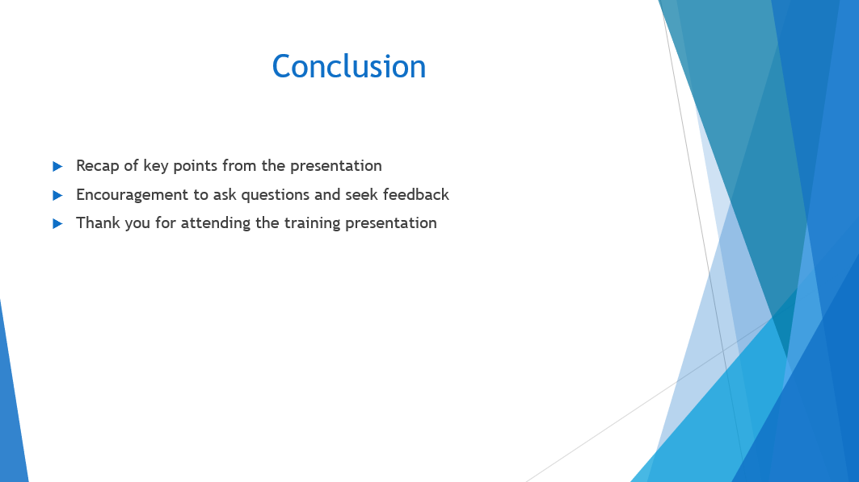

Training Notes:
Slide 10: In conclusion, we have covered key points that will help us improve our housekeeping operations, achieve brand standards, and ensure health and safety compliance. Remember to ask questions and seek feedback to improve your performance. We appreciate your attendance and commitment to improving our team's effectiveness. Please refer to the training notes for further guidance, including learning outcomes and assessment criteria. Let us apply what we have learned to become a best practice team in the hospitality industry, teams who uses their Gold Standards to achieve customer satisfaction and employee engagement. Delivery of this presentation will include interactive discussions, practical demonstrations, and knowledge checks to ensure that the team understands the content. Thank you for your attention and dedication to our team's success.

References
Alvarez Sainz, M., Ferrero, A.M. and Ugidos, A., 2019. Time management: skills to learn and put into practice. Education+ Training, 61(5), pp.635-648.
Batinić, I., 2016. Hotel management and quality of hotel services. Journal of Process Management and New Technologies, 4(1), pp.25-29.
Bimonte, S. and Punzo, L.F., 2016. Tourist development and host–guest interaction: An economic exchange theory. Annals of tourism research, 58, pp.128-139.
Davis, M., 2017. The fundamentals of branding. Bloomsbury Publishing.
Henschel, U.K., Gruner, A. and Von Freyberg, B., 2018. Hotelmanagement. Walter de Gruyter GmbH & Co KG.
Husen, S.N., 2022. Quality control.
Knezevic Cvelbar, L., Grün, B. and Dolnicar, S., 2021. “To clean or not to clean?” Reducing daily routine hotel room cleaning by letting tourists answer this question for themselves. Journal of Travel Research, 60(1), pp.220-229.
Leso, V., Fontana, L. and Iavicoli, I., 2018. The occupational health and safety dimension of Industry 4.0. La Medicina del lavoro, 109(5), p.327.
Mehrabian, A., 2017. Communication without words. In Communication theory (pp. 193-200). Routledge.
Mitra, A., 2016. Fundamentals of quality control and improvement. John Wiley & Sons.
Pathak, A., Snghal, A. and Rana, B.K., 2021, December. Review on hotel management system. In 2021 3rd International Conference on Advances in Computing, Communication Control and Networking (ICAC3N) (pp. 1834-1837). IEEE.
Rutherford, D.G., 2021. Hotel management and operations.
Thiele, L.P., 2016. Sustainability. John Wiley & Sons.
Xu, Y., Zhang, Z., Nicolau, J.L. and Liu, X., 2020. How do hotel managers react to rating fluctuation?. International Journal of Hospitality Management, 89, p.102563.

