
professional career development assessment
BMSW4005

1904937 hisham wareth

Contents
Introduction 2
Main findings 2
Swot analysis 3

Learning styles 5
Vark 6
Honey and mumford 6
kolb's learning cycle……………………………………………………………………..……8
Musus briggs 9
Gomad 10
Conclusion 11
Personal development plan 11
References 12

Introduction

This is a report to explain and state why professional career development is important for career success through the resources that are available and the research I had conducted.

It is important because it assists you to advance in your career and opens you up to new knowledge, new skills and new possibilities moving you into new jobs or positions and ensures you continue to be productive and competent in your profession. This ongoing process continues throughout a professional’s career which delivers benefits to the individual, their teams, their profession and the public. Which in turn means You become more effective in the workplace and the profession you are in.

The main focus and aim of this report is to able to highlight and identify what I need to do to better my personal development and to achieve them by reviewing and reflecting on my learning journey I will go through.

Main findings

Swot analysis

The exact origin of SWOT Analysis has been debated. Some people believe that it originated in the 1950s at Harvard Business School and was the work of professors George Albert Smith Jr and Kenneth Andrews. Others believe it was created by Albert S. Humphrey During his work at the Stanford Research Institute (1960 – 1970), he produced a team method for planning which was named SOFT analysis, this has developed into what we now know as a SWOT analysis. SWOT analysis has become very popular and is one of the most widely used management tool among business managers. it is the examination of yourself or business situation by looking at Strengths, Weaknesses, Opportunities and Threats. The swot analysis can be performed on a product, on a service, a company or even on an individual to identify areas for development, and as part of career discussions.

swot

stands for: -

- S – Strengths are internal, positive attributes of your company or one’s self. things that your organization does particularly well or yourself or in a way that distinguishes you from your competitors. Your strengths are an integral part of your organization these are within your control.
My personal strength I would say would be my time management skills as I have always made sure and insured as best as I can to never late for anything appointments or meeting deadlines as in my personal life and working life this made a big different and what effect a lot of this and cause a chain reaction for the whole day /week

- W – Weaknesses are negative factors that detract from your strengths. These are things that you might need to improve on to be competitive. What tasks do you usually avoid because you don't feel confident doing them.?
This one I have a few this that I would say fall under this section but the worst of biggest and most important is my academic writing and spelling as this is very important for my professional development career

- O – Opportunities are external factors in your business environment that are likely to contribute to your success. A company expansion or acquisition. Do you have specific skills (like a second language) that could help with the process? Which I do have and this is why I am happy to have the ability to be over other as I can speak Arabic and as the middle east is up and coming at a very fast rate and the demand for Arabic speaks increase this will help me stand above the rest if any opportunities arise

- T – Threats are external factors that you have no control over. You may want to consider putting in place contingency plans for dealing them if they occur. What obstacles do you currently face at work or in general?

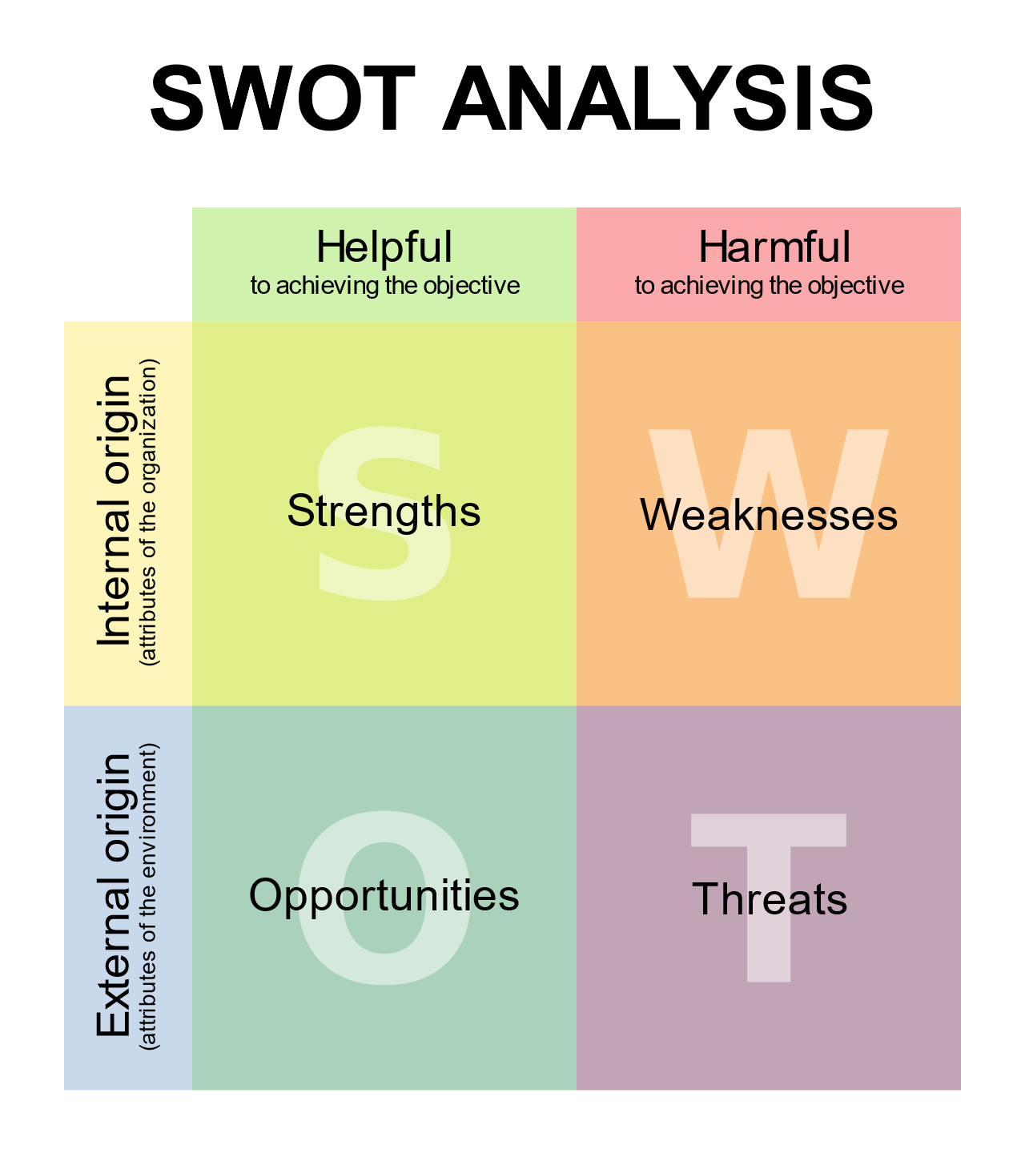

Learning styles

According to a Harvard Business Review article in 2015, there are 5 ways to increase self-awareness:
- Meditate
- Write down your key plans and priorities
- Undertake psychometric tests and profiling
- Ask trusted friends
- Get regular feedback at work

Self-awareness enables us to stand apart and examine even the way we “see” ourselves – our self-paradigm, the most fundamental paradigm of effectiveness. It affects not only our own attitudes and behaviours, but also how we see other people. It becomes our map of the basic nature of mankind.” Stephen Covey, 1999, P.66 -67 it is about focusing your awareness on yourself.
Self-awareness is very important because when we have a better understanding of ourselves as unique and separate individuals. We are then empowered to make changes and to build on our areas of strength as well as identify areas where we would like to make improvements.

Vark
VARK Initially developed in 1987 by Neil Fleming, Christchurch, New Zealand, was the first to systematically present a series of questions with help sheets for students, teachers, employees, customers, suppliers and others to use in their own way
Vark allows you to understand things about you that you did or did not know before, helping to understand your boss, your colleagues, your parents, your workmates, your partner, your customers, your teacher, your relatives, your clients and yourself. It is a short, it has helped people understand each other and assists them to learn more effectively in many situations.
When it comes to vark the questionnaire of 16 questions help you indicate and determine which learning styles suits or works best for you and weather you prefer to learn through: visual, aural, read-write, kinaesthetic or all four.
The results for me I have worked out show my preferred learning style is identified as being
‘Reading/Writing’. This preference is for information displayed as words. Being able to write well and read widely are attributes sought by employers of graduates. This preference emphasizes text-based input and output – reading and writing in all its forms but especially manuals, reports, essays and assignments.
Honey and mumford
Learning styles were developed by Peter Honey and Alan Mumford, based upon the work of Kolb, and they identified four distinct learning styles or preferences: Activist, Theorist; Pragmatist and Reflector. These are the learning approaches that individuals naturally prefer, and they recommend that in order to maximise one's own personal learning each learner ought to:
- understand their learning style
- seek out opportunities to learn using that style

The four learning styles
Activist | Activists are those people who learn by doing. Activists need to get their hands dirty. | - brainstorming  - problem solving  - group discussion  - puzzles  - competitions  role-play
Theorist | These learners like to understand the theory behind the actions. They need models, concepts and facts in order to engage in the learning process. Prefer to analyse and synthesise, | - models  - statistics  - stories  - quotes  - background information  applying theories
Reflector | These people learn by observing and thinking about what happened. prefer to watch from the side-lines. Prefer to stand back and view experiences from a number of different perspectives. | - paired discussions  - self-analysis questionnaires  - personality questionnaires  - time out  - observing activities  - feedback from others  - coaching  interviews
Pragmatist | These people need to be able to see how to put the learning into practice in the real world. Experimenters, trying out new ideas, theories and techniques to see if they work. | - time to think about how to apply learning in reality  - case studies  - problem solving  discussion
From this I worked out that I am a reflector as I like to stand back and try to see and experience things from many different perspectives and by gathering the information myself and then work out my own conclusion. Honey and Mumford point out that there is an association between the learning cycle and learning styles.

Kolb learning cycle
A slightly different perspective on learning also points up the importance of using a variety of learning styles. Kolb and other educational psychologists suggest that effective learning proceeds around a cycle, as shown below.

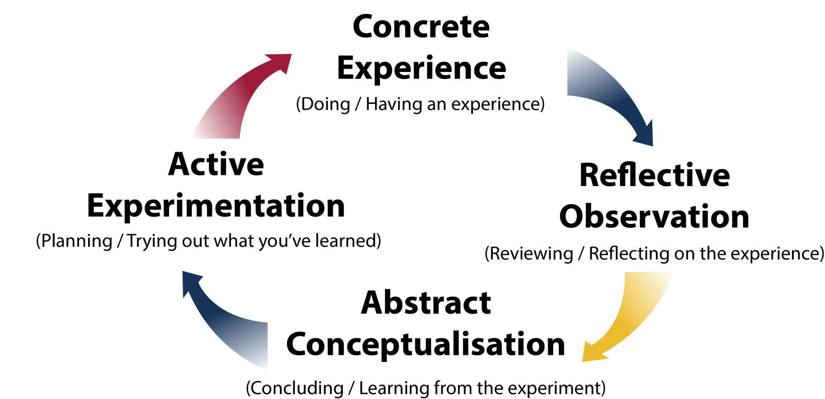

To learn effectively, you need to keep moving around this cycle:
• Experiencing – doing something;
• Reviewing – thinking about what has happened;
• Concluding – drawing some conclusions;
• Planning – deciding what to do in the future.
Completing each stage is important not just for itself, but because it improves learning in the next stage.

MYSER-BRIGGS

The Myers–Briggs Type Indicator (MBTI) is an introspective self-report questionnaire indicating differing psychological preferences in how people perceive the world and make decisions. This was constructed Katharine Cook Briggs and her daughter Isabel Briggs Myers. The MBTI is a theory proposed by Swiss psychiatrist Carl Jung, who had speculated that people experience the world using four principal psychological functions. It is based on 16 personality types, which Jung viewed as stereotypes (Jung 1921, p. 405). They act as useful reference points to understand your unique personality (Jung 1957, p. 304). At the heart of Myers Briggs theory are four preferences.
- (Extraversion or "E") direct your energy to deal with people, things, situations, or "the outer world and (Introversion or "I") prefer to direct your energy to deal with ideas, information, explanations or beliefs, or "the inner world"
- (Sensing or "S") prefer to deal with facts, what you know, to have clarity, or to describe what you see and (Intuition or "N") prefer to deal with ideas, look into the unknown, to generate new possibilities or to anticipate what isn't obvious
- (Thinking or "T") prefer to decide on the basis of objective logic, an analytic and detached approach and (Feeling or "F") prefer to decide using values and basics on what they know and what the believe
- (Judgment or "J") prefer to be planned out and well-structured and (Perception or "P") prefer to go with the flow, to be flexible and respond to things as they happen
Jung also allowed a middle group where you like an equal balance of the two. You combine the letters associated with your preferences to get your Myers Briggs personality type. For example, having preferences for E, S, T and J gives a personality type of ESTJ. Although you have preferences, you still use all eight styles in the same way. The diagram below shows some of the ways to combine them:

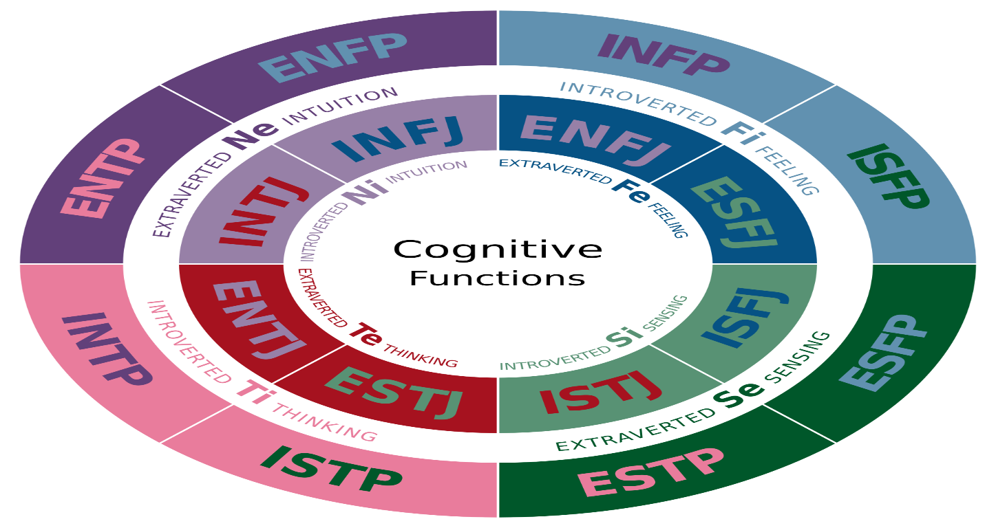
Go mad
Andy Gilbert and Ian Chakrvorty developed the Go Mad frame work System so It can be used at a more- in depth application for large scale changes and business improvement programmes.
The framework can be used at a personal level by applying the 7 key principals to making a difference in your life. Learn how to set yourself personal goals and find the energy and motivation you need to achieve them by focusing on why you want to make a change ,what you need to change and how to go about making the changes, so the Go Mad framework enables you to make significant measurable differences. 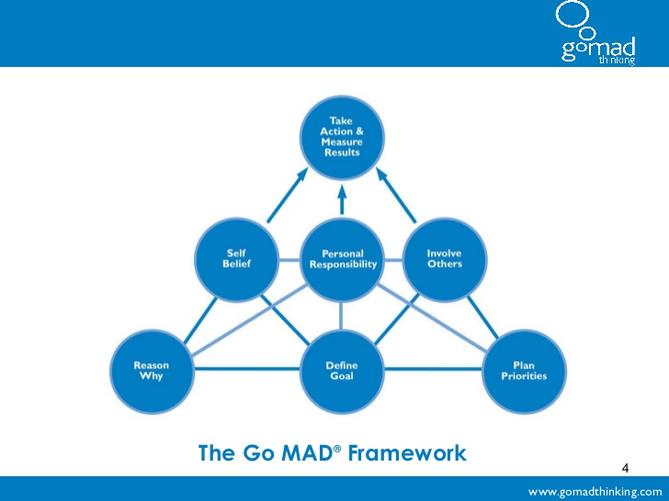

Personal development plan

I have identified my learning styles and preferences that work better for me as they are ‘read/write’ & ‘reflector’ and through the use of a SWOT analysis I have also highlighted my strengths, weaknesses and threats and how to change them into opportunities using SMART goals. The finding from this allows me and enables me to access the suitable learning materials I need to further achieve my knowledge and skills which will help develop my ability to have a better chance on completing any task or issues I may face in the work place or in my personal life, using the SMART objectives I will be able to keep track of my progress and by using Specific, Measurable, Achievable, Realistic, Time Bond actions I will be able to make sure it is completed and achieved with in the time scale I set .

Conclusion
Through this report I have been able to work out, reflect and review my learning journey through personal development. Learn how to set myself effective personal goals and find the motivation I need to achieve them. This is the essence of personal development, a set of skills designed to help you reach your full potential, at work, in study and in your personal life.

References
Anon., 2019. mindtools. [Online]
Available at: https://www.mindtools.com/pages/article/newTMC_05_1.htm
[Accessed 11 november 2019].
Anon., 2019. professinal academy. [Online]
Available at: https://www.professionalacademy.com/blogs-and-advice/marketing-theories---swot-analysis
[Accessed 11 november 2019].
Anon., n.d. verywellmind. [Online]
Available at: https://www.verywellmind.com/the-myers-briggs-type-indicator-2795583
centre, y., 2018. age djgsgsbskfb. [Online]
Available at: https://video123movies.com/watch/gold.html
[Accessed 11 november 2019].

