BSC(Hons)Cloud Computing
ACCC4004
INFORMATION ENGINEERING
Date: 07/05/2020
VERZHINIA ILIEVA
STUDENT ID: 1912496

Entity Relationship Diagram
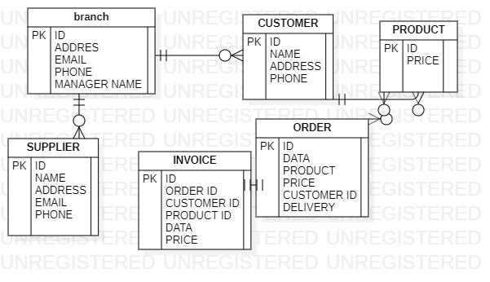

Case diagram
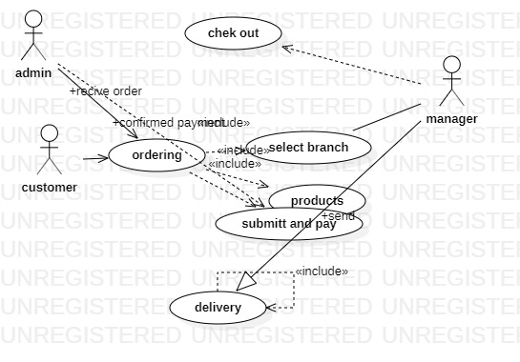
Data flow diagram



