Mohammed Shahidul Islam 1705774
Digital Skills and Research Methods
BMSK4003 Dr Anly Chandra Mohan

Report
Introduction:
In this modern era, digital skills play a huge part in the success of an organisation. More customers are now rejecting the chance to purchase products in store as it is accessible to search and buy products online from home. Organisations use social media as part of a marketing strategy because social media creates brand awareness through their online consumer base (Smith n.d). It is significant that businesses continue to invest in digital marketing because in a rapid ever-changing market, margins are slim which indicates that businesses cannot afford to be left behind through social media. This report will include modern technologies such as: web conferencing, smartphones and tablets which will be compared. In addition, the report will state how various forms of social media such as: Facebook and Twitter will be used as an effective tool for marketing within firms.
Main Body:
Modern Technologies
Two forms of modern technologies will be compared which are: smartphones and tablets. Smartphone is a mobile phone that contains applications which can allow the user to browse the web like a computer and use the phone by touch. Smartphones are now considered as a commodity in most people’s lives. One advantage of smartphones being used in a workplace environment is that people can manage their own schedules (Atkinson n.d). Some people may work in a timed manner when meeting certain deadlines or reaching targets that would be presented in an application on their smart phone. Tracking their schedule at any time could be crucial because if they have missed out on anything then they could refer to their schedule. An additional benefit is that smartphones provides a chance for employees to text other employees or clients which can give an instant response from the other party (Fitzsimons n.d). The recipient is more likely to respond more quickly since there is usually a smartphone with a person. One benefit is that smartphones creates the likely possibility of employees directly contacting their management through their personal smartphone. This reduces the chance of the message being perceived in an unusual way if the message was to be passed on in person for example: a middle man which may alter the message that was first intended to deliver. Employees can use smartphones in the workplace as it shows that they can be trusted to be independent from their employers. If staff bring their personal smartphones to use at the office then the expenditure would be reduced regarding the needs of having a computer at the office. Staff would be more comfortable with their personal smartphone which would keep them satisfied in their role as this could potentially lead to increased motivation therefore an improvement in productivity (Pitichat, 2013).
A tablet is a device that contains similar functions to a smartphone or computer. Tablets are becoming more popular in today’s world because due to its easy accessibility of the features and transportability that it has. There are many functions that a tablet has such as: browse the internet, play games, read books and check email. Tablets come in varied sizes as it can be compared to a size of either a smartphone or a laptop. A sim card isn’t in place for a tablet compared to a smartphone. Touch screen is present within tablets which is also the case for smartphones as it is favourable for the best user experience. One advantage of tablets being used in the workplace is that it is more convenient to take notes during meetings (Sears, 2014). Dropbox makes sure that the notes that are saved will be backed up which can be viewed on other devices as an insurance policy. Another advantage is that the employee can work on a specific project without being in the office by using a tablet. This shows that they can complete tasks from being at home or when on a business trip. Due to its typically larger screen size, it is more effective for when looking over notes for a PowerPoint Presentation that they would have to present to reassure them. One benefit is that tablets for a business is less costly than computers which makes it more appealing for the upper hierarchy to purchase. Tablets are easier to use for the staff and isn’t as complicated so there would be no need for the business to invest in training as they can look to be cost efficient (Marshall, 2013).
Web conferencing is an online service where summits, presentations and training exercises can be held through the internet. This allows people to communicate with each other from separate locations in the world. More users can engage into one seminar or conference by using their webcams. Examples of web conferencing are: Skype and Cisco WebEx. Skype is a free application that people can use to communicate with each other from anywhere in the world. There are premium subscriptions specifically for people in a business field that allows them to set up online summits (Poland n.d). This creates the opportunity for the audience to view a presentation and the other members can assess the ideas that have been opposed. There are two packages offered by Microsoft as the first one is Office 365 Business Essentials which contains a web conferencing of up to 250 people and costs £3.69 per month if a yearly subscription is agreed. The second package is Office 365 Business Premium which for an annual plan is £9.23 per month. Cisco WebEx allows people to create videos that other people can view. The free trial consists of 30 days where a video meeting of up to three people can be setup online. There are three packages which is organised in varied sizes. All the packages allow video conferencing and can be recorded so viewers can replay it at any time. Premium 8 is the first package which is the cheapest and allows up to 8 people for one summit. The costs are £15 per month. Premium 25 is the second package which allows up to 25 people for one meeting and the subscription per month is £30. Premium 100 is the final package offered which contains up to 100 people per meeting and the fee is £49 per month (Nimkoff, 2007). All the packages can be cheaper per month if the individual decides to agree to a yearly subscription in advance. WebEx also offers interactive events and webinars for meetings on a larger scale. The individual would need to contact sales for support so the event can be set up accordingly by an expert. These events can include in between one hundred and three thousand people. For extra customisation, WebEx offers the opportunity to create personalised invitations for selected people. Cisco WebEx offers high definition video calls only if the individual is subscribed for a premium account. However, Skype’s HD video calls is related to the speed of the internet connection and having a premium account has no effect on the quality of the video.
Social Media
A social networking service is an online platform where users can create social relationships and expand networks on various levels such as: career and personal interests. There are diverse types of social media sites such as: Facebook, Twitter, Instagram, Snapchat, Tumblr and WhatsApp. Social media makes it easier for people to communicate online on a global scale as it is readily available through smartphones via apps. Sharing information via social media has become very popular as it is a way of people expressing their interests (Gaitho, 2017). Many people are now reading news via social media sites rather than mainstream news sites such as: Sky and BBC. This is due to people posting breaking news through social media sites that are linked to a specific article. Politics is a topic that is also effected by social media. The recent U.S election winner, Donald Trump used social media effectively as he reached out the public since he spotted the major trends and capitalised by communicating with his followers unlike Hilary Clinton. Social Media has now become a constant use in people’s daily lives for assorted reasons.
Social media is an essential tool for marketing nowadays. Every business should have a social media presence so that they can expand on their marketing strategy towards their audience. For a start-up business, social media allows them to create brand awareness since they are not established. The business can therefore advertise their products and brand towards the public that are interested. Advertising on social media is much cheaper than certain types of media such as: radio, newspapers and television commercials. Businesses can now post images or videos of their products on Facebook, Twitter and Instagram for the public to see. The public can view their opinion on certain products whether they like it or not as this would be useful information for the business to read their comments and make changes if needed. Organisations can check the performance of their social media campaigns by tracking their statistics on analytics. Analytics will provide them significant information such as the specific amount of people has used their hashtag in terms of Twitter. Google Analytics allows the firm to look at the number of clicks and traffic from users towards their social media campaign. The number will determine whether the business would need to make changes or not to intrigue their audience.
Social media can be used as a tool for communication in and out of the workplace. The easily accessible platform of social media allows the organisation to be fully engaged with their employees which would make them feel valued at the company. If the engagement between both parties is constant then there would be no reason for the staff to move away from the company and would continue to be motivated to perform their tasks at hand. Communication wouldn’t be misunderstood at the company since social media is present and there can be internal communication between employers and employees via WhatsApp through their personal smartphones to avoid any mishaps. The use of social media creates the chance of employees receiving feedback online as users can see comments that have been made which can be therefore be judged upon (Martindale, 2016). Employees would expect to receive instant feedback due to many sources of contact being available through social media and whether its praise or constructive criticism, this would encourage employees as the employers are recognising the level of their performance. The possibility of higher empowerment for employees would be strengthened in this case which would help the morale of the staff which is positive for the organisation. Employees that are part of a team which are not in the same location can still communicate with each other due to the wonders of social media. The team members can figure out a time when their schedules allow them to and creates a balance both professionally and personally. One social media platform called Linked In allows the chance for organisations to spread information about specific events that are taking place for employees to hear about. The organisation can make announcements on certain issues that they think might be taking place within their environment to improve matters for employees that could be suffering. Another social media network that is useful for firms is Periscope. Periscope creates the opportunity for people within the organisation to watch specific private broadcasts which can be viewed from all parts of the world (Taurasi, 2015). This is particularly vital when a member within the company is performing a presentation live which can be viewed by other members and can be judged with feedback.

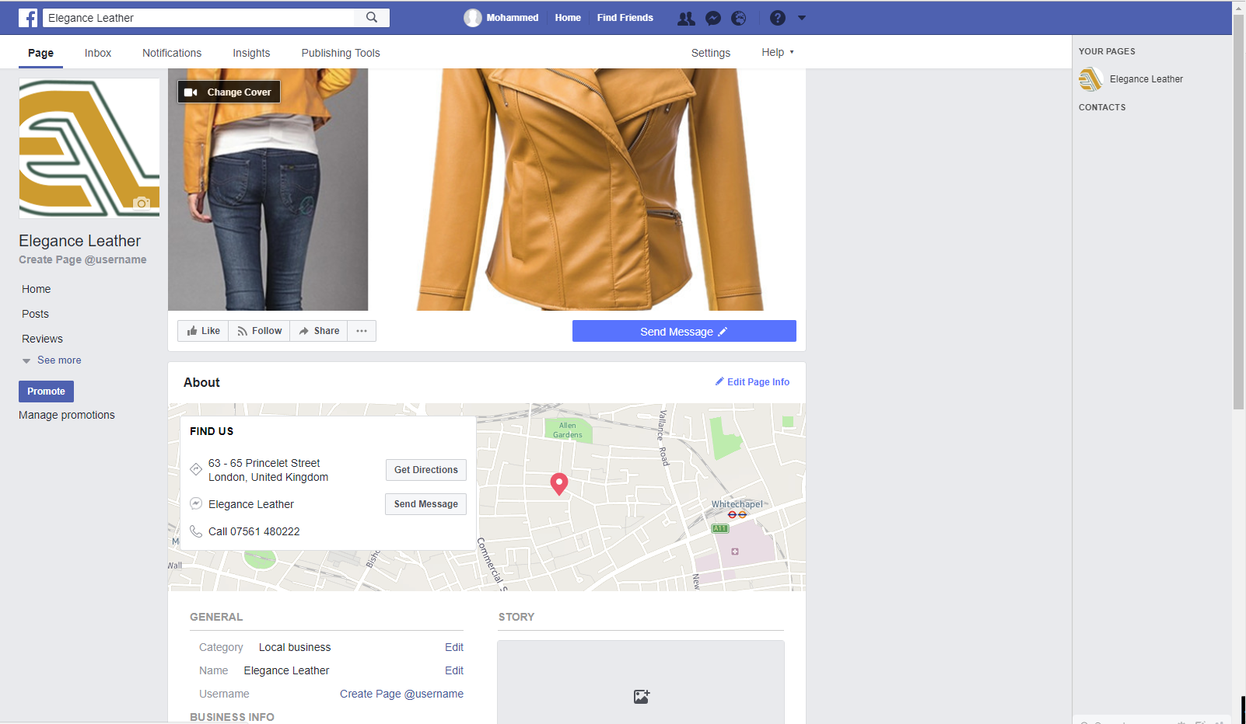

Figure 1 – Evidence of Facebook Business Page
Link: https://www.facebook.com/pg/Elegance-Leather-334080440403737/about/?entry_point=page_edit_dialog&tab=page_info
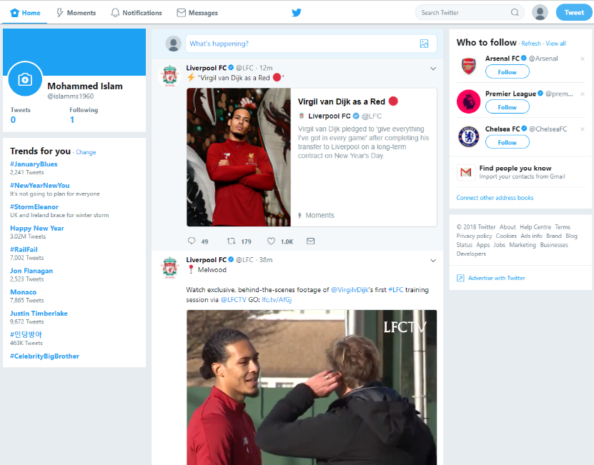

Figure 2 – Evidence of Twitter Account

Conclusion:
In conclusion, firstly there were various forms of modern technologies that were discussed which were web conferencing, smartphones and tablets. The advantages of using smartphones are: being able to manage their own schedules, being able to communicate with employees, employers and clients on a global scale and employers and employees communicating directly through their personal smartphones. Benefits of a tablet are: easier to take notes during meetings, work on a project via tablet which can be done from home or on a business trip and tablets are less costly than computers for an organisation to purchase. Web Conferencing is another form of modern technology and the examples are Skype and Cisco WebEx. Both examples allow users to arrange meetings worldwide. Skype’s packages are considerably cheaper than Cisco WebEx however doesn’t contain as much features. Social Media is vital for businesses to use because brand awareness can be expanded from a social media campaign. Communication within and out of the workplace can be performed through social media. Feedback can be received through online comments made via social networks which can be beneficial for employees to make improvements when constructive criticism is made. Businesses must look to continue their marketing campaigns through social media if they wish to be relevant in today’s business world which is heavily invested in technology nowadays.

Reference List:
Atkinson, M n.d., 6 Reasons Employers Should Allow Smartphones in the Workplace. Available at: https://www.agencycentral.co.uk/articles/2016-09/allowing-smartphones-in-the-workplace.htm
Fitzsimons, K n.d., Workplace Productivity in an Era of Smartphones. Available at: http://www.corporatewellnessmagazine.com/column/workplace-productivity-in-an-era-of-smartphones/
Gaitho, M. (2017). What is the real impact of social media? Available at: https://www.simplilearn.com/real-impact-social-media-article (Accessed at December 13, 2017)
Marshall, G. (2013). Tablets: what are the business advantages? Available at: http://www.techradar.com/news/mobile-computing/tablets/tablets-what-are-the-business-advantages-1192794 (Accessed at October 23, 2013)
Martindale, N. (2016). Social media and communication tools to win over staff. Available at: https://www.raconteur.net/business/social-media-and-communication-tools-to-win-over-staff (Accessed at May 12, 2016)
Nimkoff, L. (2007), Net connection. Journal of Property Management. 72(5), p14.
Pitichat, T. (2013), Smartphones in the workplace: Changing organizational behavior, transforming the future. A Journal of Transdisciplinary Writing and Research from Claremont Graduate University. 3(1).
Poland, A n.d., WebEx vs Skype. Available at: http://smallbusiness.chron.com/webex-vs-skype-76983.html
Sears, A. (2014). 4 Practical Benefits of Tablets for Work. Available at: https://www.business.org/it/hardware/practical-benefits-tablets-work/ (Accessed at March 12, 2014)
Smith, S n.d., Why your organisation needs digital skills training. Available at: https://digitalmarketinginstitute.com/blog/why-your-organization-needs-digital-skills-training
Taurasi, L. (2015). 7 Ways to Use Social Media for Employee Communications. Available at: http://workplace.care.com/7-ways-to-use-social-media-for-employee-communications (Accessed at July 06, 2015)

