

School of Hospitality and Tourism Management
BA International Hotel Management
Module Handbook
BMIH5007
Financial Management for the Hotel Industry LEVEL 5

Trandafir Loredana-Mihaela
Student number : 2119482
Module title: Financial Management for the Hotel Industry
Lecture name: Christopher Wilkin

Contents
Summary for Management 3
Introduction 3
Total Revenue 3
Market Position 5
The potential for growth 8
Commitment of Financial Resources to CSR 11
Recommendations 12
Conclusion 13
Reference 14

Summary for Management
This assignment will compare and contrast how Marriott International and Accor International handle their finances. The overall revenue, market position, the potential for growth, and Commitment of Financial Resources to CSR are some of the aspects of financial management that are investigated in this research. The paper conducts an in-depth analysis of the two firms' financial management procedures, emphasising both of those organisations' strong and weak points. The report also includes suggestions tailored to each organisation, each of which are determined by the method used to financial management.

Introduction
Management of finances is a vital component of every effective organisation, as well as the hotel segment is no compromise. It is essential for businesses to have efficient practises for financial management in order to assure their continued success over the long run. This research examines the different approaches to financial management used by Marriott International and Accor International, two of the most prominent companies in the hospitality industry. The research investigates a variety of facets of monetary supervision, including total returns, marketplace situation, development prospective, and fiscal assurance to CSR.

Total Revenue
A company's total revenue is the sum of all of the money it made during a certain time period through the sale of its products or services (Zietlow et al. 2018). This figure is expressed as a percentage of the company's total revenue. It is a crucial financial indicator that represents the capacity of a business to create money and maintain its operations over time. The total revenue of a firm is an important indicator for investors and other stakeholders since it offers insight into the overall financial health and performance of the organisation. Investors are able to more accurately evaluate a company's capacity to earn money and pay its financial commitments using this information. It is found on the income statement and is arrived at by multiplying the total amount of units sold by the selling price per unit. When assessing a company's overall health and financial success, investors and other stakeholders place a significant amount of weight on the company's total revenue.
The overall income of a company, especially those in the hospitality sector, is an essential indicator to track. In the year 2021, overall revenue for Marriott International was estimated at 10.6 billion dollars, while total revenue for Accor International was estimated at 3.14 billion dollars (Karam et al. 2018). It is obvious that Marriott International has substantially bigger total revenue than Accor International, showing that it has a more considerable position in the worldwide hospitality business. This is shown by the fact that Marriott International has a significantly higher market share. This is shown by the fact that Marriott International is present in over 140 countries, but Accor International is present in just 110 countries (Cirillo & Valencia, 2019).
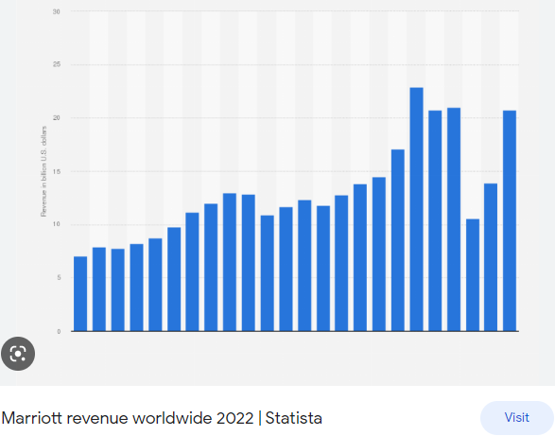
Figure: 1: Marriot International’s revenue 2022
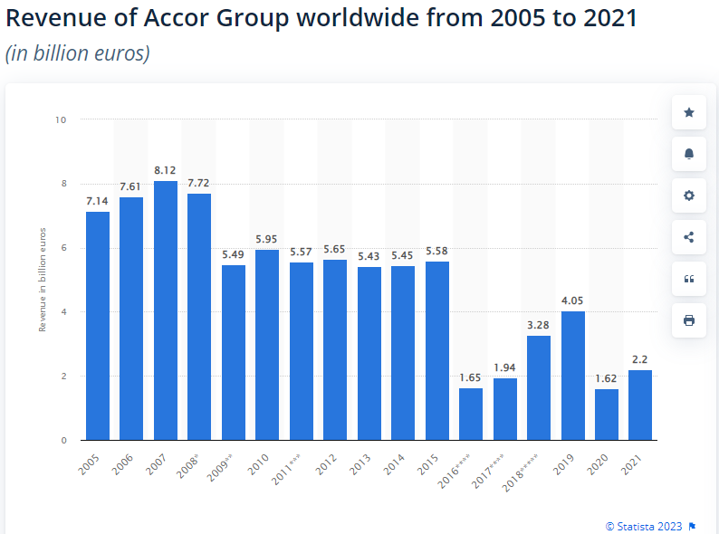
Figure: 2: Accor International’s revenue from 2005 to 2021

Market Position
The status of a corporation in the marketplace in comparison to that of its rivals is referred to as its market position (Brigham & Houston, 2021). The marketplaces in which hospitality organisations often operate are notoriously cutthroat. These markets have a large number of different hotels, resorts, restaurants, and other types of hospitality enterprises all struggling for the attention of the same clients. These companies have to find a number of strategies to set themselves apart from their competitors if they want to succeed in the marketplace and keep their dominant position.
One strategy that businesses in the hospitality industry may use to distinguish themselves from their competitors is to provide experiences or services that cannot be found anywhere else. For instance, a hotel may provide luxurious facilities such as a spa or fitness centre, or a restaurant may specialise in a specific style of food that is not often seen in the region. Both of these examples are examples of businesses that want to differentiate themselves from the competition. Establishing a powerful position in the market can also be accomplished by organisations in the hospitality industry by cultivating a client base that is devoted to the brand as a result of outstanding service and high levels of customer satisfaction. This may be accomplished by regularly delivering high-quality goods and services, reacting quickly and effectively to customer concerns, and providing incentives, such as rewards or loyalty programmes, to attract customers to return and do business with the company again. Location is another factor that may have a big impact on the market position of a hospitality organisation. A hotel or restaurant may develop a better market position and attract more customers by positioning itself in a prominent location that provides easy access to a variety of facilities, including attractions, transportation, and other conveniences.
Last but not least, the reputation of a hospitality company is another component that may be critical to its place in the market. A good reputation for quality, service, and value may assist a firm bring in new customers and keep the ones it already has, while a poor reputation can hurt a business's capacity to compete in the market and drive away current consumers.
Another essential component of effective financial management is having a strong presence in the market. There are approximately 30 different hotel brands that fall under the umbrella of Marriott International, which makes it the world's biggest hotel network (Wessel et al. 2021). It has been able to successfully use its brand in order to grow into new areas thanks to its substantial position in the luxury hotel class. Accor International, on the other hand, is the world's sixth-largest hotel chain despite having a brand portfolio that is far less than that of Marriott International (Ertuna & Yu, 2022).. In order to increase its market share, the company has mostly concentrated on growing its presence in developing areas such as Asia and Africa.
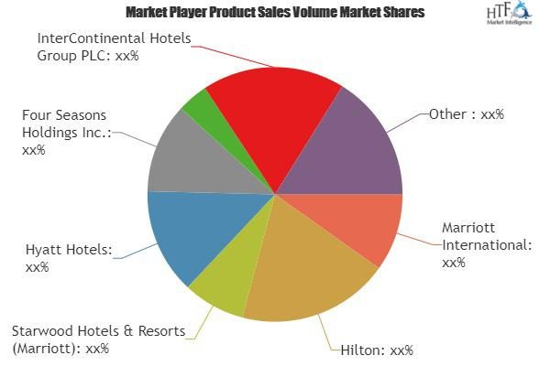
Figure: 3 Marriot International’s market position 2023

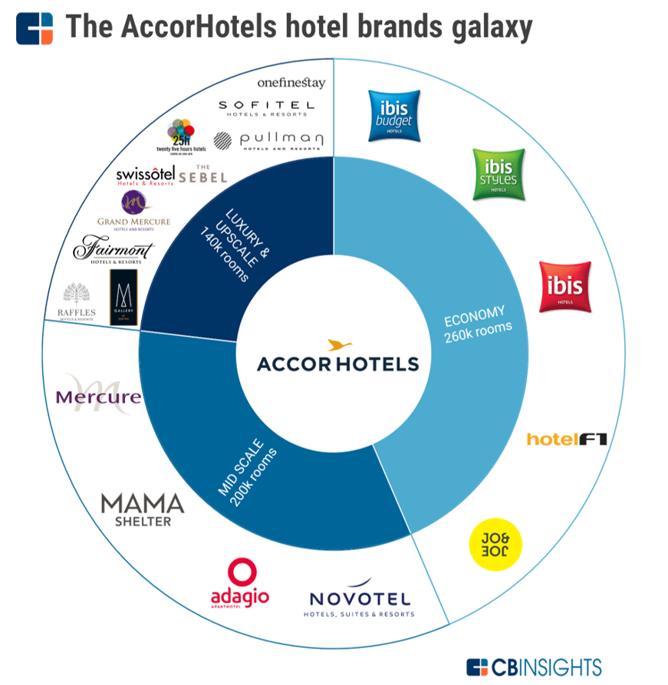
Figure: 4: Figure: 3 Accor International’s market position 2023

The potential for growth
The capacity for expansion is essential to the continued success of hospitality organisations. Because there is more competition in the industry now than ever before, and because customer tastes are always shifting, businesses in the hospitality sector need to keep growing and adapting in order to satisfy the requirements of their clientele (Nga, 2020). The following are some of the reasons why it is essential for organisations in the hospitality industry to have development potential:

Increased revenue: Hospitality companies that have growth potential are able to broaden their range of services and so increase the number of revenue streams they generate (Onoufriou, 2020). Hospitality firms have the potential to boost their revenue by increasing the number of clients they serve by expanding their range of services and amenities. This revenue can then be invested back into the organisation, which will allow for continued expansion and development of the organisation.
Enhanced reputation: Hospitality firms that have tremendous development potential and a reputation for delivering high-quality service can attract more consumers and position themselves as a top choice in their respective markets if they have a good reputation in the industry. In the long run, this could contribute to increased customer loyalty and a better reputation for the company.

Edge in the marketplace: Businesses in the hospitality sector that are committed to sustained growth and innovation have the potential to achieve a competitive edge over other organisations operating within the sector. This has the potential to assist businesses in attracting a greater number of visitors and maintaining their position as the most desirable option for hospitality services in their target market.
In conclusion, the possibility for expansion is essential for the success and longevity of organisations in the hospitality industry. It enables them to broaden the scope of their products, raise the amount of revenue they bring in, increase the level of satisfaction their customers feel they receive, enhance their reputation, gain a competitive advantage, and maintain their flexibility in the face of shifting preferences held by consumers and situations in the market. As a consequence of this, businesses related to hospitality need to place a high priority on growth potential and engage in strategies and activities that encourage it.
Both Marriott International and Accor International take distinctive approaches to the growth potential of their respective businesses, which is a crucial component of effective financial management. The Marriott International brand is internationally known, and the company has been concentrating on growing its footprint in developing countries in recent years (Sanvitale, 2020). In addition to this, it has expanded its brand portfolio via the use of a number of strategic acquisitions, one of which being Starwood Hotels and Resorts. Accor International, on the other hand, has placed a strong emphasis on expanding the breadth of its brand portfolio in order to appeal to a larger variety of consumers. In addition to this, it has been concentrating on increasing its footprint in the budget and mid-scale hotel markets, both of which offer tremendous untapped growth potential.

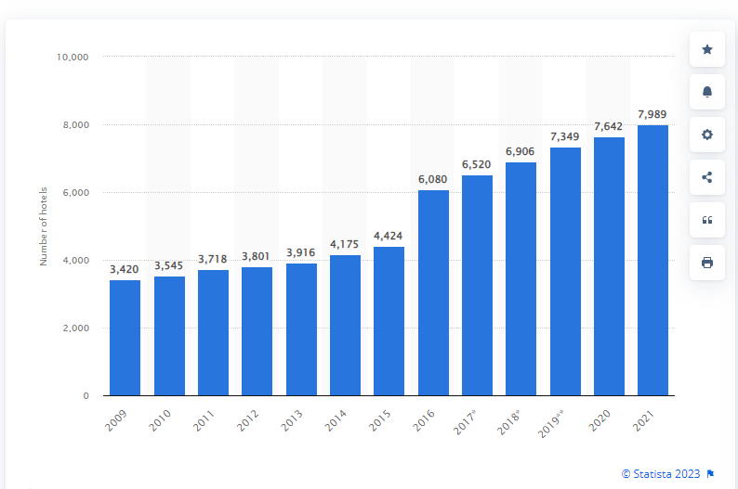
Figure: 5: market growth for Marriot International
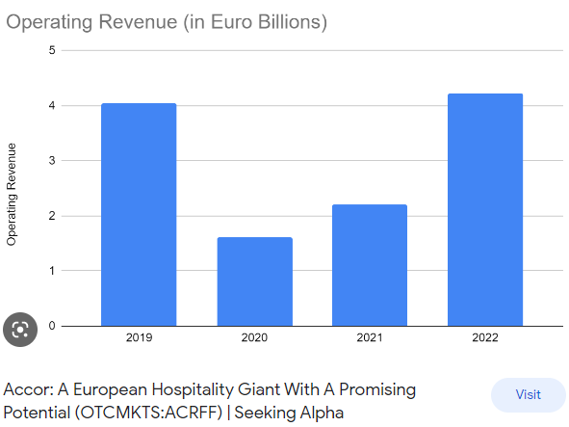
Figure: 6: market growth for Accor International

Commitment of Financial Resources to CSR
The allocation of financial resources towards programmes that are congruent with an organization's values and objectives is one approach for hospitality organisations to demonstrate their commitment to corporate social responsibility (CSR) (Bae et al. 2021). This can include programmes that encourage environmentally responsible tourism, provide assistance to local communities, cut down on waste and energy usage, and increase the well-being of employees.
When businesses in the hospitality industry devote financial resources to corporate social responsibility (CSR), they not only help the communities they are a part of, but also their own reputations and bottom lines. Hospitality businesses have the opportunity to cultivate trust and loyalty among their customers, employees, investors, and regulators by providing evidence that they are committed to practising social responsibility. Additionally, corporate social responsibility (CSR) activities can result in cost reductions and an increase in operational efficiency, as well as a gain in revenue and market share by recruiting consumers and partners that are socially conscious.
Nevertheless, it is essential for businesses involved in the hospitality industry to make certain that their CSR efforts are in line with their overarching strategic goals and are carried out in a way that is both transparent and accountable (Shin et al. 2021). They should develop crystal clear goals and metrics for measuring the impact of their corporate social responsibility programmes, and they should periodically report on their progress to the stakeholders who are interested in the matter.
A robust corporate social responsibility (CSR) programme that places an emphasis on diversity and inclusion, community participation, and sustainability is in place at Marriott International (Nga, 2020). In contrast, Accor International has a relatively young CSR programme that focuses on minimising the company's negative effect on the environment, fostering an inclusive and diverse workplace, and providing assistance to the communities in which it operates. However, in comparison to Marriott International's, their CSR programme is not nearly as well-established.

Recommendations

The following suggestions are offered on the basis of an examination of the methods used by Marriott International and Accor International in the administration of their respective financial resources:
In the case of Marriott International, the corporation need to keep working towards expanding its footprint in developing regions while also continuing to place an emphasis on environmental stewardship and corporate social responsibility (CSR). It should also give some thought to expanding the breadth of its brand portfolio in order to appeal to a larger variety of consumers.
In the case of Accor International, the corporation should prioritise extending its footprint in the budget and mid-scale hotel categories, both of which offer great potential for expansion. In addition to this, it should maintain its emphasis on sustainability and corporate social responsibility (CSR) and set loftier goals to lessen the damage it does to the environment.

Conclusion
In summary, both Marriott International and Accor International have considerable market positions, which allow them to be considered worldwide leaders in the hospitality business. In addition to having a greater income source, a more aggressive growth plan, and a stronger concentration on high-end luxury hotels, Marriott International also has a higher market share (Karam et al. 2018). Accor International, on the other hand, takes a more targeted strategy to expansion and places an even greater emphasis on preserving the environment. In order for Marriott International to maintain its position as a global leader, the company should prioritise the acquisition of additional hotel chains and the growth of its footprint in developing areas (Cirillo & Valencia, 2019). Accor International should maintain their primary emphasis on franchise and management contracts while simultaneously extending their portfolio to include more luxury hotels and investing in initiatives that are beneficial to the environment.

Reference

Bae, K. H., El Ghoul, S., Gong, Z. J., & Guedhami, O. (2021). Does CSR matter in times of crisis? Evidence from the COVID-19 pandemic. Journal of Corporate Finance, 67, 101876.
Brigham, E. F., & Houston, J. F. (2021). Fundamentals of financial management: Concise. Cengage Learning.
Cirillo, D., & Valencia, A. (2019). Big data analytics for personalized medicine. Current opinion in biotechnology, 58, 161-167.
dos Santos Garcia, C., Meincheim, A., Junior, E. R. F., Dallagassa, M. R., Sato, D. M. V., Carvalho, D. R., ... & Scalabrin, E. E. (2019). Process mining techniques and applications–A systematic mapping study. Expert Systems with Applications, 133, 260-295.
Ertuna, B., Gu, H., & Yu, L. (2022). “A thread connects all beads”: Aligning global CSR strategy by hotel MNCs. Tourism Management, 91, 104520.
Karam, M., Brault, I., Van Durme, T., & Macq, J. (2018). Comparing interprofessional and interorganizational collaboration in healthcare: A systematic review of the qualitative research. International journal of nursing studies, 79, 70-83.
Nga, M. N. T. T. (2020). Corporate social responsibility: a case study of accor hotels group. Sustainable tourism: Shaping a Better Future, 203.
Onoufriou, N. (2020). Learning from sustainability practice: case examples from Accor, Scandic and Atlantica. Worldwide Hospitality and Tourism Themes, 12(5), 587-596.
Sanvitale, A. L. (2020). Corporate Social Responsibility in the Hotel Industry: A Study of Marriott International and Odyssey Hotel Group.
Shin, H., Sharma, A., Nicolau, J. L., & Kang, J. (2021). The impact of hotel CSR for strategic philanthropy on booking behavior and hotel performance during the COVID-19 pandemic. Tourism Management, 85, 104322.
Wessel, L., Baiyere, A., Ologeanu-Taddei, R., Cha, J., & Blegind-Jensen, T. (2021). Unpacking the difference between digital transformation and IT-enabled organizational transformation. Journal of the Association for Information Systems, 22(1), 102-129.
Zietlow, J., Hankin, J. A., Seidner, A., & O'Brien, T. (2018). Financial management for nonprofit organizations: Policies and practices. John Wiley & Sons.

