Sarah Wilson - 1806665
A report into the effectiveness of the current structure of NHS Wales
Tania Davies

Abstract
Within this report the structure of NHS Wales will be discussed. It will take a look at the hierarchal structure used within NHS Wales and its seven health boards and three trusts. The report will discuss the advantages and disadvantages towards using this type of structure within a business.
The report will also discuss the management structure of NHS Wales finances, where their budget comes from and how it is split between the health boards and trusts. Within this section the report will also take a look at the NHS Wales budget and if the budget is fully getting used and take a look at any overspends. Further recommendations to the future of the NHS are included within this report.

Contents page
Pg. 4 – Introduction
Pg. 5 – Information/statistics/guides
Pg. 7 – Evaluation of current structure
Pg. 8 - Conclusion
Pg. 9 - Recommendations
Pg. 10 - Reference list

Introduction (15% - 300 words)
This report will look into the effectiveness of NHS Wales current management structure and the effect this has on organisational behaviour. The report will look at what the NHS management structures are and how they work. This will also include the evaluation of the management of funding provided to the NHS.
The National Health Service (NHS) was founded in 1948 and was created with the idea that healthcare should be provided to all for free which is one of the NHS core values. The NHS covers all aspects of healthcare dealing with over one million patients every thirty-six hours. The NHS is one of the five top employers within the world with more than one million staff members. Funding for the NHS comes directly from taxes (The National Health service (NHS), 2016).
NHS Wales has seven different health boards which look after the planning and delivering of care in Wales. These replace the twenty-two local health boards and the seven NHS trusts which were in charge of the NHS in wales before the change came about in 2009 (National Health Service Wales (NHS Wales), 2019). The NHS used to function using a wide range of trusts such as the ambulance trusts and the mental health trusts. In 2013, the NHS underwent a major restructure which now see’s the NHS being ran through NHS foundation trusts. In 2016 the NHS improvement organisation was founded which oversees all the NHS trusts and any provider of NHS funded care (NHS, 2016).
There are currently three NHS trusts in Wales; The Welsh ambulance services trust, Velindre NHS trust and Public health Wales. Public health Wales became operational in 2009 and Is the unified Public health organisation in Wales (NHS, 2019).

Information/statistics/ guides (30%- 600 words)
The funding for NHS Wales comes mainly from taxes. However, a small portion of NHS Wales funding is made up from national insurance contributions. Westminster and the Welsh government make negotiations and then allocates the Welsh government their funding. This sum of funding for health care in Wales forms a part of what is known as a ‘block-grant’ which is the total sum of the funding available to the Welsh government. This is to be shared out over all areas of their responsibility (NHS Wales, 2019).
The majority of the day to day costs of running NHS Wales comes from the Welsh government and is then shared into three categories; Allocation for hospitals, community care and primary care services, allocations to local health boards and trusts and targeted funding for health improvement (NHS Wales, 2019).
According to the Welsh Government final report 2019-2020 (Welsh government, 2018) health and social services have been given a budget of £8,348,546 for the 2019 to 2020 period out of the requested total amount of £17,222,488 giving health and social services the highest percentage of the total budget.
Despite being awarded the most money from the budget in 2017/18 the largest and second largest health boards in Wales overspent by a combined total of over £2.4 million on managing direct practices alone (Gurner, 2018).
A management structure is a hierarchy of authority within an organisation and flows through different levels of management starting with the most authority and power to make decisions at the top (Business Dictionary, 2019).
The NHS Wales structure begins with the National Assembly for Wales and the Welsh Government. This then filters down into Healthcare inspectorate Wales and the National delivery group which is a component of the department of health, social services and children. Below the National delivery group is NHS Wales seven health boards and all three of the NHS Wales trusts. The last level in the structure is the primary care services such as general practitioners, dentists, opticians and pharmacists who answer to the seven NHS Wales health boards (The Welsh affairs committee, 2015).
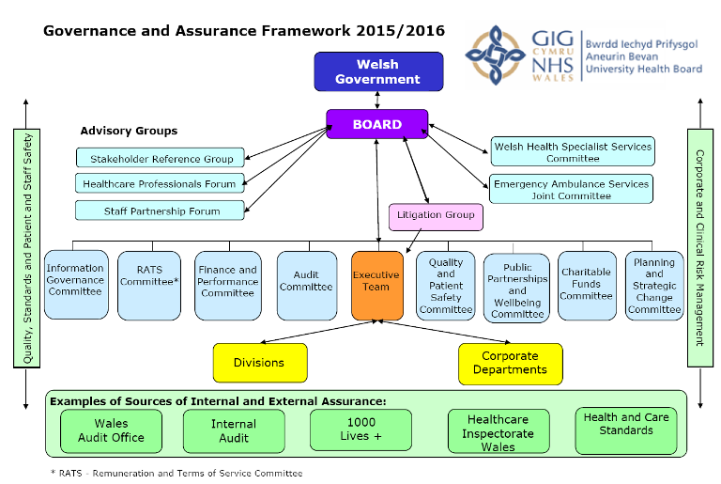
(NHS Wales University health board, 2016).
Above is a graph showing the current structure of NHS Wales. This shows how the management is shared out between each sector and who they report to or are in charge of.
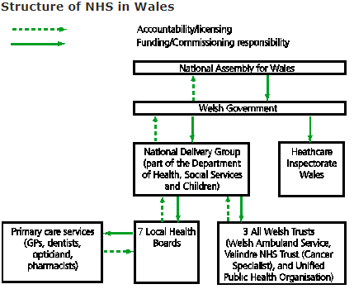
(The Welsh affairs committee, 2015).
Above is a hierarchy structure showing how the funding for NHS Wales is obtained and how the funding is shared out between the seven health boards and three trusts.

Evaluation of current structure (35% - 700 words)
Many businesses run using a hierarchal structure. This structure usually consists of a boss at the top who is in charge, leading on to the next tier which is managers then general workers. While there are advantages to using this type of structure and ensuring everyone has their own responsibilities there are however some disadvantages to using this type of structure (Bianca, 2019).
This type of structure is beneficial as it as it outlines a clear reporting structure. This automatically gives employees an understanding of who to report to as the higher they are in the hierarchal structure the more authority they obtain. This is also beneficial to employees as it shows them the steps to take to work their way up the structure and be in a role offering more authority (Bianca, 2019).
The hierarchal structure also allows for clear communication and coordination within departments. With this structure it is made clear to employees who they are reporting to but also makes it clear to who the managers will delegate tasks to. This stops managers and employees from completing irrelevant work in their department by allowing them to delegate specific tasks to dedicated teams which as a whole allows for more efficient work to be carried out as each team will know their remit (Morton, 2019). This is essential within the NHS as each department plays a very important role to the overall running of the NHS.
There are also some disadvantages to using a hierarchy structure within business. One of the major disadvantages to a hierarchal structure is the lack of collaboration and communication within the business as a whole. The hierarchal structure deters employees from communicating and collaborating with each other by sharing information as employees often feel the need to seek help from further up the structure by a more managerial role (Bianca, 2019). Employees can also feel quite territorial within their department and will often feel like they are at competition with the other departments within the business (Bianca, 2019).
This can also encourage isolation causing departments to not be made aware of another department which may be struggling and could find departments putting their individual needs first instead of prioritising the company as a whole (Morton, 2019). This can be relevant to the NHS as certain departments could end up busier than others requiring nurses to assist in the struggling department.
With a hierarchal structure the more layers there are to the structure the more decision making takes place and more managers and teams to inform. This can often be problematic in certain businesses if an employee comes up with an idea instead of being able to report straight to the CEO of the business the employee will often report to the manager who may not even take the idea further or if they do report this to the CEO, they may get all of the credit (Morton, 2019).
To conclude, there are many advantages and disadvantages to using a hierarchal structure within a business. It encourages team work within departments and clearly outlines who each employee or manager should be reporting to or can delegate tasks to. However, using this structure can also lead to a lack of team work between departments and could introduce a competitive element. Many companies are now implementing a flat structure which includes few or no levels of hierarchy (Meehan, 2019). However, a structure like this would be impossible to implement in such a big company like the NHS as a whole but could possibly be implemented on a smaller level by using a flat structure within certain departments.

Conclusion (15% - 300 words)
In conclusion of this report as a whole, the NHS works based on a hierarchal structure within management and their finances. NHS Wales is split into seven different health boards and three trusts. These health boards and trusts replaced the twenty-two Welsh health boards and seven trusts which previously made up NHS Wales.
Their finances are controlled by the Welsh government who are granted the funding by Westminster. While their budget is shared out based on the needs of each health board, hospital and department their structure is not working as well as it should as the welsh health board as a whole is overspending by more and more every year. This overspend and uncertainty is then being affected further by a turnover of staff due to job uncertainty which is affecting then the management structure of the NHS.
The NHS used a hierarchal management structure. This means the NHS is ran by a CEO who has the most authority then the hierarchy filters down through different levels of management and authority in different health boards which filters down to different departments and hospitals within that health board. Management structures as a whole have many advantages and disadvantages to them such as being able to control many departments within a business, having a clear hierarchy leads to effective reporting to management and effective delegation of tasks. However, the hierarchy structure has many disadvantages such as ineffective communication between departments, Isolation from other departments and miscommunication between employees and higher managerial staff.
Recommendations (5% - 100 words)
While the NHS is free to all the system will always be playing catchup as the demand will continuously be higher than the supply. For the NHS to get on track with their spending and being able to supply treatment at a more acceptable pace would mean that all or part of the NHS would have to be privatised to deter citizens from abusing the system. Another suggestion to discourage people from abusing the NHS would be to have a stricter screening process at walk in clinics, A&E and GP practices to allow those really in need to get the treatment they need within an appropriate time frame. The government should also be taking a more in depth look at what sectors they are spending their budget on and re-distribute a more appropriate amount to each sector.

Reference list
Bianca, A. (2019) Pros and cons of a hierarchal organizational structure. Available at: https://smallbusiness.chron.com/pros-cons-hierarchical-organizational-structure-24276.html (Accessed: 03/05/2019).
Business Dictionary (2019) Organizational structure. Available at: http://www.businessdictionary.com/definition/organizational-structure.html (Accessed: 08/04/2019).
Gurner, R. (2018) Health boards overspend on directly managing practices. Available at: https://www.bma.org.uk/news/2018/october/health-boards-overspend-on-directly-managing-practices (Accessed: 08/04/2019).
Meehan, C. L. (2019) Flat vs. hierarchal organizational structure. Available at: https://smallbusiness.chron.com/flat-vs-hierarchical-organizational-structure-724.html (Accessed: 03/05/2019).
Morton, P. (2019) The middle manager: Pros and cons of hierarchy in a small business. Available at: https://www.turbinehq.com/blog/pros-cons-hierarchy-small-business (Accessed: 03/05/2019).
NHS Wales university health board (2016) Aneurin Bevan University Health Board’s Committee structure. Available at: http://www.wales.nhs.uk/sitesplus/866/page/52736 (Accessed: 03/05/2019).
The National Health Service (2016) NHS authorities and trusts. Available at: https://www.nhs.uk/using-the-nhs/about-the-nhs/nhs-authorities-and-trusts/ (Accessed: 08/04/2019).
The National Health Service (NHS) (2016) About the NHS. Available at: https://www.nhs.uk/using-the-nhs/about-the-nhs/the-nhs/# (Accessed: 08/04/2019).
The national health service Wales (2019) Budget & Charges. Available at: https://www.wales.nhs.uk/nhswalesaboutus/budgetcharges (Accessed: 08/04/2019).
The National Health Service Wales (2019) Structure. Available at: http://www.wales.nhs.uk/nhswalesaboutus/structure (Accessed: 08/04/2019).
The Welsh affairs committee (2015) Cross-Border health arrangements between England and Wales. Available at: https://publications.parliament.uk/pa/cm201415/cmselect/cmwelaf/404/40406.htm#a13 (Accessed: 09/04/2019).
The Welsh affairs committee (2015) Funding and commissioning. Available at: https://publications.parliament.uk/pa/cm201415/cmselect/cmwelaf/404/40406.htm (Accessed: 03/05/2019).
Welsh Government (2018) Annual budget motion 2019-20. Available at: https://gov.wales/sites/default/files/publications/2018-12/final-budget-2019-2020-motion.pdf (Accessed: 08/04/2019).

