MO-VIDA

COFFEE SHOP
  - Business Plan

TABLE OF CONTENTS
Introduction……………………….All the team
1. Executive Summary…………..All the team

2. Business/Company Overview……...Irena Loncar (1917107)

3. Product and Services………… Irena Loncar (1917107)

4. Marketing Audit……………. All the team

5. Target Market ……………..Danna Michelly Quinones Rodriguez (1916136)

6. Marketing Plan …………Yazmin Vega Rodriguez (1917100)

7. Management Plan………Loraine Kristel Tabila (1917097)

8. Financial Plan……………… Jose Carmona Rodriguez (1917096)

MANAGING ENTERPRISE IN THE 21TH CENTURY

Dra Molly Jack
Lecturer

September 3rd. 2020

Introduction
Mo-Vida it was established in London in */*/ 2019, the idea comes up, one day having a coffee in our local place, as it was usually every morning. We were passionate about coffee; our friend was traveling around the world, and he brought us a sample of coffee.
We were fascinated by the smell and taste, capturing our senses. It is when we decided to create our coffee shop with our flavor and organic farm with fair trade to be distinguished from the other brands. It was limited options in London. We visualized the perfect opportunity to having our own business with a good profit, freedom, and revolutionary idea in the market.
We were inspired to have an essential impact in our consumers, be competitive with a fresh and unique vision about business, creating our coffee shop MO-VIDA the name was a fusion of our cultures ambition and creativity we wanted to grow progressively and sustainably, exploring different flavors and unforgettable experience for our customers.
Our background was the main ingredient to become successful. We had Jose the head of the knowledge to make the difference with an outstanding coffee with more than 13 years of experience and logistics. Irena is the business manager, Loraine is social media, Danna the target marketing planner, Dario is the head chef and Yazmin marketing.
We want to have a very varied and international menu working with a variety of tapas(vegan, gluten-free, organic, low calorie.) All our tapas will be imported, from our countries Tapas Will be free. This idea of free tapas we bring from Spain, where you pay for the drink, and you have your free tapa. We work a lot on decorating the bar trying to make it as organic as possible, such as Wood and plants, and thus make the bar a unique and natural place to enjoy your free time. Most importantly, there are bar services as well along with online cake orders.
This project will start with a Budget of €20.000( 5.ooo per person) the rest of the money we want to finance by the bank and request help from the government. We hope this investment begins to give good results from the first moment since our free tapas Project will attract the attention of all types of clients. We estimate that in five years it will be a recognized and consolidated bar in this sector and without forgetting that we will have the best cafes in London.
We hope this investment begins to give good results from the first moment since our free tapas Project will attract a lot of attention from all types of clients. We estimate that in five years it will
be a recognized and consolidated bar in this sector and without forgetting that we will have the best cafes in London.
https://www.youtube.com/watch?v=Q9G0u_6-fbU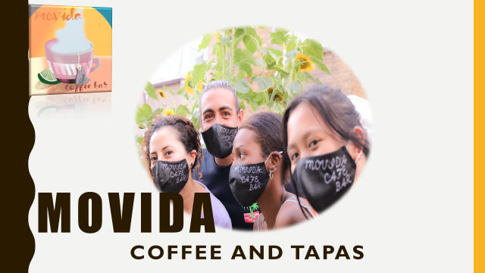

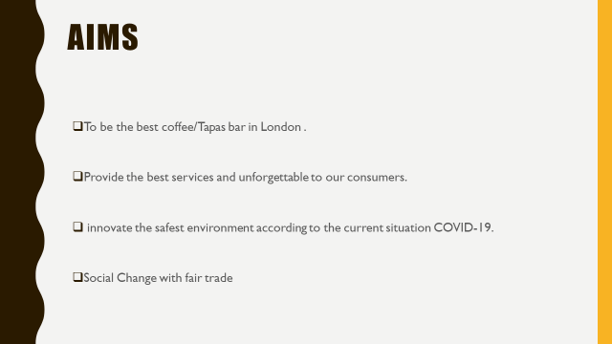
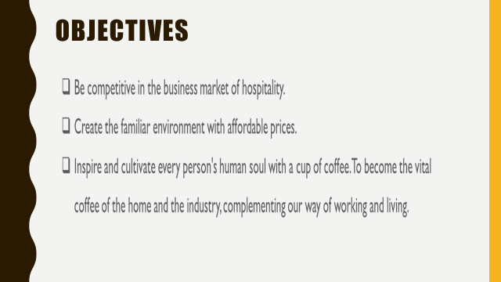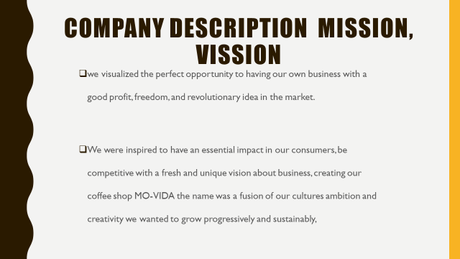

Executive Summary ALL THE TEAM
The business raised and planned is an idea that was born to provide autonomy and economic independence, although knowing the risks that could be controlled, we decided to join forces to give life to a project that we are passionate about. At each point that is exhibited in this business plan, a study has been produced following our business needs. Each investor has decided to discuss on different topics where we have reviewed, shared, and collected the pertinent information to obtain the most beneficial outcomes.
We desire to be a beneficiary company, that means that through the fair trade of coffee seeds provided from other parts of the world, we can contribute to a social change, fair market, favorable wages for farmers who plant in areas, Thus, creating harmony with the environment and the sustainability of the ecosystem, farmers play a significant role in the process of planting and caring for the land.
In the idea of tapas, we believe that it is innovative to take care of our customers, offering a variety of nearby farm products with seasonal products and others. Tapas are a channel of sociability among many who taste the food, and small portions invite you to want to savor and taste more, this is an idea that comes from the Mediterranean culture, where it has always been the way to meet in bars with friends and families and share while you eat.
The innovation in this idea is to produce small caps that are free and provide the feeling of closeness and affordability. Studying the Holloway Road area, we know that many students, residents, office workers, and business workers will be drawn to this particular mix.

The discussion has shed its light on the establishment of a new case Mo Vida in London. It has provided with the details of the business in the UK, planning of the company and the product services chosen. There are further details regarding goals, objectives and strategies that are incorporated within the marketing audit. The idea of the Café has been represented with the help of the details in the actions that support the new business ideas, business products and services along with the provision of the market audit. The business plan is supported with the company processes and plans related to the execution of business.

Our financial plan does not have budgets or profits of large amounts in the first years of opening due to the situation we have in the middle of a pandemic. The calculations made have been based on the products and services that we are going to execute. We will generate budgets that allow us the salaries, the loans, and all kinds of needs to be able to continue with this project. Our wages will be moderate to have enough capital in a short-medium term future to be able to expand the company in different parts of the country.
Mo-vida management is by six friends and owners, decided to create a familiar, unique, organic and affordable coffee bar and tapas.

Jose, Irena, Danna, Dario, Yazmin and me Loraine, we launched our Mo-vida by our skills, knowledge and being passionate for customer service.
Being partnership and friends, we became familiar to each other, that is one of our aims to our clients, to be familiar and to share our mix of culture. Having Lucia, our part-time waitress, will help us to grow in the market. We will work together like a full-time to maintain and develop more Mo-vida around United Kingdom, Spain and Serbia in the future.

BUSINESS/Company Overview IRENA Loncar (1916136)
- Business

One of the most known business chains of the food and beverage industry in the UK is the café business. The UK market is flooded with cafes and there is quite a well-structured industrial operation in the food and beverage industry. UK food businesses are growing with ideas related to the facilitation of the food business. London, as a city is believed to be obsessed with cafes and there are numerous cafes on every single road in the city. In the UK, the average turnover for a café is about 22% (worldcoffeeportal.com, 2019). There are numerous large cafes and many small cafes, which have gained a very developed position in the UK. The UK stores like the cafes Starbucks, Hardrock and Brewer’s café are growing up with every passing day and the independent sectors are developing within the overall beverage market. As per the reports, the market size of the UK café market is 25,483. Café market value is about £ 10.1 billion from the operations are regulated with the help of the growth of 7.9% in the cafeteria growth (worldcoffeeportal.com, 2019). Some of the leading coffee focused operators are entrusted within the companies like Costa, Nero and many more. The Café market is produced with the main preferences of the cappuccino, latte and American variances. Average price per cup is £ 2.66 within the café market of the UK (worldcoffeeportal.com, 2019). The Mo Vida café is supported with the aim of growing in the UK and thereby creating new opportunities as a high street café that can impede upon the ideas of operating as a ventured decision. It aims to include the opportunities that supports the recreation of people belonging from all age, and thereby keeping in mind the social norms and ideas of action. There is a plan of intrusion of a new café with a bar and also support for the children with single mother. An unparalleled and developed location is being chosen for the café and it is expected that the café will perform very well with all the inclusive effects and earn a noticeable customer base in the market

- Company

The current business idea involves the establishment of a new café Mo Vida in London. It is a plan that the coffee shop will be operative in a high street location near Holloway Road near the Arsenal Stadium. The location chosen is a prime one with respect to the volume of spectators and the visitors being very high. Moreover, with such an efficient location the project development can be made in a better way to gain the tourist as well as domestic attention. The

cafe has been designed with the proper market analysis and trend studies based on the social norms as well as trending preferences of customers. Organic Coffee is of the cult preferences in the café business and in case of cappuccino, the organic coffees are preferred more than the latte consumption. The idea of the new café is getting more diverse with the encompassment of creating a bar area, and a bakery.

The key staffs of the Café comprise of only one waitress Lucia and the line managers are recruited as per the need of the business. The key line of managers include the Jose Carmona financial Logistics, Dario Reascos, Marketing Yasmin Vegas,HR Loraine Tabila, Administration Danna Quinones and the Business manager Irena Loncar. The staffing processes are to be developed with provision of proper training processes.

There is a regulated provision that allows the party organizations and the families to pre-order cakes on the birthdays with the pre-order and the online booking of the services. Apart from this, the plan of the café also includes a bar, which is sorted for the beverage supply. Thus, there will be both alcoholic and non-alcoholic beverages and specifications for the various ages’ entertainment and support among the people. The organization is opening as a new entity within the market and the support is created with the help of the proper business aims. The company aims at targeting people of various demographics, preferences and ages along with the idea of presenting a new dimension of dining together and creating a proper environment of eating and drinking. In this case, the main target of the business is the young people and the population which is ranging from the demography of a child to a late middle aged group

- Strategies

The strategies that are to be mostly used in the designing and the establishment of the café include the planning on the basis of the market trends and performances. They are also planning to target the current customers at present. Digital application-based online market practices are to be developed within the organization. The proper investments are to be made with the marketing decisions and the creation of proper guidance among the achievements of the values of the business. The solutions will help to expand the market, gain market recognition and also engage more customers to the base of operations.

The idea of the Mo Vida Café will be designed from the wide customer variations and the need to support the diversified needs of the people from the respect of age and personal preferences. The organization will be developing with the process of encouraging social equity and the development is regulated with ages and the current choices. Murphy and Hine (2018) have commented that since UK demography is a mixed culture there lays a need of creating a confluence of the activities and channelizing the sales and regulations options. This helps in the creation of the trade impacts which regulate the impact on the coffee landscape of the UK. The café will be developed on the basis of the funds that are generated through the bank loans at the beginning. However, in case the café succeeds in maintaining a regulative position in the marker, there is a chance of creating better offers from investor or franchising the stores. The cash flow and the distribution of the cash can be generated with the help of the allocative efficiency and gaining of proper returns from the operations. Thereby the capital investment and the cash with operations can be supported in a better way. Mo Vida aims at earning most of the outcome with the help of proper market targets and regulated outcomes from the project.

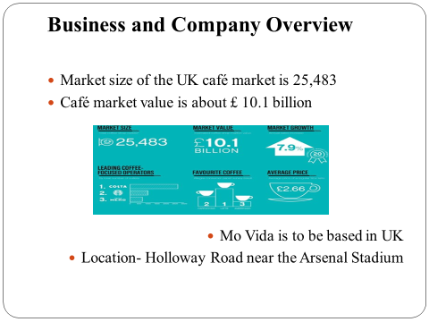
- POWERPOINT IRENA LONCAR (1916136)

Product and Services IRENA LONCAR (1916136)
A multiple range of products and services are being prepared for the café as a whole. The products and services of the café are supported with the following analysis of actions. Anthony (2020) has mentioned that with the help of the products and services designed, target customers are selected and the returns of the market can be planned. The Mo Vida Café will select the following products and services that can define the supply chain. The products and services that are majorly chosen by Mo Vida are done on the basis of proper customer segmentation and the preferences of the products among the people in the UK and the tourist area of the control. Wide ranges of services are being chosen for the offerings to be more segmented and regulated on the social needs, discrimination-free plans and the more logical outsourcing in the food and beverage market of the UK.

The main products that will be sold in the café are the coffee as per the UK preference, the organic coffee and the related options of the meals. Furthermore, there will be options for the ordering of birthday cakes, designing the pre order facilities and the bar services are also regulated for the adults.

Among the services, online pre-booking and delivery of the birthday cakes are selected to be the premium actions. These will be basically made for the customers who are arranging the parties or to the family members. Mahnood and Ishaq (2020) have mentioned that the increase in trend of the online booking and delivery of birthday cakes, it is evident that all cafes will intrude the services. There are the regulative impacts on the creation of a huge customer base with the online services and the designing of the application based market. Other than this, there will also services that regulate support to single mothers by providing free assistance to the children. The services are designed on the basis of the preferences, technical ideology and the social customs that are prevailing among the social structures. The required support and effects are created with the help of the market ideas and the customers who are visiting the places. As per the location, the vase needlessly targets all the domestic people and the spectators of the matches as well. Therefore, the recreational services are aimed under the provision of the services regulated in the product and services chain.

There are the main products which include the various preferred coffee blends for the customers. In the UK the most consumed coffee is the cappuccino or Latte. Both the products are to be available within the café. The main coffee types that will be regulated among the menu also include the American Espresso. Preferences within the blends of coffee are also decided on the basis of the choices and the most speculative results of the preferences as a whole. Since there is option for the bakery, the baked cakes, cheesecakes, and other breakfast meals are regulated within the menu and the preparation of the bowls. Along with coffee there is also the availability of the snacks and side dishes within the café. The café has also targeted the serving of an organic bend of coffee sachet which will be in high demand. As Latinen (2020) mentioned that the organic coffee powders are in high market demand and there are too many consumers for the coffee that are from the organic blends. There is a regular increase in the demand of the organic coffee in the cafes and therefore the cafes are forced to incorporate the products within their brand chain (comunicaffe.com, 2020).

The services are to be regulated on the basis of the in store as well as the action of delivery of the products via renowned food delivery application. Furthermore, there will be an effective designing of applications within the fixed area. Apart from the provision of the organic coffee there is also the requirement to maintain the lifestyle which is mostly preferred by the customers.

Therefore the designing and services within the actions are to be supported with the loss on overall consumption and regulative services.

The bar services will also be designed within the café that supports the overall activities and regulates the action within the differences of guest requirements and preferences. All over the market, there is a growth factor in offering different types of services to guests. The bar facilities will be scheduled within the evening hours and are scheduled after the protected service hours in the café. The major preferences are to be scheduled on the seasonal preferences and the regular preferences of the customers who are visiting the café on a regular basis. The customers in the UK are found to be more inclined towards food plus alcohol consumptions at the same time. Traditional food services and café are regulated more on alcoholic preferences. The cuisine based preferences are created in the consumption of alcohol. In case of the starting days, it is regulated that with the help of the preferences based on the days that are most preferable for the consumption of the alcohol along with the food preferences of the coffee and the similar product designing.

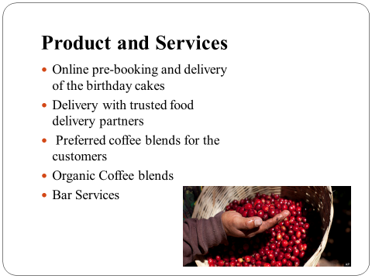
- POWERPOINT IRENA LONCAR (1916136)

MARKET AUDIt ALL the team

The marketing audit for the Mo Vida Coffee is being presented to regulate the impacts and the policies via which the company can place itself within the UK market. Market audit is regulated with services and products that are regulated with the selling of coffee, especially the organic coffee and blends. These beverages are also accompanied with the breakfast and dinner packages. There are also the supports related to the looking after of children with single mothers. The bar services are regulated with respect to the age of the people and their personal preferences of the customers
- Goals
The Goal of the company Mo Vida is to create an unparalleled experience of customers and establish itself as a high street café in London. It plans to expand itself very soon in different parts of London. The action within the café is supported to be targeting the customers beyond social prejudices and discriminations.
- Objectives
The basic objectives of the new business chain of the Mo Vida café are:
- To develop the market and the multiplication of the customer base within a very short period of time and multiplying the customer base to a 50% more
- To increase sales and earn handsome revenue from the first economic quarters with the aim of 50% in the FYI and the 75% in the second FYI.
- To present themselves as the global representative of the café world in the UK in the long run within the next FYI

- SOCIAL REACH
- Our reach in the hospitality market with the interaction channels through our Facebook, Instagram, and YouTube pages, will give us a summary of the engagement of possible clients, how many likes, comments appear in the analytics, it will illustrate how Movida Coffee and Tapas will take popularity, in the following graph is an estimate of the possible interaction in the first months of the opening of the cafeteria.
Figure 1. PowerPoint

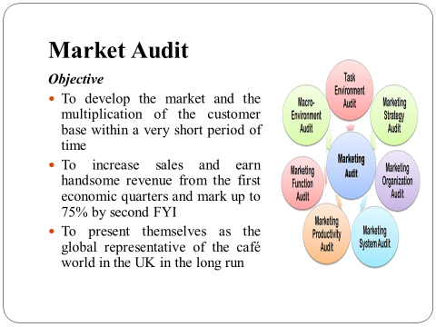

- POWERPOINT IRENA LONCAR (1916136)

REFRENCES IRENA LONCAR (1916136)

Anthony, C., (2020). Marketing Strategy Ideas for a Future Café in Helsinki.

comunicaffe.com, (2020). Organic is the next up and coming trend after gourmet coffee swept across the UK. Available at: https://www.comunicaffe.com/organic-is-the-next-up-and-coming-trend-after-gourmet-coffee-swept-across-the-uk/ [Accessed on: 05.08.2020]

Laitinen, P., (2020). Why do consumers buy organic coffee?: environmental, health and price considerations.

Mahmood, F. and Ishaq, A., (2020). Skill-Based and Interest-Free Microfinance Model of Entrepreneurship as the More Sustainable Model. In Enhancing Financial Inclusion through Islamic Finance, Volume I (pp. 221-241). Palgrave Macmillan, Cham.

Murphy, A. and Hine, B., (2019). Investigating the demographic and attitudinal predictors of rape myth acceptance in UK Police officers: developing an evidence-base for training and professional development. Psychology, Crime & Law, 25(1), pp.69-89.

worldcoffeeportal.com, (2019). £10.1bn UK coffee shop sector achieves 20 years of sustained growth. Available at: https://www.worldcoffeeportal.com/Latest/News/2019/UK-coffee-shops-achieve-20-years-of-sustained-grow [Accessed on: 05.08.2020]

TARGET MARKET ANALYSIS DANNA M. QUINONES R. (1916136)

The coffee industry has increased over time, bringing with it many types of seeds with different flavors, aromas and peculiarities, it is increasingly demanded by various markets, in the UK we find that coffee drinkers want to savor coffee beans from quality. The residents and customers in the area can be varied on the needs of each one, knowing that the coffee is love for all the cultures around the world we find the Holloway road is the perfect place to introduce our diversity, enthusiasm, and services.
Holloway is an urban area in the Borough of Islington in London and an road of 3 kilometers in length. It is one of the main shopping streets in North London. The coffee shops have increased in the last decade being very popular around London in urban and suburban areas, it brings new trends and competitors in the market of the coffee, offering the contemporary food, brunch, breakfast and all the seeds coffees that it can be found around the world. (Streetcheck, 2020)

- INDUSTRY TYPE: In the description of the coffee industry, it is noted that with the entry of fresh coffee seeds. The value of instant coffee has been decreased in most households In the UK. Overall ‘people drink 95 million cups of coffee per day – an increase of 25 million over the last ten years’. (CEUTA GROUP, 2020; CEUTA GROUP, 2020)
In our coffee shop, the objective is to ensure that our variety of coffees, accompanied by tapas with a Mediterranean touch, feel the proximity of the flavors that emanate the unique flavors with fresh ingredients.

  - SEGMENTATION

It would therefore be relevant for us to identify as well as imaginable the characteristics, expectations, unmet needs and actions of each customer, to be able to give them what they want and need, and also to figure out how much they are willing to pay to fulfil their tastes and preferences.
The unique profile of the buyer would be the one that relates to our business. That is to say. We must choose the kind of goal that will offer higher productivity, a guarantee of success as near as possible.
- Focus costumers (demographic information)

- Age
- Gender
- City
- Neighbourhood of residence
- Marital status
- Children
- Profession
- Income bracket

Age group men and women | Average consumers attender
18-19 | 53
20-24 | 154
25-29 | 65
30-44 | 60
45-59 | 31
Total | 365
- Ages estimation average consumers

This age group demographically illustrates the average age among our clients on Holloway road, as this street is popular for its bars, theatre, colleges, universities, and businesses in an area where youth add the highest percentage of visitors to entertainment venues.
In this table, a margin of estimation has been taken for future consumers and clients of our MO-VIDA Coffee - Tapas, based previously on the Holloway Road census

Figure 2. Danna (Microsoft Excel)
- With the calculation of the ages of women and men in the area and also with the survey carried out, we have found our clients are between an estimated age of 20 - 24 mostly, but in the case of multi segmentation, average points out that the ages illustrated in any case, they would be willing to enjoy a coffee and a tapa.

- SURVEY BUYER PERSONA (AVATARS)

The purpose of this survey is to observe, find information that could help us as a new business to find the tastes of our clients in the Holloway Road area.

https://docs.google.com/forms/d/1QzjBswLGx_KrwUCaIjgVyT6WJAgu-S4cVIF8YWRtszo/edit

- Q1 Do you like the area of Holloway Rd?
- Q2 Are you a coffee lover?
- Q3 Before visiting a coffee shop, you look at the website?
- Q4 When you have checked at the website, are you most focus on the coffee served, on the menu food?
- Q5 What is your age?
- Q6 What is your marital status?
- Q7 What is your gender?
- Q8 What borough do you live in?
- Q9 Do you have children?
- Q10 What is your professional status?
- Q11 What is your annual income?
  - TARGETING MULTIPLE SEGMENTATION
RESIDENTS | BUSINESS WORKERS | STUDENTS | OFFICCES WORKERS

- Describing the potentials customer:

- Holloway Road residents are the house of multiculturalism, as evidenced by the 2011 census, where household varies by their jobs, income, social grade, gender, Relationship Status and Age Groups with the age range:

Image 1. By Bing Microsoft word
It is necessary to underline the ages since the numbers indicated above are the total of the ages understood with the majority in Holloway road for nine years ago, also considering that the next census will be in year two thousand and twenty-one, we have estimated that the numbers increase with the entrance of new residents, businesses and students.

- Today university students have increased caffeine intake to maintain high efficiency in their study hours, considering that caffeine provides this cognitive effect of alertness and productivity status in their hectic lives. (Olsen, N., 2013).


Image 2. By Bing Microsoft word

Thus, the introduction of our cafeteria will bring to the students of the universities located on Holloway Road joy for a delight of an atmosphere of tranquility, relaxation and delicate attention by us members and owners of Mo-Vida implementing the typical Spanish tapas accompany those strenuous hours of study where the body and also the mind need that pause to reactivate the energy that students from the London Metropolitan University Learning Center, London Metropolitan University Rocket Complex, Central Saint Martins, Archway Campus, City and Islington College, and UNISON London Metropolitan university.(Google, 2020) will be captivated with Mediterranean flavors and absolute quality coffee.
The clearly defined business segment to be reached is the student body of the Universities, with nearly 10,000 students in three shifts. It will therefore be necessary for us to know the characteristics as well as possible,

- Offices workers and Business workers Coffee consumption habits in offices are evolving, consumers in offices are looking for places where they can serve high quality, gourmet coffee, and appropriate service, tailored to their needs since they know what they want. The potential costumers in Holloway road would be located in the offices or workspaces that are rented in the area. (FlexiOficces, 2020)

Image 3. By Bing Microsoft word



Image 4. By Bing Microsoft word

Table 1. Danna Microsoft Word

  - COMPETITORS

Figure 2. (Google, 2020)
Vagabond N7
VAGABOND is a cafeteria that has been established since 2013 on Holloway Rd. Its background owner is Lithuanian, with previous experience in the sector. The coffee shop is well-known among coffee lovers, with a distinctive menu for vegans and vegetarians in the area. They served breakfast and lunch. (Vagabond N7, n.d.)

Miki's Paradise
Miki paradise is a trendy cafeteria in the mythical Holloway road, where many businesses with all profiles can find their niche, this cafeteria offers a range of French, Mediterranean, Australian, Street Food. (Tripadvisor, 2020)

The Travel Café
DIFFERENT COFFEE SHOPS IN THE AREA(COMPETITORS) | INDICATORS OF SATISFATION (REVIEW) | LOCATION
Vagabond N7 | 489 | 105 Holloway Rd, London N7 8LT
Miki's Paradise | 326 | 221A Holloway Rd, London N7 8HG
The Travel Cafe | 106 | 253 Holloway Rd, London N7 8HG
Travel Cafe is a business with a natural theme, comfortable for those customers who want to feel surrounded by plants. Conveying a feeling of peace while enjoying a good cup of coffee or tea, it offers breakfast and brunch, bringing cuisine with a Korean background. (Tripadvisor, 2020)

- Competitor Analysis using the SWOT format

Figure 2. Danna Microsoft Excel
- With the estimate based on the reviews of our three competitors, we have been able to create a graph.
- Our three competitors are located in Holloway road, with the previous investigation, it will measure its advantages and disadvantages among the consumers of their establishments, the SWOT has been created to illustrate it and get a clear understanding.

Vagabond N7 (Google, n.d.)
STRENGHT  - Customer service is satisfactory, in most cases excellent.  - High standard coffee quality  - Variety of ingredients high standard. | WEAKNESESS  - Breakfast charges may exceed student budget limit.  - Low food hygiene rating (1/5 stars) from September 2018.  - Same menu since the launched.  - Not discount for students
OPPORTUNITIES  - The service can be relatively slow.  - Coffee quality varies depending on the barista, and the regular customer will not be happy  - The vegan food it does not attract respect with the demands of the customers | THREATHS  - Customer return to the Vagabond N7 because the treatment is very friendly  - The owner's approach with customers is close they think that he is a very affable person.
Table 2. Danna Microsoft Word

STRENGHT  - The interior decoration is delightful.  - The background music invites an atmosphere of relaxation.  The crepes.  - Crepes are the greatest strength of Miki's paradise customers' repeat experience often. | WEAKNESESS  - Not full in a variety of desserts, its main attraction is the crepe.  - The brunch selection is extremely poor limited.
OPPORTUNITIES  - Not discounts for students.  - The quality of the coffee is not to the affection of customers who demand a high standard in beans and flavor. | THREATHS  - the social media strategy attracts customers through the photos and images on the menu  - Welcoming staff.

Miki's Paradies. (Google, n.d.)

Table 3. Danna Microsoft Word

STRENGHT  - The interior decoration of the cafeteria is attractive for its plants.  - Helpful team  - Central for the offices around. | WEAKNESESS  - The food menu is limited.  - Very expensive for what you receive.  - The quality of the Oat milk is sweeter than the normal, customers with some sweet intolerance, if they are not alert to the Oat milk of travel cafe, may be affected.
OPPORTUNITIES  - Not student discount.  - Same products. | THREATHS  - Two stores of Travel Café, Waterloo and Holloway Road.  - familiar atmosphere specially families with kids
Travel Café. (Google, n.d.)

Table 4. Danna Microsoft Word

STRENGHT  - The quality of the coffee beans is of high quality. We will work with fair trade.  - Loving customer service, especially for our consumers who desire to experience a relaxing visit and a gathering point for study and recreation all week and also weekends.  - experience of all owners.  - All owners work together, and we will be responsible. | WEAKNESESS  - The owners must make tough decisions for the good of the establishment at an economic level, we must face payments that can produce disadvantages in the teamwork environment.
OPPORTUNITIES  - The tapas that are offered will be free for having a drink accompaniment.  - Student discounts.  - Resident discounts | THREATHS  - The current pandemic may slow down the flow of customers to our cafeteria.  - The challenge of the cafeteria the first year will be a success, with the least possible losses.

MO-VIDA Coffee and Tapas

Table 5. Danna Microsoft Word

In the COVID - 19 current situations, we have realized as a society that we have a responsibility to the planet, to take care of the resources, and to be as sustainable as possible. Our take-ways will be made of 100% recyclable cardboard, and emphasizing this part is crucial for our business, promoting the eco-friendly environment among customers since social concern exists and promoting it among neighboring students, office workers and residents are part of our philosophy that we want to convey.

The products that will be given to consumers will allow them to connect with the essence of the gourmet. The warmth of a Mediterranean tapa, as we all know, Spain is one of the countries with the highest-ranking of tourism and stands out for its food appetizers and tapas Of affordable prices. In the UK, this style of gastronomy is taking an extensive market, where residents, students, and consumers of good food can connect and enjoy, we have decided that Holloway is the ideal place with future open-minded customers to flavors.

We know that the positioning of our Coffee Shop and Taperia will be a triumph and that the services we offer with all the owners also play the most decisive role in building a community of regular customers and those who pass by and know that they can return to a place of good vibes and also exceptional attention.

DANNA M. QUINONES R. (1916136)
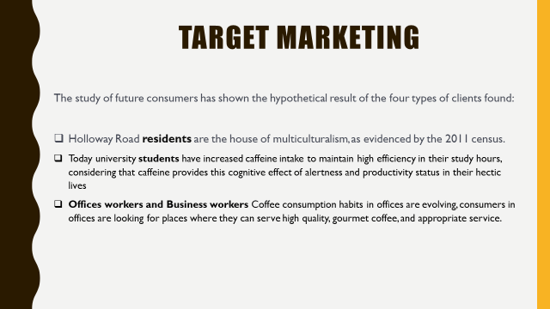
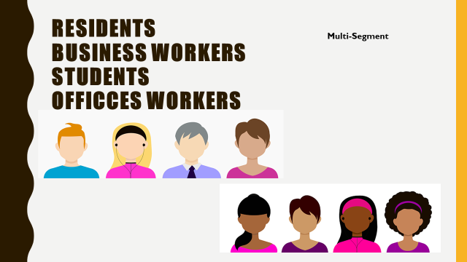

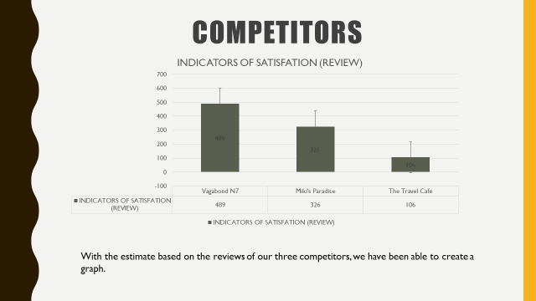
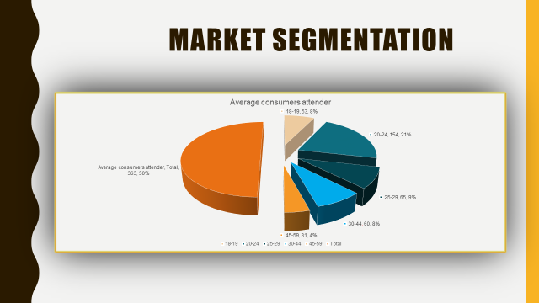

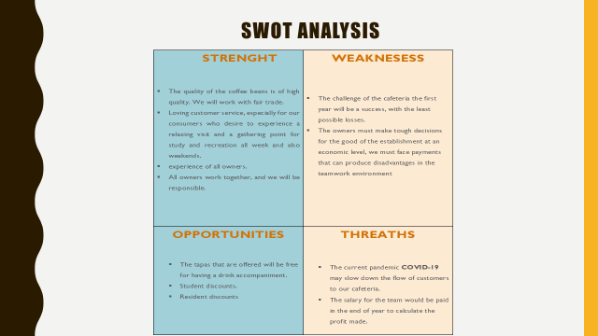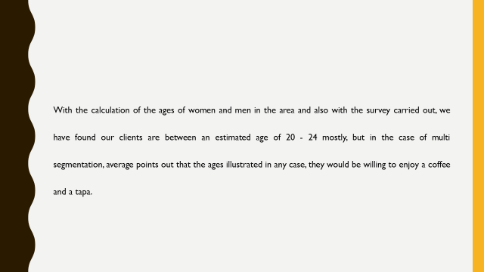

References DANNA M. QUINONES R. (1916136)
CEUTA GROUP, 2020. CONSUMER BEHAVIOUR. [Online]
Available at: https://www.ceutagroup.com/the-coffee-market-in-2019/#:C~:text=In%20the%20UK%2C%20people%20drink,in%20shops%2C%20bars%20and%20restaurants. ( Accessed 13 August 2020)
FlexiOficces, 2020. Serviced office space to rent in Holloway. [Online]
Available at: https://www.flexioffices.co.uk/london/holloway
[Accessed 13 August 2020].
Google, 2020. Holloway Road Coffee Shops. [Online]
Available at: https://www.google.com/search?safe=active&rlz=1C1CHBF_en-GBGB905GB906&tbm=lcl&sxsrf=ALeKk01PCRHcZTS5rkNk2sE2blbjEDkQIg%3A1595607935310&ei=fwsbX-HLEuSx8gLa3ofIBA&q=n7+8lt+holloway+road+coffee+shops&oq=n7+8lt+holloway+road+coffee+&gs_l=psy-ab.1.1.35i39k1l2.
[Accessed 27 July 2020].
Google, 2020. Universities in Holloway Road. [Online]
Available at: https://www.google.com/search?safe=active&rlz=1C1CHBF_en-GBGB905GB906&sxsrf=ALeKk0313LmIK9vQY8mt0DIisrvDeFsoGQ:1596060437626&q=universities+in+holloway+road&npsic=0&rflfq=1&rlha=0&rllag=51558490,-121649,1026&tbm=lcl&ved=2ahUKEwiD07K7vPPqAhVOfMAKHcPbCKwQjG
[Accessed 28 July 2020].
Google, n.d. Miki's Paradise 330 reviews. [Online]
Available at: https://www.google.com/search?safe=active&rlz=1C1CHBF_en-GBGB905GB906&sxsrf=ALeKk01OTIX1kfWZ9aM4airLSN_1WzJoVw%3A1597351177487&ei=CaU1X5WxHb-q1fAPt82x6A8&q=miki%27s+paradise+n7&oq=miki%27s+paradise+n7&gs_lcp=CgZwc3ktYWIQAzoGCAAQBxAeOggIABAHEAoQHjoECAAQDTo
[Accessed 14 August 2020].
Google, n.d. The Travel Café 107 reviews. [Online]
Available at: https://www.google.com/search?safe=active&rlz=1C1CHBF_en-GBGB905GB906&sxsrf=ALeKk00pMp9H1upIBLN2X1k8XbCJzHhNAg%3A1597354797027&ei=LbM1X6-ZAfGp8gKu5rD4Aw&q=travel+cafe+n7&oq=travel+cafe+n7&gs_lcp=CgZwc3ktYWIQAzoGCAAQBxAeOgQIABANOggIABAHEAoQHjoICAAQCBAHEB46
[Accessed 14 August 2020].
Google, n.d. Vagabond N7 492 reviews. [Online]
Available at: https://www.google.com/search?q=vagabond+n7&rlz=1C1CHBF_en-GBGB905GB906&oq=VAGABON&aqs=chrome.3.69i57j35i39l2j69i59j46j69i60l3.7183j0j7&sourceid=chrome&ie=UTF-8#lrd=0x48761b706e8eecfd:0xefe75fda890732d7,1,,,
[Accessed 13 August 2020].
Olsen, N., 2013. Caffeine Consumption Habits and Perceptions among University of New Hampshire Students. [Online]
Available at: https://scholars.unh.edu/cgi/viewcontent.cgi?article=1102&context=honors
[Accessed 29 July 2020].
Streetcheck, 2020. Area Information for Holloway Road, Islington, London, N7 0RN. [Online]
Available at: https://www.streetcheck.co.uk/postcode/n70rn
Tripadvisor, 2020. Miki's Paradise. [Online]
Available at: https://www.tripadvisor.co.uk/Restaurant_Review-g186338-d10378007-Reviews-Miki_s_Paradise-London_England.html
[Accessed 27 July 2020].
Tripadvisor, 2020. The Travel Cafe. [Online]
Available at: https://www.tripadvisor.co.uk/Restaurant_Review-g186338-d10383079-Reviews-The_Travel_Cafe-London_England.html
[Accessed 27 July 2020].
Vagabond N7, n.d. Vgabond N7. [Online]
Available at: http://www.vagabond.london/about/
[Accessed 27 July 2020].

Marketing and Sales Plan YAZMIN VEGA RODRIGUEZ ( 1917100)
1. Introduction SOSTAC model marketing

The definition of digital marketing has a diverse methodology using publicity and advertising, supported by digital platforms to obtain strategic objectives. Towards a specific organization, the marketing plan must be structure in detail and emphasis on business planning.

To identify a clear and simple strategy in (1990) an economist name PR Smith

Developed a methodology called SOSTAC, focussing on the implementation of six core strategies, based on measurable marketing results. To understand and easily comprehensibly, they represented by an acronym SOSTAC,

(S) The situation, Where are we now,(O)Objectives, Where do we want to be,(S) Strategy How do we go there, Broad direction,(T) Tactics How we monitored, Individual steps,(A) Actions Specific action for each step and (C) Control How do we know that we arrived. (Stephenson, 2020)

Cafe bar Mo-Vida

2. Situation Analysis

Our coffee bar wants to make a difference with a unique concept and high quality of product innovation, giving the consumers different flavours from de best organic plantations and baristas with invaluable knowledge, (McKnight, 2019)

our customers will experience the perfect essence of the best coffee in London, with additional products such as organic food, tapas, and birthday cakes.

Coffee is one of the world largest commodities; for that reason, we saw the perfect opportunity to develop our business plan, to be recognized as a brand, growing gradually but ensuring our business philosophy.

The Internet has been exponentially growing on the digital market; online have a massive range of opportunities to make a profit. Mo-Vida coffee will use all the available sources and advertisement to be popular. Also, we count with our selling point (SP) with unique interior design, taking into consideration the current situation to keep social distancing. And a safe `place and enjoy our products.

3.OBJECTIVES

The most crucial objective is to rich customer market, with a competitive strategy, where the consumers are the main target of the business. (Chaffey, 2020)

To increase our profit, we will sell and exchange products, connected to the service, that required to build a brand and reputation capitalizing the investment plan, that will be more achievable with an online business, divided into two useful segments: demographically and geographically to increment a higher return of investment. (Pract, 2014)

cafe Mo-Vida it will be based on the concept above want to create the connection between the customer and the brand through the logo, packaging, and labelling set, including a face mask, with the name of the company to promote Our café and in the meantime, will be part of the marketing strategy. Besides, our selected range of quality products supported, by suppliers, it will be building a healthy relationship. As part of the marketing plan and communications, we will use a website, social media platform, and product development, digital marketing is a crucial investment to promote and position the brand.

GOAL SETTING

(S) PECIFIC

(M)ESURABLE

(A)CHIEVABLE

(R)EALISTIC

(T)IMELY

4.STRATEGY DIGITAL MARKETIN

For the strategy must be concise, straightforward language and attractive to the consumers to be competitive taking advantage of digital marketing strategy, (Stephenson, 2020)

Once is identified the target market, the logo is crucial to across the digital marketing channel, the logo is a fusion of our background. The logo represents how we are projecting our business to the consumer.

In nowadays, digital marketing based on digital strategies. Have been revolutionary the market, we will attract more audience to be more competitive and minimize the cost of publicity, and in the meantime, create brand loyalty. reaction and preferences (Ballantine, 218)

Mobile access 77% of adults use smartphones for news, social networking, and other digital marketing; we can test our performance in real-time to make improvements or change of strategy.

Feedback, multimedia allows us to measure the level of satisfaction of our products.

Expansion, shopping online will be part of Mo-Vida-Caffe to boost our profit.

Influencer Engagement will facilitate the followers to introduce the brand and become customers.

We will use Facebook, Instagram, YouTube, pinteres, to attract more consumers, having the opportunity to compare with our competitors in terms of quality, prices, and space interior designer with terrace.

Making a difference in comparison with Vagabond coffee, Mila’s paradise, and travel café, in our local area. The terrace allows our consumer to enjoy with more freedom and fresh air especially, on this current situation customer can ensure that we offer them a safe and enjoyable place, maintaining social distancing.

Visual marketing will include our products emphasising on their background to ensure that the customer knows our philosophy of quality and fair trade, developing unique recipes that will consist of the ingredients with all customer standards. Also, events such as garden parties, birthdays, buffets and a showroom of organic products will be part of our marketing campaign.

5.TACTICS AND MARKETING OPERATIONS

Our strategy is structed focusing in our digital plan, detailed into an operational calendar following the next steps

Webinars will take part in a promotional approach as a tactic to introduce our products and recipes; the costumers will have the opportunity to evaluate the quality and ask questions on real-time, focus on what the needs.

The purpose of the webinar is to launch new products, new techniques using row materials diversifying target market such as celiac, vegetarian allergy intolerance and halal. Digital technology permits positioning the brand for free and the benefits will increase our sales.

YouTube will help to capitalize our brand creating a trending video every week to maintain our followers with fashionable recipes and new products engaging towards a healthy style.

The objective is to use social media to measure the acceptations of our products and compared with the others in how we can improve and expand more audience. We will innovate with trending style. Through social media such as YouTube and Facebook, we will analyse every week and Month, how we are focusing our business, related to the customers' satisfaction and demand patterns,

in conjunction with Facebook, twitter is the perfect indicators to give a general summary statistical insight into how each social media platform is performing guiding in daily and future decision making.

The fifth step is crucial for our company after structured all te strategy, target audience, competitors, product and services and defined how we take actions about it.

Finally, our business plan is taking form toward the initial objectives.

And the plan is alive. All the hard work be reflective on measurable results clarifying the question Who, what, where, when and how showing if the strategy used is giving results of our intelligent planning and proper execution.

6.ACTIONS AND CONTROL

6.1 KPIs (Key Performance Indicators)

This phase reflects the internal progress towards an intended result, creating an analytical strategy for decision making and what areas we can improve, (Stephenson, 2020)

what we have done .one of the main benefits of KPIs allow identifying the indicators, showing a future success and vice versa in the past adapting new and better tactics.

What type of action taken, the indicator is usually based on our objectives to obtain reachable results, useful KPIs, is when?

· Provide evidence of progress the desired result.

· Measure, internal and external factors, helps to make a better decision making.

· Projecting profits and losses in the long and short term.

· Can record, quality, economic indicator, timeliness, and effectiveness.

This relationship between target and performance reflect the real results based on marketing strategy and how we work on it, following the structure we have different types of (KPIs)

· INPUTS, quantify the quality, of our products, types, among in process that produces output

· PROCES, measure consistency, efficiency in a specific approach to making results such as: Equipment, tools and training.

· OUTPUTS reflect how much work has done, and what is produce

· OUTCOMES, determine objectives of brand awareness as part of marketing statistics

· PROJECT, involve the progress of innovations and new projects.

Scheduling and reporting will support how we organized daily and how we will manage time. Resources to delegate the task to each department, and work in a team,

First implementing activities on social media to engage the customer attention with the content, been dynamic and trending, videography for YouTube and notes writing to post on Facebook, Instagram, pinteres etc., including timelines and material to build for instance,

our webinars will be located on our sale point to promote the open space that (TERRACE), with natural light and stunning view, promoting organic sense, with the plant to bring positive environment.

Kitchen space will bring more customers a perfect opportunity to show to the consumer quality products. Bakery and healthy recipes. Digital marketing will need to drown up with data protection policy, SOSTAC is one of the best models of, digital

marketing will be monitoring our sales, and how good is our sales plan, On the market exist Variety of platform, focusing on tracking sales performances such as,
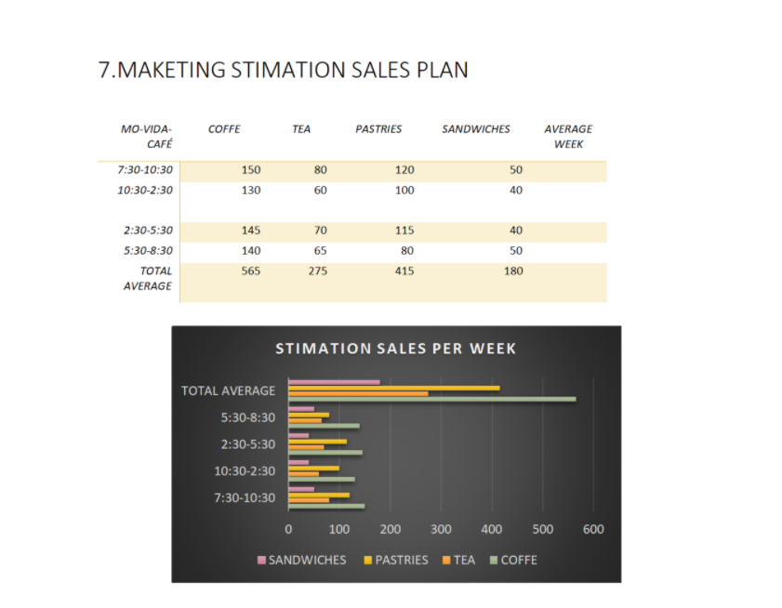
salesforce is a website that contributes to helping to track the investment done, following consumer purchases. At the meantime, we will invest minimum, and the rentability will give a general overview of how we are ongoing to our success. Our projection of sales per week will increase depending on the season, and metropolitan university football match and potential customer, increasing our profit. Positioning our brand.

this method explores the concept of SOSTAC method based on digital marketing, using publicity and advertising strategies, supporting by digital platforms by Pear Smith in (1990) focusing on six cores strategies, based on measurable marketing results, represented by acronym on SOSTAC. situation, objectives, strategy, actions and control. this method helps small and medium business online, our KPIS performance. supporting the success of the company
- Power point YAZMIN VEGA RODRIGUEZ ( 1917100)
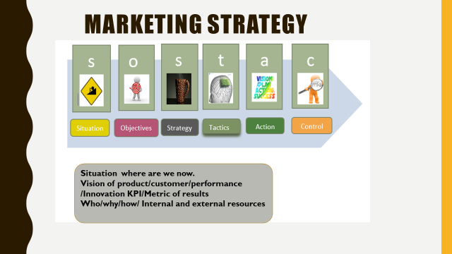
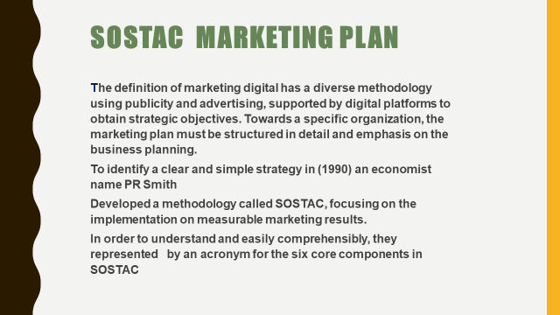
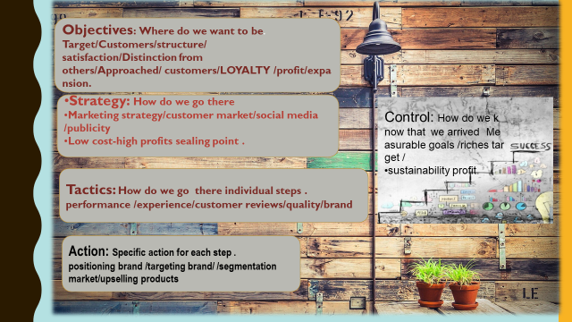
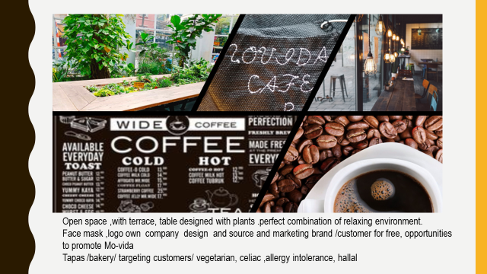
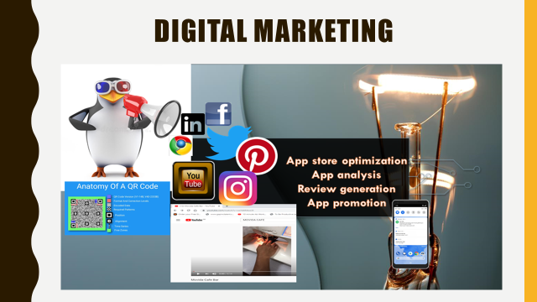

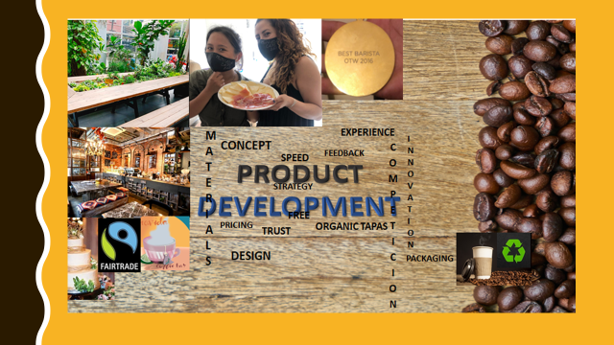

References YAZMIN VEGA RODRIGUEZ ( 1917100)
Ballantine, 218. Ballantine. [Online] Available at: https://www.ballantine.com/10-undeniable-reasons-need-digital-marketing/ [Accessed 28 AUGUST 2020].
Chaffey, D., 2020. SOSTAC marketing planning model guide. [Online] Available at: https://www.smartinsights.com/digital-marketing-strategy/sostac-model/ [Accessed 23 AUGUST 2020].
McKnight, S., 2019. Create Successful Marketing Plans Using SOSTAC. [Online] Available at: https://fourteen-forty.com/create-successful-marketing-plan-sostac-model/ [Accessed 28 AUGUST 2020].
Pract, M., 2014. SOSTAC: The guide to the perfect digital marketing plan. spinnger link, Volume 16, pp. 146-147.
Stephenson, R., 2020. How to write a digital marketing plan using PR Smith’s SOSTAC® planning model. [Online] Available at: https://digitaldimensions4u.com/how-to-write-a-digital-marketing-plan-sostac-model/ [Accessed 30 AUGUST 2020].

7. MANAGEMENT TEAM LORAINE Kristel Tabila (1917097)
Me and my friends; Jose Carmona, Irena Loncar, Danna Quinones, Yasmin Vega and Dario Reascos we decided to create our own business coffee bar and tapas Mo-vida, based in our skills, knowledge and being passionate of costumer service.
Providing our unique and delightful services of, mix of culture to gain more variation of clients in Holloway Road.
Providing them the finest, organic, Kosher and Halal with affordable prices to gain more in the market.
We decided that our business will be a partnership company, and we will be the owners and workers.
Structure of Management
A business partnership company is when two or more people make the agreements to lead a business like as a co-owners (Agarwal, n.d.) .
Mo-vida café and bar will be a Limited Partnership (LP) that will be less risk for us if our business gets in bankrupt.
We decided that our structure of the management will be Limited Partnership (LP) than Limited Liability Company (LLC) because, we invest in our money, making incomes from our profits.
In Limited partnership there is two types; one is general partnership and the limited partnership (Johnson, n.d.).
General Partnership is the one that possess the ability to make management decisions (Johnson, n.d.), that this part is in charge Irena, Jose, and me Loraine.
Limited partnership is not part of management decision is only liable for their initial investment (Johnson, n.d.), Dario, Danna and Yasmin they are in char of this limited partnership.

- Functional roles
Each of us working more than ten years in customer services and having our certificate of management and finance we decided that, in our Mo-vida we will work together and sharing the responsibilities to manage our business, even each of us we have our responsibilities we decided to share equally the jobs and to be fair.
Having a Jose in financial, Dario in logistic, Yasmin in Marketing, Danna in administration, Irena in business manager and me in HR.
And Lucia our part-time waitress.
Jose the mathematician of our company, working more than 3 years like a manager in Sodexo and supervising all in-come and out-come of the coffee shop Costa company, we decided that he will be more in charge of the financial area.
Dario sharing the same university with us and working more than 5 years in pret a manager like a barista and, working in the night life, like a bartender in one of the most privileges bar in London, having his knowledge will be more responsible of logistic.
Yasmin promoting our Mo-vida to be successful in the market, using the new digitals applications like Instagram, Facebook, Pinterest. And promoting our own website that the clients can purchase their favourite products and bring it to their house.
Me I am more in charge of HR and I will look after of our rota to make it fair for all of us.
Danna in administration looking that all the legislations that we require for our Mo-vida is updated.
And business manager Irena with her motivation to keep us successfully united.
With that we establish rules of conduct that is:
Respect all member of the group, being a good listener to not create misunderstandings, valuing all points of view of everyone. (HBR, 2017)
For our company we are looking for someone having availability, skills, motivation (HBR, 2017), Lucia Valencia she our perfect candidate, because she has the tools that we need in our coffee bar and tapas.

7.1 MANAGEMENT ORGANIZATION

This is how it will be our rota.
Every Monday it will be close our coffee bar and tapas that we can have our rest.
And having Lucia working every Thursday to Sunday, having her in two different time.
Thursday and Sunday having her 7 to 11 pm, and Friday and Saturday 5 to 11 pm.
To be fair for all of us we decided that every morning one of each will do the opening at 6 am in the morning,
We decided that 3 owners working in the morning shift, one in half day and two more in the evening.
Doing 8h each individually and to cover our self from each shift.
At 8 am two more they will come for the busy hours,

7.3 PERSONNEL PLAN
This is how it will be our Personnel plan in the first month estimation until 3 years.
Owners salary Estimation per year 1month estimation Year 1 estimation Years 2 Year 3
Jose 1200 14000 1200 1200
Danna 1200 14000 1200 1200
Yazmin 1200 14000 1200 1200
Loraine 1200 14000 1200 1200
Dario 1200 14000 1200 1200
Lucia (employee) 800 9000 8520 8520
Lucia doing her twenty hours per week, being younger than twenty-five years old and being student, the government will pay her, and after six months we will contract her with part-time with the same hours that it won’t affect her in her academics’ time. Her contract it will be with 20h/w paying her 710 monthlies.
For us, the owners based in the financial part we will gain 1200 during the fifth year, just because we want to pay our loan for five years.
And with that create and develop more Mo-vida coffee bar and tapas around United Kingdom, Spain and Serbia, that is all of us we came from.

7.5 SUPPLIERS
Our Mo-vida coffee bar and tapas we choose, the best and economic suppliers providing us their top rates sales.
We have a considerable combination of foods that it makes our Mo-vida special in unique in Holloway Road.
Providing our clients, mix of culture, creating one of our aims that is, creating a familiar environment with affordable prices. That is one of the reasons we decided to introduce in our menu Halal food and Kosher, that everyone is welcome to our Mo-vida.

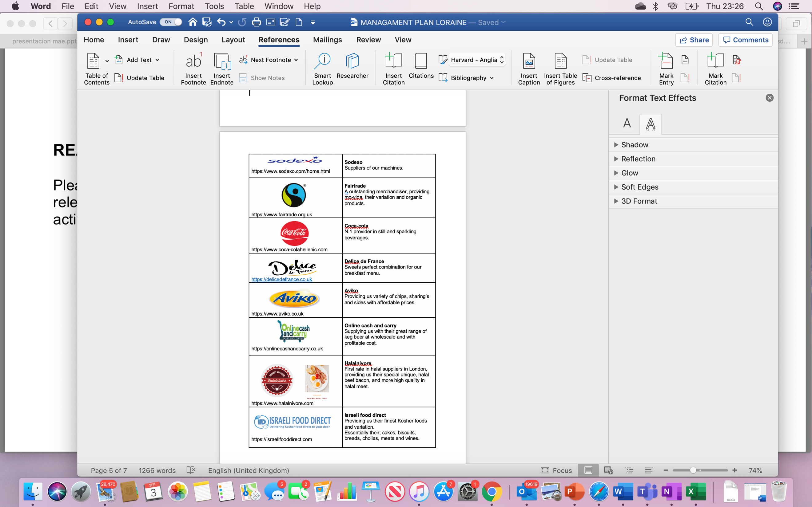

- Power points Loraine Kristel Tabila (1917097)
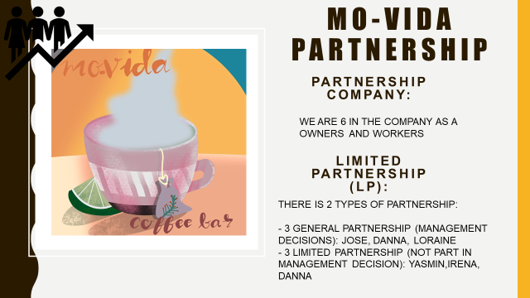
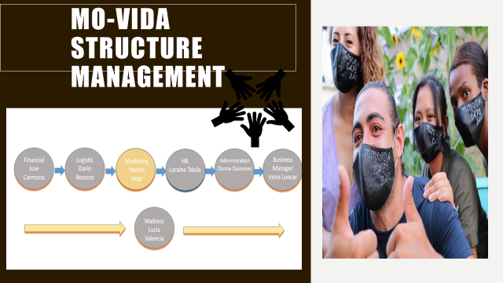

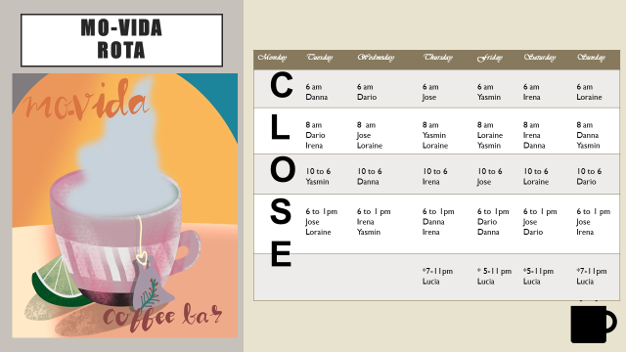

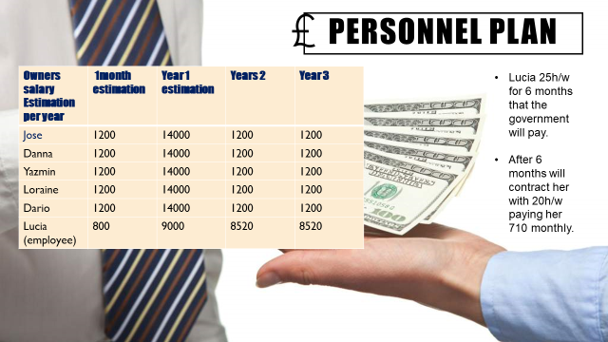

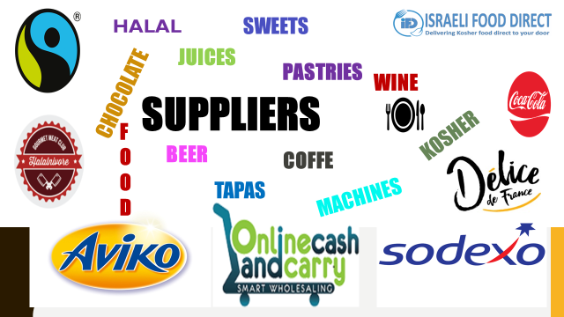

References LORAINE KRISTEL TABILA (1917097)

Agarwal, R., n.d. yourarticlelibrary.com. [Online] Available at: https://www.yourarticlelibrary.com/difference/difference-between-partnership-and-co-ownership/42046 [Accessed 02 09 2020].

HBR, 2017. Delegating with confidence. In: HBR, ed. Harvard Business Review Manager's Handbook. Boston, Massachusetts: Harvard Business Review Press, p. 144.

HBR, 2017. Fostering Creativity. In: HBR, ed. Harvard Business Review Manager's Handbook. Boston, Massachusetts: Harvard Business Review Press, p. 2019.

Johnson, R., n.d. smallbusiness.chron.com. [Online] Available at: https://smallbusiness.chron.com/main-difference-llc-lp-22354.html [Accessed 02 09 2020].

Financial Plan JOSE carmona RODRIGUEZ (1917096)

The annual estimate we have for a year is £50.000. To make this possible, we are following these steps.
£50.000 is required to open our new store.
£25.000 will come from a government loan (START UP LOANS)
Borrow: 25.000 + interest: 3,999.20 = total repayment: 28,999.20 = monthly repayment 483.32
This company has good repayment methods. The loan will be repaid in 5 years with 6% interest per annum without any changes about fees. (LOANS, s.f.)

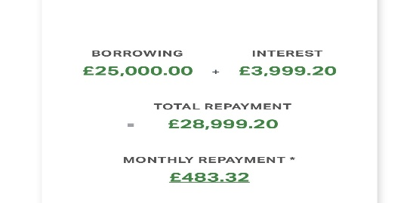
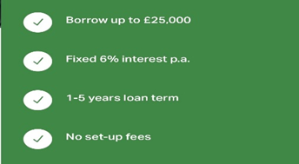

On the other hand, £30.000 will come from an individual loan of £5.000 from each owner of the establishment, which would be £30.000 in total.
Loan summary: loan amount £5.000
Monthly cost: 106.80 + interest: 1,408.00 = total payable: 6,408.00.
This loan will be repaid in 60 months (6 years) with 10,9% interest.
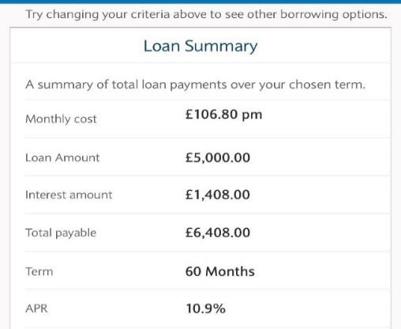

This loan we will try to remove it as soon as possible because it has a lot of interest, but for now we need it until sales go up and we get a good profit.
The total will be £55.000. We try to have something extra for any unforeseen event.

2.Purchase Cost | Products | Cost per unit | Monthly cost | Annual cost
Section A | Pastry´s | £0.39 per unit | £156 | £1,872
 | muffins | £0.56 per unit | £168 | £2,016
 | cakes | £0.35 per unit | £105 | £1,260
 | sweet | £0,35 per unit | £175 | £2,100
 | Syrups | £3,82 per bottle | £114,60 | £1,375.2
 | Chocolate powder | £2,60 per kilo | £260 | £3,120
 | Milk | £0,71 per litre | £710 | £8,520
 | Soya, coco, almond, lactose free & out milk | £0.81 per bottle | £121,50 | £1,458
 | W. sugar, B. sugar &  sweetener | £5,10 kilo | £102 | £1,224
 | Coffee beans | £11,30 kilo | £565 | £6,780
 | Tea | £0,007 unit | £70 | £840
 | Napkins | £18,39 per box | £147,12 | £1,765.44
 | Take away cups | £0,04 unit | £280 | £3,360
 | Take away lids | £0.01 unit | £50 | £600
 | Cups & plates | £1,04 unit | £83,20 | £998,40
 | Wood & metal knifes, spoons & forks | £0,21 unit | £126 | £1,512
 | Water | £0,06 per bottle | £60 | £720
 | Fruit coolers | £2,02 per litre | £101 | £1,212
 | Juice | £0,87 unit | £261 | £3,132
Section B | Soft drinks | £0.42 unit | £210 | £2,520
 | Beers | £2,18 per litre | £1,090 | £13,080
 | Wine | £1,19 unit | £518,76 | £6,225.2
 | Alcoholic drinks | £8,49 unit | £424,50 | £5,094
 | tapas | £0,40 unit | £1,000 | £12,000
 | Bread | £0,16 unit | £160 | £1,920
 | Crips | £0,24 per unit | £48 | £576
 | Sauces | £0,03 unit | £60 | £720
 | Oil | £1,79 per litre | £143,20 | £1,718.40
 | Salt & pepper | £0,01 unit | £10 | £120
 | Led bulbs | £0,80 unit | £8 | £96
Section C | Uniforms | £4,79 per unit | £33,53 | £402,36
. | Cleaning products | £0,60 per unit | £36 | £432
 | Final expenses |  |  | £88,733

These are all the products that will be in the coffee shop. As can be reflected in the panels, the total of these amounts is the total to the purchase expenses that will be seen in the next panel. Taxes will be deducted in the next section.

3. Wastage cost for perishable products
Wastage Cost for Perishable Products
 | Per Month Perishable Purchase Cost | Per Year Perishable Purchase Cost
Pastry´s | £156.00 | £1,872.00
muffins | £168.00 | £2,016.00
cakes | £105.00 | £1,260.00
sweet | £175.00 | £2,100.00
Syrups | £114.60 | £1,375.20
Chocolate powder | £260.00 | £3,120.00
Milk | £710.00 | £8,520.00
Soya, coco, almond, lactose free & out milk | £121.50 | £1,458.00
W. sugar, B. sugar & Sweetner | £102.00 | £1,224.00
Coffee beans | £565.00 | £6,780.00
Tea | £70.00 | £840.00
Water | £60.00 | £720.00
Fruit coolers | £101.00 | £1,212.00
Juice | £261.00 | £3,132.00
Soft drinks | £210.00 | £2,520.00
tapas | £1,000.00 | £12,000.00
Bread | £160.00 | £1,920.00
Crips | £48.00 | £576.00
Sauces | £60.00 | £720.00
Oil | £143.20 | £1,718.40
Salt & pepper | £10.00 | £120.00
Total Purchase Cost | £4,600.30 | £55,203.60
Wastage 5% | £230.02 | £2,760.18

Total cost for Perishable Purchase is £4600.30 per month. We took 5% wastage cost as market standard which comes to £230.02 per month on my expenses. The percentage of wastage is usually between 2 and 5 percent to be profitable. We have set it to 5% to be prevented and to know what kind of losses we could have in this regard.
Owners salary: as will be reflected in the following panel, our salaries will be mainly low. £ 1,200 is what we have on average estimated per month, with a total £7,200 per month and £86,400 per year for the first 5 years. The purpose of this is to save money to have the possibility to expand the company and open more restaurants across the country in the future.

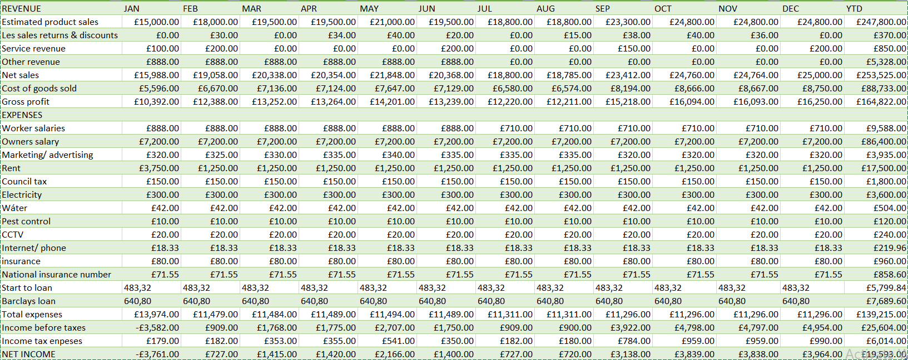
4.Start-up cost

Zero hours contract: the British government is giving help by hiring people from 16 to 24 years old and will pay 25 hours a week for the first six month to help the economy and companies. This amount will be £888 per month (8,20 per hour) as reflected in the previous panel by other revenue. (Villaescusa, 2020)
After six months of government aid, it will go to part time with 20 hours per week.
On the other hand, the government is paying 50% of the food in the establishments, but we will not use that type of vouchers because the offer will end when we open the premises.
Marketing/ advertising: this amount of money will go to face mask, Facebook, instagram and twitter. The cost of the mask will be £0.30 each with the name of the bar included. This is marketing as well for the company. This cheap price is because we manufacture it in Jose’s workshop.
Service revenue: this extra money comes the offers that Coca cola makes almost every season, the company send free products or charge for the drinks at 50% (2 x 1). The same thing happens with Fairtrade company, giving kind of free chocolates every season, for example (M & M, Cadbury, twit).
Rent: the first month of the rent is equal to 3 months, 1 of the rent and 2 of deposit.
National insurance number: this insurance is £2,75 per week, multiplied by 6 owners.
Income before taxes: only the first month is expected to be negative for the company, the other months sales will evolve positively. This happens because it is an area where there are universities (metropolitan university) Arsenal stadium and two nearby metro stops. Colleges and soccer games end in June as reflected in sales.
Income tax expenses: the tax for restaurant and coffee shops is 20%, but the government to support the economy has decided to lower the VAT to 5% during the next six months from august 2020. This type of aid has been granted due to the pandemic. (Diaz, 2020).
Our establishment will be able to enjoy this tax reduction on the first month of opening only as reflected in the panel.
Type of company: Partnership will be the type of training that we will choose. This system is very similar to Sole trader, but in partnership there can be several owners. Each person pays their share of the taxes and all owners are responsible for their debts. The downside would be that the benefits would be paid annually and could not be postponed for next year. Furthermore, the national insurance number would be £2.75 per week. (Londres, 2020)

5.Costs and pricing strategy N.1
 | Product/ service name | Coffee (americano)
A | Number unit in calculation | 360
B | Product/ service components | Coffee, water & milk
C | Total product/ service cost | £113 per 10 kilos of coffee  £0,15 Electricity per coffee  £1.00 lt. of milk (1lt milk-33 coffees overage)
D | Total cost | £178
E | Cost per unit | £0,49
F | Price per unit | £1,20
G | Profit margin (£) | £0,71
H | Profit margin (%) | 59 %
I | Total profit (£) | £254

5.1 Cost and pricing strategy N. 2
 | Product/ service name | muffins
A | Number unit in calculation | 18
B | Product/ service components | muffins
C | Total product/ service cost | £5.04 x 2= £10.08
D | Total cost | £10,08
E | Cost per unit | £0,56
F | Price per unit | £1,20
G | Profit margin (£) | £0,64
H | Profit margin (%) | 53%
I | Total profit (£) | £11,52

As reflected in the previous panel, the profit margin can generate good results in the profits for the company. We have been investigating the probability of surviving the first 3 years and the probabilities are positive due to the following points.
6. Budgets for three years
Concept | Year 1 | Year 2 | Year 3
Initial balance | £55,000 | £81,755 | £116.253
Net sales | £253.525 | £265.500 | £278.500
Other revenue | £5,328 | £5,000 | £7,000
Initial balance + revenue | £318.853 | £352.255 | £401.753
expenses
Last year | £0 | £237.098 | £236.098
Payments for purchases | £88,733 | £92,000 | £98,997
Variable expense payments | £8,463 | £700 | £850
Fixed expense payments | £120.398 | £120.398 | £120.398
Investor payments | £0 | 0 | 0
Loans repayments | £13,490 | £13,490 | £13,490
VAT payment | £6014 | £9414 | £11.500
Total expenses | £237.098 | £236.002 | £245.235
Final balance | £81,755 | £116.253 | £156.518

This panel reflects the numbers assuming that sales were the same in the `following three years.
Other revenue: this money comes from government to hire people. Would be 888 x 6 months = 5,328. After this time, the contract will be 20 hours (710 per month) as reflected on Start-up cost panel.
Variable expense payments: these payments would be £5,328 for the worker, £2,500 from bar deposit, £300 will be for club cards for customers collect discount points. Earning of £5,000 are expected for the first year, £700 the second year with an estimated profit of £7,000 and an investment of £850 for the third year as reflected in the other revenue section. £335 for the manufacture of the masks as reflected in the marketing part of the start-up cost panel. Hopefully, the mask will be used for one more year at most.
VAT payment: the first year the VAT is lower due to the reduction in taxes from 20% to 5%. Unfortunately, this discount is only available during the first month of opening. The second and third year will be 20%, as reflected on the panel.
Machines and appliances: all kinds of machinery and utensils needed for the coffee shop will be donated by Sodexo company (coffee machines, oven, shelves, trays, refrigerators. All these products are second-hand that the company no longer uses. These items will be transferred to our bar in 100% electric Sodexo cars at no cost to our company. This is possible because some of the owners have worked for the company for many years.
UC C Coffee will be the company in charge of the maintenance and repair of the coffee machines
- Power point JOSE CARMONA RODRIGUEZ (1917096)

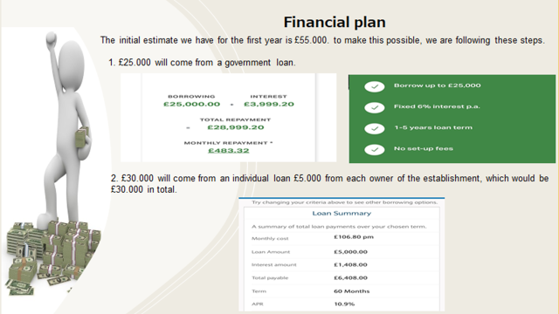.

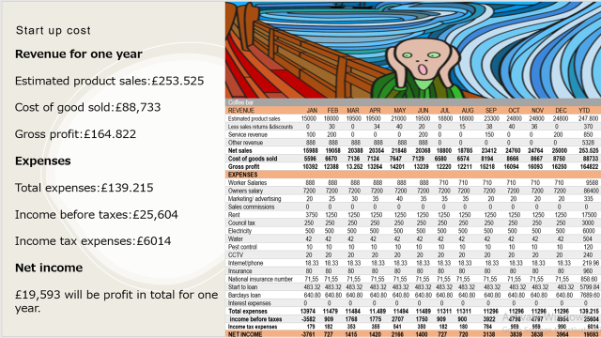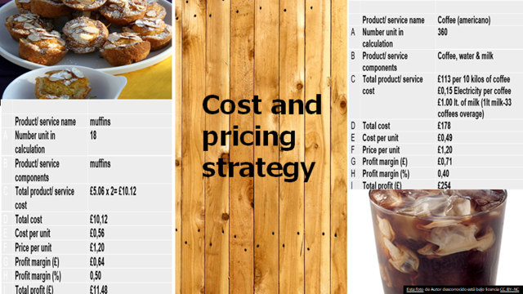
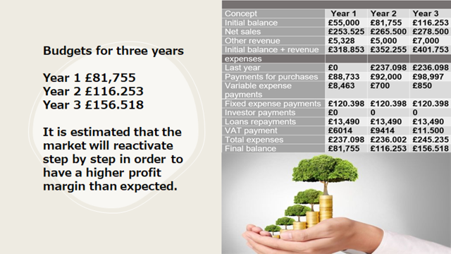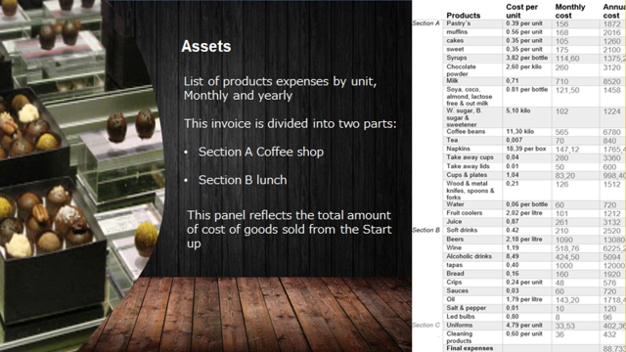
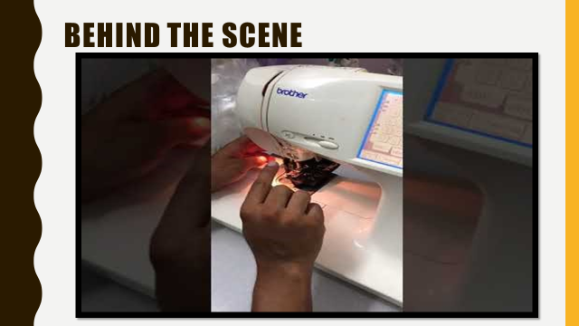

References
Diaz, R., 2020. SDPnoticias.com. [Online]
Available at: https://www.sdpnoticias.com/internacional/paquete-de-estimulos-reactivar-economia-reino-unido-baja-de-iva.html
[Accessed: 10 August 2020].
LOANS, S. U., s.f. START UP LOANS. [Online]
Available at: https://www.startuploans.co.uk/loan-repayment-calculator/?_ga=2.31188476.2147270925.1597324952-1199828717.1597324952
[Accessed: 10 August 2020].
Londres, T., 2020. Trucos londres. [Online]
Available at: https://trucoslondres.com/vivir/trabajo/abrir-empresa-inglaterra/#:~:text=Si%20te%20est%C3%A1s%20planteando%20abrir,es%20muy%20r%C3%A1pido%20y%20barato.
[accessed: 11 August 2020].
Villaescusa, P., 2020. El iberico. [Online]
Available at: https://www.eliberico.com/rishi-sunak-plan-2-mil-millones-de-libras-ayudar-jovenes/?fbclid=IwAR21RfgPuaTGKmxEe2m2dtqh04P4SLX1CYSKBzV1cFWpJ08X6_ZiTiLCuCU
[Accessed: 12 August 2020]

