Post excavation and analysis – Llanllyr finds report
2016-2017 seasons

In this report I will be covering most of the finds that were found at the Llanllyr excavation site in the 2016 and 2017 seasons, as well as doing an overview of the excavation undertaken in these excavation seasons.
TP | Context  number | find type | weight in g | quantity | other info
1 | 101 | glass | 13.93 | 3 | possible bottle stopper
 | 101 | Dyfed gravel tempered | 4.96 | 2
 | 101 | tin glazed earthen | 0.8 | 1
 | 101 | white ceramics | 10.4 | 5
 | 101 | brown ceramics | 15.26 | 5
 | 102 | glass | 0.61 | 2
 | 102 | coal? | 4.98 | 1
 | 102 | brown ceramics | 1.94 | 1
 | 102 | other ceramic | 2.71 | 3
 | 102 | Dyfed gravel tempered | 2.42 | 4
2 | 201 | white ceramics | 6 | 8 | banded ware 19th C
 | 201 | brown ceramics | 25.45 | 6 | bass of Staffordshire Bristol ware, Buckley black glazed 17-19th C
 | 201 | other ceramic | 4.03 | 3
 | 201 | glass | 50.08 | 1 | free blown glass bottle neck
 | 201 | smoking pipe piece | 4.33 | 1 | foot of the pipe
 | 201 | metal | 35.72 | 6 | largest piece may be nail head, heavily concreated
 | 202 | white ceramics | 7.1 | 6
 | 202 | charcoal | 0.22 | 1
 | 202 | metal | 369.09 | 7 | 3 large nails, one of which is flat in section. Heavily concreted
 | 203 | glass | 10.1 | 3 | largest piece has "ONS" possibly sons?
 | 203 | coal? | 0.62 | 1
 | 203 | white ceramics | 4.25 | 5
 | 203 | North Devon tempered | 8.05 | 2
 | 203 | Staffordshire ware | 9.7 | 1 | heavily stripped
 | 203 | metal | 123.95 | 10
3 | 301 | glass | 2.99 | 1
 | 301 | smoking pipe piece | 4.45 | 2 | section of stem and bowl
 | 301 | coal? | 9.84 | 2
 | 301 | orange ceramics | 23.36 | 7
 | 301 | brown ceramics | 8.8 | 2
 | 301 | other ceramic | 3.93 | 2 | one piece green glazed
 | 301 | metal | 11.93 | 1 | concreated
4 | n/a | gravel | 13.91 | 2
 | n/a | worked stone | 127.7 | 1 | possible hammer stone?
 | n/a | glass | 1.77 | 1
 | n/a | coal? | 2 | 2
 | n/a | black ceramics | 4.64 | 1
 | n/a | green ceramic | 0.94 | 1
5 | 501 | glass | 14.98 | 9
 | 501 | white ceramics | 26.81 | 14
 | 501 | brown ceramics | 12.08 | 5
 | 501 | black ceramics | 9.14 | 5
 | 501 | green glazed ceramic | 17.77 | 2
 | 501 | North Devon tempered | 31.28 | 5
 | 501 | coal? | 5.72 | 1
 | 501 | metal | 37.21 | 9
 | 502 | North Devon tempered | 22.88 | 2
 | 502 | brown ceramics | 16.11 | 3 | large piece is base of a tankard
 | 502 | black ceramics | 4.82 | 2
 | 502 | glass | 4.38 | 2
 | 502 | metal | 8.87 | 2 | concreated
6 | 601 | Buckley type | 8.47 | 1
 | 601 | North Devon tempered | 9.07 | 1
 | 601 | Dyfed gravel tempered | 1.81 | 1
7 | 701 | glass | 24.3 | 4
 | 701 | North Devon tempered | 17.97 | 2
 | 701 | Buckley type | 38.3 | 2
 | 701 | other ceramic | 2.56 | 3
 | 701 | metal | 144 | 2
 | 701 | coal? | 0.85 | 1
 | 701 | manganese deposit? | 12.52 | 17 | bag labelled charcoal, definitely not charcoal
8 | 801 | Buckley type | 52.81 | 4
 | 801 | English stone ware | 12.39 | 1
 | 801 | other ceramic | 3.5 | 2
 | 801 | white ceramics | 9.04 | 7 | blue patterns
9 | 901 | metal | 5.5 | 1
 | 901 | glass | 13.49 | 4
 | 901 | Dyfed gravel tempered | 9.96 | 5
 | 901 | brown ceramics | 10.45 | 1 | handle of some form
 | 901 | white ceramics | 5.03 | 4 | blue decoration
 | 901 | smoking pipe piece | 1.23 | 2 | stem piece, bowl section
 | 901 | unidentified material | 2.49 | 1
10 | 1001 | glass | 19.04 | 3
 | 1001 | white ceramics | 13.8 | 5 | blue decoration
 | 1001 | Buckley type | 4.83 | 3
 | 1001 | other ceramic | 3.02 | 4
 | 1001 | smoking pipe piece | 5.66 | 2 | stem pieces
 | 1001 | CBM? | 99.55 | 8
 | 1001 | worked stone? | 759.23 | 1 | possible worked stone
 | 1001 | flint | 0.18 | 1 | orange flint shard
 | 1001 | charcoal | 41.04 | 6

This table is not complete unfortunately, there were five more text pits that had finds. For example test pit 14 produced a large amount of metallic finds which may have shed some more light on the area and significantly helped with this report. There may also be some inconsistences in the labelling of the finds as some were analysed by Dee Williams and others not, meaning that some pottery types may have been missed and even ones of the same type may not have the correct labelling because of this.

The majority of the finds can be broken down into a few main groups, these being: Pottery, ceramic building material, smoking pipe, coal, charcoal, worked stone, glass and metal. Within these main groups there are some sub groups, this is mainly within the pottery group. These themselves are: Dyfed gravel tempered ware, North Devon tempered ware, Buckley ware (or Buckley type ware), brown ceramics, black ceramics, orange ceramics and white ceramics. Some of these sub groups may seem quite wide ranging, this is down to the fact I am not a pottery expert so have labelled them to the best of my ability. Some of the finds have been analysed by Dee Williams, a former UWTSD staff member, Dee is the person who has identified some of the finds as being the Dyfed gravel tempered ware and the North Devon tempered ware with a couple finds of Staffordshire ware. Not all the finds bags had been analysed by her, thus meaning some finer detailing of finds types may have been missed however most had and thus the main identifiable pottery has been labelled and noted.

In terms of dating any of the finds the Dyfed gravel tempered ware can date from anywhere between the 13th and 16th century, whilst this may appear to be useful that is a 400 year scope of which the pottery could date from. If some of the pottery pieces dated from the 13th century this would help back up any ideas of High Medieval property in the immediate area, whereas if it is from the later period then it is just more pottery from that period. The North Devon tempered ware typically dates slightly later than the Dyfed gravel tempered ware, and there are a few context layers in which these had been found, examples are 601 in which both North Devon tempered ware and the Dyfed gravel tempered ware had been found; the North Devon tempered ware has also been found in context numbers 203, 501, 502, 601 and 701. The Dyfed gravel tempered ware was found in context numbers 101, 102, 601 and 901. It is interesting to see that there is slightly more of the North Devon tempered ware found than that of the Dyfed gravel tempered ware, this is because the excavation area is situated within the old county boundaries of Dyfed (now Ceredigion) and thus it would be reasonable to think that the locally produced pot ware would be in higher use than that of an imported pot ware. It is entirely possible that the people in residence of the excavation area were wealthier people and thus could afford to have pottery imported from North Devon (it isn’t a huge distance away), however this is just speculation and not able to back this up.
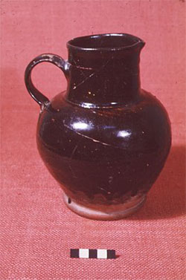
Besides these types of pottery there was a lot of other bit of much finer ceramics, these are labelled as the brown, black, orange and white ceramics on the table above. Another type of identified pottery was the Buckley ware or Buckley type ware. See below for an example of Buckley ware.

Longworth, ND.

There was a number of finds of this pottery type found on the excavation during the 2016 and 2017 excavation seasons, these were found in test pits 601, 701, 801 and 1001. As you can see on the table above, there is also brown ceramics listed these could be more samples of the Buckley type ware. The black ceramics listed in the table could also be samples of this pottery type, there may have just not been sufficient material in these samples to properly identify as such. The other types of ceramics identified as mentioned before are the brown ceramics, black ceramics, orange ceramics and white ceramics. The brown and black ceramics were pretty plain bar a couple of examples that had some simple stripped decoration. These decorations sit in line with Staffordshire ware, similar but less detailed to the below image.

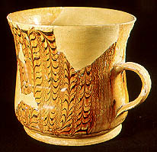
Ashmolean Museum, 2001.

As mentioned the brown ceramics which were similar to that of the Staffordshire ware were not as detailed as the above image but were certainly a similar style. Dee Williams did identify some Staffordshire ware shards in context layers 201 (this was a shard from the bass of a cup or small jug) and in 203 (this shard was heavily stripped in the brown and natural ceramic colour as shown in the above image). There were only 2 shards identified as this type of ceramic ware, if this data set is to go off then it could signify that this was an expensive pottery or ceramic type to import to Wales however the data set we have is only small section in a fairly rural area thus to find any is quite interesting. An example of English stone ware was also found at the site in context number 801, this is likely to have just been 18th or 19th century rubbish as is much of the pottery and ceramic finds from the 2016 and 2017 excavation seasons.

The white ceramics mentioned can be split into two groups. The first being plain white ceramics and the other being patterned/coloured white ceramics. The plain white ceramics were simply that plain white ceramic shards, possibly from 19th century white china ware/standard household cups and saucers type material. The patterned/coloured white ceramics were a bit more interesting. The majority of these had blue painted patterns on them, most if not all were indecipherable as to what they were depicting. An example of the blue painted white ceramics is below.
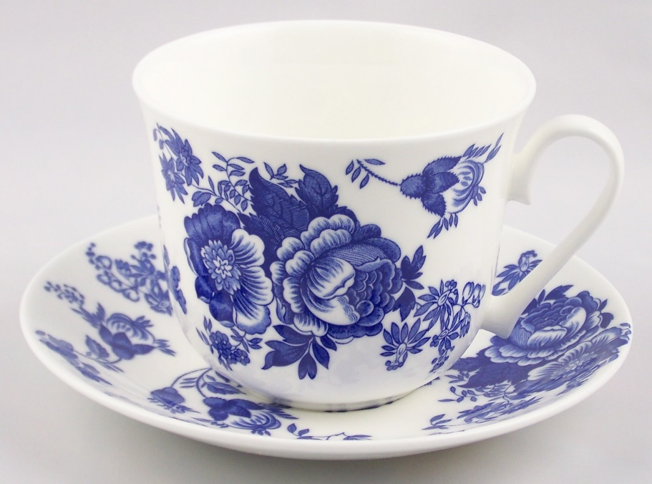
Joanbet, 2010.

This painted white ceramic would have been fairly decorative when the original ceramic artefact was in use. Dee Williams did note that one of the finds from test pit 10 context number 1001 was hand painted by children, it is unknown to me how that is known however she is the expert thus I will assume she is correct. The rest of the other blue painted white ceramics had no notes on them, likely that they are just common ceramics that have no interest/historical value. The other coloured ceramics were either brown stripped or had a slight egg shell blue haze/glaze to them. These pieces were indecipherable shards that were thin, around 2mm to 3mm.

Another common find from the excavation was glass with 8 of the 10 test pits weighed containing glass in at least one context layer. Whilst most of the glass found was thin glass possibly from tractor or vehicle windows, there were a few pieces that stood out. First of all was the probable glass stopper from test pit 1 context layer 101. This glass stopper had the lid and the stem which would have gone into the glass bottle or receptacle. The stem of the stopper was around 20mm in length, 6mm at its widest point and 4mm at its narrowest point. This could indicate that the stopper was for a small bottle, or one that you were only meant to decant a little from at a time such as a medicine jar/bottle. Another glass artefact that stands out from the rest is the bottle neck that was found in test pit 2 context layer 201, this bottle neck came from a hand blown bottle dating it to the 19th century at the latest. The bottle neck itself was made out of brown glass, this is glass with sulphur added to produce the brown colour. The bottle neck had broken off of the rest of the bottle seemingly at the shoulder to the main body of the bottle. Another interesting glass find was a fairly thick section of glass that had “ONS” on the piece of glass, this is likely from “SONS” of some company. With this information it is possible that the glass object this shard came from was originally machine made, and thus produced after the turn of the 20th century.

There was a large collection of metal finds from the various test pits. Due to the natural process of corrosion in the ground all bar a few of the metal finds were pretty indistinguishable. Test pit 2 context layer 201 produced 6 pieces of metal, the largest of which may have been a fairly large nail head. This is discernible from the mushroom type shape of the concreated find. In the same test pit but in context layer 202 three large nails were uncovered, two of them were standard looking nails but the other was a flat rectangular section nail. The use of such I nail I am not entirely sure of, however I have seen them used in fixing objects to stone gate pillars. As mentioned there was a lot of metal finds discovered, however they were all heavily corroded and concreated. Test pit 14 produced a significant amount of metal artefacts, more than the rest of the test pits combined. Unfortunately I did not have the time to weigh out and properly check over the contents of the metal finds from this test pit so cannot give any more detail on them. From feeling the weight of the bag containing the finds, there is easily 3kg of metal finds from test pit 14. The test pit in question did appear to be a waste disposal area, as there was a significant amount of both metal and ceramic/pottery finds from test pit 14.

There were a few finds of smoking pipe pieces from the 2016 and 2017 excavation seasons. Test pit 2 context layer 202 produced the base/foot of the pipe bowl, this would indicate a later period ceramic pipe. Test pit 3 context layer 301 produced 2 sections of pipe stem, interesting to note that these pipe stem sections had quite thick walls, around 2mm all the way around, and the hole in the stem was quite central as this is not always the case in ceramic/clay pipes. Test pits 9 and 10 also produced pieces of pipe in context layers 901 and 1001. These were mainly stem pieces, though one was a section of the bowl of the pipe. This bowl section would indicate that the pipe was of later period production, this would line up with the foot section of the pipe from test pit 2.

There were two pieces of worked stone found on the site. One in the 2016 season and one in the 2017 season. The worked stone from the 2016 season was from test pit 4, sadly without context number. This find is what appears to be a hammer stone, the stone itself had the clear tell-tale signs of being a hammer stone with slightly chipped edges and a perfectly smooth and rounded stone. This find is quite significant to the area as previous knowledge of Palaeolithic, Mesolithic, Neolithic finds were unknown of in the immediate area. The other find which is from the 2017 season is only a possible worked stone, found in test pit 10 context layer 1001. This stone appears to be worked due to the perfect angles on the stone, the use of the stone is uncertain and very difficult to tell. Though due to the size of the stone, roughly 10cm long by 5cm, it is highly likely to not have been hugely structural in any way. This find is not diagnostic unfortunately.

There were a few coal finds: test pit 1 context layer 101; test pit 2 context layer 203; test pit 3 context layer 301; test pit 4; test pit 5 context layer 501 and test pit 7 context layer 701. Although there was a fair amount found this does not really tell us much, this is because coal was used in home and to heat most things for quite a period of time. There were a few samples of charcoal found on the excavation through both seasons, however most of this was not salvageable during excavation due to the excavation conditions in the wet sticky clay. There was a bag labelled as charcoal from test pit 7 context layer 701, however upon further examination these finds were not charcoal but were another hard deposit of some form, possibly a sort of manganese or other mineral deposit however I am uncertain further chemical analysis would need to be undertaken to be certain.

One of the most interesting and important finds from the excavation was the discovery of a small flake of orange flint found during the 2017 season in test pit 10 context layer 1001. This could indicate Palaeolithic, Mesolithic or Neolithic activity in the area (alongside the hammer stone) however due to it being only one small shard of flint and not a full scatter pile it is not diagnostic.

Alongside the listed finds above during the 2017 season there was a considerable amount of preserved wood discovered. From a preliminary view of the wood finds there were not worked pieces of wood and likely were just pieces of wood that either got buried for some reason or were covered in a flooding incident. The excavation site is in the immediate vicinity of a palaeochannel. I do believe that one of the more substantial pieces of wood recovered was dated to the bronze age, however I am uncertain of this and do not have that data to give a detailed and confirmed answer to. The wood was discovered in a water logged state and were preserved due to being in waterlogged clay deposits.

In conclusion the site for the 2016 and 2017 excavations at Llanllyr produced a wide array of artefacts from the common ceramic/pottery to the more unexpected flint, hammer stone and wood finds. Although there were a lot of finds recovered from the excavation seasons not a lot, possibly none, are truly diagnostic to tell us a great deal about the site and its use. This is unfortunate as the site does show some promise for future excavation, be it field school excavation or research excavation. The finds from test pit 14 may shed some more light on the use of the site as there was a lot of finds, especially metal finds, all deposited in one place. The use of Dee Williams being able to take a look at the pottery finds and identifying some of them has been vital in this analysis and report. As I myself would not know what I was looking at in terms of the specific pottery, to me they are bits of pottery that show no significant importance or I may have placed importance on unimportant pieces and missed the important pieces. In terms of the analysis and weighing of the finds I had to do this on my own, whilst it didn’t take too long to do it was meant to do undertaken by the class though this did not happen and thus was left down to me again.

References:
Ashmolean Museum. 2001. 2000 years of pottery forms and shapes Post Medieval AD 1600 – 1720. Available from: http://potweb.ashmolean.org/PotChron6-35.html [Accessed 28/05/2018]
Dee Williams – Pottery expert, ex UWTSD staff member
Joanbet. 2010. Fine English Bone China Cup and Saucer - Roy Kirkham Breakfast Set - Blue Rose Chintz. Available from: http://www.joanbet.com/index.php/review/product/list/id/490/category/6/ [Accessed 29/05/2018]
Longworth, C. ND. Buckley Ceramics in the Seventeenth Century: Socio-Economic Status of the Potters and Possible Design Influences. Interpreting ceramics. Available from: http://interpretingceramics.com/issue006/articles/01.htm [Accessed 28/05/2018]

