NAME: | STUDENT NO: | LCLM: | LECTURER  NAME: | ASSIGMENT TITTLE:
ENODOGBAN  AIBANGBEE  IYEKHU | 2330350 | 5003 | DOREEN  NRYAA | A PROJECT PORTFOLIO.

Table of Contents
Introduction 3
Resources and Budget 9
Risk management 10
Quality and performance……………….…………………………………………………………………11
Scopes...…………….……………………….………………………………………………………………12
Sustainability and Resilience………………………………………………………………………….13
Conclusions…………………….……………………………………………………………………………14
Stakeholder management…….……………………….……………………………………………….15
References….………………………………………………………………………………………………16

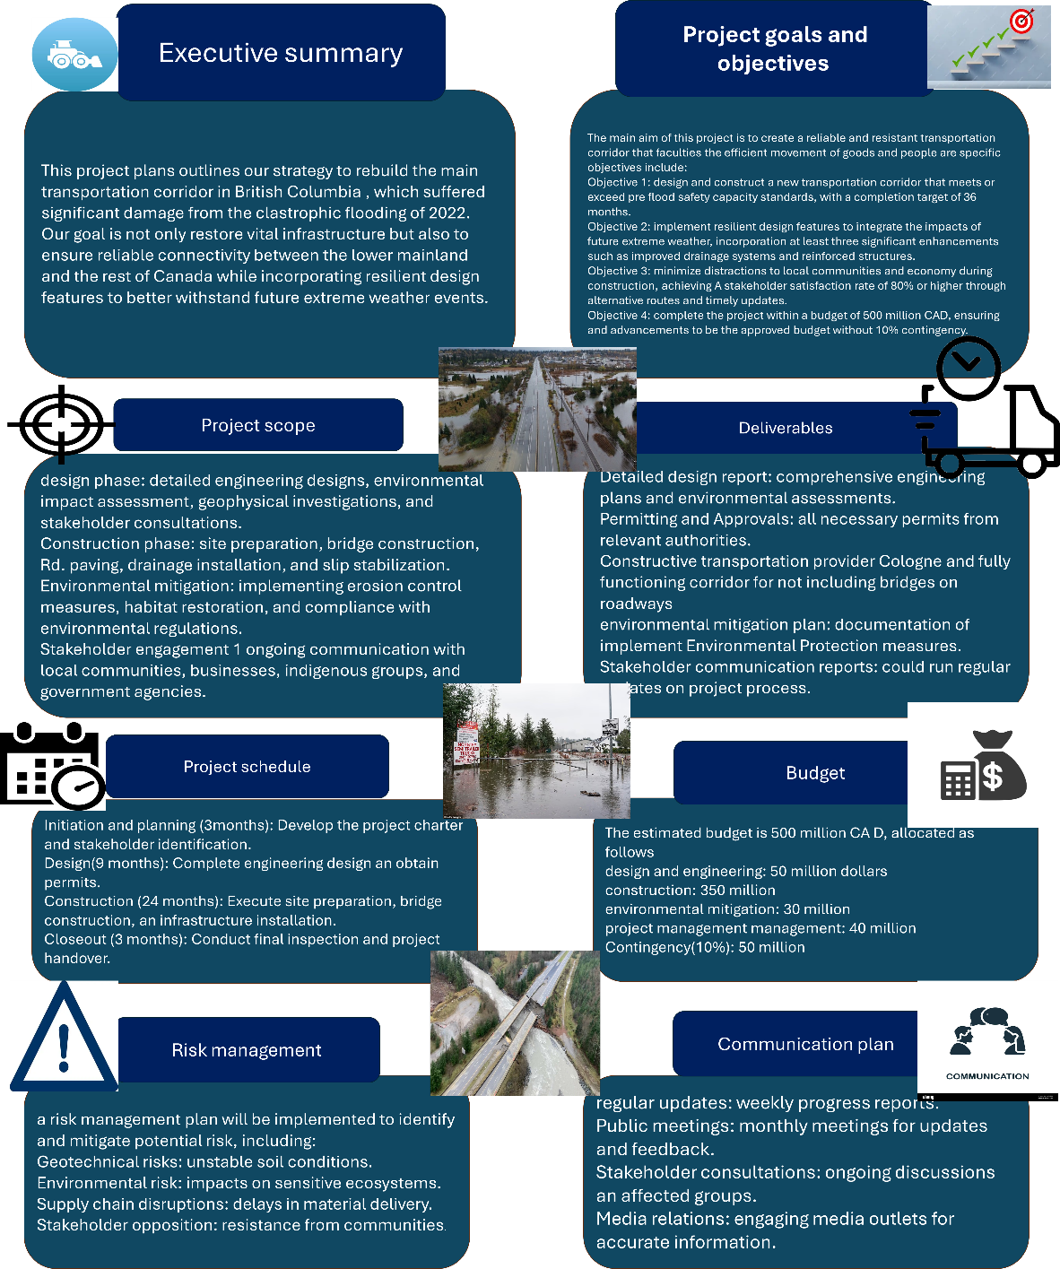
After presenting my poster and receiving comments from my tutor on my classmates, I came away with much clearer understanding of what word well and what needed improvement in my project pro proposal. The feedback I received was incredibly valuable because they highlighted areas that they consider deeply enough and help me to think more realistically about how such a large could be delivered.
One major area for improvement is realism and detail in planning. My Lecturer and peers pointed out that my schedule was overly ambitious and lacking clear milestones I tend to be optimistic when setting deadlines which can lead to unrealistic expectations who stop I learn how to build more achievable timelines by considering constraints such as weather procurement delays and regulation approvals who start in future work I will discuss our focus on applying project management tools like critical path analysis and risk adjust schedule to create timeless that are more evidence based and defensible.
I need to communicate stakeholder engagement more thoughtfully. That feedback revealed that much stakeholder feedback revealed that my stakeholder section was too general and didn't reflect a deep understanding of each group specific needs are learned that engagement is not a state box task it requires empathy timing on continuous dialogue who stop I need to become better mapping out who needs to be informed consulted or directly involved I each project phase the looping clear communication plans such as using frameworks and ACI charts will help me do this more effectively.
Another personal learning is about risk management contingency planning although I mentioned risking a poster I haven't properly prioritise or link them to integration actions I realised that effective risk management requires going beyond identifying threads a involves quantifying like livelihood and planning proactive responses I would make continuous effort to use troops should risk register and update them regularly rather than treat them as one of deliverable.
Lastly, I recognise that I must strengthen my presentation and communication skills who stop some peace said that Palmerston felt a technical indent attention over focus on content under focus on how it's delivered who stopped in future presentations our aim to simplify my language use more visuals and focus on telling a classical rather than overwhelming the audience with deal.
Overall, the feedback helped me see that improvement isn't just about fixing a project is about developing my professional habits who stop by working on realism common resource planning, stakeholder empathy, structured risk management, and communication clarity, I can grow into a more effective and real active project manager. These lessons have also reminded me that collaboration and feedback are vital in my professional environment. Listening to others perspective not only strengthens my word but also broadens my man said come on helping me approach complex challenges with more confidence, humility, and awareness in the future.

Introduction
Project name: Highway 5 principal corridor reconstruction
Sponsor: province of British Columbia ([ministry of transportation and infrastructure) Project manager: assigned PMO (proposed: senior infrastructure PM from provisional PMO)
Purpose: following catastrophic 2022 flooding, Hay way 5 the principal corridor connecting the region to mainline Canada is severely damaged. This project will restore safe slash reliable transport of people and goods by reconstruction the damage stretches, repairing/replacing which is an essential infrastructure, and we establish full operational capacity.

OBJECTIVES:
- Re-establish emergency capable boot temporary repairs within eight weeks of project mobilisation.
- We open A two lane limited capacity corridor for freight and passages within six months
- complete full corridor we construction to design standard within 24 months.
- Ensure safety, environmental Compliance an indigenous consultation throughout.
- Integrate indigenous knowledge into planning and decision making.
- Deliver value for money with transparency and accountability.
ASSUMPTIONS:
- Provisional and fed Federal Emergency funding it's available
- Key contractors and suppliers can be procured rapidly through accelerated procurement.
- Weather and river flow patent follow historical ranges, with some seasonal constraints.
Each of these goals connect to a bigger vision: building back better. They remind us that infrastructure is more than concrete and asphalt it's the foundation of economic recovery and social connection
When I reflect on these objectives, I see how they require both technical skill and emotional intelligence. Achieving them will mean balancing deadlines with compassion, budget with environmental care, and design efficiency with structure respect.

PROJECT DESCRIPTION:
This project reconstructs approximately off Highway 5 including multiple bridges placements, slip stabilisation, repairs, pavement replacement, on utility with location
- PHASE A: this stage focuses on making corridor usable again. Include site inspections, debris removal, temporary bypasses, And the installation of modular bridges to restore limited access for emergency and for vehicles
- PHASE B: Reconstruction this is the main construction stage. It covers detailed design work, bridge replacement, drainage improvements, be paving, a final environmental restoration.
The final goal is not just to rebuild what was lost but to reimagine the corridor for the future. Incorporating climate resilient materials and engineering practises will ensure the highway come better withstand with similar disasters.
This this overview shows how I clear call my face approach bring structure to complexity. He reminds me that in project management, clarity is power when every stakeholder can see the big picture, they can align the efforts toward a common goal.
SCOPES:
- Repairing or replacing damaged bridges and payment sections.
- Stabilising slopes and rebuilding embankments.
- Installing new culverts, drainage, and erosion control systems
- Coordinating with utility providers for relocations or protection works.
- Managing environmental permits and rehabilitation.
- Engaging with engaging indigenous communities and residents.
- Testing, commissioning, and final handover to operations.
Not included:
- Highway widening or new capacity expansion.
- Private property repairs outside the highway corridor.
- Long term maintenance beyond the handover.
Success criteria:
- Safe, two-lane highway restored to provisional design standards.
- Environmental and cultural commitment met.
- Positive acceptance from key stakeholders.
Defining script clear this start prevents confusion later. In past projects, I've seen how unclear boundaries can cause delays and cost overruns. Here, the scope ensures focus and discipline, which are critical when working under public scrutiny.
This section reinforces how bad toy is to protect the project from scope creep. Staying discipline does not mean being inflexible it means being intentional about where effort and money are spent.

WORK BREAKDOWN STRUCTURE:
- Project setup and governance establish the PMO, reporting structure, and communication processes.
- Site assessment and design conduct geothermal service, environmental assessments call mom I'm prepared for the final design drawings.
- Procurement and contracting pre-qualified contractors, order long lead materials like bridge components and finalise contracts.
- Emergency restoration clear debris, installed temporary bridges, and restore basic access.
- Permanent reconstruction builds new bridges, stabilise slopes, lay new pavement, complete drainage updates.
- Testing on handover carry out inspections, safety cheques, an environmental sign off.
- Stakeholder engagement maintains ongoing communication with indigenous group, businesses on the public.
Reflection: I realised that structure is not just about control it's about empowerment. When everyone knows what they are responsible for, the project becomes smoother and more collaborative. This breaks down gives clarity was still living space for flexibility and problem solving when unexpected challenges arise.

Work break down structures table is as follows below:
CATEGORY | BUDGET IN MILLIONS | % of total budget | ACTIVITIES
DAMAGE ASSESMENT | 25 million | 5% | Structural and environmental | Early accurate assessments
SITE CLEANING | 40 million | 8% | Debris remove, temporary bridge | Enables emergency transport
BRIDGE AND ROAD RECONSTRUCTION | 260 million | 52% | Core rebuilding of bridges | Central infrastructure
DRAINAGE AND RESILIENCE | 45 million | 9% | Culverts, slope stabilization | Strengthens long term resilience
MATERIALS AND LOGISTICS | 40million | 8% | Procurement and delivery | Efficient supply chain
LABOUR AND CONTRACTOR | 45 million | 9% | Skilled workforce | Promotes local employment while maintaining quality
RISK CONTIGENCY FUND | 25 million | 5% | Reserve for unseen | Ensures financial flexibility
MONITORING & QUALITY CONTROL | 10 million | 2% | Inspections, testing, and compliance | Maintains safety and ensures adherence to national standards
COMMUNITY ENGAGEMENT | 5 million | 1% | Public consultation | Promotes transparency, reduces resistance
PROJE CT MANAGEMENT | 5 million | 1% | Oversight coordination | Provides governance and accountability across all phases

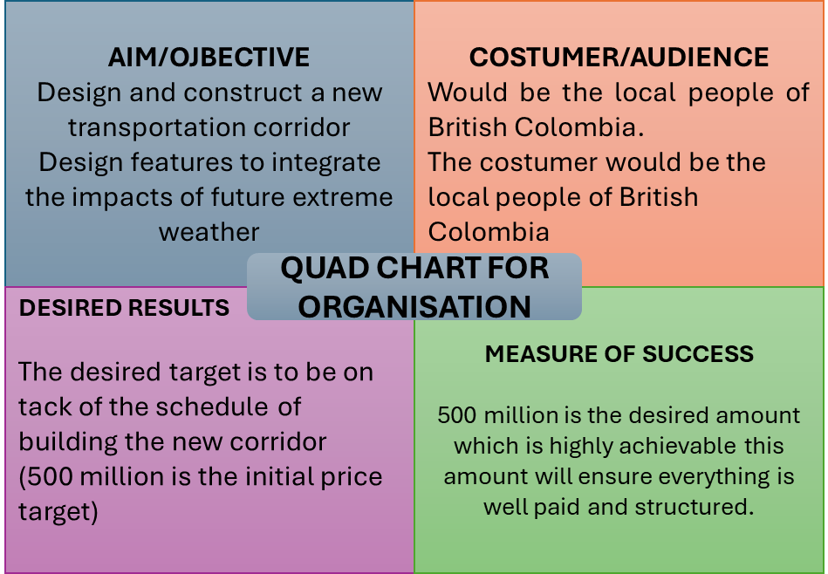

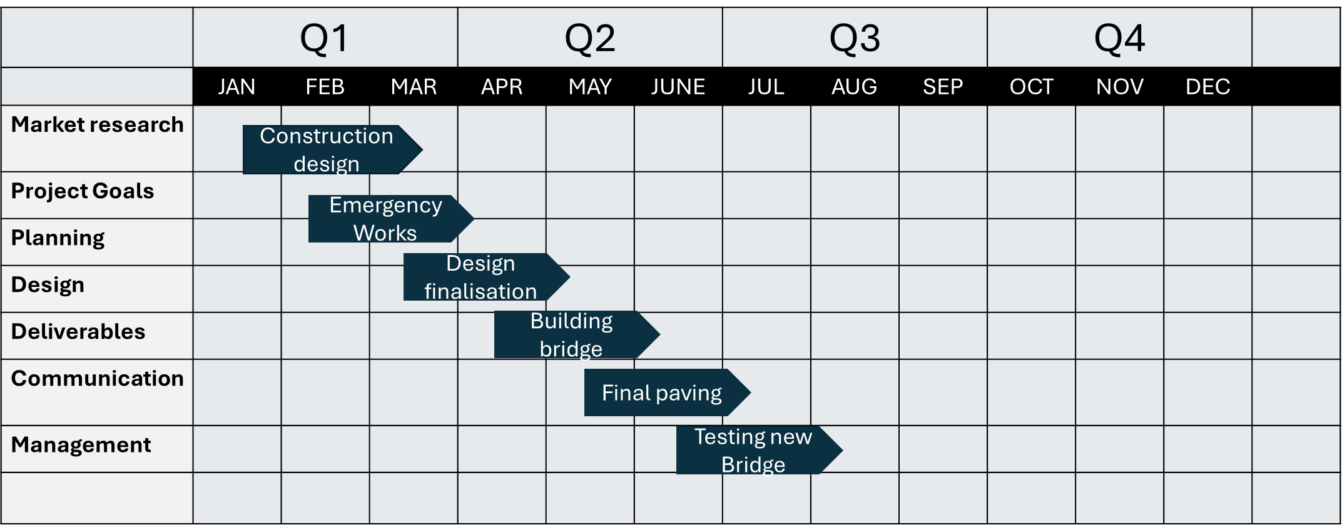

RESOURCES AND BUDGET:
• Project director
• Senior project manager
• Construction manager
• Design needs
• Procurement and commercial lead
• QA/QC and HSE officers
• Stakeholder an indigenous engagement lead.
Equipment on materials: gardeners, compactors, prefabricated bridge sections, drainage materials, safety barriers, and temporary traffic control systems.
Budget approach:
Early estimates will be broad, Rih find as the design matures. As a contingency allowance around 15 to 20% will be built into both schedule and budget to cover unforeseen issues. Strong financial controls and transparent reporting will keep the project accountable and on track.

The budget reflects a balance between efficiency and resilience. Using prefabricated bridge components, for example it can save time but requires upfront investment. Transparent cost control, monthly financial reporting, and continuous risk-based adjustments will keep speeding on track.

Reflecting on this, I realised that budgeting isn't just about numbers it's about trust and credibility. Our war manage budget we reassure funders, motivate the team, and signal to the public that their money is being used wisely and responsibly.

STAKEHOLDER MANAGEMENT

Stakeholder management is one of the most critical parts of this project. The 2022 floods didn't just damage infrastructure being disrupted communities, economies and livelihoods. Rebooting must therefore involve meaningful collaboration.

KEY STAKEHOLDER:
- provisional and federal governments
- Local municipalities
- Indigenous nations on communities
- Free operators and logistic companies
- Local businesses and residents
- Environmental and regulation agency

RISK MANAGEMENT
RISKS | LIKELIHOOD | IMPACT | MITIGRATION
Delays in environmental permitting | Medium | High | Start permit discussions early
Severe weather disruptions | Medium | High | Plan work around seasonal windows
Supply chain delays | High | High | Pre-order materials; use local suppliers where possible
Unstable ground condition | Medium | Medium | Conduct early geothermal test; maintain design flexibility
Community or indigenous concerns about impact | Medium | Medium | Engage early and often; adjust plans collaboratively
Cost escalation from market changes | Medium | High | Include price-escalation clauses; update estimates regularly

I realised that our strong risk plan is like a safety net you hope to never use it but it's still comforting to know it's there the best managers don't just identify risk they create coaches and anticipation adaptation.
QUALITY AND PERFORMANCE
To make sure the rebuilt corridor meets the highest standards, the project will adopt A proactive approach to quality assurance.
Bailey inspections, laboratory testing of materials, an independent structural cheque will ensure that every section meet provincial design codes. Performance indicators will include:
- safety records (zero serious incidents).
- On time completion of emergency reopening.
- Environmental compliance and permit closure.
- Positive feedback from communities and indigenous partners.
Regular internal audits will keep the team accountable and highlight any need for corrective action.
Quality isn't just technical it's a mindset the team was so empowered to speak up if something doesn't look right. Creating a culture where quality is everyone’s responsibility is one of the most powerful ways to prevent issues before they occur.
This section reinforces that excellence isn't achieved through inspection and learn bought through Pride in craftsmanship. Every bridge joint, every pavement layer tells a story of human effort and teamwork.

SUSTAINABILITY AND RESIELIENCE
beyond the building what was last, the project aims to create more sustainable and climate resilient corridor. This means selecting durable materials, improving drainage, would you sing environmental footprints, an integrating climate adoption design principle. Wherever possible, local contractors and suppliers will be used to support regional economies and reduce transport emissions.
Environmental restoration including replanting native vegetation and stabilising will be a visible part of the project legacy.
Additionally, the project will commit to low carbon construction practises using recycled aggregates, would you sing waste, and optimising fuel consumption. Collaboration with environmental scientists and local indigenous groups would guide ecosystems restoration efforts.
This focus on resilience reminds me that sustainability isn't just an add-on it's a mindset shift it's about leaving behind infrastructure that supports future generations are not burdens them.
GOVERNANCE AND REPORTING
clear governance keeps a large project focused and transparent.
- Project steering committee: senior representatives from the province call mark federal partners and the PMO to oversee progress and key decisions.
- Project management office: responsible for daily control, budget monitoring, and reporting.
- Change control process column to manage any changes in scope, budget, or timeline.

By keeping decision making structure and communication open, the project can stay align with its original purpose while adapting to new challenges.
Monthly progress reports will summarise budget performance, scheduled status, and emerging risks.
Reflecting on governments, I've learned that structure doesn't stifle creativity it supports it when Roseanne responsibilities are clear, people can focus on solving problems rather than navigating confusion.

LESSONS LEARNED ND CONTINIOUS IMRPOVEMENT
Throughout this project, lessons will be documented at each milestone. This would be informed future infrastructure projects across the province
Capturing lessons about humanity recognizing that no project is perfect, and every challenge is an opportunity to learn it's a reminder that the best managers are lifelong students of their craft.

CONCLUSION
Rebuilding Highway 5 is more than a construction project it's about restoring vital connection for people and communities of British Columbia it's about safety, economic recovery, and resilience in the face of climate driven disasters.
This plan sets out a practical yet responsible path forward. It focuses on clear communication, careful risk management, collaboration with indigenous partners, and a committee to sustainability. The lesson learned from the floods will inform every stage and ensuring that the rebuilt corridor is not only stronger but smarter.
By staying realistic implanting transparent in communication, and flexible in delivery this project concern example for how critical infrastructure is restored after major natural not just as a repaired bridge but as a symbol of recovery resilience and respect for the communities it serves.
Being on this journey, I understand that project management isn't just about charts and checklists it's about leadership empathy and the quiet determination to do things right even if they are hard.
What makes this plan truly meaningful its integration of people, culture, and environment. The consultation with indigenous nations brings traditional knowledge and respect for the land into modern engineering. That partnership changes how we define success it's not just a completed red, but I relationship of trust built through listening and shared responsibility. The environmental restoration efforts, from replanting vegetation to improve drainage, will leave a legacy that supports biodiversity and climate millions long after the last construction vehicle leave the site.
From a professional standpoint, this project is also personal learning journey. Managing a programme of this still requires humility recognising that no single person has all the answers. It's a reminder that strong relationship doesn't mean having complete control it means creating conditions where others can contribute their experiences confidently. Their Highway 5 reconstruction will test coordination, patients, and adaptability, but I also strengthen every person involved.
Ultimately the project success will not be measured only kilometres of payment restored, but it in how well it reveals confident and safety for everyone who depends on the corridor. This plan stands as both a road map for recovery and reflection of what are effective project management looks like then when guided by empathy, mark transparency and foresight if executed as visualised, Highway 5 would become a model for sustainable infrastructure prove that even after disaster, careful planning call my collaboration and shared purpose consent devastation into opportunity, leaving behind not just a stronger word but a stronger province.

REFRENCES
- Nitrocdn.com. (2025). Available at: https://cdn-jhedb.nitrocdn.com/sOEUXIIujYCjpbdSSOunwuzNLmVSudKp/assets/images/optimized/rev-c7368de/www.citation.co.uk/wp-content/uploads/2020/10/ppc-dark.jpg [Accessed 2 Nov. 2025].
- Project management institute 2021. A guide to the project management body of knowledge.
- Government of Canada 2023. Disaster mitigation and adaptation fund guidelines.
- CSA group 2022. Canadian highway bridge design code (CHBDD)
- engineers and geoscientists BC 2024. Guidelines for professional practise: sustainability in engineering.
- Infrastructure Canada 2023. National adaptation strategy building resilient communities and a strong economy.
- United Nations office for disaster risks reduction (UDRR) 2022. Sendai framework for Disaster Risk Reduction 2015 to 2030 progress on implementation report.
- Google schooler
- Gov.uk

