

Introduction to Physiology
(BMHP5003_LON)
Assessment Component 2
REPORT

Student name: Justyna Cichocka
Student number: 1916227
Group: 2
Lecturer name: Noura Mohamed
SUBMISSION DATE: 08/09/2021

Contents
- Introduction…………………………………………….........2
- Normal and Abnormal Physiology of the Pancreas…. 3
- Case Study…………………………………….....................4
- Impact of Exercise………………………………………...5
- Impact of Diet………………………………………………..6
- Importance of Exercise…………………………………….7
- Impact of Smoking………………………………………….8
- Recommendations……………………………………........8
- Conclusion…………………………………………….........9
- References……………………………………………11
- Appendix……………………………………………13

Introduction
The pancreas is predominant organ in human physiology because is responsible for dual functions [Tucker, 2015]. The endocrine function taken place in ‘‘islets of Langerhans’’, where each islet contains 4 different types of cells (alpha, beta, delta, PP cells) and each cell produce different hormone [Tucker, 2015]. Mainly insulin and glucagon are hormones that regulate blood sugar level in a healthy range in the human body. The exocrine function is to produce enzymes that help digest our food [Tucker, 2015].
Diabetes is a chronic health condition that affects the way human body converts food into energy. Most of the food you eat is broken down into monosaccharide sugar also knows as glucose and released into your bloodstream [Gordon Betts et al., 2013]. When your blood sugar rises, it signals the pancreas to release insulin. Insulin acts like a key to let the blood sugar into your body’s cells for use as energy. Diabetes is a chronic disease in which the pancreas does not make enough insulin, or the produced insulin is not use properly by the cells in the human body. When there is not enough insulin or cells stop responding to insulin, too much blood sugar stays in the bloodstream [Gordon Betts et al., 2013]. Over time, that can cause serious health problems, such as heart disease, vision loss, and kidney disease.

- Normal and Abnormal Physiology of the Pancreas
Figure 1 present the principal of homeostasis that is attached in appendix 2. In appendix 3 and 4 it is attached explanation in detail.
Insulin is delivered from the beta cells in your pancreas in light of rising glucose in your circulation system. After you eat a dinner, any sugar you've taken are separated into glucose and passed into the circulatory system. The pancreas distinguishes this ascent in blood glucose and begins to discharge insulin. Insulin works by working on the take-up of glucose from the blood across cell films and into the cells of the body, thus removes glucose from the circulation system (Chera et al., 2014). Once in the cells, the glucose is utilised as the energy to fuel the cells doing their various positions or is put away in the liver or muscle cells as glycogen. This outcomes in the glucose level of the blood dropping, which then, at that point triggers the pancreas to turn off the arrival of insulin. The issue in individuals with diabetes is that possibly they don't deliver sufficient insulin, or the insulin they accomplish produce doesn't work as expected, or their cells don't react as expected to insulin. The net outcome is that glucose isn't cleared from their circulation system and they have high blood glucose levels which the body attempts to clear by different compensatory techniques, like excessive urination (Chera et al., 2014).
Hormone glucagon has the opposite effect and increases the concentration of glucose in the blood. If you do not eat for a while, blood glucose levels drop, causing glucagon to be released from another group of cells in the pancreas, called the alpha cells. Glucagon acts on the liver by breaking down glycogen into glucose and releasing it into the bloodstream, causing it to return to higher blood sugar levels. This reduces the secretion of glucagon and returns the system to homeostasis.

- Case Study
From the lifestyle questionnaire, attached in appendix 1, I noticed that the patient age is 46, it means is in group with potential high risk of developing diabetes. Increasing age also affects glucose metabolism, as blood glucose levels spike more rapidly and take longer to return to normal in the elderly. The patient A is consuming a lot of carbohydrates which contain glucose and raise blood sugar levels.
The respondent stated that consumption of frozen food takes place 4 times a week. Trans fats in frozen meals can cause a patient to be diagnosed with high cholesterol, knows as hyperlipidemia, which can increase the risk of type 2 diabetes, as well as stroke and vascular disease. The results showed that the patient's sister also had high cholesterol, indicating a recurring family history of symptoms.
The respondent said that only exercises once a month, so it is obvious that her lifestyle is sedentary. Studies have shown that a sedentary population poses a high risk of type 2 diabetes, high blood pressure and even cardiovascular disease.
The findings revealed that the patient suffers from hypertension also knows as high blood pressure, the blood pressure results are 140/90 mmHg, which is higher than the normal range which should be 120/80 mmHg. It is very likely that the respondent is at risk of diabetes 2 and cardiovascular disease.
The results showed that the patient consumes 3 to 6 units of substances a day, such as alcohol, and this unhealthy daily habit can lead to chronic disease, stroke, and heart problems.
The results showed that smoking was enjoyed by the patient over a wide range, from 1 to 9 a day. Smoking is associated with the premature development of vascular disease and leads to type 2 diabetes. The relationship between smoking and the development of diabetes is not fully understood, but recent studies have shown that quitting smoking is the key to advanced diabetes prevention.
If you have diabetes, you are more at risk of a heart attack, heart failure or stroke because high blood sugar levels damage the heart and blood vessels over a long period of time. People with diabetes are more likely to suffer from depression, being depressed for longer and more frequently. Around 40% of people with diabetes struggle with their psychological wellbeing. Symptoms of type 2 diabetes are not always obvious, so it is important to be aware of the factors that can affect the risk of developing this chronic condition. They can include: your ethnicity, high blood pressure, family history, being overweight.

- Impact of Exercise
If an individual is a Type 1 diabetic patient it is important to be active to avoid the complications related to diabetes. These complications mainly include higher level of blood pressure, damaged nervous system, cardiovascular diseases and partial blindness. It is also observed that regular walk or exercise helps to enhance the overall quality of a balanced and healthy life.
If a diabetic patient does strenuous exercise it would help them lower their blood sugar level because the sugars are metabolized to generate energy for the exercise. The amount of ATP molecules required during this strenuous exercise are increased and there is a less chance for sugars to be deposited in the form of glycogen or their presence in the blood system (Kennedy et al., 2018). There is also a chance that such hectic exercise results in the drop of sugar level in the blood and the diabetic patient may suffer from hypoglycemia. It is also a possibility that excess exercise may cause higher sugar levels to be observed in blood. This can be explained as homeostasis phenomena in which strenuous exercise required sugar in blood to provide energy to parts of body. This results in presence of carbohydrates in blood, however, when the exercise is stopped the excess molecules of carbohydrates released in blood are not converted to glycogen by the glucagon. The rise in level is termed as hyperglycemia. It is however advised to the adults to perform vigorous aerobic respiration of about 2 to 3 hours in the form of swimming, cycling, running or sports like football or soccer. Different workouts have their own outcomes and the researcher’s advice that longer period of aerobic respiration will decrease your blood sugar level (Chetty et al., 2019).
Carbohydrate intake needs to be increased during exercise routine (Codella et al., 2017).
Type 2 Diabetes
The type 2 Diabetes results in 90 % - 95% of diabetes cases. It results in the inability of the muscular cells to collaborate with insulin molecules and an inadequate insulin secretion is observed. There is a relatively less common form gestational diabetes that is linked to 40 % to 60 % probability of having the type 2 diabetes in the upcoming decade (Verbovenet al., 2019).
It is also studied that diabetes can be due to genetic factors that does not let insulin perform its function, sugar infections, diseases related to pancreas, or at times it is due to chemical or drug utilization that prevents the functionality of insulin. Scientists are still not able to identify the genetic root cause of diabetes. It is however, statistically analysed that the risk factor prevails with the increasing age, inactivity and obesity. Diabetes type 2 is observed more regularly among people who suffer from hypertension and dyslipidemia (Nesti et al., 2020).

- Impact of diet
To maintain a healthy lifestyle is important for people suffering from type 1 diabetes. The balanced diet chart is designed for type 1 diabetic patients to give them maximum nutrition by observing the fats, lipids, carbohydrates, and protein ratios. It is recommended for diabetic patients to refrain from diet and follow mindful lifestyle about what to eat and the response produced by the body to a certain food. The sufferers of type 1 diabetes need to regularly cater their blood sugar levels. If the diet is not taken properly, therapy it would result in visionary problems, renal damage, infections and sores on the dermal layer. If the blood pressure is high, the risk for cardiovascular disease also increases. Moreover, it is important to prepare customised insulin dosage as per the routine and levels of blood sugar. The intake of carbohydrates needs to be supervised for better outcomes and prevention of diabetes (Yamamoto, et al., 2018).

- Importance of exercise
During the type 1 diabetes exercise is considered as important lifestyle as it keeps a normal person healthy, and it is essential for diabetic patients to spend more than two hours in exercise to decrease the blood sugar level and to prevent excess sugars in blood. It is important for type 2 diabetic patients to draw attention towards the risks related to high carbohydrate and low carbohydrate diets (Jung and Choi, 2017).
The prime focus is on the effects of high carbohydrates diets that include lipids, fats, glucose and body mass and weight with type 2 diabetes mellitus patients. High carbohydrates are considered less effective in comparison to low carbohydrate diets and this results in an ultimate decrease in the weight loss. The glucose level, HbA1c and less density cholesterol-lipoprotein (C-LDL) levels, this ultimately increase the cardiovascular ailments. If the glucose level were high, it would result in blood clotting and the constriction of vessels leading to narrowing and eventually blockage (Choi, Jeon and Shin, 2020).
Carbohydrate consumption needs to be tailored and low level of calories content is always a crucial effect to enhance the sensitivity of insulin and body weight is reduced. The high carbohydrate diet that is fiber rich with a low level of glycemic value is recommended to patients suffering from type 2 Diabetes mellitus (Brouns, 2018).

- Impact of Smoking
The cigarette smoking is linked with premature growth of vascular disease development and leads to type 2 diabetes. Smoking is a predictor evolution of glucose bigotry at both the transition from normal glycaemia to impaired glucose tolerance status and the increased risk of developing diabetes. The recent studies on smoking makes it evident that smoking termination is vital for improved lung functioning but also leads to an advanced prevention of diabetes, but also has a role in limiting vascular disease through glycaemia control in this disorder (Śliwińska-Mossoń and Milnerowicz, 2017).

- Recommendations
1. Diabetes type 2 can be prevented through lifestyle modifications. Healthy diet can really help, eat food which is rich in fruits, vegetables, include fish and white meat as a source of protein. The patient should ask GP to refer for nutrition or dietician where actually can have diet balance in professional settings [NHS, 2021; NIDDK, 2021].
2. To decrease the probability or the treatment in type 2 diabetes can be maintained through exercise and to move towards healthy lifestyle which mainly includes blood glucose level and blood pressure level. The optimal blood pressure (BP) and blood glucose (BG) levels are required to control the complications of type 2 diabetes. The average value of Blood Glucose level can be achieved if the nutritional diet plan is followed. Only a balanced diet is not enough it should be accompanied with exercise, weight loss lifestyle, oral medications, and the use of supplements having insulin and self-care behaviours. Diet and physical activity are central for prevention of type 2 diabetes (Pan et al., 2018). Healthy exercises such as cycling, jogging, or tennis, etc. must be implemented to daily routine [NHS, 2021; NIDDK, 2021].
3. Self-management education and support will be helpful. Keeping health care appointments can also reduce the impact of diabetes on your life.
4. The patient needs to reduce the amount of alcohol consumed, perhaps only drinking sporadically or on weekends to start a healthy change.
5. The patient should use a stop smoking service, which can be contacted through the GP, there are specialized nurses who can help with treatment and provide medications, or recommend like nicotine patches or gum, which can be purchased from a pharmacy.
6. To manage Type 1 diabetes insulin injections are needed, along with dietary and lifestyle interventions. Type 2 diabetes can be managed with a combination of lifestyle changes, exercise, and dietary treatment, and often insulin treatments.

- Conclusion
Diabetic disorders are the most prominent metabolic concerns and emerge due to genetic, behavioural and environmental implications. Maintaining homeostasis is the main key to proper functioning of the body. Insulin and glucagon are involved in the regulation of glucose metabolism. Lifestyle suggestions for a patient A are likely to be affordable, safe, effective, and well tolerated by most diagnosed diabetic patients.

- References
Brouns, F., (2018) ‘Overweight and diabetes prevention: is a low-carbohydrate–high-fat diet recommendable?’ European journal of nutrition, 57(4), pp.1301-1312.
Chera, S., Baronnier, D., Ghila, L., Cigliola, V., Jensen, J.N., Gu, G., Furuyama, K., Thorel, F., Gribble, F.M., Reimann, F. and Herrera, P.L., (2014) ‘Diabetes recovery by age-dependent conversion of pancreatic δ-cells into insulin producers.’ Nature, 514(7523), pp.503-507.
Chetty, T., Shetty, V., Fournier, P.A., Adolfsson, P., Jones, T.W. and Davis, E.A., (2019) ‘Exercise management for young people with type 1 diabetes: a structured approach to the exercise consultation.’ Frontiers in endocrinology, 10, p.326.
Choi, Y.J., Jeon, S.M. and Shin, S., (2020) ‘Impact of a ketogenic diet on metabolic parameters in patients with obesity or overweight and with or without type 2 diabetes: a meta-analysis of randomized controlled trials.’ Nutrients, 12(7), p.2005.
Codella, R., Terruzzi, I. and Luzi, L., (2017) ‘Why should people with type 1 diabetes exercise regularly?’ Acta diabetologica, 54(7), pp.615-630.
Diabetes U.K., [2019] Tackling the crisis: Transforming diabetes care for a better future England. Available at: https://www.diabetes.org.uk/resources-s3/2019-04/Diabetes%20UK%20Tackling%20the%20Crisis.pdf [Accessed: 16/07/2021].
Diabetes U.K., [2021] What is dka (diabetic ketoacidosis)? https://www.diabetes.org.uk/guide-to-diabetes/complications/diabetic_ketoacidosis (Accessed: 28/07/2021).
Gordon Betts, J. et al., [2013] Anatomy and Physiology. 1st edn. OpenStax: Houston. Available at: https://openstax.org/books/anatomy-and-physiology/pages/1-introduction (Accessed: 17/07/2021).
Jung, C.H. and Choi, K.M., (2017) ‘Impact of high-carbohydrate diet on metabolic parameters in patients with type 2 diabetes.’ Nutrients, 9(4), p.322.
Kennedy, A., Narendran, P., Andrews, R.C., Daley, A. and Greenfield, S.M., (2018) ‘Attitudes and barriers to exercise in adults with a recent diagnosis of type 1 diabetes: a qualitative study of participants in the Exercise for Type 1 Diabetes (EXTOD) study.’ BMJ open, 8(1), p.e017813.
Nesti, L., Pugliese, N.R., Sciuto, P. and Natali, A., (2020) ‘Type 2 diabetes and reduced exercise tolerance: a review of the literature through an integrated physiology approach.’ Cardiovascular Diabetology, 19(1), pp.1-17.
NIDDK, [2021] Type 1 Diabetes. Available at: https://www.niddk.nih.gov/health-information/diabetes/overview/what-is-diabetes/type-1-diabetes (Accessed: 28/07/2021).
NIDDK, [2021] Type 2 Diabetes. Available at: https://www.niddk.nih.gov/health-information/diabetes/overview/what-is-diabetes/type-2-diabetes (Accessed: 28/07/2021).
NIDDK, [2021] What is Diabetes? Available at: https://www.niddk.nih.gov/health-information/diabetes/overview/what-is-diabetes (Accessed: 28/07/2021).
NHS, [2021] Diabetes. Available at: https://www.nhs.uk/conditions/diabetes/ (Accessed: 28/07/2021).
NHS, [2021] Food and keeping active: Type 2 diabetes. Available at: https://www.nhs.uk/conditions/type-2-diabetes/food-and-keeping-active/ (Accessed: 28/07/2021).
Pan, B., Ge, L., Xun, Y.Q., Chen, Y.J., Gao, C.Y., Han, X., Zuo, L.Q., Shan, H.Q., Yang, K.H., Ding, G.W. and Tian, J.H., (2018) ‘Exercise training modalities in patients with type 2 diabetes mellitus: a systematic review and network meta-analysis.’ International Journal of Behavioral Nutrition and Physical Activity, 15(1), pp.1-14.
Peate, I. & Nair, M., [2011] Fundamentals of anatomy and physiology for student nurses. Wiley-Blackwell. Available at: https://www-vlebooks-com.ezproxy.uwtsd.ac.uk/Vleweb/Product/Index/44116?page=0 (Accessed: 27/07/2021).
Śliwińska-Mossoń, M. and Milnerowicz, H., (2017) ‘The impact of smoking on the development of diabetes and its complications.’ Diabetes and Vascular Disease Research, 14(4), pp.265-276.
Train Education, [2021] Diabetes Type 2: Nothing Sweet About It Prediabetes and Metabolic Syndrome. Available at: https://www.atrainceu.com/content/7-prediabetes-and-metabolic-syndrome (Accessed: 29/07/2021).
Tucker L., [2015] An Introductory Guide to Anatomy & Physiology. London: EMS Publishing. Available at: https://search-ebscohost-com.ezproxy.uwtsd.ac.uk/login.aspx?direct=true&db=nlebk&AN=1020735&site=ehost-live (Accessed: 23 July 2021).
WHO, [2020] Diabetes. Available at: https://www.who.int/news-room/facts-in-pictures/detail/diabetes (Accessed: 16/07/2021).
Verboven, M., Van Ryckeghem, L., Belkhouribchia, J., Dendale, P., Eijnde, B.O., Hansen, D. and Bito, V., (2019) ‘Effect of exercise intervention on cardiac function in type 2 diabetes mellitus: a systematic review.’ Sports medicine, 49(2), pp.255-268.
Yamamoto, J.M., Kellett, J.E., Balsells, M., Garcia-Patterson, A., Hadar, E., Solà, I., Gich, I., van der Beek, E.M., Castañeda-Gutiérrez, E., Heinonen, S. and Hod, M., (2018) ‘Gestational diabetes mellitus and diet: a systematic review and meta-analysis of randomized controlled trials examining the impact of modified dietary interventions on maternal glucose control and neonatal birth weight.’ Diabetes Care, 41(7), pp.1346-1361.

Appendix 1. Lifestyle questionnaire
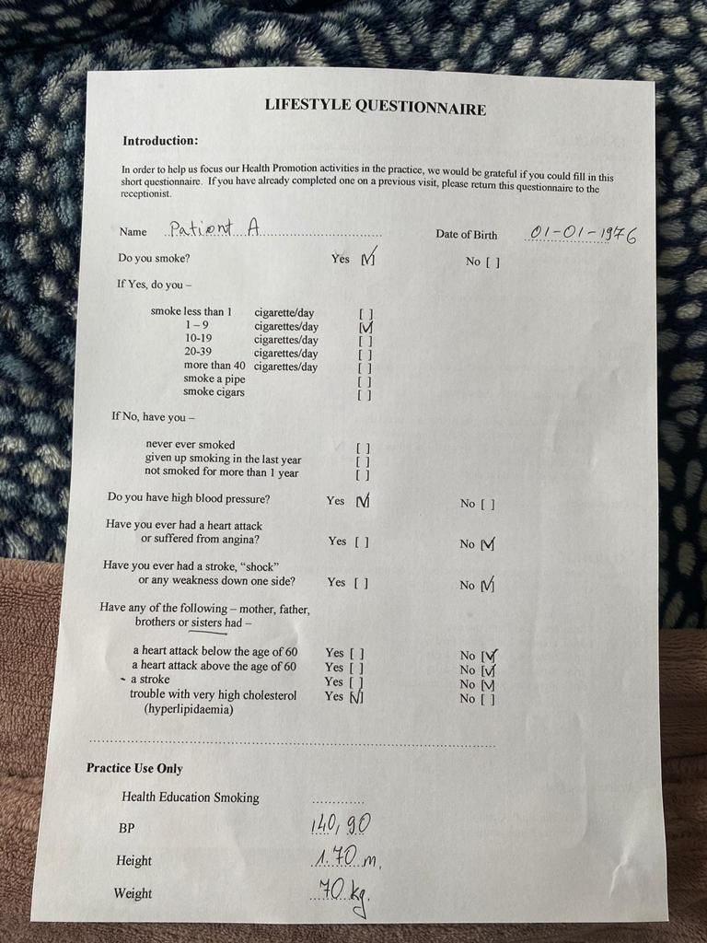
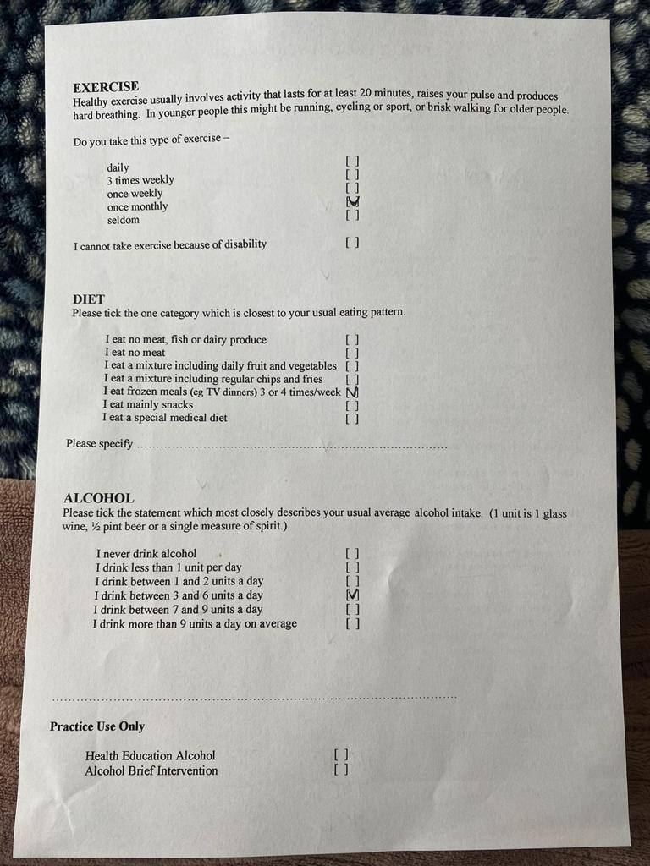

Appendix 2. Principle of homeostasis
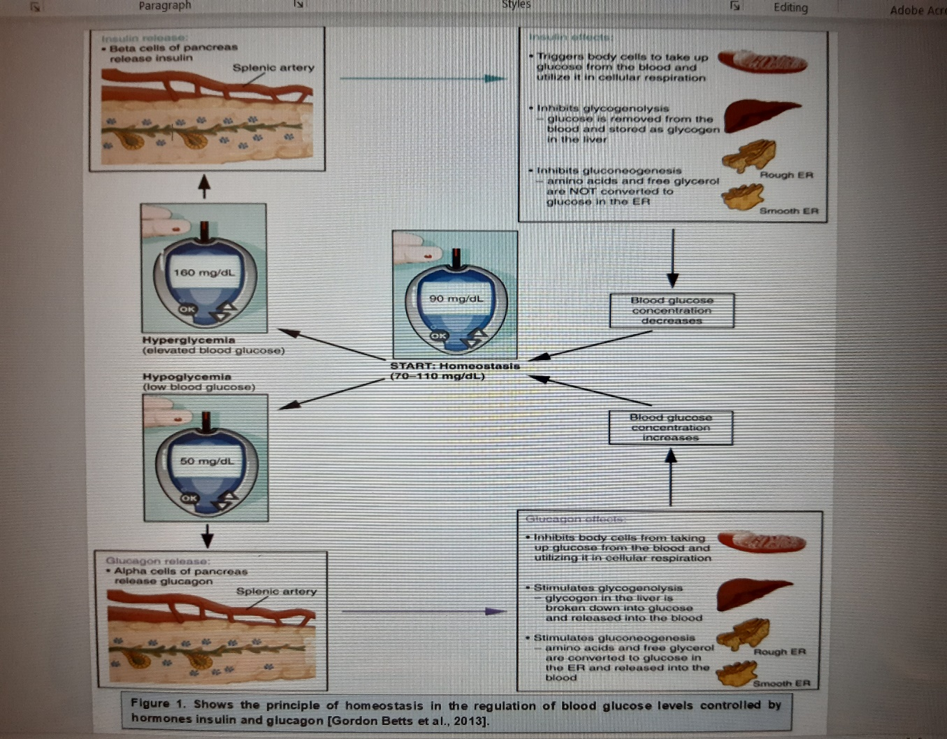

Appendix 3
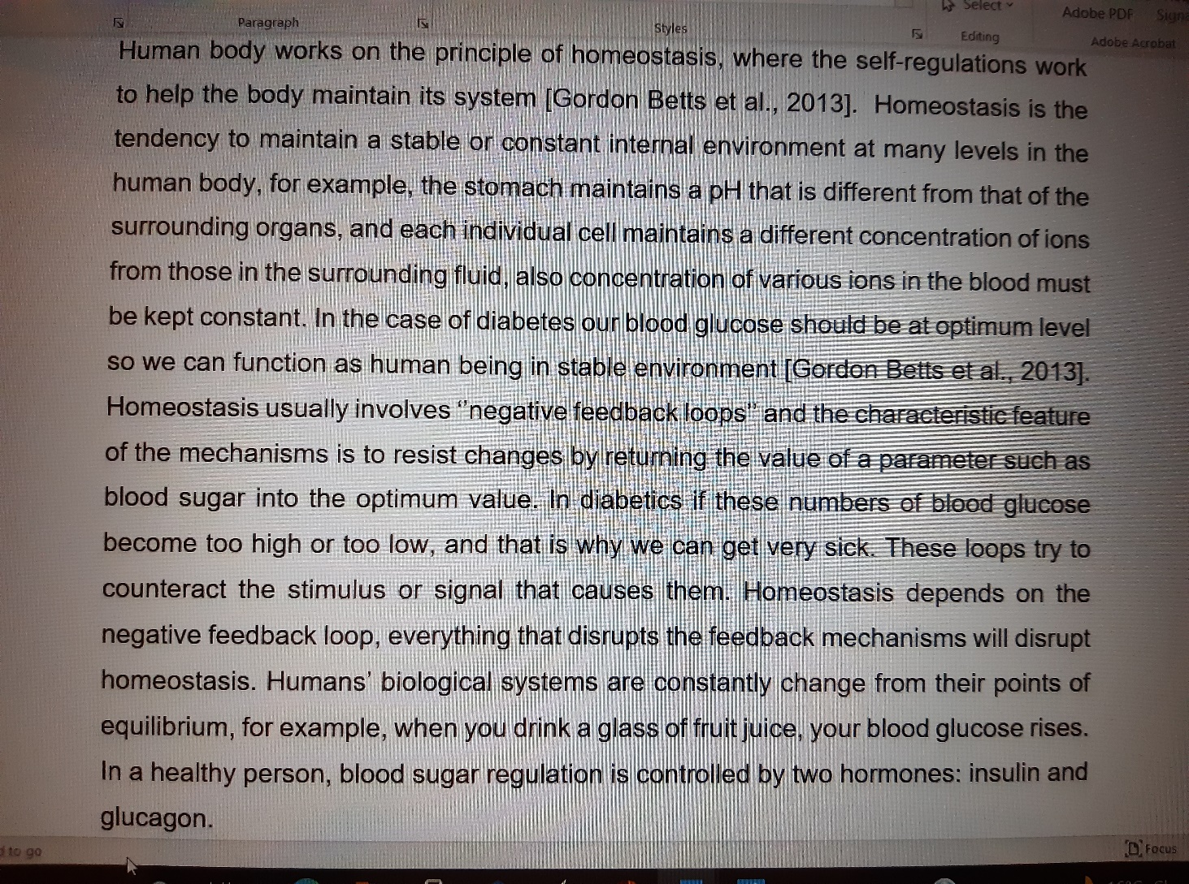

Appendix 4


