
Professional Career Development
Assignment 1- Reflective Review of Learning Journey

February 26, 2019
SHARMIN ALI

Table of Contents
INTRODUCTION 3
Outline the task 3
Evidence 3
What is Development? 3
Why is Development important? 3
MAIN BODY 3
About myself 3
SWOT 4
What is SWOT? 4
Who created it? 4
Define SWOT 5
Strengths 5
Leaning Styles 6
VARK 6
Honey and Mumford 7
Go M.A.D 7
Define 7
My GO M.A.D framework 8
Barriers to learning and development 8
Conclusion 9
Personal Development Plan 10

INTRODUCTION

Outline the task
For assignment 1, I have been assigned to produce a report for professional career development. I will be demonstrating an understanding of the skills and knowledge that contribute towards working effectively and towards employment. I will also be discussing personal strengths that I’ve already gained and weaknesses that I've yet to further improve on. Lastly, I will be discussing goals that I've already achieved and goals that I would like to accomplish in the future.

Evidence
In this report I will include the following evidence: SWOT analysis of myself, at least two learning style questionnaires, GO M.A.D frame work and a Personal Development Plan. The following evidence will help to prove what kind of person I am and also highlight my strengths and weaknesses. It will also show how I can overcome any threats and turn them into possible opportunities.

What is Development?
Development is defined as the process of growth or changes that are taken place. This is also the act of improving yourself or something. Development consists of different stages and consumes a lot of time. There are also different areas of development. For example: education, human development, equality, gender, goals, aspirations, health and wealth.
https://www.soas.ac.uk/cedep-demos/000_P501_USD_K3736-Demo/unit1/page_12.htm
https://dictionary.cambridge.org/dictionary/english/development

Why is Development important?
There are many reasons why development is important. Development is crucial because it allows you to enhance your skills and upgrade any existing knowledge in order to perform better. Development also allows you to identify problems and overcome them with a suitable solution. Development also helps to build and boost your confidence and self-esteem during process. Lastly, it allows you to build a bond with somebody else if you’re working in the same job or career field as them.

MAIN BODY

About myself
I’m a mother of four children who are aged between 12-22 years old. I’ve gotten married at the age of 18 and since then I’ve been a housewife for the majority of my time. But because my children are old enough to cope and manage on their own without my help. I have decided to go for a change and make use out of my time. I’ve decided to work part time and also study. This will help to benefit my family and me.
I’ve had multiple and various jobs since I’ve decided to do something else with my lifestyle. I’ve had the following jobs: School midday supervisor, Breakfast club supervisor and shop assistant. But now I'm currently working as Minibus schools run supervisor for special needs children. During the process of applying for these jobs wasn’t easy and it was also a challenge because everything was very new to me and out of my comfort zone.
To get to this stage I had to take part in various education courses such as IT and Heritage Studies project. I had to participate in these education courses because the qualification that I have already attained in my home country Bangladesh was Bachelor of arts- Geography, History and Economics but it was of no use here. I have also completed some work experience including Private nursery and teaching assistant.
I’m now very happy and satisfied with what I've achieved because I've come a long way from being a housewife to working part time and studying fulltime. I can now say that I'm providing for my family after all these years alongside my husband.
Before applying for these jobs and education courses I've already attained some skills such as Non-Verbal and Verbal communication, Team work, Interpreter, working under pressure, planning, creativity, organisation and problem solving. But after completing both sectors I've now gained and developed more key skills. The key skill that I’ve accomplished is IT, Customer Service, Analytic, resilience, motivation, report writing and time management.

SWOT

What is SWOT?
SWOT is a short abbreviation for Strengths, Weaknesses, Threats and Opportunities. The purpose of a SWOT analysis is to understand your Strengths, Weaknesses and identify any threats and how you could possibly change them into Opportunities. A SWOT analysis is a technique for assessing any performances, competitions, risk and potential barriers. SWOT analysis can be used for absolutely anything but its most commonly used in businesses and organisations. This method can also help you to develop a strong business strategy whether you’re building a startup or guiding an existing company. This method can further guide someone, businesses or an organisation towards strategies that are more likely to be successful or are likely to be less successful. Lastly, a SWOT analysis can also be used to explore new solutions to problems, identify barriers that will limit goals/objectives and decide on direction that will be most effective towards an organisation.
https://articles.bplans.com/how-to-perform-swot-analysis/

Who created it?
The SWOT analysis was created by an individual called Albert S. Humphrey. He was an American business and management consultant. He had created this technique while working for the Stanford Research Institute, now known as SRI International. SWOT is a strategic planning method used to evaluate the Strengths, Weaknesses/Limitations, Opportunities, and Threats involved in a project or in a business venture.
https://en.wikipedia.org/wiki/Albert_S._Humphrey
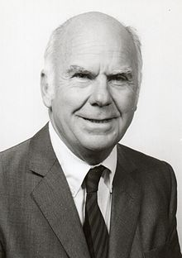

Define SWOT
S- Strengths
W-Weaknesses
T-Threats
O-Opportunities
Strengths- Strengths are attributes that are positive. This can also be labeled as skills of knowledge that an individual has attained. Strengths can be developed overtime and during the experience of something. Strengths also resolve around successes.
Weaknesses- Weakness resolve around negative attributes. This also falls into something that an individual lacks and needs to improve on. Weakness can be changed and developed overtime but to do so individuals would need to be open to developing their weaknesses and turning them into strengths.
Threats- Threats refer to factors that have the potential to harm a person, business or organisation. These are also factors that you have no control over. Threats can eventually be changed into opportunities.
Opportunities- This is a positive factor. Opportunities are aims and goals that someone would want to accomplish. Opportunities also come and go. But when an opportunity arises you should always say yes even if it’s not suitable for you. Saying yes could give you a real insight of the real world and be the root to other career paths and opportunities.

Strengths
I believe that I have developed various kind of strengths. These strengths are some of my hobbies, what I’m good at and how I’ve come across to others.
The strengths that I have include:
- Cooking
- Sewing
- Knitting
- Embroidery work
- Cleaning
- Beauty
- Fashion
- Gardening
- Swimming
- Badminton

- Independence
- Team work
- Perseverance
- Responsibility
- Ability to work under pressure
- Creativity
- Patience
- Hardworking
Weaknesses
I also believe that I’ve some weaknesses and areas that I would like to further improve on. These weaknesses can also be a threat towards certain opportunities that I might come across. These weaknesses is what I lack in the most and they’re important to me because I might need them for certain jobs, and educational areas. However, I’m open to turning them into strengths.
The weaknesses that I have yet to further develop include:
- Leadership
- Grammar
- Time keeping
- Flexibility
- Presentations/ Presenting
- Distractions
- IT
To improve these weaknesses and change them into strengths I could possibly be open to more leadership roles and put my name forward to take part on that role. I could also use a dictionary to find out the meaning of words and how they should be spelt correctly. I could also use a thesaurus to help me identify more advanced words that I could use in my work. I should try to create a plan of what I will be doing each day. This would help to balance out my routine. To improve presentations I should consider including only five or less main bullet points on each slide providing with a speaker notes of full detail because slides that consist of a lot of text could be very dull and boring to read. To improve my presenting weaknesses I should practice and go over what I would like to say over and over again. I should also highlight any keywords. I would like to avoid any distractions so I can get on with my work. To do this I should work in a quiet and tidy environment. Lastly, to improve my IT skills I should consider looking at YouTube tutorials on how to do certain things or I can ask someone for extra help.

Leaning Styles

VARK
http://vark-learn.com/the-vark-questionnaire/?p=results
This learning style shows that I am an Aural learner and less of a Visual learner.
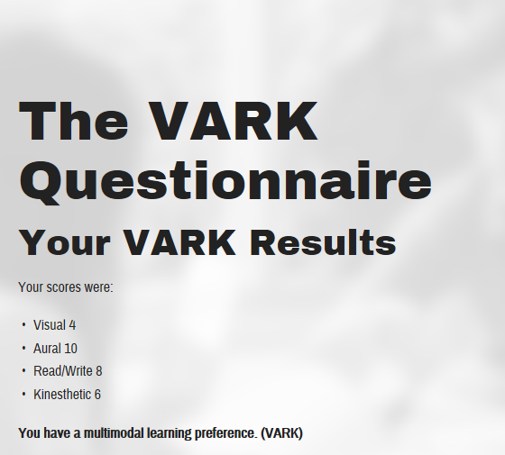

Honey and Mumford
http://resources.eln.io/honey-mumford-learner-types-1986-questionnaire-online/

This learning styles shows that I am a Reflective person and I learn best by observing and thinking.
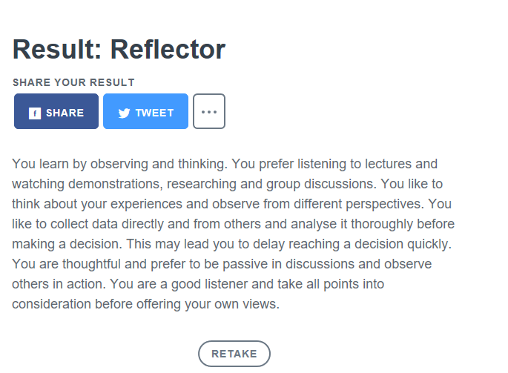

Go M.A.D

Define

GO M.A.D framework is structures as a triangle consisting of seven different steps. This was created in 1999. The purpose of this it to help organisation improve their productivity and effectiveness by transforming the way people think and engage in the workplace. This was also created to find a success process and to help you think of possible situations to solve any problems and achieve goals.

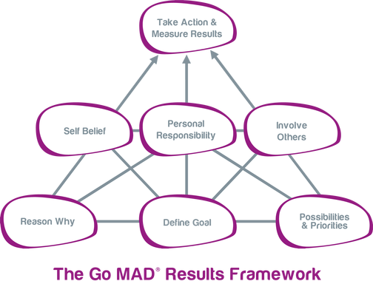

My GO M.A.D framework

Leadership
Distractions
Presenting
Grammar
Time Keeping
Flexibility
IT

Barriers to learning and development
The barriers that I have towards learning is my family, being distracted, not having much knowledge in a particular area and also not being in education for years. Using the two learning styles has helped me to figure out what kind of person I am and how I learn best. To overcome these barriers and help to develop my weaknesses I could ask my tutors or family for extra help as they would know a lot more in certain areas than I would. To make this happen I should try out for revision sessions or on-to-one situations, I can also ask my children to sit with me and go through some of my work so I can have a better understanding.

Conclusion
Overall, in this document I have outlined many things and I have spoken about what I will be doing, something about myself, my strengths, weaknesses, skills and I have also included learning styles and an example of my own GO M.A.D framework. I have also created a personal development plan describing three main skills that I would like to improve. I have also mentioned steps, resources, support and barriers that can work with these skills. However, this PDP can change in the process so I would need to follow this and keep it updated ensuring that I use the actions to follow each step.

Skills | Action Needed | Resources needed | Barriers and how will they be removed | Support Required
Presentations | - 3 bullet points per page  - An image per page  - Videos | - Microsoft PowerPoint Presentation  - YouTube  - Google Images  - Reliable sources | - Try to not try to much information  - Highlight key points and facts  - Look at presentation examples | No
Distractions | - Switch off my TV  - Switch off my phone  - Study in a quiet and empty place | - Use books  - Set an alarm for breaks  - Work in a library instead of home to focus | - Complete any work on holidays  - Complete work after the lesson so I can remember what to do | No
Time keeping | - Create a plan  - Set alarms  - Leave early for lessons | - Mobile phone for alarm  - Bus timetables  - Deadline dates | - Follow each action  - Ask for help | Yes

Personal Development Plan

