Sophie Evans (2108843)

Changemakers: Creativity and Value Creation (BMSP5013/C)

Contents

Mind Map …………………………………………………………Page 3
Why developing Entrepreneurial skills benefit both the individual & society at large……………………………….Page 4-5
Double sided flyer………………………………………..…….Pages 6-7
Link For Video…………………………………………………….Page 8
Poster…………………………………………………………………Page 9
References …………………………………………………………Page 10-11

Resilience is key to becoming an entrepreneur, not giving up and to keep going. As Ilonya, F mentions Entrepreneurial Resilience refers to the ability of an individual to successfully navigate through crises, setbacks, or hurdles (2021)
Knowledge is a great aspect for becoming an entrepreneur as according to Indeed Editorial Team An entrepreneur must recognise the importance of knowledge since staying on top of the latest market developments is a continuous endeavour (2020). When aspiring to be an entrepreneur, entrepreneurs must always have knowledge of their products or services that they are offering.
Becoming an entrepreneur involves risk taking. As JBCN School Blog mentions Exploring the unknown and discovering something new is what risk taking is all about. Taking risks entails having investment ideas, being willing to devote time and money, and always having a contingency plan (n.d.)

(Michele.R.Speno, 2021)
Knowledge
Resilience
Passion can create an entrepreneur, as according to McLaughlin, M, Entrepreneurs are driven by a sense of purpose. They have an unbreakable sense of purpose and an instinctive capacity to lead from the heart (n.d.).
Creativity is crucial for being a successful entrepreneur, as according to Walker, B, with so much competitiveness these days, entrepreneurs are challenged to come up with unique concepts that set them apart from the competitors. Thinking up innovative business concepts is an example of creativity (2020).
Risk-taking
Qualities and Attributes that create an Entrepreneur

Creativity
Communication
Passion

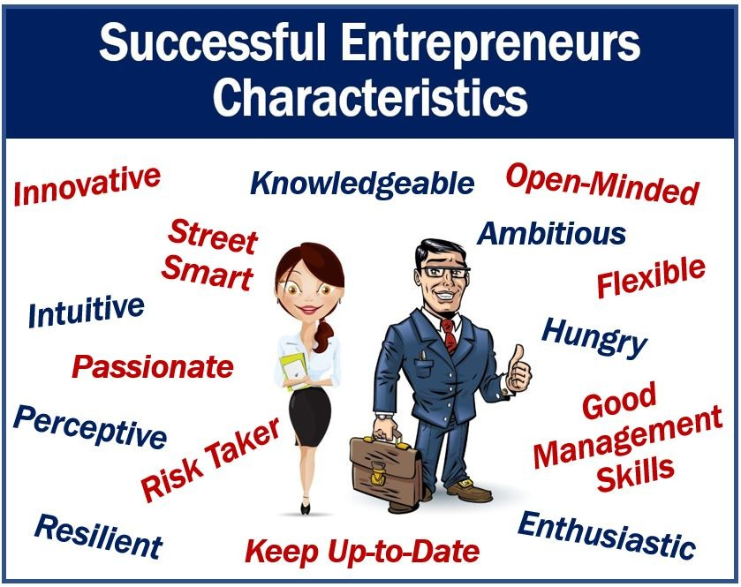
Communication and understanding how to market oneself are essential in being an entrepreneur. According to Wenta Once an entrepreneur has a clear vision for their business, they must be able to communicate and write about it in a way that inspires consumers and distinguishes them from the competitors (n.d.)

Why developing Entrepreneurial skills benefit both the individual & society at large.

Benefits of Entrepreneurial skills for Society at Large.
In many ways developing entrepreneurial skills can benefit both the individual and society at large as they can according to Greater Birmingham & Solihull as they frequently join the market with cheaper pricing and a wider selection of products, entrepreneurs put established businesses under pressure to become more competitive. This may prompt current market participants to re-evaluate their strategies, raise their worth, cut expenses, and improve efficiency. A more competitive economy is beneficial because businesses and individuals will look for ways to enhance their operations (2021).This can provide society with new, improved and less expensive goods and services, making them more affordable and valued by consumers. By entrepreneurs using their skills Mohamed, N mentions that by developing new merchandise and services, they encourage job growth, which eventually stimulates economic growth. Entrepreneurship generates lots of new possibilities and employment. Numerous entry-level positions created by entrepreneurship are crucial for transforming non-skilled workers into proficient ones (2020). Entrepreneurial abilities also assist society according to Greater Birmingham & Solihill since they lead to the creation of new goods and services that generate income in new markets. Additionally, entrepreneurship-related gains in income contribute to an increase in the country's GDP. Higher taxation and government spending translate into investments in underperforming industries and human resources (2021).
Benefits of Entrepreneurial skills for individuals
Having entrepreneurial skills can be a positive for the individual itself as there can be a higher level of income, their ideas are their own and according to Business and Finance, Investors will be willing to pay for a share of the entrepreneur's ownership if the company' success is established and there is a consistent stream of sales and profits. This implies that a business owner may cash in on his success much sooner by selling a portion of the company's ownership to investors rather than having to wait years to do so (2018).
An advantageous set of key skills that good entrepreneurs have include:
Resilience
The ability to be resilient is one of several traits that can help entrepreneurs according to Forbes, to deal with obstacles including rejection, stress, burnout, lack of focus, and poor growth. Building a company from the ground up requires tenacity and the desire to face the same beast every morning (2017).
Critical Thinking Skills
As Herrity, J, explains, making decisions and addressing problems can be aided by having the ability to view issues, circumstances, projects, and operations from several angles. Critical thinking abilities may also be required for strategic planning and assessing the methods entrepreneurs employ to adjust or enhance their business plans as necessary (2022).
Leaderships Skills
Leadership skills are important qualities for an entrepreneur as according to Nolley, B, because in order to succeed, they must be able to inspire and motivate their team. (2022), whilst also bringing out the best qualities in each team member.
Many entrepreneurs could positively impact the world and society at large by utilizing and continuing to develop new skills.



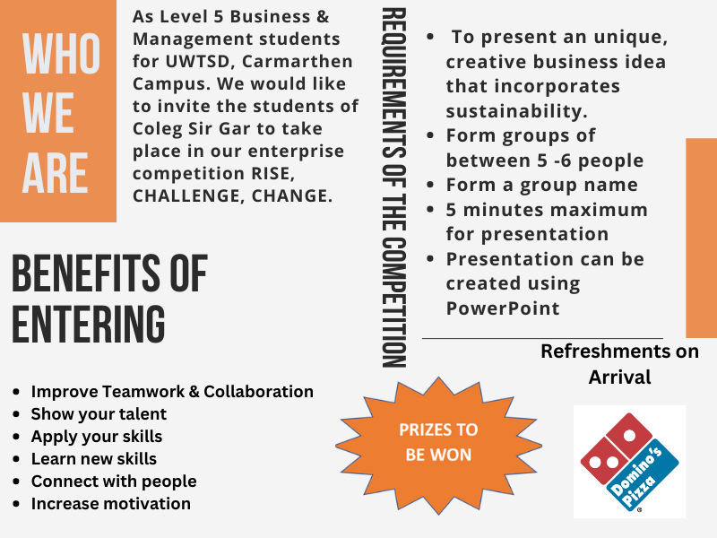

Link For Video: Video for Flyer.pptx

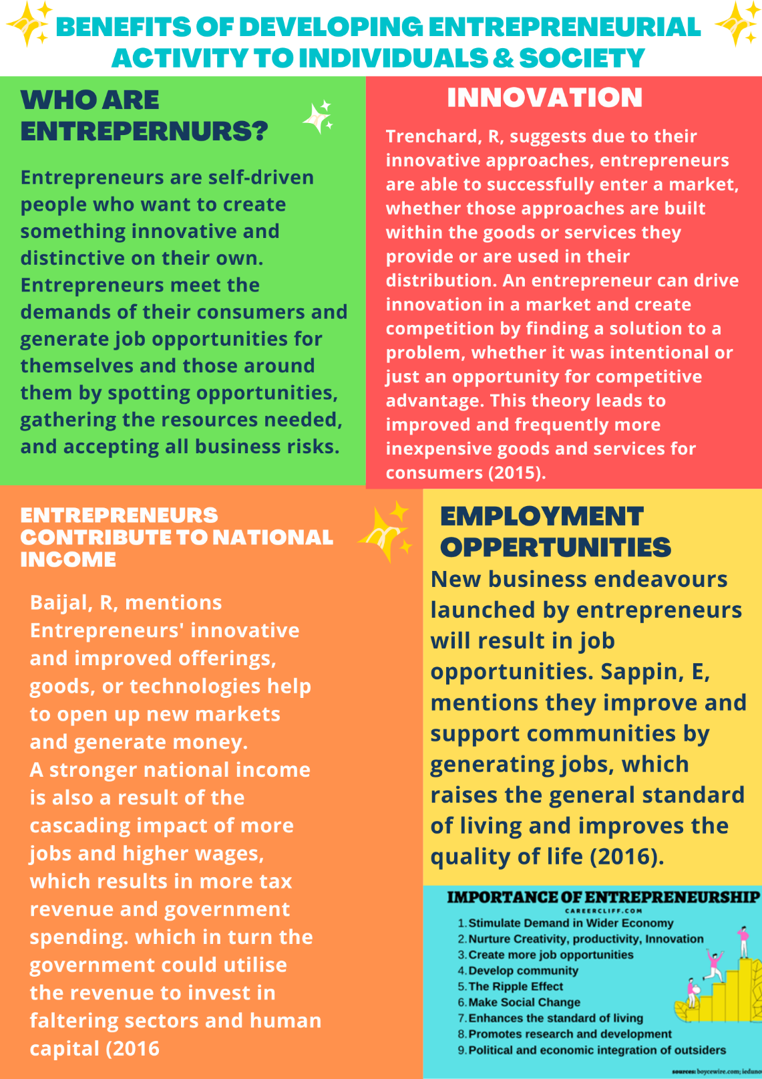

References
Ansary, A. S. (2022, May 17). Career Cliff. Retrieved from 23 Undeniable Importance of Entrepreneurship in 21st Century [Image]: https://www.careercliff.com/importance-of-entrepreneurship/
Baijal, R. (2016, January 20). Entrepernur. Retrieved from 4 reasons why entrepreneurship is important: https://www.entrepreneur.com/en-in/finance/4-reasons-why-entrepreneurship-is-important/269796
Business and Finance. (2018, August 04). Business and Finance. Retrieved from Advantages of Entrepreneurship for Individual and Society: https://businessandfinance.expertscolumn.com/advantages-of-entrepreneurship
Forbes. (2017, September 2017). Forbes. Retrieved from What Are The Most Important Skills Entrepreneurs Need?: https://www.forbes.com/sites/quora/2017/09/11/what-are-the-most-important-skills-entrepreneurs-need/?sh=42bc9753106c
Google. (n.d.). Retrieved from Carmarthen Campus Image: https://www.google.co.uk/search?q=Carmarthen+Campus+images&sxsrf=ALiCzsZXVOLzxbv43tThHxU0y65rhtp0QA:1668682454799&source=lnms&tbm=isch&sa=X&ved=2ahUKEwiG6dfHhrX7AhWTUsAKHTL-CIQQ_AUoAXoECAIQAw&biw=1233&bih=743&dpr=1.5#imgrc=UPTAvptGnqiUpM
Greater Birmingham & Solihill. (2021, October). Greater Birmingham & Solihill. Retrieved from 5 BENEFITS OF ENTREPRENEURSHIP IN THE ECONOMY: https://www.gbslepgrowthhub.co.uk/news/5-benefits-of-entrepreneurship-in-the-economy#:~:text=The%20new%20products%20or%20services,struggling%20sectors%20and%20human%20capital
Greater Birmingham & Solihull. (2021, October 12). Greater Birmingham & Solihull Local Enterprise Partnership. Retrieved from 5 BENEFITS OF ENTREPRENEURSHIP IN THE ECONOMY: https://www.gbslepgrowthhub.co.uk/news/5-benefits-of-entrepreneurship-in-the-economy#:~:text=1%201.%20Entrepreneurs%20provide%20job%20opportunities%20One%20of,income%20...%205%205.%20Entrepreneurs%20introduce%20innovative%20technologies
Herrity, J. (2022, June 13). Indeed. Retrieved from A Guide to Entrepreneurial Skills: Definition and Examples: https://www.indeed.com/career-advice/career-development/entrepreneurial-skills
Iloanya, O. (2021, August 25). Linkedin. Retrieved from The Importance of Resilience in Entrepreneurship: https://www.linkedin.com/pulse/importance-resilience-entrepreneurship-ofodile-iloanya#:~:text=Entrepreneurial%20Resilience%20is%20an%20individual%27s,factors%20such%20as%20personal%20trauma.
Ilukthenna, N. (2021, May 2023). LinkedIn. Retrieved from Economic and Social Benefits of Entrepreneurship: https://www.linkedin.com/pulse/economic-social-benefits-entrepreneurship-neranjan-ilukthenna
Indeed Editorial Team. (2020, May 11). Indeed. Retrieved from What Are the Characteristics of Successful Entrepreneurs?: https://uk.indeed.com/career-advice/career-development/characteristics-of-entrepreneurs
JBCN SCHOOL BLOG. (n.d.). JBCN SCHOOL BLOG. Retrieved from If You Identify With These 10 Characteristics You Are Thinking Like An Entrepreneur!: https://www.jbcnschool.edu.in/blog/characteristics-of-an-entrepreneur/
Mcloy, J. (2019, Octrober 2018). Greencoast. Retrieved from 64 Best Quotes About Sustainability (Including Inspiring, Funny & Short): https://greencoast.org/quotes-about-sustainability/
McLughlin, M. (n.d.). McLaughlin. Retrieved from The Four Character Traits of Entrepreneurs: https://www.mclaughlinpc.com/blogs/the-four-character-traits-of-entrepreneurs
Michele.R.Speno. (2021, October 13). Linkedin. Retrieved from 10 Important personal characteristics of entrepreneurs: https://www.linkedin.com/pulse/10-important-personal-characteristics-entrepreneurs-michele-r-speno
Microsoft Bing. (n.d.). Retrieved from Domionos Pizza Logo: https://www.bing.com/images/search?view=detailV2&ccid=kmmJ0by5&id=FBAB7A3AD790FB83B5D7E5F4DC7E1372DCA5D195&thid=OIP.kmmJ0by5Z_7G0HcgmiKyxQHaHa&mediaurl=https%3a%2f%2flogos-download.com%2fwp-content%2fuploads%2f2016%2f04%2fDominos_Pizza_logo.png&cdnurl=htt
Mohamed, N. (2020, March 30). Duke Sanford Center for International development. Retrieved from Top 5 Takeaways On The Importance of Entrepreneurship: https://dcid.sanford.duke.edu/importance-of-entrepreneurship/
Nolley, D. B. (2022, March 03). Linkedin. Retrieved from What it Takes for an Entrepreneur to Become a Leader: https://www.linkedin.com/pulse/what-takes-entrepreneur-become-leader-dr-bob-nolley?trk=articles_directory#:~:text=Leadership%20skills%20are%20essential%20for,that%20need%20to%20be%20overcome.
Sappin, E. (2016, October 20). Entrepreneur. Retrieved from 7 Ways Entrepreneurs Drive Economic Development: https://www.entrepreneur.com/leadership/7-ways-entrepreneurs-drive-economic-development/283616
Trenchard, R. (2015, November 17). Virgin. Retrieved from What impact do entrepreneurs have on society?: https://www.virgin.com/about-virgin/latest/what-impact-do-entrepreneurs-have-society
UWTSD. (n.d.). [Image] Retrieved from https://www.uwtsd.ac.uk/
Walker, B. (2020, May 11). Forbes. Retrieved from Six Personality Traits Of Successful Entrepreneurs: https://www.forbes.com/sites/theyec/2020/05/11/six-personality-traits-of-successful-entrepreneurs/?sh=de32df970ba9
Wenta. (n.d.). Wenta. Retrieved from Key Skills and attributes for Entrepreneurs : https://wenta.co.uk/the-business-bookshelf/articles/key-skills-and-attributes-for-entrepreneurs/

