LEVEL 6 ASSESSMENT
Assignment 2
Programme: International Hotel Management (BA)
Module: International Hotel Management (BA)
Module Code: BMIH6007
Assignment 2: Event Strategic Planning and Delivery Considerations for an International Meeting / Event
Name of the Student: Andrei Maria
Student ID: 2243878

Executive Summary
The development of this report provided a strategic delivery and planning framework for the ‘Wales Arts and Craft Fair 2025’ while aligning with the campaign of ‘Year of Croeso’ by Visit Wales. The event has been scheduled in Cardiff while targeting to increase the arts and culture of Wales through a 3-day event of workshops, performances, and exhibitions. This report has also focused on the identification of the event cycle and concept, along with the SMART Objectives, which have further helped in understanding the current market trends. Moreover, through the application of models such as the 5C framework, EMBOK, and others, the overall event has been planned as an inclusive, sustainable, and economically manageable fair.
Table of Contents
1. Introduction 3
2. The Event Cycle 4
3. Event Concept 5
4. Aim and Objectives of the Event 7
5. Event Management 8
6. Event Budget 9
7. Industry Trends 11
8. Situational and Cultural Considerations 12
9. Conclusion 14
Reference List 15

1. Introduction
The event, which has been proposed to be named the ‘Wales Arts and Craft Fair 2025’ while aligning with the initiative of ‘Year of Croeso 2025’ with Visit Wales, has focused on the cultural heritage, hospitality and creativity of Wales. This event mainly aims to provide a warm welcome to all the tourists while further inviting global audiences to increase their experience of their language and several unique attractions. This identified campaign mainly showcases the contemporary and traditional offerings of Wales while maintaining the operations related to ‘Year of Croeso 2025’ (TravelTrade, 2025). Being the event planner, the event format which has been selected is for 3 days, targeting all the travel influencers and the operators of global tours, along with the stakeholders of hospitality, who further influence the decisions of the tourists as well.
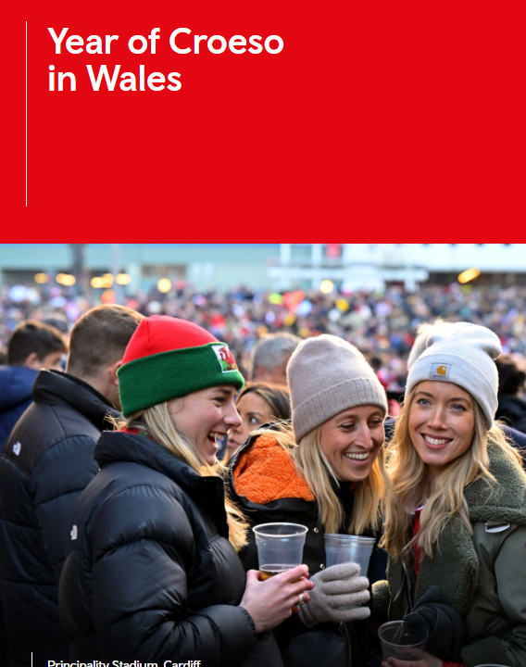
Figure 1: Year of Croseo 2025 Initiative
(Source: TravelTrade, 2025)
This planned fair will mainly take place within Cardiff, which is the capital of the place Wales and is capable of offering a better platform for all the crafts and arts of Welsh artists and also international buyers (Wales, 2025). This art and craft fair will further focus on featuring interactive programmes involving several exhibitions along with live demonstrations, while further focusing on the model arts and crafts of Wales. By targeting both the local communities and global buyers, this event further offers a better platform for education and trade, along with networking. Through the overall development of this report, a proper idea about the event cycle, budget plan, concept, current industry trends, and event management approaches will be developed. A successful plan will be further executed through the development of this report.

2. The Event Cycle
The model of EMBOK or ‘Event Management Body of Knowledge’ focuses on the management of the Event Cycle as a well-structured framework involving events of planning, evaluating, and executing. As per van Antwerpen (2023), this framework involves 5 specific phases which help in ensuring the development of a strategic alignment with the event requirements while maintaining a smooth delivery of the events.
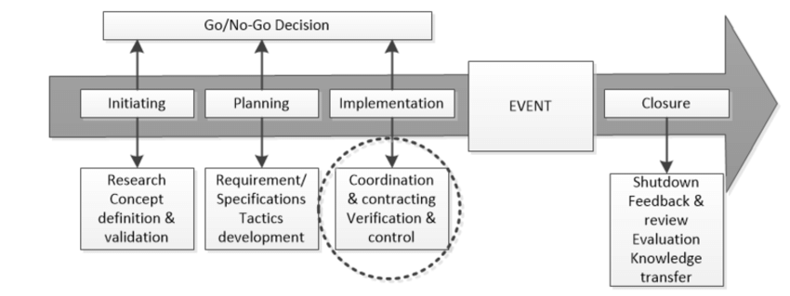
Figure 2: Event Management Framework
(Source: Penn et al., 2017)
1. Initiation
This first stage mainly involves the identification of the objectives, purpose, and feasibility of the selected events through the analysis of stakeholders' engagement, market research, and alignment with the strategic goals (Dassah, 2023). For the ‘Wales Arts and Craft Fair 2025’, aligning with the campaign of ‘Year of Croeso’ is required to analyse objectives and stakeholder engagement approaches, mainly while focusing on the aspects of Visit Wales. A proper engagement within the communities for local artists and the Arts Council is also required to be developed in this phase to validate the market research.
2. Planning
This second stage helps in focusing on the management of timelines, sources of the suppliers, defining roles, and the development of proper operational frameworks (Penn et al., 2017). For the event, it is important to select the venue first based on the cultural demands, which in this case has been selected to be ‘Cardiff’. A proper timeline, along with risk assessments, is also required to be done for the fair in this phase.
3. Implementation
In this phase, all the activities are required to be planned while further executing the contracts based on the launched campaigns of marketing, along with confirming the logistics (Thomas and Stephens, 2022). For the fair, the marketing launch is required to be done by confirming the sponsors and also the overall infrastructure, along with the effective digital systems.
4. Execution
This is the actual stage for delivering the overall event while involving different aspects of guest management, real-time problem solving, and many more. For the ‘Wales Arts and Craft Fair 2025’, which is going to be an event for 3 days, several art activities are required to be involved in for the final execution, while also focusing on the B2B tourism trade.
5. Closure
After all the activities of the event, the evaluation needs to be done in this phase through the collection of feedback and by the reviews of media coverage. For the ‘Wales Arts and Craft Fair 2025’, surveys are required to be provided for understanding the satisfaction of the event participants.

3. Event Concept
The 3-day fair event ‘Wales Arts and Craft Fair 2025’, based on the ‘Hwyl through Heritage’, mainly involves the cultural exhibition approaches of MICE (Meetings, Incentives, Conferences, and Exhibitions) and the business approach of B2B for promoting the cultural tourism and Welsh creativity within the campaign of ‘Year of Croeso 2025’. The event has been set to take place in the ‘Cardiff City Hall’ along with the Alexandra Gardens, while combining the presence of elegance and accessibility in an open-air space. As per Faralla et al. (2025), the development of an inclusive and multi-sensory event for all international audiences based on the travel professionals can help in managing positivity within the travel industry as well.
Day-by-Day Itinerary
Day | Theme | Activities
Day 1 | Welcome to Wales | - Inauguration by Visit Wales.  - Welsh language crash course.  - Traditional craft demos (weaving, woodwork).  - Networking banquet with Welsh cuisine.
Day 2 | Balance & Business | - B2B Networking Expo with local tourism vendors.  - Artist-led master classes.  - Buyer-meet-maker sessions.  - Evening cultural performance.
Day 3 | Explore & Connect | - Live painting competitions.  - Youth art exhibitions.  - Food stalls and souvenir markets.  - Closing ceremony and awards presentation.
Table 1: Day-by-Day Activities
(Source: Self-created)
The development of this event also supports the objective of the Welsh Government while using a placemaking approach to manage the cultural identity, along with attracting more international tourists. As per Bazalgette (2017), the soft power of the events can be promoted while focusing on the involvement of cultural activities of any place, while further increasing community engagement along with appreciating heritage.

4. Aim and Objectives of the Event
The aim of ‘Wales Arts and Craft Fair 2025’ is mainly to increase the cultural profile of Wales along with its economic potential, through focusing on the international management within heritage, arts, and crafts. This also aligns with the goal of the campaign ‘Year of Croeso 2025’ that focuses on managing the identity of Wales while further promoting inclusivity, along with attracting global tourists.
As per Ogbeiwi (2017), SMART objectives involve specific elements which help in measuring the overall impact of any specific approaches while meeting the goals. Based on the aim, the SMART objectives of this event are as follows:
SMART Criteria | Objective
Specific | Attract a minimum of 100 international art buyers and stakeholders.
Measurable | Achieve 1 million+ social media impressions during event week.
Achievable | Reach an 85% or higher satisfaction rate based on exit survey data from attendees.
Relevant | Align with Croeso 2025 campaign goals and cultural tourism objectives.
Time-bound | Generate £250,000 in direct and indirect revenue within 3 months post-event.
Table 2: SMART Objectives
(Source: Self-created)

5. Event Management
The appropriate planning, along with the delivery of the event on ‘Wales Arts and Craft Fair’ focusing on “Hwyl through Heritage”, needs the presence of a well-structured event management approach, which can further maintain coordination within stakeholder engagement and logistics, followed by the marketing aspects. As per Ujam (2020), the use of the 5C model for event management mainly focuses on the factors like coordination, concept, culmination, control, and lastly closure, while providing a better manageable approach for all the resources along with decreasing the risks for meeting the goals.
a. Operational Activities
As part of the 5C model, while focusing on the concept and coordination stages, the operational activities for the event ‘Wales Arts and Craft Fair’ align with that. This involves booking the Alexandra Gardens and Cardiff City Hall for the fair while ensuring accessibility to both outdoor and indoor elegance. As per Khir et al. (2019), some of the main logistics which are required to be followed in an arts and craft fair are venue accessibility, booth setup, measures of fire safety, and lastly, insurance on public liability for meeting the standards. Moreover, some of the onsite services which are required to be included are first aid personnel, professional security, and lastly, all the sanitation crews for ensuring a welcoming environment during the fair.
b. Planning Activities
These activities mainly align with the phases of Control and Culmination of the 5C model, which at first involve the risk assessment. It is important to develop an alignment with the ‘Health and Safety at Work Act (1974), as it helps in guiding the event layout along with the overall planning (HSE, 2025). Through the selection of a proper timeline of the fair, along with budget forecasting, a better alignment with the financial objectives can be made. On the other hand, it is important to select the vendors while contracting with food vendors, artists, and all the tech suppliers. According to Ballico and Carter (2018), legal licensing for food distribution, alcohol sales, and live music during any event is important to manage coordination within the local council as well.
c. Marketing Activities
Within the last stage of the 5C model, which is Closure, it involves the collection of feedback along with the final identification of several marketing activities. For this fair, the market campaign has been planned to be executed based on the partnership with the Arts Council, along with Visit Wales, while being supported by the outreach of International PR for all the cultural institutions. As per Al-Zoubi (2022), the use of influencer marketing through different platforms like Instagram and TikTok mainly helps in targeting global audiences. A proper collaboration with the heritage bodies and craft councils is required to be made for increasing the credibility and visibility of the fair.

6. Event Budget
The development of the project ‘Wales Arts and Craft Fair 2025’ needs to focus on the inclusion of a balanced approach for the development of proper budget planning, while focusing on the identification of other aspects like total revenue and many more. As per Hayes et al. (2021), through the identification of revenue generation and cost management, financial sustainability can be managed while maintaining the quality of any event. The overall budget plan for the event is discussed in the table below:

Category | Estimated Cost (£) | Revenue Source | Projected Income (£)
Venue & Setup | 15,000 | Delegate fees (100 x £100) | 10,000
AV, Lighting, Tech Support | 10,000 | Booth fees (30 x £500) | 15,000
Catering & Food Stalls | 8,000 | Public Tickets (1,000 x £5) | 5,000
Marketing and PR | 7,000 | Sponsorships (Visit Wales, other sponsors) | 10,000
Cultural Performances | 3,000 | Merchandise and artisan sales shares | 3,000
Staffing & Miscellaneous | 5,000
Total | £48,000 | Total Projected Revenue | £43,000
Table 3: Total Budget Plan
(Source: Self-created)
The total projected revenue has been analysed to be about £43,000, whereas the overall expenditure has been analysed to be about £48,000, which indicates a shortfall that can be managed through several adjustments. To decrease the overall gap of £5000, it is important to involve the strategy of additional sponsorships along with increasing the prices of the public tickets to £6 from £5. As per Conlon and Rao (2020), the overall identification of total revenue further depended on the fees of booths, along with the overall profits collected from the merchandise.

7. Industry Trends
The delivery and planning of ‘Wales Arts and Craft Fair 2025’ is mainly influenced by the current challenges and trends within the events and meetings industry. As per Smith (2012), the involvement of both local practices along with global insights an inclusive and impactful event can be developed.
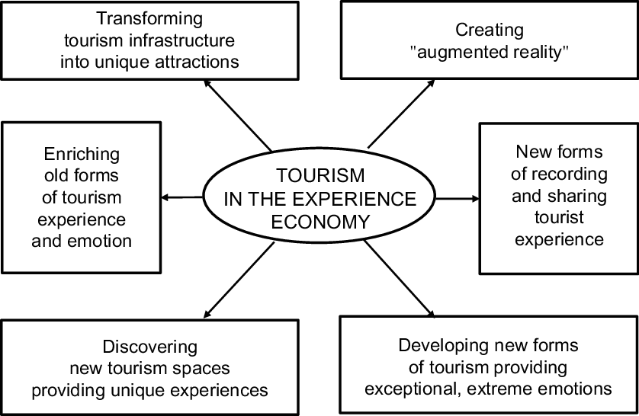
Figure 3: Experience Economy of Tourism
(Source: Stasiak., 2019)
Experience-Driven Tourism
All the modern tourists mainly demand to achieve meaningful and immersive experiences. As per Paulauskaite et al. (2017), interaction and authenticity have been identified as one of the major parts of the ‘experience economy’. The development of this fair mainly responds to the offering of live workshops organised by the artists along with the demonstrations of different traditional crafts, followed by the involvement of useful cultural elements of Welsh.
Sustainability
With the enhancement of environmental awareness, this event focuses on the involvement of green practices while including a policy of zero-plastic along with digital ticketing, and the use of the catering service, which is locally sourced. As per Chen et al. (2022), the initiatives of carbon offset can help in encouraging all the international delegates while also further decreasing the total level of ecological footprint. Moreover, according to Iglesias et al. (2019), the presence of sustainability can not only help in managing ethical approaches but can also help in increasing the perceptions of brands.
Digital Engagement
The involvement of technology in the events helps in reshaping the overall delivery of the events. The involvement of hybrid elements like virtual exhibition booths along with the live streaming of the events is required to be done in ‘Wales Arts and Craft Fair 2025’. As per Getz and Page (2019), the involvement of digital features within the events can help in increasing inclusivity, along with increasing the popularity of the events among all international audiences.
Bleisure Travel
Through merging business with leisure, another major trend in the current market can be followed. The development of this fair helps in encouraging the tourism of post and post-events while promoting the scenic tours within Wales. According to O’Toole (2011), events with more tourism appeal for international visitors can further help in increasing the economy of the countries as well.

8. Situational and Cultural Considerations
Through the use of the SWOT analysis, the cultural and logistical approaches related to the ‘Wales Arts and Craft Fair 2025’ have been analysed in the table below:

Strengths | Weakness
- Strong national branding under Croeso 2025.  - Rich cultural heritage and artisan talent.  - Excellent transport links and venue flexibility. | - Weather risks for outdoor elements.  - New event with low initial public awareness.  - Reliance on public and campaign funding.
Opportunities | Threats
- Rising global interest in cultural tourism.  - High potential for digital and global engagement.  - Strategic partnerships with EU-based art networks. | - Inflation is impacting vendor and logistics costs.  - Political/economic instability is affecting grants.  - Competing events across the UK cultural sector.
Table 4: SWOT Analysis
(Source: Self-created)
Some of the major cultural considerations involve the presence of bilingual signage in English and Welsh, along with inclusive facilities like gender-neutral toilets and many more (Welsh Government, 2017). Also, the placemaking is mainly done based on storytelling and the demonstrations of authentic crafts of Wales.

9. Conclusion
The event of ‘Wales Arts and Craft Fair 2025’ is planned based on a specific cultural event while supporting the objectives of the campaign related to ‘Year of Croeso’, while promoting the Welsh heritage, hospitality, and creativity. Through the overall development of this report by using proper planning and theoretical models, an alignment with the current industry trends has been further made. Through this report, a proper identification of all the approaches related to sustainability and inclusivity has been managed, while further understanding the social and cultural values related to the fair. The involvement of traditional arts within the fair has further focused on the development of a memorable sense as well.

Reference List
Al-Zoubi, M. M. (2022) ‘The growth of influencer marketing: A comparison of TikTok and Instagram’, Contention in the Reshaping Global Economy, 345.
Ballico, C., and Carter, D. (2018) ‘A state of constant prodding: Live music, precarity and regulation’, Cultural Trends, 27(3), 203-217.
Bazalgette, P. (2017). Independent review of the creative industries. Department for Digital, Culture, Media & Sport.
Chen, L., Msigwa, G., Yang, M., Osman, A. I., Fawzy, S., Rooney, D. W., and Yap, P. S. (2022) ‘Strategies to achieve a carbon neutral society: a review’, Environmental chemistry letters, 20(4), 2277-2310.
Conlon, C. T., and Rao, N. L. (2020) ‘Discrete prices and the incidence and efficiency of excise taxes’, American Economic Journal: Economic Policy, 12(4), 111-143.
Dassah, S. S. (2023). Event planning: Crafting the perfect Chale Wote Street Art Festival atmosphere; How event planners are making a memorable event (Master's thesis, UiT The Arctic University of Norway).
Faralla, V., Abrate, G., and Fraquelli, G. (2024) ‘The interplay between perceived quality, sustainability attitudes, and consumers’ modal choice in local transportation’, Management of sustainability and well-being for individuals and society, 243.
Getz, D. and Page, S. (2019) Event studies: theory, research and policy for planned events. 3rd Edition. Routledge: Oxford.
Hayes, D. K., Hayes, J. D., and Hayes, P. A. (2021). Revenue management for the hospitality industry. John Wiley & Sons.
HSE (2025). Health and Safety at Work etc Act 1974. https://www.hse.gov.uk/legislation/hswa.htm.
Iglesias, O., Markovic, S., Singh, J. J., and Sierra, V. (2019) ‘Do customer perceptions of corporate services brand ethicality improve brand equity? Considering the roles of brand heritage, brand image, and recognition benefits’, Journal of business ethics, 154, 441-459.
Khir, M. M., Demong, N. A. R., Ahmad, N. L., Sabar, S., and Omar, E. N. (2019) ‘Exploring the Legal and Safety Issues amongst Event Planners and Venue Managers in Malaysia’, International Journal Of Academic Research in Business and Social Sciences, 9(3).
O’Toole, W. (2011) Events feasibility and development:from strategy to operations. Elsevier: Oxford.
Ogbeiwi, O. (2017) ‘Why written objectives need to be really SMART’, British Journal of Healthcare Management, 23(7), 324-336.
Paulauskaite, D., Powell, R., Coca‐Stefaniak, J. A., and Morrison, A. M. (2017) ‘Living like a local: Authentic tourism experiences and the sharing economy’, International journal of tourism research, 19(6), 619-628.
Penn, C., Farnes, K. L., and Rahmani, F. (2017) ‘Early contractor involvement (ECI) in event planning and management’, EPiC Series in Education Science, 1, 54-61.
Smith, A. (2012) Events and urban regeneration: the strategic use of events to revitalise cities. Routledge:Oxford
Stasiak, A. (2019) ‘Creating tourism experiences—Theoretical foundations’, World Scientific Book Chapters, 17-41.
Thomas, K., and Stephens, S. (2022) ‘Understanding the Management Theory in Event Management: A Conceptual Framework’, Available at SSRN 4051469.
TravelTrade (2025). Wales is celebrating a Year of Croeso, a Welsh welcome for visitors. https://traveltrade.visitwales.com/useful-information/toolkit/year-of-croeso.
Ujam, L. (2020) ‘The 5C Framework and Maturity Assessment: a New Approach to Technology Transfer in Biopharmaceutical Contract Manufacturing’, Level 3, 15(2), 8.
van Antwerpen, S. (2023) ‘A proposed integration of the event and project management body of knowledge’, International Journal of Applied Sciences in Tourism and Events, 7(2), 107-119.
Wales (2025). Cardiff: a thoroughly modern capital. https://www.wales.com/about/cities-and-regions/cardiff-thoroughly-modern-capital.
Welsh Government (2017) Welsh Government HR policies: Gender neutral and accessible toilets. https://www.gov.wales/sites/default/files/publications/2023-06/atisn17524doc2.pdf.

