Computer Forensics


Synthesize a solution to a potential real-life scenario.

Dr Nitheesh Kaliyamurthy
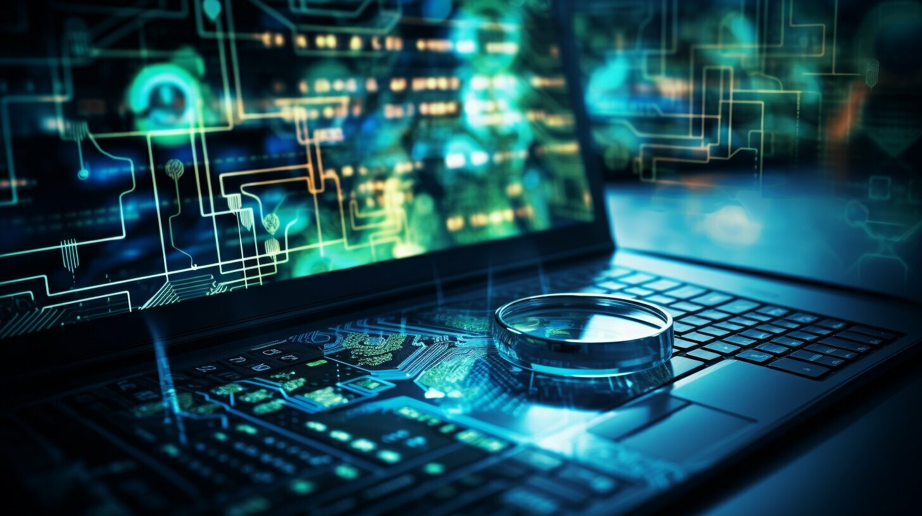

Charbel BAAKLINI

2024

Summary

Introduction 4
Task 1 4
Definitions and historical evolution 4
Fundamental concepts4
Scope and applications5
Example of relevant cases5
References 15
Task 2 6
Features and capabilities of digital forensic tools 6
Categorization of tools6
Distinguishing capabilities6
Real world use cases 7
Advancements and innovations 7
Adaptation to evolving technologies. 8
references 2 9
Task 3 9
References 16

Introduction
Computer forensics is a branch of digital forensic science focused on the investigation and analysis of digital devices and data to uncover evidence for legal purposes. It involves the systematic examination of computers, mobile phones, storage media, and networks to retrieve, preserve, and analyse electronic information. Computer forensics experts utilize specialized tools and techniques to recover deleted files, trace digital footprints, and identify malicious activities, assisting law enforcement agencies, corporations, and legal professionals in solving cybercrimes, data breaches, and other digital incidents.

Task 1:
- Definitions and Historical Evolution:
Computer Forensics: Initially coined as a term, "computer forensics" primarily focused on the investigation of computer systems and related devices for legal evidence. It emerged in the 1980s with the proliferation of personal computers. Computer forensics traditionally involved the recovery and analysis of data from physical devices like hard drives, floppy disks, and CDs.
Digital Forensics: The term "digital forensics" is a broader concept encompassing the investigation of any digital device or digital data. It emerged later, around the late 1990s and early 2000s, as technology advanced and the variety of digital devices expanded beyond just computers. Digital forensics includes not only computer systems but also mobile devices, digital cameras, GPS systems, IoT devices, and more.

- Fundamental Concepts:
The fundamental concepts underlying both computer forensics and digital forensics are similar, revolving around the investigation, preservation, analysis, and presentation of digital evidence for legal purposes. Both disciplines involve:
- Data Acquisition: Gathering digital evidence from various devices while maintaining its integrity.
- Data Analysis: Examining the collected data to identify relevant information and patterns.
- Chain of Custody: Documenting the handling of evidence to ensure its admissibility in court.
- Legal Compliance: Conducting investigations in adherence to legal and regulatory requirements.

- Scope and Applications:
Computer Forensics:
- Focuses primarily on traditional computing devices like desktops, laptops, servers, and storage devices.
- Used in cases involving cybercrimes such as hacking, data breaches, intellectual property theft, and unauthorized access.
- Applied in corporate investigations, criminal investigations, civil litigation, and incident response.
Digital Forensics:
- Encompasses a broader range of digital devices beyond traditional computers, including smartphones, tablets, wearables, and IoT devices.
- Applied in cases of digital fraud, online harassment, cyberbullying, child exploitation, and digital asset recovery.
- Widely used in law enforcement, government agencies, corporate security, and private investigations.

- Examples of Relevant Cases:
Computer Forensics Case: The investigation of a corporate data breach involving unauthorized access to sensitive financial information stored on company servers. Computer forensics techniques were used to analyse server logs, network traffic, and system configurations to identify the source of the breach and gather evidence for legal action.
Digital Forensics Case: The forensic examination of a suspect's smartphone in a criminal investigation involving online harassment and threats. Digital forensics tools were used to recover deleted messages, call logs, and location data from the device, providing crucial evidence for the prosecution.

References:
Kessler, G.C. (2004). Computer Forensics: Computer Crime Scene Investigation. Boston: Thomson Course Technology.
Carrier, B. (2005). File System Forensic Analysis. Upper Saddle River, NJ: Addison-Wesley.
Casey, E. (2011). Digital Evidence and Computer Crime: Forensic Science, Computers and the Internet. London: Academic Press.
Nelson, B., Phillips, A., & Steuart, C. (2009). Guide to Computer Forensics and Investigations. Boston: Cengage Learning.
Beebe, N.L., & Clark, J.A. (2012). The Essential Guide to Computer Forensics. Boston: Pearson.
Task 2:

1. Features and Capabilities of Digital Forensic Tools:
Digital forensic tools include a wide range of functionalities to aid investigators in collecting, analysing, and presenting digital evidence. Some key features include:
Disk Imaging: Ability to create forensic images of storage devices without altering the original data.
File Carving: Extraction of files from fragmented or corrupted storage media.
Keyword Searching: Identification of specific terms or patterns within digital evidence.
Metadata Analysis: Examination of file attributes, timestamps, and other metadata.
Hashing: Calculation and verification of cryptographic hash values to ensure data integrity.
Reporting: Generation of detailed reports for legal documentation and presentation.

2. Categorization of Tools:
Digital forensic tools can be categorized based on their primary functionalities:
Disk Forensics: Tools for analysing storage devices such as hard drives, SSDs, and removable media.
Memory Forensics: Tools for examining volatile memory (RAM) to extract process information and artifacts.
Network Forensics: Tools for capturing and analysing network traffic to investigate cyberattacks and unauthorized access.
Mobile Forensics: Tools for extracting and analysing data from smartphones, tablets, and other mobile devices.
Multimedia Forensics: Tools for analysing digital images, audio files, and video recordings for forensic analysis.

3. Distinguishing Capabilities:
Each tool within its category may have unique features that distinguish it from others, such as:
Disk Forensics: Encase Forensic, FTK Imager, Autopsy. Encase Forensic offers comprehensive disk imaging and analysis capabilities, while Autopsy provides open-source disk forensics with powerful search and indexing features.
Memory Forensics: Volatility, Rekall, Mandiant Redline. Volatility is widely used for analysing memory dumps from various operating systems, while Mandiant Redline offers advanced memory analysis and threat detection capabilities.
Network Forensics: Wireshark, Network Miner, Bro/Zeek. Wireshark is a popular open-source packet analyser, while Bro/Zeek focuses on network security monitoring and intrusion detection.
Mobile Forensics: Cellebrite UFED, Oxygen Forensic Detective, Magnet AXIOM. Cellebrite UFED is widely used by law enforcement for extracting data from mobile devices, while Oxygen Forensic Detective offers advanced analytics and reporting features.
Multimedia Forensics: Amped FIVE, Forensic Image and Video Enhancement (FIVE), DVR Examiner. Amped FIVE specializes in forensic image and video enhancement, while DVR Examiner is used for extracting and analysing surveillance footage from digital video recorders.

4. Real-world Use Cases:
Disk Forensics: In a corporate espionage case, Encase Forensic was used to analyse a suspect's hard drive, revealing evidence of data theft and unauthorized access to sensitive documents.
Memory Forensics: Volatility played a crucial role in identifying and analysing a memory-resident malware infection on a compromised system, leading to the detection and removal of the threat.
Network Forensics: Wireshark helped investigators trace the source of a DDoS attack by analysing network traffic and identifying the compromised devices involved.
Mobile Forensics: Cellebrite UFED was instrumental in extracting incriminating messages and media files from a suspect's smartphone in a cyberbullying investigation.
Multimedia Forensics: Amped FIVE was used to enhance surveillance footage in a criminal investigation, improving the clarity of the video and aiding in suspect identification.

5. Advancements and Innovations:
Recent advancements in digital forensic tools include:
- Integration of Artificial Intelligence and Machine Learning: Digital forensic tools are increasingly leveraging AI and machine learning algorithms to automate repetitive tasks, enhance analysis accuracy, and detect anomalies in large datasets. These technologies enable predictive modelling for identifying potential threats and suspicious activities, reducing the time and effort required for manual analysis.
- Cloud-Based Forensic Solutions: With the proliferation of cloud computing services, digital forensic tools have evolved to support the acquisition and analysis of data stored in cloud environments. Cloud-based forensic solutions offer remote access to cloud platforms like Amazon Web Services (AWS), Microsoft Azure, and Google Cloud Platform (GCP), allowing investigators to collect evidence from cloud storage, virtual machines, and other cloud-based resources.
- Support for Emerging Technologies: Digital forensic tools are adapted to support emerging technologies such as Internet of Things (IoT) devices, blockchain, and virtual reality (VR). Specialized tools have been developed to extract and analyse data from IoT devices, including smart home appliances, wearables, and connected vehicles, expanding the scope of digital investigations to include a wider range of digital endpoints.
- Enhanced Scalability and Performance: As the volume and complexity of digital data continue to grow, digital forensic tools are being enhanced to improve scalability and performance. These tools can now handle large datasets more efficiently, enabling faster processing and analysis of digital evidence. Scalable architectures and distributed computing techniques are being employed to support forensic investigations involving massive volumes of data.
- Data Visualization and Interactive Analysis: Advanced data visualization techniques are being integrated into digital forensic tools to provide investigators with intuitive ways to explore and interact with complex datasets. Interactive dashboards, timeline analysis, and geospatial visualization tools help investigators uncover patterns, correlations, and relationships within digital evidence, facilitating deeper insights and more informed decision-making during investigations.
- Mobile and Remote Forensics: With the increasing use of mobile devices for communication and data storage, digital forensic tools are evolving to support mobile and remote forensic investigations. Mobile forensic tools offer capabilities for extracting, analysing, and recovering data from smartphones, tablets, and other mobile devices, including deleted files, call logs, messages, and app data. Remote forensic solutions enable investigators to collect evidence from remote endpoints and cloud-based storage without physical access to the device or location.
- Open-Source and Community Collaboration: The digital forensic community has seen a growing trend towards open-source collaboration and knowledge sharing. Open-source forensic tools and frameworks, supported by active developer communities, provide accessible and cost-effective solutions for digital investigations. Collaboration platforms, forums, and online communities enable forensic practitioners to exchange ideas, share best practices, and contribute to the development of new tools and techniques.

6. Adaptation to Evolving Technologies:
Digital forensic tools are continually evolving to keep pace with advancements in technology, such as:
Cloud Computing: Tools now support the acquisition and analysis of data stored in cloud services like AWS, Azure, and Google Cloud.
IoT Devices: Forensic tools have been developed to extract and analyse data from IoT devices such as smart home appliances, wearables, and connected vehicles.
Encrypted Communications: Tools are incorporating techniques to decrypt and analyse encrypted communications, such as messaging apps and email services, to uncover evidence in criminal investigations.

In conclusion, digital forensic tools play a crucial role in investigating and solving digital crimes by providing investigators with the capabilities to collect, analyse, and present digital evidence effectively. Continuous advancements and innovations in these tools ensure their adaptability to evolving technologies and emerging threats in the digital landscape.

References:
Carrier, B. (2014). File System Forensic Analysis. Upper Saddle River, NJ: Addison-Wesley.
Prosise, C., Mandia, K., & Pepe, M. (2011). Incident Response and Computer Forensics. San Francisco, CA: McGraw-Hill.
Casey, E. (2011). Digital Evidence and Computer Crime: Forensic Science, Computers and the Internet. London: Academic Press.
Pollitt, M. (2016). "Advancements in Digital Forensics Tools and Techniques." Journal of Digital Forensics, Security and Law, 11(1), 31-46.
Garfinkel, S. (2010). Digital Forensics Research: The Next 10 Years. NIST.
Quick, D., & Choo, K.K.R. (2014). Handbook of Digital Forensics and Investigation. Amsterdam: Academic Press.

Task 3

(This work wasn’t done on a virtual machine because I ran into problems, so I decided to do it on my own laptop)
For this task, Dr. Nitheesh provided us with digital evidence. We first imported it on a small capacity USB, and the holder sent us a link via Moodle where we were able to take and examinate the evidence.
First, I downloaded the evidence file as Zip file, then I extracted it, so I’ll be able to import it into autopsy. Autopsy is an application specialized with Digital evidence investigation.
Once everything setup, I waited till Autopsy analyse the files so I could have access to all of them. I found a lot of images, Videos, Audios, Archives and Database files. These were found by clicking on File view File types By Extension.

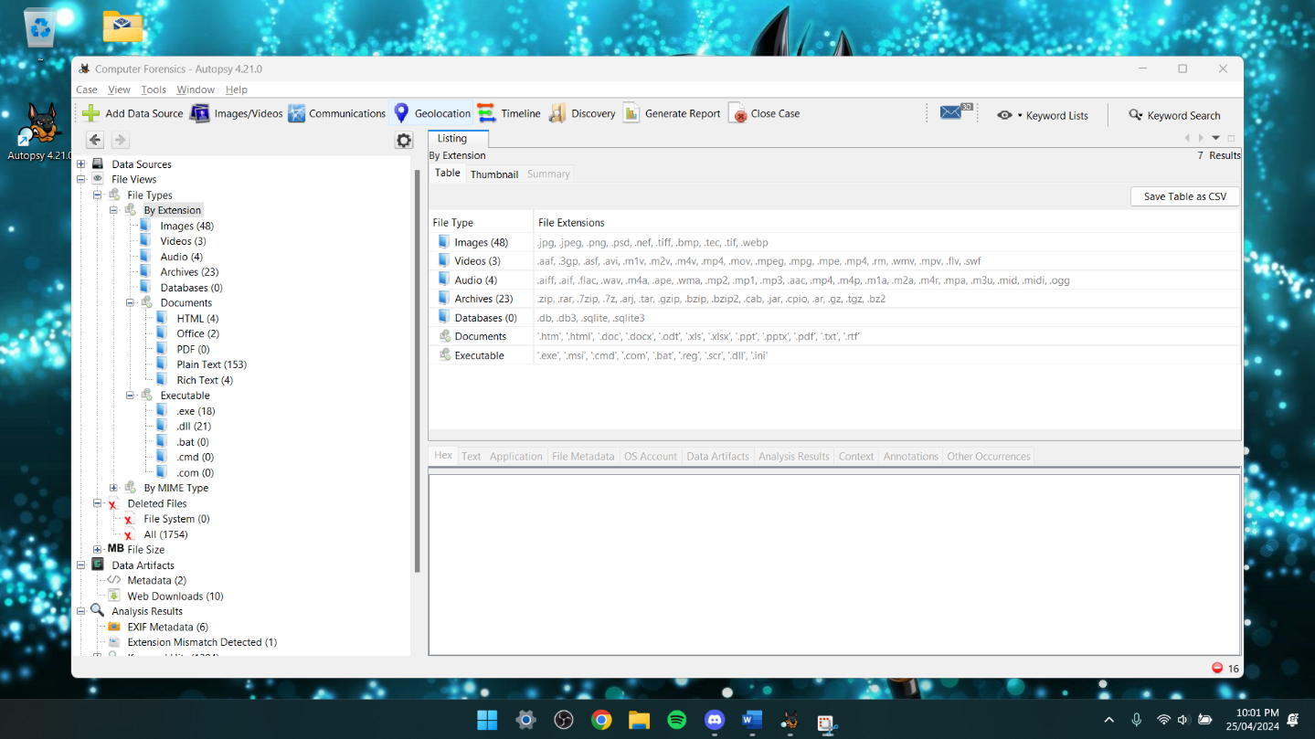
I also found a Mismatch extension in the “Analysis Result”, where I could see a random generator that generated people’s first and last name, gender, age, email, phone, education, occupation, experience, salary, and finally marital status.
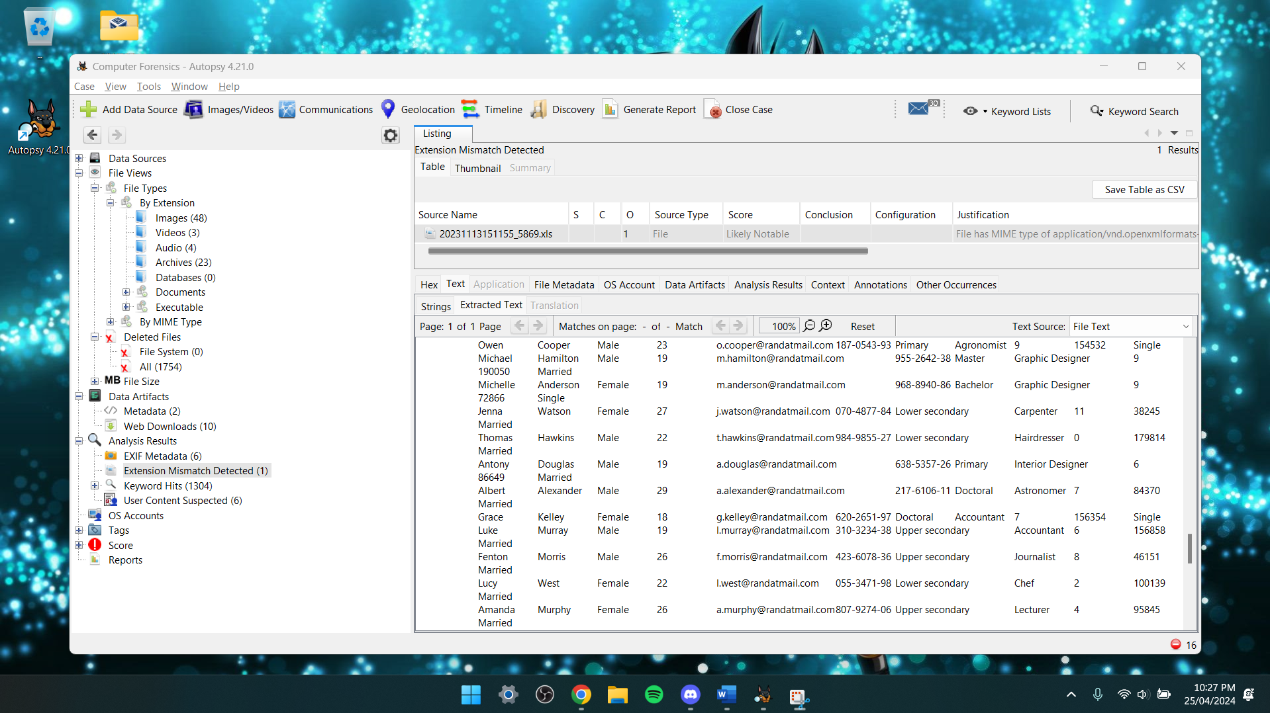

As well as the metadata:
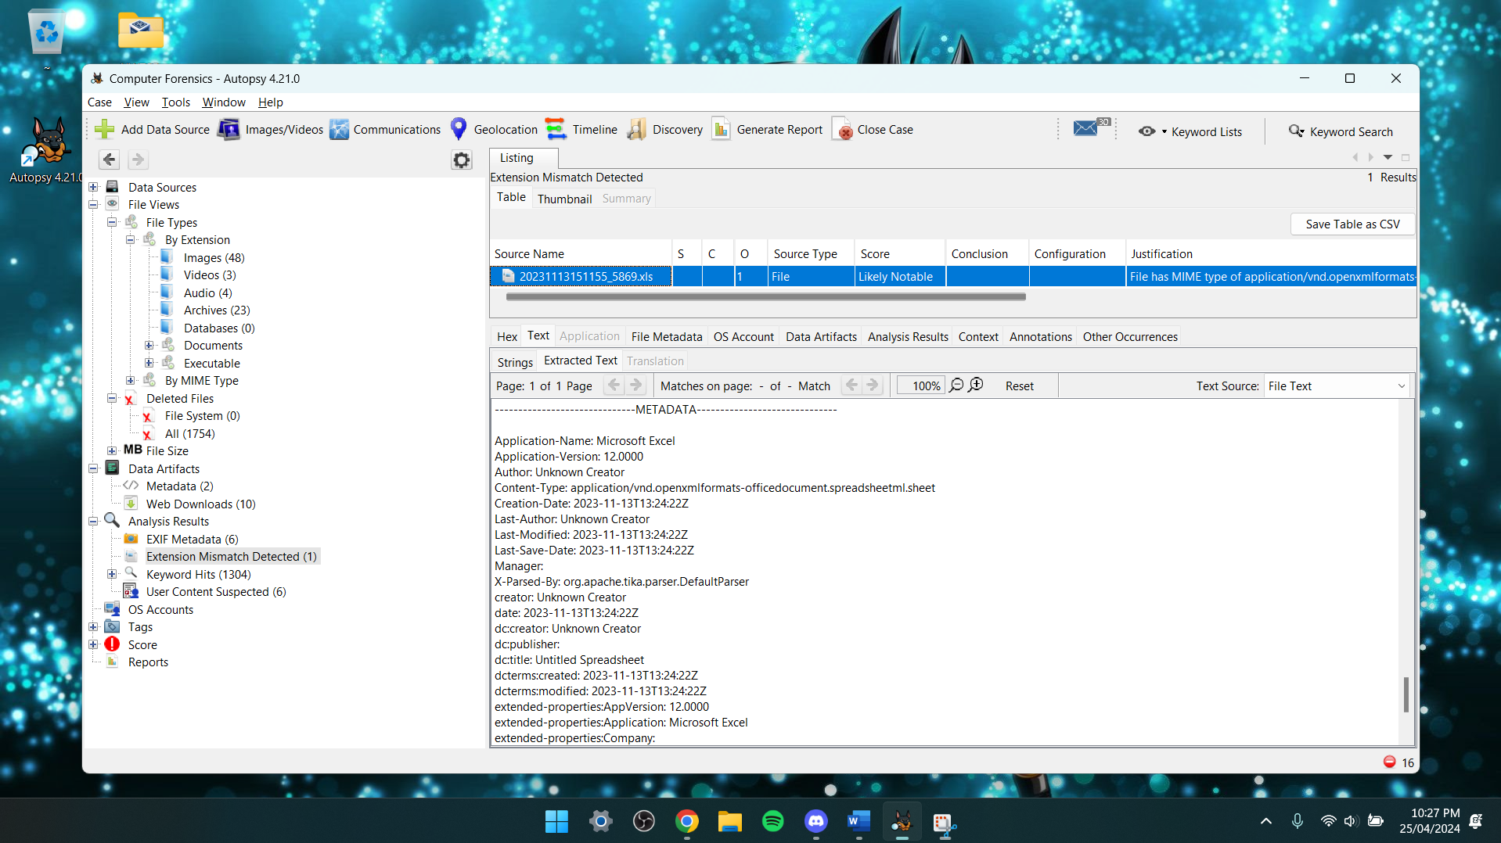

Most of the files were fine, but I found some corrupted files and a lot of deleted files.
In the deleted files I pressed on thumbnail and found pictures with their metadata:
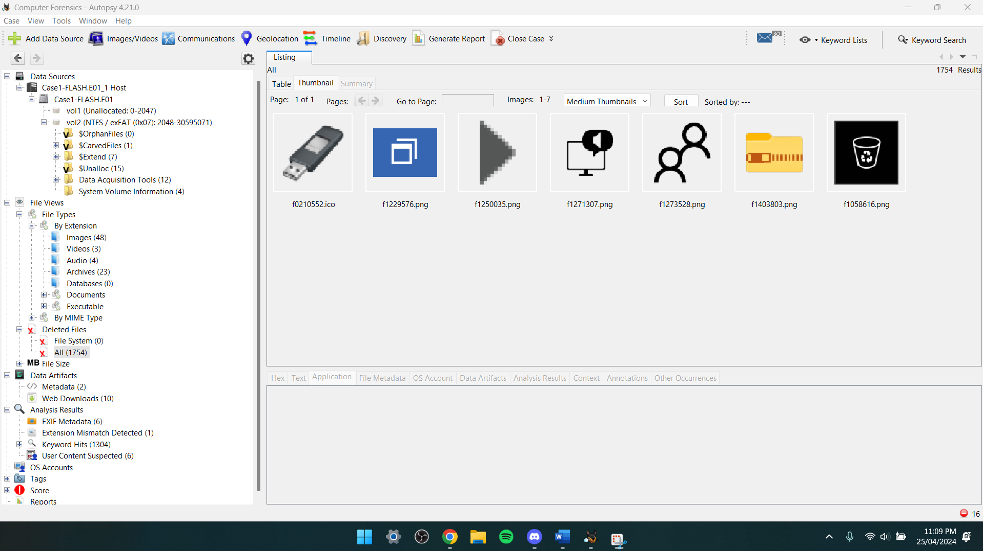

I found a zoom meeting:
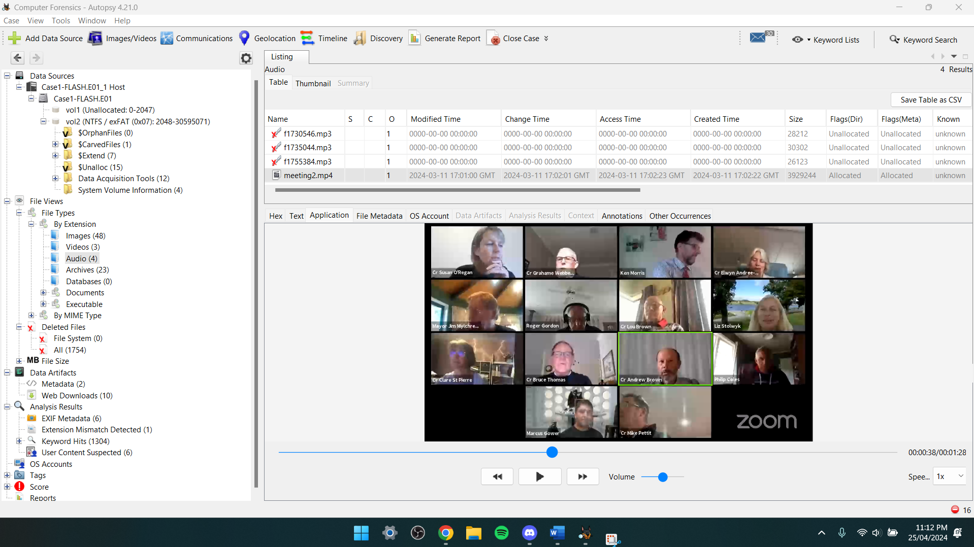

I also found a password for files:
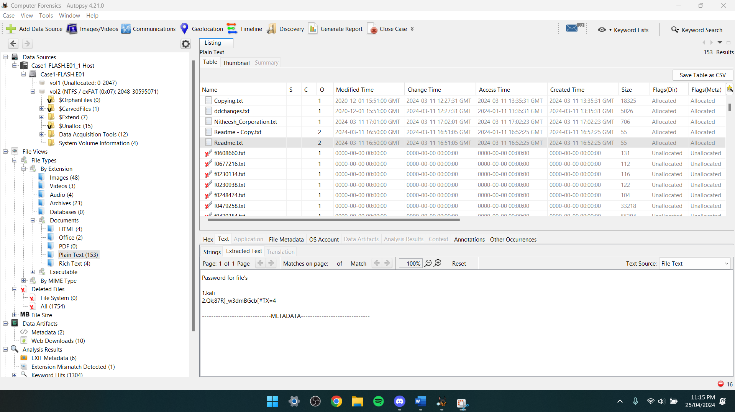

In the images I was able to find several stuffs:
I first noticed that most of the images contained text messages between two people where a random guy is trying to hack into someone’s account detail/life or trying to meet this girl in real life where she clearly didn’t want to, but he kept insisting on it and made her uncomfortable. He also tried to act as he is in her school and acting like he is one of the students having a crush on her.
I also found 3 database images with a ton of people’s information.

In one of the images, an email was sent to nitheesh@gmail.com to verify bank account details which is a scam sent by “Josh”.
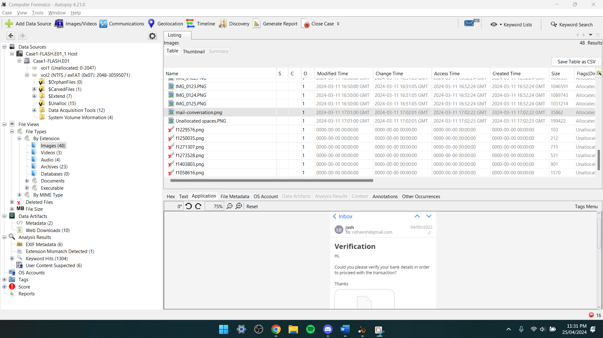
Never trust random people’s mails or texts.

To try and get more details, I looked up on YouTube to see what more I can find in those files, so I see that I can check the timeline of the images, the details, and the counts:
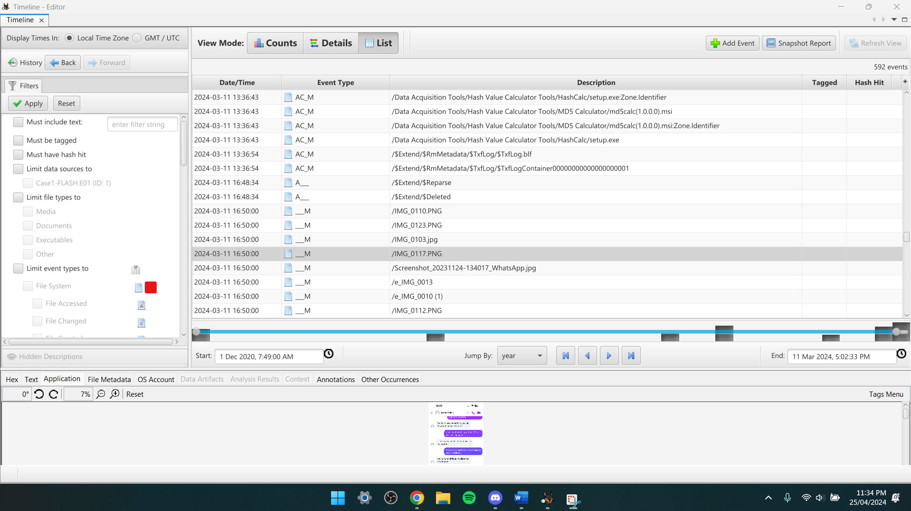

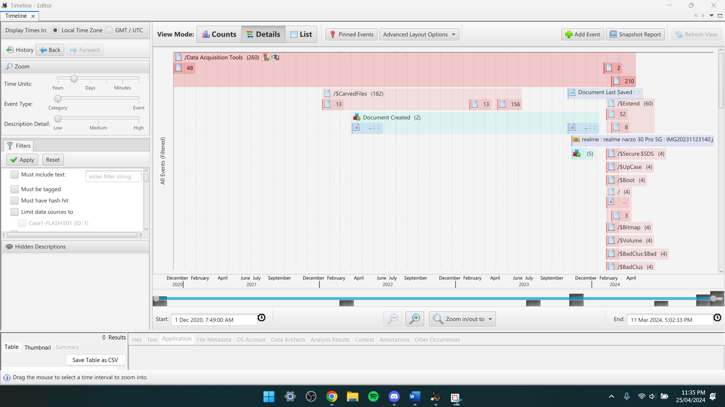

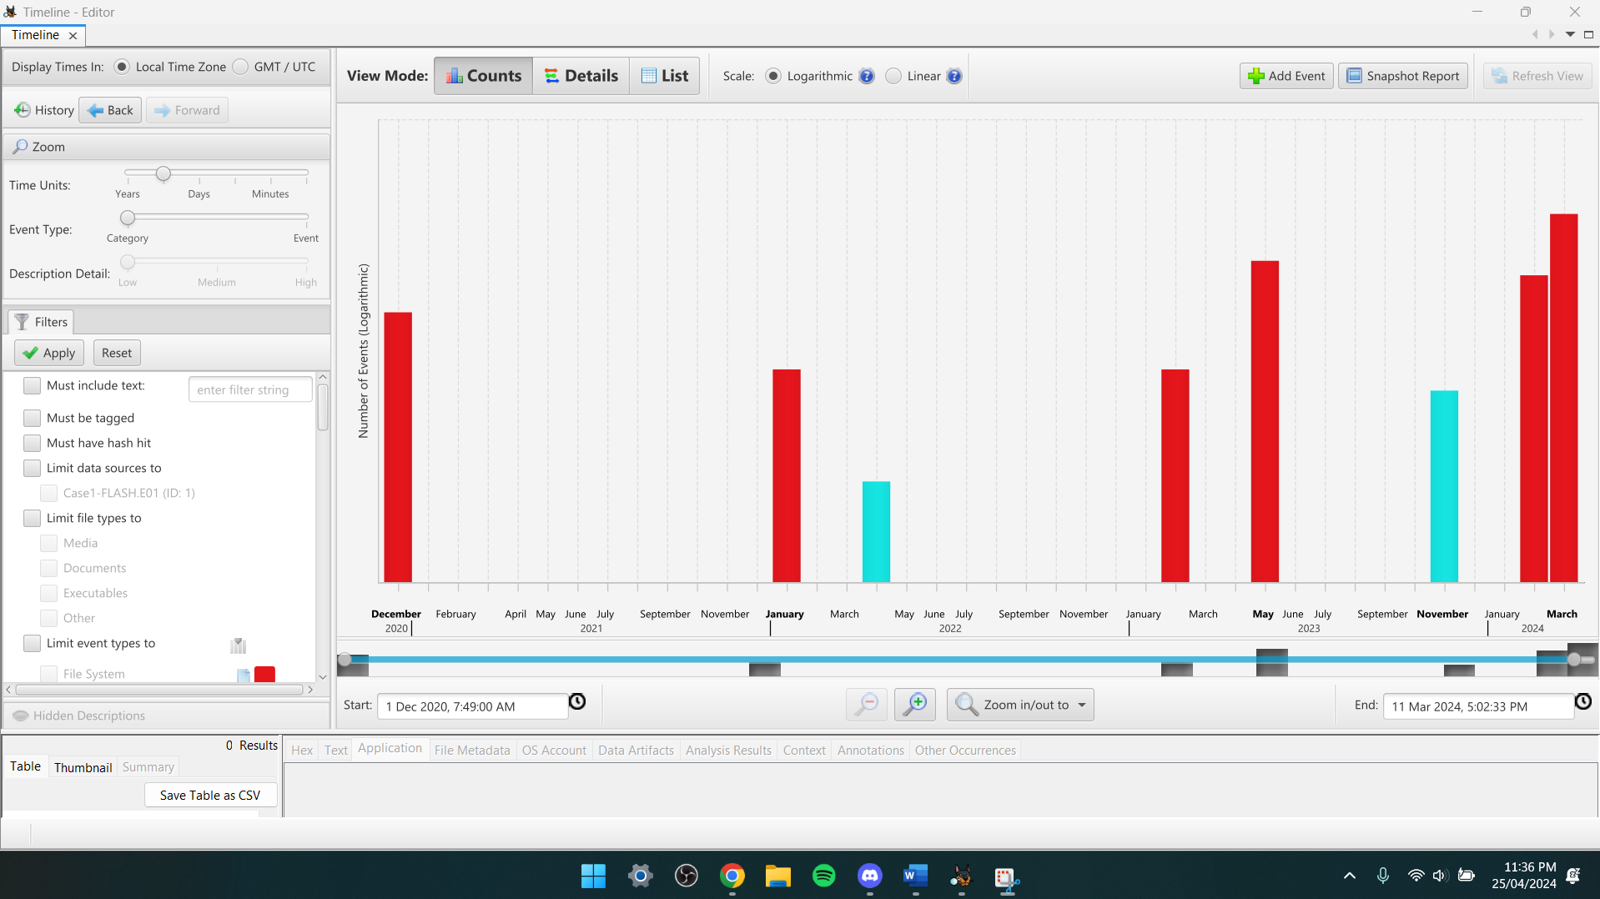

References:
https://chat.openai.com/
https://www.nu.edu/blog/what-is-computer-forensics/#:~:text=The%20history%20of%20computer%20forensics,civil%20litigation%2C%20among%20other%20areas.
https://www.quora.com/What-is-the-difference-between-computer-forensics-and-traditional-forensics
https://www.techtarget.com/searchsecurity/definition/computer-forensics#:~:text=Digital%20evidence%20is%20useful%20in,run%20accidents%2C%20and%20even%20murder.
https://libguides.hull.ac.uk/other/cases
https://recordedfuture.com/threat-intelligence-101/intelligence-sources-collection/information-gathering
https://www.salvationdata.com/knowledge/network-forensics-tools/
https://www.cascade.app/blog/vrio-framework
https://eclipseforensics.com/3-famous-cases-solved-through-digital-forensics/
https://www.researchgate.net/publication/343665051_Digital_forensic_tools_Recent_advances_and_enhancing_the_status_quo
https://www.researchgate.net/publication/375675596_Innovations_in_Security_A_Study_of_Cloud_Computing_and_IoT
https://youtu.be/sSLinAlFow0
https://youtu.be/-UZo1wP_4GY
https://youtu.be/pum8OW5Ecqc
https://youtu.be/r3tjiUW24qs
https://youtu.be/S6V66G2tVr8

