Student name: Samuel Jones
Student number: 2024633
Module code: ACCB5011
ADVANCED SOFTWARE DEVELOPMENT
Inventory Management System (IMS)

Introduction
Welcome to my overly complicated assignment documentation, of which I will be explaining and documenting the steps I’ll take to explain, test, and analyse the program I have created. The task I have taken on is the Inventory Management System, which I’ll be referring to as IMS.
I’ve chosen IMS as my assignment since it’s familiar to me in my day-to-day life as a software engineer and IT system manager. The code is written in C++, which isn’t new to me as I’ve developed many projects in this language, which in my case I may have developed the software to my standard in the workplace. This comes as an advantage to me coming into this assignment, albeit I’m slightly rusty.

Table of contents
Contents
1. Introduction 1
Table of contents 1
2. Introduction 2
2.1 What’s an IMS? 2
2.2 Developing my software 2
2.3 My plan 3
3. The plan 3
Introduction 3
2.2 Objectives 3
2.3 Functionality testing 4
2.4 Performance testing 6
2.5 Usability testing 6
2.6 Security testing 6
2.7 Integration testing 6
2.8 Regression testing 7
3. Test environment 7
3.1 Hardware 7
3.2 Software 7
3.3 Test data 7
3.4 User 7
4. Testing 7
4.1. Functionality testing: 7
4.2 Adding a product: 8
4.3 Removing a Product Test: 9
4.4 Performance testing 10
Memory usage: 11
CPU usage: 12
4.3 Usability testing 13
4.5 Integration testing 13
6. Test reporting 14

Introduction
Testing software is an essential and crucial step in the life cycle of software development, its purpose is to assure quality and ensure the software meets the intended goal and the mechanics are performing well. In my approach to testing the software, I’ll be using various techniques to recognise the diverse impact that will need to be evaluated. Testing functions ensures that the functionality of the software is stable and performs its developed purposes accurately, whilst also analysing the performance of event actions to assess how efficiently it can handle various tasks while minimising memory bottlenecks. Finally, I’ll be regression testing to ensure that any new code added to the software performs as it should without affecting the stability of the program.

What’s an IMS?
An IMS is a tool in the supply chain management and business management to optimise tracking, monitoring, and control of a company’s asset inventory. Think of it this way, imagine having a company that has multitude of assets, whether it may be expensive or not, and there’s no digital way of keeping track of all these assets. Well, that’s pretty much what an IMS is in short. Computers in our day and age is vital to the day-to-day operations of businesses and they’d be completely lost without it. Now my tool isn’t really suited to any corporation to use as it may have bugs, untested features, and it’s not a good-looking user interface to use. However, for this assignment I enjoyed using my skill and scraping some of the rust off and develop a fun project.

Developing my software
Developing my software brought some challenges, as C++ is such a high-level language it’s difficult to track bugs when (and they will) come. Overcoming these bugs requires focus on the exception messages, and without these it’ll be very frustrating to fix and deploy new versions to the software. Luckily, before I’m able to deploy software and in this case, submit it to the university, I can create a test plan, take screenshots of features and/or bugs and give a plan of how I’ll be fixing these issues. These will include testing objectives, expected results and test cases.
I kept logs within the console command that the user can see and that I can see, for when there’s an unexpected outcome, I’m able to capture the message and see what and where it went wrong. This is good practice for software engineers, in fact it’s vital. I’ll be hunting bugs and stamping them out with bug reporting, keeping a detailed list and log of information such as the issue description, severity, and impact to the program.
I’ve ensured that when it comes to regression testing, I can make changes and update the IMS after initial testing, documenting the results to ensure that the existing functionality of the program remains intact. The importance of availability to a vital software is paramount to every business, and although this is just an assignment, I’m holding myself accountable as if I’m creating a tool for the real world.

My plan
I’ve created a test plan detailed below, with initial objectives as to what I want the program to achieve in terms of availability and integrity. I’ll be performing regression testing to ensure that no bugs can destroy the running time of the program and it remains online despite anything it’s thrown at it.

The plan

Introduction

What’s the purpose of planning a test?
Good question, the purpose of testing is to define a testing strategy to expect the results you set the objectives to. It defines the scope of the project and the goals you set out.

The plan covers activities that will test the resources available, the schedule to validate its functionality, availability, performance, and the usability of the system. Without these objectives, it’s difficult to set out objectives and provides a poor concept to the performance of your software.

2.2 Objectives
I will be:

Testing each of the items from the menu

Adding data into the data stream in the system.

Removing data currently held in the data stream.

Editing data in the data stream

Checking if the data integrity

Ensuring the user is using the correct data into the prompts.

Ensure the data the user inputs are correct and inserted.

Running through the functionality of the software

Ensure the usability remains the same despite an error occurring.

2.3 Functionality testing

To ensure that all the features I’ve included in the software and its functions are working as intended.

Identify the functions and features of your IMS that need to be tested.

Create test cases for each function or feature.

2. Test Data Preparation:
- I’ve prepared test data that covers the scenario, which test data validation and invalid inputs.

3. Test Execution:
- Execute each test, providing the necessary inputs as required.
- Observe the program's output and behaviour during each test.

4. Functional Testing Scenarios:

a. Adding a Product:
- Test adding a product with valid data.
- Test adding a product with invalid data (e.g., incorrect price (double) or quantity (int).
- Verify that products with the same ID cannot be added.

b. Removing a Product:
- Test removing a product by providing an ID, whether it’s a valid ID or not.
- Test removing a product by providing an invalid or non-existent ID.
- Verify that the product is no longer present in the inventory after removal.

c. Finding a Product:
- Test finding a product by providing a valid ID, testing the user input prompt.
- Test finding a product by providing an invalid or non-existent ID.
- Verify that the correct product details are displayed if they’re found.

d. Editing a Product:
- Test editing a product with data.
- Test editing a product with invalid data (e.g., empty name or incorrect price).
- Verify that the product details are updated correctly.

e. Viewing Products:
- Test viewing all products in the inventory, even if the data stream is empty.
- Verify that the list of products is displayed correctly.

f. Saving and Loading Inventory:
- Test saving the inventory to a file.
- Test loading the inventory from the saved file.
- Verify that the data is correctly saved and loaded.

5. Record Results:
- For each test case, record whether it passed or failed.
- If a test case fails, document the specific issue or error encountered.

6. Regression Testing:
- After fixing any identified issues, re-run the test cases to ensure that new changes do not tamper with the functionality.

7. Verify Data Validations:
- Test the data validation functions (e.g., getIntegerInput, getStringInput, getDoubleInput, productIdValidation) to ensure they correctly validate user inputs.

8. Usability Testing:
- Evaluate the usability of the IMS by considering the user experience and the overall user interface.

9. Error Handling Testing:
- Test how the program handles errors, such as incorrect file paths when loading inventory.

10. Documentation and Reporting:
- Document the test results, including which test cases passed and which failed.
- Include recommendations for improvements.
- Document the severity of the problems and mitigate it through changes.

11. Continuous Improvement:
- Use the results to identify areas for improvement in the code.
- Update your code based on the testing feedback and retest.

2.4 Performance testing

2.4.1 Performance Metrics
- Response time for operations (e.g., adding, editing, removing, and searching for products).
- Memory usage during normal operation and under stress.
- Scalability (how the system handles a growing amount of data).
- Concurrent user load (simultaneous user interactions).

2.4.2 Performance Testing Tools
- Visual Studio offers tools such as the Performance Profiler and Load Testing.

2.4.3 Performance profiling
- Using the Performance Profiler in Visual Studio to identify snippets that consume amounts of CPU or memory.

2.4.4 Response time
- Measure the response times of basic and some critical operations, such as adding, editing, and searching for products within the data stream.

2.4.5 Memory Analysis
- Look for memory leaks or inefficient memory management.

2.4.6 CPU Utilisation
- Monitor CPU utilization during functions to identify bottlenecks.

2.5 Usability testing

2.5.1 Establishing goals.
- I analyse how users interact with the tool, identify any pain points, and find any improvements necessary.

2.5.2 Prioritize Improvements
- I find usability bottlenecks to address, focusing on those that have the most significant impact on memory efficiency and user experience.

2.6 Security testing

2.7 Integration testing

2.7.1 Data validation
- I’ll be testing user input and their validation to ensure that the prompts are carefully bulletproof.
- Ensure that any incorrect data prompts are handled correctly.
- Give a chance to the user to correctly fix their mistake in the program by recursion.
- Ensure no defects are found or anomalies inside the data stream if the user incorrectly inserts data but the system accepts the information.

2.8 Regression testing

2.8.1 Environment changes
- Ensure that any improvements or changes to the software do not affect the usability of the software.
- Retest the software to see any defects in the changes, fix if necessary.
- Ensure that no bugs or errors occur affect the program and the usability.

3. Test environment

3.1 Hardware

3.1.1 My computer

3.2 Software

3.2.1 IMS Tool

3.3 Test data

3.3.1 inventory.txt

3.4 User

3.4.1 Samuel Jones (Me)

Testing

4.1. Functionality testing:
- Go through each function and test its usability and functionality.
- 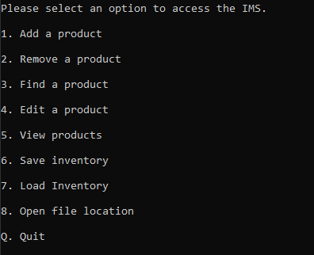
- Load files to ensure that the data stream created by the user prompt successfully executes the full code without problems.
- 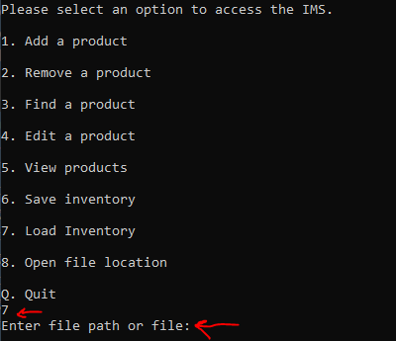
- Ensure that all products added to the data stream are visible and can be edited/updated/removed.
- 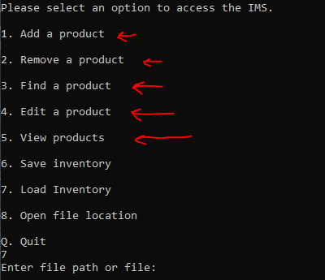
- Ensure that data validation is sanitising the user input.
- 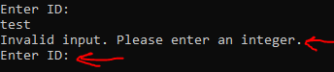
- Check if the try {} and catch {} blocks are successfully avoiding program instability by inserting incorrect prompts.
- 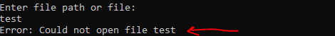
- Ensure that existing data cannot be overwritten to ensure data integrity, unless the Edit a product option is selected.
- 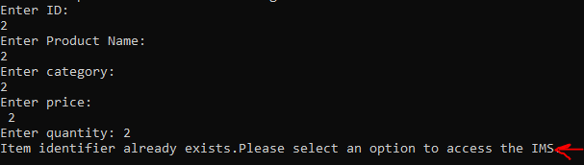

Adding a product:

Expected outcome:
Test Case ID | 33
Description | Verify product addition (against the vector ID values)
Precondition | IMS application is running
Test Data | Valid product data
Steps | 1. Select 'Add product’.  2. Enter product details  3. Press enter
Expected outcome | Product is added to inventory.
Postcondition | Product added successfully. Back to main. Print out to console.

Actual outcome:
Steps | Action
- Pressed 1 on menu to add product | Entered add product menu with prompts for the user
- Enter the test case ID | User prompt is valid, continue to next prompt
- Enter Product name | User prompt is valid, continue to next prompt
- Enter price as a double | User prompt is an integer therefore valid, continue to next prompt
- Enter quantity as an integer | User input confirmed as an integer, add the product to the inventory.
- Print out the outcome of adding product to inventory | Product added successfully and printed out for the user.

Screenshots:
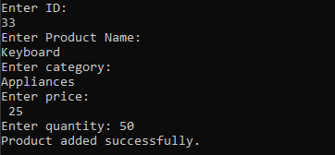
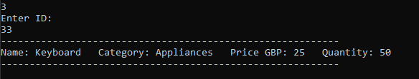

Conclusion:
- Adding products is successful, inputting correct data types into the prompt.
- Will need to delete the whitespace under ‘Enter Price:’.
- The message ‘Product added successfully’ needs to be clearer.

Removing a Product Test:

Expected outcome:
Test Case ID | 33
Description | Verify product is in the inventory (against the vector ID values)
Precondition | IMS application is running
Test Data | Product ID valid (valid/invalid)
Steps | 1. Select ‘Remove a product’.  2. Enter product ID  3. Press enter
Expected outcome | Product removed if ID is valid, error message if invalid.
Postcondition | Product removed or not found.

Actual outcome:
Steps | Action
- Pressed 2 on menu to add product | Entered product ID
- Check if prompt is valid | User prompt is valid, continue to next prompt
- Removed product from inventory if valid | Product ID 33 is removed from the inventory, per message.
- Check if product has been removed. | Using ‘Find a product’ menu prompt to verify.

Screenshots:
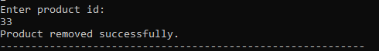
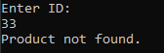

4.4 Performance testing

Response Time Test:

Concurrent User Load Test:

Expected outcome:
Test Scenario | Expected Outcome
Response Time Test
Add a Product Response Time | Record the time taken to add a product for different data loads.
Edit Product Response Time | Record the time taken to edit a product for different data loads.
Find Product Response Time | Record the time taken to find a product for different data loads.
Memory Usage Monitoring
Monitor Memory During Operations | Monitor and record memory usage during operations.
CPU Usage monitoring
Monitor CPU usage | Monitor and record the % of CPU is being used.

Memory usage:
- Adding a product:
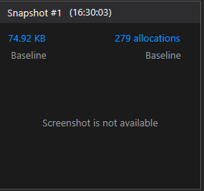
- Find a product:
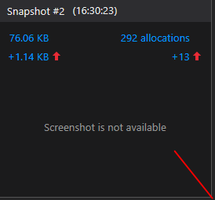

Load data into inventory:
- 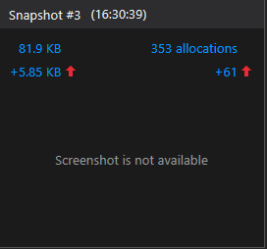

View inventory:

- 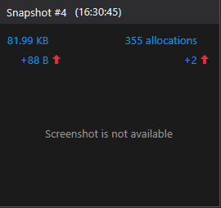

Overall memory usage:

CPU usage:

% of CPU usage

Functions called
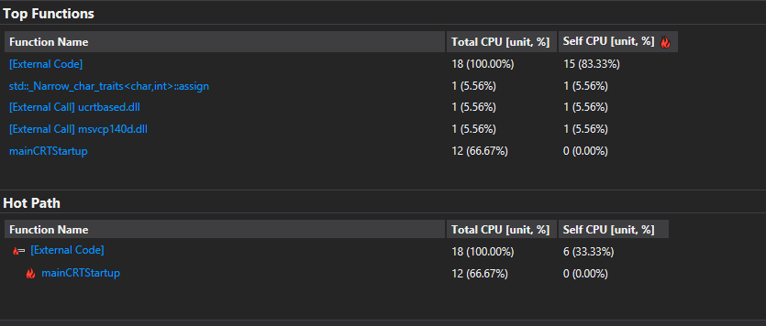
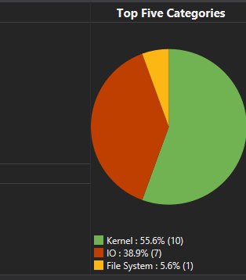
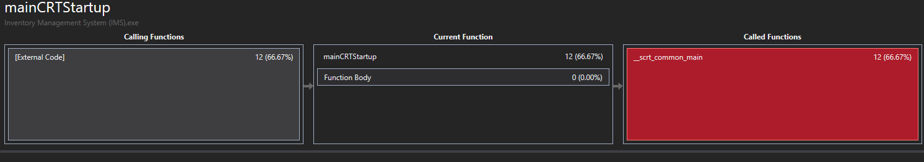

Conclusion:
Overall, the program utilises very little CPU usage and no bottlenecks are found. This test concludes that the software has no bad memory management and intensive tasks that overflow the program.

4.3 Usability testing

Usability Testing Procedures:
Task | Expected Outcome
Task 1: Launch application | Application launches successfully
Task 2: Add a Product | User can add product to the inventory without difficulty.
Task 3: Search a Product | User can search for a product and find product details.
Task 4: Edit a Product | User can edit the product information accurately and save to the inventory.
Task 5: Remove a Product | User can remove a product from the inventory with ease.
Task 6: View Products | User can view the list of products in a clear and organized manner.
Task 7: Save Inventory | User can save the inventory data to a file successfully.
Task 8: Load Inventory | User can load the inventory data from a saved file without errors.
Task 9: Navigate Menu | User can easily navigate through the application menu and perform desired actions.

4.5 Integration testing

Input Validation Test
Test Scenario | Expected Outcome
Scenario 1: Text Input (String) | Program accepts and processes string inputs correctly.
Scenario 2: Integer Input | Program accepts and processes integer inputs accurately.
Scenario 3: Double Input | Program accepts and processes double inputs without errors.
Scenario 4: Empty Input | Program rejects empty input fields and provides appropriate error messages.
Scenario 5: Invalid Character in Input | Program detects and rejects inputs containing invalid characters (e.g., special symbols).
Scenario 6: Input Exceeds Character Limit | Program enforces character limits for inputs and rejects inputs that exceed limits.
Scenario 7: Negative Integer Input | Program rejects negative integer inputs and provides an error message.
Scenario 8: Valid file path input | Program verifies the file path format is correct and checks if file exists.

Regression testing
Test Scenario | Expected Outcome
Change Impact Test:
Scenario 1: Replace and fix any bugs | Document any bugs and replace the broken code. Recompile to verify the program remains functional.
Functionality Verification:
Scenario 1: Find Product - Non-existing Product | When finding a non-existing product, it should provide an appropriate message indicating that the product is not found.

6. Test reporting

