Appendices:

Appendix 1 – Ethics form:

APPLICATION FOR ETHICAL APPROVAL

In order for research to result in benefit and minimise risk of harm, it must be conducted ethically. A researcher may not be covered by the University’s insurance if ethical approval has not been obtained prior to commencement.

The University follows the OECD Frascati manual definition of research activity: “creative work undertaken on a systematic basis in order to increase the stock of knowledge, including knowledge of man, culture and society, and the use of this stock of knowledge to devise new applications”. As such this covers activities undertaken by members of staff, postgraduate research students, and both taught postgraduate and undergraduate students working on dissertations/projects.

The individual undertaking the research activity is known as the “principal researcher”.

Ethical approval is not required for routine audits, performance reviews, quality assurance studies, testing within normal educational requirements, and literary or artistic criticism.

Please read the notes for guidance before completing ALL sections of the form.

This form must be completed and approved prior to undertaking any research activity. Please see Checklist for details of process for different categories of application.

Delete the Guidance Notes at the end of the form BEFORE submitting your application

SECTION A: About You (Principal Researcher)
Full Name: |  | Hannah Louise Warrilow
Tick all boxes which apply: |  | Member of staff: | ☐ | Honorary research fellow: | ☐
Undergraduate Student | ☒ | Taught Postgraduate Student | ☐ | Postgraduate Research Student | ☐

Faculty/School/Centre: | Initial Teacher Education, Yr Athrofa
Campus: | Carmarthen
E-mail address: | 1801583@student.uwtsd.ac.uk
Contact Telephone Number: | 07956764068
For students:
Student Number: | 1801583
Programme of Study: | BA Primary Education with QTS
Director of Studies/Supervisor: | Dr. Sioned V. Hughes

SECTION B: Approval for Research Activity
Has the research activity received approval in principle?  (please check the Guidance Notes as to the appropriate approval process for different levels of research by different categories of individual) |  | YES | ☒ | NO | ☐
 |  |  |  | Date
If Yes, please indicate source of approval (and date where known): Approval in principle must be obtained from the relevant source prior to seeking ethical approval | Research Degrees Committee |  | ☐
 | Faculty Research Committee |  | ☐
 | Other (write in) ECAD5010 Module Lead |  | ☒ | 27.02.20

SECTION C: Internal and External Ethical Guidance Materials
Please list the core ethical guidance documents that have been referred to during the completion of this form (including any discipline-specific codes of research ethics, and also any specific ethical guidance relating to the proposed methodology). Please tick to confirm that your research proposal adheres to these codes and guidelines.
UWTSD Research Ethics & Integrity Code of Practice | ☒
UWTSD Research Data Management Policy | ☒
British Educational Research Association [BERA] (2018) Ethical Guidelines for Educational Research. Fourth ed. London.  https://www.brea.ac.uk/researchers-resources/publications/ethical-guidelines-for-educational-research-2018 | ☒
 | ☐

SECTION D: External Collaborative Research Activity
Does the research activity involve collaborators outside of the University? |  | YES | ☐ | NO | ☒
If Yes, please provide the name of the external organisation and name and contact details for the main contact person and confirmation this person has consented to their personal data being shared.as part of this collaboration.
Institution
Contact person name
Contact person e-mail address

Has this individual consented to sharing their details on this form? |  | YES | ☐ | NO |  |  | ☐
Are you in receipt of a KESS scholarship? |  | YES | ☐ | NO |  |  | ☐
Is your research externally funded |  | YES | ☐ | NO |  |  | ☐
Are you specifically employed to undertake this research in either a paid or voluntary capacity? | Voluntary | YES | ☐ | NO |  | ☐
 | Employed | YES | ☐ | NO |  | ☐
Is the research being undertaken within an existing UWTSD Athrofa Professional Learning Partnership (APLP) | If YES then the permission question below does not need to be answered. | YES | ☒ | NO |  |  | ☐
Permission to undertake the research has been provided by the partner organisation | (If YES attach copy)  If NO the application cannot continue | YES | ☐ | NO |  |  | ☐

Where research activity is carried out in collaboration with an external organisation
Does this organisation have its own ethics approval system? | YES | ☐ | NO | ☒
If Yes, please attach a copy of any final approval (or interim approval) from the organisation

SECTION E: Details of Research Activity
Indicative title: | Does self-assessment encourage learners to progress?
Proposed start date: | 02.03.20 | Proposed end date: | 01.04.20
Introduction to the Research (maximum 300 words)
Ensure that you write for a Non-Specialist Audience when outlining your response to the three points below:
- Purpose of Research Activity
- Proposed Research Question
- Aims of Research Activity
- Objectives of Research Activity
Demonstrate, briefly, how Existing Research has informed the proposed activity and explain
- What the research activity will add to the body of knowledge
- How it addresses an area of importance.
Purpose of Research Activity

- To explore how the school implements self-assessment.
- To trail different research tools in practice.
- To explore how a specific class uses self-assessment.
- To understand if and how self-assessment encourages the children to progress.

(this box should expand as you type)
Research Question

Does self-assessment encourage learners to progress?

(this box should expand as you type)
Aims of Research Activity
- To explore different perceptions from the staff and learners of learners’ self-assessment.
- To critically evaluate different research tools such as Questionnaires, Interviews and Observations.
- To develop personal knowledge and understanding of self-assessment to improve professional practice.

(this box should expand as you type)
Objectives of Research Activity

- To explore the self-assessment strategies within the school and how that is implemented by staff.
- To interview 7- and 8-year-old learners to capture their views about self-assessment.
- To observe a small group of children to witness how the children complete self-assessment.
- To critically reflect on the process of using different research tools to collect data.

(this box should expand as you type)
Proposed methods (maximum 600 words)
Provide a brief summary of all the methods that may be used in the research activity, making it clear what specific techniques may be used. If methods other than those listed in this section are deemed appropriate later, additional ethical approval for those methods will be needed.
Interviews – A small group of children from a mixed year class will be involved in a semi-structured interview where they will be invited to respond and expand on key questions. An example of a question, ‘Do you think ‘Tickled Pink and Green for Growth’ helps you reflect on your work?’. The interview will be conducted in an informal setting where I will make notes along with audio recording the interview. I will ensure that all learners are aware of the right to withdraw and that all children taking part in the interview are happy to be there by asking them during regular intervals. The learners’ names will not be recorded at any time.

Questionnaire – Questionnaires will be completed electronically using an iPad or laptop. I have written a separate questionnaire for staff and learners. Despite the questionnaires not requiring names, some learners chosen will have to have their questions read to them as they have a low reading ability. The questionnaires will be given to the same learners identified to partake in the interviews and observations. The questionnaires will be given to the children simultaneously to avoid discussion about questions.

Observations – The observations will be overt, and children will be aware of my presence. I plan to place myself at the back of the classroom in a central position, so I am able to observe the chosen participants simultaneously. The whole class of learners will be informed at the beginning of the session that an observation will take place however I will not disclose which students I am specifically observing. I will also not disclose my research question to reduce the learner’s acting falsely at specific times.

(this box should expand as you type)

Location of research activity
Identify all locations where research activity will take place.
The research activity will take place in a small rural school with approximately 200 pupils.

(this box should expand as you type)
Research activity outside of the UK
If research activity will take place overseas, you are responsible for ensuring that local ethical considerations are complied with and that the relevant permissions are sought. Specify any local guidelines (e.g. from local professional associations/learned societies/universities) that exist and whether these involve any ethical stipulations beyond those usual in the UK (provide details of any licenses or permissions required). Also specify whether there are any specific ethical issues raised by the local context in which the research activity is taking place, for example, particular cultural and/or legal sensitivities or vulnerabilities of participants.
N/A

(this box should expand as you type)
Use of documentation not in the public domain: Are any documents NOT publicly available? | NO | ☒
 | YES | ☐
If Yes, please provide details here of how you will gain access to specific documentation that is not in the public domain and that this is in accordance with prevailing data protection law of the country in question and England and Wales.

(this box should expand as you type)

SECTION F: Scope of Research Activity
Will the research activity include: | YES | NO
Use of a questionnaire or similar research instrument? | ☒ | ☐
Use of interviews? | ☒ | ☐
Use of diaries? | ☐ | ☒
Participant observation with their knowledge? | ☒ | ☐
Participant observation without their knowledge? | ☐ | ☒
Use of video or audio recording? | ☒ | ☐
Access to personal or confidential information without the participants’ specific consent? | ☐ | ☒
Administration of any questions, test stimuli, presentation that may be experienced as physically, mentally or emotionally harmful / offensive? | ☐ | ☒
Performance of any acts which may cause embarrassment or affect self-esteem? | ☐ | ☒
Investigation of participants involved in illegal activities? | ☐ | ☒
Use of procedures that involve deception? | ☒ | ☐
Administration of any substance, agent or placebo? | ☐ | ☒
Working with live vertebrate animals? | ☐ | ☒
Other primary data collection methods, please explain in this box  For example, ‘focus groups’. Please indicate the type of data collection method(s) in this box and tick the accompany box. | ☒ | ☐
Details of any other primary data collection method:  Focus Groups  (this box should expand as you type) | ☒ | ☐
If NO to every question, then the research activity is (ethically) low risk and may be exempt from some of the following sections (please refer to Guidance Notes).

If YES to any question, then no research activity should be undertaken until full ethical approval has been obtained.

SECTION G: Intended Participants
Who are the intended participants: | YES | NO
Students or staff at the University? | ☐ | ☐
Adults (over the age of 18 and competent to give consent)? | ☒ | ☐
Vulnerable adults? | ☐ | ☐
Children and Young People under the age of 8? (Consent from Parent, Carer or Guardian will be required) | ☒ | ☐
Prisoners? | ☐ | ☐
Young offenders? | ☐ | ☐
Those who could be considered to have a particularly dependent relationship with the investigator or a gatekeeper? | ☐ | ☐
People engaged in illegal activities? | ☐ | ☐
Others (please identify specifically any group who may be unable to give consent) please indicate here and tick the appropriate box. | ☐ | ☐
Other – please indicate here:  (this box should expand as you type) | ☐ | ☐

Participant numbers and source How will you identify participants and how will they be recruited?
How many participants are expected? | 7 participants  (this box should expand as you type)
Who will the participants be? | 1 Teacher and 6 Pupils : Pupils aged 7-8  (this box should expand as you type)
How will you identify the participants? | Previous experience in the school during PTE2  (this box should expand as you type)

Information for participants: | YES | NO | N/A
Will you describe the main research procedures to participants in advance, so that they are informed about what to expect? | ☒ | ☐ | ☐
Will you tell participants that their participation is voluntary? | ☒ | ☐ | ☐
Will you obtain written consent for participation? | ☐ | ☐ | ☒
Will you explain to participants that refusal to participate in the research will not affect their treatment or education (if relevant)? | ☒ | ☐ | ☐
If the research is observational, will you ask participants for their consent to being observed? | ☒ | ☐ | ☐
Will you tell participants that they may withdraw from the research at any time and for any reason? | ☒ | ☐ | ☐
With questionnaires, will you give participants the option of omitting questions they do not want to answer? | ☒ | ☐ | ☐
Will you tell participants that their data will be treated with full confidentiality and that, if published, it will not be identifiable as theirs? | ☒ | ☐ | ☐
Will you debrief participants at the end of their participation, in a way appropriate to the type of research undertaken? | ☐ | ☐ | ☒
If NO to any of above questions, please give an explanation
(this box should expand as you type)

Information for participants: | YES | NO | N/A
Will participants be paid? | ☐ | ☒ | ☐
Is specialist electrical or other equipment to be used with participants? | ☐ | ☒ | ☐
Are there any financial or other interests to the investigator or University arising from this study? | ☐ | ☒ | ☐
Will the research activity involve deliberately misleading participants in any way, or the partial or full concealment of the specific study aims? | ☐ | ☒ | ☐
If YES to any question, please provide full details
(this box should expand as you type)

SECTION H: Anticipated Risks

Outline any anticipated risks that may adversely affect any of the participants, the researchers and/or the University, and the steps that will be taken to address them.

If you have completed a full risk assessment (for example as required by a laboratory, or external research collaborator) you may append that to this form.
Full risk assessment completed and appended? |  | Yes | ☐
 |  | No | ☒
Risks to participants
For example: emotional distress, financial disclosure, physical harm, transfer of personal data, sensitive organisational information
Risk to Participant:  - Pupils may feel pressured to give the correct answer to the questions.  - Pupils may not feel comfortable enough to withdraw.  (this box should expand as you type) | How will you mitigate the Risk to Participant  - Pupils will be told that there is no consequence for anything they say. I will make it clear that I want open and honest answers. I will make it clear that the answers they give will not affect their education and there will be no repercussions for their actions and answers in regard to the research.  - I will ensure that the children understand that this research is not compulsory and that they will always have the option to stop and leave if they want to. The children will know that if they want to leave, their answers will not be included in the research.  (this box should expand as you type)
If research activity may include sensitive, embarrassing or upsetting topics (e.g. sexual activity, drug use) or issues likely to disclose information requiring further action (e.g. criminal activity), give details of the procedures to deal with these issues, including any support/advice (e.g. helpline numbers) to be offered to participants. Note that where applicable, consent procedures should make it clear that if something potentially or actually illegal is discovered in the course of a project, it may need to be disclosed to the proper authorities
N/A
(this box should expand as you type)
Risks to investigator
For example: personal safety, physical harm, emotional distress, risk of accusation of harm/impropriety, conflict of interest
Risk to Investigator:  - The children may disclose something confidential or important whereby the research may have to stop.  (this box should expand as you type) | How will you mitigate the Risk to Investigator:  - The majority of the research will take place within the classroom. The children will know that they are taking part in research and will hopefully keep their focus.  (this box should expand as you type)
University/institutional risks
For example: adverse publicity, financial loss, data protection
Risk to University:  e.g.  1. The school may view behaviour in an unprofessional way.  (this box should expand as you type) | How will you mitigate the Risk to University:  - I will ensure that I behave professionally at all times.  (this box should expand as you type)

Disclosure and Barring Service
If the research activity involves children or vulnerable adults, a Disclosure and Barring Service (DBS) certificate must be obtained before any contact with such participants. | YES | NO | N/A
Does your research require you to hold a current DBS Certificate? | ☒ | ☐ | ☐

SECTION I: Feedback, Consent and Confidentiality
Feedback
What de-briefing and feedback will be provided to participants, how will this be done and when?
N/A

(this box should expand as you type)
Informed consent
Describe the arrangements to inform potential participants, before providing consent, of what is involved in participating. Describe the arrangements for participants to provide full consent before data collection begins. If gaining consent in this way is inappropriate, explain how consent will be obtained and recorded in accordance with prevailing data protection legislation.
I will converse with my class teacher, senior mentor and head teacher informing them of the research I will be conducting along with the reasoning and rationale behind my research. I will verbally ask the children chosen if they wish to participate in the research. I will ensure that the children are regularly asked if they are happy to continue and feel comfortable enough to carry on. The children will complete the questionnaires individually and will be asked for honest and open answers. Children will be informed that expanding on answers or offering any other relevant information will be encouraged.

(this box should expand as you type)
Confidentiality / Anonymity
Set out how anonymity of participants and confidentiality will be ensured in any outputs. If anonymity is not being offered, explain why this is the case.
No names will ever be recorded. I will ensure that no individual, identifiable data be collected such as audio recordings will be made available to schools/parents.

(this box should expand as you type)

SECTION J: Data Protection and Storage NO NEED TO COMPLETE SECTION J
In completing this section refer to the University’s Research Data Management Policy and the extensive resources on the University’s Research Data Management web pages (http://uwtsd.ac.uk/library/research-data-management/).
Does the research activity involve personal data (as defined by the General Data Protection Regulation 2016 “GDPR” and the Data Protection Act 2018 “DPA”)? | YES | NO
“Personal data” means any information relating to an identified or identifiable natural person (‘data subject’). An identifiable natural person is one who can be identified, directly or indirectly, in particular by reference to an identifier such as a name, an identification number, location data, an online identifier or to one or more factors specific to the physical, physiological, genetic, mental, economic, cultural or social identity of that natural person. | ☐ | ☐
If YES, provide a description of the data and explain why this data needs to be collected:
(this box should expand as you type)
Does it involve special category data (as defined by the GDPR)? | YES | NO
“Special category data” means sensitive personal data consisting of information as to the data subjects’ –  (a) racial or ethnic origin,  (b) political opinions,  (c ) religious beliefs or other beliefs of a similar nature,  (d) membership of a trade union (within the meaning of the Trade Union and Labour Relations (Consolidation) Act 1992),  (e) physical or mental health or condition,  (f) sexual life,  (g) genetics,  (h) biometric data (as used for ID purposes), | ☐ | ☐
If YES, provide a description of the special category data and explain why this data needs to be collected:
(this box should expand as you type)
Will the research activity involve storing personal data and/or special category data on one of the following: | YES | NO
Manual files (i.e. in paper form)? | ☐ | ☐
University computers? | ☐ | ☐
Private company computers? | ☐ | ☐
Home or other personal computers? | ☐ | ☐
Laptop computers/ CDs/ Portable disk-drives/ memory sticks? | ☐ | ☐
“Cloud” storage or websites? | ☐ | ☐
Other – specify: | ☐ | ☐
For all stored data, explain the measures in place to ensure the security of the data collected, data confidentiality, including details of password protection, encryption, anonymisation and pseudonymisation:
(this box should expand as you type)
All Data Storage
Will the research activity involve any of the following activities: | YES | NO
Electronic transfer of data in any form? | ☐ | ☐
Sharing of data with others at the University? | ☐ | ☐
Sharing of data with other organisations? | ☐ | ☐
Export of data outside the European Union or importing of data from outside the UK? | ☐ | ☐
Use of personal addresses, postcodes, faxes, emails or telephone numbers? | ☐ | ☐
Publication of data that might allow identification of individuals? | ☐ | ☐
Use of data management system? | ☐ | ☐
Data archiving? | ☐ | ☐
If YES to any question, please provide full details, explaining how this will be conducted in accordance with the GDPR and DPA (and/or any international equivalent):
(this box should expand as you type)
List all who will have access to the data generated by the research activity:
(this box should expand as you type)
List who will have control of, and act as custodian(s) for, data generated by the research activity:
(this box should expand as you type)
Give details of data storage arrangements, including security measures in place to protect the data, where data will be stored, how long for, and in what form. Will data be archived – if so how and if not why not.
(this box should expand as you type)
Please indicate if your data will be stored in the UWTSD Research Data Repository (see https://researchdata.uwtsd.ac.uk/ ). If so please explain. (Most relevant to academic staff)
(this box should expand as you type)
Confirm that you have read the UWTSD guidance on data management (see https://www.uwtsd.ac.uk/library/research-data-management/) | YES | ☐
 | NO | ☐
Confirm that you are aware that you need to keep all data until after your research has completed or the end of your funding | YES | ☐
 | NO | ☐

SECTION K: Declaration
The information which I have provided is correct and complete to the best of my knowledge. I have attempted to identify any risks and issues related to the research activity and acknowledge my obligations and the rights of the participants.

In submitting this application I hereby confirm that I undertake to ensure that the above named research activity will meet the University’s Research Ethics and Integrity Code of Practice
Signature of applicant: | H.Warrilow | Date:  27.02.20

For STUDENT Submissions:
Director of Studies/Supervisor: | Dr. Sioned V. Hughes | Date:  27.02.20
Signature: | S.V.Hughes | Date:  27.02.20

For STAFF Submissions:
Head of School/Assistant Dean: |  | Date:
Signature: |  | Date:

Checklist: Please complete the checklist below to ensure that you have completed the form according to the guidelines and attached any required documentation:
☒ | I have read the guidance notes supplied before completing the form.
☒ | I have completed ALL RELEVANT sections of the form in full.
☒ | I confirm that the research activity has received approval in principle
☐ | I have attached a copy of final/interim approval from external organisation (where appropriate)
☐ | I have attached a full risk assessment (and have NOT completed Section H of this form) (where appropriate) ONLY TICK IF YOU HAVE ATTACHED A FULL RISK ASSESSMENT
☒ | I understand that it is my responsibility to ensure that the above named research activity will meet the University’s Research Ethics and Integrity Code of Practice.
☒ | I understand that before commencing data collection all documents aimed at respondents (including information sheets, consent forms, questionnaires, interview schedules etc.) must be confirmed by the DoS/Supervisor, module tutor or Head of School.
☒ | I have deleted the guidance notes before submitting the PG2 for consideration

Appendix 2 – Consent form:
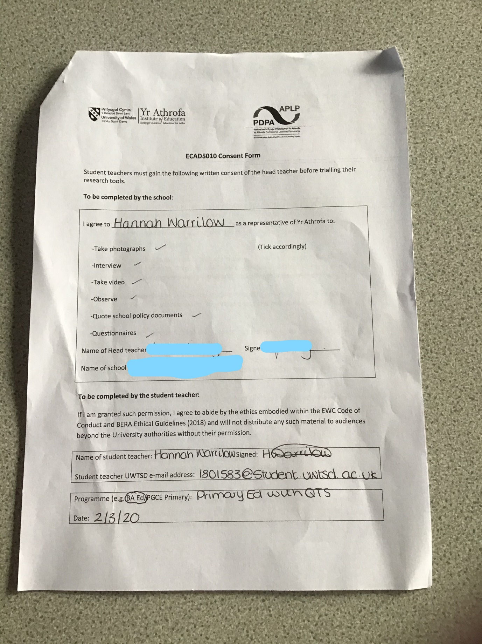

Appendix 3 – Questionnaire Templates: (Teacher Not Included)
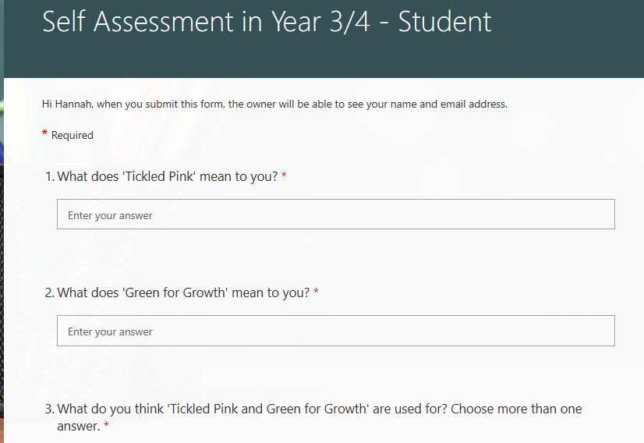
Student:

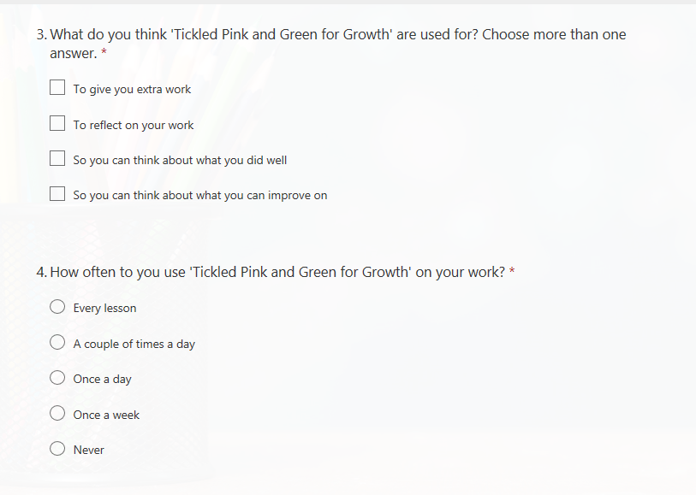

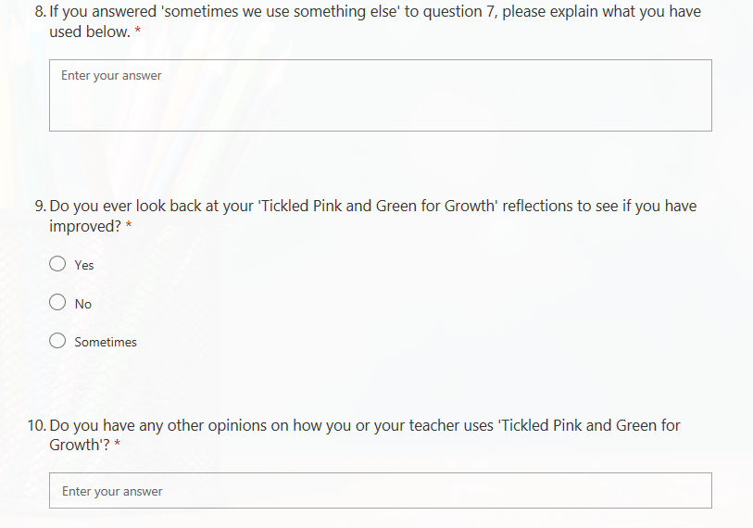
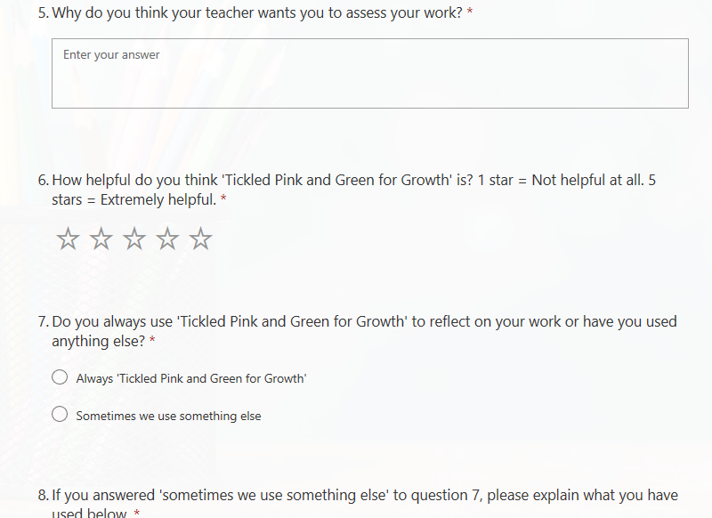

Appendix 4 – Partial Interview Transcript:
Researcher: “Ok, so question number one. These questions are similar to those in the questionnaire but this gives you the chance to expand on your answers more if you want to. So, when you have finished your work, how does your teacher ask you to reflect on that work?”
Child B: “What does reflect mean?”
Researcher: “To look back”
Child C: “Tickled Pink and Green for Growth”
Researcher: “Ok, so what is that? What does that mean to you?”
Child E: “Its, so Ticked Pink is what you think you have done great and Green for growth is what you can improve”
Child A: “Yes”
Child D: “I agree with that”
Researcher: “Ok, thank you. Next question”

Appendix 5 – Observation Schedule:
Observation Schedule – Self Assessment 02/03/20

Class size:
Number of pupils being observed:
Duration of observation:
Lesson during observation:
Focus | Was this evident? | Duration (minutes) | Additional Notes
Success Criteria explained by teacher

Pupil engagement

Clear explanation of ‘Tickled Pink and Green for Growth’

Expectations of ‘Tickled Pink and Green for Growth’ explained clearly

Completion of ‘Tickled Pink and Green for Growth’

What happens after ‘Tickled Pink and Green for Growth’ is completed?

Appendix 6 – Pupil Self- Assessment Responses:


