HTML and CSS Web Development

Internet Technology and Security
ACCA4018

By Geraint Hill
9900497



TABLE OF CONTENTS

1. Introduction 3
2. Requirements 3
1.0 Structure 3
2.1Theme 4
3. Implementation 4
3.1 Index.html 4
3.2 Mercury.html 6
3.3 Venus.html 6
3.4 Earth.html 7
3.5 Other.html (Under Construction) 7
3.6 SignUp.html 8
3.7 HTML Validation 9
3.8 CSS Validation 16
4. Evaluation 17
4.1 Code 17
4.2 Contrast 17
References 19
Bibliography 19

Introduction
The author was tasked to create a Website, using a theme of his choice to produce as part of his University assignment for the Internet Technology and Security module. The language of the code used to produce the website was HTML and CSS. The assignment brings together the skills that the author has learned during this course, and his ability to demonstrate them. This report has been produced to review the authors approach, discuss improvements and aide the assessor whilst navigating through the website.

Requirements

Structure

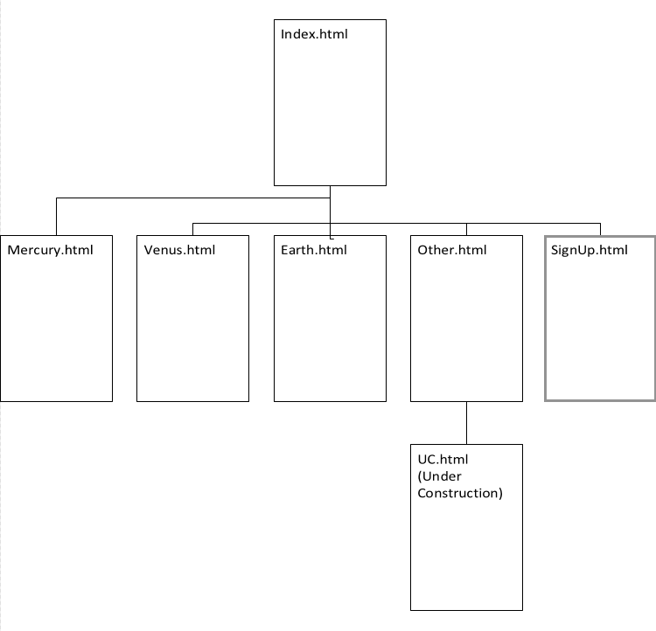
Figure1.0: Sitemap of the website design created by the author.

2.1Theme
The author decided to create an informative website about space and the planets in the solar system. The author had no real prior knowledge in this subject, however he felt that this would be an interesting theme that viewers of the website could enjoy. The visual theme could be kept through ought the project and the author found that there was sufficient and informative material available for the reader and future expansion. The author decided on the font-family monospace, which he believed was a good fit given the theme.

Implementation

3.1 Index.html
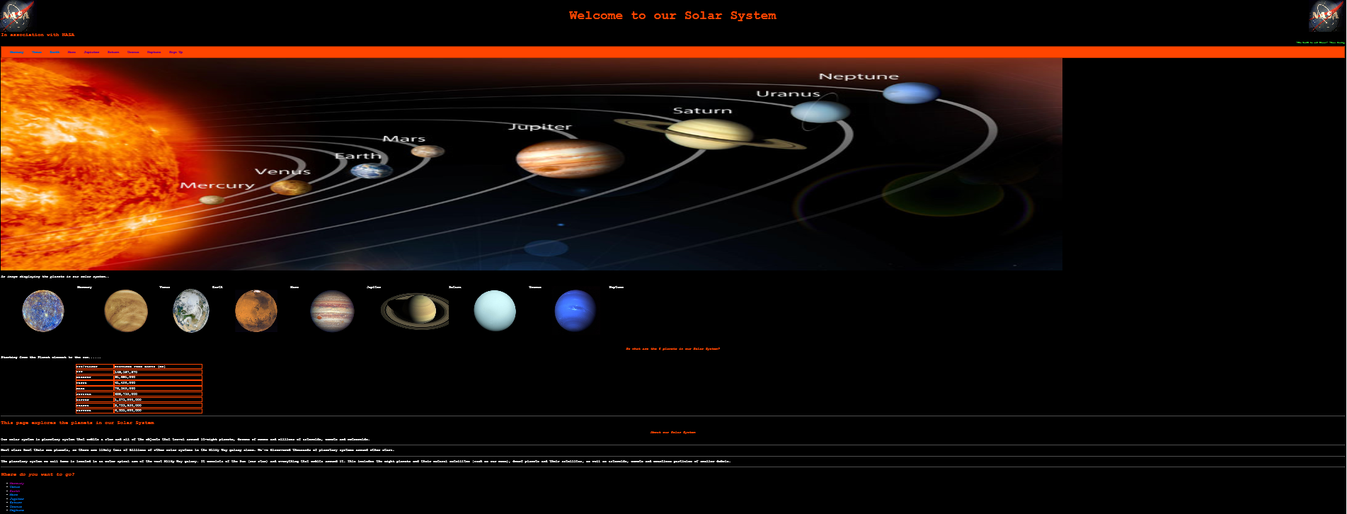
Figure 1.1: Cropped Screenshot of the home page.
The author displays the NASA logo[1], as it is a webpage themed with space, the author felt that the NASA logo would be appropriate. The title is presented in an orange-blood font in the centre of the page between the NASA logos. The author felt that the orange on a black background blended well, however contrast is explained further in the document. Below the main title, the nav bar, which is a solid orange background presents links to other pages in the series. The links to the other pages are standard blue links that turn purple when the page is visited. For further information on where the user will navigate to once clicking the links, please see Figure 1.0.
Further statements include a large image of the Solar System that has been used to convey to the user the position of the planets in our Solar System. The image was retrieved from the universe today website[2] and provides a good visual representation of the planets in our solar system.
The author also produced a slideshow of the planets. The images used were downloaded from the Space Facts website[3] . The slideshows animation slides at 15second intervals. The purpose of the slideshow is to give the user an interesting feature to look at.
The Table shown, provides the user with the distance each planet is (in KM) from the Earth[3]. The user can use this in conjunction with the main image to gain further understanding.
For further information, the paragraphs below the table give the user an overview of the Earths solar system and what it contains of.
The hyperlinks at the bottom of the cropped image, take users to a section that is relevant to the planet they would like to “launch to” for more information.
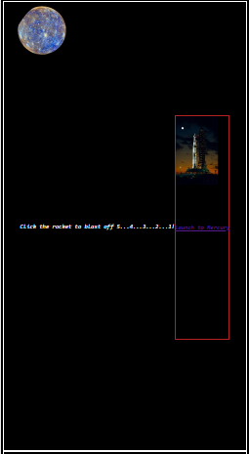
Figure 1.2 Cropped Screenshot of the planet sections.
Each planet has its own section with an image of the planet at the top left, and a clickable link, represented by a rocket or “take off”. The user is instructed to click the rocket to Launch to their planet of choice, in the case above, the user would go to the Mercury.html page. The images were taken from the space facts website[3].

Figure 1.3 Footer section created by the author.
At the bottom of the page, the user will be presented with a link to click for emailing the author, and on the bottom right social media links. The links don’t visit a specific page relating to space, however they demonstrate if there were related social media pages, they could be linked here.

3.2 Mercury.html
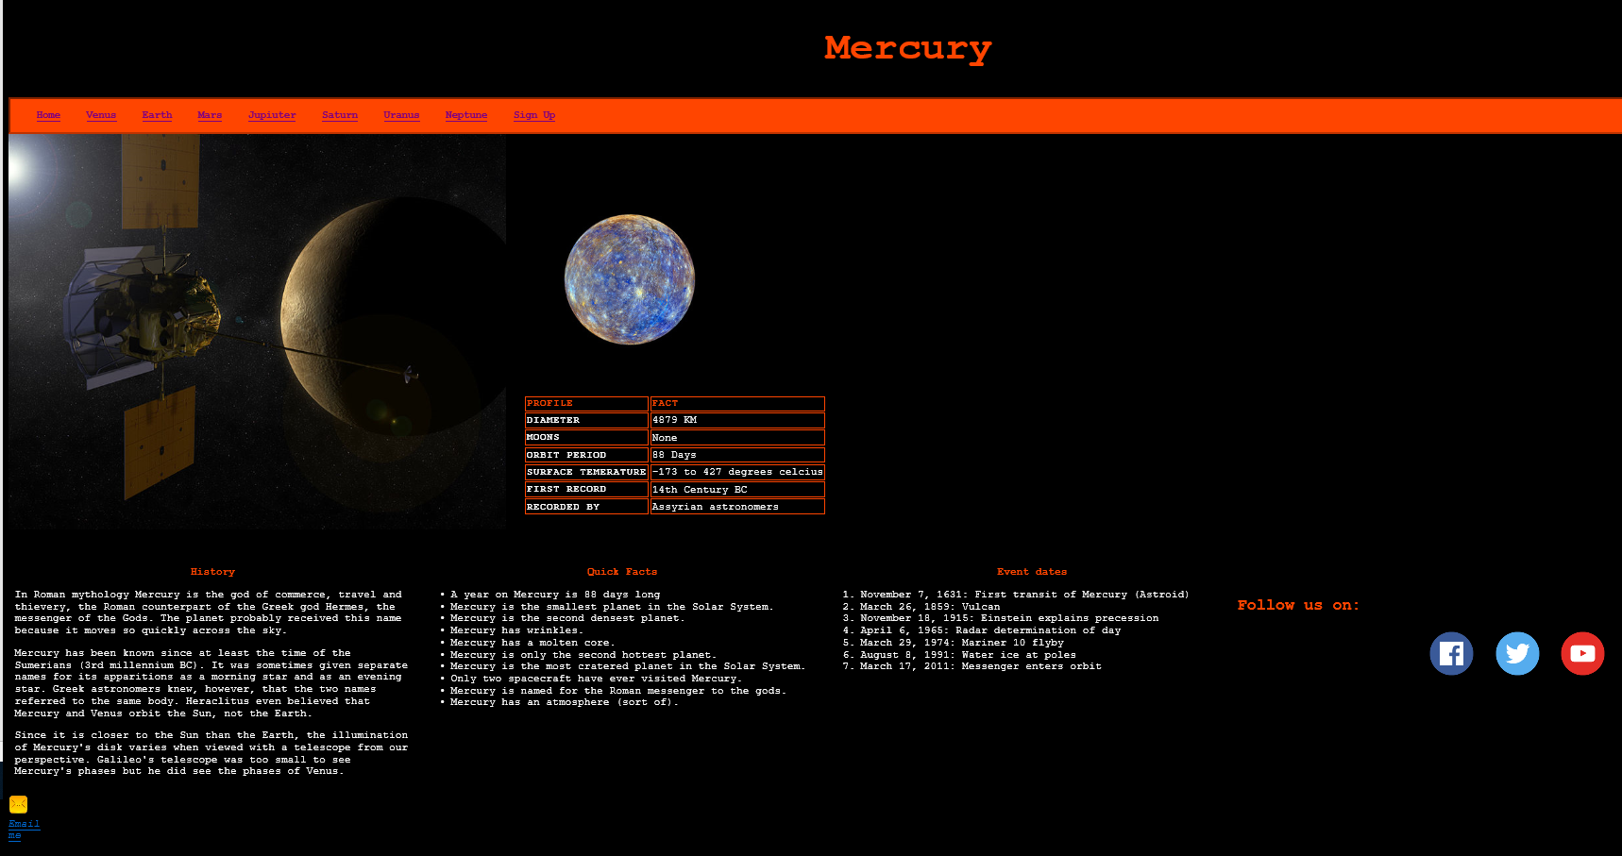
Figure 1.4:Authors caption of Mercury.html.

3.3 Venus.html
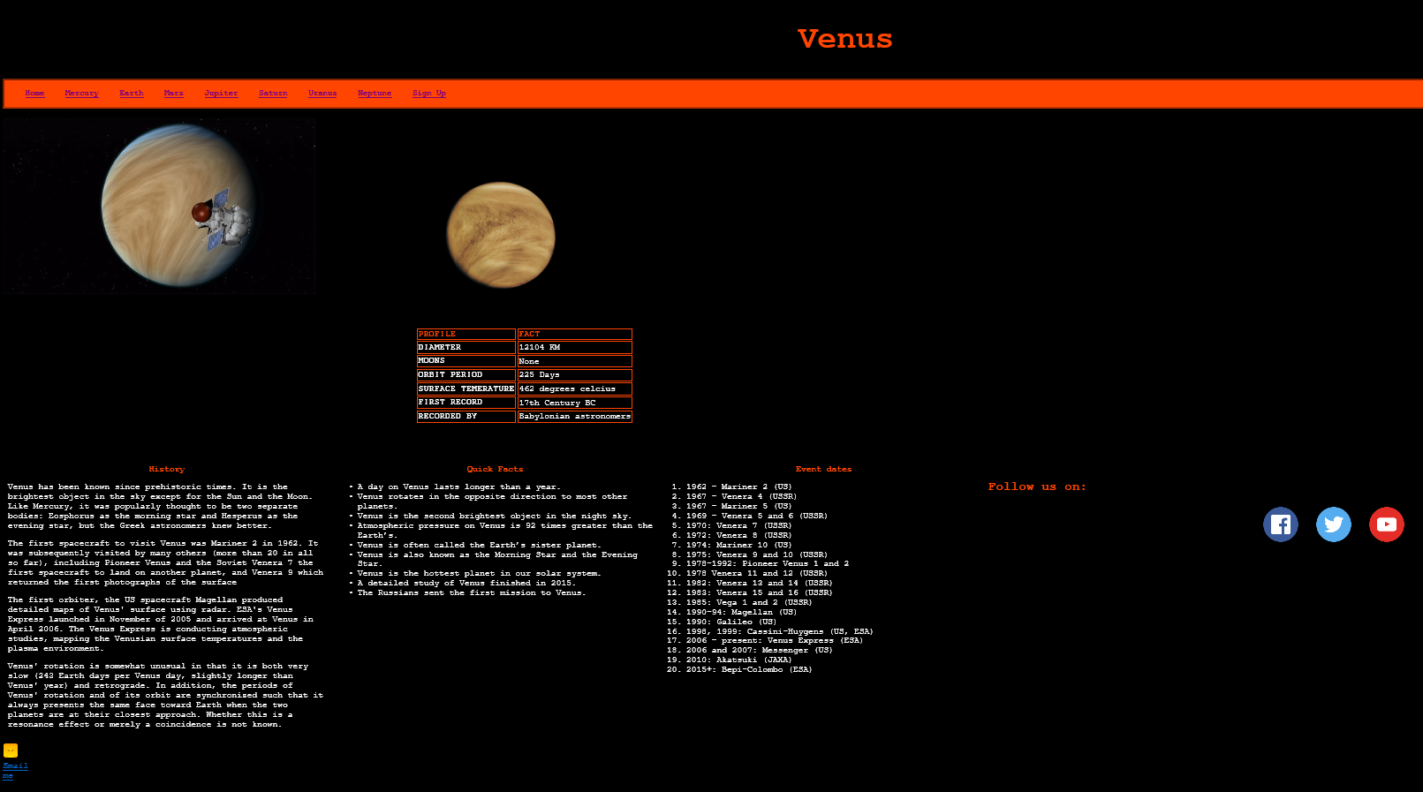
Figure 1.5: Authors caption of Venus.html.

3.4 Earth.html
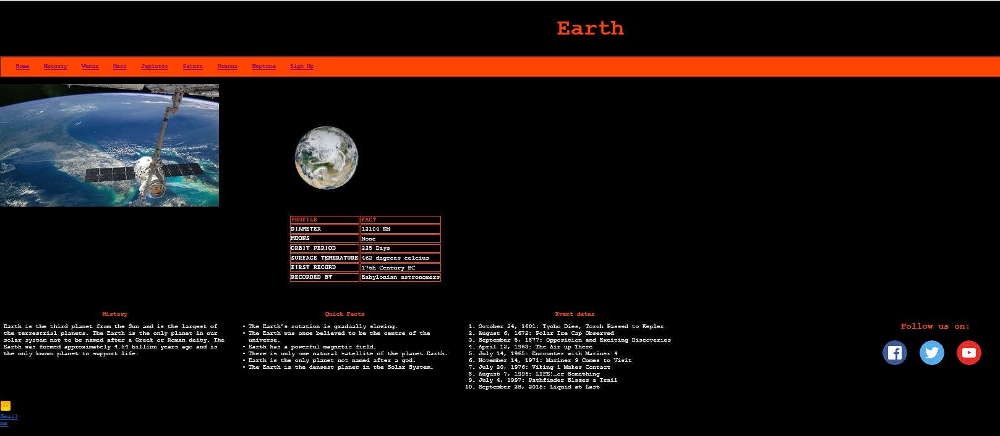
Figure 1.6: Authors caption of Earth.html
The above pages are the pages that the author created to inform the user about facts of their chosen planet. The completed design would include all 8 planets. The idea is that that the user could access the page they want, and their navigation and search for information would be the same per page, without advertisements or popups, something different from the current active webpages. The pages consist of an image of the planets taken from space (perhaps from a mission), an image of the planet that we all recognise, a table providing quick facts, and 3 sections displaying lists (unordered and organised).
The sections provide an insight on:
- History of the planet,
- Quick interesting facts,
- Key dates of events relating to the planet.
If the user lands on the Earth website, note that earth is no longer displayed in the nav bar, this follows suit with other scenarios.

3.5 Other.html (Under Construction)
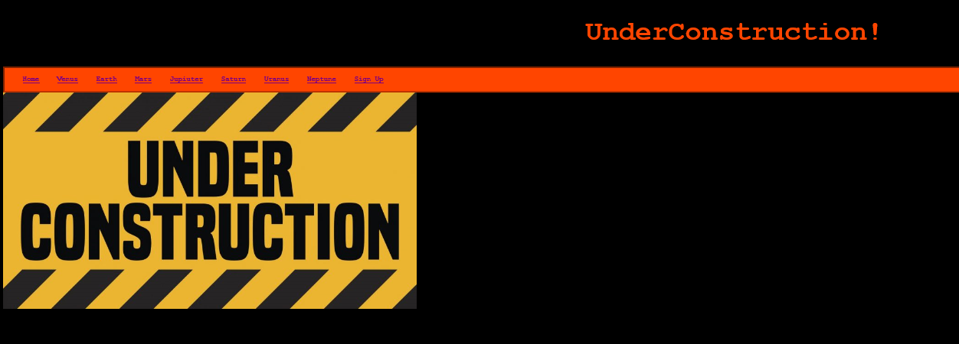
Figure 1.7:Authors caption of Under Construction page.
Whilst the author was only required to create five webpages, an “Under Construction” page was created for the remaining pages so the user could be notified that this was a working progress.

3.6 SignUp.html

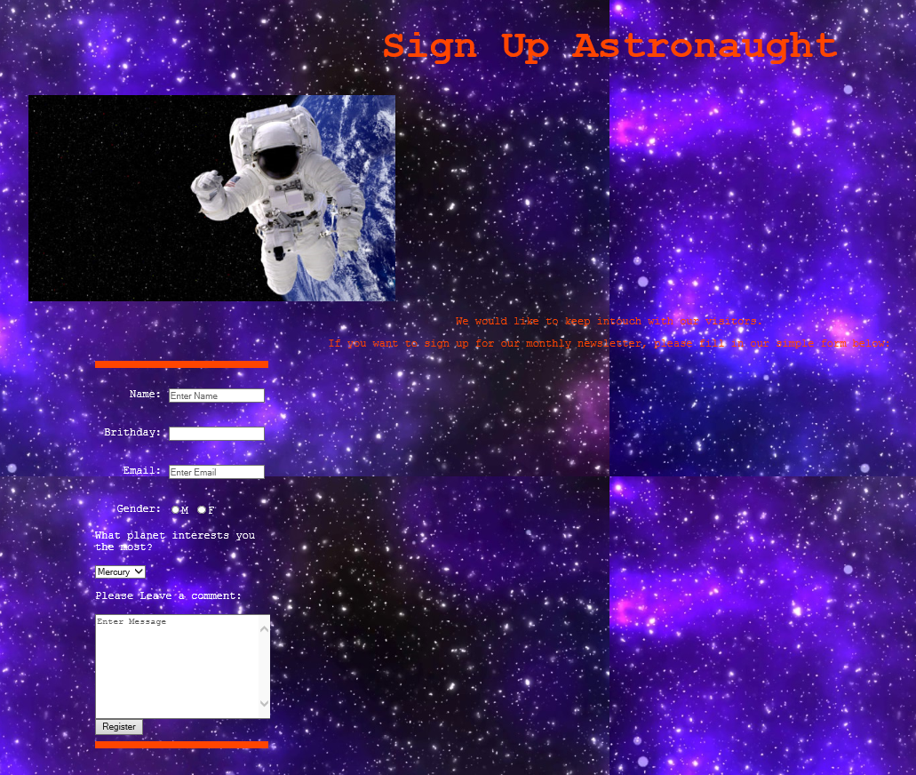
Figure 1.8: Authors caption of SignUp page
The SignUp section provides the user with a form to fill. The form directs the user as to what to type into each field. The birthday field automatically sets the input as a date that the user can select. A radio button allows the user to either select either Male or Female. The user selects from a drop down box what their planet of interest is, and an option to leave a comment or question. The register button in a real-time environment would send the form to the website administrator to process, this would allow the administrator to answer any questions or deal with any queries, however this is beyond the scope of the assignment.

HTML Validation
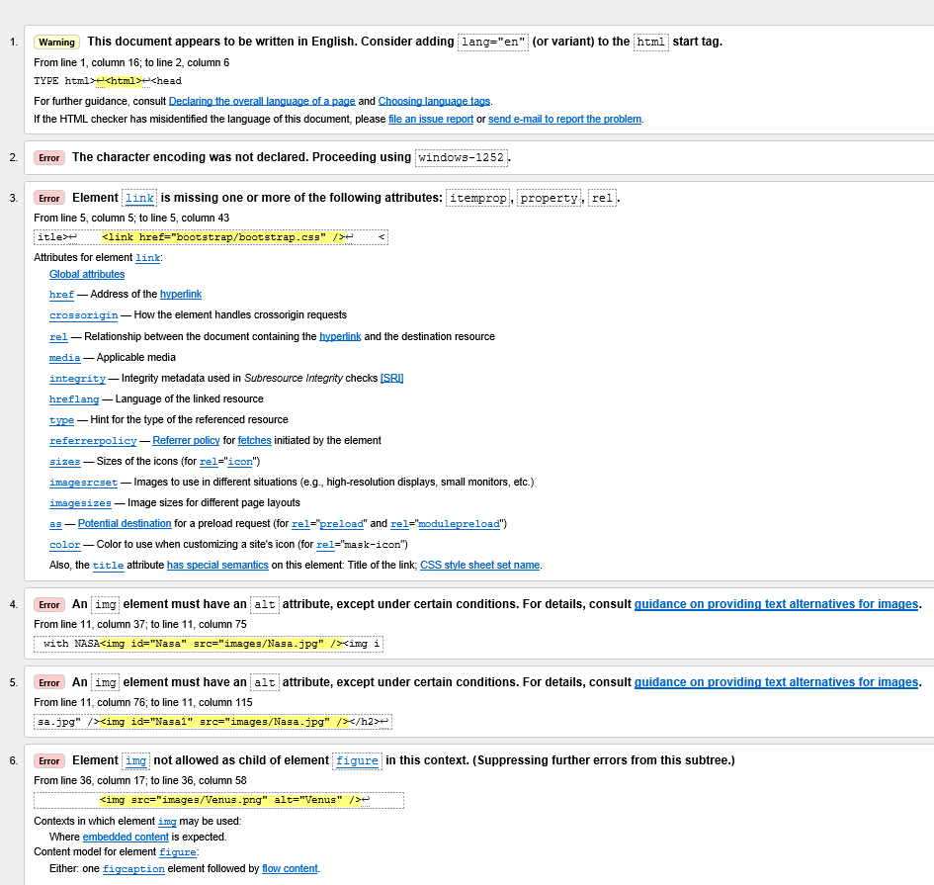
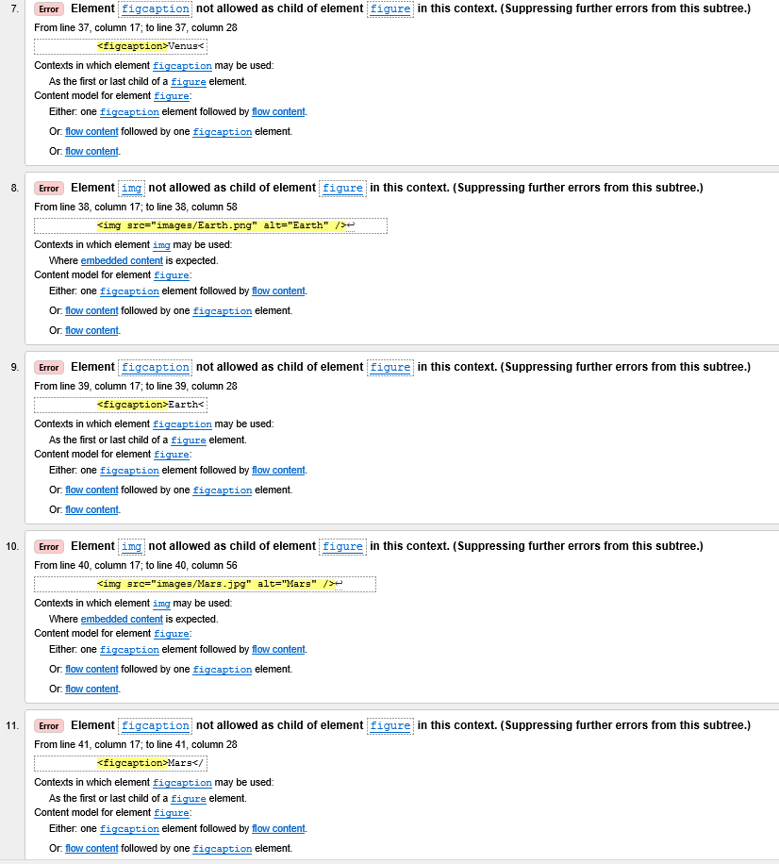
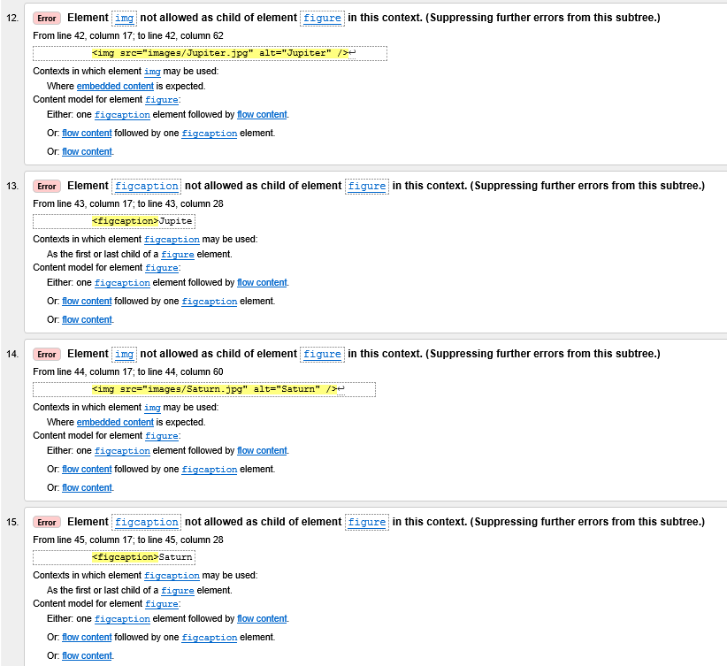
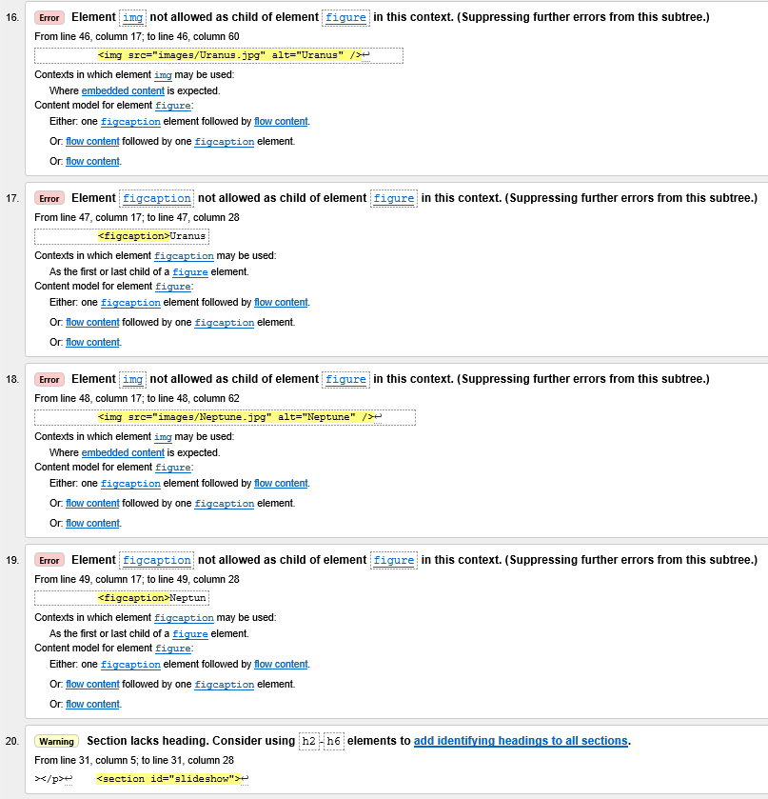
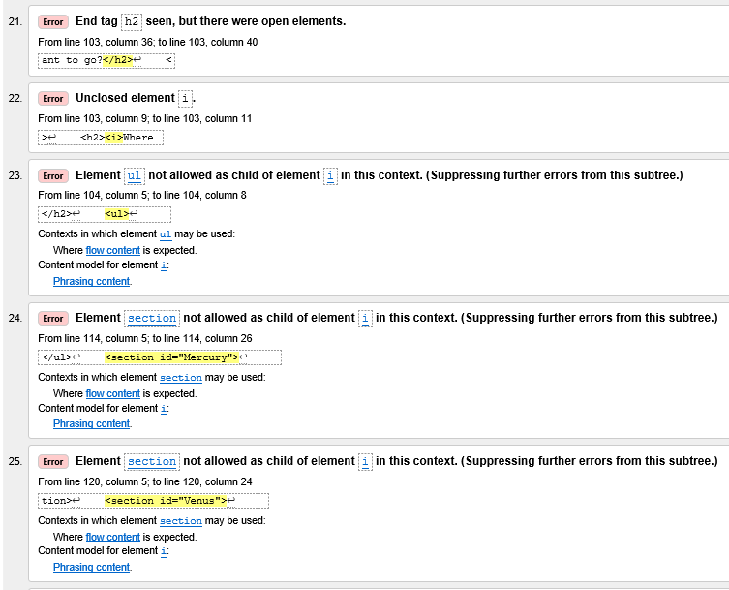
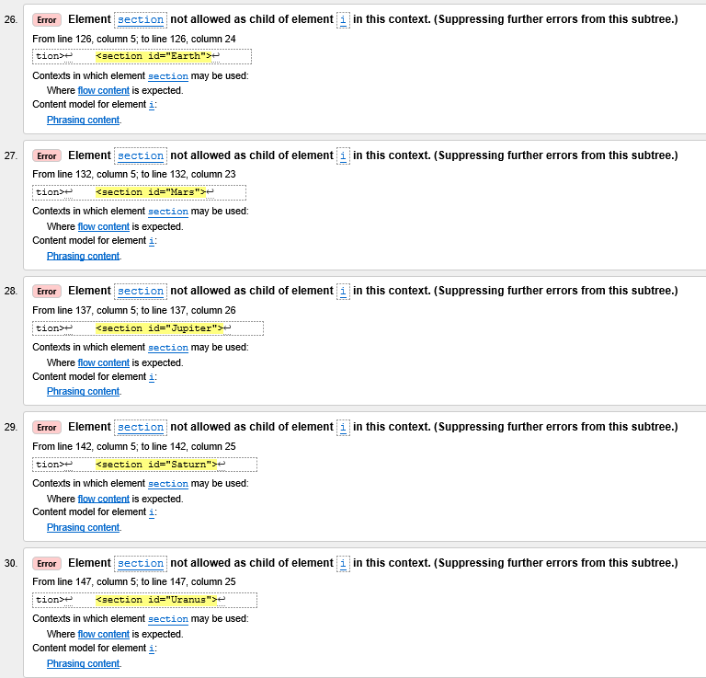
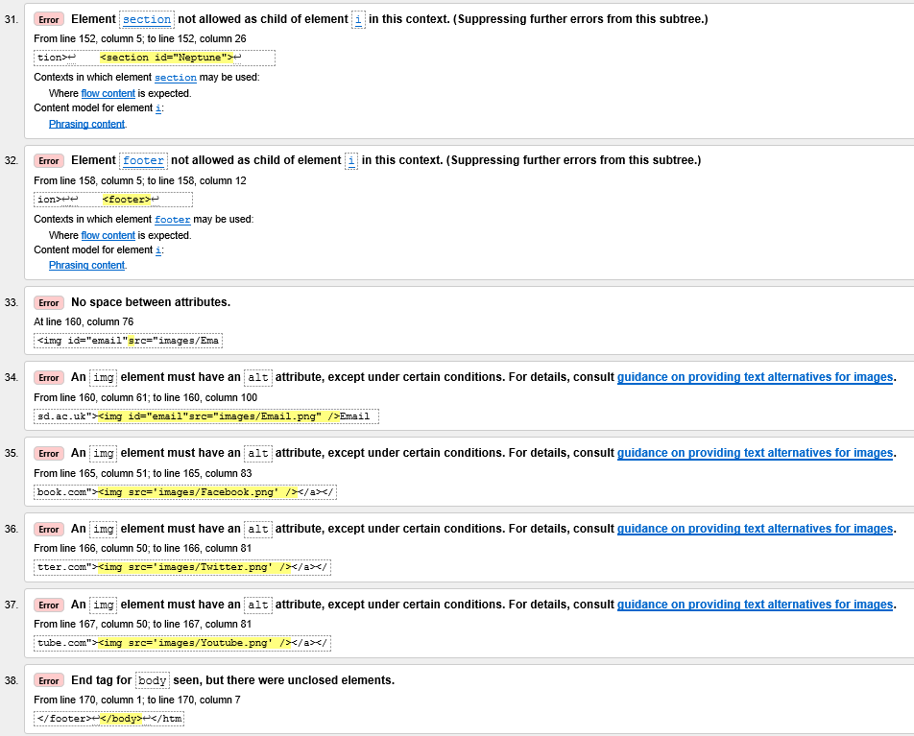
**All 38 errors listed above were rectified. However, the slideshow tab did not perform as initially intended. The author was unable to revert back to it working and producing one caption at a time. The errors were straight forward to resolve, and for the scope of the assignment were cleared to prove that they could be resolved to keep in line with standards and practice set out by w3.
The main reason for the high rate of errors were because of point 22, an unclosed <i>.
The errors that were advisory i.e. the <alt=”> were all corrected, as was the use of a heading in a section field.
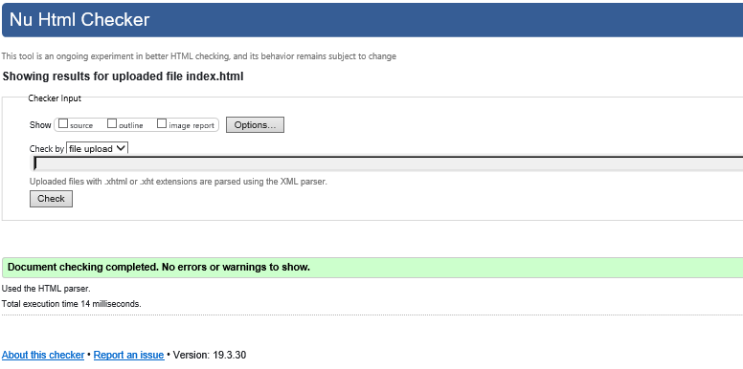

CSS Validation
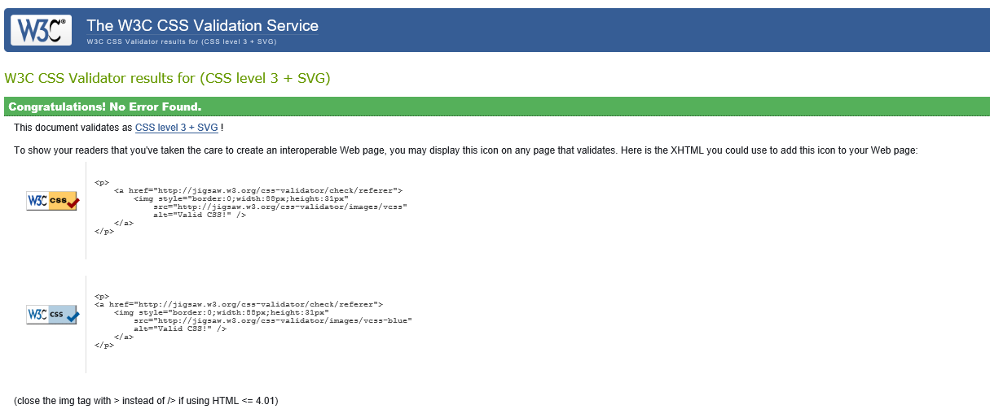

The CSS validation came back all clear.

Evaluation

4.1 Code
The code used in visual studio is sectioned and indented so it is easy for any developer to read. The CSS code is sectioned according to what section / element is being styled. As the author becomes more competent in writing code, perhaps a CSS sheet for each page would be better.
The author, although referencing bootstrap, avoided to use it. The author was challenged in styling his webpage, however knowing bootstrap was available if it all went wrong gave him confidence.

4.2 Contrast

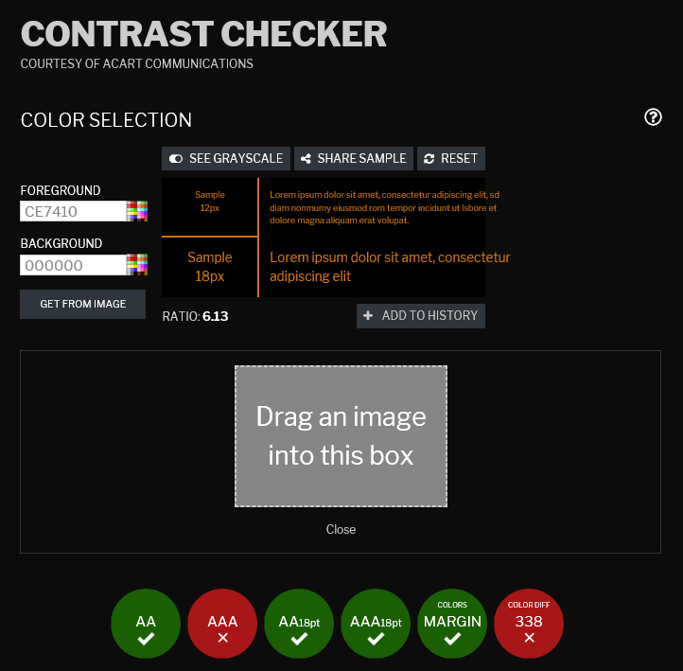
The contrast checker suggest that enhanced contrast for fonts below size 18 (AAA) has failed and that colordiff, suggests that people with colour blindness could potentially struggle to read my contents on the page[4]. As the website is a space themed website, to keep in line with the guidelines, the page could adopt the below styling: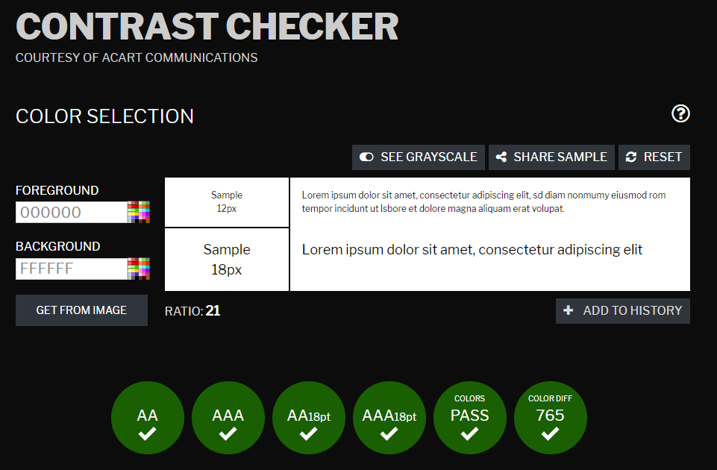
The space website is easy to navigate around, there are instructions displayed on how to navigate around the pages, and what to click. The content provides the user with what the website was originally intended to do. The material is clearly displayed for the user, on the individual planet pages, they have all incorporated the same style, which means that the user can navigate to the information they want in the same way.
The form does not ask for much information from the user, but in what it does ask for, the user is prompted. Overall the author feels the website is a very basic, easy to use and delivers informative content to anyone interested in the planets.
Further improvements would include a responsive webpage so that the site expands and collapses so that each page can be viewed correctly on each platform. The page has been tested on Google Chrome and Internet Explorer 11, with no issues identified on these. Other browsers could be interrogated to ensure compatibility,

References
[1] Nasa, “NASA,” 2019. [Online]. Available: https://www.nasa.gov/. [Accessed: 01-Apr-2019].
[2] “Solar Disruption Theory - Universe Today,” 2019. [Online]. Available: https://www.universetoday.com/85731/solar-disruption-theory/. [Accessed: 01-Apr-2019].
[3] “Space Facts ? - Interesting Facts about Space,” 2019. [Online]. Available: https://space-facts.com/. [Accessed: 01-Apr-2019].
[4] WCAG - Contrast Checker. .
[5] D. Jon, Importance of Time Management. John Wiley and Sons, Inc.

Bibliography
[1] J. Ducket, “HTML&CSS design and build websites”.Indianapolis, Indiana: John Wiley&Sons,Inc, 2011
[2] B.Hussey, “Build websites from scratch with HTML & CSS”, [ONLINE]. Available http://wwww.idemy.com[Accessed 01-Apr-2019].

