

Effective Team Working and Communication

Student Name: Corina Elena Vrinceanu
Student Number :2133494
Submission Date: 3.01.2023
Lecturer: Toyin Adisa
Table of Contents

Executive Summary ………………………………………………………………………………3
Introduction…………………………………………………………………………………………..4
Three types of communication models…………………………………………………..5
Different forms of communications skills………………………………………………..8
Advantages and disadvantages of technology on communication ……9
Example of poor communication …………………………………………10
Conclusion…………………………………………………………………..11
References …………………………………………………………………12

Executive Summary

Effective communication is a crucial ability in every setting where people engage with one another. However, effective communication in the workplace is crucial to company success.
The following report uses models of communication by Berlo’s, Shannon and Weaver, and Schramm to explain what communication is and how it works. It has been made clear how important good communication is, and suggestions have been given on how to improve communication skills. The report also talked about the pros and cons of a student using communication technology.

Introduction

The term "communication" refers to the exchange of information between people. In the next report, we'll look at three ways to talk to people. Berlo’s model of communication, Shannon and Weaver's model of communication, and Schramm's model of communication were chosen to help us understand communication. The report also can talk about different ways to communicate, like verbal. Nonverbal and listening skills will help you understand how to communicate more effectively. Technology has become an important part of everyone's lives as it has grown. Since this is the case, many students also use technology to learn. Even though technology is important, there are some problems with it in the modern world. So, the report will talk about different problems and good things about technology. Finally, a situation in the workplace where communication is bad will be used to show how to improve it.

Three models of communication

Berlo’s Model of communication
Berlo's communication model is linked to the emotional element of the message, which influences the different components of the communication process. This communication model is also in charge of focusing on encoding and decoding that may occur between the sender and the receiver.

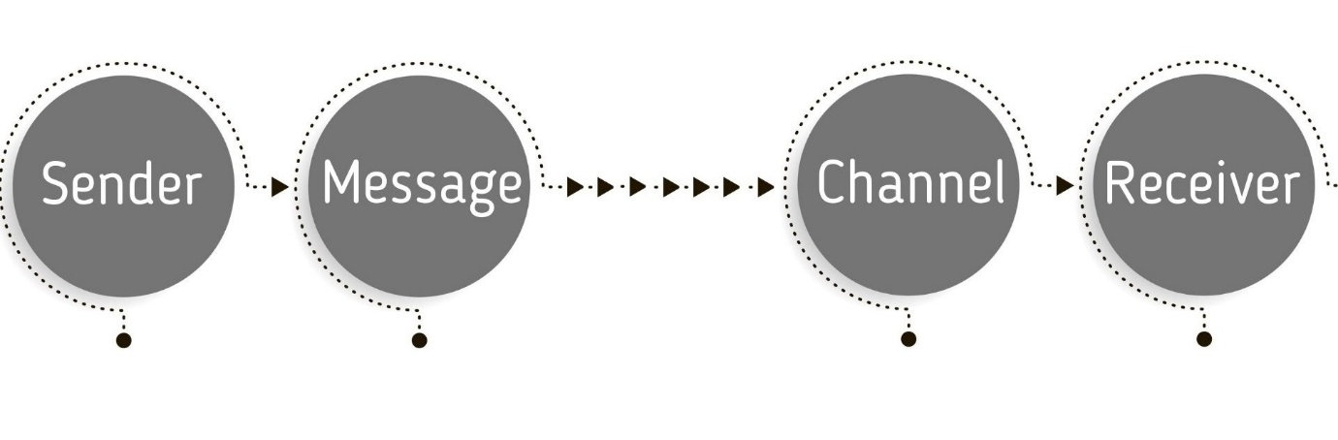
Figure 1: The communication model of Berlo’s

Sender
The person or thing that sends the message is called the sender or source. The person who sends a message is called an encoder because they oversee encoding or framing it.

Message
To be able to communicate in different ways, when someone sends a message, they need to turn their thoughts into voice, video, text, or any other type of message.

Channel
A channel is the way that a message gets from the sender to the receiver. People can talk to each other through many different ways. But most of the time, people use their five senses to send messages.

Receiver
Communication is a two-way process, and to send a message to the receiver, the sender must go through all of the above steps. The person who gets the message and figures out what it means is the receiver. The person who gets the message is responsible for figuring out what it means and how to interpret it. For communication to work, both the sender and the receiver must be on the same level of understanding.

Shannon and Weaver's Model of Communication


Figure 2: The communication model of Shannon and Weaver
The Shannon-weaver model is one of the first and most influential models of communication . The math theory became known as the Shannon-Weaver model of communication or the "mother of all models" over time. This model is more technical than other linear models.
Information source: The sender is the person who makes the message, chooses the channel, and sends the message.
Transmitter: An encoder is a person or machine that sends a message by turning it into signals or binary data. It could also be talking about the machine itself.
Receiver: A decoder is a machine that takes signals or binary data and turns it into a message, or a receiver that takes signals and turns them into a message.
Destination: The receiver is the person or place the message needs to get to. The person who gets the message responds based on what it says.
Noise is any physical disturbance, such as the environment, people, etc., that keeps the message from getting to the receiver as it was sent.

Schramm’s Model of Communication

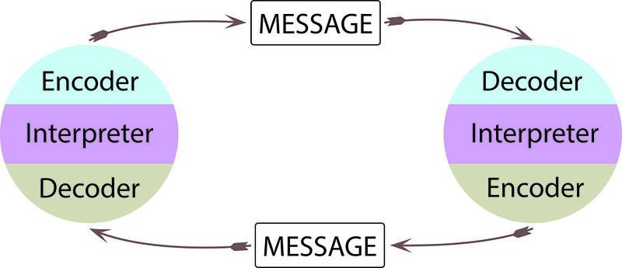
Figure 3: Communications Model of Schramm

The model of communication that Osgood-Schramm came up with is called a "circular model" because it shows that messages can go in both directions. 24 So, once someone figures out how to decode a message, they can put it back into code and send a message back to the person who sent it. They could keep encoding and decoding in an endless loop. This new model shows that 1) communication is not linear, but rather circular; 2) communication is two-way and equal; 3) messages depend on how they are interpreted; and 4) communication involves encoding, decoding, and interpreting. The good thing about this model is that it shows that feedback is a cycle. It also shows that communication is hard because it has to take into account how things are understood. This model also shows that we are active communicators and that we make choices about how to understand the messages we get.

Different types of communication skills

Verbal communication

When you're a speaker, it's important to pay attention to things like tone, word choice, and pace. It's also important to know how to read your audience and change these things on the spot to make yourself clearer.
To be a good verbal communicator, you also need to be able to listen well. Even if you give the most eloquent speech in the world, it doesn't matter if you don't respond to the right parts of what your partner said.
Verbal communication skills are especially important for people who do a lot of work over the phone, since you don't get the same nonverbal cues that you do when you meet someone in person. Still, almost every job requires talking to people, whether it's with bosses, co-workers, clients, or distributors.

Non-verbal communication
Body language is a form of nonverbal communication. Nonverbal communication includes things like body language, eye contact, handshakes, and expressions on the face.
All of this is considered by your listeners as they try to figure out what you're saying. A confident stance, direct eye contact, and a relaxed face will show that you are sure of yourself and make it more likely for people to believe what you say.
It's hard to show off nonverbal communication skills on a resume or cover letter, so you'll have to wait until the interview to show off your acuity.

Listening skills
Active listening means really paying attention to what other people are saying. It’s totally different from just hearing someone. In this, you must pay full attention to the other person and understand what they are thinking and feeling. If you want to improve your ability to communicate, you need to learn how to listen actively. You can learn this skill with some work, but if you want to master it, you'll have to put in a lot of time and effort. But you can get good at it with practise and time.

Advantages and disadvantages of communication technology

Time has not slowed the progression of technology, and makers have always come up with new and creative approaches to creating new and improved gadgets. Everyday people benefit from this because it makes their life more convenient, less complicated, and more intelligent. Access to information, communication, e-commerce, entertainment, and global sociability are just few of the many benefits made possible by the internet.

Access to information
People can find information about everything from politics to health and nutrition by using search engines like Google and Yahoo. This easy access to information is useful not only for personal research but also for schoolwork.

Communication
People in different parts of the world can now talk to each other faster over the internet because of emails. Businesses and trade have grown because of how fast and easy it is to send messages right away. Also, people often use video conferencing, chat rooms, and voice-over-internet protocol to talk to each other in real time over the internet.

Social Media
The world has changed because of social media. Because of how quickly and widely these technologies are being used, they are changing how we find partners, how we get news, and how we organise to get political change.

E-Commerce
The Internet has made online businesses easier by connecting buyers and sellers. With just a computer or smartphone, a buyer can look for a specific product, look at its features, order it online, and pay for it. This is convenient for both the buyer and the seller and helps the market run smoothly. Also, the Internet makes it easier to pay recurring expenses and utility bills. This saves time, makes things more efficient, and makes keeping records easier.

COMMUNICATION TECHNOLOGY (DISADVANTAGES)

Privacy Invasion
Even though technology lets people share information with friends and other people all over the world, many people don't realise how their privacy is being lost. (Yiga, 2017)
People's privacy rights are violated every day and can be attacked by a hacker or a virus, which can cost them money and hurt their personal lives. (Ahmad, 2016).

Hacking
It's easy to get into personal information and privacy on the Internet and share it with other people. Which can lead to both financial and personal loss. In the same way, identity theft is another problem that can cost people money by hacking into their personal accounts. In the past, hackers broke into several people's Twitter and Facebook accounts and posted things that affected the people's personal lives. This is one of the most dangerous problems with social media, and everyone should make sure their personal information and accounts are safe to avoid this kind of thing.

Fraud and Scams
There are many examples of fraud and scams that people have done through social media. For example, this list shows the five most common social media scams.

Example from real circumstances

Due to the teamwork and communication focus of the most recent modules, I had a terrible experience with my group in those courses. Each of us failed a module mostly due to our right to free speech! My colleagues could not understand each other at all, no one listened to anyone's perspective, and the quarrels between them became more and more frequent, causing the group to split! My suggestion to other groups is to listen to each other and allow everyone in the group a voice, which means not distinguishing between one another.

Conclusion

Communication has been crucial to developing better methods to make life simpler. This study explains three communication models. Some were Berol’s, Shannon and Weaver, and Schramm's model. Verbal, nonverbal, and listening abilities are emphasised. Also highlighted are the pros and cons of mobile phones and the internet.

References
- Al-Fedaghi, S., 2012. A conceptual foundation for the Shannon-Weaver model of communication. International journal of soft computing, 7(1), pp.12-19.
- Ahmad, B. (2016) “10 advantages and disadvantages of social media for society”. Retrieved December 19, 2017 from https://www.techmaish.com/advantages-and-disadvantages-of-social-media-for-society/
- Ismail, N. (2017) “Modern technology: advantages and disadvantages” Retrieved December 19, 2018 from http://www.information-age.com/modern-technology-advantages-disadvantages-123465637/
- Ludlow, R. and Panton. F. (1992) The Essence of Effective Communication. New York. Prentice Hall.
- Morgan, P., (2017) The Business Student’s Guide to Study and Employability; London. Sage.
- Stanton, N. (2009). ‘Mastering Communication.’ Basingstoke: Palgrave Macmillan
- Schramm, W., 2015. 2. Communication Development and the Development Process. In Communications and Political Development.(SPD-1) (pp. 30-57). Princeton University Press.

- Kelly Quintanilla Miller, S. T. W., 2011. Business and Professional Communication: KEYS for Workplace Excellence. s.l.:s.n.

