Introduction to Physiology (BMHP5003) - WORKBOOK
WORKBOOK EXERCISE ONE
Question 1. The smallest independently functioning unit of an organism is a(n) ________.
- cell
- molecule
- organ
- tissue
Question 2. A collection of similar tissues that performs a specific function is an ________.
- organ
- organelle
- organism
- organ system
Question 3. The body system responsible for structural support and movement is the ________.
- cardiovascular system
- endocrine system
- muscular system
- skeletal system

Critical Thinking Questions
Question 4. Name the six levels of organization of the human body.
Question 5. The female ovaries and the male testes are a part of which body system? Can these organs be members of more than one organ system? Why or why not?
…………………………………………………………………………………………………………………………………………………………………………………………………………………………………………………………………………………………………………………………………………………………………………………………………………………………………………………………………………………………………………………………………………………………………………………………………………………………………………………………………………………………………………………………………………………………………………………………………………………

WORKBOOK EXERCISE TWO

Question 1. The following diagram contains body cavities.
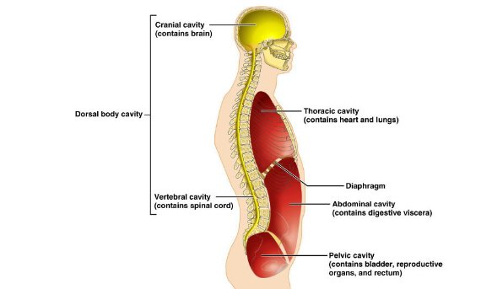
- What do you understand by dorsal cavity?
………………………………………………………………………………………………………………………………………………………………………………………………………………………………………………………………………………………………………………………..
- List any two organs located in the following:
- Thoracic cavity
…………………………………………………………………………………………………………………………………………………………………………………………………………………………………………………………………………………………………………………………
- Abdominal cavity
…………………………………………………………………………………………………………………………………………………………………………………………………………………………………………………………………………………………………………………………
- Pelvic cavity
…………………………………………………………………………………………………………………………………………………………………………………………………………………………………………………………………………………………………………………………

Question 2. In-class online session to label the skeletal bones
You are expected to label the bones in your workbook as we participate in the online activity. The online activity is available from: https://www.free-anatomy-quiz.com/skeletonIDQ1.html

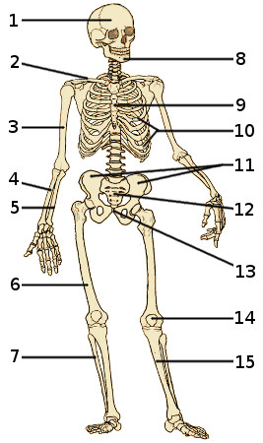

Question 3. As part of your homework name the types of joints:

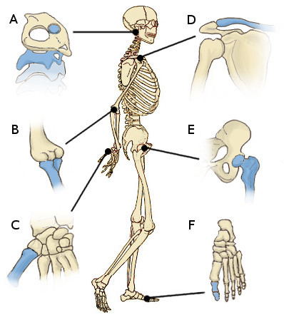
a……………………………………………………………………………………………………
b……………………………………………………………………………………………………
c…………………………………………………………………………………………………….
d……………………………………………………………………………………………………..
e…………………………………………………………………………………………………….
f……………………………………………………………………………………………………..
What are the functions of:
- Synovial fluid…………………………………………………………………………………………………………………………
- Tendon……...............................................................................................................................
- Ligament………………………………………………………………………………………………………………………………

WORKBOOK EXERCISE 3
Question 1. Label the diagram of the cell below. Write the name of the structure next to the number.
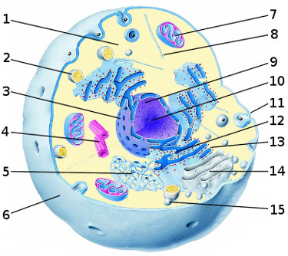

Question 2a. State the function of:
- Plasma membrane……………………………………………………………………………………………………………
- Lysosomes………………………………………………………………………………………………………………………..
- Mitochondria……………………………………………………………………………………………………………………
- Ribosomes………………………………………………………………………………………………………………………..
- Rough endoplasmic reticulum………………………………………………………………………………………….
………………………………………………………………………………………………………………………………………..
Question 2b. What is importance of a laboratory test for full blood count?
…………………………………………………………………………………………………………………………………………………………….………………………………………………………………………………………………………………………………………………………………………………………………………………………………………………………………………………………………………………………...
Question 2c. What is the effect of a reduction of white blood cells?
………………………………………………………………………………………………………………………………………………………………………………………………………………………………………………………………………………………………………………………..
Question 2d. Where are white blood cells produced?
………………………………………………………………………………………………………………………………………………………………………………………………………………………………………………………………………………………………………………………….

