The Global Buisness Environment

Student name: Ventsislava Kostadinova (2023558)
Lecturer name: Dr. Rexon Nting
Date: 04/05/21

Table of Contents
Introduction 3
Main body 3
A) External environment assessment 3
B) Changes in the fashion industry amid the crisis 6
Conclusion 9
References 10

Introduction
The importance of understanding the specifics of the surrounding business environment has grown in the epoch of globalisation (Hulleman and Marijs, 2021). Business organisations and especially multinational brands have become increasingly dependent on external developments; hence, the ability to recognise and adapt to external trends has been a central factors sustainable development. The importance of the external environment has increased in the current pandemic environment due to its profound effects on the way of doing business and across sectors (Humphries, 2020; Ratten, 2020). This may be clearly seen in the current case of fashion sector in UK and the chosen company under consideration – Zara. The pandemic caused unprecedented 25% decline in sales of new clothes, whereas Zara realised 44% decline in sales and a financial loss of €409 million during the 2nd quarter of 2020 (BBC, 2020; Jolly, 2020).
Having said this, it is very important to explore in more details the specific elements of the external environment and the industry, as well as outline a set of relevant strategic actions to adjust to existing circumstances. The current report focuses on these main aims by considering the particular case of Zara in more details.

Main body

A) External environment assessment
Using the PESTEL model, fashion brands are able to continuously discover new opportunities, while addressing the shortcomings related to the external environment. The abbreviation stands for political, economic, social, technological, environmental and legal factors, highlighting the spheres of analysis (Johnson et al., 2017). The external environment in the UK is analysed by taking into consideration the fashion sector.
The relative political stability of the UK presupposes a good business environment, guaranteeing freedom of speech, fair treatment, stimulating measures and private property. The country occupies one of the top places in the Transparency International (2021) ranking for its lack of corruption and exceptionally high level of institutional effectiveness. The BBC (2020) also reports that due to the relatively successful outcome of the Brexit process and the deal which the government was able to secure with Europe private business in the UK may freely trade with the rest of the continent. The World Bank (2020) also gives the country a positive assessment for being conducive to entrepreneurship and progress in its Doing Business review.
The COVID-19 pandemic dealt a lot of damage to the UK economy in 2020, raising unemployment to the highest levels in five years. As 5.1% of the population was struggling to find work, people refused to spend and uncertainty skyrocketed, moreover that the threat of the virus was not yet completely understood (Atkinson, 2021). Economically, the fashion industry is undoubtedly hurt by the situation as governments everywhere restrict travelling and lockdowns are in place. As shown below, the level of gross domestic product (GDP) declined at record levels of more than 11% in 2020 (Harari, 2021). The decline was quite severe and much larger in comparison to other advanced economies, as shown at the chart. Having said this, UK consumers are likely to be more cautious and spend less on fashion retail products; thereby, reducing the revenue of the industry as a whole.
Figure 1 – GDP growth for 2020 for several selected countries
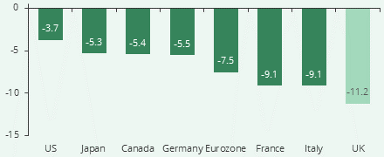
Source: Harari (2021)
The UK population grows with around 500,000 people annually, a steady pace making for a growing market, as described by Focus Economics (2020). Worthington and Britton (2006) emphasise the importance of an increasing population on the future of consumer demand and attracting investment. The fashion industry still has to adapt to the changing consumer demands, as people insist on receiving sustainably developed products where raw materials avoid animal harm and originate from organic sources. Carlile (2018) points out that the market for sustainable goods in the UK is already at a size of £83 billion per annum; thereby, incentivizing fashion brands to be more sustainable.
Online sales will make up a significant portion of companies’ revenues in 2021 and beyond. So far, online retailing has been developing for more than ten years but according to the Office for National Statistics (ONS) (2021) major growth is still ahead. According to them, one third of all transactions now happen online, setting a strong trend for the future. This is a major technological trend which was fueled during the pandemic and imposed lockdown measures. Respectively, the UK consumers are more likely to engage in online sales channels in the future due to convenience and information availability – major concerns for fashion brands in the future.
Figure 2 – Share of online sales in UK
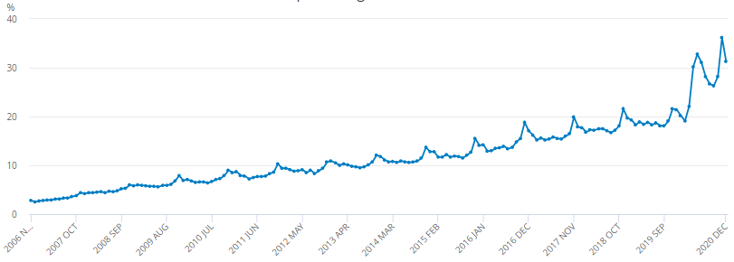
Source: ONS (2021)
The UK is technologically advanced, friendly to discovery, research and innovation and building its own infrastructure. As the Global Innovation Index (2020) reports, the country’s advantage lies in attracting capable professionals from all over the world and setting up its own investments and strategies. Technology also means efficiency, ensuring appropriate use of resources and opportunities. All of these benefits may be accessed by fashion brands operating in the UK.
Fashion brands have to comply with environmental regulations strictly everywhere throughout the world. In the UK case, management should work on controlling emissions, as well as setting requirements for environmentally-friendly fashion products primarily over the past few years (UK Government, 2013). Although abiding by the regulations carries its own costs, doing so gives the company access to one of the world’s thriving and advanced markets.
The UK’s legal system carries its own requirements for businesses operating in the country, including environmental, health and safety standards. In this relation, fashion brands have to make sure to incorporate all legal requirements as a part of business models and daily operations in order to secure stable and efficient operations (Croner, 2020).
To sum up, the external environment amid the COVID-19 crisis provides opportunities and threats to fashion industry in the UK. The country’s political stability, strong demographic trends and technological advancement are key advantages to be considered by industry players. In contrast, the economic difficulties, changing consumer preferences, as well as environmental and legal compliance costs are challenges for the sector as a whole.

B) Changes in the fashion industry amid the crisis
The COVID-19 crisis has caused numerous changes in the fashion industry. As already mentioned, the crisis has led to economic difficulties and lower revenue. For example, the total sales of new clothes declined by 25% for the entire 2020 – the largest drop on record (BBC, 2021).
In order to understand the changes in the industry and respective measures by fashion brands, the Porter’s Five Forces model is applied. It is an extensive model for evaluating the level of profitability of any industry (Porter, 1979). The theory suggests that the attractiveness of a given sector depends on the interaction of five distinctive forces – bargaining power of suppliers and customers, threats of substitutes and alternatives, as well as existing rivalry (Porter, 1979). These forces are explained in more details below and used in the analysis of the UK fashion sector.

Figure 3 – A detailed overview of Porter’s Five Forces model
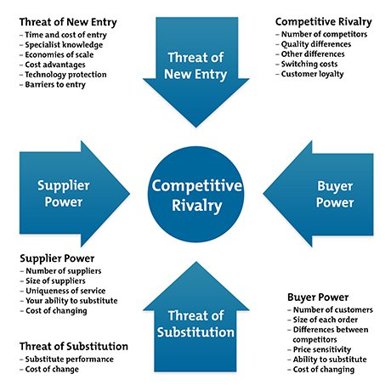
Source: Mind Tools (2020)
Most suppliers of fashion brands are small and undifferentiated business organisations. They typically supply raw materials which cannot be differentiated and may be easily substituted at a low switching cost (Giokarini, 2015). For example, in the case of Zara, there are 1,400 separate suppliers located across the globe (Giokarini, 2015). As a result, the fashion brand does not depend on a single supplier and may choose the best providers depending on the current market conditions and exchange rate circumstances. As a large buyer, Zara is also able to negotiate discount prices which additionally reduce the cost of supplies. The extensive portfolio of suppliers has also enabled Zara maintain uninterrupted business operations, despite the imposed lockdown measures and border control measures amid the COVID-19 crisis (Reuters, 2020). Thus, the company has maintained its operational capacity during the crisis which contributed to strong performance.
Customers’ bargaining power remains high in the case of UK. This is mainly because customers have access to various alternatives and they are able to replace Zara’s products with other fashion brands at the same quality and price without experiencing significant switching costs (Giokarini, 2015). More importantly, the severe economic recession have significantly changed consumer behaviour. As earlier noted, UK consumers have a lower purchasing power due to the GDP decline of 11% in 2020 (Harari, 2021). The 25% decline in clothes sales also means that UK consumers have become increasingly price sensitive. As argued by Krugman and Wells (2017), the demand curve becomes steeper and less elastic in the case of price sensitive consumers. As a result, fashion brands are required to reduce profit margins in order to sustain market share in the UK. This is a very unfavourable development which puts profit pressure on fashion brands, including Zara. In an attempt to stabilise its performance, Zara has closed some of its brick-and-mortar stores in UK, although most of closures affected Europe and Asia (Jolly, 2020). Instead, the fashion brand has dedicated efforts to expanding its online sales channels and capacity in order to get access to new consumer groups and maintain its market share in a fast transforming industry amid the COVID-19 crisis. This is clearly seen by the 50% increase of online sales in the case of Zara during the pandemic 2020 (Jolly, 2020).
To carry on, the threat of substitute product is explored. As argued by Giokarini (2015), this threat is really high because consumers have a wide range of alternatives to branded fashion products. These alternatives include hand made products, vintage clothing, homemade items, etc. (Giokarini, 2015).
Next, the threat of new entrants is explored, as it may increase the level of competition in the fashion industry and influences the profit margins of existing companies (Porter, 1979). According to Giokarini (2015), this particular threat remains moderate. On the one hand, the fashion retail sector is capital intensive due to the significant investment requirements in global distribution channels, production facilities, marketing research, etc. (Giokarini, 2015). Moreover, existing companies also have strong and recogniseable brands which demonstrate the existing of loyal and committed customers. For instance, the brand of Zara is estimated to be equal to more than $18.4 billion (Sabanoglu, 2021). This discourages the entrance of new competitors with unknown brands. On the other hand, there are very insignificant regulations and other legal obstacles to enter the sector (Giokarini, 2015). This provides an easy entry to new companies which use various sources of differentiation in order to successfully compete in the marketplace.
Finally, the Porter’s Five Forces model explores the impact of the existing rivalry in the industry. The fashion retail sector is characterised with a high level of rivalry due to the large number of competing brands. Rivalry has also been intensified due to the fact that the sector decline by 25% in 2020 (BBC, 2021). As a result, brands have to compete for lower total revenues. This situation puts additional pressure of profit margins due to the high prospects for a price war. The closure of physical stores by Zara and reduction in labour force size could be seen as a way of reducing costs and optimising performance in a shrinking market (Jolly, 2021). This is an effective strategy to adjust productivity levels to survive in an environment of increasing competitive rivalry.

Conclusion
Research findings demonstrate the challenges experienced by fashion brands in the UK. The external environment has been quite dynamic by providing potential opportunities and threat for companies. As evidenced in the case of Zara, the brand managed to adapt some of its operations in order to benefit from the growth in the online retailing, as well as minimise operational costs related to having physical stores. The decisions made by Zara could also be explained by the findings for the fashion industry. The analysis of the five competitive forces clearly demonstrated the declining profitability in the sector mainly due to increasing bargaining power of customers, threat of substitutes and increasing rivalry in a shrinking market. Considering this, Zara has engaged in appropriate strategic move aiming at accessing new prospect customers and minimising the costs of doing business. The evidence also clearly shows the need for Zara and other fashion brands to stay flexible and responsive to changes in the external and industry environments. Business success is more likely to depend on the ability of fashion brands to effective adjust to changing external circumstances which are more extensive in scope as a whole.

References
Atkinson, A. (2021) UK unemployment rate raises to highest in almost five year, [online] Available: https://www.bloomberg.com/news/articles/2021-02-23/u-k-unemployment-rate-rises-to-highest-in-almost-five-years [Accessed: 30 April 2021]
BBC (2021) Shoppers stuck at home shun new clothes in 2020, [online] Available: https://www.bbc.com/news/business-55762644 [Accessed: 29 April 2021]
Carlile, C. (2018) The rise and rise of the ethical consumer: UK ethical markets worth over £83bn, [online] Available: https://www.triodos.co.uk/articles/2018/the-rise-and-rise-of-the-ethical-consumer [Accessed: 30 April 2021]
Croner (2020) A list of employment laws in the UK, [online] Available: https://croner.co.uk/resources/employment-law/legislation-list/#:~:text=Employment%20Rights%20Act%201996%3A%20An,and%20employers%20across%20the%20UK [Accessed: 25 April 2021]
Focus Economics (2020) UK Economic Forecast, [online] Available: https://www.focus-economics.com/countries/united-kingdom [Accessed: 24 April 2021]
Giokarini, M. (2015) ZARA’s Business Strategy, [online] Available: https://www.slideshare.net/marigiok/zaras-business-strategy [Accessed: 30 April 2021]
Global Innovation Index (GII) (2020) Global Innovation Index 2020: Who will finance innovation? [online] Available: https://www.wipo.int/edocs/pubdocs/en/wipo_pub_gii_2020.pdf [Accessed: 30 April 2021]
Harari, D. (2021) GDP – International Comparisons: Key Economic Indicators, House of Commons, [online] Available: https://commonslibrary.parliament.uk/research-briefings/sn02784/ [Accessed: 30 April 2021]
Hulleman, W. and Marijs, A. (2021) Economics and Business Environment. 5th edition, Routledge
Humphries, J., Neilson, C. and Ulyssea, G. (2020) The Evolving Impacts of COVID-19 on Small Businesses Since the CARES Act. Social Science Research Network: Rochester, NY, USA
Johnson, G., Whittington, R., Angwin, D., Regner, P. and Scholes, K. (2017) Exploring Strategy. 11th edition, Pearson
Jolly, J. (2020) Zara owner to close up to 1,200 fashion stores around the world, [online] Available: https://www.theguardian.com/business/2020/jun/10/zara-owner-to-close-up-to-1200-fashion-stores-around-the-world [Accessed: 30 April 2021]
Krugman, P. and Wells, R. (2017) Essentials of economies. 4th edition, Macmillan Learning
Mind Tools (2020) Porter’s Five Forces, [online] Available: https://www.mindtools.com/pages/article/newTMC_08.htm [Accessed: 27 April 2020]
Office for National Statistics (ONS) (2021) Internet sales as a percentage of total retail sales (ratio) (%), [online] Available: https://www.ons.gov.uk/businessindustryandtrade/retailindustry/timeseries/j4mc/drsi [Accessed: 30 April 2021]
Porter, M. (1979) How Competitive Forces Shape Strategy, Harvard Business Review, Vol. 57(2), pp. 137–145.
Ratten, V. (2020) Coronavirus and international business: An entrepreneurial ecosystem perspective, Thunderbird International Business Review, Vol. 62, pp. 629–634.
Reuters (2020) Zara owner Inditex pledges support for fashion supply chain as coronavirus bites, [online] Available: https://www.reuters.com/article/us-inditex-workers-idUSKCN2511MZ [Accessed: 1 May 2021]
Sabanoglu, T. (2021) Zara's brand value worldwide from 2016 to 2019(in million U.S. dollars), [online] Available: https://www.statista.com/statistics/980126/brand-value-of-zara-worldwide/ [Accessed: 29 April 2021]
Transparency International (2021) Corruption Perceptions Index 2020, [online] Available: https://www.transparency.org/en/cpi/2020/index/nzl [Accessed: 30 April 2021]
UK Government (2013) Transparency data: Environmental and sustainability policy, [online] Available: https://www.gov.uk/government/publications/environmental-and-sustainability-policy#:~:text=The%20policy%20sets%20out%20the,re%2Duse%20and%20recycling%20methods [Accessed: 27 April 2021]
World Bank (2020) Ease of Doing Business rankings, [online] Available: https://www.doingbusiness.org/en/rankings [Accessed: 30 April 2021]
Worthington, I. and Britton, C. (2015) The business environment. 7th edition, Harlow: Pearson Education

