ENHANCING SUSTAINABILITY PRACTICES IN HILTON MALDIVES AMINGIRI RESORT & SPA– ENVIRONMENTAL AND COMMUNITY ENGAGEMENT DEPARTMENT
Student name: Rodica Cornea
Student number:2110386
Lecturer: Jaliya de Silva

Organisational Consultancy (BMIH6005)

EcoLuxe Advisors
EcoLuxe Advisors

Consult us, make the world a better place.

Report Delivery Date:26.02.2024.

Table of Contents
Executive Summary 2
ENHANCING SUSTAINABILITY PRACTICES IN HILTON MALDIVES AMINGIRI RESORT & SPA– ENVIRONMENTAL AND COMMUNITY ENGAGEMENT DEPARTMENT 7
Analysis 11
Identifying and Explaining Sustainability Issues 11
The Principal Aspects of Sustainability and Associated Complexities 12
STEEPLE Analysis 15
The Hotel's Positive Aspects and Strengths 18
The TOWS Analysis 19
Recommendations and Change Management Practises 22
Recommendations 22
Change Management Practices 25
Possible Advantages and Expenses 27
Action Plan 28
Conclusion 31
References lists 33

Executive Summary
Nestled in the stunning and vibrant Island of Maldives, Hilton Maldives Amingiri Resort & Spa is a beacon of luxury and green tourism that pioneers sustainability in luxurious hotel management. According to Legrand, Chen, and Gabriel (2022), sustainability is a growing concept that has earned world attention due to its impact on world economic GDP. The sustainability concept has earned high-value focus from corporate customers, travellers, and hotels in the value chain, such as Hilton Maldives Amingiri Resort & Spa (Han, 2021; Park et al., 2020). The hotels today lean towards the Sustainable Development Goals (SDGs) between 2015 and 2030, formulated by the UN members. The sustainability momentum in the hospitality industry has awakened a series of initiatives, which have focused much energy on environmental sustainability, as Legrand, Kuokkanen, and Day (2023) elaborate.
The tranquillity of the blue waters from the North Malé surrounding the award-winning guest-loyalty destination brews an unforgettable experience for adventurous and environmental-conscious guests. The resort's strategic location, a twenty-minute boat journey from Velana International Airport, makes it easily accessible to customers for thrilling services and extensive family-friendly amenities. Packaged with customised and various options from its eight restaurants and lounges, the hotel creates an ambience of customer satisfaction and a lasting experience. The Environmental and Community Engagement Department (ECED) is one of the vital departments in the hotel. The department commits to the creation and implementation of the hotel's corporate social responsibility (CSR) initiatives, such as waste management, energy conservation, landscaping, and fostering community engagement, as Taylor, Vithayathil, and Yim (2018) recommend, because the CSR closure is associated with many benefits to the hotel.
EcoLuxe Advisors, a New York-based consultancy firm, is a record-breaking European firm grounded on credible operations portfolios. The firm has a record of the most effective strategies, branding services, and CSR programs, evidenced by our serving over 100 hotels at the helm of environmental sustainability. EcoLuxe Advisors also provides standards assessments of sustainability, assists with green building design, and respectfully educates staff and visitors about conservation through training and reading materials. The firm alludes to the golden opportunity to advise Hilton Hotels & Resorts on integrating sustainability across its global enterprise. This study focused on sustainability and explored the Environmental and Community Engagement Department of Hilton Maldives Amingiri Resort & Spa. Over the years, the hotel has experienced environment-related challenges that have hindered achieving optimal results for the hotel projects.
This report compiles in-depth analysis and actionable recommendations that further the resort's emphasis on sustainability, reflecting upon the problematic dynamics gestures that crack the balance between top-notch accommodation and environmental obligation (Ferrari, Hernández-Maskivker, and Nicotera). The department faces a couple of barriers to maintaining sustainable environmental responsibilities due to the resort's location, which is a fragile environment that threatens the implementation of any change-oriented environmental initiative. The analysis reveals critical sustainability challenges such as resource overconsumption, biodiversity conservation, and ecosystem blueprints that the Environmental and Community Engagement Department faces and the negative impacts they have accumulated. Silva (2023) explains that resource conservation practices such as wastewater treatment aid in minimising water wastage and increasing the volume of available clean water. The challenges allow the department's leadership to resonate in line with sustainability initiatives that promote eco-conscious luxury hospitality for customer satisfaction and environmental conservation, as Elhegazy and Eid (2020) state.
The department tools and models such as STEEPLED, SOAR, and TOWS models are used in this report and focus on short-term goals based on profitability and emphasising long-term goals that focus on energy conservation, waste management, and legislation conservation. Besides, technological innovations significantly contribute to the emerging sustainability challenges and have altered the realisation of efficiency and cost-effectiveness in the ecological scope. The sustainability goals of the department directly relate to the amount of revenue generated from tourism, which reflects the importance of all stakeholders' involvement in biodiversity conservation and resource preservation plans, which highly define the resort's future success. Political stability and adherence to legislative laws governing environmental practices enable equitable and responsible operations (Koval et al., 2021). The comprehensive and intricate CSR sustainability programs highlight the department's dedication to sustainable and ethical luxury with a central focus on ecological footprints and community engagement.
The study delineates strengths used by the department to ground its opportunities and address such results as measurable outcomes necessary in building brand loyalty (Górska-Warsewicz and Kulykovets, 2020). The department's efforts and values in its environmental stewardship, luxury amenities, top customer service, and strategic location give it a unique identity to dominate the triumphs of the hospitality sector in Maldives. Resource consumption and energy efficiency pose significant obstacles due to the resort's isolated location, leading to high energy usage despite efforts to incorporate renewable sources (Luo et al. 2021). Water conservation emerges as the most relevant condition to prevent island ecosystems from overexploiting freshwater resources to avert aquifer depletion and ingress of saline water. The levels of biodiversity and impact on the ecosystem are closely monitored in the Maldives to ensure that plant and animal species live in secure habitats.
In early projects, departmental challenges such as cultural and social sustainability were prioritised, which aimed at economic growth without undermining the cultures of local people. Additionally, other threats like coral bleaching and other natural environmental destructions will be addressed under climate change. As reflected in this report, all recommendations favour sustainability initiatives. The insights introduce energy-saving appliances, alternative green sources of renewable energy, involvement in habitat conservation, eco-friendly landscaping, planting practices, and total waste management plans (Higgins-Desbiolles, Moskwa, and Wijesinghe, 2019). Moreover, the emphasis is made on corresponding interaction with local representatives using instruments such as follower tracking, promotion of cultural events, and cooperation with industrial corporations and ecological organisations. Furthermore, the report recommends implementing a robust climate resilience plan that will help reduce the hitches of climate change and shield the resort's investment and resources.
Therefore, the environmental review highlighted herein provides sound guidance to the Environmental and Community Engagement Department of Hilton Maldives Amingiri Resort & Spa to complement its efforts toward making its green initiatives more successful, as Molina-Collado et al. (2022) state. The research is effective when applied to resolve the challenges associated with a resort on environmental and communal dimensions. EcoLuxe Advisors is committed to assisting the resort's department to regain its stature in the tourism sector by implementing the recommendations by analysing the problems' complexity and integrating them into manageable steps.

ENHANCING SUSTAINABILITY PRACTICES IN HILTON MALDIVES AMINGIRI RESORT & SPA– ENVIRONMENTAL AND COMMUNITY ENGAGEMENT DEPARTMENT

Introduction
Hilton Maldives Amingiri Resort & Spa, established in July 2022, is a luxurious and eco-friendly travel destination in the Maldives that is known for its natural beauty, easy access, and commitment to quality sustainability in the hospitality industry as Chatterjee and Karmakar (2023) explains. The resort offers six luxury villas, blending modern luxuries with Maldivian settings, with stunning landscapes and convincing hotel interiors that meet sustainability, economic, and luxury specifications, as Jadallah et al. (2023) state. Hilton Maldives Amingiri offers quality services, including fitness centres, spas, private infinity pools, and five-star restaurants, all characterised by exceptional service.
EcoLuxe Advisors is a New York-based consultancy firm specialising in establishing practical strategies to counter environmental challenges and integrating community engagement into departmental operations. With our strategic and professional team of experts, we are dearly committed to increasing the productivity of the Environmental and Community Engagement Department of the Hilton Resort. The consultancy firm enhances the achievement of all the exception results by applying results-oriented techniques. The techniques include creating strategic goals anchored on the department's mission, using cost-cutting effective models, using green building designs that align with environmental requirements, and using community educational programs on environmental sustainability.
The luxury destination resort must minimise environmental impact by conserving electricity, water, and waste, preserving local biodiversity, and promoting sustainability in a climate-vulnerable area. It must also integrate the local community and culture for social responsibility as a shift into sustainable luxury creates an opportunity for more sustainable mass products (Kunz, May, and Schmidt, 2020). Indigenous peoples have practised sustainability for millennia, focusing on three sustainability pillars: environmental, social, and economic (Purvis, Mao, and Robinson, 2019). These practices emphasise an understanding of cycles and changes in ecosystems and human relationships, including implications that social-ecological sustainability systems can have. (Latulippe and Klenk, 2020). According to Duric and Potočnik (2021) on global statistics, hotels make a 10% contribution to the sustainability ratio. This is the third largest contribution after transport and goods, contributing 49% and 12% respectively.

SOCIETY

ENVIRONMENT

ECONOMY

Figure 1: The interdependence of society, environment and economy (Cie T Y E C O N O M Y, 2022).
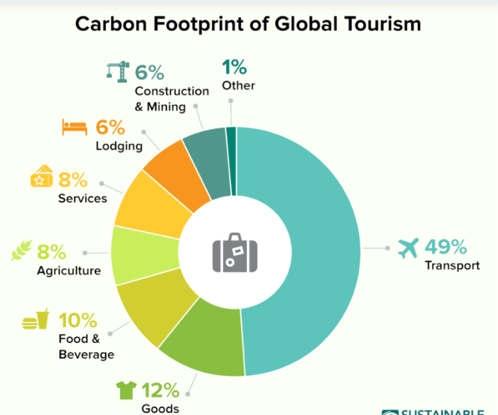
Figure 2: How different factors have contributed to sustainability worldwide (Sustainable Travel International, 2020)
For the concept mapping and issue identification of Hilton Maldives Amingiri Resort & Spa's challenges that stem from the environmental and community engagement department, our team will rely on several theoretical frameworks to explain the emerging problems in the sustainability scope. The theories that will be utilised to explain the concepts include stakeholder theory, corporate social responsibility (CSR), and triple bottom line theory. The general knowledge of the stakeholder theory will be used in the report to explain the relationship between the department and other stakeholders such as consumers, suppliers, and government and how the relation can facilitate value addition to foster and maintain sustainability and normativity (Freeman, Dmytriyev, and Phillips, 2021). The principles of Corporate Social Responsibility (CSR) ensure that whatever has been proposed abides by regulations on CSR governance. Additionally, the recommendations seek to balance economic viability, social responsibility, and environmental stewardship.
Moreover, we will utilise various models and methodologies such as STEEPLED, SOAR, and TOWS models for better analysis. The STEEPLED analysis will comprehensively understand the external variables affecting the sustainability efforts, which cover socio-cultural, technological, economic, environmental, political, legal, and ethical aspects (George, 2021). The SOAR framework will be utilised to evaluate the department's potential, strengths, and measurable sustainability outcomes about its goals. Moreover, a TOWS analysis will help link internal strengths and weaknesses with external opportunities and threats to formulate a comprehensive approach concerning the department's sustainability issues. All these frameworks provide a detailed systematic analysis that helps develop strategic approaches and formulate and evaluate the various measures that guide organisational performance, as Fuertes et al. (2020) sta

Analysis

Identifying and Explaining Sustainability Issues
Sustainability challenges have been drawbacks to ECED in maintaining the brand reputation, consistency in department operations, and community engagements in the department's projects (Khatter, 2023). Andersson et al. (2022) state that such challenges hinder resilience in implementing sustainability measures. Among the challenges affecting the hotel are resource consumption and energy. The resort's climatic change is a growing concern threatening sustainability efforts and is likely to affect the habitat's adaptive capacities soon despite the department's efforts to sustain the condition (Barnett et al. 2022). Dysfunctional water usage systems and electrical appliances influence resource overconsumption. The department must limit operations, which potentially cause aquifer depletion and saltwater intrusion, but instead focus on conserving the scarce water resource, as Tzanakakis, Paranychianakis, and Angelakis (2020) state. On the other hand, Corlett (2020) also states that working in a biodiverse area like the Maldives entails safeguarding and maintaining indigenous plants and animals.
Difficulties in the availability of green technologies and practices pose another barrier to efficiency strides towards reducing the ecological footprint. According to Pilkey, Longo, and Neal (2023), beach mining of coral reefs causes erosion and threatens aquatic animals and plants. Waste disposal and coral mining are the major threats to environmental sustainability and have dire effects on the Maldives' habitats. Wang, Lee, and Mokhtar (2021) state that waste management is crucial for an island resort, as improper disposal, such as sewage disposal, leads to pollution and threatens marine life. Due to the consistency of these underlying problems, the department faces the challenge of integrating solution recommendations for consistent operations and profit gains. The resort is committed to harmonising resource availability and consumption to avoid increased operational costs and financial constraints.
The department also faces cultural and social sustainability due to limited public awareness of environmental sustainability measures and inadequate community engagement in resort activities. These efforts are not only a question of social responsibility but also the impacts of all sustainability initiatives on the community development and preservation of ethics and cultural norms. The department's relationship with the community reflects the tenderness of the project's actualisation for the benefit of the community and resort development goals. Obstacles such as insufficient cultural awareness, language barriers, and insufficient cooperation with local organisations influenced the department's detachment from the community. The lack of integration with the public may prevent the department from developing friendly relationships with the community members. Such ethical divisions lead to lost opportunities for the resort to get meaningful partnerships and programs.

The Principal Aspects of Sustainability and Associated Complexities
Resource consumption management and energy efficiency are crucial for eco-conscious visitors as the energy sector continues to take shape (Kober et al., 2020). Water stewardship promotes cost-effectiveness and enhances resource efficiency in serving the hotel in the long run.( Antonova, Ruiz-Rosa, and Mendoza-Jimenez, 2021). According to Mendoza et al. (2022), tourism is rated as one of the major water consumers, and hotels can cut their water usage by up to 50% by installing water-saving fixtures. Any damage to the region's ecology draws criticism, but Taylor et al. (2020) state that community can influence biodiversity and promote cultural ecosystems. According to the International Energy Agency, the hospitality industry is responsible for about 1% of the world's CO₂ emissions. Lenzen et al. (2018) and Arabadzhyan et al. (2021) explain that the global carbon footprint will increase if the tourism sector does not embrace responsible tourism. Tropical hotels require higher energy and water consumption, increasing expenses and the possibility of carbon in the air. Ahmed Ali, Ahmad, and Yusup (2020) state that investing in efficiency and renewable energy can save up to 60% of energy consumption, and commitment to carbon reduction can promote environmental sustainability.
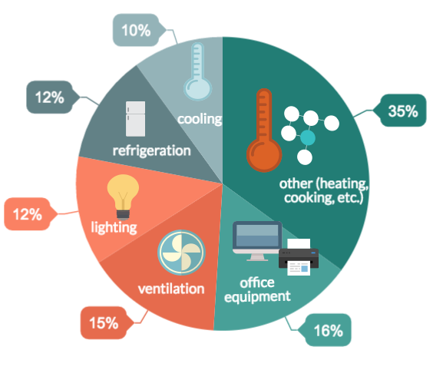
Figure 3: Energy usage in the hotels (Harper, 2019).
Modifications to processes and infrastructure may also be necessary when converting operations to use more sustainable energy. According to Nolan's Cornell University School of Hotel Administration study, hotels can use energy-efficient techniques to save up to 20% of their energy expenses. The tourism industry is also responsible for around 5% of the world's garbage. According to the UNEP law and environment assistance platform, Maldives' territory constitutes 98% ocean and 2% islands, creating a strong challenge in waste management. However, Maldives Health Master Plan 2016-2025 strengthens the efforts of the ECED with its three main goals, which include establishing trust in the healthy system, minimising the inequality in access to better healthcare, and reducing the constant diseases and disabilities that are influenced by environmental factors. Filimonau and De Coteau (2019) and Dhir et al. (2020) assert that food waste (40%) accounts for a large portion of the trash produced by the hotel sector.
The importance of social and cultural sustainability has also increased as visitors look for environmentally conscious hotels to tailor their experiences. Community ties and collaborations help establish a company's reputation and generate economic opportunities; involving local suppliers and expertise guarantees supply chain stability (Arora et al. 20218). Creating visitor experiences based on the community's culture exemplifies the key role played by the community in crafting guests' experiences and maintaining environmental sustainability. On the other hand, accelerated climate change shapes expectations for resilience planning and environmental actions, as stated by Ikeobilor (2022). If climatic disruptions worsen, there could be significant financial losses due to storm damage or business disruptions, given that the department is central in developing climate change programs (Dogru et al. 2019). According to CPG 229 (Campiglio et al., 2022), three risks are associated with climate change: liability, transition, and physical hazards, as shown below.
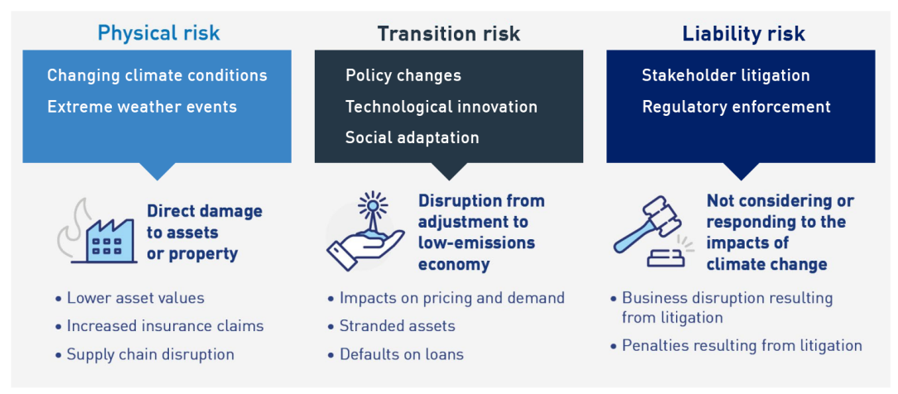
Figure 4: Climate change financial risks (APRA.2022)

STEEPLE Analysis
STEEPLE analysis is a technique that helps businesses strategise, evaluate, and resolve issues in their daily operations. This method ensures that market research considers the dynamic environment and that strategic management can effectively promote sustainability (Henry, 2021). Understanding a STEEPLE analysis can aid in creating successful business marketing plans, according to a report by Uzbekistan (2024). PESTEL Analysis -Comprehensive Country Outlook. The analysis below offers an overview of various external aspects. In this report, the STEEPLE analysis examines the external factors influencing the sustainability initiatives of the Environmental and Community Engagement Department, examining their impact on the hotel's eco-friendly programs.
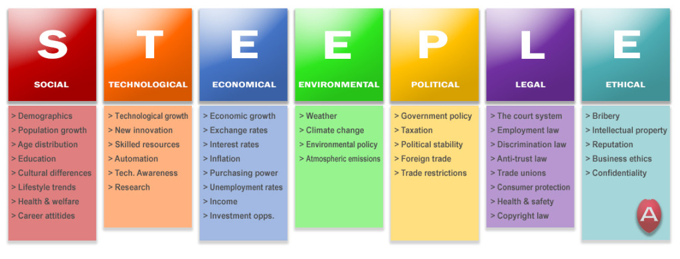
Figure 5: STEEPLE Analysis (Stephens, 2021)

STEEPLE Analysis on the Hilton Hotel Environmental and Community Engagement Department
Factor | Effect on the Hotel's Efforts in Sustainability
Social | An increase influences the department's employee sourcing policies for tourists. Locally sourcing labour promotes community involvement, and the community can easily support the department's environmental and development programs.
Technological | Technological advancements have a direct impact on maintaining environmental sustainability. Advancements such as LED lights and automatic light sensing in guest rooms necessitate commitment.
Economical | The department's ability to fund sustainability projects and its revenue are both impacted by the cyclical nature of tourism demand, which is impacted by local and worldwide economic conditions.
Environmental | Due to biodiversity and climate vulnerability, the department must take strict precautions to manage waste, preserve water, safeguard the local ecosystem, and reduce carbon emissions.
Political | The policies of national and local governments concerning tourism, environmental preservation, and corporate operations can substantially affect the department's sustainability practices and compliance needs.
Legal | The department's waste management, energy use, and infrastructure development may be governed by rules about labour legislation, environmental protection, and construction.
Ethical | The department's approach to sustainability, which includes fair labour policies, responsible sourcing, and public reporting, is influenced by its dedication to ethical practices.

The Hotel's Positive Aspects and Strengths
Organisations can use a SOAR analysis as a strategic planning tool to develop a shared future vision that builds on the organisation's existing strengths (Purwanggono and Pratiwi, 2022). As Kordana-Obuch (2023) states, organisations can use a SOAR analysis to visually represent their company's key strengths and how to build on them.
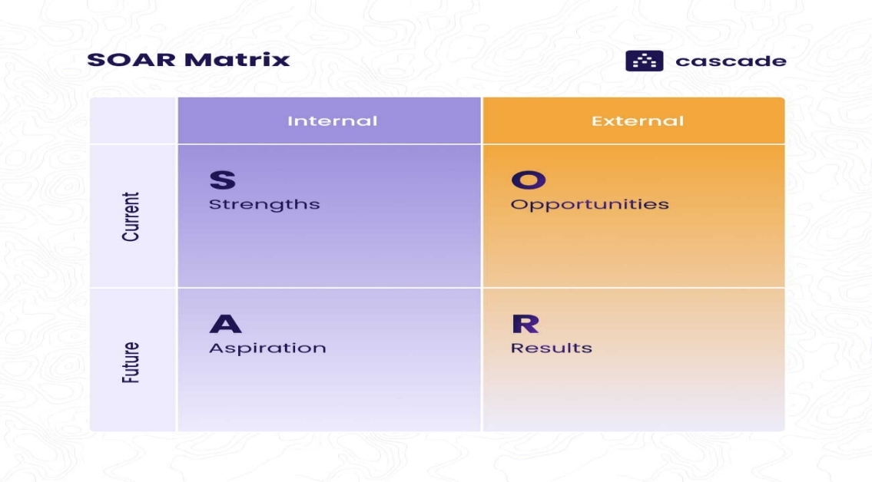
Figure 6: SOAR analysis 2*2 Matrix (Cascade team, 2023)
Committed to sustainability and operational efficiency, the environmental and community engagement department exhibits several benefits. The following SOAR analysis outlines the department's strengths, opportunities, aspirations, and quantifiable results. It also highlights the department's excellent practices and possible growth areas.
Strengths | Opportunities | Aspirations | Results
- Dedication to ecological responsibility and sustainability.  - Luxurious facilities and superior visitor services.  - Excellent reputation and brand recognition.  - A prime location in the Maldives that provides memorable and alluring experiences. | - Increasing interest in sustainable travel and ecotourism.  - Possible collaborations with neighbourhood associations and environmental groups.  - Possibilities to combine renewable energy sources with cutting-edge green technologies. | - To lead the Maldives' sustainable luxury hospitality industry.  - To make a significant and enduring contribution to the community and surrounding environment.  - To respect sustainable ideals while consistently improving the visitor experience. | - Accomplishments in cutting out trash production and energy use.  - Positive reviews from visitors and excellent ratings for environmental initiatives.  - Contributions to neighbourhood improvement and environmental preservation initiatives in the area.

The TOWS Analysis
The TOWS (Threats, Opportunities, Weaknesses, and Strengths) analysis is conducted to analyse the hotel department. According to Brown Epstein (2022), this analysis enables one to consider tactics related to both internal and external domains. TOWS analysis provides a comprehensive view of possible future orientations and tactics by strategically aligning the department's internal strengths and weaknesses with external possibilities and threats. TWOS analysis highlights that focusing on the specialised ecotourism package and establishing good community relations with the local communities and environmental organisations will help the ECED attract many environmentally conscious tourists. Additionally, to counter climate change, the organisation must invest in the department's green technologies and sustainability projects for greater achievement, as Falcone (2020) recommends.
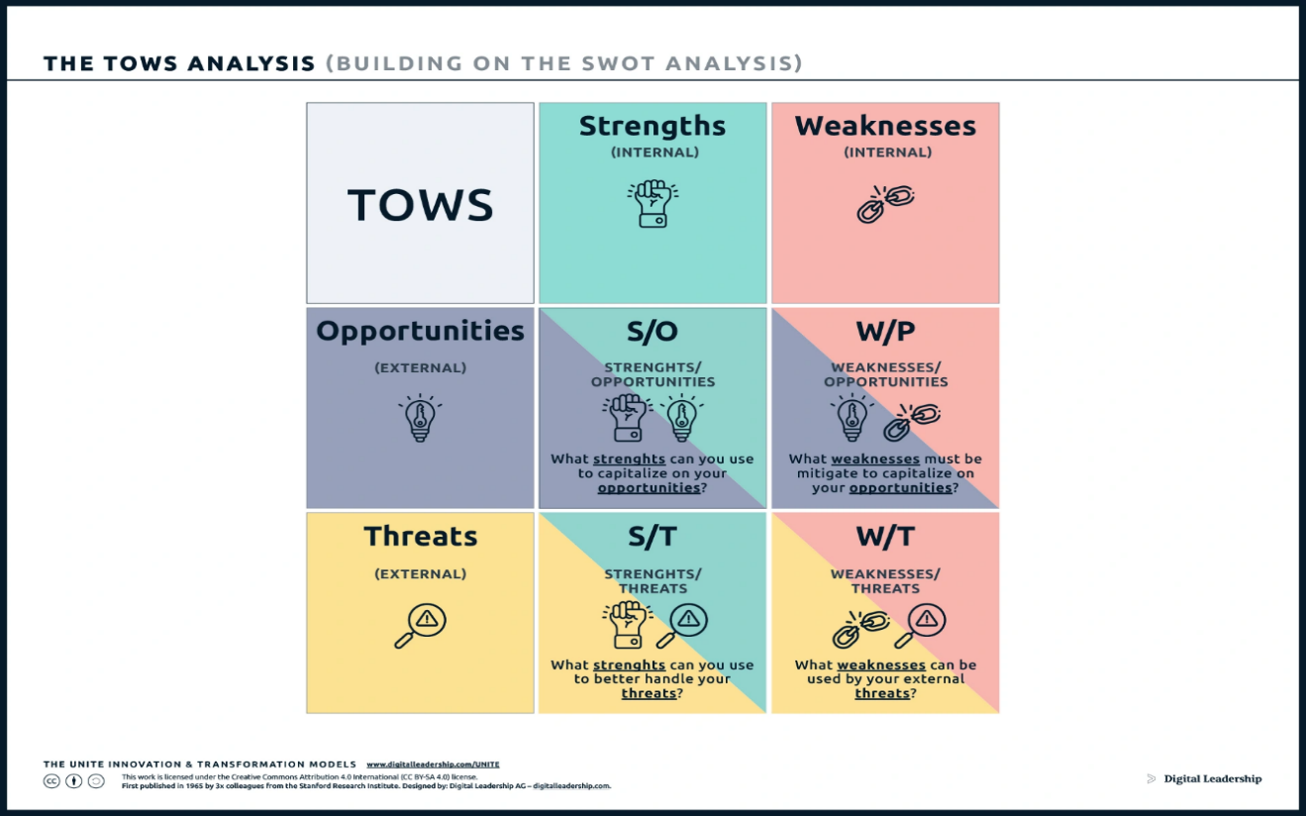

Figure 7: TOWS Analysis 2*2 matrix (Stephens, 2021).

Tows analysis on Hilton Maldives Amingiri Resort & Spa
 | Opportunities | Threats
Strengths | S-O STRATEGIES  1. Draw ecologically conscious tourists with your solid brand reputation and dedication to sustainability.  2. Create distinctive ecotourism packages using a prime location and opulent amenities. The resort's strategic location is advantageous for guests' attraction.  3. Work with community organisations and environmental advocacy associations to improve the department's community involvement and sustainability programs. | S-T STRATEGIES  1. Use green technologies and sustainable practices to reduce environmental impact and prepare for the dangers posed by climate change.  2. To handle political and economic unpredictability, partner with government and other policy-making bodies to build coherent policies that align with environment and community needs.
Weaknesses | W-O STRATEGIES  1. Minimise vulnerability by using renewable energy sources and green initiatives to address operational inefficiencies.  2. Embrace employee training to raise customer satisfaction, improve service quality, and strengthen staff.  3. Create marketing plans that showcase the department's eco-friendly initiatives and distinctive experiences and commitment that radicalised environmental sustainability. | W-T STRATEGIES  1. Strengthen risk management measures and contingency planning on geopolitics and climate hazards.  2. Put strict legal and moral compliance procedures in place to reduce the risk to reputation and the law.  3. Strictly partner with authentic local suppliers that comply with environmental sustainability requirements.

Recommendations and Change Management Practises

Recommendations
To protect against environmental uncertainties, the department should implement environmental sustainability policies to minimise environmental impact. The policies should ensure that societal harmony is maintained, operational excellence is cultivated, and customer satisfaction aligns with the international environmental and sustainable development objectives (Jones, Hillier, and Comfort, 2019). To showcase its commitment to environmental conservation, the department should install energy-efficient appliances such as water-saving devices in guest rooms, light sensors, energy-efficient HVAC systems, and LED lighting. To emphasise conservation initiatives and carbon footprint reduction, the hotel department needs to formulate strategies that align with renewable energy sources like solar and wind power turbines, as Dhirasasna and Sahin (2021) elaborate.
Regular audits of resource utilisation enhance understanding of the patterns and trends of department consumption of energy, water, and other resources. The resources are essential in fostering environmental sustainability and implementing significant elements of social welfare optimisation. These audits will enlighten the hotel on where it can enhance energy consumption measures, saving much cost and having less environmental impact. The department also needs to install periodic energy audits as a timeline and means for implementing recommendations from such audits in the future. Considering the audit's resource consumption insights, the department can swiftly collaborate with local environmental groups and experts to lead sound sustainability practices oriented on resort objectives and community needs.
The department can carry out habitat conservation programs to save aquatic lives. Carlson et al. (2022) emphasise the need for hotels to collaborate with environmental enthusiasts through habitat conservation programs to prevent beach erosion and coral reef destruction and ensure that all development projects are ecologically responsible. United States Environmental Agency ascertained that practises such as dredging, overfishing, boat anchors and grounding, mining of the reefs for building, collection of live corals for the aquarium market, and use of heavy explosives like dynamite cause stress on reefs and can lead to them cracking. Moreover, the department's eco-friendly landscaping will help maintain the resort's natural beauty while minimising its ecological impact. For example, natives do not require much water and have some resistance to local pests through their landscape.
The department should also create wildlife habitats promoting biodiversity, widespread waste reduction, recycling, and disposal practices. A well-designed waste management plan that embodies strategies such as composting and recycling, reduction of waste creation, and proper trash disposal is key to reducing the environmental footprint, as Falcone (2020) advises. The department should also involve guests in waste management initiatives through educational programs on the department platforms and seek customer feedback on the environmental sustainability services they offer. Waste disposal alliances with regional waste treatment centres can help make processing more efficient. Due to environmental constraints and local policies, the department should collaborate with local community facilities in waste recycling. Such partnership leads to economic development and socialisation, thereby improving its ecological footprint. The department should consider recruiting locals into the hotel for cultural community engagement and providing them with training opportunities to develop the local community.
Moreover, the department can promote and develop local culture by purchasing local products and artworks, using regional characteristics to design the infrastructure and activities for visitors, and supporting local festivals or events in the resort. The department should also prompt the resort to join nearby partnership wings to develop a cultural economic web that builds the region's economy, fosters intercultural dialogue, and ensures the preservation of traditional handicrafts, as Hariram et al. (2023) explain. Localisation of strategies that make the hotel's department operations compatible with the socioeconomic environment goals is vital before spreading within the locality. Examples of these may include health and wellness campaigns, environmental conservation activities, or educational initiatives that positively affect the department and the resort in general.
In addition, the department should also reflect on constructing a climate resilience plan by structuring an all-inclusive network that caters to issues concerning climate resilience since the Maldives Islands are vulnerable to changes occurring in climatic conditions. The goals of this approach should focus on minimising and adapting to the effects of climate change through sustainable innovations (Tiwari and Thakur, 2021). In addition, the department should address the disaster and ineffective building practices through infrastructure planning and disaster risk mitigation measures. Measures such as routine climate risk assessments and the integration of cultural resilience elements in every aspect of resort work and planning are recommended by this report. Furthermore, the report recommends that the department establish and promote responsible diving policies and confer legal repercussions on people who engage in coral bleaching and mining. By implementing the policies, the department will likely attract more guests who believe in green tourism.

Change Management Practices
Successful change management requires effective employee training and embracing effective communication (Ushakov et al., 2020). Information that employees and other stakeholders should know about the upcoming changes, their causes, and what they will bring should be given through an appropriate communication channel. Open and consistent communication reduces resistance, promotes trustworthiness, and gives employees a sense of ownership in their work. It requires several means of communication, including conferences, newsletters, and all types of digital platforms, to ensure clarity and consistency in the message. In addition, comprehensive training programs equip employees with skills and knowledge that facilitate seamless transition. Employees should be trained in correspondence to their responsibilities in the implementation process to ensure real results are attained.
The initiatives staging approach ensures that the stakeholders are confident in implementing the sustainability measures. Knowledge gained during workshops and online courses must be used to foster the implementation of the recommended measures and control the transition of the events seamlessly. Performance can be assessed by employing key performance indicators. Measuring the success of sustainability programs is essential so that decisions can be made accordingly. All phases must have clearly defined goals, specific timelines, and realistic performance measurement metrics. Observation and input are other practices, and they involve regular monitoring. Chofreh et al. (2020) assert that tracking the progress and implementation of all the changes is crucial as it makes it possible to prove whether they worked and what needs to be done next. The department should conduct continuous data collection and analysis to monitor its evolution in the resort, celebrate employee achievements, and motivate staff for change implementation.
Embracing staff feedback and creating a comfortable environment for their opinions is crucial for effective change processes as it enhances efficiency, employee motivation, and commitment to crafting creative solutions. Aboramadan et al. (2022) assert that being receptive to input, whether criticisms or support assurance, is the most critical aspect of continuous development, establishing mechanisms for employees and other interested parties to give feedback. On the other hand, energy usage should be recorded and compared with baseline data every month. The data comparison helps to assess the sustainable transitions in food, accommodations, and other factors (Bux, Aluculesei, and Moagăr-Poladian, 2022). To provide a better real-life picture of energy efficiency improvement, metrics such as kWh per guest night or kg CO2/m² can be used. To monitor the waste produced in a given month, keep a consistent record of the waste quantity, specifying the percentage of waste used in compost and the recycling process. On community engagement, monitor and keep data on local hiring numbers, local procurement percentages, and the results of community outreach programs.
Biodiversity can be promoted by closely monitoring marine habitats and other natural areas to ensure they are not intruded on and exposed to exploitation (Nielsen et al., 2021). Habitats such as mangroves or coral reefs, and the accomplishment of conservation efforts. The department can gauge visitors' satisfaction with their services by utilising questionnaires and online platforms. To measure awareness and involvement, monitor the degree of guest participation in sustainability programs. Creating a sustainability report is essential in evaluating the progress of the implemented measures. The report can be produced quarterly or annually to identify possible loopholes that need instant action. The report must be open and honest, outlining the accomplishments and the room for development. Moreover, stakeholder engagement should be prioritised to obtain a variety of viewpoints and promote a cooperative approach to sustainability.

Possible Advantages and Expenses
The Improved Brand Image is a possible advantage. The department will grow the resort's reputation fast by implementing the suggested sustainable initiatives (Abdou et al. 2020). Showcasing a dedication to sustainability might draw in more clients and result in favourable press attention. Many guests are likely to visit the resort when they know that the visit aids the communal people and nature. Some of the factors that contribute to the enhancement of guest satisfaction and loyalty are local cultural life interaction amenities and resort sustainability practices awareness. Embracing sustainability promotes long-term cost savings, which involves spending on energy-efficient appliances and renewable power sources. Conserving energy energies and committing to carbon emission reduction can attract rewards such as tax refunds and operational subsidies from the government. The department can develop solid community ties by promoting activities such as employment and sourcing or saving cultures.
The first-time capital outlay is the cost the department incurs while doing the changes for the first time. For instance, renewable energy sources and energy-efficient appliances like HVAC systems that use less energy cost $5,000 to $15,000 per unit. Retrofitting lighting to LED costs $100 to $300 per fixture. Installation costs for solar panels range from $10,00 to $32 per kW. Moreover, upgrades to the infrastructure costs. For these, an upgrade cost for a waste management system costs $20,000 to $50,000. Systems for conserving water (such as greywater recycling) cost between $10,000 and $25,000. Another cost to consider is the training and development cost. Training programs are developed and delivered for $1,000 to $5,000 per program. Sourcing external advisors or instructors costs $500 to $2,000 per day. Monitoring and reporting costs $5,000 to $15,000, while reporting on sustainability costs $3,000 annually. Programs for the community and conservation initiatives for community engagement cost $10,000 to $30,000 annually.
Adherence to the requirements of legal and regulatory authorities is essential to define all programs aimed at environmental protection scattered in resort communities. In the Maldives, environmental standards are implemented stringently due to its position as one of the countries vulnerable to climate change and appreciate the tourism sector it depends on. Resorts must comply with national and local laws related to the environment, which may involve garbage dumping and water modification regulations by the board required to ensure the safety of marine life. Failure to comply may lead to legal action, and such resorts will be treated like other hotels. The Maldives has unique standards regarding sustainable tourism; these are targets designed to achieve energy efficiency, waste management, and community interaction. Such standards ensure, however minimally possible, the negative influence of tourism on nature and that it benefits the local population. Suppose Green Globe and LEED certifications are to be obtained. In that case, it can prove compliance with some international sustainability standards, thereby supporting the resort's reputation as a reputable accommodation facility for eco-conscious visitors.
Good communication of the sustainability initiatives undertaken is instrumental in engaging guests, stakeholders, and community members and improving the resort's brand image. Sustainability should be also be integrated into the guest experience at this resort by offering educational activities surrounding local ecosystems and conservation efforts as well as cultural heritage. This can be achieved through the interactional experience, guest room information materials available, and digital platforms. To keep the stakeholders like investors, partners, and environmental organisations more informed about sustainability activities and successes as well as share regular news reports on these matters, various forms of reports such as newsletters and organization meetings are all essential means for informing people.
Action Plan
No | Issue | Action | Desired Outcome | Timeline | Completion Date | Budget
1 | High energy usage | Install energy-efficient appliances and equipment. Conduct energy audits. | Reduce energy consumption by 20%. | Six months | August 2024 | $50,000
2 | Habitat and ecosystem impact | Launch conservation initiatives to protect local flora and fauna. | Minimal environmental impact from operations | One year | January 2025 | $20,000
3 | Waste management challenges | Implement comprehensive waste reduction and recycling plans. Partner with local facilities and the National Waste Management Authorities. | 50% reduced waste output. 85% of waste recycled | Nine months | October 2024 | $40,000
4 | Water usage concerns | Install water-efficient appliances such as sensor taps.  Landscape with native plants. | 40% reduction in water consumption. | 12 months | January 2025 | $30,000
5 | Lack of community ties | Local hiring initiatives. Procurement from local suppliers. Support cultural events. | 60% of staff hired locally. 40% suppliers from the community. | Ongoing | Annual evaluation | $50,000/year
6 | Climate change vulnerabilities | Develop climate resilience strategy and infrastructure upgrades. | Minimised operations disruption from weather events. | 18 months | August 2025 | $500,000
7 | Monitoring sustainability progress | Track KPIs. Issue annual sustainability reports.  Hold regular progress review meetings. | Quantifiable results to showcase achievements | Ongoing | Annual reporting | $15,000/year

The report provides environmental and community engagement guidelines with a detailed action plan to improve its sustainability efforts in seven critical areas. Energy-efficient appliances will be installed within six months to lower excessive energy demand, and energy audits will be conducted to find additional savings opportunities. Within a year, programs to conserve habitat and ecosystems will be initiated to reduce the resort's environmental effects. Implementing a trash reduction and recycling plan with nearby facilities over nine months is a primary priority to enhance waste management.
The goal of using native landscaping with water-efficient fixtures is to cut water usage by 40% in a year. Maintaining connections with the community is a top priority, which is why we promote cultural events and hire and procure locally. Infrastructure modifications will be implemented in conjunction with developing a climate resilience strategy over 18 months to reduce interruption from weather events and climate change. The foundation of these programs is an emphasis on KPI monitoring, with yearly sustainability reports used to monitor advancement. The first-time capital outlay budget is projected to be between $500,000 and $750,000.

Conclusion
The research furnished a thorough account and a feasible plan outlining how the environmental and community engagement department might enhance its sustainability initiatives for the resort. This report has methodically outlined the realism of merging pleasurable services with environmentally conscious methods. On the one hand, due to the hotel's location, accessibility, and sensitivity to environment-conscious tourists, the Hilton Maldives Amingiri Resort & Spa has encountered significant difficulties in executing its operations. However, by developing sustainable programs in the tourism sector, the department has provided many employment opportunities for the people and contributed to preserving the local culture while becoming a part of society. The report has utilised the analysis models such as STEEPLED, SOAR, and TOWS to evaluate the realism of the green initiatives and to table recommendations that would be impactful if applied by the management.
On the other hand, it was found that finding an equilibrium between short-term profit desires and long-term sustainability objectives is very critical. Energy conservation, waste management, and conservation-oriented legislation had a particular place in this department's and the resort's future. It was subsequently determined that the quality of labour, procurement, and environmental care reinforced the reputation concurrently, strengthening the department's sustainability objectives and fostering substantive community engagement. The report has found that the department has invested much effort towards attaining the resort's sustainability and social change. Embracing technological innovations can solve problems such as waste management and energy overconsumption. However, the technological integration must be objective and logistical to address all the prevailing challenges and enhance the attainment of environmental sustainability and profit gains upon the cost-benefit analysis.
Additionally, the department's sustainability spending is intertwined with tourism revenue, and biodiversity conservation and resource preservation matter greatly in the future. Political stability and policies ensure the resorts execute beneficial and environment-friendly projects, whereas legislative laws enforce amiable relations between businesses and communities, solid waste management, and general environmental conservancy. Labour quality, sourcing, and environmentalism increase the reputation level of the resort. After analysing the online and physical customer feedback, it was discovered that Hilton Maldives Amingiri Resort and Spa has a great competitive advantage regarding brand reputation, which helps attract external partnerships and sponsorship to promote environmental sustainability and community engagement. Seeing how committed the department is to sustainability and operational efficiency is impressive.
The sustainability programs foster energy conservation, reduced utilisation of natural resources, waste management, and the development of people's engagements like social networks. The Environment and Community Engagement Department can implement a climate change program that includes ecological footprints, community liaison, and operations resiliency. They also have very friendly landscaping practices and strict waste management laws. Moreover, it was a sign of responsibility and sustainable hospitality that the department was interested in connecting with the local community and preserving Maldivian cultural heritage. The strategy aimed to strengthen the brand reputation, increase the guests' satisfaction levels, and improve financial performance. EcoLuxe Advisors takes pride in helping the department enhance the sustainability measures to foster resort growth.

References lists
Abdou, A.H., Hassan, T.H. and El Dief, MM (2020) 'A description of green hotel practices and their role in achieving sustainable development,' sustainability, 12(22), p.9624. Available at: https://www.mdpi.com/2071-1050/12/22/9624
Aboramadan, M., Crawford, J., Turkmenoglu, M.A. and Farao, C. (2022) Green inclusive leadership and employee green behaviors in the hotel industry: Does perceived green organisational support matter?. International Journal of Hospitality Management, 107, p.103330. https://www.sciencedirect.com/science/article/pii/S0278431922001967
Ahmed Ali, K., Ahmad, M.I. and Yusup, Y. (2020) Issues, impacts, and mitigations of carbon dioxide emissions in the building sector. Sustainability, 12(18), p.7427. https://www.mdpi.com/2071-1050/12/18/7427
Andersson, E., Elmqvist, T., Haase, D., Kronenberg, J., Langemeyer, J., Mascarenhas, A. and Wolff, M. (2022) 'Based on nature, enabled by social-ecological-technological context: deriving benefit from urban green and blue infrastructure,' Ecology and Society. Available at: https://helda.helsinki.fi/bitstream/handle/10138/354593/ES_2022_13580.pdf?sequence=1
Antonova, N., Ruiz-Rosa, I. and Mendoza-Jimenez, J.(2021) 'Water resources in the hotel industry: a systematic literature review,' International Journal of Contemporary Hospitality Management, 33(2), pp.628-649. Available at: https://www.emerald.com/insight/content/doi/10.1108/IJCHM-07-2020-0711/full/html
APRA. (2022). ` Climate Change Financial Risks. Available (Online) www.apra.gov.au
Arabadzhyan, A., Figini, P., García, C., González, M.M., Lam-González, Y.E. and León, C.J. (2021) 'Climate change, coastal tourism, and impact chains–a literature review,' Current Issues in Tourism, 24(16), pp.2233-2268. Available at: https://www.tandfonline.com/doi/abs/10.1080/13683500.2020.1825351
Arora, N.K., Fatima, T., Mishra, I., Verma, M., Mishra, J. and Mishra, V. (2018) 'Environmental sustainability: challenges and viable solutions,' Environmental Sustainability, 1, pp.309-340. Available at: https://link.springer.com/article/10.1007/s42398-018-00038-w
Barnett, J., Jarillo, S., Swearer, S.E., Lovelock, C.E., Pomeroy, A., Konlechner, T., Waters, E., Morris, R.L. and Lowe, R. (2022) 'Nature-based solutions for atoll habitability,' Philosophical Transactions of the Royal Society B, 377(1854), p.20210124. Available at: https://royalsocietypublishing.org/doi/abs/10.1098/rstb.2021.0124
Brown Epstein, H.A. (2022) 'SWOT/TOWS/OTSW Analysis of recent past and near future,' Journal of Hospital Librarianship, 22(4), pp.333-339. Available at: https://www.tandfonline.com/doi/full/10.1080/15323269.2022.2132089
Bux, C., Aluculesei, A.C. and Moagăr-Poladian, S.(2022) How to monitor the transition to sustainable food services and lodging accommodation activities: A bibliometric approach - Sustainability, 14(15), p.9102. Available at: https://www.mdpi.com/2071-1050/14/15/9102
Campiglio, E., Daumas, L., Monnin, P. and von Jagow, A. (2023) 'Climate‐related risks in financial assets,' Journal of Economic Surveys, 37(3), pp.950-992. Available at: https://onlinelibrary.wiley.com/doi/abs/10.1111/joes.12525
Carlson, R.R., Foo, S.A., Burns, J.H. and Asner, G.P. (2022) 'Untapped policy avenues to protect coral reef ecosystems,' Proceedings of the National Academy of Sciences, 119(49), p.e2117562119. Available at: https://www.pnas.org/doi/abs/10.1073/pnas.2117562119
Cascade team (2023) SOAR Analysis: What It Is & Step-By-Step Guide (2024). Available at: https://www.cascade.app/blog/soar-analysis-guide
Chatterjee, P. and Karmakar, R. (2023) 'Role of Sustainable Development Goal and Digitalization in Hospitality Industry: A Systematic Literature Review,' Fostering Sustainable Businesses in Emerging Economies: The Impact of Technology, pp.223-245. Available at: https://www.emerald.com/insight/content/doi/10.1108/978-1-80455-640-520231014/full/html
Chofreh, A.G., Goni, F.A., Klemeš, J.J., Malik, M.N. and Khan, H.H. (2020) 'Development of guidelines for the implementation of sustainable enterprise resource planning systems,' Journal of Cleaner Production, 244, p.118655. Available at: https://www.sciencedirect.com/science/article/pii/S0959652619335255
Cie T Y E C O N O M Y, S. (2022) E N V I R O N M E N T. [online] Available at: https://www.thenaturalstep.de/wp-content/uploads/TNS-from-reductionism-to-whole-systems-thinking-vs-nested-interdependence-.pdf [Accessed 30 Jan. 2024].
Corlett, R.T. (2020) Safeguarding our future by protecting biodiversity - Plant diversity, 42(4), pp.221-228. Available at: https://www.sciencedirect.com/science/article/pii/S2468265920300354
Dhir, A., Talwar, S., Kaur, P. and Malibari, A. (2020) 'Food waste in hospitality and food services: A systematic literature review and framework development approach,' Journal of Cleaner Production, 270, p.122861. Available at: https://www.sciencedirect.com/science/article/pii/S0959652620329061
Dhirasasna, N. and Sahin, O. (2021) 'A system dynamics model for renewable energy technology adoption of the hotel sector,' Renewable Energy, 163, pp.1994-2007. Available at: https://www.sciencedirect.com/science/article/pii/S0960148120316542
Dogru, T., Marchio, E.A., Bulut, U. and Suess, C. (2019) 'Climate change: Vulnerability and resilience of tourism and the entire economy,' Tourism Management, 72, pp.292-305. Available at: https://www.sciencedirect.com/science/article/pii/S0261517718303145
Duric, Z. and Potočnik Topler, J. (2021) 'The Role of Performance and Environmental Sustainability Indicators in Hotel Competitiveness,' Sustainability, 13(12), p.6574. Available at: https://www.mdpi.com/2071-1050/13/12/6574
Elhegazy, H. and Eid, M.M.M. (2020) 'A state-of-the-art-review on grey water management: a survey from 2000 to 2020s,' Water Science and Technology, 82(12), pp.2786–2797. Available at: https://iwaponline.com/wst/article-abstract/82/12/2786/78152
Falcone, P.M. (2020) 'Environmental regulation and green investments: The role of green finance,' International Journal of Green Economics, 14(2), pp.159-173. Available at: https://www.inderscienceonline.com/doi/abs/10.1504/IJGE.2020.109735
Ferrari, S., Hernández-Maskivker, G. and Nicotera, T. (2021) 'Social-cultural sustainability of roots tourism in Calabria, Italy: A tourist perspective,' Journal of Vacation Marketing, p.135676672110204. Available at: https://doi.org/10.1177/13567667211020493.
Filimonau, V. and De Coteau, DA (2019) 'Food waste management in hospitality operations: A critical review,' Tourism Management, 71, pp.234–245. Available at: https://doi.org/10.1016/j.tourman.2018.10.009.
Freeman, R.E., Dmytriyev, S.D. and Phillips, R.A., (2021) 'Stakeholder theory and the resource-based view of the firm,' Journal of Management, 47(7), pp.1757-1770. Available at: https://journals.sagepub.com/doi/abs/10.1177/0149206321993576
Fuertes, G., Alfaro, M., Vargas, M., Gutierrez, S., Ternero, R. and Sabattin, J. (2020) ‘Conceptual Framework for the Strategic Management: a Literature Review—Descriptive,’ Journal of Engineering, [online] 2020(6253013), pp.1–21. Available at: https://doi.org/10.1155/2020/6253013.
George, R., (2021) 'The Tourism and Hospitality Marketing Environment,' In Marketing Tourism and Hospitality: Concepts and Cases (pp. 183-219). Cham: Springer International Publishing. Available at: https://link.springer.com/chapter/10.1007/978-3-030-64111-5_6
Górska-Warsewicz, H. and Kulykovets, O. (2020) 'Hotel Brand Loyalty—A Systematic Literature Review,' Sustainability, 12(12), p.4810. Available at: https://doi.org/10.3390/su12124810.
Han, H. (2021) 'Consumer behaviour and environmental sustainability in tourism and hospitality: a review of theories, concepts, and the latest research,' Journal of Sustainable Tourism, [online] 29(7), pp.1–22. Available at: https://tandfonline/doi/full/10.1080/09669582.2021.1903019
Hariram, N.P., Mekha, K.B., Suganthan, V. and Sudhakar, K. (2023) Sustainalism: An integrated socio-economic-environmental model to address sustainable development and sustainability. Sustainability, 15(13), p.10682. Available at https://www.mdpi.com/2071-1050/15/13/10682
Henry, A. (2021). Understanding Strategic Management. Google Books. Oxford University Press. Available at: https://books.google.com/books?hl=en&lr=&id=M7wyEAAAQBAJ&oi=fnd&pg=PP1&dq=Henry,+A.+(2021).+Understanding+Strategic+Management.+Google+Books.+Oxford+University+Press.&ots=Z4s5shfEzs&sig=J169qZvlhP7C83KMndjgx0PDTJg
Higgins-Desbiolles, F., Moskwa, E. and Wijesinghe, G. (2019) 'How sustainable is sustainable hospitality research? A review of sustainable restaurant literature from 1991 to 2015,' Current Issues in Tourism, 22(13), pp.1–30. Available at: https://www.tandfonline.com/doi/abs/10.1080/13683500.2017.1383368
Ikeobilor, J. (2022) 'Urban Green Infrastructure and its Effects on Climate Change - A Review,' SSRN Electronic Journal. Available at: https://papers.ssrn.com/sol3/papers.cfm?abstract_id=4190459
Jadallah, R., Alqudah, D., Ismail, M., Baker, F.A., Ebraheim, A., Alghamdi, S. and Al-Karablieh, M., (2023) 'Meeting the Needs of Sustainability, Economics, and Luxury in The Specification of Hotel Interiors,' Migration Letters, 20(S6), pp.584-603. Available at: https://migrationletters.com/index.php/ml/article/view/4197
Jones, P., Hillier, D. and Comfort, D. (2019) 'Sustainability in the global hotel industry,' International Journal of Contemporary Hospitality Management, 26(1), pp.5–17. Available at: https://www.emerald.com/insight/content/doi/10.1108/IJCHM-10-2012-0180/full/html
Khatter, A. (2023) Challenges and Solutions for Environmental Sustainability in the Hospitality Sector. Sustainability, 15(15), p.11491. Available at: https://www.mdpi.com/2071-1050/15/15/11491
Kober, T., Schiffer, H.-W. ., Densing, M. and Panos, E. (2020) 'Global energy perspectives to 2060 – WEC's World Energy Scenarios 2019,' Energy Strategy Reviews, 31, p.100523. Available at: https://www.sciencedirect.com/science/article/pii/S2211467X20300766
Kordana-Obuch, S., Michał Wojtoń, Starzec, M. and Piotrowska, B. (2023) 'Opportunities and Challenges for Research on Heat Recovery from Wastewater: Bibliometric and Strategic Analyses,' Energies, 16(17), pp.6370–6370. Available at: https://www.mdpi.com/1996-1073/16/17/6370
Koval, V., Mikhno, I., Udovychenko, I., Gordiichuk, Y. and Kalina, I. (2021) Sustainable natural resource management to ensure strategic environmental development. Available at: https://www.ceeol.com/search/article-detail?id=977526
Kunz, J., May, S. and Schmidt, H.J. (2020) 'Sustainable luxury: Current status and perspectives for future research,' Business Research, 13, pp.541-601. Available at: https://link.springer.com/article/10.1007/s40685-020-00111-3
Latulippe, N. and Klenk, N. (2020) Making room and moving over: knowledge co-production, Indigenous knowledge sovereignty and the politics of global environmental change decision-making. Current Opinion in Environmental Sustainability, 42, pp.7-14. https://www.sciencedirect.com/science/article/pii/S1877343519300892
leap.unep.org. (2022). The Maldives | UNEP Law and Environment Assistance Platform. [online] Available at: https://leap.unep.org/en/countries/mv/case-studies/maldives [Accessed 31 Oct. 2023].
Legrand, W., Chen, J.S. and Gabriel (2022) Sustainability in the Hospitality Industry - Taylor & Francis. Available at: https://books.google.com/books?hl=en&lr=&id=NWJ6EAAAQBAJ&oi=fnd&pg=PT19&dq=Legrand,+W.,+Chen,+J.S.+and+Gabriel+(2022)+%E2%80%98Sustainability+in+the+Hospitality+Industry.+Taylor+%26+Francis.&ots=bgzXfntSSY&sig=0b-63AEpEesFN78-Ye15KTBD1Qg
Legrand, W., Kuokkanen, H. and Day, J. eds. (2023) Critical Questions in Sustainability and Hospitality -Taylor & Francis. Available at: https://books.google.com/books?hl=en&lr=&id=ecWrEAAAQBAJ&oi=fnd&pg=PT21&dq=Hilton+Maldives+Amingiri+Resort+%26+Spa+&ots=N4HBfbxDR8&sig=NEJeuJ5upiD7km5a7Xhm94vk5KA
Lenzen, M., Sun, Y.Y., Faturay, F., Ting, Y.P., Geschke, A. and Malik, A. (2018) 'The carbon footprint of global tourism,' Nature climate change, 8(6), pp.522-528. Available at: https://www.nature.com/articles/s41558-018-0141-x
Luo, J.M., Chau, K.Y., Fan, Y. and Chen, H. (2021) Barriers to the implementation of green practices in the integrated resort sector. SAGE Open, 11(3), p.21582440211030277. Available at: https://journals.sagepub.com/doi/abs/10.1177/21582440211030277
Mendoza, E., Ferrero, G., Slokar, Y.M., Amores, X., Azzellino, A. and Buttiglieri, G. (2022) 'Water management practices in Euro-Mediterranean hotels and resorts,' International Journal of Water Resources Development, pp.1–22. Available at: https://www.tandfonline.com/doi/abs/10.1080/07900627.2021.2015683
Molina-Collado, A., Santos-Vijande, M.L., Gómez-Rico, M. and Madera, J.M. (2022) 'Sustainability in hospitality and tourism: a review of key research topics from 1994 to 2020,' International Journal of Contemporary Hospitality Management, 34(8), pp.3029–3064. Available at: https://doi.org/10.1108/ijchm-10-2021-1305.
Nielsen, K.S., Marteau, T.M., Bauer, J.M., Bradbury, R.B., Broad, S., Burgess, G., Burgman, M., Byerly, H., Clayton, S., Espelosin, D. and Ferraro, P.J. (2021) 'Biodiversity conservation as a promising frontier for behavioural science,' Nature Human Behaviour, 5(5), pp.550-556. Available at: https://www.nature.com/articles/s41562-021-01109-5
Park, E., Kang, J., Choi, D. and Han, J. (2020) 'Understanding customers' hotel revisiting behaviour: a sentiment analysis of online feedback reviews,' Current Issues in Tourism, 23(5), pp.605-611. Available at: https://www.tandfonline.com/doi/abs/10.1080/13683500.2018.1549025
Pilkey, O.H., Longo, N.J. and Neal, W.J. (2023) Vanishing Sands: Losing Beaches to Mining - Duke University Press. Available at: https://library.oapen.org/handle/20.500.12657/77076
Purvis, B., Mao, Y. and Robinson, D. (2019) 'Three Pillars of sustainability: in Search of Conceptual Origins,' Sustainability Science, 14(3), pp.681–695. Available at: https://link.springer.com/article/10.1007/s11625-018-0627-5
Purwanggono, C.J. and Pratiwi, R., (2022) ‘SOAR-based msme competitiveness in purworejo regency,’ Enrichment: Journal of Management, 12(3), pp.2330-2338. https://www.enrichment.iocspublisher.org/index.php/enrichment/article/view/658
Silva, J.A. (2023) 'Wastewater Treatment and Reuse for Sustainable Water Resources Management: A Systematic Literature Review,' sustainability, 15(14), p.10940. Available at: https://www.mdpi.com/2071-1050/15/14/10940
Stephens, L. (2021) STEEPLE Analysis outline for an organisation. community.budleaders.org. Available at: https://community.budleaders.org/activity/steeple-analysis-outline-for-an-organisation.
Taylor, J., Vithayathil, J. and Yim, D. (2018) Are corporate social responsibility (CSR) initiatives such as sustainable development and environmental policies value enhancing or window dressing?. Corporate social responsibility and environmental management, 25(5), pp.971-980. Available at: https://onlinelibrary.wiley.com/doi/abs/10.1002/csr.1513
Taylor, L., Leckey, E.H., Lead, PJ and Hochuli, DF (2020) 'What Visitors Want From Urban Parks: Diversity, Utility, Serendipity,' Frontiers in Environmental Science, 8. Available at: https://www.frontiersin.org/articles/10.3389/fenvs.2020.595620/full
Tiwari, V. and Thakur, S. (2021) 'Environment sustainability through sustainability innovations,' Environment, Development and Sustainability, 23, pp.6941-6965. Available at: https://link.springer.com/article/10.1007/s10668-020-00899-4
Tzanakakis, V.A., Paranychianakis, N.V. and Angelakis, A.N. (2020) 'Water Supply and Water Scarcity,' Water,12(9), p.2347 Available at: https://www.mdpi.com/2073-4441/12/9/2347
Ushakov, R.N., Kryukova, E.M., Khetagurova, V.S., Mukhomorova, I.V. and Zelenov, V.V. (2020) Efficiency of hotel management. Training of specialists in hotel industry field. Journal of Environmental Management & Tourism, 11(2 (42)), pp.388-395. https://search.proquest.com/openview/b39d50eda81ab3ff35b0855c367e3f3f/1?pq-origsite=gscholar&cbl=466419
Uzbekistan (2024) PESTEL Analysis -Comprehensive Country Outlook. Available at: https://pdf.marketpublishers.com/bac_swot/uzbekistan-pestel-analysis-comprehensive-country-outlook.pdf [Accessed 23 Jan. 2024].
Wang, K.C.M., Lee, K.E. and Mokhtar, M. (2021) 'Solid Waste Management in Small Tourism Islands: An Evolutionary Governance Approach,' sustainability, 13(11), p.5896. Available at: https://www.mdpi.com/2071-1050/13/11/5896

