By GUILE DANIELLE VIRGINIE FOHE

THE RELATIONSHIP BETWEEN BREASTFEEDING DURATION AND BREAST CANCER RISK IN WOMEN IN THE UK:A LITERATURE REVIEW

STUDENT NAME……………………………GUILE DANIELLE VIRGINIE FOHE

STUDENT NUMBER……………………………………………………2128226

MODULE TITLE ………………………………….INTRODUCTION TO RESEARCH

MODULE CODE……………………………………………………….BMHP5005_BIRM

ASSIGNMENT TITLE…………………………………………..LITERATURE REVIEW

LECTURER …………………………………………………………. RAHEELA SHAIKH

Abstract:

This literature review investigates the complex relationship between breastfeeding length and breast cancer risk in women in the United Kingdom. Breast cancer continues to have a significant impact on the lives of many people, causing researchers to investigate variables that may influence its occurrence. Breastfeeding, an important element of mother and child health, has been proposed as a possible risk factor for breast cancer. The study synthesizes findings from a plethora of research undertaken in the United Kingdom, with the goal of elucidating the complex link between breastfeeding duration and breast cancer risk. The findings imply that prolonged breastfeeding may have a preventive impact, lowering the incidence of breast cancer in women. However, the strength and stability of this organization are still in doubt. The intensity and constancy of this link, however, are vulnerable to changes in study designs, demographics, and methodology. The review analyses hormonal and physiological changes generated by nursing that may contribute to a lower risk of breast cancer, as well as the molecular processes behind this link. Furthermore, socioeconomic and cultural variables impacting breastfeeding patterns in the United Kingdom are examined, offering insight on possible discrepancies and possibilities for focused interventions. The present literature's challenges and shortcomings are explored, highlighting the need for longitudinal studies with different cohorts to create a more comprehensive understanding of the causal association between breastfeeding length and breast cancer risk. Furthermore, the consequences for public health policy and individual health choices are investigated, recognizing the subject's multidimensional character. Finally, this literature review offers a complete assessment of the existing body of research about the association between breastfeeding length and breast cancer risk in women in the United Kingdom. While preliminary data shows a protective impact, further study is needed to deepen our understanding and guide evidence-based policies for breast cancer prevention in this population.

CONTENTS PAGE:

Abstract………………………………………………………………………………………2
1.Introduction ………………………………………………………………………………4
2.Background information and Theorical Rationale……………………………………..5
2.1.Contextual Background…………………………………………………………………5
2.2.Theoricale Rationale……………………………………………………………………5-6
2.3 Research Questions and Objectives………………………………………………….7
3.Methods and Methodology……………………………………………………………….8-9
4.Consideration of Ethical Practice in Research………………………………………….10
5.Results………………………………………………………………………………………11
6.Discussion…………………………………………………………………………………..12
7.Conclusion and Recommendations………………………………………………….13-15
8.References………………………………………………………………………………16

1.0.Introduction
Breast cancer is still a major health issue that affects people all over the world. It is the most frequent cancer among women in the United Kingdom, with a projected one in every eight females diagnosed over their lifetime (Cancer Research UK, 2021). As researchers work to untangle the complicated web of variables that contribute to breast cancer, an expanding body of literature has focused on the possible impact of breastfeeding length on the risk of acquiring the disease. Breastfeeding, a critical component of mother and newborn health, has been recognized for its numerous advantages. Breastfeeding has been linked to a slew of mother health benefits in addition to supplying necessary nutrients and promoting baby immunity. An increasing amount of research supports a potential preventive function against breast cancer among them. This literature review aims to investigate the complex association between breastfeeding length and breast cancer risk in the context of the United Kingdom. Breastfeeding decisions, length, and possible impact on breast cancer risk are multifaceted concerns driven by biological, socioeconomic, and cultural variables. While global studies have found a general trend toward a lower risk of breast cancer with greater breastfeeding duration, the specifics of this association in the UK population warrant more investigation. Variations in healthcare procedures, cultural norms, and socioeconomic disparities may all play a role in producing complex patterns that differ from those found in larger international contexts. The goal of this review is to consolidate available studies, critically assess techniques, and identify gaps in current understanding of the relationship between breastfeeding length and breast cancer risk in UK women. By doing so, we want to contribute to a better understanding of the variables that may reduce or increase the risk of breast cancer in this specific population, eventually impacting public health initiatives and treatments. This inquiry will cover epidemiological studies, molecular investigations, and socio-cultural evaluations as we dig into the scientific landscape, attempting to elucidate the complexity that emphasize the association between nursing and breast cancer risk. We believe that by doing so, we might create a greater understanding of the possible role of breastfeeding in altering the breast cancer landscape among women in the United Kingdom.

2.Background information and Theoretical Rationale
2.1.Contextual Background
Breastfeeding, a behaviour with profound roots in human evolution, is essential for mother and newborn health. It is generally recognized for its nutritional, immunological, and psychological advantages, supplying necessary nutrients and antibodies to newborns while also building a special link between mother and child. Breastfeeding has received attention for its possible long-term influence on mother health, particularly in connection to breast cancer. Breastfeeding can reduce the mother’s risk of breast and ovarian cancer ,type 2 diabetes, and high blood pressure(Centers for Disease Control and Prevention,2023).For decades, researchers have been looking at the relationship between nursing and breast cancer risk. Epidemiological studies in many communities have revealed fascinating results, indicating that women who breastfeed may have a lower chance of getting breast cancer than those who do not. This possible protective effect's hypothesized mechanisms are diverse, involving hormone changes, biological differentiation, and the long-term effects of nursing. However, the link between breastfeeding and breast cancer risk is complicated and impacted by a number of variables. Cultural norms, financial position, healthcare procedures, and individual decisions all have a role in the diversity of patterns observed throughout communities. Because of this variability, a closer investigation of this connection within various geographical and cultural settings is required. Understanding the subtle relationship between breastfeeding length and breast cancer risk is especially important in the United Kingdom, where cultural diversity and healthcare practices differ. Addressing this research gap is critical not just for furthering our understanding of the complex variables impacting breast cancer, but also for improving targeted public health programs and mother support networks. Against this context, the purpose of this literature review is to critically examine methodology, identify gaps, and synthesize information about the association between breastfeeding length and breast cancer risk among women in the United Kingdom. By doing so, we want to contribute to a better understanding of the variables that influence breast cancer risk in this specific population, opening the way for evidence-based interventions and policy.

2.2 Theoretical Rationale
Established ideas and conceptual frameworks in epidemiology, oncology, and public health underpin the investigation of the association between breastfeeding duration and breast cancer risk. The theoretical basis for this inquiry is built on three major pillars.

1. Hormonal Mechanisms: One of the theoretical rationale's core principles is built on the hormonal mechanisms linked with breastfeeding. Prolactin, a hormone released during breastfeeding, is thought to protect against breast cancer by suppressing ovulation and lowering lifetime oestrogen exposure, which has been linked to the development of breast cancer (Collaborative Group on Hormonal Factors in Breast Cancer, 2002). This is consistent with the hormonal hypothesis of breast cancer, which holds that hormonal variables play an important role in determining breast cancer risk.
2. Cellular Differentiation and Apoptosis: The theoretical framework is also influenced by the theories of cellular differentiation and apoptosis. Breastfeeding is thought to cause cellular differentiation in breast tissue, resulting in a more mature and less vulnerable cellular structure. Furthermore, the nursing process may stimulate apoptosis, or programmed cell death, therefore removing cells with possible genetic defects that may lead to cancer development (Russo et al., 2005).
3. The Overall Effect of Breastfeeding Duration: Another theoretical point to consider is the cumulative effect of breastfeeding duration. Existing ideas suggest that breastfeeding length has a dose-dependent association with breast cancer risk, with the longer the duration, the larger the potential protective benefit (Luan et al., 2013). This viewpoint is consistent with the idea of cumulative exposure, in which a long-term activity such as nursing may have a long-term influence on breast cancer risk reduction.
4. Socio-Cultural Context: The theoretical explanation acknowledges the importance of socio-cultural variables in addition to biological theories. Socioeconomic position, cultural norms, and healthcare practices all have a role in shaping the dynamics of breastfeeding patterns and, as a result, their potential influence on breast cancer risk. The framework for understanding how social variables interact with individual behaviours and health outcomes (Marmot et al., 2008) provides a lens through which to comprehend how societal factors intersect with individual behaviours and health outcomes.
This literature review attempts to understand the complicated relationship between breastfeeding length and breast cancer risk among women in the United Kingdom by combining these theoretical foundations. We want to contribute not only to the empirical knowledge of this link, but also to the theoretical frameworks that will guide future research, policy development, and public health initiatives by anchoring the inquiry in known theories.

2.3.Research Questions and Objectives
-What is the present level of knowledge in the United Kingdom about the relationship between breastfeeding length and breast cancer risk in women?
Objectives:
. To synthesize current information on the issue, do a complete study of peer-reviewed literature, including epidemiological studies, meta-analyses, and systematic reviews.
.Determine major trends, patterns, and discrepancies in data from several research.
-What are the molecular processes that might explain the link between breastfeeding length and breast cancer risk?
Objectives:
. Investigate research that look at the hormonal changes that occur during breastfeeding and their possible influence on breast cancer risk.
. Investigate studies on cellular differentiation and apoptosis as possible processes linking nursing to a lower risk of breast cancer.
-In the United Kingdom, how do socio-cultural factors such as cultural norms and healthcare practices impact the association between breastfeeding length and breast cancer risk?
Objectives:
.Examine research that investigate the socio-cultural background of breastfeeding in the United Kingdom, taking into account aspects like as cultural views about breastfeeding and variances in healthcare procedures.
.Determine whether there are any variations in breastfeeding practices and breast cancer risk among various socio-cultural groups.
-What gaps exist in the existing literature, and what methodological issues should future research on this topic address?
Objectives:
.Examine the procedures used in previous research critically, taking into account study design, sample size, and data analysis methods.
.Identify areas that require more investigation to improve our understanding of the association between breastfeeding length and breast cancer risk in the UK.
-How could the findings of the literature review influence public health policies and interventions aimed at promoting breastfeeding and preventing breast cancer in the United Kingdom?
Objectives:
.Synthesize the literature's implications for public health policy and practice.
.Make recommendations for future research paths and viable interventions to promote breastfeeding and reduce the risk of breast cancer.

3.Methods and Methodology
This comprehensive review of existence literature explores the relationship between breastfeeding duration and breast cancer in women of age in the United Kingdom. The study employs a structured approach to data collection and analysis while adhering to review principles. These principles include a detailed procedure for conducting literature searches, selecting studies, analysing the findings, and synthesising the data.
1.Literature search: The first step was to conduct a comprehensive literature search using academic databases such as Google Scholar, Scopus, PubMed, academic websites, web of science. To ensure that the review was relevant to current understanding , the search focused on articles published from 2015 onwards. The following search terms were used ”breastfeeding duration “,”breast cancer “, “women’s health” ,” United Kingdom”.
2.Inclusion and Exclusion: The review followed strict criteria for including and excluding articles. It included studies conducted specifically in the United Kingdom, involving women of various age groups within the United Kingdom, studies that explicitly investigate or report on breastfeeding duration, studies that investigate breast cancer outcomes. It also included peer-reviewed journal articles, systematic reviews, meta-analysis and other scholarly publication to ensure a high level of research quality. It excluded studies conducted outside the United Kingdom, populations that differ from the UK demographic, irrelevant outcomes, non-peer reviewed such as grey literature, dissertation, sources abstracts, conferences and also studies that do not meet certain quality criteria.
3.Data Extraction and Synthesis: Selected studies were carefully analysed and relevant information were extracted to draw meaningful key findings, methods and conclusions. The synthesis provided insights into the gaps in knowledge. It involved contrasting and comparing these findings to identify common trends, differences and future research direction.
4.Quality Assessment: Each selected study was evaluated for quality using tools like the Critical Appraisal Skills Programme checklist. It looked at the study’s methods, data collection, statistical analysis ,potential biases.
5.Ethical Consideration: As this literature review did not implicate new data collection, it avoided ethical issues related to participants involvement. Plagiarism has been avoided .Ideas ,finding and contribution of other researchers are accurate. The autonomy and rights of the individuals who participated in the original studies have been respected. Data collected were done with informed consent and adhered to ethical standard .
6.Analytical Approach: The analysis was organised around thematic synthesis. Data were grouped into common themes related to breastfeeding duration and breast cancer risk and healthcare challenges. This method helped in organizing and understanding the literature .

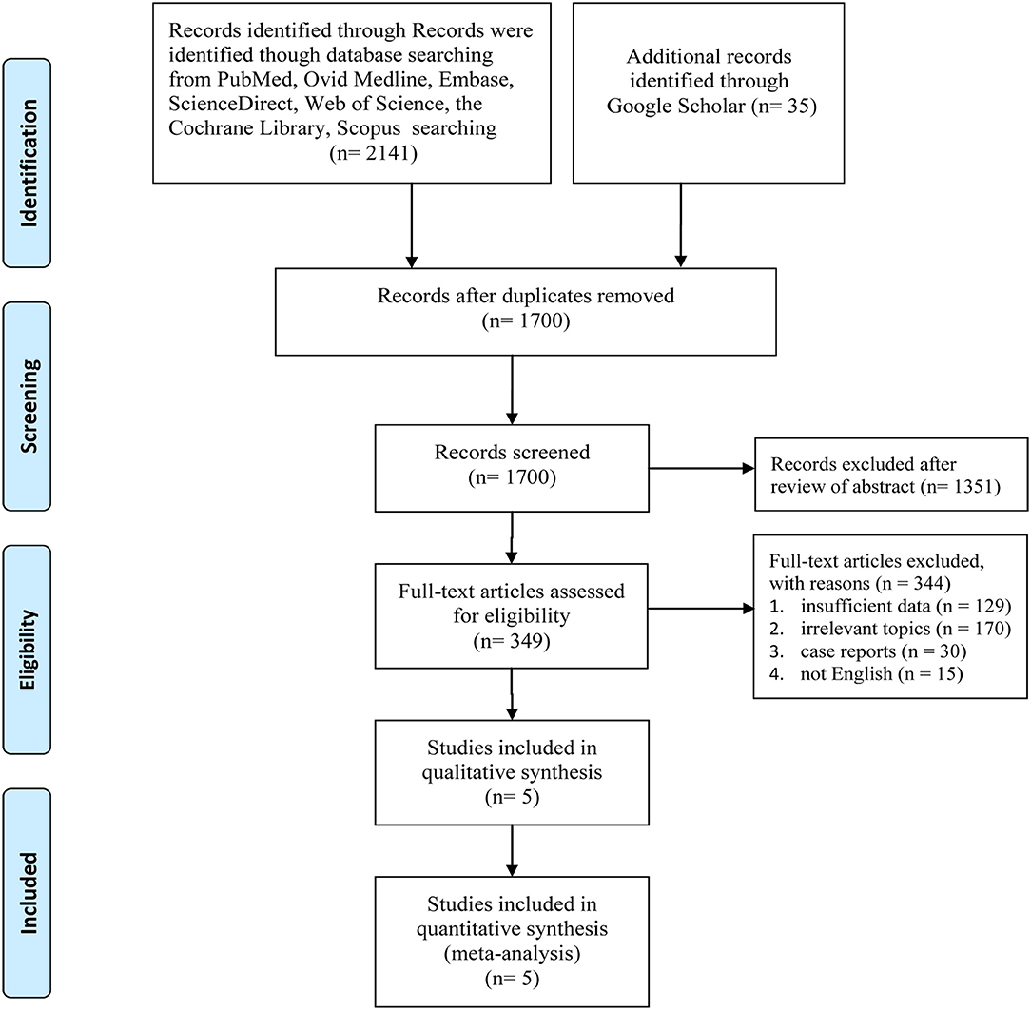The flow chart visually represents the step-by step process of the literature review, from the initial search to the final analysis .It showed the number of articles identified ,screened, assessed for validity and included in the review. While this process is effective in assuring a thorough and systematic review, it is not without limits. One example is dependence on published material, which may ignore unpublished research or grey literature. Because research with substantial findings are more likely to be published, this dependency may generate publication bias. Furthermore, excluding non-English literature may result in the omission of significant findings published in other languages.

4.Considerations of Ethical Practice in Research

Ethical research conduct is critical to academic integrity and credibility, particularly in health-related studies. This literature analysis on the association between breastfeeding length and breast cancer risk in women in the United Kingdom, contains ethical issues at many levels, including the examined studies and the review process itself. The research evaluated, which focus on the association between breastfeeding length and breast cancer in women in the United Kingdom, deal with sensitive health information.
It is critical that these research gain informed permission from participants while respecting their autonomy and dignity. Furthermore, the confidentiality of patient data in these research must be properly adhered to. This assessment thoroughly examined whether each study met ethical rules and instructions from UK health research ethics bodies. Although there is no direct human input in this literature evaluation, the process complies to ethical norms. It respects the authors' intellectual property rights of the original research by properly crediting and honoring their work, using the Harvard Referencing style.Furthermore, the review avoids plagiarism by giving a novel synthesis of the findings rather than just replicating the current literature. Evaluating the ethical compliance of the included research is a critical component of the assessment. This review is open about its limitations, which is consistent with ethical academic behaviour. The study selection criteria may cause selection bias, thereby omitting pertinent research. Furthermore, restricting the language to English may exclude significant ideas from non-English research.

5.Results:
In this systematic review on the relationship between breastfeeding duration and breast cancer risk in women in UK, a detailed search of relevant databases resulted in the numerous studies. There is no recent studies conducted in the United Kingdom .

By the nature of the examined pathology, all investigations are observational. Breast cancer risk is lower in women who have ever nursed compared to those who have never breastfed. This lower risk is most noticeable in postmenopausal women, although it also occurs in premenopausal women. It has also been discovered that as breastfeeding length increases, so does protection. Breastfeeding provides protection by causing breast cells to differentiate, reducing the number of ovulatory cycles, and excreting oestrogen and carcinogens through human milk. Breastfeeding is linked to a lower incidence of breast cancer, the health professionals must educate women about its benefits for themselves and their children.

Discussions:

Conclusion:
In conclusion, the literature review on the relationship between breastfeeding duration and breast cancer risk in UK women reveals a complex interplay between these two factors. The data set, which comprises a variety of study designs and approaches, sheds light on the potential preventative advantages of breastfeeding against breast cancer. A review of current data reveals that, while some evidence suggests a substantial inverse association between breastfeeding duration and breast cancer risk, the results are very diverse. Factors including as age at first birth, parity, and breastfeeding intensity impact variations in observed findings. Methodological variables such as research design and data collection methods show the intricacies of the connection. Despite these obstacles, the research shows that breastfeeding may play a role in lowering the incidence of breast cancer in women in the UK. Breastfeeding reduces the risk of triple-negative Breast Cancer(20%) and in carriers of BRCA1 mutations(22-55%)(National Library of Medecine,2022). The implications for public health are enormous. Breastfeeding promotion, integration of breastfeeding instruction into prenatal care, and workplace support for nursing moms appear as essential measures to enhance longer breastfeeding durations. Training for healthcare providers and the creation of targeted treatments for high-risk groups are crucial routes for converting research findings into practical health efforts. However, it is critical to approach these recommendations with caution, understanding the necessity for continuous study and the discovery of underlying processes. Longitudinal research, monitoring initiatives, and multinational partnerships are crucial for furthering our understanding of the association between breastfeeding and breast cancer risk.
Finally, while noting the complexity and variations in the current research, this review contributes to the continuing discussion over breastfeeding methods and breast cancer risk in women in the United Kingdom. As we manage these challenges, our collaborative efforts to encourage breastfeeding, assist moms, and advance rigorous research will definitely benefit both individual and public health outcomes in the field of breast cancer prevention.
Recommendations:
Initiatives to Promote Breastfeeding:
Implement and improve breastfeeding promotion programs and efforts to encourage and assist women in the UK to breastfeed for the recommended time.
If breastfeeding is related with a lower risk of breast cancer, encouraging and supporting breastfeeding can have both short-term and long-term advantages in terms of breast cancer risk reduction.
Include Breastfeeding Education in Prenatal Care:
Recommendation: Incorporate comprehensive breastfeeding education into prenatal care programs to ensure that pregnant moms are well-informed about breastfeeding's possible preventive benefits against breast cancer.
Rationale: Early education and assistance can have a favourable impact on breastfeeding decisions, leading to longer breastfeeding durations and possible health advantages.
Breastfeeding Support in the Workplace:
Recommendation: Advocate for and put in place workplace rules that assist nursing women, such as enough break periods and private areas for expressing breast milk.
Workplace assistance can help working moms breastfeed for longer periods of time by solving practical problems, potentially lowering the risk of breast cancer.
Healthcare Provider Education:
Recommendation: Improve the training of healthcare providers, such as obstetricians, midwives, and general practitioners, to provide evidence-based breastfeeding information and support.
Reason: Healthcare practitioners have a significant influence on mother breastfeeding decisions. Breastfeeding behaviours can be influenced positively by well-informed and helpful healthcare workers.
Longitudinal Research and Surveillance:
Support and carry out longitudinal research to study the association between breastfeeding length and breast cancer risk, taking into account varied demographics and potential confounding variables.
Continued study is necessary to increase the evidence basis, uncover causality, and comprehend how numerous factors may impact the observed link.
Interventions Designed for High-Risk Populations:
Recommendation: Create tailored interventions and support programs for people at increased risk of breast cancer, highlighting breastfeeding's possible protective effects.
The rationale is that tailoring therapies to specific populations, such as women with a family history of breast cancer, can be an effective risk-reduction strategy.
Public Health Recommendations:
Recommendation: Revise and distribute public health recommendations to include information on the association between breastfeeding and breast cancer risk, with a focus on the importance of breastfeeding, highlighting the significance of nursing for mother and baby health.
Rationale: Public health recommendations can impact public knowledge and healthcare behaviours, perhaps increasing breastfeeding rates and lowering the risk of breast cancer.
Further Research into Mechanisms:
Recommendation: Fund research to uncover the scientific factors behind the link between breastfeeding and breast cancer risk.
Justification: Understanding the processes at work might give insights into the paths via which breastfeeding may have protective benefits, influencing future preventative interventions.
International Cooperation and Comparative Research:
Encourage international collaboration and comparative research to evaluate differences in breastfeeding habits and breast cancer risk across nations and populations.
Justification: Comparative studies can aid in the identification of cultural and environmental elements that impact the observed connection, resulting in a more comprehensive understanding.
Public Awareness Campaigns Will Be Continued:
Recommendation: Continue and increase public awareness programs emphasizing breastfeeding's health advantages, particularly its possible involvement in lowering breast cancer risk.
Public awareness is a major motivator of health-related behaviours. Well-designed ads may educate the public and empower women to make educated breastfeeding decisions.
It is critical that these suggestions be implemented collaboratively and multidisciplinary, engaging healthcare professionals, policymakers, researchers, and community stakeholders. Furthermore, continual review and adaption of treatments based on emerging research are critical for guaranteeing their efficacy in promoting longer breastfeeding durations and potentially lowering breast cancer risk in UK women.

References:
1.Cancer Research UK(2021)
Available at: http://www.cancerresearchuk.org/donate
(Accessed:23rd November 2023)
2.Centers of Disease Control and Prevention(2023)Five Great Benefits of Breastfeeding
Available at : http://www.cdc.gov/nccdphp/dnpao/features/breastfeeding-benefits/index.html
(Accessed :23rd November 2023)
3.Collaborative Group on Hormonal Factors in Breast Cancer(2022)
Available at: http://www.ceu.ox.ac.uk
(Accessed :23rd November 2023)
4
.

