 |  | SAIMA Jalil HABIB

PROFILE

Passionate and with professional hospitality with over 3 years of experience in food service operations and production management. I have gained my leadership skills, productivity, quality assurance, culinary knowledge and management, communication skills with guest experiences, working in fast paced environment etc. Seeking to handle the Manager role at Arnabeet, London
SKILLS  - Team leadership and guest service excellence.  - Kitchen and food production management  - Food safety, hygiene, and allergy protection.  - High level of Communication and problem-solving skills.  - Quality control of the food and supplying management.  - Labor cost management.  OTHER SKILLS AND EXTRA CURRICULAR  - IT: MS Office Suite (including Word, Excel and PowerPoint).  - Fluent in reading, writing, and speaking Bangla, English and Urdu. |  |  | WORK EXPERIENCE  Production Supervisor [Full Time]- GREENCORE LTD, London, July/2024- Current  - Checking daily effectively kitchen operations including production planning, proper ingredients.  - Recipe development of the food, quality control check as usual.  - Understanding cooking techniques and presenting food in the teams.  - Managing supplier agreements, reducing food waste by 5%, controlling food cost by 6% of the sales.  - Maintaining food safety, also hygiene & allergen protocols, operating staff training and food preparing examinations.  - Inspiring the team leaders, maintaining well with high standards and guests with happy reactions.  - Learning strong culinary knowledge such as mediterranean cuisine.  - Checking the inventory management system.  Production Operative [Part Time]- Single Resource LTD, London, May/2022 – Aug/2024  - Working in multiple place and different work such as wrapping, packing, making sandwiches too in fast speed.  - Packing the food by maintaining checking of the quality in even fast speed.  - Passionate and gaining knowledge about the ingredients of each food.  - Have been worked for more than 3 years  - Good communicator and can handle several tasks.  RESTAURANT STAFF [Work Experience]- Wolk to Walk, London, February- 2022  - CUSTOMERS SERVED in eating places that specialized in fast service and inexpensive carry-out food.  - Accepted payments from customers and made change as necessary.  - Requested and recorded customer orders and computed bills using cash registers, multi counting machines, track food cost, and report about any bad circumstances.  - Prepared food, cooked and served with politely.  - Cleaned and organized eating, service and kitchen areas.  - Strong problem solver who can give good suggestion and motivate others.  ACHIEVEMENTS  - Learnt strong culinary knowledge and recipe of the foods.  - guest satisfaction score in the team since last year.  - Excellence hospitality award from all staff and team members.  - Experience for more than 3 years.

EDUCATION

- Studying CertHE Business skills for the workplace course in weekends- 2025
University of Wales Trinity Saint David
- Level 3 food hygiene- 2024
- Level 2 in English and Maths- 2023
- BTEC Level 1 in IT, English and Maths- 2022
- Studied IT course on Entry level 3 – 2021
Newham College Stratford Campus
- Secondary School Certificate- SSC (Achieved 4.50 on a scale of 5.00)- 2020
- Junior School Certificate- JSC (Achieved 5.00 on a scale of 5.00)- 2018
A.k High School and College.

HOBBIES

- Fitness Activities- Energy, discipline, stamina for busy life.
- Exploring Food Stalls- trying different cuisine and having food knowledge.
- Experimenting food recipes- From passion, trying to make homemade delicious food with the recipes.
- Organising Social Events- Attending on social events with friends for enjoyment.

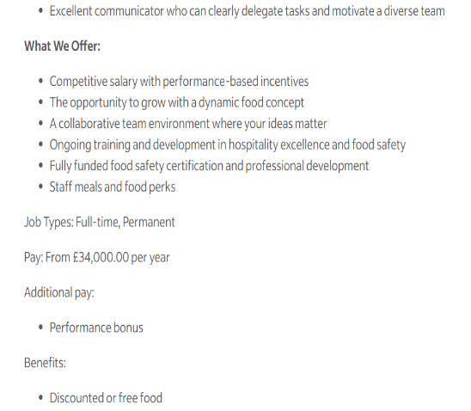
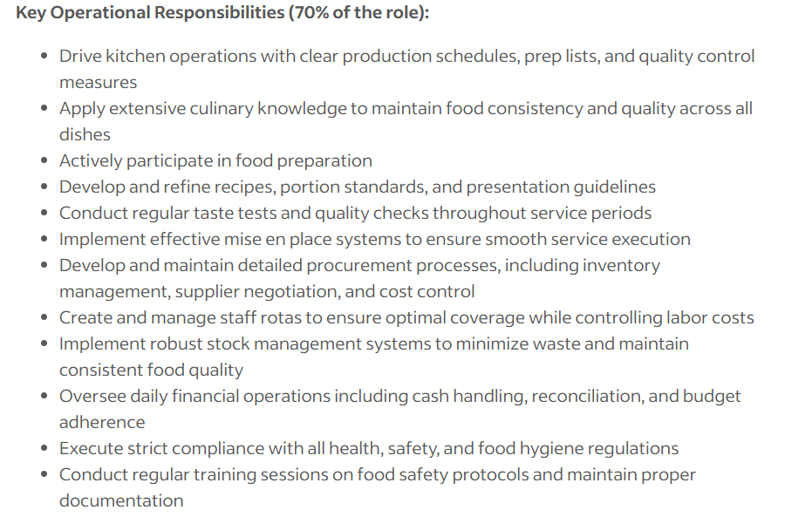
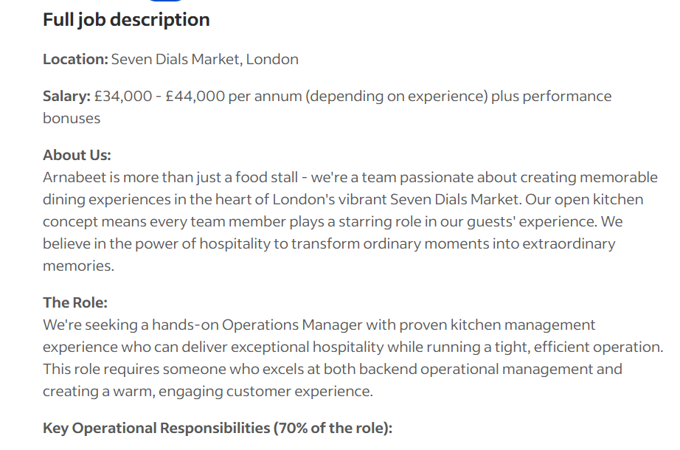
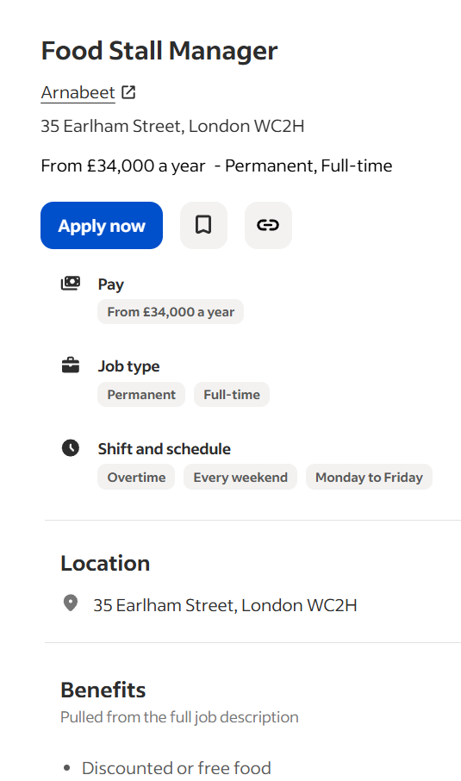
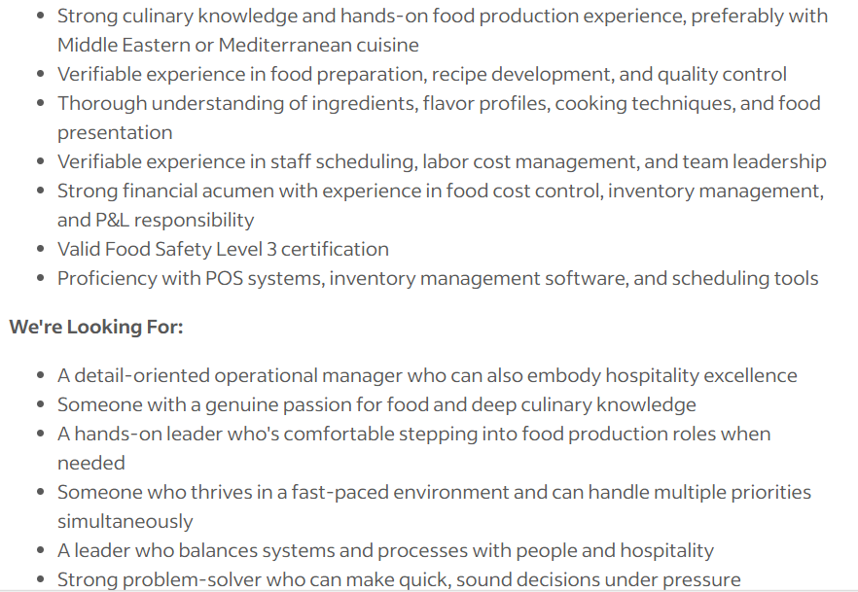
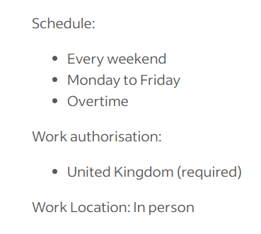
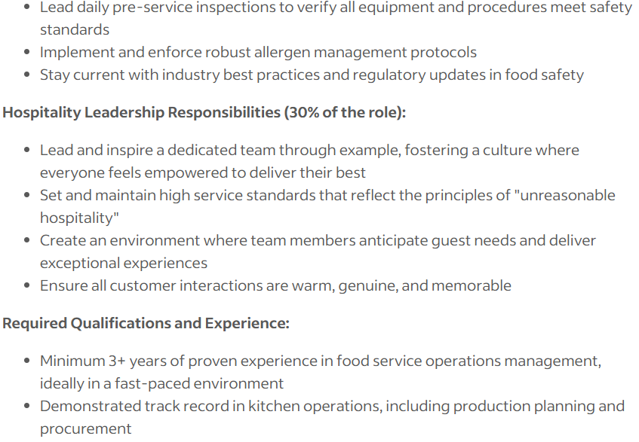

 | SAIMA Jalil HABIB
Contact  [Flat 39, Alfred Prior House, Grantham Road, London, E12 5NA] |  | Dear [Hiring Manager],  I am writing to express my strong interest in the Food Stall Manager position at Arnabeet (location- Seven Dials Market, London) as advertised. Moreover, having three years of experience in fast speed food service, great hospitality, a deep culinary knowledge, I am confident with my ability to contribute toyour team and deliver outstanding welcome services.  In My current job, as a supervisor at Greencore, working in production, I have led kitchen operations from planning and preparation by quality control and service. I have created systems for recipes, portion control and running efficiency. Also, I have achieved reductions in waste and improved food cost management. I have also been taking care of supplier negotiations, inventory management, scheduling of labour, and cost control.  The most curiosity thing that excites me about Arnabeet is the transformational power of hospitality as because it reminds me about my own philosophy. As I always love people and environment, doing hospitality is just my nature. With good experience in food production, inventory and cost control, strong leadership in communicating and hospitality, I am eager to bring my skills to the Food Stall Manager role at Arnabeet. I also have studied level 3 food hygiene, and I am efficient to handle the inventory management, scheduling tools.  I would love to wait for your response. I look forward to the possibility of interviewing with you.  Yours sincerely,  Saima Jalil Habib
[Hiring Manager]
[Arnabeet]
[35 Earlham Street]
[London WC2H]

