Extreme Sports Engineering E-Books
The following books are recommended for this module
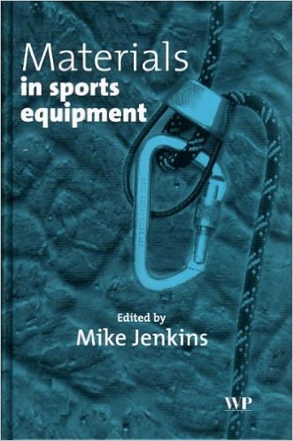
http://web.a.ebscohost.com/ehost/results?sid=591c0148-666d-4202-86cd-1b9b93da09fe%40sessionmgr4007&vid=0&hid=4207&bquery=(JN+%22Materials+in+Sports+Equipment%22)+AND+FT+Y&bdata=JmRiPXMzaCZ0eXBlPTEmc2l0ZT1laG9zdC1saXZl

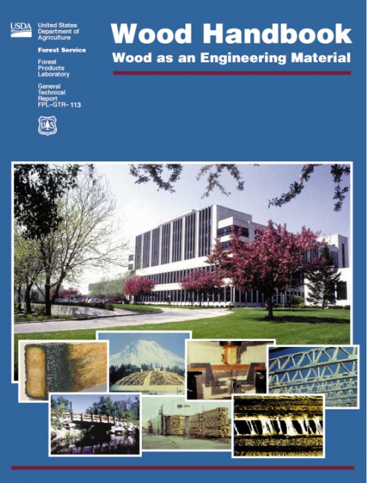

http://www.esf.edu/wus/documents/WoodHandbook-fplgtr113.pdf

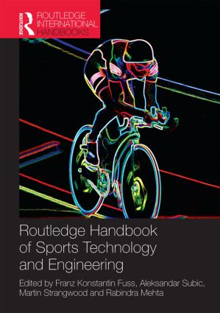
http://librarycatalogue.uwtsd.ac.uk/44WHELF_UWTSD_VU1:CSCOP_EVERYTHING:44UWTSD_ALMA21174169940002421 (Reference only)

