Dissertation Proposal



Name: Abdallah Sultan
Student Number: P148182
Module: Dissertation
Module Code: M3X9083
Lecturer: Mr. Ian Jackson
Date of Submission: 19th of November 2018

Table of Contents

1.Introduction 3
1.1Rationale 3
1.2 Aims and Objectives 4
1.3 Background and Literature Review 4
2.Research Design 5
2.1 Methodology 5
2.2 Philosophy 6
2.3 Research Approach 6
2.4 Research Strategy and Choice 7
2.5 Time Horizon 8
2.6 Sample 8
2.7 Data Collection Methods 8
2.8 Research Limitations 8
2.8.1 Time Management 8
2.8.2 Ethical Concerns 8
3.Reliability and Validity 9
4. Resources and Planning 9
4.1 Resources 9
4.2 Gantt Chart 10
6.References 11
7.Appendices 13
7.1 Appendix 1 13

1.Introduction

The research carried out will consider the consequences of making tax digital (MTD), which was implemented by the government in 2016. The research will solely look into the affect that this regulation will have on accounting firms in the Swansea area. The discoveries that are found will hopefully give some insight into how accounting firms are going to prepare for this change as well as adjusting their current processes to implement this change moving forward.

From April 2019, all businesses that have a turnover above the VAT threshold of £85,000 will have to submit their returns their returns digitally in accordance with MTD. Most businesses already file their returns electronically; HMRC (2018) backs this, stating that 92.8% of tax returns have been submitted online.

Despite the popularity of online tax filing, the MTD regulation will be implementing some further changes that are relatively substantial compared to the system that is currently in place (Downing, 2018).

According to Massie (2018), one of the main changes will be the termination of the government gateway portal, which is currently being used to submit tax filings. Third party software will be used to fill this void and will result in a more streamlined system that can be accessed very easily (Massie, 2018).

1.1Rationale

According to Thomas-Bryant (2018), the implications of the introduction of MTD will have a significant affect on accountants and bookkeepers. Wrightwhyte (2018) explains that despite the limited amount of time left until the MTD regulation is put in place, many accountants are not ready to advise their clients regarding this change nor do they fully understand the new system.

There is much literature on what MTD is and who must abide by this new law, however there is a lack of information regarding the affect this scheme has on accounting practices. By conducting thorough research on this topic, a critical analysis can be carried out on the implementation MTD.

The lack of literature as well as the lack of understanding of the topic is the main motivation for carrying out this research. The results may also prove useful to local and national accounting firms alike.

1.2 Aims and Objectives

The main aim of this dissertation is to assess and evaluate the affect of HMRC ‘s introduction of the new and digitalized regulation and how this affects accounting firms based in Swansea. In order to thoroughly research this topic, the following objectives will need to be thoroughly analyzed:

- To conduct research into the reason HMRC are implementing the making tax digital regulation.
- To identify the challenges, prospects and effects that making tax digital would have on the accounting firms based in the Swansea area.
- To make recommendations to accounting firms within the Swansea area to ensure the effective implementation of MTD.

1.3 Background and Literature Review

The new taxation regulation that is going to be implemented will be a major upgrade to the current tax system; it will essentially modernize the way in which tax is submitted and end the use of the self-assessment return. The main reason for the employment of this new regulation is efficiency; it will allow all taxpayers to submit their taxes via a quick and easy digital platform. This will therefore reduce costs for both the taxpayer and HMRC as there is much less administration involved (Thomson Reuters, 2018).

Underwood (2018) states the importance of the shift to digitalization, as it will force accountants to revaluate their relationships with their clients. The outcomes of MTD may result in clients adopting a digital relationship with their accountants; however, this will not always be the case.

According to HMRC (2018), the introduction of MTD is an essential step in ensuring taxes are submitted and handled correctly. Furthermore the main aim of this new system is to be the most advanced in tax administration.

Despite the advantages that come with implementation of MTD, there are some issues in terms of the adoption. According to the Chartered Institute of Taxation (2018), the time frame provided for MTD to be fully operational is very challenging; this is due to the software trials only being available until recently. This will only allow for a short period of training and testing times.

As HMRC will be implementing this new regulation, it is good practice to retrieve literature from either their website or any other publications they have released. Sources from the ACCA will also be investigated as they are a very well known and well-respected institute, publications by this accounting board will contribute positively towards the research carried out. In addition to this, the large accountancy firms also known, as the ‘Big Four’ will be researched, their opinions and their approaches to MTD will be thoroughly evaluated.

2.Research Design

2.1 Methodology

Kothari (2004) states that the main objective of research is to obtain answers to questions through the implementation of methodical processes and in turn to discover hidden truths. Creswell (2012) backs this by stating that research is a process that is carried out in stages in order to obtain and examine information which will ultimately increase the level of understanding of a given topic or issue. Generally it begins with posing a question, then collecting data in order to answer the question and finally presenting the answer to the question.

According to Ethridge (2015), there are many different forms of research design and each form can have countless variations, this means that each research design will be unique and it prove difficult to find two that are remotely identical. One effective method of conveying an efficient research strategy is the use of ‘The Research Onion’ designed by Saunders et al (2009).

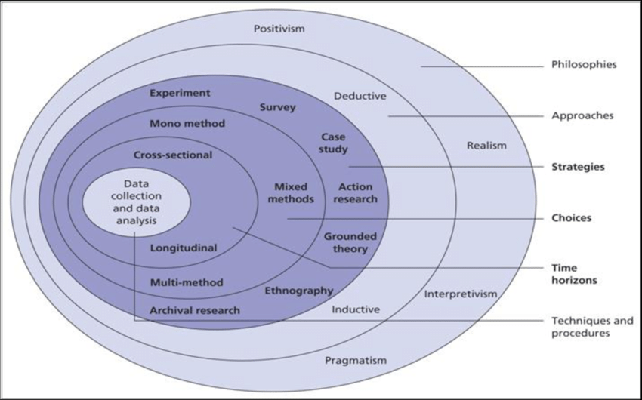
Figure 2.1 - The Research Onion. Source: (Saunders, et al., 2009)

As demonstrated in figure 2.1, the Research Onion is made of up multiple layers, hence the naming of the illustration. In order to create a clear and understandable research strategy, the Research Onion will be used. The headings mentioned outside the ‘Onion’ will be analyzed thoroughly in the upcoming sections.

2.2 Philosophy

As shown in Figure 2.1, the main philosophies are outlined in the outer layer of the Research Onion. The philosophies that will be used for the purpose of this research are positivism and interpretivism. Blaikie (2009) explains that positivism treats knowledge as an objective entity whereas interpretivism is subjective and regards knowledge as the interpretation of the collected data by consciousness.

Positivism is based on the notion that reality is external and objective. Hence, the subject under research must be examined using objective methods only without employing anything subjective e.g. intuition or reflection (Easterby-Smith et al, 2002). In effect positivists explain the behavior of the subject under research by identifying fundamental laws through observable reality. (Saunders et al, 2003; Easterby-Smith et al, 2002). Other main requirements are the maintenance of independence of the observer or subject and the fundamental questions of what, and how to study must be resolved employing objective and not subjective criteria.

According to interpretivism “reality is determined by people rather than by objective and external factors” (Easterby-Smith et al, 2002, p30). This is the case where the researcher is mainly interested in gathering insights into subjective meanings rather than concrete objective results (Saunders M and Tosey P, 2013).

The data for this project consists of questionnaires that will be handed out to accounting rims in Swansea, the interview that will be conducted with a partner of one of their firms and any journal or newspaper publications deemed relevant to the project at hand. Therefore, the data for this project is well structured and its impact is conducive to measurement processes. According to Simpson (2009) pragmatism is a mixture of positivism and interpretivisim and, while in effect positivism is the philosophy of choice, there is an aspect of interpretation involved.

2.3 Research Approach

The approach will be mixed, both deductive and inductive, as there are both quantitative and qualitative aspects to be taken into consideration. Qualitative research is centered in exploration and description (Patton, 2002) while quantitative research is around description and explanation (Johnson and Christensen, 2010). The difference between the two is that deductive theory is aimed at testing a theory whereas the other one formulates a theory on the basis of collected data (Hennink, Hutter and Bailey, 2010)

In this project the theory being tested is whether this measure is useful and acceptable by the actors involved. The theory to be formulated is the relationship between the pros and cons of the measure as function of firm size and scope of the businesses involved. In case of qualitative aspects the method of Qualitative Content Analysis will be used as illustrated in figure 2.2.
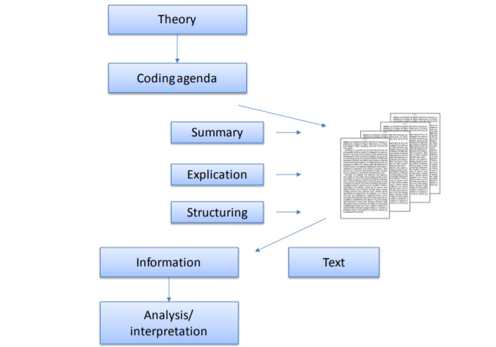

Figure 2.2 – Method of Qualitative Content Analysis (Kohlbacher, 2006)

2.4 Research Strategy and Choice

Saunders, et al., (2009) explains that the research strategy is the general plan of how the researcher will go about answering the research questions. As illustrated in figure 2.1, there are multiple methods available to collect primary data. During this research both questionnaires and interviews will be carried out as these two data collection methods fall under the survey heading within the research and onion.

According to Hair et al., (2011) the collection of quantitative data provides the researcher with numerical information through the use of questionnaires; this is also known as survey research and is the most effective method when gathering information on a large number of individuals. The use of questionnaires will be implemented in order to obtain statistical data regarding the effect of MTD on accounting firms. This section of the research will mainly target the accountants dealing with the tax filings.

Myers (2013) states that the purpose of qualitative data is to aid researchers into understanding the social and cultural environments in which people live, it provides context to the actions carried out by a person in a given scenario. In essence qualitative research is the best choice to understand the reasons behind the motivations and actions of a particular individual.

In order to compliment the numerical data collected through questionnaires, a qualitative approach will also be implemented through the use of interviews. As mentioned above it will give more rich and detailed data. The interviews will be aimed at managers and partners working in the field of accountancy.

2.5 Time Horizon

The study will implement a cross-sectional approach, as most of the samples will be studied in a multiple cross sectional manner. The measure under examination refers to the future and has no past application to be examined; therefore the approach is not longitudinal. This method will allow the comparing of data to be efficient.

2.6 Sample

The sample is the number of questionnaires that are carried out. The total sum of the Swansea accounting firms will be approached via questionnaire and there is no realistic determination of sample or sampling technique in this instance. The list of accounting firms based in the Swansea area is shown in the appendix 1.

2.7 Data Collection Methods

According to Hesse-Biber (2010), a mixed method involves the implementation of a research design that covers both quantitative and qualitative aspects.
This study intends to collect data primary data through the use of questionnaires, which produce quantitative data and interviews, which produce qualitative data.

2.8 Research Limitations

2.8.1 Time Management

One of the main factors to adhere to is time. This is an important factor as it could affect the quality of the research as well as its evaluation. The research is based on accounting firms within the Swansea area, as there are not many accounting firm in Swansea, the amount of time taken to provide these establishments with the surveys will be very minimal.

An issue to consider would be that there is no guarantee that the response rate will be 100% and therefore the results may not provide an accurate representation of the subject at hand.

2.8.2 Ethical Concerns

There is no particular ethical issue relating to this research. The surveys that have been constructed will be sent to managerial and non-managerial staff at accountancy firms within the Swansea area. All participants will be above the age of eighteen and the information collected will be stored confidentially.

3.Reliability and Validity

According to Schensul et al. (1999), reliability and validity are both derivatives of the positivist research philosophy. Bruce further explains that reliability represents the reliability of the obtained results over time, whereas validity is the measure of what research think their results indicate and whether these results can be applied to different populations. The outline of this research purposes that the reliability and validity factors pertain to questionnaires and interviews respectively.

It is important that the results obtained during this research are both valid and reliable. This can be achieved through carrying out research consistently and minimizing any potential variable factors.

4. Resources and Planning

4.1 Resources

The resources available will mainly assist in acquiring secondary data. This can be done through the use of electronic and hard copies of books, journals and reports as well as reputable websites.

According to Vartanian (2011), the use of secondary data is advantageous as the sample size and the amount of data collected is much higher than primary data, additionally the data collected from secondary sources tends to be over a longer time period which providers an aspect of reliability.

Vartanian (2011) explains that secondary data can cause an issue in terms of the specificity of the questioned posed. For the purpose of this dissertation, a very specific question is being presented. The likelihood of acquiring secondary data that will directly answer questions relating to this research topic is very low. It is therefore important to use an element of both primary and secondary data in order to critically analyze the subject in question.

4.2 Gantt Chart

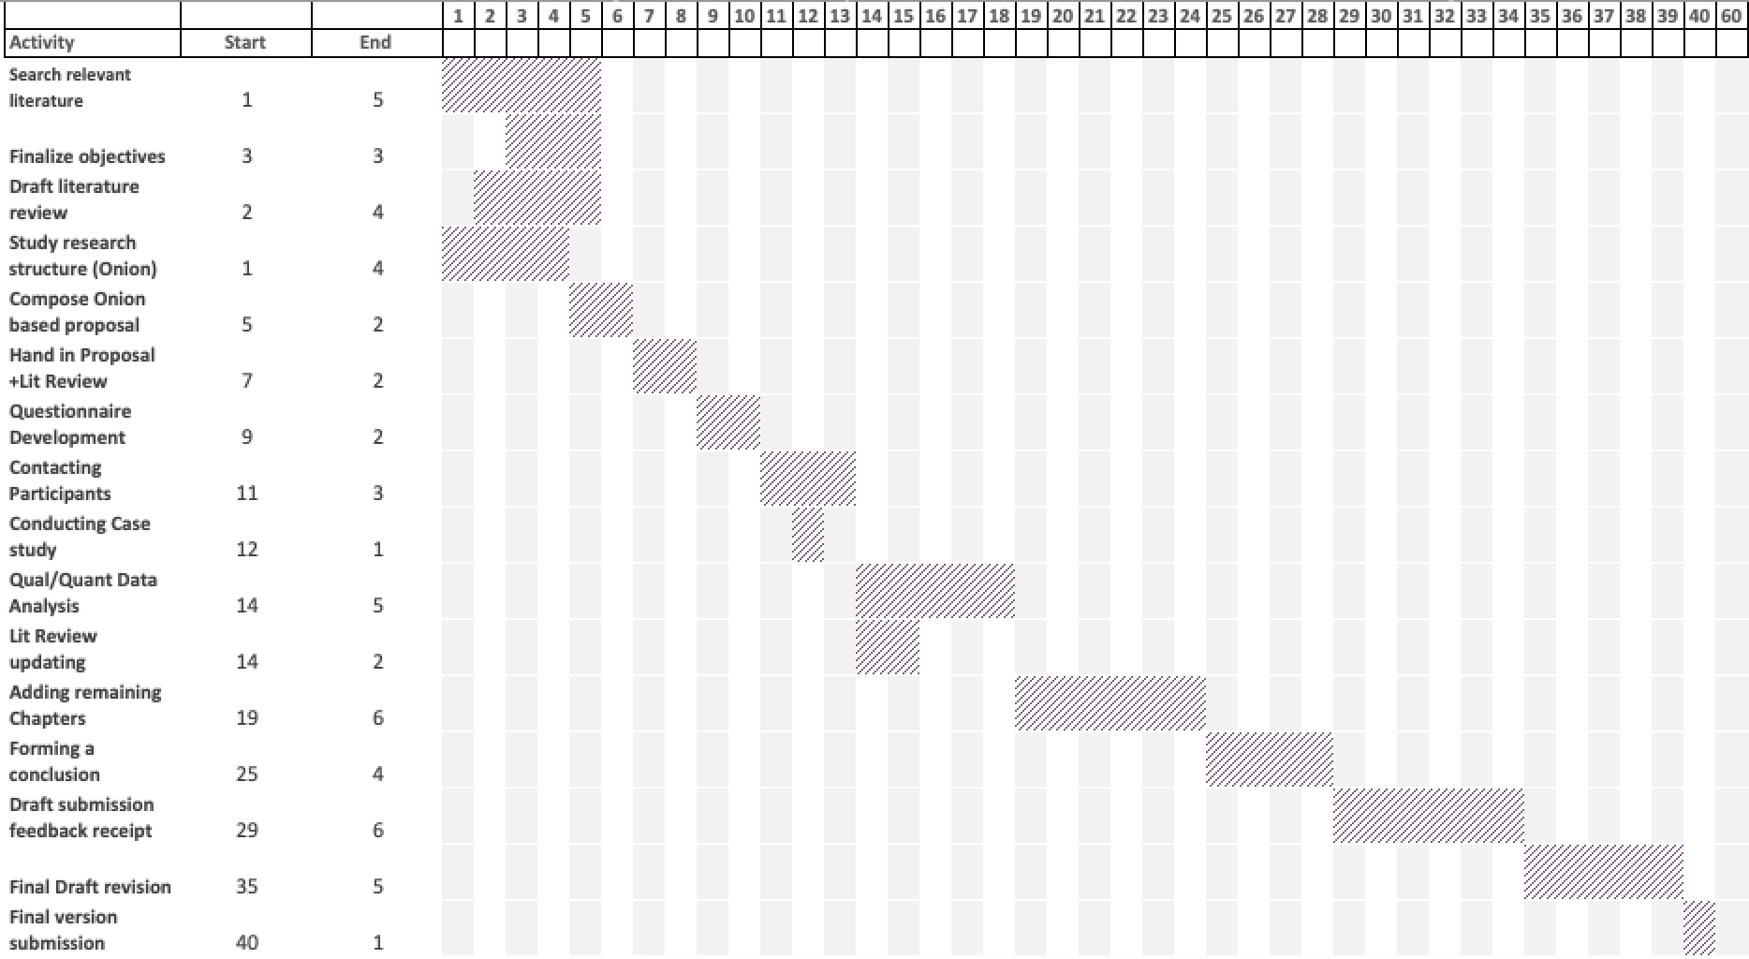

The Gantt chart above illustrates the horizontal timescale. The horizontal timescale units, which are approximately half a week, are shown along side the activity. The start date of the research is the 10th of October and this runs through to the 14th May. This gives 216 days to complete the dissertation in full.

6.References
Blaikie, N. (2009) Designing social research. Cambridge: Polity Press.

Collis, G. and Hussey, R. (2017) Business Research: A Practical Guide for Undergraduate and Postgraduate Students. 4rth edn. MacMillan Red Globe Press.

Creswell, J. (2012). Educational research: Planning, Conducting, and Evaluating Quantitative and Qualitative Research. 4th ed. Boston: Pearson, p.3.

Downing, C. (2018). Making Tax Digital for VAT. [online] KPMG. Available at: https://home.kpmg.com/uk/en/home/insights/2018/07/making-tax-digital-for-vat.html [Accessed 6 Nov. 2018].
Easterby-Smith, M., Thorpe, R. and Lowe, A. (2002). Management research. 2nd ed. London: Sage Publications, p.30.

Ethridge, M. (2015). The Political Research Experience: Readings and Analysis. 3rd ed. New York: Routledge, p.20.

Hair, J., Celsi, M., Money, A., Samouel, P. and Page, M. (2011). Essentials of Business Research Methods. 2nd ed. New York: M.E. Sharpe, p.197.

Hennink, M., Hutter, I. and Bailey, A. (2010) Qualitative research methods. London: Sage.

Hesse-Biber, S. (2010). Mixed Methods Research: Merging Theory with Practice. New York: Guilford Press, p.3.
Johnson, R. R. B. and Christensen, L. B. (2010) Educational research: Quantitative, qualitative, and mixed approaches. 4rth edn. Thousand Oaks, CA: Sage Publications.
Kohlbacher, F. (2006) ‘The Use of Qualitative Content Analysis in Case Study Research.’, Qualitative Sozialforschung, 7(1).
Kothari, C. (2004). Research Methodology: Methods and Techniques. 2nd ed. New Delhi: New Age International, p.2.
Massie, L. (2018). Making Tax Digital - 5 benefits for your business. [online] Castle Computer Services. Available at: https://www.castle-cs.com/blog/11/09/2018/5-making-tax-digital-benefits-for-your-business/ [Accessed 15 Nov. 2018].
Myers, M. (2013). Qualitative Research in Business & Management. 2nd ed. London: Sage Publications, pp.5-6.

Patton, M. Q. (2002) Qualitative research and evaluation methods. Thousand Oaks, CA: Sage Publications.
Robson, C. (2002) Real World Research. 2nd edn. Oxford: Blackwell.
Saunders, M., Lewis, P. and Thornhill, A. (2009). Research Methods for Business Students. 5th ed. Essex: Pearson Education.
Saunders M & Tosey P, ‘The Layers of Research Design’ (2013) <https://www.academia.edu/4107831/The_Layers_of_Research_Design> accessed 16 November 2018

Schensul, S., Schensul, J. and LeCompte, M. (1999). The Ethnographer's Toolkit. Walnut Creek: AltaMira, p.271.
Simpson, B. (2009) ‘Pragmatism, Mead and the practice turn.’, Organization Studies, 30(12), pp. 1329–1347.
Tax.org.uk. (2018). Making Tax Digital for VAT - Main issues for consideration | Chartered Institute of Taxation. [online] Available at: https://www.tax.org.uk/policy-technical/technical-news/making-tax-digital-vat-main-issues-consideration [Accessed 12 Nov. 2018].

Thomas-Bryant, K. (2018). Making Tax Digital for accountants | Sage Advice UK. [online] Sage Advice UK. Available at: https://www.sage.com/en-gb/blog/making-tax-digital-accountants-now/ [Accessed 10 Nov. 2018].
Thomson Reuters. (2018). What is Making Tax Digital (MTD)? What is Digital Tax?. [online] Available at: https://tax.thomsonreuters.co.uk/making-tax-digital/what-is-making-tax-digital/ [Accessed 7 Nov. 2018].
Underwood, K. (2018). Are you ready for digital client relationships? | ACCA Global. [online] Accaglobal.com. Available at: https://www.accaglobal.com/ca/en/member/member/accounting-business/2018/06/practice/client-relationships.html [Accessed 11 Nov. 2018].

Vartanian, T. (2011). Secondary Data Analysis. New York: Oxford University Press, pp.13-15.
Wrightwhyte, K. (2018). Almost half of all UK accountants do not understand Making Tax Digital | Accounts and Legal. [online] Accountsandlegal.co.uk. Available at: https://www.accountsandlegal.co.uk/small-business-advice/-making-tax-digital-accountants [Accessed 11 Nov. 2018].
www.gov.uk. (2018). On-time Self Assessment returns break the record again. [online] Available at: https://www.gov.uk/government/news/on-time-self-assessment-returns-break-the-record-again [Accessed 14 Nov. 2018].
www.gov.uk. (2018). Overview of Making Tax Digital. [online] Available at: https://www.gov.uk/government/publications/making-tax-digital/overview-of-making-tax-digital [Accessed 16 Nov. 2018].

7.Appendices

7.1 Appendix 1

List of accounting firms within the Swansea area:

Morgan Hemp & Co
Butterfield Morgan Ltd
Clive Atkins & Co Limited
Bevan Buckland LLP
HR Harris & Partners
Cross & Bowen
Owen John & Co Ltd
WBV Ltd
McAlister & Co Insolvency Practitioners
Down Gordon
Assurance Accountancy
DRP & Co Accountants
Conte Davies
Willis Jones Accountants
MHA Broomfield Alexander
Gerald Thomas

