Gower College Swansea

HND in Electrical and Electronic Engineering

Electrical and Electronic Principles

Transistor as an amplifier

Logan Roberts

ROB24876064

Contents page
Introduction: page 3
Objectives: page 4
Different Transistor configurations: page 5
Components in a common emitter transistor circuit: page 7
Circuit theory calculations: page 9
Circuit simulation and their test results: page 12
Voltage gain calculations: page 13
2 stage amplifier calculations: page 14
Building Single Stage Amplifier on a breadboard: page 17
Evaluation: page 22
Conclusion: page 23
Equipment required: page 24
References: page 25

Introduction

This report will start off by looking at the 3 different types of transistors before moving on to explaining what components are used and what they do. This report will then show the calculations for all the resistor values for both the single stage and the two-stage amplifier. I will be using a common emitter circuit. I will then build my circuit on a simulation software and by doing this it will show the voltage gain of the correct value that is needed for this assessment. This report will also see and explain the outcome of the results by adding somethings called a bypass capacitor.
Next, I will then make the 2-stage amplifier as I mentioned above, this will show us why adding bypass capacitors are vital while making a 2-stage amplifier. Next, I will show me building the circuit on a breadboard and explaining why the results are slightly different from the ones on the simulation software.

Objectives

This assignment's primary goal is to design a single-stage transistor amplifier circuit that satisfies the given performance specifications. This includes choosing the right transistors, doing design calculations, and creating a schematic. Next, simulate the design and assess the important parameters with Multisim. After that is demonstrated, the design will be expanded to a two-stage amplifier for improved performance, requiring component modelling and computation.
The selection of components while taking cost, availability, and dependability into account will be the second goal. Next, to analyse simulation data and optimise the design to evaluate the quality of the design.
The third goal entails designing the circuit for a single-stage transistor amplifier on a breadboard and connecting it to a multimeter to observe how the simulation software's prototype and the total voltage gain values coincide.
Writing a thorough report with computations, schematics, simulation results, and research findings will be the goal. It will highlight IT abilities, critical thinking, and communication while exhibiting presentation skills through efficient organisation, formatting, referencing, and adherence to academic traditions.

Different Transistor configurations

One of the three transistor configurations that can be utilised in an amplifier is the common base arrangement. The base in this arrangement will be linked to the input and output terminals. Expect to observe a high current gain and a modest voltage gain in this setup; these are often used as an impedance buffer and for low voltage amplification. Despite being less prevalent as an amplifier than the more widely used common emitter (CE) or common collector (CC) configurations, the common base configuration is nevertheless in use because of its special input/output qualities. AspenCore (2024) This book was especially helpful because it clarifies how common this configuration is and how it functions. Due to its high frequency response, the common base arrangement is primarily utilised in single stage amplifier circuits, such as radio frequency amplifiers and microphone pre-amplifiers. (Electronics course, 2024)
The emitter terminal of a transistor arranged in the common emitter configuration is shared by the input and output signals. In this instance, the emitter is wired common to both the collector and the base terminal of the transistor, which serve as the input and output, respectively. (Stagatem, 2024) The typical emitter configuration's primary features are a raised output resistance, a moderate input resistance, and a high current gain. Because of this, this arrangement is well-liked for higher voltage amplification. Due to its great use in achieving a significant current gain, the common emitter configuration is one of the most popular transistor configurations.
A voltage buffer is provided by a single-stage bipolar junction transistor (BJT) amplifier, sometimes referred to as an emitter follower or common collector amplifier. It is especially well-suited for impedance-matching applications due to its high input impedance and low output impedance. The base terminal receives the input signal in this setup, whereas the emitter terminal receives the output signal. Interestingly, the input and output circuits share a same connection with the collector terminal. Although there is no voltage gain with this setup, there is current gain, which results in power gain. Reducing the consequences of impedance loading is its main goal. (Fiore, 2022) Similarities exist between common emitter and collector transistor variations. as both can be utilised to achieve high current gain when required.

Capacitors in a common emitter amplifier- Circuits for both single- and multi-stage amplifiers require capacitors because of their ability to store and release voltage, or electrical energy, into the load as needed. They're frequently referred to as coupling capacitors. They function by charging the load with a voltage greater than the initial input voltage, which raises the amplitude of the signal, and by amplifying the initial voltage signal by releasing the stored energy into the load. The main function of capacitors in filter circuits is to either selectively block or permit particular frequency ranges. They are employed in many different applications, including power supplies, audio systems, and communication equipment, to guarantee appropriate signal processing and get rid of noise and interference. (Magnetism - Electricity, 2024) In multistage amplifiers, the primary function of these coupling capacitors is to prevent the DC offset from moving on to the next stage.

Resistors- According to (Mercer, 2020), if there is a precise ratio between R1 and R2, the values of the two don't matter. They're often referred to as biassing resistors. It is possible for RL to be expressed as the impedance, or Z, rather than as a fixed value. In this case, RC can be made equal to the load to cancel each other out. This is known as balancing the load and it is done to maximize the efficiency and performance of the system. The voltage values across the biasing resistors (R₁ and R₂) can be worked out using the Voltage divider rule, the value at R₂ is the same as the voltage value across the Base of the transistor V_{B}.

Calculations
𝑉_{CC} = 12𝑉
ℎ𝑓𝑒 = 𝛽 = 100
𝑉_{be} = 0.7𝑉
𝐴_{V} = 5
Impedance=RL=600Ω

$$VC= \frac{Vcc}{2}$$
$$=\frac{12}{2}= 6V$$
The first step is to find V_{C} this is done by dividing the input (V_{CC}) by each part of the circuit (2)
$$RC=RL=600Ω this will give max power transfer$$
$$Ic = \frac{Vc}{Rc}= \frac{6}{600} = 0.01A , Ic = \frac{Vc}{Rc}= \frac{6}{600} = 0.01A$$
I_{C} can then be found using ohms law by placing the V_{C} voltage over the resistance at R_{C}.

$$Ib=\frac{Ic}{}= \frac{10x{10}^{-3}}{100}= 100uA$$
The next step is to determine the current flowing towards the transistor's base terminal, which may be done by utilising the method above, where IC is the 10mA that was determined using the previous equation and β = 100.
$$Vgain =5= \frac{Rc}{Re}$$
$$5=\frac{Rc}{Re}$$

$$Re= \frac{600}{5} = 120 ohms Re= 120 ohms$$
The next value to find would be the Resistance for Re. This can be done by dividing the resistance at RC by the required voltage gain (5V) this gives us the value of 120Ω.
I₂=10 I_{b,}
I₁=11 I_{b}
You can then locate I1 and I2. The current in a single stage amplifier circuit is assumed to be 11 times greater across I1 than across the transistor's base, and 10 times more across Ib. For this reason, the equations (10Ib and 11Ib) are utilised.
$$Ic=Ie$$
$$so Ie=10mA$$
$$Ve = Ie x Re = 10x10^-3 x 120 = 1.2V$$
$$VR2 = Ve + Vbe = 1.2 + 0.7 = 1.9V$$
$$VR1 = Vcc – VR2 = 12 – 1.9 = 10.1V$$

$$R1 = \frac{10.1}{11x{10}^{-4}}= 9181 ohms or 9.181k ohms$$
$$R2 = \frac{1.9}{10x{10}^{-3}}= 1900 ohms or 1.9k ohms$$

Finally, we can calculate the resistance values across R1 and R2 using Ohm's law. To do this, divide the voltage across each resistor by the current flowing through it at that moment. After they have been determined, the values of the four resistors can now be simulated using CAD (Computer Aided Design) software to verify the voltage gain obtained from them and to determine whether the values are accurate. R₁=9181Ω

Circuit simulation and their test results.
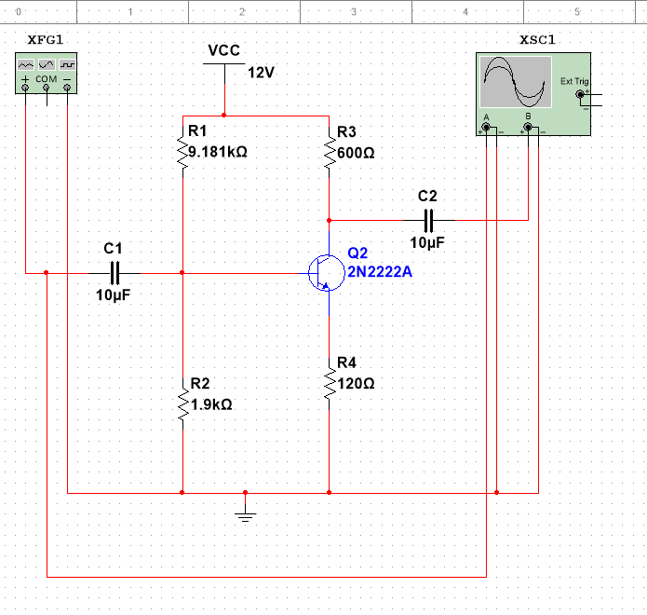
The Multisim layout of the design is seen in the image above. R1 and R2 serve as the circuit's biassing resistors. Since the capacitors are only coupling, they were set to a typical 10uF. They are employed to stop the bias of the AC voltage source from interfering. Since the 2N2222A transistor can handle very little current, it was chosen. After that, the circuit's digital oscilloscope was connected to measure the input and output voltages and determine the total voltage gain.
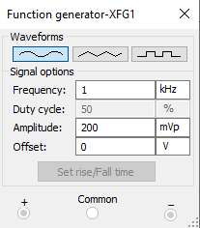
To supply the AC input signal to the amplifier and to provide us with the input signal that the oscilloscope could read, we needed a function generator. Its frequency was set to 1kHz (1000Hz), and its input signal's amplitude was set to 200mVp. Since the signal is AC, a sine wave was selected as the waveform.

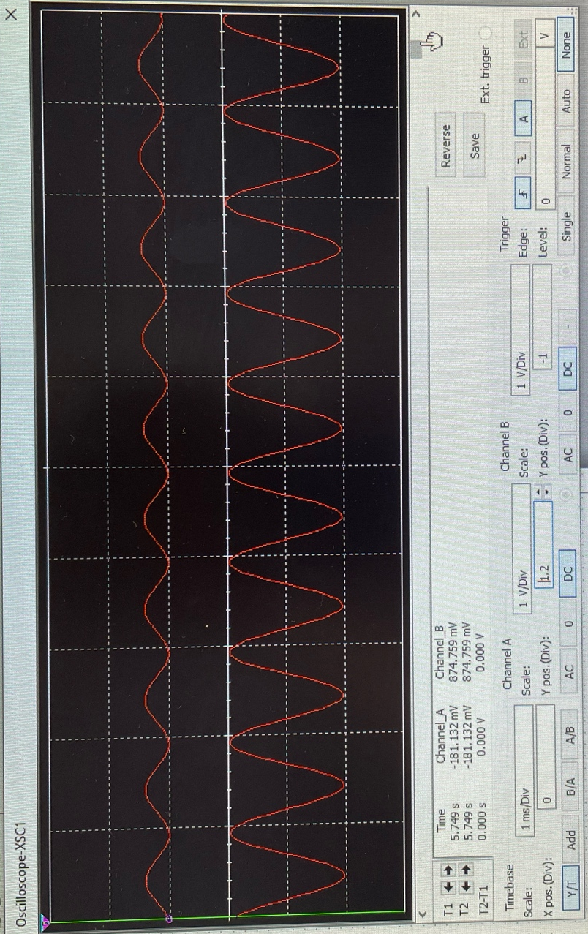
These were my results for the first stage amplifier, this shows that the gain of 5V is correct and it matches up to what I needed to do for this assessment.

Voltage gain calculations
By counting the number of boxes, the signal filled on the oscilloscope, the voltage gain was determined. Upon filling little more than 1.5 boxes, the scale was adjusted to 500 mV/Division. The input's calculation would be as follows:
$$1.6*500mV/division$$

Because the scale was set to 2V/Division, the output could be measured in the same manner. The computation would be:
$$2*2V=4V$$

It was necessary to convert the output into millivolts prior to solving the voltage gain equation. To do this, the 4V was multiplied by 1000.
mV= $4*1000=4000mV$

The final step is to calculate the circuit's overall voltage gain, which is obtained by dividing the output voltage by the input voltage, yielding the necessary 5 volts of voltage gain.
$$Voltage gain= \frac{4000}{1.6*500}=5$$

The resistor calculations yielded precise numbers. This is demonstrated by the computations performed by analysing the input and output signals using an oscilloscope to determine the difference. The voltage gain of +5 volts is the difference.

Adding a bypass capacitor made no difference in the single stage amplifier as the output and the signals all stayed the same.

2 stage amplifier calculations

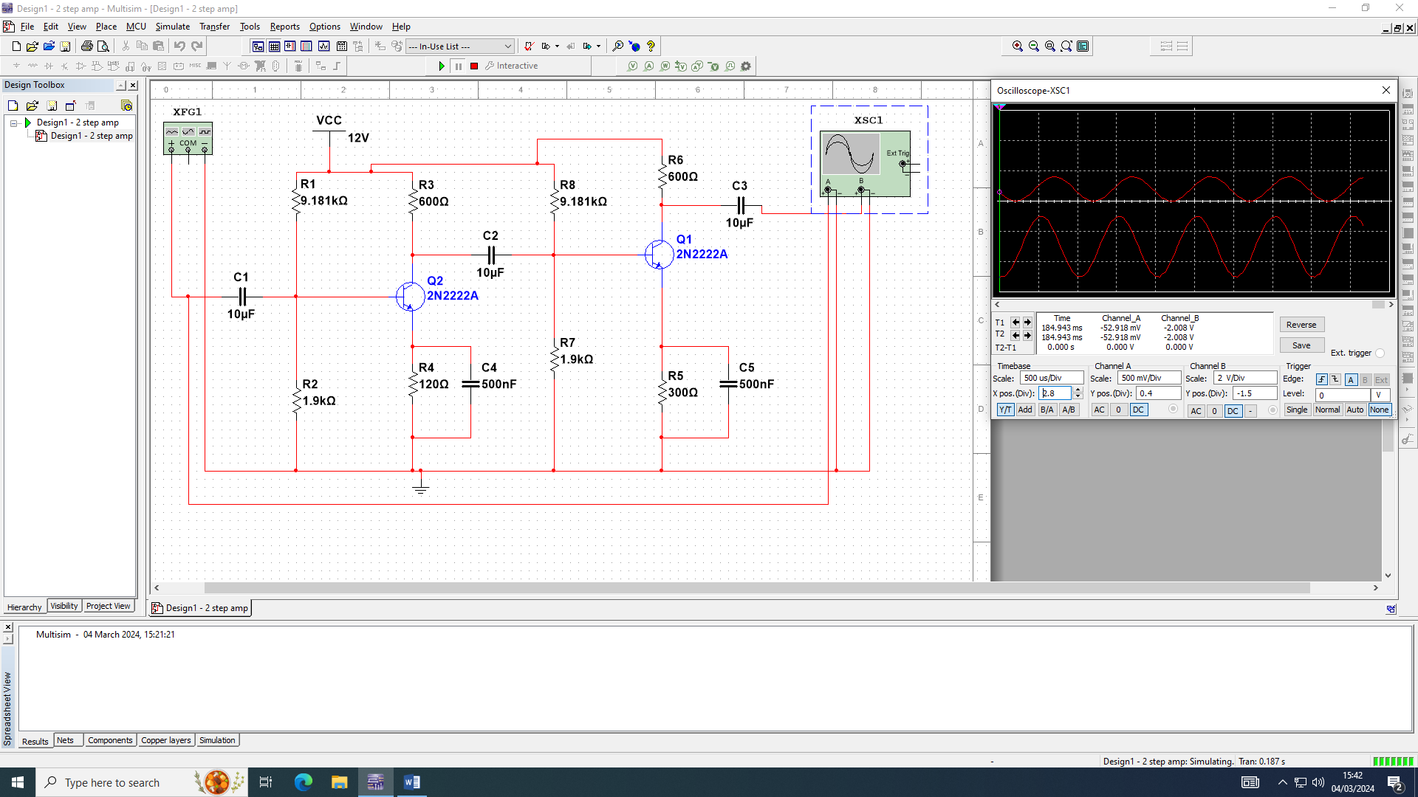
Using Multisim, the two-stage common emitter transistor amplifier shown above was created. It makes use of the first stage's single stage amplifier and adds a second stage consisting of a transistor and four additional resistors. For this one, it has a coupling capacitor at either end of the entire circuit and uses one between each stage. Since R1 and R2 are merely biassing resistors, their resistor values stayed the same and didn't need to be changed. Because the second stage only required a gain of two to double the output voltage to ten, the load (RC) remained the same, and the only variable was the resistance (RE). Thus, the RE value at 300Ω was obtained by dividing the RC value by two.

The function generator's readings for the two-stage amplifier were left unchanged since it was producing the input signal and didn't require modification.

The same scale from the single stage amplifier was applied to the oscilloscope readings on the two stage amplifier. The output signal was different because the circuit included an extra stage, but the input signal stayed the same because it had not changed.
$$Voltage gain=\frac{Output }{Input}=\frac{\left(2.8*3\right)*1000}{1.6*500}=7V$$

The Output given was only 7V this was different to the 10V gain that it should have been emitting however, this can be resolved by adding bypass capacitors in parallel with the RE resistors in both phases.

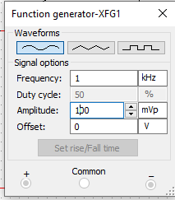
Because maintaining the amplitude at 200 was overwhelming the circuit and significantly altering the output waveform, the function generator's amplitude was cut in half to 100 mVp.

Building Single Stage Amplifier on a breadboard.

The last task for this assignment is to create a single stage amplifier circuit on a breadboard using the 4-resistor layout. The resistors used are from the E12 series of resistors, this means that the values calculated may be different form the ones used to build the circuit.

Using the resistors from this series gave me the values of R1=10kΩ R2=1.8kΩ RC=680Ω RE=120Ω. When using these resistor values, I still got the required gain of +5V.

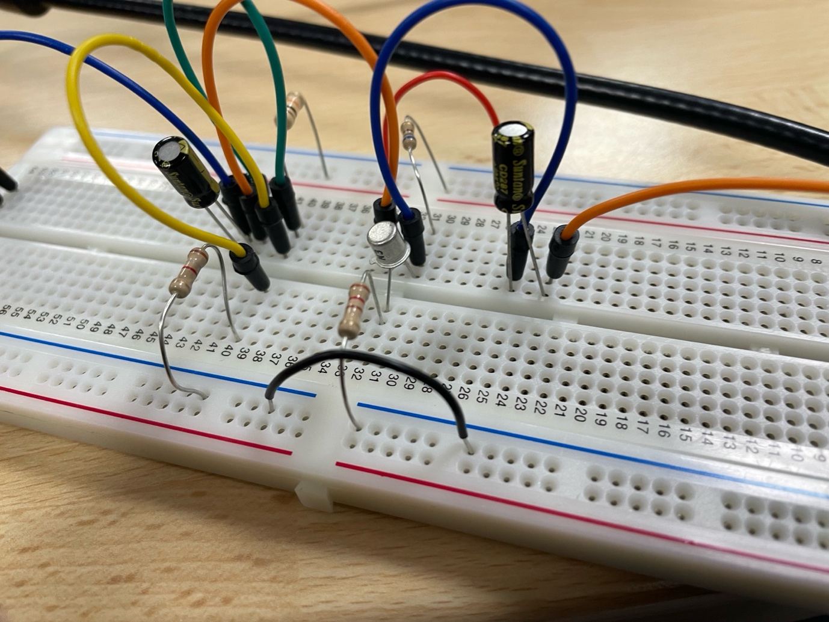

The circuit displayed above was constructed using the same design schematic that was designed and simulated on Multisim, utilising the provided parameters. It used two voltage sources to generate the input voltage: a 200mV supply from the function generator and a 12V DC supply. The simulation appeared to function well using 10uF coupling capacitors.

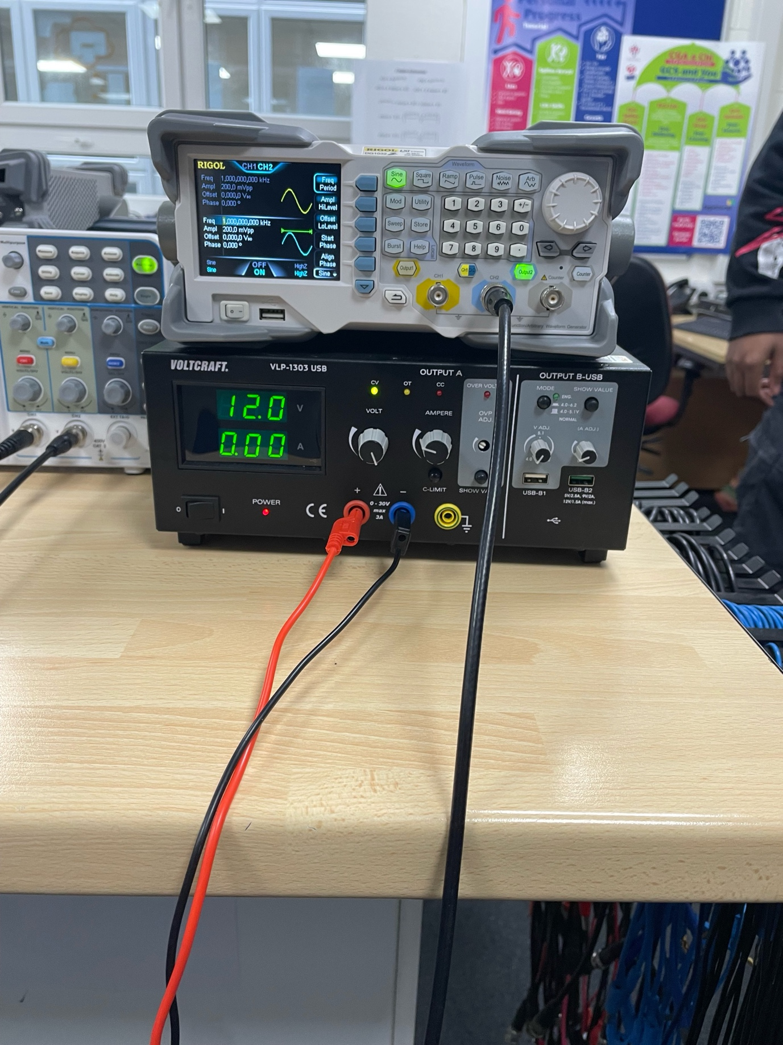

Both the power supply and the function generator used the same values as the ones on multisim.

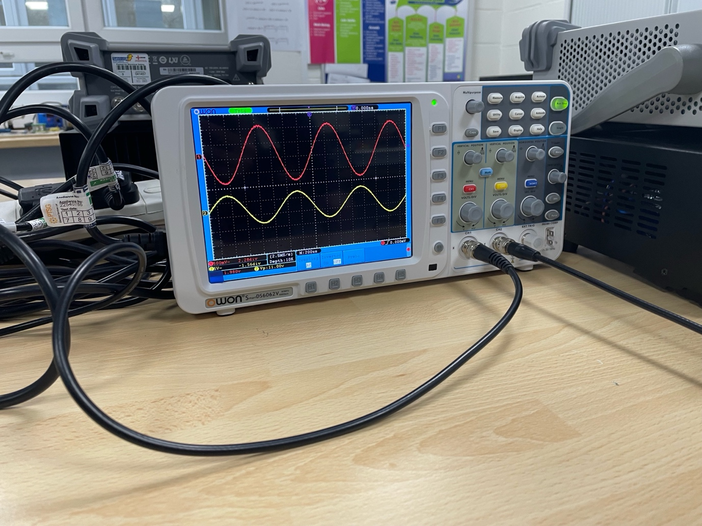
When the input and output waves on the oscilloscope above are calculated, the results show the same 5V gain. These readings match the ones in Multisim.

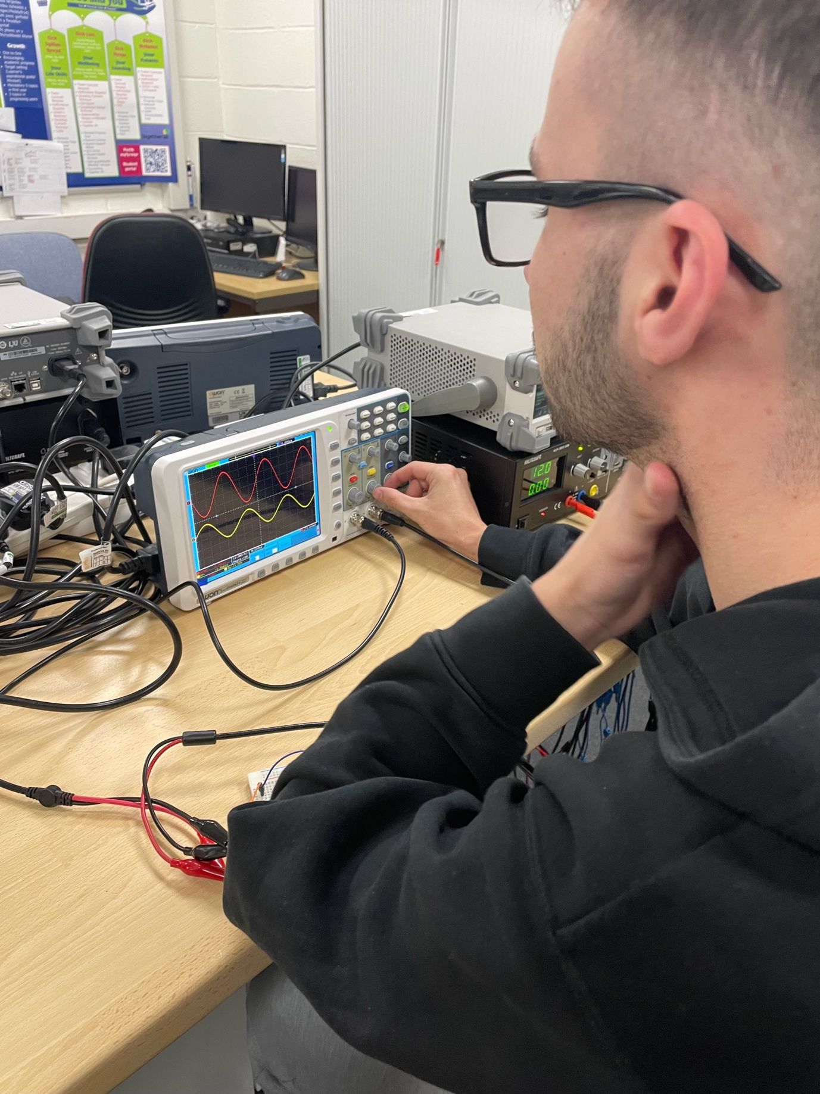

Evaluation

I was able to design the circuit for the single-stage amplifier after figuring out all the numbers required for the four distinct resistors. Despite not having a bypass capacitor to provide a further power boost, the initial design produced the intended output of five volts. I created it first without the bypass capacitor and then added it to see what value it provided. Everything above 500nF seemed to distort the output signal, so I set it at that value. My gain was five volts, same with or without this. The circuit might have produced a marginally larger gain if the capacitor had been gradually increased and monitored.

I started by building the single stage amplifier and then moved on to the two stages. I simulated the circuit and achieved a gain of only seven volts after figuring out the resistor value for RE in the second stage. Because there wasn't enough power input to provide the necessary output, there was a voltage drop along the circuit. In order to raise the gain to the necessary ten volts, I added some bypass capacitors to both sections and decreased the input AC signal to 100 mVpp.

The problem was that the precise resistor values that were calculated were not available when it came time to build the single-stage circuit on a breadboard. Nevertheless, it was quite simple to obtain the values that were closest by utilising the E12 series of resistors. When I did test the circuit, it provided me with the right necessary gain of five volts, thus it may have had a negative effect during testing and given a lesser gain. Given that the resistors had a tolerance level of five to ten percent, the physical circuit may have had a lower overall value. This may have happened if the values were slightly higher or lower than reported. Since the gain was precisely five volts, it did not appear that this problem affected my circuit.

Conclusion

This article concludes by outlining the variations in transistor configurations and the other components used in the circuit. This article also outlines all the necessary procedures for constructing a common emitter transistor amplifier, both single and double stage. To determine whether there is a difference in gain, they first calculate the resistor values for the four-resistor setup before adding a bypass capacitor.
After that, it demonstrates how to build a two-stage amplifier and the adjustments that must be made to the calculation for the second stage's RE value. It also explains the necessity of bypass capacitors to prevent the desired output from being interfered with by the voltage drop along the circuit.
It then goes on to describe why the resistor values used in the simulated design differed from those used in the physical design. Following this explanation, a breadboard layout of the circuit is shown, along with the resistor values that were selected. Following an explanation of the findings, a brief explanation of how the resistors' tolerance levels could have caused the results to differ was given.

Equipment required.

Equipment | Quantity
Function generator | 1
Oscilloscope | 1
2N2222 NPN Transistor | 1
Electrolytic capacitors 1uF | 2
120Ω Resistor | 1
1.9kΩ Resistor | 1
600Ω Resistor | 1
9.181kΩ Resistor | 1

References
Electronics Tutorials. (2022). Amplifiers Archives. [Online]. Basic electronics tutorials. Available at: https://www.electronics-tutorials.ws/category/amplifier [Accessed 1 March 2024].

Electricity - Magnetism. (2022). What is the role of a capacitor in a filter circuit. [Online]. Electricity - Magnetism. Available at: https://www.electricity-magnetism.org/what-is-the-role-of-a-capacitor-in-a-filter-circuit/#:~:text=C [Accessed 1 March 2024].

IIT JEE. (2021). Transistor as an amplifier and oscillator. [Online]. IIT JEE. Available at: https://unacademy.com/content/jee/study-material/physics/transistor-as-an-amplifier-and-oscillator/ [Accessed 1 March 2024].

