
Programme: Master of Business Administration
Module: MARKETING MANAGEMENT
Module code: LCMB7024
Lecturer: Laila Maazouz
Taonga Kaonga Sobere- Snithers
Assessment component 1: Individual report
Student name: Rutvik Ashokbhai Sutariya
Student ID: 2530030
Submission deadline: Friday 24th July 2026 by 2 PM
Word: 2691

ASSIGNMENT TITLE: MARKETING ENVIRONMENT ANALYSIS OF BHP (AUSTRALIA)

Table of Contents
Task 1: Marketing Environment Analysis 3
External environmental analysis of BHP 3
Impact on BHP’s adoption of low carbon products 4
Critical Evaluation of BHP’s response towards the external environmental factors 5
Integrating another relevant Actors- Legal and Regulatory Actor 6
Task 2: Strategic Growth and Competitive Positioning 6
The Ansoff Matrix 6
Strategic Growth Positioning 8
Strategic Product Development Pathways 9
Achieving Competitive Advantage 10
Reflection on AI Usage 11
a. Tool Disclosure 11
b. Critical Evaluation of AI Output 11
c. Contribution Analysis 12
d. Ethical & Professional Reflection 12
References 14
Appendix- 1 AI Output 17

Task 1: Marketing Environment Analysis
The marketing environmental analysis of BHP is effective as a strategic process of evaluating external and internal factors that are influencing the company’s performance. The marketing environment analysis of BHP is conducted for evaluating an identity into external marketing environmental factors that is impacting the transition of BHP towards its lower-carbon products. Based on the strategic assessment of the marketing environment factors that are impacting the business, comprehensive recommendations are provided that focus on enhancing competitive advantages of BHP and also ensure tradition to lower carbon business models.

External environmental analysis of BHP
External factors | Impact | Attributes
Political | Positive | Political stability  - Political stability is at 0.79 points of Australia (The Global Economy, 2024)
Economic | Positive | GDP rates  - The GDP in Australia grew by 2.5% from March 2025 to March 2026 (Australian Bureau of Statistics ABS, 2026).
Social | Negative | Changing consumer reference and demands  - Solar energy meets 59% of electricity demands and 30% of all electricity demands in Australia (Morton, 2026).
Technology | Positive | Increasing technology advancement in Australia  - Rise in Australian government investment of $4.379 million in R&D for business disruption (Australian Bureau of Statistics ABS, 2026).
Legal | Positive | Regulatory framework for business accountability  - Carbon pricing under the Clean Energy Act covers 50% of Australia’s emission and provides financial support for renewable energy (GOV, 2025).
Environmental | Negative | Emission from metals and mining sector  - The Australian metals and mining sector accounts for 60% of emission in Australia (GOV, 2025).
Table 1: Pestle Analysis of Australia
(Source: Influenced by GOV, 2025)

Impact on BHP’s adoption of low carbon products
External Factor 1- Customer and Investors (Micro Environment)
External environmental analysis of Australia outlined two major external environmental marketing factors that impact BHP such as rising emission concerns (Macro environment) and changing consumer preference (Micro environment). Customers such as China Baowu and HBIS of BHP are demanding green inputs for decarbonising sateen value chain, low emission steelmaking to improve sustainability (BHP, 2026). Since the iron ore and metallurgical coals cause significant indirect emission for BHP, such customers require low-carbon alternatives for meeting net zero mandates. The demands of low carbon products of the customers has assisted BHP to collaborate and partner with industry experts such as Tata Steel for reduction of emission intensity of integrated steel mills by 30% (International Mining, 2022). On the other hand, sustainability and focusing on generating renewable energy are a significant aspect of BHP’s business approach that assists the business to gain competitive advantages.
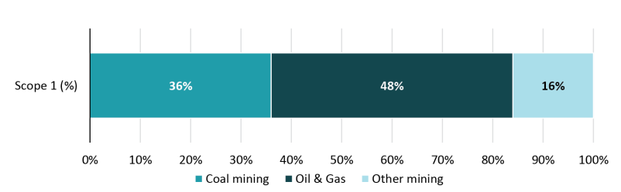
Figure 1: Mining related emission in Australia
(Source: GOV, 2025)
External environment Factor 2- Renewable energy generation and natural resources (Macro Environment)
The macro environment factors such as carbon emission are the major concerns in the mining sector as mining processes cause 60% of fugitive emissions in Australia (GOV, 2025). The growing concerns of sustainability and increasing emission rates in the mining sector has enabled BHP to focus on reducing its emission through renewable energy generation. BHP signed a renewable Power Purchase Agreement (PPA) with Neoen that allows BHP to maintain a 100% renewable electricity supply chain at Escondida and Spence, supporting long-term growth (International Mining, 2026). Moreover, transition towards low carbon products of BHP is impacted by acute and chronic water stress in areas such as Escondida copper mine in Chile. BHP was fined an unprecedented $47m fine (£34.5m) for using groundwater for mining operations and damaging the surrounding vegetation (Heikkinen, 2025). In addressing the concerns of water scarcity and risks of regulatory fines, BHP has invested US$5 billion for the "Escondida New Concentrator" plan in Chile to trade since its reliance on groundwater for mining operations (BHP, 2026). Thus, this outlines the challenges that natural environment actors such as water use and impact of business options on the environment have on the adoption of low carbon product adoption for BHP.

Critical Evaluation of BHP’s response towards the external environmental factors
BHP has identified that Electrification is one of the key aspects of the business’ Decarbonisation strategy that enables BHP in meeting its optional greenhouse to gas emission targets. As per the Decarbonisation strategy of BHP, the business is aiming to reduce 30% of its Scope 1 and Scope 2 emission from operated assets by FY2030 (BHP, 2026). This also has helped the business in meeting its scope 1 and 2 emission reduction target within its operated asset and reduce the risks of regulatory and sustainability concerns. BHP has successfully met 36% reduction of its operational emissions by shifting from diesel engines to renewable electricity use in its Chile supply chain and downstream processing (BHP, 2026). However, BHP’s approach to enhance its business accountability and sustainability marketing has been impacted by its lack of strategic approach to reduce business emission. For instance, BHP has shelved the plan to build its Jimblebar processing facility that reduces scope 3 emission by 1.7m tonnes (Knaus and Morton, 2026). The building of the Jimblebar processing facility was a mega renewable energy generation project that aims to produce 50-megawatt solar and was a 20MW battery project (Knaus and Morton, 2026). Thus, this outlined that BHP must focus on its strategic approach to reduce emissions and rely on renewable energy sources for environmental marketing and competitive advantages.

Integrating another relevant Actors- Legal and Regulatory Actor
Legal and Regulatory factors such as the Paris Agreement and Climate Change Act 2022 are key external marketing environment factors, impacting BHP’s transition towards lower-carbon product adoption in Australia. BHP is lagging behind in meeting its decarbonising steelmaking strategy and reducing Scope 3 emission that has reached 378 million tonnes (Mt) in FY2025 (Nicholas, 2025). The regulatory compliance with frameworks such as the Paris Agreement by BHP is hampered due to its slow progress in decarbonising steelmaking and reduction of Scope 3 emission. Moreover, in 2020, around 22.4% shareholders of BHP suspended membership of the industry association as it was misaligned with the Paris Agreement in reducing emission (ACCR, 2022). Thus, the regulatory framework is being more complex, forcing the business such as BHP to focus on improving its sustainability by aligning business’s low carbon approach with regulatory guidelines.

Task 2: Strategic Growth and Competitive Positioning
Building on the environmental analysis of renewable energy generation (macro environment) and customer/investor expectations (micro environment), this section Ansoff Matrix to suggest strategic directions for the company’s development. This will help to ensure that the positioning of BHP is both competitive and sustainable.

The Ansoff Matrix
Market Penetration: This consists of increasing the existing market share by using current products. BHP can strengthen its positioning in the existing markets by making use of renewable energy into its operations as well as communicating this change to the consumers as well as investors. BHP could achieve greater market penetration by establishing itself as a leader in “green mining” (Onifade et al. 2024). This can be done through its use of 100% renewable energy sources and certification of its products as low-carbon.
Market Development: This consists of entering new markets by introducing the current products (Peterdy, 2022). BHP can enter the new geographic as well as sectoral market by positioning itself as a leader in sustainable mining. BHP has opportunities to develop its markets through expansion into new regions as well as sectors with the help of renewable energy extraction, low carbon processing technologies as well as partnerships in green infrastructure supply chains.
Product Development: This means introducing new products in the existing markets. BHP can innovate new renewable energy product offerings like green metals, carbon neutral commodities and recycled metals which can play a very important role in the transition of BHP towards its sustainable positioning.
Diversification: This consists of entering new markets with the new products. Diversification would provide BHP with a radical growth pathway by aligning with global energy shifts towards sustainability.
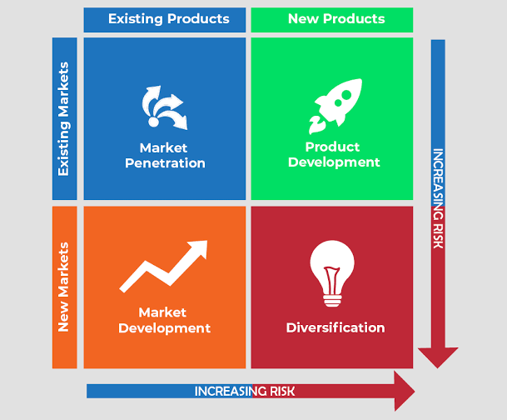
Figure 2: Ansoff Matrix
(Source: MBAKNOL, 2022)

Strategic Growth Positioning
The global mining industry is currently under high pressure for reducing the carbon footprint with the renewable energy adoption, as well as high expectations of stakeholders that requires strategic change. The global mining sector drives roughly 11% of global greenhouse gas emissions, consuming immense energy for extraction and processing. For BHP, the transition towards a low carbon business model is not only an important environmental necessity, but it is also important for the competitive advantage of the company. Among all four strategic options of Ansoff Matrix, Product Development is one of the most suitable pathways for BHP. The innovation of new, low carbon products as well as integration of renewable energy into the production can help BHP in strengthening its market positioning while also meeting the expectations of the stakeholders (Bashir et al. 2022).
Justification: The consumers are constantly demanding more sustainable products, while the investors are focusing on the organisations that aligns with the ESG principles and showcases resilience in the world of acute climate change risks. The insights from PESTLE analysis showcases 0.79 points for political stability of Australia, along with GDP growth of 2.5% in 2026, which provides a very supportive environment for innovation (The Global Economy, 2024). From the social point of view, the renewable energy adoption is also increasing with solar energy now meeting 59% of electricity demands. The consumers are investing more in ESG compliance as well as BHP’s own 2030 sustainability goal consisting of decarbonisation along with a responsible supply chain (Morton, 2026). The failure of innovation can lead to the risk of obsolescence because the demand for carbon intensive products is reducing and the government is also tightening the climate regulations. This will also meet the customer expectations and will maintain long term competitiveness in quickly decarbonisation the global economy.
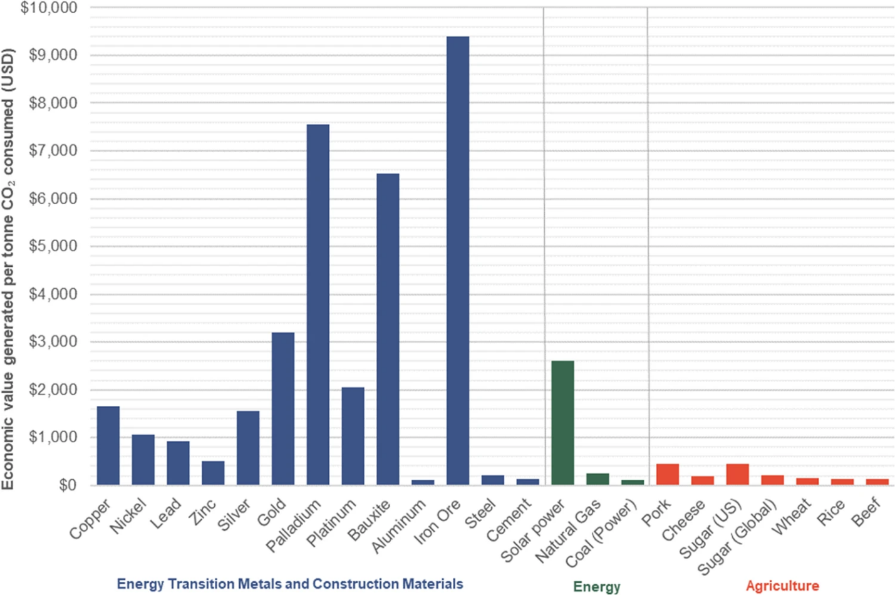
Figure 3: Economic value per tonne of CO2 emitted in USD
(Source: Cox et al. 2022)

Strategic Product Development Pathways
Green Steel and Low Carbon Copper: BHP can invest in producing green steel as well as copper by making use of renewable energy sources like solar and wind. Given that, BHP is collaborating with 11 steelmakers representing 22% of global steel production to develop technologies capable of reducing greenhouse gas (GHG) emissions intensity by 30% by 2030 (BHP, 2024). This would help by giving a macro environmental push for decarbonisation while also meeting the demand for the consumers for sustainable construction as well as infrastructural materials. The investors are increasingly focusing upon the companies that supply green metals which would provide a competitive advantage to the brand.
Carbon-Neutral Commodities: Integrating Capture Carbon and Storage (CCS) into mining as well as processing operations would help BHP in offering carbon neutral products (Ahleyani et al. 2025). This innovation would appeal to the institutional investors who are de-investing from the high emission industries as well as the consumers are looking for compliance with strong climate regulations. The climate transition action plan of BHP has set a net zero scope 3 emission target by 2050, which is the medium term goal for steelmaking decarbonisation (BHP, 2024). The incorporation of carbon neutral commodities will enhance the resilience for BHP and will also boost the cost efficiency.
Digital Traceability Platforms: The Blockchain and AI driven transparency tool would allow the customers so that they can verify the sustainability credentials for the products of BHP (Talla, 2022). This type of platform would respond to the cause of investors for accountability as well as the demand of consumers for ethical sourcing. The offering of triable, certified low carbon commodities can strengthen the trust and loyalty for BHP while also differentiating it from the competitors.
Recycled Metals & Circular Economy: BHP can expand into the recycling of metals from end of life products that would reduce dependence on the virgin extraction of the metals. This would align with the principles of circular economy as well as it will address the environmental concerns about resource depletion (Hagelüken and Goldmann, 2022). The customers can benefit from a sustainable supply chain, while investors can view recycling as a hedge against the volatility of the commodity prices.

Achieving Competitive Advantage
BHP can achieve competitive advantage in its shift towards a low carbon business model by making use of sustainability directly into product innovation. The development of green steel as well as low carbon copper through renewable powered operations can help the company in differentiating itself from the competitors who are still dependent upon fossil fuels (Yao et al. 2024). The integration of carbon capture and storage helps reduce the exposure to the carbon axis, while on the other hand; digital traceability platforms increase the transparency as well as confidence of the investors (Ahleyani et al. 2025). Moreover, expanding into recycled metals, BHP can support the circular economy principles which would lower the cost and also will appeal to the ESG focused consumers (Hagelüken and Goldmann, 2022). Altogether, these initiatives would strengthen the brand reputation, will secure the long-term contracts and will also ensure resilience against regulatory as well as market shifts that would position BHP as a global leader in the sustainable mining.
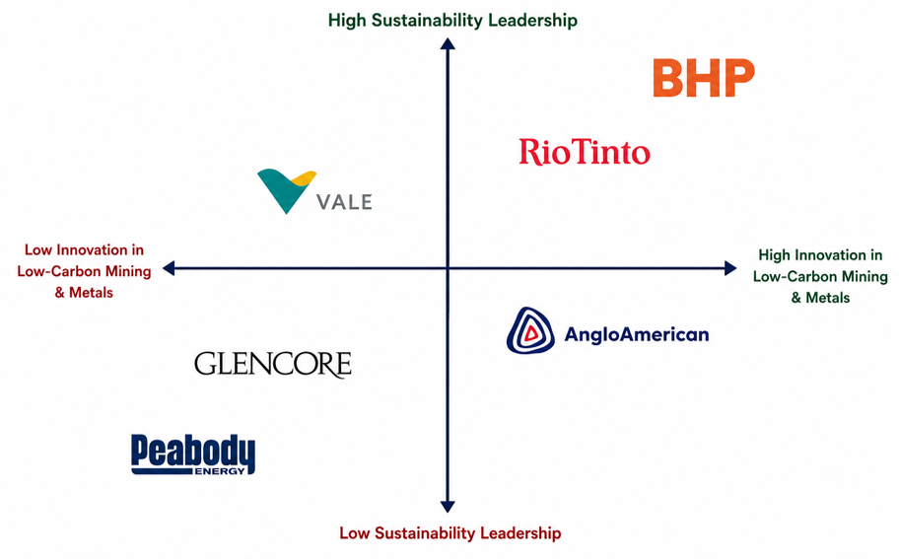
Figure 4: Perceptual Mapping (BHP and its Global Competitors)
(Source: Self-developed)

Reflection on AI Usage

a. Tool Disclosure
The AI tools that were used for structuring and generating ideas regarding marketing environmental analysis of BHP consist of ChatGPT. The use of ChatGPT as one of the most effective AI tools is efficient for idea generation and supporting initial research on an issue (Filippi, 2023). The use of ChatGPT was effective as it assisted in identifying the external environmental factors that may impact business such as BHP's adoption of low carbon products. The adherence and compliance with the AI use acknowledgement was ensured for reducing the risks of plagiarism and using the AI output for supporting idea generation and backing the findings of the study. Thus, the use of AI tools such as ChatGPT was efficient to support the research, structuring the reports, along with creative idea generation.

b. Critical Evaluation of AI Output
The ideas generated by using AI were cross-checked through comparison and analysing the output with academic journals, company reports, and industry records with comprehensive online search. The facts, information and text generated by AI can be addressed through connecting justifications and exploring entailments. Reducing AI hallucinations and errors (Sun et al. 2024). Similarly, the AI generated data and evidence were compared with the company reports, industry records and peer-reviewed journals to reduce logical errors and improve accuracy of the study. Thus, comparison of textual information with current industry reports and company data regarding environment impact and low carbon products adoption has been ensured with referencing and in-text citation for accuracy.

c. Contribution Analysis
The AI generated content provided a structured overview of the marketing environment as well as strategic options for BHP, but it largely remained descriptive and generic. In contrast to this, my own contribution involved, critically refining the analysis, selection of product development as most suitable and soft strategy and integration of real world data like four $420 million steel decarbonisation investment by BHP (BHP, 2024). However, the output of AI suggested several strategies without focusing upon appropriate prioritisation as per the requirement of the companies, on the other hand, my work contradicted this by narrowing down the focus, justify the choice as well as linking to the PESTLE insights. This, AI offered a foundation for the project, but my original analysis added depth, specificity as well as academic rigor.

d. Ethical & Professional Reflection
The use of AI in market marketing analysis rises some important ethical as well as professional questions. While, AI tools can enhance the research and can provide structural support, but overdependence on it can risk the academic integrity if the outputs are not properly evaluated. Here, it is very important to comply with the ethical frameworks like GDPR (Bakare et al. 2024). The ethical practices require proper transparency in disclosing the use of AI, careful verification to avoid misinformation as well as ensuring that original analysis remains intact. Professionally I think that AI should complement rather than replacing the judgement of humans, supporting the efficiency without compromising the accountability. In marketing context, this helps in balancing and safeguarding the creditability, preventing the biases and ensuring that the sustainability strategies are properly communicated in a responsible manner to the stakeholders.

References
ACCR (2022) BHP MUST CEASE LOBBYING EFFORTS WHICH ARE INCONSISTENT WITH PARIS TARGETS. Available at: https://www.accr.org.au/news/bhp-must-cease-lobbying-efforts-which-are-inconsistent-with-paris-targets/ (Accessed: 30 June 2026).
Ahleyani, M., Rohima, A. and Kurniawan, W. (2025) ‘Green economy in the mining industry: CCS synergy for sustainable natural resource management’, MiftahulUlum, 3(2), pp. 97–106. Available at: https://doi.org/10.64405/jm.v3i2.156
Australian Bureau of Statistics (ABS) (2026) Australian National Accounts: National Income, Expenditure and Product. Available at: https://www.abs.gov.au/statistics/economy/national-accounts/australian-national-accounts-national-income-expenditure-and-product/latest-release (Accessed: 30 June 2026).
Australian Bureau of Statistics (ABS) (2026) Technology and innovation. Available at: https://www.abs.gov.au/statistics/industry/technology-and-innovation (Accessed: 30 June 2026).
Bakare, S.S., Adeniyi, A.O., Akpuokwe, C.U. and Eneh, N.E. (2024) ‘Data privacy laws and compliance: a comparative review of the EU GDPR and USA regulations.’ Available at: https://doi.org/10.51594/csitrj.v5i3.859
Bashir, M.F., Sadiq, M., Talbi, B., Shahzad, L. and Bashir, M.A. (2022) ‘An outlook on the development of renewable energy, policy measures to reshape the current energy mix, and how to achieve sustainable economic growth in the post COVID-19 era’, Environmental Science and Pollution Research, 29(29), pp. 43636–43647. Available at: https://doi.org/10.1007/s11356-022-20010-w
BHP (2024) Climate Transition Action Plan. Available at: https://www.bhp.com/sustainability/climate-change/climate-transition-action-plan (Accessed: 30 June 2026).
BHP (2024) Pathways towards steelmaking decarbonisation. Available at: https://www.bhp.com/news/bhp-insights/2024/10/pathways-towards-steelmaking-decarbonisation (Accessed: 30 June 2026).
BHP (2026) BHP partners with China Baowu to address the challenges of climate change. Available at: https://www.bhp.com/news/media-centre/releases/2020/11/bhp-partners-with-china-baowu-to-address-the-challenges-of-climate-change (Accessed: 30 June 2026).
BHP (2026) Escondida | BHP submits environmental permit to build a new concentrator plant. Available at: https://www.bhp.com/news/articles/2026/03/escondida--bhp-submits-environmental-permit-to-build-a-new-concentrator-plant (Accessed: 30 June 2026).
BHP (2026) Why electrification is gaining momentum across Australia's mining sector. Available at: https://www.bhp.com/news/bhp-insights/2026/06/why-electrification-is-gaining-momentum-across-australias-mining-sector (Accessed: 30 June 2026).
Cox, B., Innis, S., Kunz, N.C. and Steen, J. (2022) ‘The mining industry as a net beneficiary of a global tax on carbon emissions’, Communications Earth & Environment, 3, article 17. Available at: https://www.nature.com/articles/s43247-022-00346-4
Filippi, S., (2023). ‘Measuring the impact of ChatGPT on fostering concept generation in innovative product design’. Electronics, 12(16), p.3535. Available at: https://doi.org/10.3390/electronics12163535
GOV (2025) Australian Carbon Credit Unit Scheme. Available at: https://cer.gov.au/schemes/australian-carbon-credit-unit-scheme (Accessed: 30 June 2026).
GOV (2025) Resources sector emissions: an overview. Available at: https://www.industry.gov.au/publications/resources-sector-plan/resources-sector-emissions-overview (Accessed: 30 June 2026).
Hagelüken, C. and Goldmann, D. (2022) ‘Recycling and circular economy—towards a closed loop for metals in emerging clean technologies’, Mineral Economics, 35(3), pp. 539–562. Available at: https://doi.org/10.1007/s13563-022-00319-1
Heikkinen, A. (2025) Mining companies are pumping seawater into the driest place on Earth. But has the damage been done. Available at: https://www.theguardian.com/global-development/2025/jul/17/green-transition-water-chile-atacama-desalination-plants-lithium-copper-mining (Accessed: 30 June 2026).
International Mining (2022) BHP and Tata Steel to partner on low carbon iron and steelmaking tech. Available at: https://im-mining.com/2022/07/19/bhp-and-tata-steel-to-partner-on-low-carbon-iron-and-steelmaking-tech/ (Accessed: 30 June 2026).
International Mining (2026) BHP advances renewable power supply and storage at Escondida & Spence. Available at: https://im-mining.com/2026/06/01/bhp-advances-renewable-power-supply-and-storage-at-escondida-spence/ (Accessed: 30 June 2026).
Knaus, C. and Morton, A. (2026) BHP quietly scrapped plan to build Pilbara plant that would have drastically cut emissions. Available at: https://www.theguardian.com/world/2026/may/25/bhp-mining-pilbara-iron-ore-plant-to-drastically-cut-emissions-scrapped (Accessed: 30 June 2026).
MBAKNOL (2022) Strategic marketing tools: Ansoff Matrix and BCG Matrix. Available at: https://www.mbaknol.com/strategic-management/strategic-marketing-tools-ansoff-matrix-and-bcg-matrix/ (Accessed: 30 June 2026).
Morton, A. (2026) Australia’s grid now relies on renewable energy as much as coal. Those who doubted it look foolish. Available at: https://www.theguardian.com/environment/2026/jan/31/australias-grid-now-relies-on-renewable-energy-as-much-as-coal-those-who-doubted-it-look-foolish (Accessed: 30 June 2026).
Nicholas, S. (2026) BHP: Time to get real about steel technology change and met coal. Available at: https://ieefa.org/resources/bhp-time-get-real-about-steel-technology-change-and-met-coal (Accessed: 30 June 2026).
Onifade, M., Zvarivadza, T., Adebisi, J.A., Said, K.O., Dayo-Olupona, O., Lawal, A.I. and Khandelwal, M. (2024) ‘Advancing toward sustainability: The emergence of green mining technologies and practices’, Green and Smart Mining Engineering, 1(2), pp. 157–174. Available at: https://doi.org/10.1016/j.gsme.2024.05.005
Peterdy, K. (2022) Ansoff Matrix: The Product/Market Expansion Grid. Corporate Finance Institute. Available at: https://corporatefinanceinstitute.com/resources/management/ansoff-matrix/ (Accessed: 30 June 2026).
Sun, Y., Sheng, D., Zhou, Z. and Wu, Y., (2024). ‘AI hallucination: towards a comprehensive classification of distorted information in artificial intelligence-generated content’. Humanities and Social Sciences Communications, 11(1), pp.1-14. Available at: https://doi.org/10.1057/s41599-024-03811-x
Talla, R.R. (2022) ‘Integrating blockchain and AI to enhance supply chain transparency in energy sectors’, Asia Pacific Journal of Energy and Environment, 9(2), pp. 109–118. Available at: https://hal.science/hal-04862355/document
The Global Economy (2024) Australia: Political stability. Available at: https://www.theglobaleconomy.com/Australia/wb_political_stability/ (Accessed: 30 June 2026).
Yao, X. and Xie, H. (2024) ‘Renewable energy and green metallurgy technology’, Processes, 12(2), p. 340. Available at: https://doi.org/10.3390/pr12020340

Appendix- 1 AI Output
Task 1: Marketing Environment Analysis (Approx. 1000 words)
Introduction
The global mining industry is undergoing a major transformation due to increasing environmental concerns and regulatory pressure to reduce carbon emissions. As highlighted in your brief, firms like BHP must transition toward lower-carbon products while responding to multiple external environmental forces. This section critically analyses two key external marketing environment actors influencing BHP:
- Natural Environment (primary focus)
- Political/Regulatory Environment (secondary actor)

1. Natural Environment (Primary Actor)
The natural environment is the most critical factor influencing BHP’s transition strategy. Climate change, carbon emissions, and sustainability expectations directly affect the company’s operations and marketing positioning.
Impact on BHP
- Mining contributes significantly to global greenhouse gas emissions.
- BHP faces pressure to reduce emissions from both operations (Scope 1 & 2) and value chain (Scope 3).
- Increasing demand for sustainable materials (e.g., copper for renewable energy).
Strategic Response
BHP has:
- Invested in low-carbon technologies
- Shifted focus toward future-facing commodities such as copper and nickel
- Committed to net-zero emissions targets
Critical Evaluation
While BHP’s sustainability initiatives enhance brand reputation and stakeholder trust, challenges remain:
- High dependency on fossil-fuel-related commodities (e.g., coal)
- Technological limitations in achieving full decarbonisation
- Cost implications of green transformation
Thus, the natural environment is not only a constraint but also a driver of innovation and competitive repositioning.

2. Political and Regulatory Environment (Secondary Actor)
Governments and regulatory bodies strongly influence BHP’s sustainability transition.
Key Influences
- Carbon pricing and emission regulations
- Environmental protection laws
- International climate agreements (e.g., Paris Agreement)
Impact on Marketing Strategy
- Forces BHP to communicate sustainability commitments transparently
- Encourages investment in cleaner production methods
- Shapes stakeholder expectations
Critical Evaluation
Political factors create both risks and opportunities:
- Strict regulations increase operational costs
- However, compliance enhances legitimacy and long-term market positioning
BHP must continuously adapt to changing policies across multiple countries, making strategic planning complex.

Conclusion of Task 1
The natural environment and political/regulatory forces are deeply interconnected and significantly shape BHP’s transition to a low-carbon business model. While environmental pressures drive innovation, regulatory frameworks enforce accountability, together influencing BHP’s marketing strategies and competitive positioning.

Task 2: Strategic Growth and Competitive Positioning (Approx. 1000 words)
Introduction
Based on the environmental analysis, BHP must adopt a growth strategy that aligns with sustainability goals while maintaining competitive advantage. The Ansoff Matrix provides a useful framework for identifying growth opportunities.

Application of Ansoff Matrix
1. Market Penetration (Existing Products, Existing Markets)
- Improve efficiency in existing mining operations
- Promote lower-carbon versions of current products
Limitation:
Does not significantly support long-term sustainability transformation.

2. Product Development (New Products, Existing Markets)
This is the most suitable strategy for BHP.
Examples
- Development of low-carbon steel inputs
- Expansion into green metals (copper, nickel) for EVs and renewable energy
Advantages
- Meets growing demand for sustainable materials
- Strengthens relationships with environmentally conscious customers

3. Market Development (Existing Products, New Markets)
- Expansion into emerging economies adopting green infrastructure
Risk:
Depends on regulatory stability and infrastructure readiness.

4. Diversification (New Products, New Markets)
Examples
- Investment in renewable energy projects
- Green hydrogen initiatives
Evaluation:
High risk but offers long-term growth potential and sustainability leadership.

Recommended Strategy: Product Development + Related Diversification
BHP should adopt a hybrid strategy:
- Focus on low-carbon product innovation
- Gradually diversify into renewable energy and green technologies

Competitive Advantage Strategy
To sustain competitive advantage, BHP should adopt a Differentiation Strategy (Porter):
Key Elements
- Position as a sustainable mining leader
- Invest in innovation and technology
- Build strong ESG (Environmental, Social, Governance) credentials
Sources of Advantage
- Strong financial resources for R&D
- Global operational scale
- Established supply chain relationships

Critical Evaluation
While the proposed strategy aligns with global trends:
- High investment costs may reduce short-term profitability
- Technological uncertainty remains a risk
- Competitors (e.g., Tata Steel, Codelco) are also pursuing similar strategies
However, early adoption provides first-mover advantage and long-term resilience.

Conclusion of Task 2
BHP can achieve sustainable growth by focusing on product development and diversification strategies aligned with low-carbon innovation. By differentiating itself through sustainability, the company can strengthen its competitive position in the evolving mining industry.

