Saieed Hussain
1605696
Employability EMPL4007LON
Mary March

Task 1
An explanation of the purpose of a job specification within recruitment and selection process.
According to go2 Tourism HR Society 2017 providing job description forms a foundation for making important processes such as job postings, recruitment selection, setting expectations, and training and performance management.
A good job description should provide a brief overview of the duties and possibly a brief overview of how it relates to the companies vision adding a list of responsibilities, requirements and qualification.
“TIME SPENT DEVELOPING JOB DESCRIPTIONS HAS SEVERAL PAY-OFFS”
According to N Mayer who wrote on his article explaining that a well prepared job description providing an accurate assessment of staffing needs and clearly informing what the employer is offering will allow both parties of what’s expected whilst employed.
A good job description will have summarised all duties of the position and state clary all the essential responsibilities of the job. The information that’s required on the job description will narrow down all potential candidates.
It should consist of elements such as the position title, the nature of work performed, purpose of the job and key functions and a summary of the job possibly also duties in a list order of any formal training, education, certificate, licenses or work experience that’s related to the job, All of the mentioned will help identify if the applicant bests suits the job.

Iain Maitland, wrote in how to recruit 1993, When recruiting there are a few points that an employer will have to ensure when planning for an advert, it is ideally to attract a selective pool of applicants, and discourage unsuitable applicants from getting in touch.
Everyone should know what is involved with the post and whom you wish to employ.
You would usually try to supply as much as possible about, the job description, the location, the duties the salary, the benefits of the company and how to apply.
The main purpose of a job descriptions provided by employees is so it can allow the applicant to get an understanding of what duties and responsibilities are expected of them as a whole whilst employed.
It’s also a guideline to assist in the monitoring of your performance, normally it’s written clearly on a document which you would have had to read to understand prior to applying to ensure you meet with the requirements set at the initial stage.
Task 2.
An explanation of the purpose of a person specification within recruitment and selection process.
Reed employment wrote an article which was quite good providing me with a clearly written and presented breakdown of the purpose of a person specification within the recruitment and selection process it went on to explain the five steps to a good PS
One being that it is very helpful in the interview process if the candidate who applied passes the first stage.
Secondly it will provide an understanding to the applicant so they are able to ask within themselves if the job they are applying for is the right choice for them.
Thirdly it will clarify the essential and desirable requirements for the job in hand.
Fourthly is that the candidate is in understanding of the abilities needed related to the job.
And lastly the structure designed based for the job will have illuminated any room for miscommunication and should conclude for a clear result as smoothly as possible.

The person specification is a description of the qualifications, skills, experience, knowledge and other attributes which a candidate must possess to perform the job, this not only assists the employer but also narrows down what is required from the employee. It’s the foundation and the core structure for the recruitment process.
Specification is normally derived from the job description.
The person specification is an important part of the recruiter’s toolbox. It allows the company to communicate the exact traits they find desirable in their ideal candidates such as education, previous work experience and any extra traits that are needed in the role.

Task 2 was to prepare a CV for a specific job role. And Within my CV, it should demonstrate an understanding of the importance of skills and knowledge for working effectively and to focus my CV to the specific role.

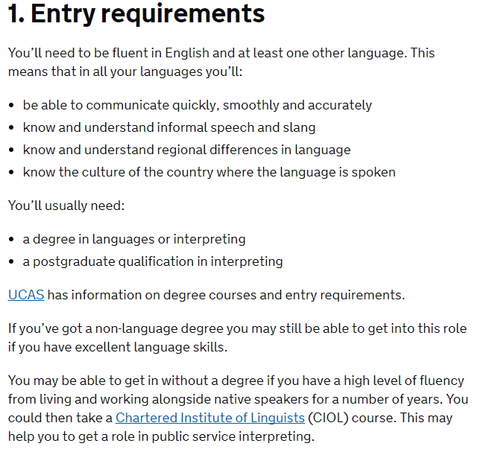
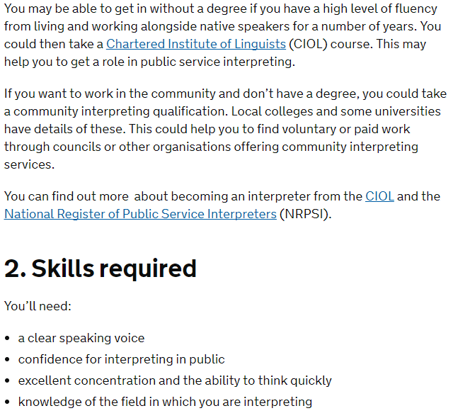
I searched online using the internet to locate a job based on what I believe will assist this what I have come up with.
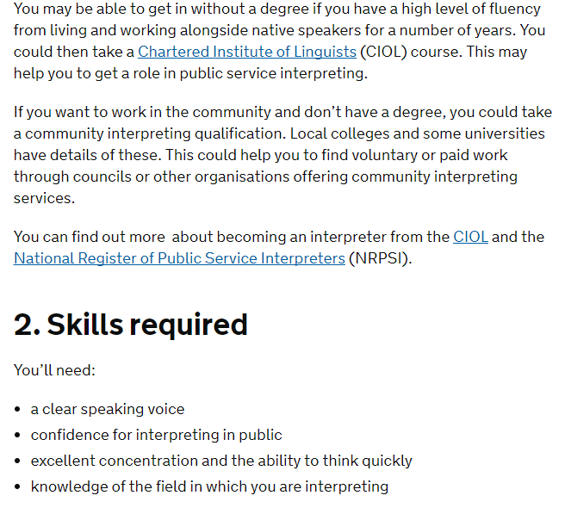

Using last terms module to assist in narrowing down my goals in life I have come to a conclusion that I would like to follow the career of becoming a social worker working with broken families.
In order for me to achieve my commitment I have come to a conclusion that I do require an enhanced qualification which is to be obtained by attending university for a duration of three years at the very least.
Using the resources available on the internet and speaking to friends and family to gain directions it became apparent for me to work in the industry with individuals to first identify weather this is the correct path for me.
As a member of the community and a resident of the small estate I have a high number of Bangladeshi residents who are yet still adapting to the English language.
This is my way in to build hands on experience as a translator to support a professional possibly who is acting as a social worker already.
so as a translator I would have to know the language Bengali which I do as my mother raised me in a house hold speaking this language and it is my second language which I am fluent in speaking but lack the writing skills.

Saieed Hussain
Saieedhussain1@gmail.com
07554001670
Personal Statement
I am an extremely confident, motivated and flexible and well-presented individual with great communication skills with the ability to meet set targets with minimal supervision. I have an efficient and practical approach to work and enjoy working with the public. I am Fluent in English and Bengali and very good with managing my time with the ability to prioritise workloads.

Education

2017-2016 University of Whales Trinity Saint David
Skills for Work Level 4 Certificate in Higher Education
1999-2002 Bethnal Green Technology College
Six A-C grades including English, Mathematics and Science

Work Experience

2012-2015 Advance Security UK Limited – Elite Security Officer.

NHS In house Security Officer

• My Roles were ensuring that hospitals are welcoming and accessible but also a safe environment for patients, visitors and staff, I often used my second language to guide and direct individuals as the local community were of the Bengali nationality.
• As part of the team we had to secure the building and the knowledge of the premises was a must.
• on a daily basis I had to diffuse potentially difficult situations and had to be able to react appropriately in an emergency as I dealt with the critical care unit and accident and emergency department.

2003-2011 Dial a cab – Customer Service Representative Supervisor.

• Whilst working in a busy contact centre amongst other individuals at different levels and departments I had to be very professional and clearly spoken.
• I was processing accurate and precise taxi bookings for clients and the public using the telephone.
• Handling client’s personal details on a computerised despatching system.
• Using emails from customers to book the required taxis at exact times and places where and when required.
• Confirming customers of their bookings and the status regularly and as frequently as requested.
• Dealing with customer’s queries, questions and complaints when necessary.
• Working as a team player and being able to work well under pressure during peak periods.

Hobbies & Interests

I attend my local community centre and interact as a youth worker.
I enjoy a good swim and to keep myself fit and healthy I attend the gym on a regular basis.

References

Available on request.

For task 3 I used team working and time management from the list and using previous experiences I demonstrated the STAR model
Time management

I found that managing my time is so vital for a successful positive approach to life setting clear goals focusing on the priorities taking steps and reviewing your progress and possibly an action plan written down definitely helps
Why use time management skills?
It's important that i develop effective strategies for managing my time to balance the conflicting demands of time for study, leisure, earning money and job-hunting. Time management skills are valuable in job-hunting, but also in many other aspects of life: from revising for examinations to working in a vacation job.
Once i have identified ways in which i can improve the management of my time, i can begin to adjust my routines and patterns of behaviour to reduce any time-related stress in my life.

Example
I had an experience once where we were working at a busy fast food restaurant and just prior to rush hour period where we know from experience that the outlet is expected to reach a point where were all rushed off our feet’s preparing and serving to the hungry member of public popping in for their spot of lunch some be it having thirty minutes break period to pick up their desired meals or dining in for forty five minutes a situation happened when the head chef became very light headed and had to be go home leaving the team to operate, without the main chef on the restaurant kitchen the manger was new to the team at this branch the whole team were panicking.
Just as this started customers started strolling in we all hurdled together and spoke our minds seeking for a solution as promptly as possible.
I made it an option as the kitchen porter that I from experience and shadowing the head chef that I feel comfortable to take the active role as head chef and possibly shift the till staff to overlook me as she had been the longest working staff at the branch, very confidently she agreed and made mention that she’s aware of most of what the head chefs roles and responsibilities were and was happy to commit to this temporary role until a new solution was in place.

The operation of the restaurant operated a little slower than usual but with the clear polite communication related to the customers and great commination skills we were able to work well throughout the whole shift.
This was recognised by all of us on the kitchen floor and we were awarded with a bonus for that months end.
I was later promoted to head chef as I had picked up a lot whilst head chef was off work and my confidence was reassured with my work colleague beside me.
we delegated what suited us best in this scenario working well with each other ensuring we knew what was needed as an individual and as a whole team so this is why is worked smoothly and yet we were meeting the target of an fully operational fast food branch ensuring we were abiding by all procedures of the companies policies and terms and conditions.

What skills are required for effective time management?
Some of these skills including setting clear goals, breaking your goals down into discreet steps, and reviewing your progress towards your goals are covered in Action Planning.

Other skills involved include prioritising - focusing on urgent and important tasks rather than those that are not important or don't move you towards your goals; organising your work schedule; list making to remind you of what you need to do when; persevering when things are not working out

Managing my time is so crucial in my life and being disciplined and focused if I am to achieve my goals for a much smoother life and they key is that I abide to a well-balanced life style.
Working well with others in work industries operate so much productively and that’s a known fact having an positive approach, demonstrating respect for other individuals values and cultures and setting out responsibilities and roles is a smart approach too.
Example
Managing my punctuality became a huge problem whilst travelling to get to work was a nightmare as the trains would quite frequently not stop off at my desired location this all became overwhelming at times as I would arrive an hour late into my shift not only disappointing my team who had to cover my work load but I would have to make up the hour towards the end of my allocated shift time which interfered with the new team that arrived to take over.
The transport for London did make mention of the disruptions and the alternatives offered were too costly for me.
After a meeting with the management team at work they proposed that I would need to either change complete shifts as a solution or alternatively it had to improve as it was affecting the operations of the business.

I researched online and found out that the alternative was a commute via a green route which was accessible to the comity of cyclists and with the correct resources I eventually invested in purchasing a bicycle alongside all the right gear for a long comfortable journey to and from work.
I discussed this with the management at work who were happy to tailor my need of securing my bicycle at the work premises.
My commute to work not only was a healthy way forward but I also experienced a new part of London and I was never was late to work.

References

www.go2hr.ca/articles/why-you-need-job-descriptions
Last Accessed 22.11.2017
http://work.chron.com/meaning-job-description.
Last Accessed 18.12.2017
Iain Maitland, 1993
https://www.redglobal.com/blog/2017/07/the-purpose-of-a-person-specification
Last accessed 18.12.2017

